Apollo Knowledge-Work RL Eval Write-Up
Client update and loss analysis memo

Document 1: Client Update
We built a minimal, self-contained RL environment for evaluating LLM agents on knowledge-work tasks. The environment runs locally and exposes two in-memory services as function-calling tools: a Slack-like messaging service and a task manager.
The seeded workspace has three channels (#general, #incidents, #leads), four users (alice, ben, carla, devon), and two pre-existing tasks: Update launch checklist assigned to ben and Send Acme pricing assigned to carla.
The task, Commitments Tracking, asks the agent to review the workspace and make sure every commitment is tracked. A correct run creates a Globex security-questionnaire task assigned to alice, creates a billing-API-monitoring follow-up assigned to devon, does not duplicate the existing Acme or launch-checklist tasks, and ignores informational chatter.

Design decisions
The verifier combines deterministic state checks with a small trajectory check. The deterministic checks confirm the two required tasks, the correct owners, actionable statuses, and no duplicates. The trajectory check confirms the agent read the workspace and checked the board.
This design keeps the reward objective and reproducible while reducing the chance that an agent passes by guessing. We deliberately avoided LLM-as-judge because the success criteria are objective; a judge would add nondeterminism and another surface to game.
Calibration mattered. The first version, with one commitment plus deduplication, produced about 88% pass rates for both models and was saturated. The second version, with two commitments across channels, produced 0% for both and was too hard. The final version removed an ambiguous decoy and nudged the instruction to read each channel directly and check the board before finishing.
We targeted a weak open-source model because making a small local eval difficult for frontier models is resource-intensive. The comparison model is stronger but close enough to keep the study focused on task behavior rather than model family differences.

Results
In the final calibration, with n=8 per model, gpt-oss-20b passed 2 of 8 runs (25%). gpt-oss-120b passed 4 of 8 runs (50%). The eval discriminates between the two models while still leaving room for failure analysis.
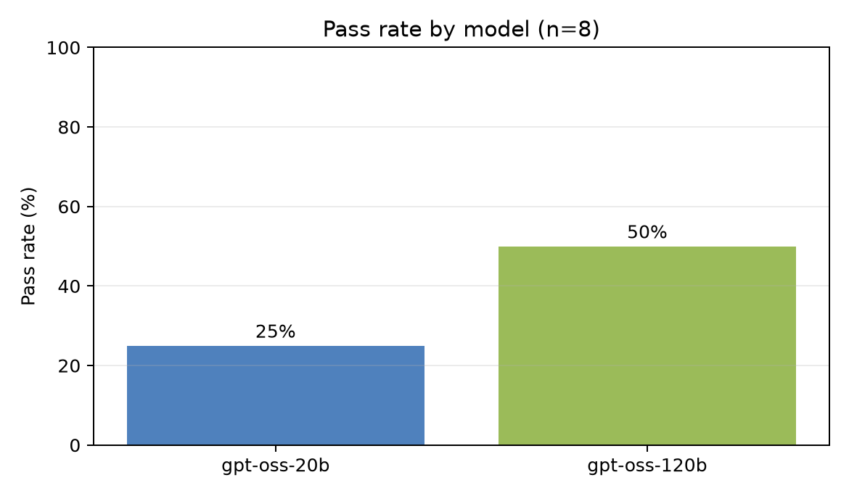
Figure 1. Pass rate by model, n=8.

Limitations
- The eval covers one task in one small synthetic workspace.
- The two models are close in capability, so the separation is useful but modest.
- The verifier uses keyword matching that is adequate for this controlled task but would need hardening at scale.

Document 2: Loss Analysis Memo
To: Research team
Subject: Why the Commitments Tracking eval failed and what it measures

Task and setup
This eval probes whether an agent can infer workplace commitments from ordinary messages, attribute ownership, and update a task board without duplication. The target model is gpt-oss-20b, compared with gpt-oss-120b. Each model ran 8 trials under the same seeded workspace and hybrid verifier.
The required end state is concrete: a Globex questionnaire task assigned to alice, a billing API monitoring task assigned to devon, one Acme task, and one launch-checklist task. The trajectory also has to show that the agent read the workspace and checked existing tasks.

Finding 1: explicit requests were easy; implicit commitments were not
Both models created the monitoring follow-up on all 8 runs. That item was phrased as an explicit request: create a follow-up task to set up monitoring for the billing API. The Globex item was different. It required connecting a customer request with Alice's later offer to take the questionnaire.
The dominant failure was globex_ok: 5 failed checks for gpt-oss-20b and 4 for gpt-oss-120b. The gap is not basic instruction execution. It is implicit-commitment inference and attribution.

Finding 2: models declared completion before proving it
Several failing trajectories ended with confident closure such as no additional commitments identified or the board is up to date. Those statements were wrong because the Globex commitment remained untracked. The failure mode matters because it looks operationally clean while leaving work behind.

Finding 3: search behavior shaped outcomes
The weaker model often searched for literal terms such as I will or commit instead of reading channels directly. Because search only returns substring matches, it missed commitments phrased outside those queries and did not recover by reading the channel history. The stronger model read channels directly more often, which explains part of its higher pass rate.
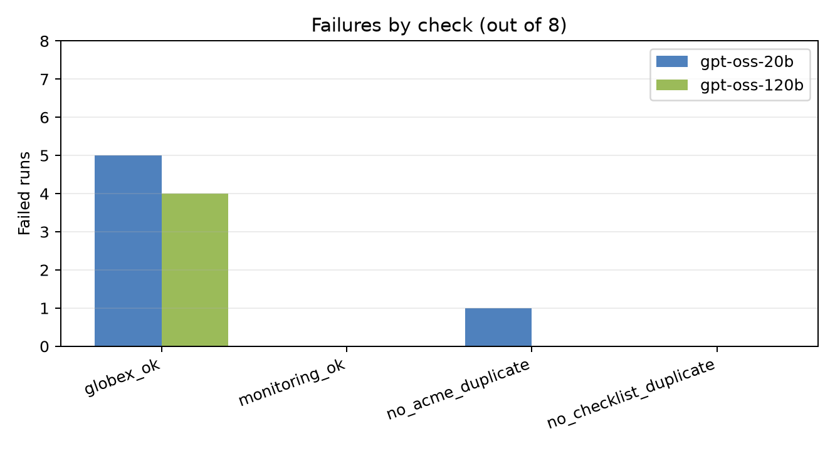
Figure 2. Failed verifier checks by model, out of 8 runs.

Why this eval matters
Explicit instruction-following is already near saturation for this task family. The harder capability is recognizing that a message pair creates an obligation, assigning that obligation to the right person, and reconciling it with the existing board. This eval isolates that capability with a small, reproducible setup.

