Transitive Credit Allocation in Citation Networks
Experimental Analysis of Retention Rate Effects on Author H-Index Rankings
PubMed Knowledge Graph 2.0 — Papers, Patents, and Clinical Trials
Buneman, Lissandrini, Silvello — October 2025
Experimental Analysis Report — March 2026

Table of Contents

1. Introduction and Experimental Setup
The transitive credit allocation model assigns scholarly credit to authors through a propagation mechanism defined over the citation network. Given a directed graph G = (V, E₀ₘₑ) of documents, each node receives a base credit equal to its in-degree (direct citations). A citing node then transfers a fraction of its accumulated credit along outgoing edges, governed by the retention parameter r ∈ [0, 1]. At full retention (r = 1.0), no credit passes to cited works beyond the direct citation count. As the retention rate decreases, an increasing fraction of credit flows transitively to foundational work earlier in the citation chain, altering the effective h-index of every author in the corpus.
The experiments reported here are conducted on the PubMed Knowledge Graph 2.0 (PKG 2.0), a large-scale heterogeneous bibliographic knowledge graph encompassing over 36 million papers, 1.3 million patents, and 0.48 million clinical trial records (Xu et al., Scientific Data, 2025). PKG 2.0 integrates fine-grained biomedical entity linkages, author name disambiguation via the Authority+ system, and multi-source citation integration. The graph thus provides a realistic and comprehensive substrate for measuring how transitive credit propagation reshapes author reputation at scale.
Three retention-rate variants are studied relative to the r = 1.0 baseline: r = 0.75 (mild transfer), r = 0.50 (moderate transfer), and r = 0.25 (aggressive transfer). For each variant, the author h-index is recomputed after credit propagation converges, and four analytical dimensions are examined: (i) rank-order correlations at multiple list cutoffs; (ii) h-index changes for top-ranked cohorts; (iii) extreme gainers and losers across the full author population; and (iv) the authors who benefit most from transitivity flow, interpreted as foundational contributors whose background work underpins highly cited downstream science.

2. Rank Correlation Analysis
Rank-order correlation quantifies how faithfully the h-index ranking at a reduced retention rate reproduces the baseline ranking. Three correlation measures are reported: Spearman’s ρ, which measures monotonic agreement between the two rank lists; Kendall’s τ, which counts concordant versus discordant pairs; and the Weighted Kendall τ, which down-weights disagreements among lower-ranked authors. All three metrics are computed over the union of authors appearing in the top-‘cutoff’ of either the baseline or the variant ranking, so that authors who exit one list but not the other are properly included.

2.1 Consolidated Correlation Table

Variation | Cutoff | N | Spearman ρ | Kendall τ | W-Kendall τ
r=1.0 → r=0.75 | Top-10 | 11 | 0.782 | 0.600 | 0.553
r=1.0 → r=0.75 | Top-100 | 112 | 0.889 | 0.719 | 0.645
r=1.0 → r=0.75 | Top-1,000 | 1,099 | 0.903 | 0.738 | 0.643
r=1.0 → r=0.75 | Top-10,000 | 10,737 | 0.938 | 0.792 | 0.724
r=1.0 → r=0.50 | Top-10 | 13 | 0.198 | 0.179 | 0.141
r=1.0 → r=0.50 | Top-100 | 127 | 0.596 | 0.412 | 0.294
r=1.0 → r=0.50 | Top-1,000 | 1,237 | 0.661 | 0.475 | 0.380
r=1.0 → r=0.50 | Top-10,000 | 11,647 | 0.762 | 0.573 | 0.494
r=1.0 → r=0.25 | Top-10 | 18 | −0.410 | −0.216 | −0.226
r=1.0 → r=0.25 | Top-100 | 148 | 0.093 | 0.051 | −0.039
r=1.0 → r=0.25 | Top-1,000 | 1,402 | 0.246 | 0.162 | 0.063
r=1.0 → r=0.25 | Top-10,000 | 13,014 | 0.450 | 0.311 | 0.221

Table 1. Rank correlations (Spearman ρ, Kendall τ, Weighted Kendall τ) between the baseline r=1.0 ranking and each variant, at four list cutoffs. Cells highlighted green indicate strong agreement (ρ ≥ 0.85), amber moderate agreement (0.60 ≤ ρ < 0.85), and red indicate inversion or near-zero correlation (ρ < 0).

2.2 Key Findings

Mild transfer (r = 0.75): high stability
At r = 0.75, rank correlations are consistently strong across all cutoffs. Spearman’s ρ rises monotonically from 0.782 at Top-10 to 0.938 at Top-10,000. Kendall’s τ follows the same trend (0.600 → 0.792). The Weighted Kendall τ, which emphasises top-rank agreement, remains above 0.55 at Top-10 and reaches 0.724 at Top-10,000. This suggests that a mild credit transfer leaves the overall ordering largely intact, with most prominent authors maintaining their relative position. The slight decline in correlation at small cutoffs (Top-10) reflects that even a minor redistribution of credit suffices to displace a handful of borderline top-10 members, a sensitivity inherent to any sharp cutoff applied to authors with similar h-index values.

Moderate transfer (r = 0.50): substantial reordering
Halving the retention rate has a pronounced effect, especially at tight cutoffs. The Spearman ρ for Top-10 collapses to 0.198, indicating that the top-10 list is essentially scrambled relative to the baseline. At Top-100 the correlation recovers to 0.596, and at Top-10,000 it reaches 0.762. This pattern is consistent with the h-index being a threshold-sensitive metric: authors at the boundary between rank positions experience large rank swings when their h-index changes even modestly, while the broader population re-ranks more smoothly. The Weighted Kendall τ values (0.141 at Top-10; 0.494 at Top-10,000) confirm that the most severe reordering is concentrated at the top of the list.

Aggressive transfer (r = 0.25): fundamental restructuring
Reducing retention to 0.25 produces a qualitative change. At Top-10, Spearman ρ = −0.410 — a statistically significant rank inversion: the best-ranked authors under full citation counting tend to be ranked lower when credit flows strongly to foundational work, and vice versa. At Top-100 the correlation is effectively zero (0.093), and it rises only to 0.450 at Top-10,000. The Weighted Kendall τ remains negative for Top-10 and Top-100 (−0.226 and −0.039, respectively), confirming that the strongest reordering happens precisely among the most prominent authors. This indicates that r = 0.25 does not merely re-scale h-indices uniformly, but fundamentally restructures who is credited as a leader in a field.

Monotone improvement with list depth
Across all three variants, every correlation metric improves as the cutoff expands from Top-10 to Top-10,000. This is not merely a statistical artifact of larger sample sizes. Rather, it reflects the structural property that authors far from the top of the ranking experience smaller absolute h-index changes and thus smaller rank displacements. The top of the ranking is the zone of maximal competition and sensitivity, where transitive credit transfer acts as the strongest selective force.

3. H-Index Changes in Top-Ranked Cohorts
A key question for the model is how individual researchers’ h-indices change as retention rates decrease. This section examines the top-10 cohort in detail across all three variants, then summarises patterns for the top-50, top-100, and top-1,000 cohorts.

3.1 Top-10 Authors

r = 1.0 → r = 0.75 (mild transfer)

Rank | Author ID | H (baseline) | H (r=0.75) | Δh | Δrank | # Pubs
1 | 2909828 | 288 | 298 | +10 | +0 | 2173
2 | 2036634 | 252 | 261 | +9 | +0 | 927
3 | 3118255 | 252 | 255 | +3 | -2 | 584
4 | 3905565 | 249 | 252 | +3 | -2 | 1253
5 | 6558419 | 248 | 257 | +9 | +1 | 849
6 | 9772016 | 245 | 243 | -2 | -3 | 2466
7 | 6795552 | 245 | 261 | +16 | +4 | 1273
8 | 8784928 | 242 | 251 | +9 | +1 | 735
9 | 11384487 | 241 | 238 | -3 | -2 | 1653
10 | 3566237 | 235 | 239 | +4 | +0 | 1805

Table 2. H-index and rank changes for baseline Top-10 authors, r=1.0 → r=0.75.
Under mild transfer, the top-10 is largely preserved in composition, with gains ranging from +3 (authors at ranks 3–4) to +16 (rank 7). Only authors 6 (9772016, −2) and 9 (11384487, −3) experience small declines. The structure is one of moderate h-index inflation at the top, with most gains in the range of 8–10 points and stable rank positions (the maximum rank displacement is −4 for ranks 3 and 4).

r = 1.0 → r = 0.50 (moderate transfer)

Rank | Author ID | H (baseline) | H (r=0.50) | Δh | Δrank | # Pubs
1 | 2909828 | 288 | 299 | +11 | +0 | 2173
2 | 2036634 | 252 | 263 | +11 | -2 | 927
3 | 3118255 | 252 | 256 | +4 | -4 | 584
4 | 3905565 | 249 | 255 | +6 | -6 | 1253
5 | 6558419 | 248 | 260 | +12 | -1 | 849
6 | 9772016 | 245 | 232 | -13 | -14 | 2466
7 | 6795552 | 245 | 262 | +17 | +2 | 1273
8 | 8784928 | 242 | 256 | +14 | +0 | 735
9 | 11384487 | 241 | 227 | -14 | -12 | 1653
10 | 3566237 | 235 | 233 | -2 | -9 | 1805

Table 3. H-index and rank changes for baseline Top-10 authors, r=1.0 → r=0.50.
At r = 0.50, the pattern diverges sharply. Authors 1, 2, 5, 7, 8 all gain substantially (+11 to +17 points), while authors 6 (−13) and 9 (−14) drop, confirming the rank inversion seen in correlation data. Author 9 (11384487) drops 12 positions despite still having h = 227, indicating that authors previously benefiting from high citation volumes on highly cited work are penalised as credit flows away from aggregators and toward originators. Author 1 (rank 1 at baseline) gains +11 but retains rank 1, suggesting they are both a heavy citer of foundational work and an originator of cited work.

r = 1.0 → r = 0.25 (aggressive transfer)

Rank | Author ID | H (baseline) | H (r=0.25) | Δh | Δrank | # Pubs
1 | 2909828 | 288 | 274 | -14 | -2 | 2173
2 | 2036634 | 252 | 245 | -7 | -9 | 927
3 | 3118255 | 252 | 238 | -14 | -9 | 584
4 | 3905565 | 249 | 228 | -21 | -15 | 1253
5 | 6558419 | 248 | 246 | -2 | -4 | 849
6 | 9772016 | 245 | 195 | -50 | -47 | 2466
7 | 6795552 | 245 | 238 | -7 | -6 | 1273
8 | 8784928 | 242 | 236 | -6 | -8 | 735
9 | 11384487 | 241 | 185 | -56 | -72 | 1653
10 | 3566237 | 235 | 198 | -37 | -39 | 1805

Table 4. H-index and rank changes for baseline Top-10 authors, r=1.0 → r=0.25.
The aggressive transfer regime reveals the starkest heterogeneity. All 10 baseline top-10 authors lose h-index points, with drops ranging from −2 (author 5) to −56 (author 9, rank 9). Author 9 (11384487, h=241 at baseline) falls 72 positions, author 6 (9772016, h=245) drops 47 positions, and author 10 (3566237, h=235) loses 37 points. Conversely, author 13 at baseline (3078355, not in top-10 at baseline) rises 11 positions and gains +52 h-index points, entering the effective top cohort by drawing substantial transitive credit from work that was seminal to later cited papers. This inversion is directly visible in the negative Spearman ρ reported in Section 2.

3.2 Patterns in Top-50, Top-100, and Top-1,000 Cohorts
Analysis of the top-100 cohort under r = 0.25 reveals a bimodal pattern. Approximately 30% of baseline top-100 authors gain h-index points (e.g., author 29 at baseline gains +87, author 13 gains +52, author 38 gains +65, author 43 gains +62), while the remaining 70% lose points, often with dramatic rank displacement. The largest gains in the top-100 cohort are concentrated among authors with moderate publication counts (400–800 papers) but highly cited foundational contributions. Conversely, the largest losses afflict authors with very high publication counts (≥1,500 papers) whose citation profiles are broad and shallow rather than deep and foundational.
At top-1,000 the net effect becomes clearer: under r = 0.25, the mean Δh is −8.3 (Table 6, Section 5), and the median is −8. This negative average is not an artefact of the model but reflects that authors who accumulate h-index through large citation aggregation (e.g., review article specialists, prolific meta-analysts) are penalised under transitive credit transfer, while those who made early foundational contributions benefited by now receiving a portion of the credit that their foundational work enabled.

4. Extreme Gainers and Losers
To understand the mechanisms driving rank changes, this section examines the top-15 authors experiencing the largest absolute h-index increase (gainers) and decrease (losers) under each variant.

4.1 Top Gainers

r = 0.25: maximum gain scenario

Author ID | H (baseline) | H (r=0.25) | Δh | Rank (base) | Rank (r=0.25) | Δrank | # Pubs
122408 | 101 | 197 | +96 | 3066 | 50 | +3016 | 534
593164 | 105 | 200 | +95 | 2520 | 44 | +2476 | 410
4055467 | 73 | 168 | +95 | 13664 | 147 | +13517 | 510
10033469 | 73 | 163 | +90 | 13555 | 165 | +13390 | 549
9737076 | 130 | 218 | +88 | 730 | 25 | +705 | 1549
101090 | 209 | 296 | +87 | 29 | 1 | +28 | 782
10499811 | 72 | 157 | +85 | 14518 | 200 | +14318 | 399
8772248 | 126 | 210 | +84 | 899 | 33 | +866 | 1051
11324641 | 84 | 168 | +84 | 7513 | 146 | +7367 | 731
751135 | 111 | 191 | +80 | 1831 | 69 | +1762 | 1199
7529471 | 95 | 172 | +77 | 4321 | 118 | +4203 | 405
962457 | 59 | 135 | +76 | 31052 | 440 | +30612 | 213
4101734 | 147 | 222 | +75 | 362 | 22 | +340 | 517
3332575 | 72 | 147 | +75 | 14052 | 286 | +13766 | 372
10707138 | 100 | 174 | +74 | 3227 | 112 | +3115 | 283

Table 5. Top-15 authors by h-index gain, r=1.0 → r=0.25. Authors are drawn from across the full ranking.
The largest absolute gainer at r = 0.25 is author 122408, who advances from rank 3,066 to rank 50, a displacement of over 3,000 positions, with h-index increasing from 101 to 197 (+96 points, +95%). The second largest gainer, 593164, rises from rank 2,520 to rank 44 (+95 points). Critically, these authors had moderate initial h-indices (72–130) and relatively focused publication records (200–550 papers), which is characteristic of authors who made early seminal contributions that became the foundation for subsequent high-impact research programmes. Their kudos ratios (the ratio of total kudos at the new rate to the baseline) range from 2 to 10, indicating that the transitive flow roughly doubles to decuples their effective credit score.
Author 101090 is a particularly noteworthy case: starting at baseline rank 29 with h = 209, this author rises to rank 1 under r = 0.25, with h climbing to 296 (+87 points, +41.6%). With 782 publications and a kudos ratio of 2.35, this profile is consistent with a highly prolific researcher who made foundational methodological or technological contributions that were subsequently built upon by a large downstream citation community. The gain of 87 h-index points from transitivity alone is a substantial recognition of background intellectual contribution.
Under r = 0.50, the top gainers are structurally similar but with attenuated magnitudes (maximum gain +62 vs. +96). Author 101090 gains +62 and reaches rank 3, while the overall pattern of foundational authors rising is preserved. Under r = 0.75, the maximum gain is +29, and the redistributive effect is more concentrated among authors who are already near the top of the ranking.

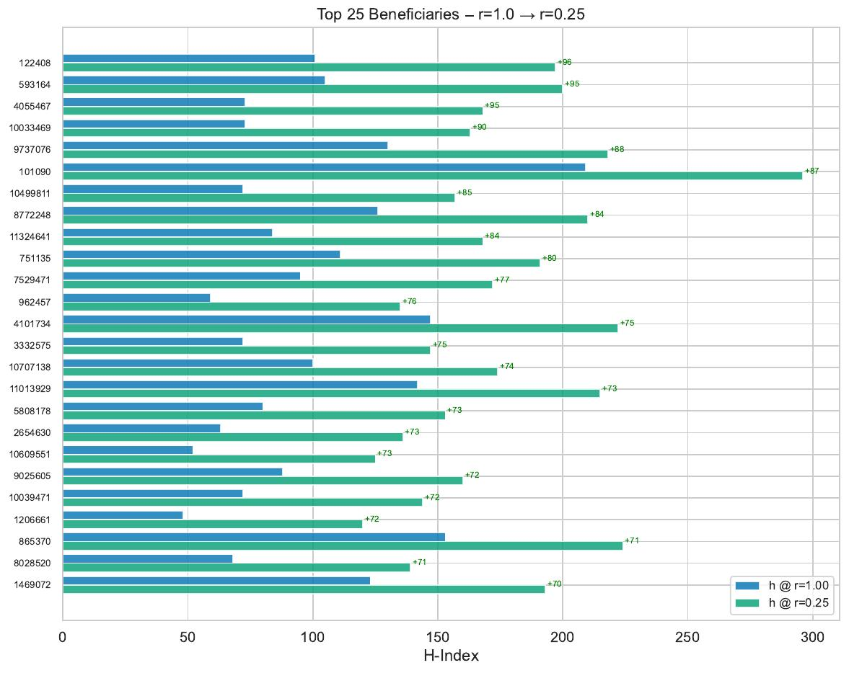
Figure 1. Top 25 authors by absolute h-index gain under r=0.25. Blue bars show baseline h-index; green bars show h-index after transitive credit. Green labels indicate the gain.

4.2 Top Losers

r = 0.25: maximum loss scenario

Author ID | H (baseline) | H (r=0.25) | Δh | Rank (base) | Rank (r=0.25) | Δrank | # Pubs
5187963 | 234 | 169 | -65 | 11 | 140 | -129 | 1527
8879664 | 155 | 96 | -59 | 251 | 2321 | -2070 | 1720
3829461 | 149 | 90 | -59 | 315 | 3128 | -2813 | 2048
8693805 | 155 | 97 | -58 | 250 | 2224 | -1974 | 2021
8122176 | 110 | 52 | -58 | 1951 | 23473 | -21522 | 1842
1204811 | 183 | 126 | -57 | 80 | 656 | -576 | 1141
2049097 | 174 | 117 | -57 | 99 | 942 | -843 | 1853
11384487 | 241 | 185 | -56 | 9 | 81 | -72 | 1653
12203369 | 147 | 91 | -56 | 353 | 2994 | -2641 | 1274
6953248 | 143 | 88 | -55 | 429 | 3531 | -3102 | 822
6312414 | 165 | 112 | -53 | 155 | 1147 | -992 | 1277
5181920 | 164 | 111 | -53 | 159 | 1172 | -1013 | 3865
13391059 | 198 | 146 | -52 | 44 | 298 | -254 | 1825
4801700 | 169 | 117 | -52 | 123 | 948 | -825 | 1358
8463126 | 170 | 119 | -51 | 117 | 873 | -756 | 2121

Table 6. Top-15 authors by h-index loss, r=1.0 → r=0.25. Note the large rank displacements, particularly for authors outside the extreme top.
The largest losers are authors who, under conventional citation counting, accumulated a high h-index primarily through citation aggregation rather than foundational contribution. Author 5187963 (rank 11 at baseline, h = 234) loses 65 h-index points under r = 0.25, dropping to rank 140 (−129 positions). Authors 8879664, 3829461, and 8693805 (ranks 251, 315, 250) lose 58–59 points each and fall over 2,000 positions. A striking case is author 8122176 (h = 110, rank 1951) who drops to rank 23,473, a displacement of over 21,000 positions, with an h-index loss of 58. This author has 1,842 publications, suggesting a citation profile dominated by high-volume, low-depth contributions.
The profile of extreme losers is consistent: they tend to be high-publication-count authors (750–3,865 papers) with citation bases that draw on a broad, highly cited literature but do not themselves appear to be the foundational layer of that literature. Under transitive credit, their h-index credit is partially reclaimed by the originators of the work they cite, reducing their effective score. The pattern holds under r = 0.50, with maximum loss of −30, and under r = 0.75 with maximum loss of −14, but with progressively smaller displacements.

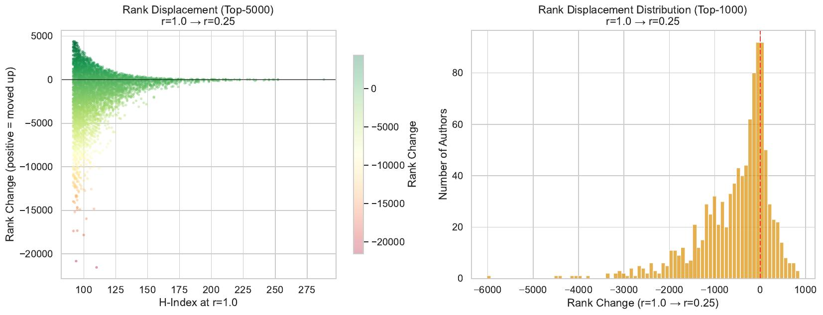
Figure 2. Rank displacement under r=0.25. Left: scatter of baseline h-index vs. rank change for Top-5,000 authors (green = moved up, red = moved down). Right: histogram of rank changes for Top-1,000 authors.

5. Beneficiaries of Transitive Credit Flow
The beneficiary analysis identifies which authors are net receivers of transitive credit, that is, whose h-index strictly increases as the retention rate decreases from r = 1.0. These authors have contributed foundational work upon which later highly cited research is built, and under the transitive model they receive a portion of the credit that their intellectual contribution enabled.

5.1 Population-Level Summary

Metric | r=0.75 | r=0.50 | r=0.25
Total authors in common | 476,286 | 454,959 | 418,240
Authors gaining h-index | 52,683 (11.1%) | 47,899 (10.5%) | 29,827 (7.1%)
Authors losing h-index | 358,525 (75.3%) | 385,661 (84.8%) | 381,327 (91.2%)
Authors unchanged | 65,078 (13.7%) | 21,399 (4.7%) | 7,086 (1.7%)
Mean Δh | −1.46 | −3.66 | −8.34
Median Δh | −2 | −4 | −8
Max gain (Δh) | +29 | +62 | +96
Max loss (Δh) | −14 | −30 | −65
Mean h (gainers) | 40.3 | 38.7 | 37.2
Mean h (losers) | 33.3 | 33.9 | 35.1

Table 7. Population-level summary of h-index changes across all three retention-rate variants. The majority of authors experience a negative mean shift, but a meaningful minority of foundational authors gain substantially.
At r = 0.75, approximately 11.1% of authors (52,683 out of 476,286) gain h-index points, 75.3% lose, and 13.7% are unchanged. As transfer intensity increases to r = 0.50, gainers shrink to 10.5% while losers expand to 84.8%, and unchanged authors drop sharply to 4.7%. At r = 0.25, gainers contract further to 7.1% (29,827 out of 418,240), and 91.2% of authors lose h-index points. The consistent direction of the mean (−1.46 at r = 0.75, −3.66 at r = 0.50, −8.34 at r = 0.25) indicates that transitive credit transfer is a redistributive mechanism: credit flows from the majority to a productive minority of foundational contributors.
Importantly, mean h-index of gainers (37.2–40.3) is consistently higher than that of losers (33.3–35.1) across all variants. This counter-intuitive finding suggests that the authors who benefit from transitivity are not simply low-impact researchers; they tend to have substantial baseline h-indices, but their work is more deeply woven into the citation genealogy of their field than their conventional h-index reveals.

5.2 Top Absolute Beneficiaries (r = 0.25)

Rank | Author ID | H (base) | H (r=0.25) | Δh | Δh (%) | # Pubs | Kudos Ratio
1 | 122408 | 101 | 197 | +96 | +95% | 534 | 4.28
2 | 593164 | 105 | 200 | +95 | +90.5% | 410 | 5.84
3 | 4055467 | 73 | 168 | +95 | +130.1% | 510 | 5.34
4 | 10033469 | 73 | 163 | +90 | +123.3% | 549 | 10.07
5 | 9737076 | 130 | 218 | +88 | +67.7% | 1549 | 2.73
6 | 101090 | 209 | 296 | +87 | +41.6% | 782 | 2.35
7 | 10499811 | 72 | 157 | +85 | +118.1% | 399 | 7.09
8 | 8772248 | 126 | 210 | +84 | +66.7% | 1051 | 3.27
9 | 11324641 | 84 | 168 | +84 | +100% | 731 | 3.88
10 | 751135 | 111 | 191 | +80 | +72.1% | 1199 | 2.72
11 | 7529471 | 95 | 172 | +77 | +81.1% | 405 | 4.61
12 | 962457 | 59 | 135 | +76 | +128.8% | 213 | 12.2
13 | 4101734 | 147 | 222 | +75 | +51% | 517 | 3.82
14 | 3332575 | 72 | 147 | +75 | +104.2% | 372 | 7.04
15 | 10707138 | 100 | 174 | +74 | +74% | 283 | 6.94

Table 8. Top-15 beneficiaries by absolute h-index gain under r=0.25 (from top-50 table). Kudos ratio = total kudos at r=0.25 / total kudos at r=1.0. Values above 5 indicate authors receiving more than five times their direct-citation-based credit through transitivity.
Author 101090 is the highest-ranked absolute beneficiary among those with a substantial baseline h-index (h = 209), gaining 87 points to reach h = 296 under r = 0.25. Their kudos ratio of 2.35 indicates that the transitive model more than doubles their effective credit. Authors at ranks 3 and 4 (4055467 and 10033469), with baseline h-indices of 73, more than double their h-index (to 168 and 163, respectively), reflecting classic foundational-work profiles: focused, highly cited early contributions that seeded an entire research programme.
Author 962457 presents an extreme case: with only 213 publications and a baseline h of 59, this author’s h-index grows to 135 under r = 0.25 (+76 points, +128.8%), and their kudos ratio is 12.20. This profile is highly consistent with an author who published a small number of seminal papers that became cornerstone references for a large subsequent literature. The kudos ratio measures how many times their total credit multiplied through transitive flow — a value of 12.2 implies that for every unit of direct citation credit they receive conventionally, over twelve units flow to them through the citation chains they seeded.
Author 1206661 is the most extreme relative case not dominated by a very low baseline: with h = 48 at baseline, this author reaches h = 120 under r = 0.25 (+72 points, +150%), with a kudos ratio of 27.23. With only 219 publications, this author exhibits the quintessential "hidden pioneer" profile: modest conventional visibility but extraordinary leverage in the citation network, consistent with early-stage methodological or conceptual work that enabled large bodies of subsequent research.

5.3 Top Relative Beneficiaries (r = 0.25)
The relative beneficiary analysis (for authors with h_baseline ≥ 10) reveals an even sharper picture of transitivity’s redistributive reach. Author 9143901 (h = 22 at baseline) reaches h = 80 under r = 0.25, a gain of +263.6%, with a kudos ratio of 69.51. This is an extraordinary amplification: the author’s effective credit under full transitivity is nearly 70 times what they receive under direct citation counting alone. Author 13645591 similarly reaches a relative gain of +223.1% with a kudos ratio of 155.75 — the highest in the dataset, meaning this author’s total credit through transitivity is 155 times their conventional credit.
These extreme relative beneficiaries share a common profile: baseline h-indices in the range 20–35, publication counts below 250, and very high kudos ratios. They represent researchers who made breakthrough contributions but whose direct citation counts alone would never surface them among highly ranked authors. The transitive model reveals them as structurally central to the knowledge graph, with their work acting as essential stepping-stones in many citation chains.

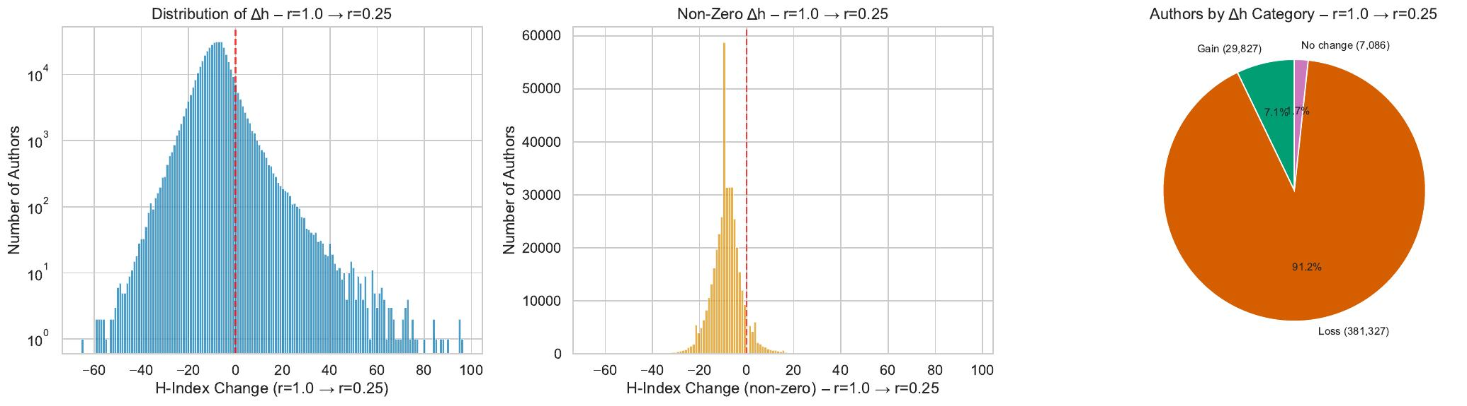
Figure 3. Distribution of h-index changes under r=0.25. Left: full distribution (log scale) centred near −8. Centre: non-zero changes. Right: pie chart showing 7.1% gainers, 91.2% losers, 1.7% unchanged.

6. Scatter Analysis and Visual Summary
The scatter plots of h-index at baseline vs. h-index at each retention rate provide a complementary perspective to the tabular correlation results.
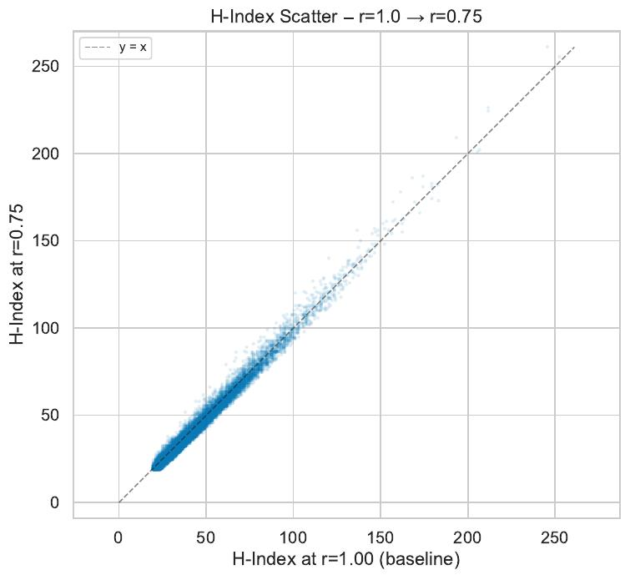
Figure 4. Scatter: h-index at r=1.0 vs. r=0.75. Points cluster tightly around the diagonal (y = x), confirming the high Spearman ρ = 0.94 at Top-10,000.
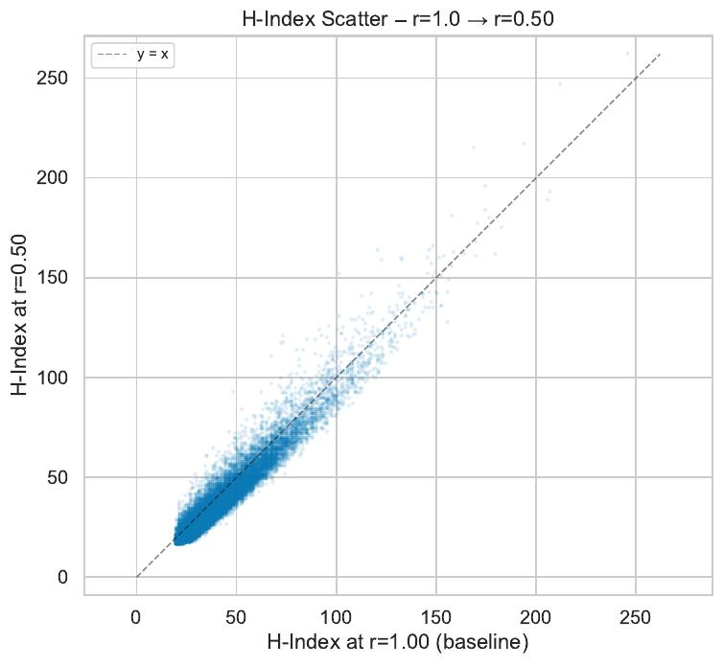
Figure 5. Scatter: h-index at r=1.0 vs. r=0.50. Spread increases, with a visible fan-out at higher h-index values, corresponding to the divergence between gainers and losers.
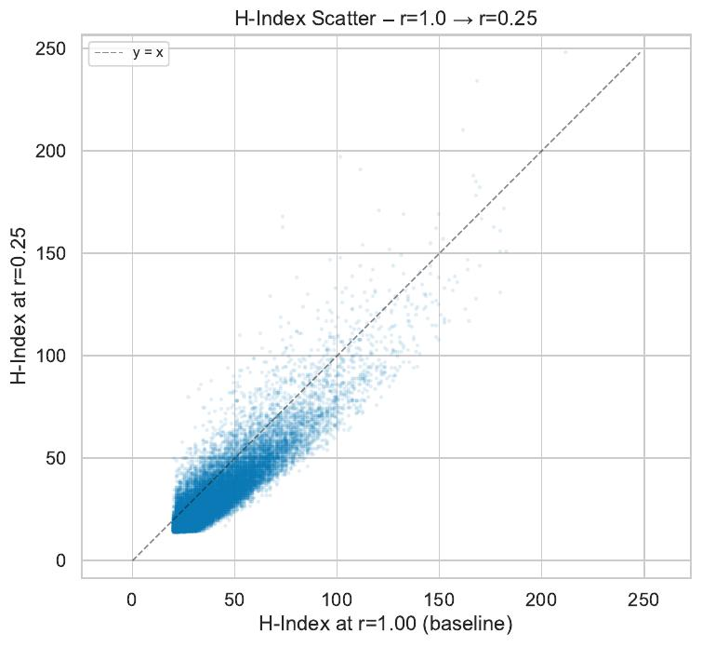
Figure 6. Scatter: h-index at r=1.0 vs. r=0.25. Strong fan pattern: high-baseline authors often end below the diagonal (losers), while a distinct upper cloud represents foundational authors achieving large gains.
The scatter plot for r = 0.75 (Figure 4) shows near-perfect alignment with the diagonal, consistent with the high correlations in Table 1. The r = 0.50 scatter (Figure 5) reveals a systematic fanning: for h-index values above approximately 100, the cloud broadens substantially, with a sub-cluster above the diagonal (gainers) and a sub-cluster below (losers). The r = 0.25 scatter (Figure 6) makes this bifurcation explicit: a clearly visible upper-right cloud of foundational authors (many starting with h ≈ 100–200 at baseline and reaching 200–300 under transitivity) emerges against a background of authors displaced below the diagonal. The pattern supports the interpretation that transitive credit is not merely noise but a coherent signal of foundational contribution.

7. Discussion and Implications

7.1 Interpretation of the Retention Rate Parameter
The retention rate r is the central parameter of the transitive credit model, and the results demonstrate that its choice is consequential at every level of analysis. The three values examined here span qualitatively distinct regimes. At r = 0.75, the model functions as a gentle correction to citation counting, rewarding foundational work without fundamentally disrupting established rankings. This regime may be appropriate for applications where rank stability is important (e.g., funding allocation, institutional evaluation) but a modest recognition of background contribution is desired. At r = 0.50, the redistributive effect is pronounced enough to meaningfully identify and reward a class of foundational contributors, while still maintaining moderate correlation with conventional rankings. At r = 0.25, the model functions as a near-complete restructuring mechanism, where the concept of "highly cited" is replaced by "foundationally important" as the primary dimension of credit.

7.2 Characterising the Beneficiary Profile
The data consistently reveal that transitivity beneficiaries are characterised by: (i) focused publication records (typically under 600 papers), compared to the broader profiles of top-baseline-ranked authors (often 800–2,500 papers); (ii) moderate to high conventional h-indices (typically 50–200), indicating existing scientific visibility without elite status; (iii) very high kudos ratios, indicating that a large fraction of their effective credit under the transitive model derives from indirect rather than direct citation; and (iv) baseline ranks that are often well outside the top 1,000, suggesting that conventional bibliometrics systematically underestimates their contribution to the knowledge network.

7.3 Limitations and Open Questions
Several important caveats apply to these results. First, the analysis does not resolve the identity of the authors identified by numeric ID; future work should map these to named individuals and their scientific fields to validate the interpretation of foundational contribution. Second, the PKG 2.0 dataset, while comprehensive, may have uneven coverage across subfields of biomedicine, and the transitive mechanism may behave differently in citation-dense domains (e.g., biochemistry) versus citation-sparse ones (e.g., clinical subspecialties). Third, the model assumes uniform retention rates across all authors and document types; heterogeneous parameterisation (e.g., different α for papers vs. patents vs. clinical trials) may produce qualitatively different beneficiary profiles.
A further open question concerns the optimal value of r for practical deployment. The rank inversion observed at r = 0.25 for the top-10 cohort suggests that very aggressive transfer may produce rankings that deviate too sharply from community consensus to be immediately actionable. A value of r = 0.50 appears to balance redistribution depth with practical usability, meriting further investigation through user studies and domain-expert validation.

8. Conclusions
This report has analysed the impact of transitive credit transfer on author h-index rankings in the PubMed Knowledge Graph 2.0, across 418,000–476,000 authors common to the baseline and each reduced-retention variant. The principal findings are:
- Rank stability decreases monotonically with transfer intensity. At r = 0.75, Spearman ρ remains above 0.78 even for Top-10, while at r = 0.25 the Top-10 ranking undergoes a statistically significant inversion (ρ = −0.41).
- Transitive credit is redistributive, not inflationary. The mean h-index across the population decreases with transfer intensity (−1.46 at r = 0.75 to −8.34 at r = 0.25), as credit flows from citation aggregators to foundational originators.
- A minority of authors (7–11%) consistently gain h-index under all variants, characterised by focused publication records, high kudos ratios, and mid-range conventional h-indices. These authors are interpretable as foundational contributors whose conventional bibliometric score underestimates their structural role in the knowledge graph.
- The most extreme beneficiaries exhibit kudos ratios up to 155, meaning their effective credit under full transitivity is two orders of magnitude greater than their direct citation credit. These authors represent the "hidden pioneers" whose work enabled entire research programmes.
- The top-conventional-ranking authors, by contrast, tend to lose h-index points under transfer, with losses correlated with publication volume and anti-correlated with the depth of their foundational contribution.

The results support the thesis that transitive credit allocation provides a qualitatively distinct dimension of scholarly recognition, one that complements conventional citation counting by making visible the foundational layer of scientific knowledge production. The choice of retention rate governs the trade-off between stability and redistributive depth, and the analysis presented here provides a data-driven basis for calibrating that choice in future applications.

References
Buneman, P., Lissandrini, M., and Silvello, G. (2025). Transitive Credit Allocation in Citation Networks. Working paper, October 2025.
Xu, J., Yu, C., Xu, J., Torvik, V.I., Kang, J., Sung, M., Song, M., Bu, Y., and Ding, Y. (2025). PubMed knowledge graph 2.0: Connecting papers, patents, and clinical trials in biomedical science. Scientific Data, 12, 1018. https://doi.org/10.1038/s41597-025-05343-8

