Observable Trends of Pymoli

There are several conclusions we can make based off of the data generated by this Pandas project. One conclusion we can make is that males are more likely to purchase this game and most of its in-game content. According to the data pictured below, about 84% of purchases related to “Heroes of Pymoli” were by male players. Although the average total purchase per person implies that females and other genders tend to pay more, the total purchase value of males far exceed the total purchase value of the other genders.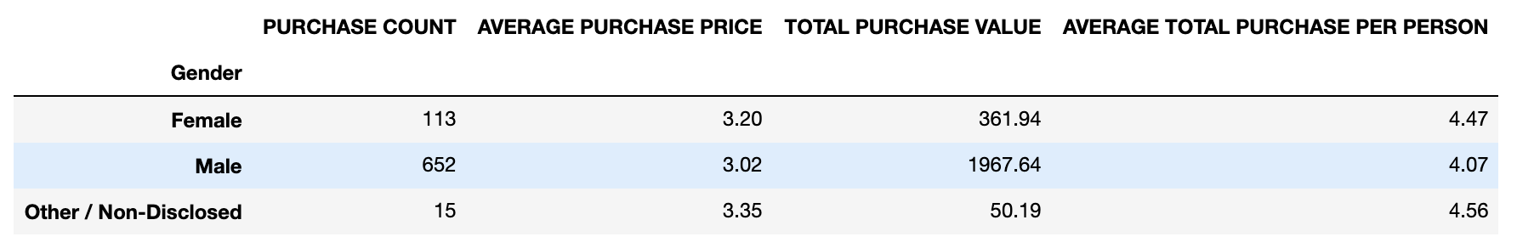

Further generated data shows that a large majority of buyers are between the ages of 15 and 29. Pictured below, about 78% of purchases were done by age groups 15-29, with the majority of the purchases from ages 20-24. Game developers could use this information to focus most game-related products toward millennials or similar age groups.

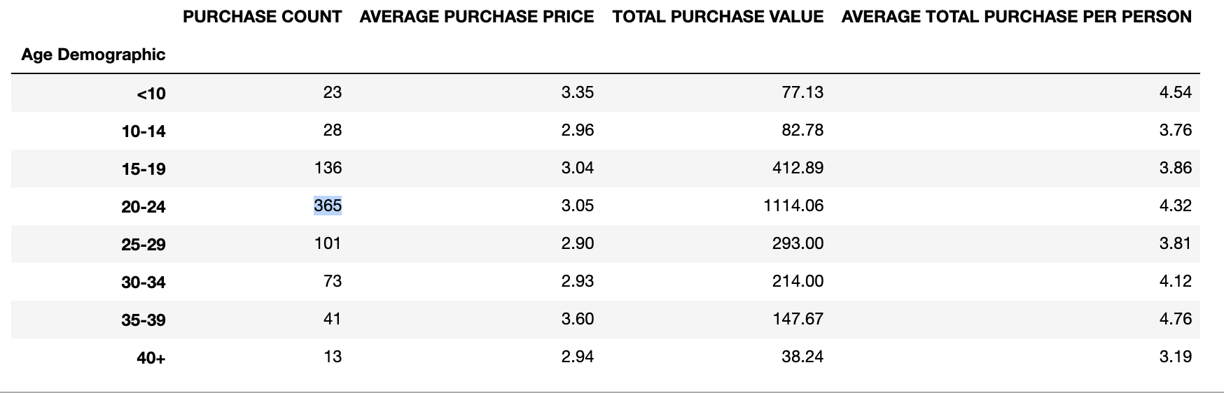

Although, the data can show which products deserve more focus than others, it can also disprove hypotheses that price and popularity affect one another. For example, pictured below is a data frame displaying the ten most popular items in “Heroes of Pymoli”. The “Oathbreaker, Last Hope of the Breaking Storm” was purchased more frequently than any other item and has an average cost of $4.23, considered to be more expensive than the average. However, the fifth most purchased item, “Pursuit, Cudgel of Necromancy”, has an average cost of $1.02. These two pieces of data may lead an analyst to conclude that pricing may not contribute to an item’s popularity.

