Pymaceuticals Observable Trends

This project analyzes the effects of Capomulin, Infubinol, Ketapril, and Placebo. By using Matplotlib tools to create graphs, we can observe the trends of these drugs on tumors. For example, the graph below displays the tumor responses to treatment throughout the 45 days (timepoints). According to this graph, Capomulin was the only drug administered to this sample of mice that had a positive effect on tumor volume reduction. Throughout the treatment, the other three drugs shared similar, unsuccessful results while Capomulin showed a an increasingly successful rate of decreasing tumor volume.

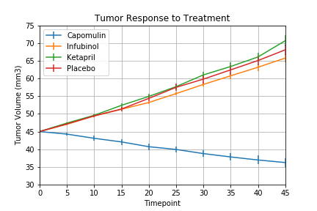

Below is a graph that exhibits the survivability of mice throughout the administration of the four drugs. Again, the analysis supports the theory that Capomulin has a more beneficial effect on tumor treatment than the other drugs. Although the rate of survivability does decrease over time, Capomulin stays well above an 80% survivability rate while the survival rate of the other drugs plummeted greatly (with Infubinol survival rate at around 35%).

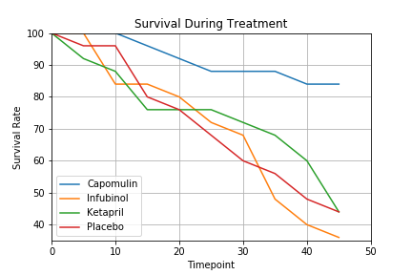

Although Capomulin is an apparent choice of drug for this population of mice, one cannot ignore the probability of improvement for the other drugs. For instance, Infubinol has shown a mix of effectiveness. It may have similar results as Ketapril and Placebo with regard to treatment over time, however, it resulted in fewer metastatic sites compared to the metastasis of both Ketapril and Placebo. Although Infubinol has a less-than-desirable survival rate, its effectiveness should be investigated further.

