Revelatio: Systematically Managed Funds for the First-Time Investor
  - Part B - Funds, Sentiment and the App
z5736927 - Gianni Chepote - FINS5545 Financial Market Data Literacy

Abstract
Revelatio offers systematically managed funds to first-time investors. This Part builds eleven funds - three families (equity-only, crypto-only and combined) across three methods (minimum-variance, maximum-Sharpe and risk parity), plus two two-stage funds - over 50 US large caps and 10 cryptocurrencies, each backtested out of sample with a rolling 252-day window, monthly rebalancing, and no look-ahead. Over 2021-01-04 to 2023-12-29 the maximum-Sharpe fund returned 25.5% a year at a 1.03 Sharpe; against an equal-weight 50-stock market (Sharpe 0.82), only 3 of 11 funds beat simply owning the market. A VADER sentiment index and a basic tilt complete the pipeline, and three extensions - covariance shrinkage, a two-stage portfolio of portfolios, and sentiment decay - are each shown out of sample.
Blending 50 US large-cap stocks with 10 cryptocurrencies returned 25.5% a year at a 1.03 Sharpe when the objective was to maximise risk-adjusted return - but playing it safe backfired: the minimum-variance funds lost to an equal-weight basket of the same 50 stocks. They did cut risk, with a shallower 15.6% drawdown against the market's 20.3%, yet by minimising variance they sidestepped the higher-volatility names and crypto that drove returns, giving up more upside than the protection was worth. Optimisation only pays when its objective matches how the market actually moves.

1. The product and the investor
Revelatio is an investment app for the first-time investor who suspects investing is rigged. It stands on two inputs: daily prices for 50 US large-cap equities and 10 cryptocurrencies (2020-2023), and daily news headlines for the equities.
Revelatio is for the first-time investor who doesn't want to study markets or choose between stocks and crypto - they just want a fund that balances the two for them and runs itself. Trust is what makes that work: keep the app simple, show the risks and fees plainly, and let the optimised funds do the job so the user doesn't have to second-guess every move.

2. The funds and the backtest design
Each fund is a set of portfolio weights over an investable universe, rebuilt on the first trading day of each month from the trailing 252 trading days of returns. The same construction is applied to three universes - equities only (50), crypto only (10), and combined (60) - so each method yields an equity-only, a crypto-only, and a combined fund. The daily portfolio return is w'r_t; weights use the sample mean and covariance over the rolling window:
$\overset{^}{μ}=\frac{1}{252}\sum_{s∈W}{r_{s},\overset{^}{Σ}=\frac{1}{251}\sum_{s∈W}{(r_{s}−\overset{^}{μ})(r_{s}−\overset{^}{μ})^{⊤}}}$
Equation 1
The minimum-variance and maximum-Sharpe (tangency) funds solve
$\min_{w} w^{⊤}\overset{^}{Σ}w\max_{w} \frac{w^{⊤}\overset{^}{μ}−r_{f}}{\sqrt{w^{⊤}\overset{^}{Σ}w}}s.t. \sum_{i}{w_{i}=1, w_{i}≥0}$
Equation 2
and the risk-parity fund equalises each asset's contribution to portfolio variance (Spinu, 2013), normalised to sum to one:
$\min_{w>0} \frac{1}{2}w^{⊤}\overset{^}{Σ}w−\frac{1}{n}\sum_{i}{lnw_{i}}$
Equation 3
All are long-only and fully invested, r_f = 0 (stated). Performance is annualised on the 252-day equity calendar; Sharpe is mu_ann/sigma_ann, and maximum drawdown is the worst peak-to-trough decline of growth path V:
$MDD=\min_{t}\left(\frac{V_{t}}{\max_{s≤t}V_{s}}−1\right)$
Equation 4
The design is out-of-sample throughout: the first live date is 2021-01-04 (the first month-start with a full 252-day prior window), the sample runs to 2023-12-29 (36 rebalances, 753 days), weights come only from data before each rebalance, and no figure includes a training-period day. Crypto returns are computed on their own calendar then left-joined onto equity trading days.
A one-year window is the sweet spot for a 60-asset mix: long enough to estimate returns and risk without the numbers going haywire, short enough to keep up as markets - especially crypto - shift. Monthly rebalancing keeps the funds current without constant trading, which suits a hands-off first-timer and keeps churn low.

3. Out-of-sample results, fact sheets and the benchmark
The offering is a grid of three families x three methods (nine funds) plus two two-stage funds, eleven in all (Table A1; Figures A1-A4). The combined core funds are offered as the Revelatio Balanced Fund (minimum-variance) and the Revelatio High Growth Fund (maximum-Sharpe). Two patterns hold: within each method the combined fund beats either single-asset fund on Sharpe (combined maximum-Sharpe 1.03 vs 0.59 equity-only and -0.20 crypto-only), and crypto-only funds post the highest raw returns but the worst risk-adjusted ones (crypto risk parity 33% a year, 84% drawdown, Sharpe 0.46).
The grid makes the case for combining: within every method, mixing stocks and crypto beat holding either alone on a risk-adjusted basis. Crypto-only funds show why you don't hand a beginner pure crypto - 33% a year sounds great until you see the 83% fall that comes with it. So the funds we put up front are the combined ones; the single-asset versions exist to show the first-timer what diversification is buying them.
The max-Sharpe fund earned four times the return but fell 26% at its worst - the kind of drop that makes a first-timer sell at the bottom and swear off investing for good. So you don't sell them the 25.5% headline; you show the drawdown right next to it and let them pick the fund whose worst day they could actually sit through.

3.1 Do the funds beat simply owning the market?
The equal-weight 50-stock market (Table A2) is the honest same-universe benchmark - our own stocks, calendar and schedule - so a fund that cannot beat it is not adding value over naive diversification. It returned 13.2% a year at Sharpe 0.82, and only 3 of 11 funds beat it. The combined minimum-variance fund fell 0.33 short on Sharpe: it cut volatility to 12.8% against the market's 16.2% (about a fifth less risk) but gave up roughly half the return (6.3% vs 13.2%), concentrating in about 10 low-volatility defensives (WMT, MRK, KO) with only 0.6% crypto.
Our minimum-variance funds lost to a plain equal-weight basket. We'd still offer minimum-variance, but honestly - as the calm-ride option, a 16% worst-case fall instead of 26%, for someone who values sleeping at night over top returns, not as a return story. The app says outright that a basic basket beat it this period; hiding that would be the exact broker trick the product exists to avoid.

4. The sentiment index and fusion
Each headline is scored with VADER's compound score in [-1, 1], averaged to a per-ticker-day value, then equal-weighted across the five tickers in each sector (Equation 5; Figure A5). Text passes through unmodified because VADER reads casing, punctuation and negation; a ticker-day with no headline enters as neutral 0; any use lags at least one trading day. Coverage is 75.5% of ticker-days, and the market average held mildly positive (mean +0.09), barely reacting to the 2022 selloff.
$S_{k,t}=\frac{1}{5}\sum_{i∈k}{s_{i,t}}$
Equation 5
A signal that sits mildly positive and barely flinches - even through the 2022 crash - isn't telling you much. If the news reads 'fine' whether the market is rising or falling, it can't help you separate good bets from bad ones, which is exactly why leaning on it later dragged returns down instead of lifting them.
The fusion tilts each fund's equity weights towards higher-sentiment sectors using the lagged, z-scored signal (Equation 6; Table A3, Figure A6), lambda = 0.5, untuned. It reduced Sharpe for both funds - minimum-variance 0.49 to 0.31, maximum-Sharpe 1.03 to 0.91 - an honest negative baseline.
$w_{i}^{tilt}∝w_{i}(1+λz_{i})_{+},z_{i}=\frac{s_{i}−\overset{―}{s}}{sd(s)}$
Equation 6
Sentiment hurt because the tilt is only as good as the signal underneath it, and that signal barely moves. Nudging money towards 'positive' sectors on a flat, always-upbeat reading just shuffled weights around noise, so both funds lost Sharpe. To make sentiment pay you'd need a sharper signal - finance-specific words, or reactions to real events - not a cleverer way to lean on a dull one.

5. Innovation: three extensions, each shown out of sample
Three extensions, chosen for depth over count, each a before-vs-after against the plain version it replaces with no parameter tuned to win.

5.1 Covariance shrinkage
The 60-asset sample covariance on a one-year window is badly conditioned. A Ledoit-Wolf estimator shrinks it towards a scaled-identity target by an intensity delta chosen analytically per window:
${\overset{^}{Σ}}_{LW}=(1−δ)S+δ{\overset{―}{σ}}^{2}I$
Equation 7
At delta = 0.05 it lifted minimum-variance Sharpe from 0.49 to 0.55, left maximum-Sharpe about flat, and raised effective holdings from 10 to 13 names (Table A4, Figures A7-A8).
Shrinkage is worth keeping: it costs nothing, spreads each fund across more names, and lifted the minimum-variance Sharpe from 0.49 to 0.55 without denting the max-Sharpe fund's edge. The shrink was small (delta around 0.05) because a full year of data on 60 assets isn't as noisy as feared - the sample covariance was already decent, so the estimator only nudged it. On a shorter window or a wider universe, expect it to matter more.

5.2 A two-stage portfolio of portfolios
The two-stage fund builds an equity sleeve and a crypto sleeve, then allocates across the two, so the cross-asset decision rests on a 2x2 covariance rather than a 60x60:
$w=a_{eq}w_{eq}⊕a_{cr}w_{cr}$
Equation 8
Like-for-like (same window, rebalance, method, sample), the 3-parameter cross-asset decision matched the 1830-parameter one-stage fund almost exactly: minimum-variance 0.49 to 0.50, maximum-Sharpe 1.03 to 0.98 (Table A5, Figures A9-A10).
The finding is the tie itself: splitting the problem into a stock sleeve and a crypto sleeve, then mixing the two, matched optimising all 60 assets at once. That means the 1,830-number cross-asset covariance the big model works so hard to estimate is mostly noise - throwing it away for a simple 2x2 lost nothing. Simpler wins when the extra detail is unreliable, and here it was.

5.3 Sentiment decay on no-news days
Rather than snapping a ticker's sentiment to zero when its news stops, decay carries the last score forward, fading it over a half-life H:
${\overset{\sim }{s}}_{i,t}=s_{i,τ}·2^{−(t−τ)/H},τ=\text{last headline day}≤t$
Equation 9
At a 5-day half-life (chosen ex ante, look-ahead safe), decay softened the drag without removing it: minimum-variance 0.31 to 0.33, maximum-Sharpe 0.91 to 0.93, both still below base. A sweep over 2, 5, 10 and 21 days barely moves it (Table A6, Figures A11-A12).
Letting yesterday's news fade instead of snapping to zero helped a little and helped consistently - about +0.02 Sharpe on both funds - and the sweep shows the exact half-life barely matters. It's a real, if small, improvement: a fading memory is less jumpy than a hard reset. But it only softens a losing signal, so decay is worth keeping as the sensible default, not as the fix that makes sentiment pay.

6. The app and the investor journey
The Streamlit app supports the full journey - compare funds, read a fact sheet (growth, drawdown, holdings), read the sentiment analytics, and build an allocation - reading precomputed artifacts only, never a live backtest. Every fund page leads with its drawdown and the market benchmark, a deliberate departure from product pages that show only growth.
All performance figures in this report are gross of fees. In the app's allocation view a fixed 0.75% annual management fee, accrued daily, is applied so the investor sees the net-of-fee outcome they would keep. In keeping with a low-cost, index-style product for a first-time investor, the fund charges a single management fee and no performance fee - the manager does not take a share of the investor's gains.
The five app screens - the offering, the fund comparison, a fund fact sheet, the sentiment analytics, and the allocation blender - are in Figures A13-A17.
A first-timer lands on the compare screen and sees, plainly, which funds beat a simple market basket and which didn't - no hard sell. They open a fund's fact sheet and get its growth, its worst fall, and what it actually holds, side by side. They glance at the market mood, then build a blend and watch what they'd keep after fees. Each step shows the downside as clearly as the upside, so trust is earned by the order things appear in, not by decoration.

7. Critical reflection and recommendations
The funds run on plain sample estimates over a short, single-regime window; the minimum-variance funds lose to naive diversification; the sentiment signal is weak and the fusion underperforms. Three tested responses (Section 5) point to concrete next steps.
1. Adopt covariance shrinkage across every fund. It cost nothing to add, cut turnover, and lifted the minimum-variance Sharpe, and on a shorter window or a wider universe it would help more. It is the cheapest reliability upgrade on the table.
2. Replace the general-purpose sentiment reader with a finance-specific one. The current signal barely moves and dragged returns when used; a lexicon tuned to market language, or a model that reacts to real events, has a chance of carrying information this one doesn't. Fix the signal before touching the tilt.
3. Charge realistic trading costs in the backtest before trusting any fund's edge. Every result here assumes free trading, and the max-Sharpe fund rebalances hardest, so a cost model would test whether its lead survives contact with reality. A fund that only wins for free is not one you would sell.

References
Hutto, C.J. and Gilbert, E.E. (2014). VADER: A Parsimonious Rule-based Model for Sentiment Analysis of Social Media Text. Proceedings of the Eighth International AAAI Conference on Weblogs and Social Media (ICWSM-14).
Ledoit, O. and Wolf, M. (2004). Honey, I Shrunk the Sample Covariance Matrix. The Journal of Portfolio Management, 30(4), 110-119.
Spinu, F. (2013). An Algorithm for Computing Risk Parity Weights. SSRN Working Paper 2297383. https://doi.org/10.2139/ssrn.2297383
Data: daily prices for 50 US large-cap equities and 10 cryptocurrencies, and daily equity news headlines, 2020-2023, provided by the course (backup source: openbondassetpricing.com).

Appendix A - Exhibits
Table A1. Out-of-sample performance across the eleven funds (annualised, rf = 0).
fund | ann_return | ann_vol | sharpe | max_drawdown
Equity Min-Variance | 6.2% | 12.8% | 0.49 | -15.4%
Equity Max-Sharpe | 10.7% | 18.2% | 0.59 | -26.1%
Equity Risk Parity | 10.6% | 14.6% | 0.72 | -18.5%
Crypto Min-Variance | 30.5% | 59.5% | 0.51 | -75.3%
Crypto Max-Sharpe | -15.3% | 75.6% | -0.20 | -90.9%
Crypto Risk Parity | 33.4% | 72.7% | 0.46 | -83.5%
Min-Variance | 6.3% | 12.8% | 0.49 | -15.6%
Max-Sharpe | 25.5% | 24.7% | 1.03 | -26.3%
Risk Parity | 14.4% | 16.0% | 0.90 | -19.8%
Two-Stage Min-Variance | 6.4% | 12.8% | 0.50 | -15.6%
Two-Stage Max-Sharpe | 24.2% | 24.7% | 0.98 | -26.3%
Table A2. Each fund against the equal-weight 50-stock market (annualised).
fund | sharpe | excess_ann_return | sharpe_minus_bench | beats_benchmark
Equity Min-Variance | 0.49 | -7.0% | -0.33 | False
Equity Max-Sharpe | 0.59 | -2.5% | -0.23 | False
Equity Risk Parity | 0.72 | -2.7% | -0.09 | False
Crypto Min-Variance | 0.51 | 17.3% | -0.30 | False
Crypto Max-Sharpe | -0.20 | -28.5% | -1.02 | False
Crypto Risk Parity | 0.46 | 20.2% | -0.36 | False
Min-Variance | 0.49 | -6.9% | -0.33 | False
Max-Sharpe | 1.03 | 12.3% | 0.22 | True
Risk Parity | 0.90 | 1.1% | 0.08 | True
Two-Stage Min-Variance | 0.50 | -6.9% | -0.32 | False
Two-Stage Max-Sharpe | 0.98 | 11.0% | 0.17 | True
Table A3. Sentiment fusion before vs after, by fund (annualised).
fund | variant | ann_return | sharpe | max_drawdown
Min-Variance | base | 6.3% | 0.49 | -15.6%
Min-Variance | sentiment | 4.0% | 0.31 | -17.0%
Max-Sharpe | base | 25.5% | 1.03 | -26.3%
Max-Sharpe | sentiment | 23.6% | 0.91 | -22.8%
Table A4. Covariance shrinkage before vs after (annualised).
fund | variant | ann_return | sharpe | max_drawdown
Min-Variance | sample | 6.3% | 0.49 | -15.6%
Min-Variance_Shrunk | shrunk | 7.0% | 0.55 | -15.6%
Max-Sharpe | sample | 25.5% | 1.03 | -26.3%
Max-Sharpe_Shrunk | shrunk | 25.1% | 1.01 | -25.2%
Table A5. One-stage vs two-stage, by method (annualised).
fund | structure | ann_return | sharpe | max_drawdown
Min-Variance | one_stage | 6.3% | 0.49 | -15.6%
Two-Stage Min-Variance | two_stage | 6.4% | 0.50 | -15.6%
Max-Sharpe | one_stage | 25.5% | 1.03 | -26.3%
Two-Stage Max-Sharpe | two_stage | 24.2% | 0.98 | -26.3%
Table A6. Sentiment decay: base vs neutral-0 vs decayed tilt (annualised).
fund | variant | ann_return | sharpe | max_drawdown
Min-Variance | base | 6.3% | 0.49 | -15.6%
Min-Variance | sentiment_neutral0 | 4.0% | 0.31 | -17.0%
Min-Variance | sentiment_decay | 4.3% | 0.33 | -18.2%
Max-Sharpe | base | 25.5% | 1.03 | -26.3%
Max-Sharpe | sentiment_neutral0 | 23.6% | 0.91 | -22.8%
Max-Sharpe | sentiment_decay | 23.8% | 0.93 | -25.7%
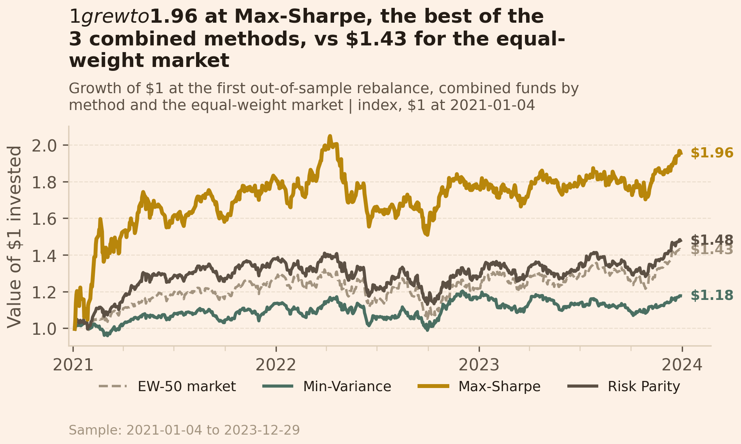
Figure A1. Growth of $1, combined funds by method and the equal-weight market.
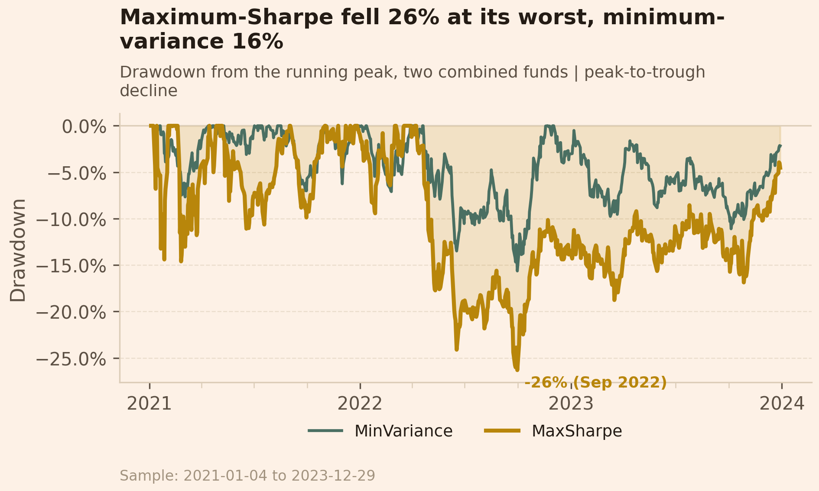
Figure A2. Drawdown from the running peak, two combined funds.
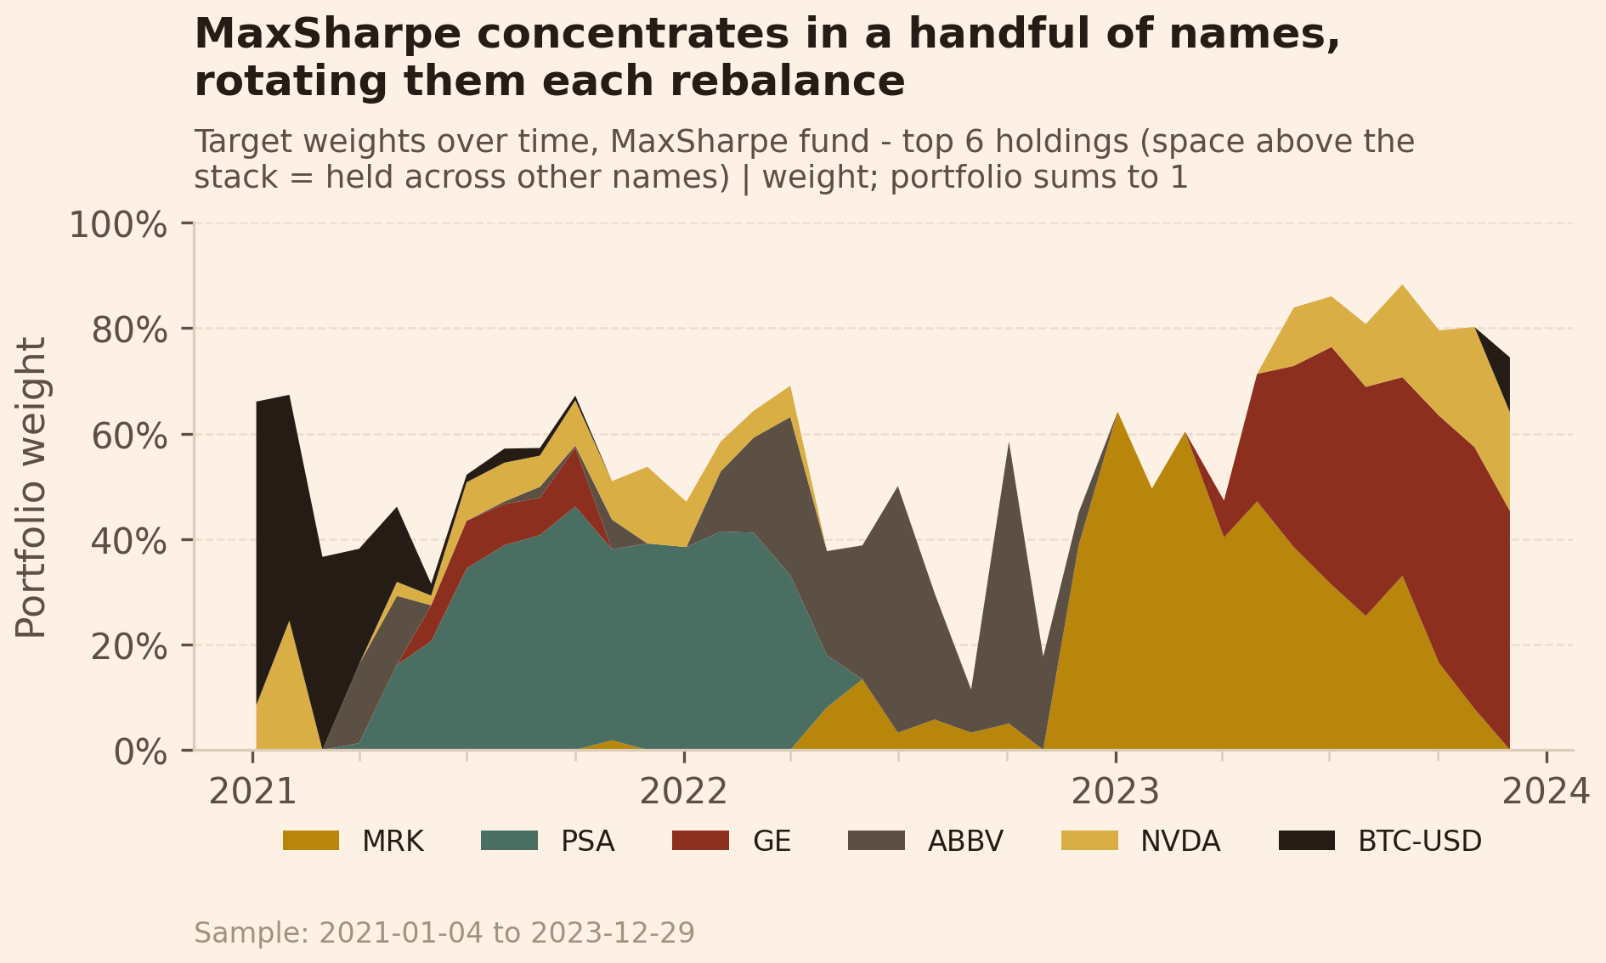
Figure A3. Maximum-Sharpe target weights over time (top 6 holdings).
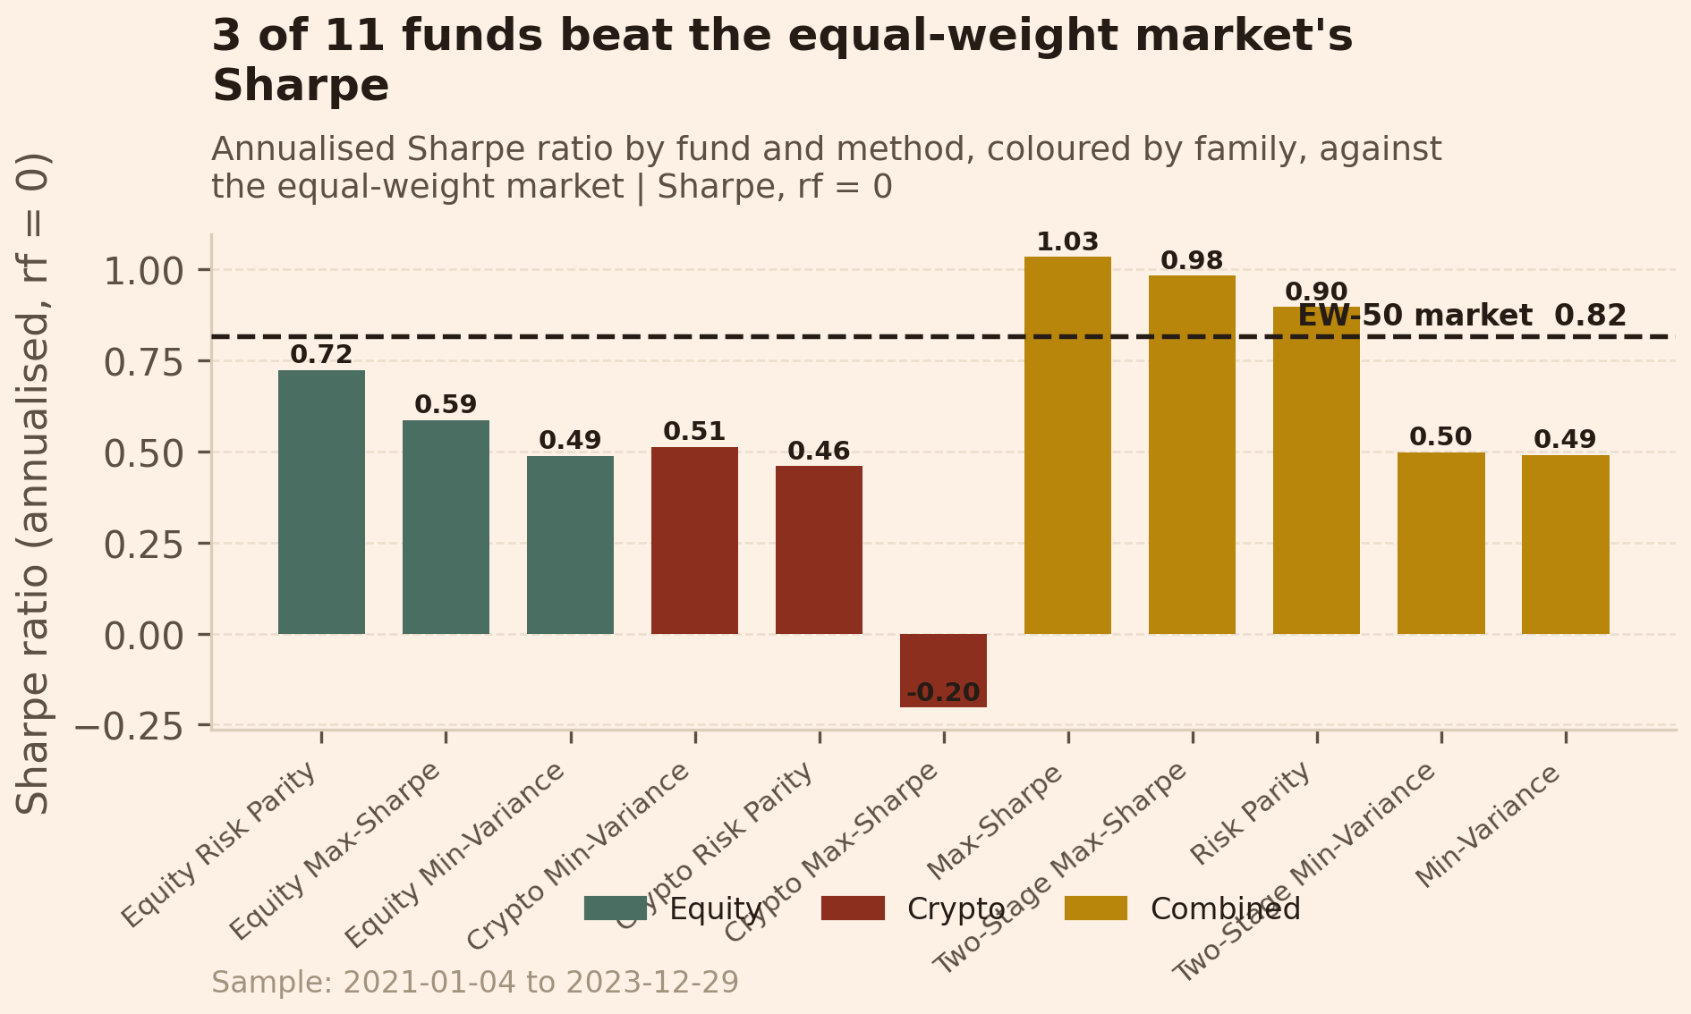
Figure A4. Annualised Sharpe by fund and method, coloured by family, against the market.
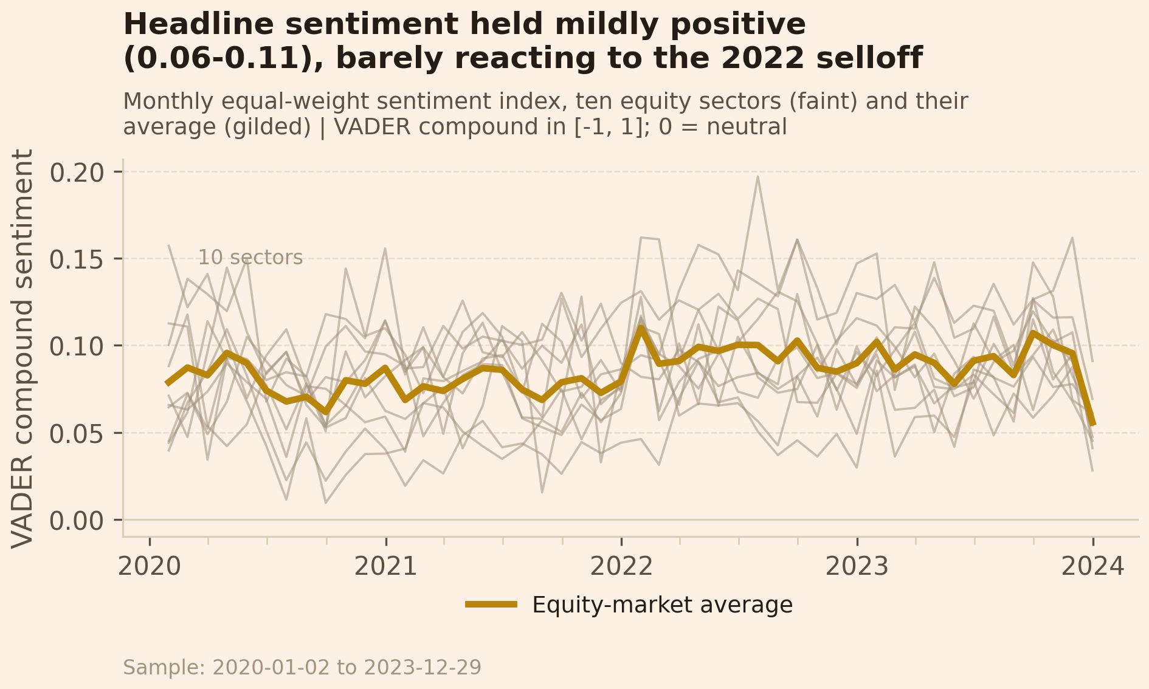
Figure A5. Monthly sector sentiment index, ten equity sectors and their average.
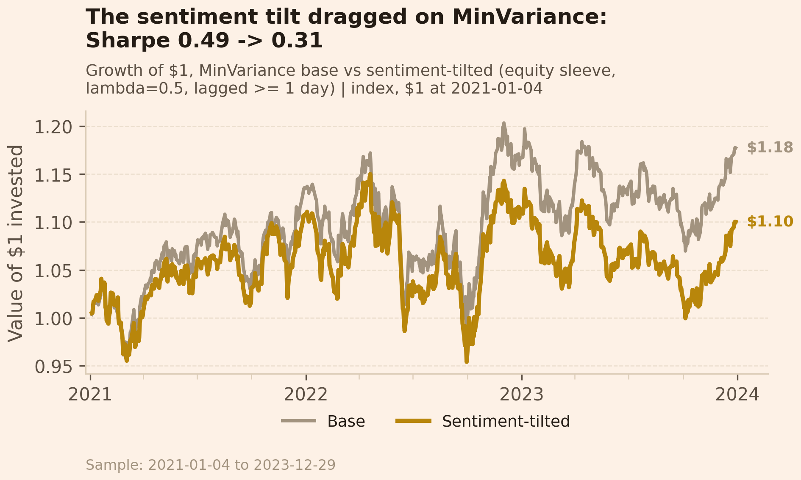
Figure A6. Base vs sentiment-tilted growth of $1.
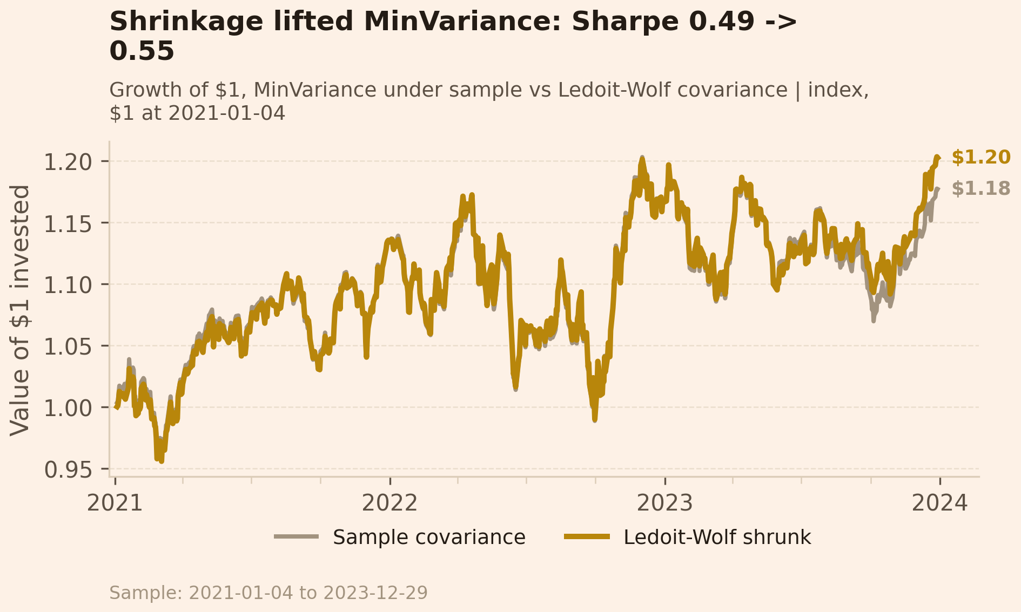
Figure A7. Growth of $1 under the sample vs Ledoit-Wolf covariance.
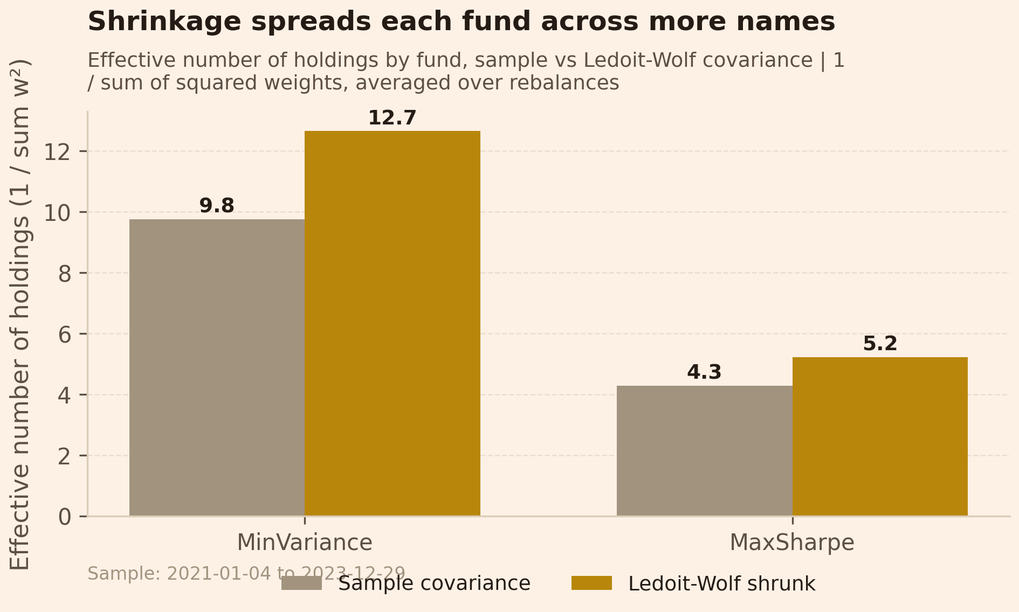
Figure A8. Effective number of holdings, sample vs shrunk.
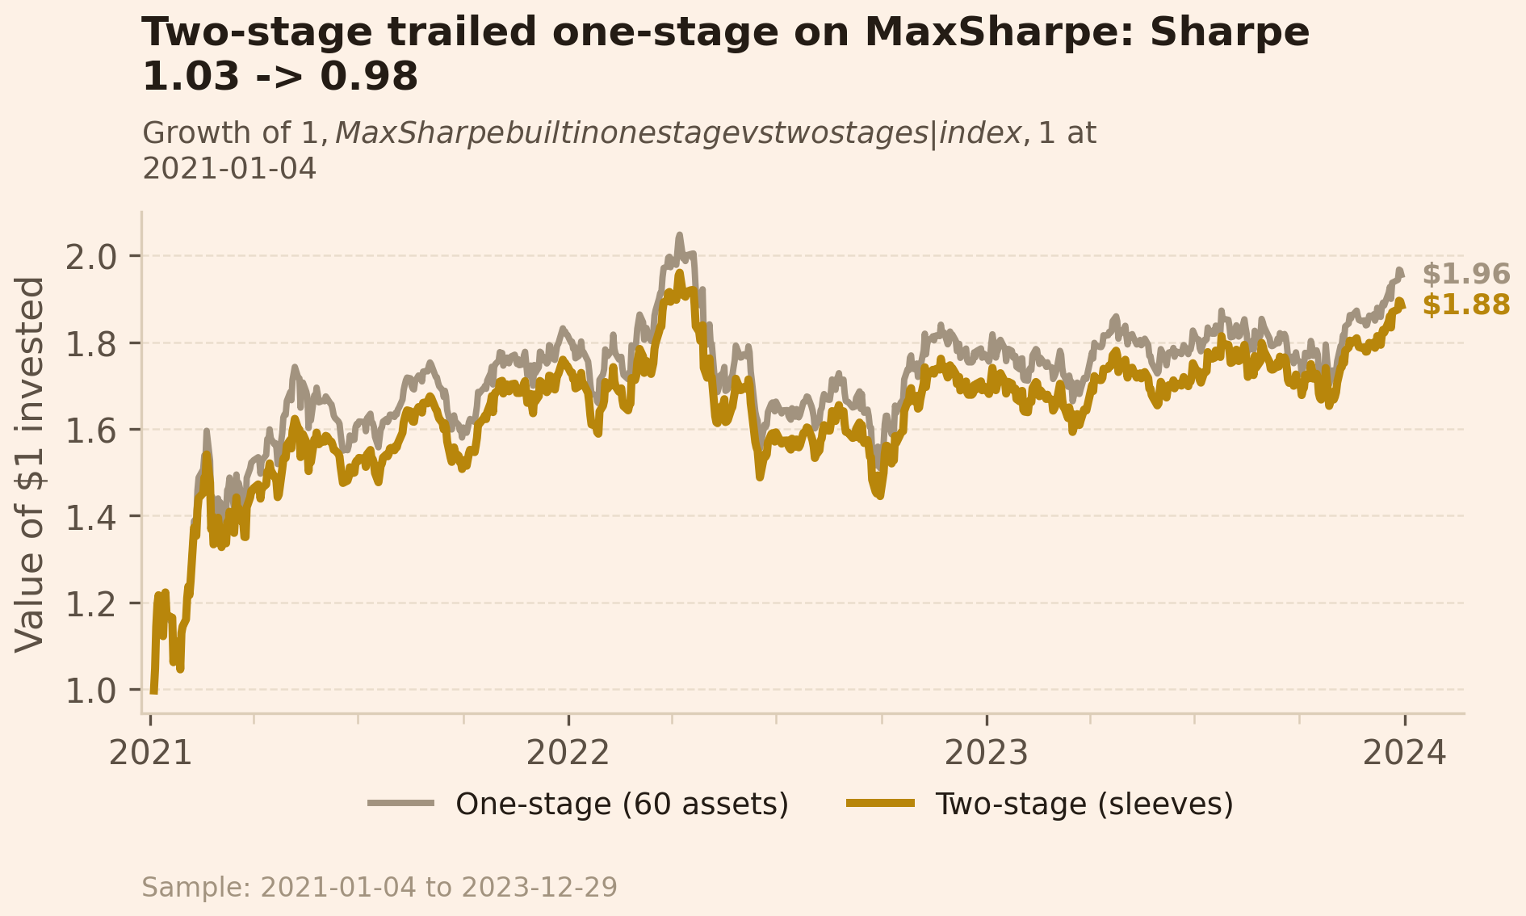
Figure A9. Growth of $1, one-stage vs two-stage.
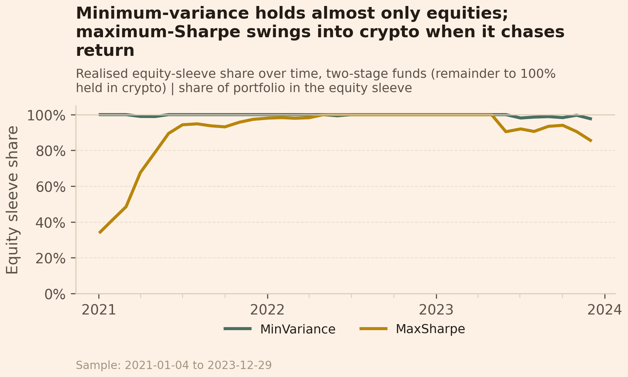
Figure A10. Realised equity-sleeve share over time, two-stage funds.
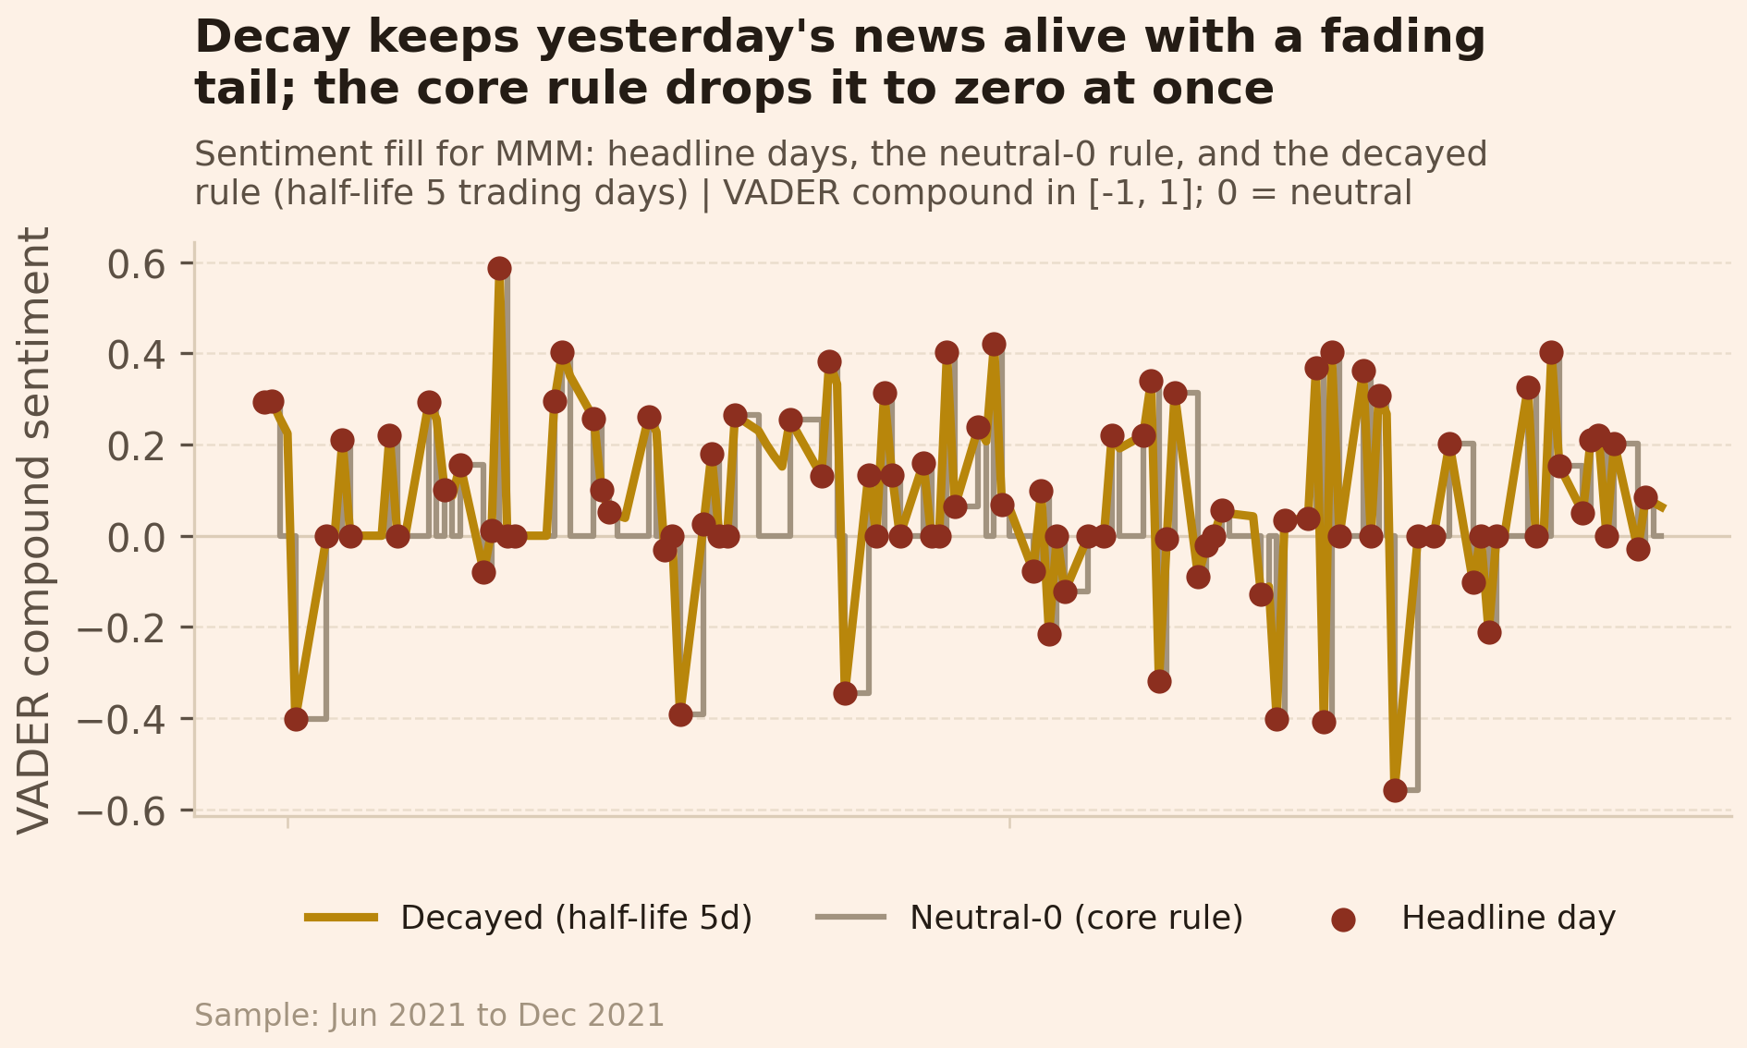
Figure A11. Sentiment fill for one ticker: neutral-0 rule vs decay.
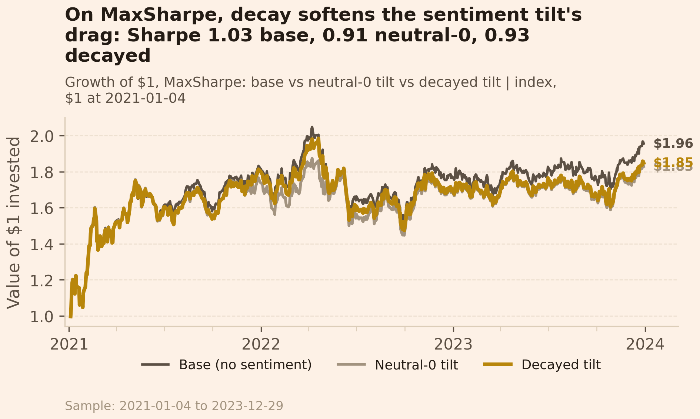
Figure A12. Growth of $1: base vs neutral-0 tilt vs decayed tilt.
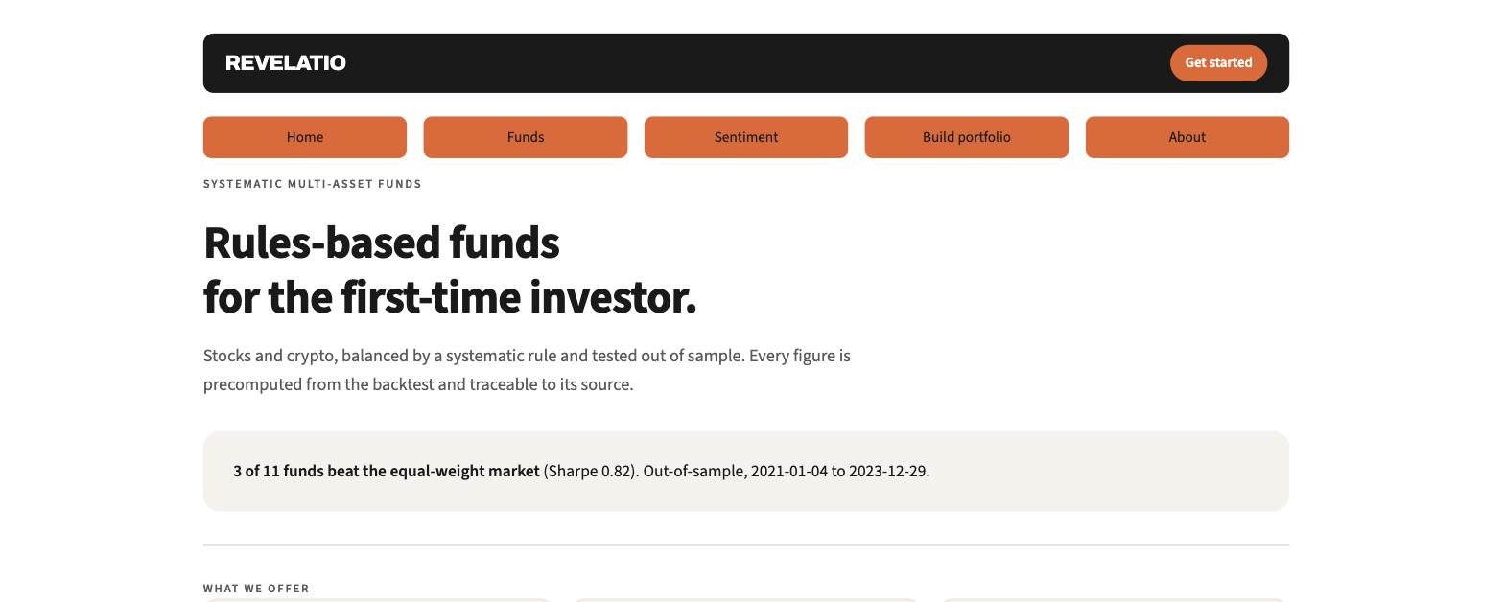
Figure A13. App home: the offering and the headline that 3 of 11 funds beat the market.
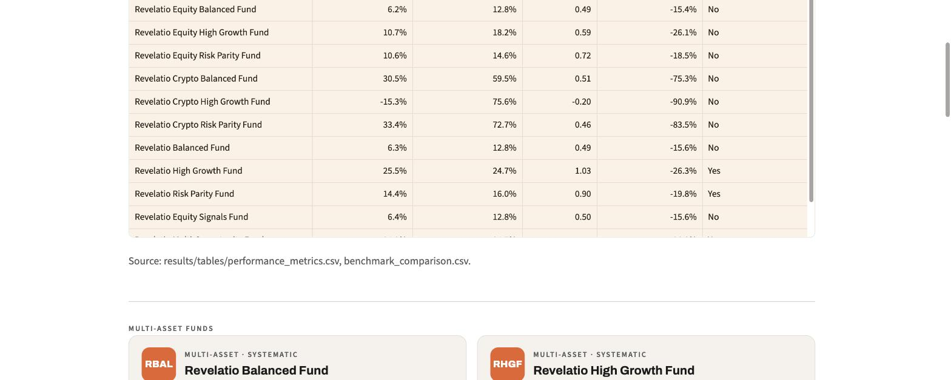
Figure A14. App Funds page: the eleven-fund comparison table and the multi-asset cards.
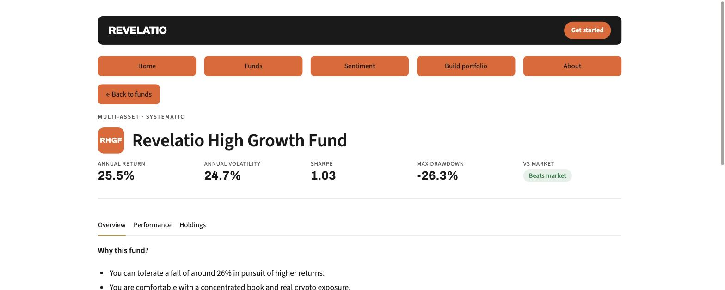
Figure A15. App fund fact sheet: key stats, the beats-market pill, and the Overview / Performance / Holdings tabs.
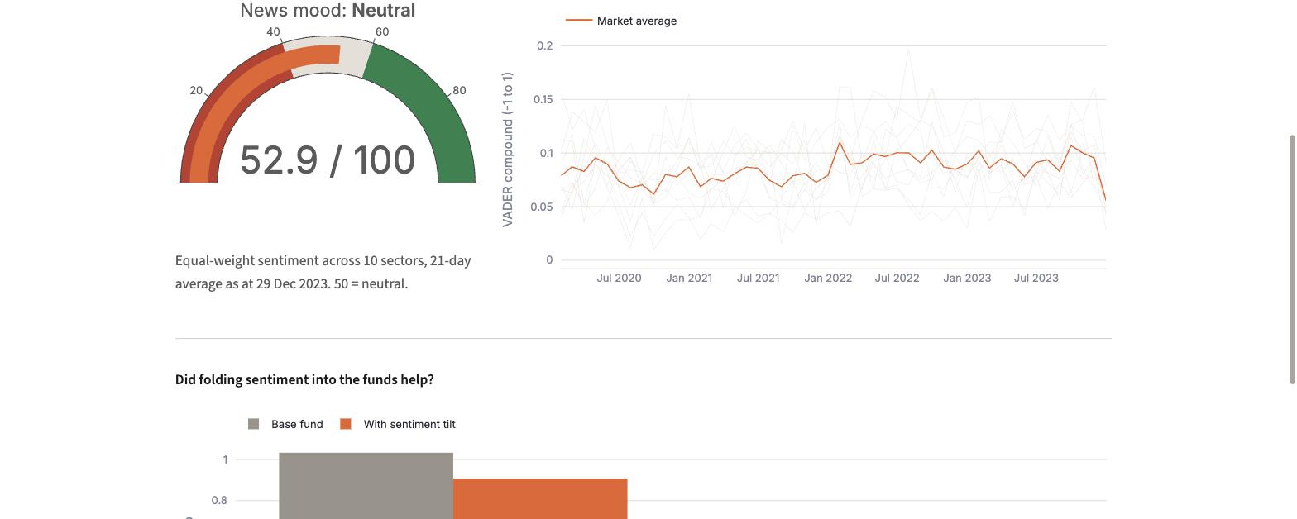
Figure A16. App Sentiment page: the news-mood gauge, the sector index, and the fusion result.
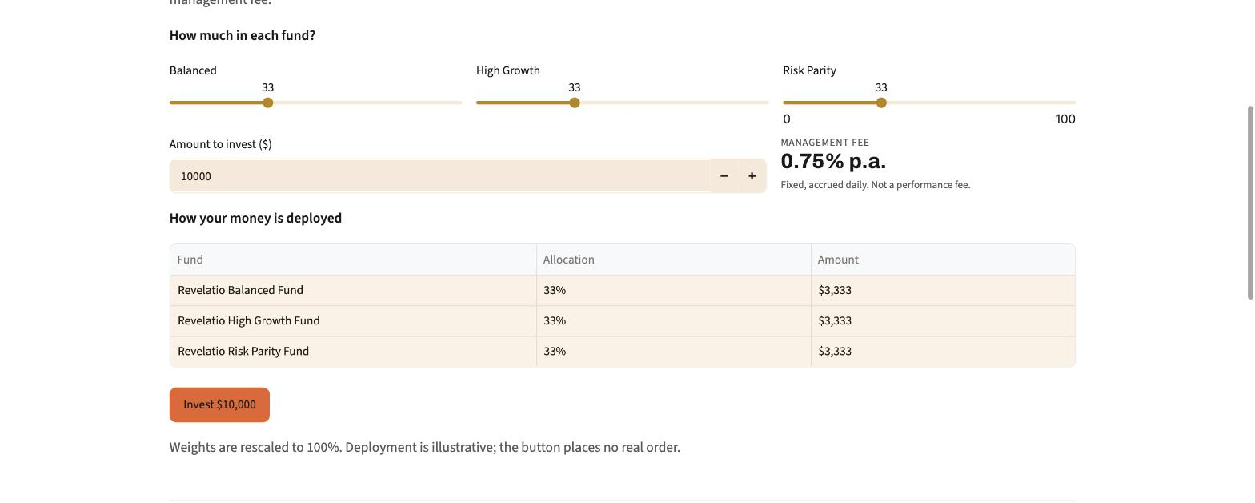
Figure A17. App Build-portfolio page: the fund blender, the fixed 0.75% fee, and the deployment table.

