1. Visible errors in the VendorLeadID column (#NAME? values). Created a new column to put a placeholder for error values



2. As mentioned in the dataset description, all empty rows in CallStatus column are replaced to “Status Unknown.”

1. Categorized the CallStatus column under a new CallStatusType column (for analysis purposes).

1. As mentioned in the dataset description, all “300250” and “302252” in the WidgetName column are replaced to “30” under a new WidgetSize column.

1. Categorized the AddressScore column under a new AddressScoreType column (for analysis purposes).

1. Categorized the PhoneScore column under a new PhoneScoreType column (for analysis purposes).

1. All empty rows in ReferralDomain column are replaced to “NA.”

1. All empty rows in SearchQuery column are replaced to “NA.”

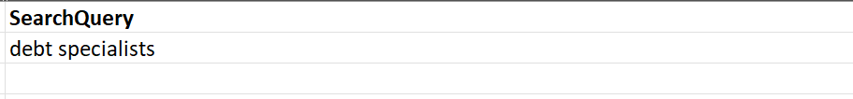

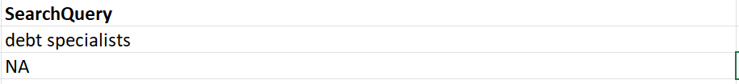

1. All empty rows in ReferralURL column are replaced to “NA.”

1. All empty rows in ReferralURL Parameters column are replaced to “NA.”

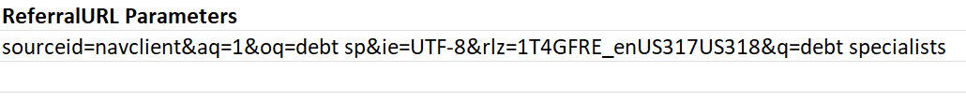

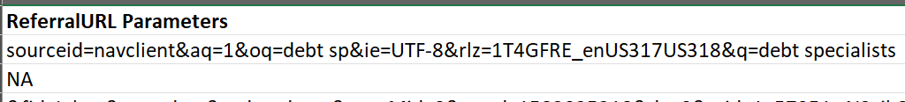

1. Duplicate data in row 2938 and 2939. Removed row 2939

