Customer Behaviour & Value Analysis

# Objective

To understand customer behavioral patterns — particularly distinguishing One-Off, Low Engagement, and Repeat users — and to assess their impact on revenue over time. This analysis supports strategic planning around growth.

## What are our customers doing, and who brings in the most value? How do our customers behave over time, and which segments truly drive revenue? We identified three key customer segments based on transaction frequency and time: - One-Off: 1 transaction in 1 quarter - Low Engagement: ≤10 transactions in ≤2 quarters - Repeat: All others

# 1. Findings

Repeat customers are the clear revenue drivers for the business. Although they represent just under 60% of all active customers they contribute to around 95% of total revenue, nearly £3 billion in value.

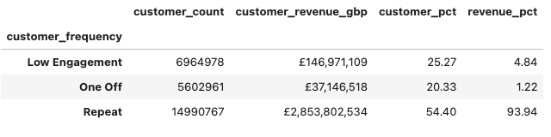

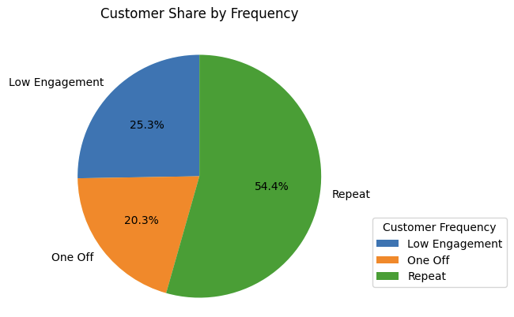

# 2. Behaviour by Engagement Level

Three heatmaps were created using binned data (transaction count × number of quarters):

## a.Customer Count per Bin

- The largest user group is concentrated in the (1 transaction, 1 quarter) bin (~5.6M users).  
- Most customers are short-lived and low-volume.

- A substantial amount of customers is concentrated in 10–100 transactions over 4–16 quarters. Some of these bins/brackets seem to be associated with the highest amounts of revenue (next graph).

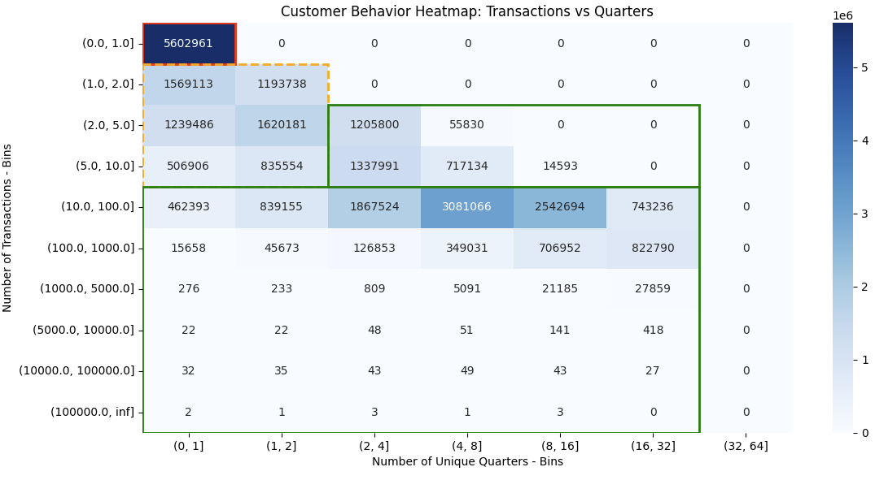

## b. Heatmap 2 – Total Revenue per Bin

- Despite high user count, One-Offs generate only ~£37M.  
- Repeat users (e.g., 10–100 transactions over 4–16 quarters) dominate total revenue — contributing hundreds of millions.

- The largest bin/bracket is located in the bin/bracket of 10 to 100 transactions over 8 to 16 quarters and has yielded over £669M.

- The second largest is that of 100 to 1000 transactions over 16 to 32 quarters. £654M.

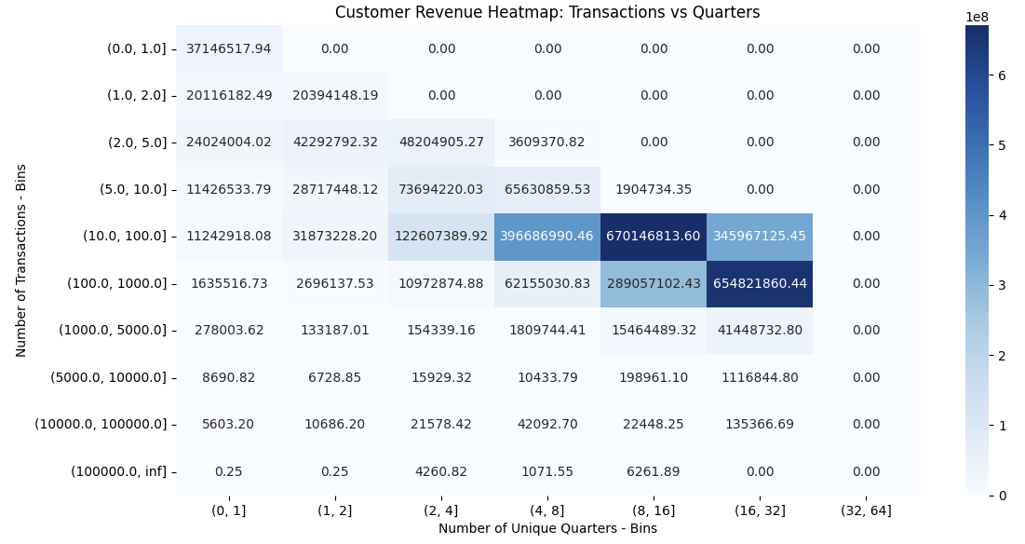

## c. Heatmap 3 – Average Revenue per User per Bin

-One-Offs average ~£6 per user, while top repeat segments reach up to £5,000 per user. It separates customer volume from true economic impact.  
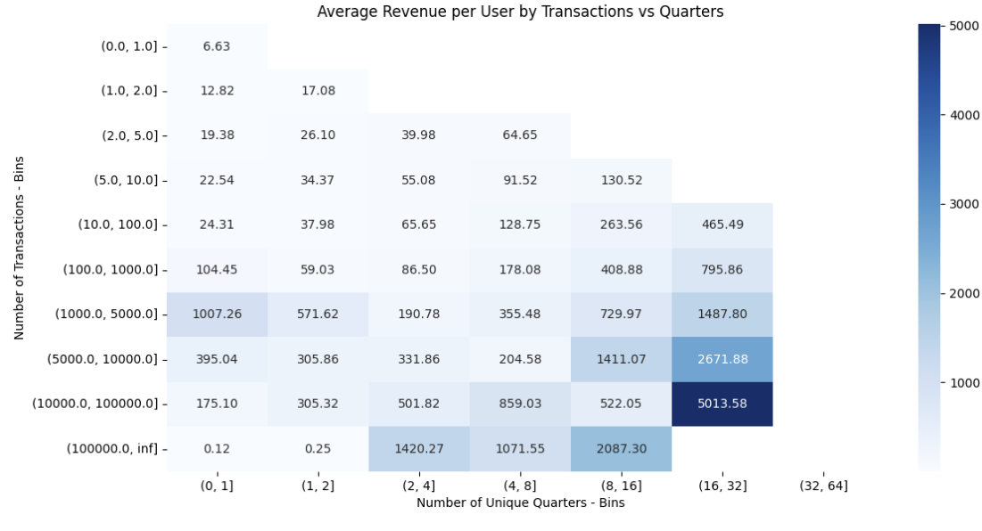

# 3. Longitudinal Behavior

## a. Revenue and Volume Over Time

- The Repeat segment has delivered the bulk of revenue consistently over time.  
- One-Off and Low Engagement groups remain flat.  
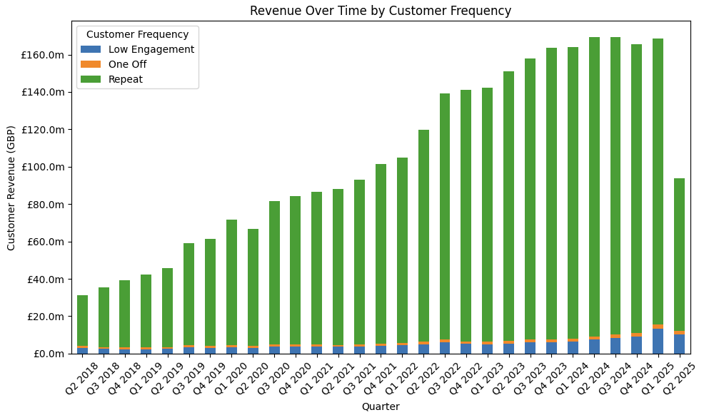

## b. Year-over-Year Growth Trends

- Repeat customers show higher consistency and compoundable growth. Recent softness is likely due to data lag and newer users not yet qualifying as repeat.  
- Growth in One-Off/Low Engagement segments is unstable, signaling churn-prone behaviors. (Last quarters are provisional due to recency and may underrepresent repeat)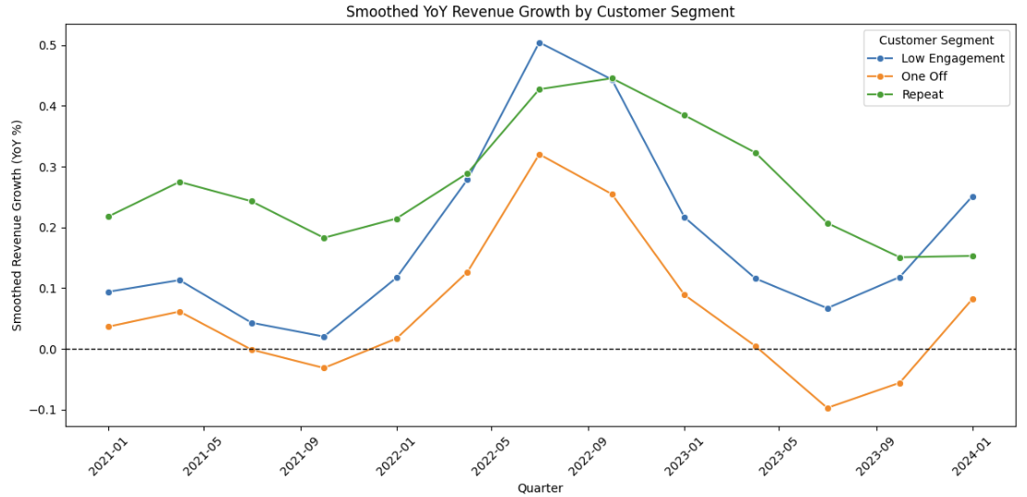

# 4. Summary & Recommendations

## Key Messages:

Repeat customers are the main revenue drivers of the business. They represent roughly 60% share of all users and contribute more than 95% to revenue. This validates the focus on retention, loyalty, and growth strategies targeted at this group.

## Suggested Next Steps:

While this analysis provides a foundational segmentation, next steps could include

- the Repeat segment itself could be further segmented — for example, into high-frequency low-value, high-value long-term, or seasonal repeaters — to uncover deeper behavioral insights across repeat customers themselves.

- Deeper investigation into Repeat user acquisition sources  
- Conversion paths from Low Engagement → Repeat  
- Tailored retention or winback initiatives by segment