

Pneumonia Detection using Artificial Intelligence
Bachelor Thesis

Student Name: Ioannis Vardakis
Student ID: 100728283
Supervisor: Markos Vasileios

Abstract
This study describes the development of an artificial intelligence system designed to identify pneumonia and other lung diseases through analysis of chest X-ray images. Despite the availability of various diagnostic algorithms and clinical tools, pneumonia remains one of the most significant public health challenges worldwide. Timely and accurate assessment of pneumonia is essential for effective patient management; however, human interpretation of chest X-rays is highly dependent on clinical experience, leading to substantial variability in diagnostic outcomes.
To address this challenge, a deep learning approach based on the DenseNet-121 architecture is proposed. The model is designed, trained, and evaluated on a multi-class dataset encompassing five categories: COVID-19, Emphysema, Normal, Pneumonia-Bacterial, and Pneumonia-Viral. Data preprocessing and augmentation techniques are applied to improve model generalization and overall performance.
The proposed model achieves an AUC score of 0.981 and a test accuracy of 85.7%, demonstrating strong classification capability across the majority of classes. The model performs particularly well in detecting COVID-19 and identifying normal cases. However, it encounters difficulty in distinguishing between bacterial and viral pneumonia, due to the significant visual overlap between these two classes in chest X-ray imaging. Model performance is evaluated using standard metrics including Precision, Recall, F1-score, Confusion Matrix, and ROC Curve analysis.
This research demonstrates that deep learning models have the potential to enhance diagnostic support systems within healthcare frameworks. The findings suggest that AI-based systems can be developed to reliably and consistently identify pathological conditions from medical images. Future work will focus on improving model generalizability, incorporating larger and more diverse datasets, and integrating the system into practical clinical workflows.

Contents
Abstract 2
1. Introduction
1.1 Background of the Study 4
1.2 Problem Statement 4
1.3 Aim and Objectives 5
1.4 Research Questions 5
1.5 Structure of the Thesis 6
2. Literature Review
2.1 Pneumonia: Medical Overview 7
2.2 Traditional Diagnosis Methods 7
2.3 Artificial Intelligence in Healthcare 8
2.4 Deep Learning and Convolutional Neural Networks (CNNs) 8
2.5 Related Work in Pneumonia Detection 9
2.6 Research Gaps and Motivation 9
3. Theoretical Background
3.1 Machine Learning vs Deep Learning 11
3.2 Neural Networks Fundamentals 11
3.3 Convolutional Neural Networks Architecture 12
3.4 Transfer Learning (DenseNet-121) 12
3.5 Evaluation Metrics 13
3.6 Explainability Methods (SmoothGrad) 15
4. Methodology
4.1 Research Design 17
4.2 Dataset Description 17
4.3 Data Preprocessing 18
4.4 Data Augmentation 18
4.5 Model Architecture 18
4.6 Training Process 19
4.7 Class Imbalance Handling 20
4.8 Tools and Technologies Used 20
5. System Implementation
5.1 System Architecture Diagram 22
5.2 Development Environment 22
5.3 Model Integration 23
5.4 Streamlit Application 23
6. Results and Evaluation
6.1 Model Performance Results 25
6.2 Confusion Matrix Analysis 25
6.3 Classification Report Analysis 27
6.4 Comparison with Related Work 28
6.5 Limitations of the Model 29
7. Discussion
7.1 Interpretation of Results 30
7.2 Clinical Relevance 30
7.3 Ethical Considerations 31
7.4 Security and Data Privacy 31
8. Conclusion and Future Work
8.1 Summary of Findings 33
8.2 Contribution of the Study 33
8.3 Future Improvements 33
8.3.1 Larger and More Diverse Datasets 33
8.3.2 Improved Multi-Class Classification 34
8.3.3 Real-Time Hospital Integration 34
8.3.4 Additional Future Directions 34
9. References 35

1. Introduction

1.1 Background of the Study
Pneumonia is one of the leading causes of morbidity and mortality worldwide, affecting hundreds of millions of people each year across all age groups [1]. The disease is characterised by inflammation of the alveoli — the small air sacs within the lungs — which become filled with fluid or pus, significantly impairing respiratory function [2]. While pneumonia poses a health risk to individuals of all ages, it is particularly life-threatening for young children, the elderly, and immunocompromised individuals [1].
Early and accurate diagnosis of pneumonia is critical to achieving favourable patient outcomes. In clinical practice, chest X-ray imaging is the most commonly employed diagnostic tool due to its accessibility, speed, and relatively low cost [3]. Radiologists and clinicians examine X-ray images for characteristic abnormalities such as consolidations, opacities, and infiltrates. However, accurate interpretation of chest X-rays requires substantial clinical experience, and even among trained radiologists, there exists a degree of inter-observer variability [4].
The rapid advancement of Artificial Intelligence (AI) in recent years has opened new avenues for medical image analysis. Deep learning — a subfield of machine learning — has demonstrated remarkable performance in image classification tasks, particularly through Convolutional Neural Networks (CNNs) [5]. These architectures can automatically extract and learn complex visual patterns from large datasets, making them well-suited for detecting pathological features in chest X-rays [6].
Among the deep learning architectures evaluated for medical imaging tasks, DenseNet-121 has shown exceptional performance, particularly in chest X-ray classification. Its densely connected layer structure promotes feature reuse and gradient flow, enabling the model to learn complex representations efficiently. Building upon these advances, this research aims to develop a practical, AI-based system capable of classifying chest X-ray images into multiple diagnostic categories [7].

1.2 Problem Statement
The accurate detection of pneumonia from chest X-ray images remains a clinically challenging task [4]. Chest X-rays exhibit a wide variety of normal and pathological visual characteristics, and the features associated with different types of pneumonia — particularly bacterial and viral — often overlap significantly, making reliable differentiation difficult even for experienced clinicians [8].
Healthcare systems worldwide face growing patient loads alongside a shortage of trained radiological personnel, contributing to diagnostic delays and increased risk of error. Delayed or incorrect diagnoses of pneumonia can result in serious complications and increased patient mortality. Conventional diagnosis relies heavily on human expertise, introducing potential for subjectivity and inconsistency [3].
Furthermore, the distinction between bacterial and viral pneumonia is particularly problematic, as both conditions may present with similar radiographic features, such as bilateral infiltrates or patchy consolidations. The development of an intelligent, automated system capable of reliably classifying chest X-ray images into multiple pneumonia-related categories is therefore both clinically valuable and technically challenging.

1.3 Aim and Objectives
Aim
The aim of this research is to develop an Artificial Intelligence system capable of detecting and classifying pneumonia and other lung-related conditions from chest X-ray images. The research focuses on the application of deep learning techniques, specifically transfer learning using the DenseNet-121 architecture [7], to improve diagnostic accuracy and support clinical decision-making.
Objectives
- To review existing literature on the application of artificial intelligence and deep learning in medical image analysis, with a focus on pneumonia detection.
- To acquire and prepare a multi-class chest X-ray dataset encompassing the categories: COVID-19, Emphysema, Normal, Pneumonia-Bacterial, and Pneumonia-Viral.
- To apply appropriate data preprocessing and augmentation techniques to improve model generalisation and performance.
- To develop and train a deep learning model based on the DenseNet-121 architecture for multi-class chest X-ray classification.
- To evaluate model performance using standard metrics including Accuracy, Precision, Recall, F1-score, AUC, and Confusion Matrix analysis.
- To integrate explainability techniques (SmoothGrad) to improve model transparency and clinical interpretability.
- To implement the trained model within a user-facing web application using Streamlit, demonstrating practical usability.
- To identify model limitations and propose directions for future improvement.

1.4 Research Questions
This study is guided by the following research questions:
- RQ1: How accurately can a DenseNet-121-based deep learning model classify chest X-ray images into the categories of COVID-19, Emphysema, Normal, Pneumonia-Bacterial, and Pneumonia-Viral?
- RQ2: What levels of accuracy, precision, recall, F1-score, and AUC can the proposed model achieve across all five classes?
- RQ3: What are the primary sources of misclassification in the model, particularly with respect to bacterial and viral pneumonia?
- RQ4: How can explainability methods such as SmoothGrad improve the clinical transparency and trustworthiness of the proposed AI system?
- RQ5: To what extent can the developed system be integrated into a practical, user-friendly application suitable for use in a clinical or research setting?

1.5 Structure of the Thesis
This thesis is structured into eight chapters, each addressing a distinct aspect of the research.
Chapter 1 (Introduction) establishes the research context, identifies the problem being addressed, defines the aim and objectives, and outlines the research questions guiding the study.
Chapter 2 (Literature Review) examines existing research on pneumonia detection, traditional diagnostic methods, the role of AI in healthcare, and the application of CNNs and deep learning to medical imaging. Key research gaps motivating this study are identified.
Chapter 3 (Theoretical Background) presents foundational concepts in machine learning, deep learning, neural networks, CNN architecture, transfer learning with DenseNet-121, evaluation metrics, and explainability methods including SmoothGrad.
Chapter 4 (Methodology) describes the research design, dataset, preprocessing and augmentation strategies, model architecture, training procedure, class imbalance handling, and the tools and technologies employed.
Chapter 5 (System Implementation) outlines the system architecture, development environment, model integration process, and the Streamlit web application interface.
Chapter 6 (Results and Evaluation) presents experimental results, confusion matrix analysis, classification report analysis, comparison with related work, and identified model limitations.
Chapter 7 (Discussion) interprets the results in terms of clinical relevance, ethical considerations, and data privacy implications.
Chapter 8 (Conclusion and Future Work) summarises the key findings, contributions of the study, and directions for future research and development.

2. Literature Review

2.1 Pneumonia: Medical Overview
Pneumonia is an acute respiratory infection that primarily affects the alveoli — the microscopic air sacs responsible for gas exchange within the lungs [2]. When infected, these structures become inflamed and may fill with fluid or pus, substantially impairing the transfer of oxygen into the bloodstream. Clinically, pneumonia manifests as cough, fever, chest pain, and dyspnoea. The condition may be caused by a variety of pathogens, including bacteria, viruses, and fungi, with bacterial and viral infections accounting for the majority of clinical cases [3].
Pneumonia remains one of the leading causes of death globally, and is recognised by the World Health Organization as a major public health concern, particularly in low- and middle-income countries with limited healthcare resources [1]. Vulnerable populations — including young children under five years of age, elderly individuals, and those with compromised immune systems — are disproportionately affected [1, 9].
Timely and accurate diagnosis is critical to effective pneumonia management and improved patient outcomes [10]. However, the clinical presentation of pneumonia frequently overlaps with that of other respiratory conditions such as bronchitis, tuberculosis, and heart failure, complicating the diagnostic process. The lack of universally accessible diagnostic infrastructure in many healthcare systems contributes to the ongoing global burden of this disease [3].

2.2 Traditional Diagnosis Methods
Conventional diagnosis of pneumonia typically involves a combination of clinical assessment, laboratory investigations, and medical imaging [4]. Clinicians conduct thorough patient histories and physical examinations, supplemented by blood tests — including full blood counts and inflammatory markers — and sputum cultures to identify the causative organism [3].
Chest X-ray imaging is the most widely used diagnostic modality for pneumonia, owing to its speed, accessibility, and relatively low cost. Radiologists examine X-ray images for pathological features including infiltrates, consolidations, and pleural effusions. However, the interpretive nature of X-ray analysis introduces a degree of subjectivity, and diagnostic accuracy is heavily dependent on the experience level of the examining clinician.
Research has consistently documented significant inter-observer variability in chest X-ray interpretation, even among experienced radiologists [4]. This variability is particularly pronounced in cases involving visually similar disease patterns. Moreover, in healthcare settings with high patient volumes and limited specialist availability, the manual analysis of X-ray images can become a bottleneck, increasing the risk of diagnostic error and delay [11]. These limitations have motivated the development of automated diagnostic support systems based on artificial intelligence [5, 6].

2.3 Artificial Intelligence in Healthcare
The integration of Artificial Intelligence (AI) into healthcare has undergone significant transformation over the past two decades. Early applications of AI in medical imaging were based on Computer-Aided Diagnosis (CAD) systems, which relied on hand-crafted feature extraction methods such as edge detection and texture analysis to identify abnormalities [4]. While these systems offered some diagnostic benefit, their limited ability to generalise across diverse datasets restricted their clinical utility.
The introduction of machine learning algorithms such as Support Vector Machines (SVM) and k-Nearest Neighbours (k-NN) represented a notable improvement, enabling systems to learn classification boundaries from data without explicit feature engineering [5]. However, these approaches still required manual feature design and demonstrated limited scalability when applied to high-dimensional image data [6].
The advent of deep learning has fundamentally changed the landscape of AI in healthcare. Unlike traditional machine learning approaches, deep learning models can automatically extract hierarchical representations directly from raw image data [6]. These models have been successfully applied across a broad range of medical domains, including the detection of cancers, neurological conditions, and respiratory diseases [12]. In the context of pneumonia detection, deep learning systems have shown promise in reducing diagnostic errors, accelerating clinical decision-making, and supporting clinicians in resource-constrained environments [13].
Despite these advances, important challenges remain, including the need for large, high-quality labelled datasets, improved model interpretability, and careful consideration of ethical and regulatory implications.

2.4 Deep Learning and Convolutional Neural Networks (CNNs)
Convolutional Neural Networks (CNNs) have emerged as the dominant architecture for medical image analysis within the deep learning paradigm. Their effectiveness stems from their ability to automatically learn and extract hierarchical feature representations from raw image data, without the need for manual feature engineering [6].
A standard CNN architecture comprises three principal components. Convolutional layers apply learned filters to the input image, detecting low-level features such as edges and textures in early layers and progressively more complex structures in deeper layers. Pooling layers reduce the spatial resolution of feature maps, lowering computational cost and providing a degree of translation invariance. Fully connected layers consolidate the extracted features and perform the final classification task [14].
CNNs have consistently outperformed classical machine learning algorithms in image classification benchmarks. Their ability to capture both local and global image features makes them particularly suitable for the analysis of medical images, where subtle visual distinctions between pathological and normal tissue must be reliably detected [11]. In the context of chest X-ray classification, CNNs have demonstrated the ability to distinguish pneumonia-affected lung regions from normal tissue with clinically meaningful accuracy [15].

2.5 Related Work in Pneumonia Detection
A substantial body of research has examined the application of deep learning architectures to pneumonia detection and chest X-ray classification. The following architectures have been among the most widely investigated:
VGG Networks
VGG architectures employ uniform, deep networks with small (3x3) convolutional filters. While these models achieve strong classification performance, they are associated with a high parameter count and consequently significant computational cost, limiting their scalability in resource-constrained environments [17].
Residual Networks (ResNet)
ResNet introduced skip connections to address the vanishing gradient problem, enabling the training of substantially deeper networks and improving classification performance [18]. ResNet-based models have shown strong results in chest X-ray analysis tasks [12].
Dense Convolutional Networks (DenseNet)
DenseNet extends the concept of skip connections by connecting each layer directly to all subsequent layers in a feed-forward manner. This design promotes feature reuse, reduces the number of trainable parameters, and improves gradient flow throughout the network [7]. DenseNet-121 has achieved state-of-the-art results in chest X-ray classification, with the CheXNet model demonstrating performance comparable to practising radiologists in detecting pneumonia [19].
EfficientNet
EfficientNet introduces a compound scaling method that simultaneously adjusts network depth, width, and resolution. This approach achieves high classification accuracy with considerably fewer parameters than comparable architectures, offering improved computational efficiency [20].
Among these architectures, DenseNet-121 has demonstrated the most consistent performance in medical imaging applications, and has therefore been selected as the base architecture for the present study [21, 22].

2.6 Research Gaps and Motivation
Despite the considerable progress achieved in applying deep learning to pneumonia detection, several important gaps remain in the existing literature [23]. A primary limitation is the reliance on small or imbalanced datasets for model training, which can impair a model's ability to generalise to real-world clinical populations and may lead to overfitting [22].
Furthermore, much of the published research focuses on binary classification — distinguishing pneumonia from normal cases — rather than the clinically more relevant multi-class problem of differentiating between subtypes of pneumonia, such as bacterial and viral forms [23, 24]. The challenge of distinguishing between these subtypes is particularly significant, as their radiographic features overlap substantially [4, 8].
A further gap exists in the translation of developed models into practical clinical tools [25]. The majority of published studies evaluate model performance in controlled experimental settings without addressing the requirements for real-world deployment, including system usability, integration with clinical workflows, and regulatory compliance. Ethical concerns relating to algorithmic bias, data privacy, and the need for explainable AI also remain insufficiently addressed [13, 26].
The present research aims to address these gaps by developing a multi-class pneumonia detection system incorporating explainability features and a practical web-based application interface, with explicit consideration of the ethical and technical requirements for clinical deployment.

3. Theoretical Background

3.1 Machine Learning vs Deep Learning
Machine learning is a subfield of Artificial Intelligence concerned with the development of algorithms that enable systems to learn from data and make predictions or decisions without being explicitly programmed. Traditional machine learning approaches — including Support Vector Machines (SVM) and k-Nearest Neighbours (k-NN) — rely on manually engineered features extracted from raw data. Domain experts identify and define the relevant features that are subsequently used as inputs to classification algorithms [5].
This approach has several inherent limitations. The process of feature engineering is time-consuming and requires specialised domain knowledge. In high-dimensional domains such as medical imaging, manually defined features may fail to capture the full complexity of the data, restricting classification performance and scalability across different datasets.
Deep learning represents a fundamentally different paradigm, in which multi-layered artificial neural networks learn feature representations automatically and hierarchically from raw data. This eliminates the requirement for manual feature engineering and enables the model to capture complex patterns at multiple levels of abstraction. In the field of medical imaging, deep learning has consistently outperformed traditional machine learning approaches, particularly in tasks requiring the detection of subtle and complex visual patterns such as those associated with pneumonia [5, 6].

3.2 Neural Networks Fundamentals
Artificial Neural Networks (ANNs) are computational models inspired by the structure and function of biological neural networks in the brain. An ANN consists of interconnected layers of artificial neurons, or nodes, organised into an input layer, one or more hidden layers, and an output layer.
Each neuron receives weighted inputs from the previous layer, computes a weighted sum, and applies a non-linear activation function to produce an output. Activation functions introduce non-linearity into the model, enabling it to learn complex, non-linear relationships within the data. Commonly used activation functions include the Rectified Linear Unit (ReLU), widely employed in hidden layers due to its computational efficiency and ability to mitigate the vanishing gradient problem; the Sigmoid function, used in binary classification output layers; and the Softmax function, used in multi-class classification output layers [14].
During training, the network minimises a loss function by adjusting its weights through a process called backpropagation, which computes the gradient of the loss with respect to each weight using the chain rule of calculus. Weight updates are applied using an optimisation algorithm; in this study, the Adam optimiser is employed, which adapts the learning rate for each parameter individually, offering efficient convergence on complex optimisation landscapes [27].

3.3 Convolutional Neural Networks Architecture
Convolutional Neural Networks (CNNs) are a specialised class of deep learning architecture designed to process structured grid data, such as images. Their key advantage over standard fully connected networks is the use of convolutional operations, which exploit the spatial structure of image data through parameter sharing and local connectivity [6, 14].
A typical CNN architecture is composed of three principal layer types. Convolutional layers apply learned filter banks to the input, producing feature maps that highlight the presence of specific visual patterns — such as edges, textures, and shapes — at different spatial locations. Pooling layers reduce the spatial dimensions of feature maps through operations such as max pooling or average pooling, decreasing computational cost and providing spatial invariance. Fully connected layers combine the extracted feature representations to produce the final class predictions [6].
CNNs learn features in a hierarchical manner: early layers capture low-level features such as edges and gradients, while deeper layers represent increasingly abstract, high-level concepts such as anatomical structures. This hierarchical representation learning is particularly advantageous in medical imaging, where pathological findings may manifest as subtle alterations in tissue texture, shape, or density that require multi-scale analysis for reliable detection.
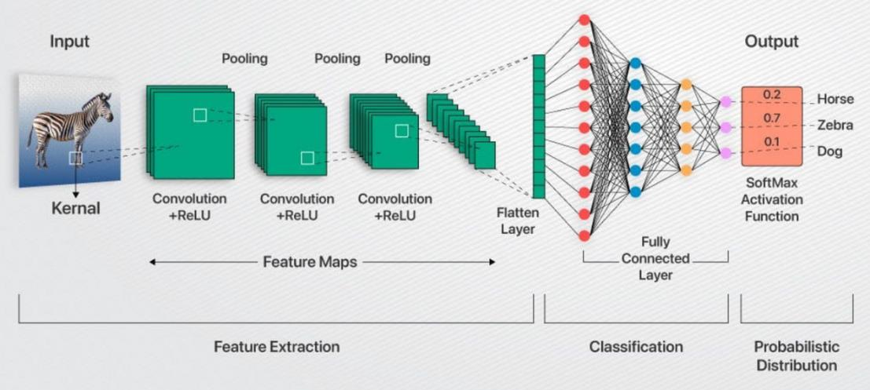
Figure 1: Basic architecture of a Convolutional Neural Network (CNN)

3.4 Transfer Learning (DenseNet-121)
Transfer learning is a technique in which a model pre-trained on a large source dataset is adapted for use on a different, typically smaller, target dataset [28]. In the context of medical image classification, transfer learning is particularly valuable because large labelled medical imaging datasets are difficult and costly to obtain [6]. By initialising model weights from a network pre-trained on ImageNet [29] — a dataset comprising over one million natural images across one thousand categories — the model can leverage previously learned low-level and mid-level feature representations, substantially reducing the quantity of labelled medical data required for effective training.
The DenseNet-121 architecture was selected as the base model for this study [7]. DenseNet (Densely Connected Convolutional Network) introduces a connectivity pattern in which each layer receives as input the feature maps of all preceding layers and passes its own feature maps to all subsequent layers. This dense connectivity yields several important advantages:
- Enhanced gradient flow throughout the network, mitigating the vanishing gradient problem in very deep architectures.
- Promotion of feature reuse across layers, improving model efficiency.
- Reduction in the total number of trainable parameters relative to traditional deep architectures of comparable depth.
- Improved feature propagation, enabling the network to retain both low-level and high-level representations simultaneously.
DenseNet-121 comprises 121 layers and has demonstrated state-of-the-art performance in chest X-ray classification tasks. The CheXNet model, which is based on DenseNet-121, achieved performance comparable to expert radiologists in detecting pneumonia from chest X-rays.
In the present study, transfer learning is implemented by loading the DenseNet-121 model with pre-trained ImageNet weights and replacing the final classification layer with a custom layer configured for five-class output. Fine-tuning is performed by unfreezing the deeper layers of the network and training them on the chest X-ray dataset, allowing the model to adapt its representations to the specific characteristics of medical imaging data [19].
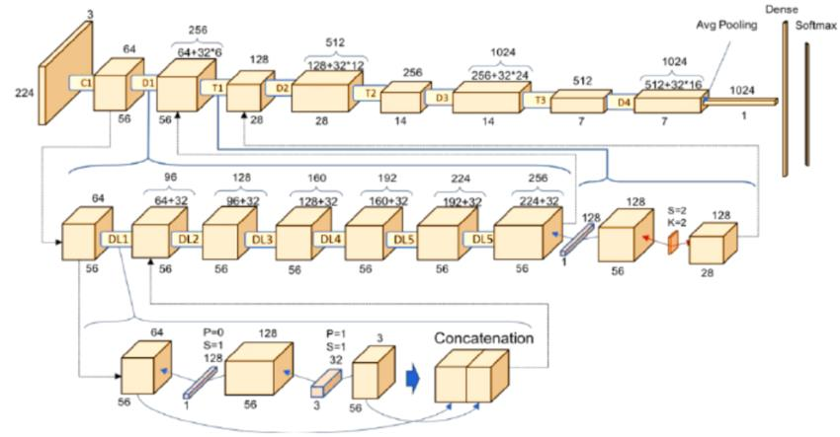
Figure 2: DenseNet architecture showing dense connections between layers

3.5 Evaluation Metrics
The rigorous evaluation of deep learning models for medical image classification is essential to assess clinical reliability and applicability [30]. To make the evaluation framework concrete, it is helpful to first introduce the four basic outcomes of a binary medical classification task, since all of the metrics described below are derived from these. Considering pneumonia detection as an example: a True Positive (TP) corresponds to a case in which a patient with pneumonia is correctly classified as positive; a True Negative (TN) corresponds to a healthy patient correctly classified as negative; a False Positive (FP) — also known as a Type I error — occurs when a healthy patient is incorrectly classified as having pneumonia; and a False Negative (FN) — a Type II error — occurs when a patient with pneumonia is incorrectly classified as healthy. Multiple complementary evaluation metrics, all derived from these four quantities, are employed in this study.
Accuracy
Accuracy measures the overall proportion of correctly classified instances across all classes, calculated as (TP + TN) / (TP + TN + FP + FN). For example, if a model is evaluated on 100 chest X-rays and correctly classifies 86 of them, the resulting accuracy is 86%. While widely reported, accuracy can be misleading in the presence of class imbalance, as high accuracy may be achieved by a model that performs well on majority classes while performing poorly on minority classes. To illustrate, in a dataset where 95% of cases are normal and only 5% are pathological, a trivial model that predicts every case as normal would achieve 95% accuracy while failing to detect any disease at all — clearly an unacceptable outcome in a clinical setting.
Precision
Precision measures the proportion of positive predictions that are truly positive, calculated as TP / (TP + FP). It reflects the model's ability to avoid false positive predictions. For example, if the model predicts 100 X-rays as showing pneumonia and 90 of those predictions are correct, the precision is 0.90 (or 90%). High precision is particularly important in medical diagnosis to minimise the risk of unnecessary treatments, additional imaging, or invasive interventions resulting from false positive predictions.
Recall (Sensitivity)
Recall, also referred to as sensitivity, measures the proportion of actual positive cases that are correctly identified by the model, calculated as TP / (TP + FN). For example, if 100 patients in the test set actually have pneumonia and the model correctly identifies 85 of them, the recall is 0.85 (or 85%). In a clinical context, high recall is critical to ensure that true cases of disease are not missed, as false negative predictions may result in delayed or absent treatment with potentially serious consequences for patient outcomes. The trade-off between precision and recall is a fundamental consideration in medical AI: a model tuned for very high precision tends to miss disease cases, whereas a model tuned for very high recall tends to over-diagnose.
F1-Score
The F1-score is the harmonic mean of precision and recall, calculated as 2 × (Precision × Recall) / (Precision + Recall), providing a single metric that balances both measures. For example, a model with precision of 0.90 and recall of 0.80 yields an F1-score of approximately 0.847. The harmonic mean is used rather than a simple average because it penalises extreme values: a model that achieves perfect precision (1.0) but very low recall (0.10) would have an arithmetic mean of 0.55 but an F1-score of only 0.18, more accurately reflecting the model's poor overall performance. The F1-score is particularly informative in scenarios with uneven class distributions, as it penalises models that achieve high performance on one metric at the expense of the other.
Confusion Matrix
The confusion matrix provides a detailed breakdown of model predictions for each class, comparing predicted labels against ground truth labels. In the multi-class setting addressed in this study, the matrix is a 5×5 grid in which the rows represent the true classes and the columns represent the predicted classes. The diagonal entries indicate correctly classified cases, while off-diagonal entries reveal specific misclassification patterns. For example, a confusion matrix may show that 75 cases of true viral pneumonia were predicted as bacterial pneumonia, indicating systematic confusion between these two visually similar classes — a pattern that would not be captured by aggregate metrics such as overall accuracy. The confusion matrix therefore provides clinically actionable insight into where a model is failing and why.
ROC Curve and AUC
The Receiver Operating Characteristic (ROC) curve is a graphical representation of a classifier's performance across all possible decision thresholds. A deep learning model typically produces a probability between 0 and 1 for each class, and a threshold (commonly 0.5) is applied to convert this probability into a discrete prediction. As the threshold is varied from 0 to 1, the trade-off between the True Positive Rate (TPR, equivalent to recall) and the False Positive Rate (FPR, calculated as FP / (FP + TN)) changes: a low threshold flags more cases as positive, increasing both TPR and FPR, while a high threshold reduces both. The ROC curve plots TPR on the y-axis against FPR on the x-axis as the threshold is varied.
The Area Under the Curve (AUC) provides a scalar summary of overall classification performance, with values ranging from 0.5 (random classification, equivalent to flipping a coin) to 1.0 (perfect classification). An AUC of 0.7 is generally considered acceptable, 0.8 good, and above 0.9 excellent in medical imaging applications. The intuitive interpretation of AUC is that it represents the probability that the model assigns a higher score to a randomly chosen positive example than to a randomly chosen negative example: an AUC of 0.98, for instance, means that 98% of the time the model correctly ranks a diseased case above a healthy one. AUC is particularly valuable in multi-class settings as it summarises performance across all classes and is robust to class imbalance, since it does not depend on the choice of a specific decision threshold [31].

3.6 Explainability Methods (SmoothGrad)
A significant limitation of deep learning models in clinical settings is their inherently opaque decision-making process, often described as a 'black box' problem [13]. For AI systems to be trusted and adopted by medical professionals, it is important that the model's predictions can be interpreted and explained in clinically meaningful terms.
SmoothGrad is a gradient-based explainability technique that generates saliency maps highlighting the regions of an input image that most strongly influenced the model's prediction. The method improves upon basic gradient-based approaches by averaging gradients over multiple versions of the input image with added Gaussian noise, which reduces the visual noise present in standard sensitivity maps and produces cleaner, more interpretable visualisations [32].
In the context of this study, SmoothGrad is applied to generate visual explanations for the model's classification decisions. The resulting saliency maps highlight specific regions of the chest X-ray — such as areas of consolidation or infiltrate — that the model identifies as diagnostically relevant. This provides clinicians with a degree of transparency into the model's reasoning, supporting informed clinical decision-making and facilitating the identification of cases where the model may be relying on spurious or non-diagnostic image features.

4. Methodology

4.1 Research Design
This research adopts a quantitative experimental research design to develop, train, and evaluate a deep learning model for multi-class chest X-ray classification [33]. The research process is structured into a series of sequential phases: dataset acquisition and preparation, data preprocessing and augmentation, model development and training, and systematic performance evaluation.
This structured experimental approach enables the systematic measurement and analysis of model performance across all five diagnostic categories. Each phase is designed to ensure that the model is adequately trained and rigorously evaluated, yielding quantifiable results that can be meaningfully interpreted and compared.

4.2 Dataset Description
The dataset used in this study comprises chest X-ray images sourced from publicly available repositories on Kaggle [34]. The dataset encompasses five diagnostic categories:
- COVID-19 — 129 images
- Emphysema — 250 images
- Normal — 327 images
- Pneumonia-Bacterial — 301 images
- Pneumonia-Viral — 166 images
The total dataset comprises 1,450 labelled chest X-ray images. To enable proper model training and unbiased evaluation, the dataset is partitioned into three subsets using a stratified split to preserve class proportions across subsets:
- Training set: 70% of total data (approximately 1,015 images)
- Validation set: 15% of total data (approximately 218 images)
- Test set: 15% of total data (approximately 217 images)
The training set is used exclusively for model parameter optimisation. The validation set is used during training to monitor generalisation performance and guide hyperparameter selection. The test set is held out entirely until final evaluation, ensuring an unbiased assessment of model performance on unseen data. This partitioning strategy mitigates the risk of overfitting and provides a reliable estimate of real-world model performance [22].
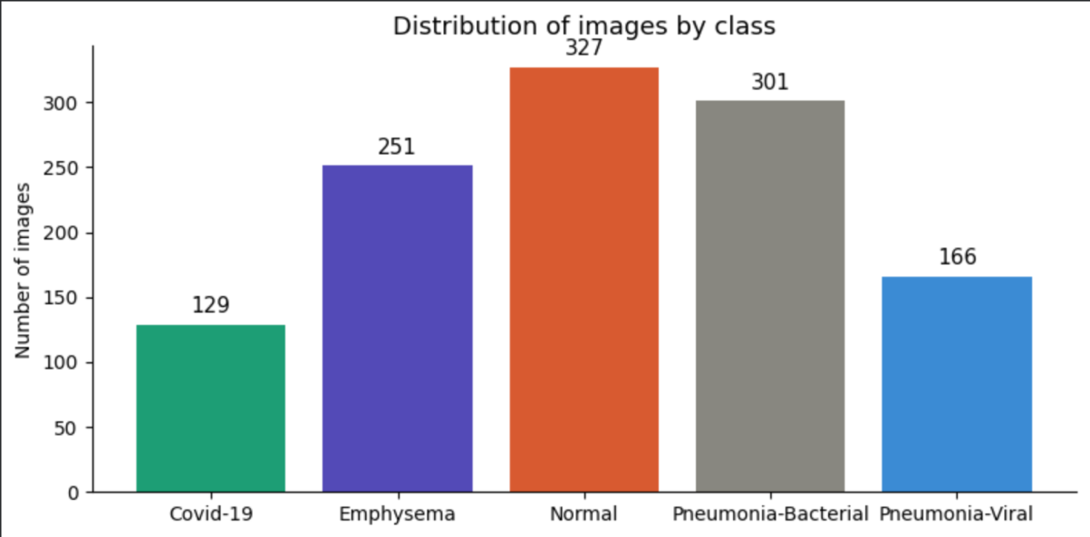
Figure 3: Sample chest X-ray images from different classes used in the dataset

4.3 Data Preprocessing
All images undergo a standardised preprocessing pipeline prior to model training, ensuring consistency across the dataset and improving training stability [35].
- Image Resizing: All images are resized to 224 x 224 pixels to match the input dimensions required by the DenseNet-121 architecture.
- Normalisation: Pixel values are rescaled from the range [0, 255] to [0, 1] by dividing by 255. This normalisation improves gradient stability and accelerates model convergence during training.
- Class Label Encoding: Each class label is encoded as a one-hot vector for use with the categorical cross-entropy loss function.

4.4 Data Augmentation
Data augmentation techniques are applied exclusively to the training set to artificially increase dataset diversity and reduce the risk of overfitting [36]. The following augmentation operations are applied randomly to each training image during model training:
- Random rotation: up to ±15 degrees
- Horizontal flipping: applied with a probability of 0.5
- Random zoom: up to 10%
- Width and height shifting: up to 10%
These transformations simulate the natural variability present in clinical chest X-ray acquisitions [36, 37], such as differences in patient positioning and imaging angles, thereby improving the model's robustness to such variations in real-world deployment.

4.5 Model Architecture
The proposed system employs the DenseNet-121 architecture [7] as the base feature extractor, pre-trained on the ImageNet dataset [29]. The original classification head of DenseNet-121 is removed and replaced with a custom classification block tailored for the five-class output required by this study.
The modified architecture comprises the following components:
- Pre-trained DenseNet-121 base model (weights initialised from ImageNet pre-training)
- Global Average Pooling layer — reduces spatial feature maps to a single vector per feature channel
- Fully connected (Dense) layer with 256 units and ReLU activation
- Dropout layer (rate = 0.5) for regularisation
- Softmax output layer with five units corresponding to the five diagnostic classes

4.6 Training Process
The model is trained using the Adam optimizer [27] with an initial learning rate of 1e-4 and categorical cross-entropy as the loss function. Training is conducted over 30 epochs with a batch size of 32. A learning rate reduction callback is applied, halving the learning rate if validation loss does not improve for five consecutive epochs.
Fine-tuning is performed by initially freezing all base DenseNet-121 layers and training only the custom classification head for the first 10 epochs. The final 20 convolutional layers of the DenseNet-121 base are subsequently unfrozen, and the entire network is trained at a reduced learning rate of 1e-5 to allow the pre-trained features to adapt to the chest X-ray domain [38].
Early stopping with a patience of 10 epochs is employed to prevent overfitting, restoring the model weights corresponding to the best validation AUC observed during training. Model performance is monitored using training and validation accuracy, loss, and AUC across all epochs [17].
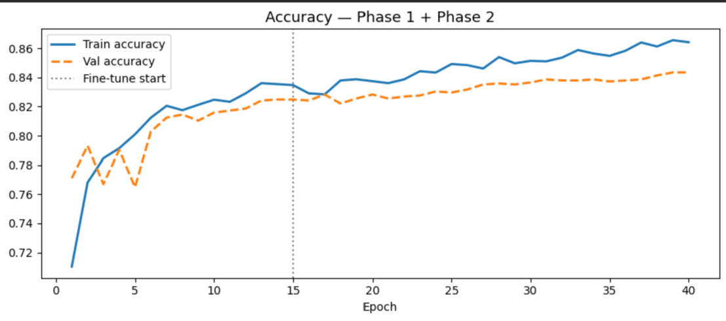
Figure 4: Training and validation accuracy over epochs
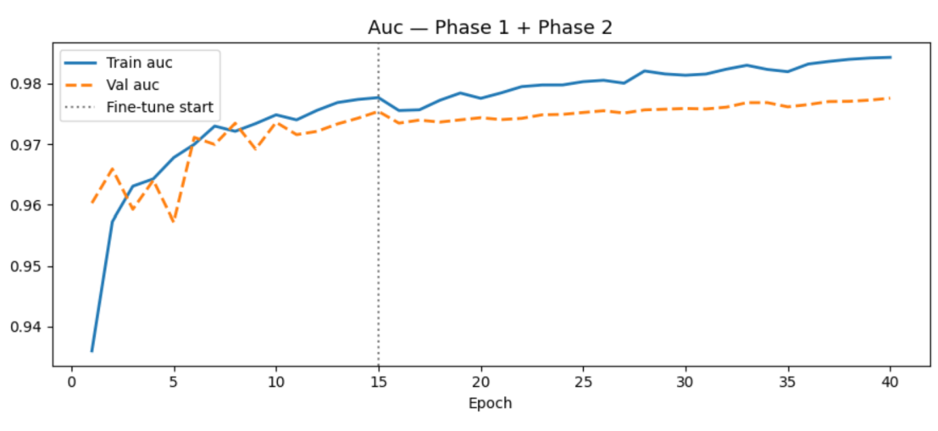
Figure 5: Training and validation AUC over epochs
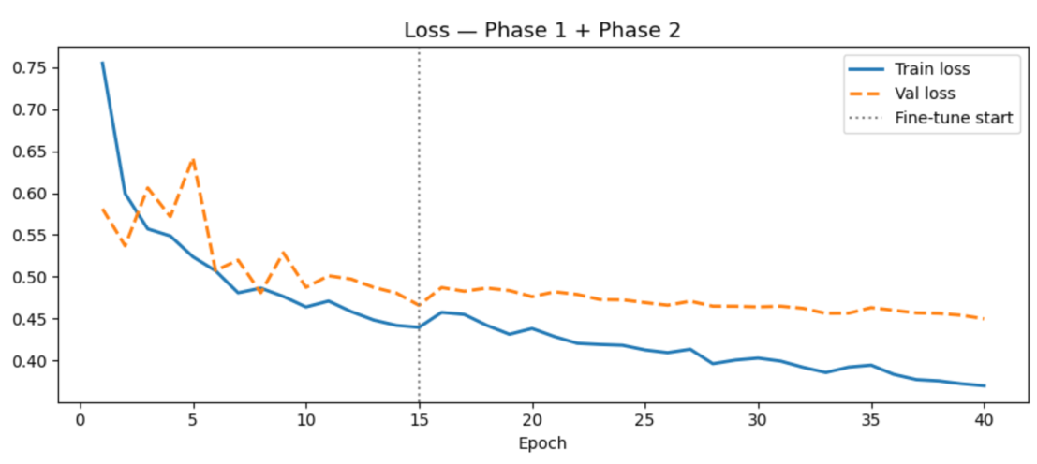
Figure 6: Training and validation loss over epochs

4.7 Class Imbalance Handling
The dataset contains a mild class imbalance, with the Emphysema class comprising 250 images compared to 300 images in the remaining four classes. To mitigate the potential impact of this imbalance on model training, class weights are computed inversely proportional to class frequency and applied during training [39]. This ensures that the model assigns proportionally greater penalty to misclassifications of the minority class, reducing the risk of biased predictions in favour of majority classes.
Additionally, stratified splitting is used during dataset partitioning to ensure that each subset maintains the same class distribution as the overall dataset, preventing disproportionate representation of any class within the training, validation, or test sets [22].

4.8 Tools and Technologies Used
The following tools and technologies are used throughout the development and evaluation of the proposed system:
- Python (v3.9): Primary programming language, widely used in data science and machine learning.
- TensorFlow (v2.10) and Keras: Deep learning framework used for model construction, training, and evaluation.
- Google Colab: Cloud-based development environment providing GPU acceleration, enabling efficient training on large datasets.
- NumPy: Numerical computation library used for array operations and data manipulation.
- Pandas: Data manipulation and analysis library used for dataset management.
- Matplotlib and Seaborn: Visualisation libraries used for plotting training curves and confusion matrices.
- Scikit-learn: Machine learning library used for computing evaluation metrics and generating classification reports.
- Streamlit: Python-based web application framework used for developing the user-facing diagnostic interface.

5. System Implementation

5.1 System Architecture Diagram
The implemented system follows a sequential processing pipeline, from image input to diagnostic prediction output. The overall architecture is designed for simplicity, efficiency, and practical applicability in real-world settings.
The system operates as follows:
- The user uploads a chest X-ray image via the Streamlit web application interface.
- The uploaded image undergoes preprocessing, including resizing to 224 x 224 pixels and pixel value normalisation.
- The preprocessed image is passed to the trained DenseNet-121 model.
- The model generates a probability distribution across the five diagnostic classes.
- The predicted class and associated confidence scores are displayed to the user.
- A SmoothGrad saliency map is generated and displayed, highlighting the image regions that most strongly influenced the model's prediction.
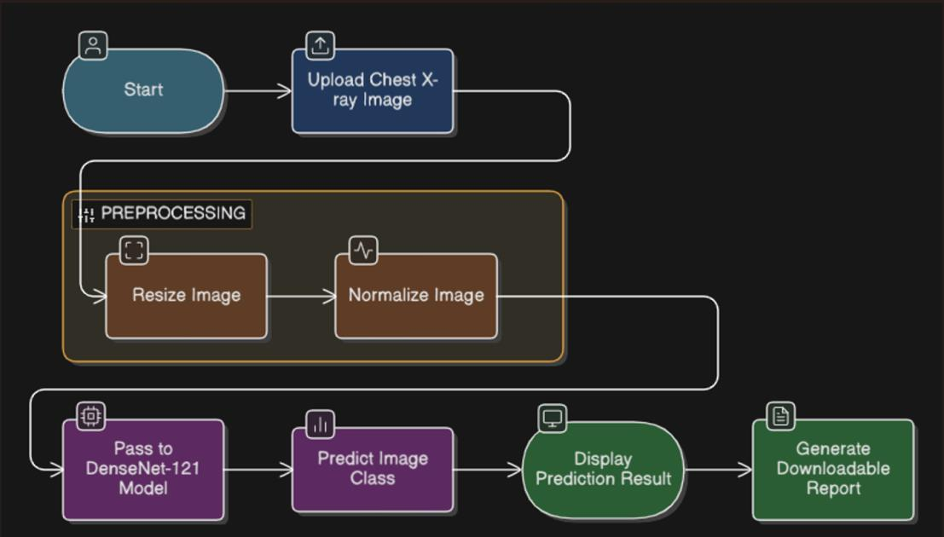
Figure 7: System architecture of the proposed pneumonia detection system

5.2 Development Environment
The system was developed using Python as the primary programming language. TensorFlow and Keras were used for model implementation and training. Google Colab was used as the development and training environment, providing cloud-based GPU resources that significantly reduced training time.
The trained model is saved in the TensorFlow SavedModel format and loaded within the Streamlit application for inference. The deployment environment requires Python 3.9, TensorFlow 2.10, and Streamlit installed as dependencies.

5.3 Model Integration
Following the completion of training, the DenseNet-121 model is serialised and integrated into the Streamlit web application for real-time inference. The model integration pipeline involves the following steps:
- Loading the serialised model from disk at application initialisation.
- Receiving and preprocessing the uploaded image to match the model's expected input format.
- Passing the preprocessed image through the model to obtain class probability predictions.
- Generating a SmoothGrad saliency map to provide visual explanation of the prediction.
- Displaying the predicted class, confidence scores, and saliency map to the user.
This integration allows end users to interact with the model without requiring any knowledge of machine learning or programming, making the system accessible to clinical and non-clinical users alike.

5.4 Streamlit Application
The diagnostic system is implemented as a web-based application using Streamlit, providing an intuitive and accessible interface for chest X-ray classification. The application is designed to be deployable on standard web servers and accessible via a web browser without the need for local software installation.
The application provides the following user-facing functionality:
- Image upload: Users can upload chest X-ray images in common formats (JPEG, PNG).
- Automatic preprocessing: Uploaded images are automatically resized and normalised before inference.
- Real-time classification: The trained model generates a predicted diagnostic class and class-wise confidence scores within seconds of image upload.
- Explainability visualisation: A SmoothGrad saliency map is generated and displayed alongside the original image, highlighting the regions of the X-ray that were most influential in the model's decision.
The integration of explainability features within the user interface is a key design consideration, as it promotes transparency and facilitates informed clinical interpretation of model predictions. The application demonstrates the feasibility of deploying deep learning-based diagnostic tools in practical healthcare settings.
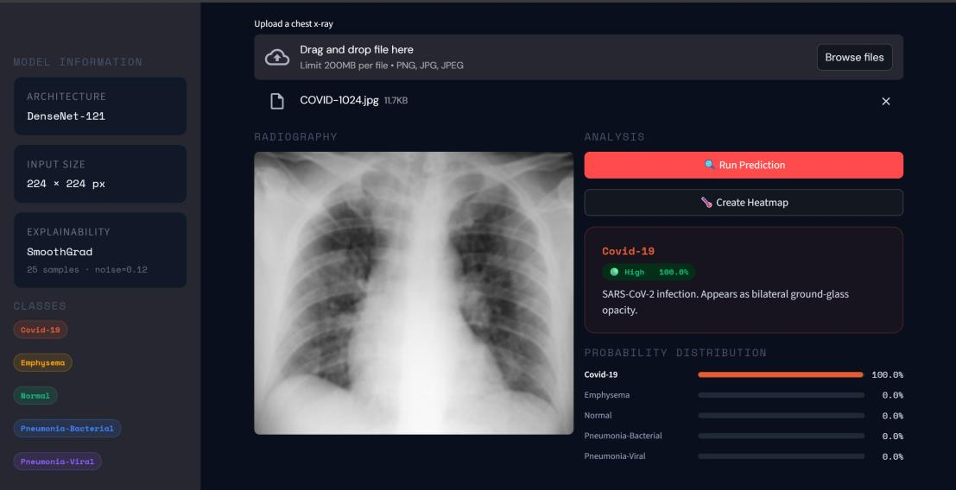
Figure 8: Main interface of the developed Streamlit application, where users can upload chest X-ray images and obtain classification results.
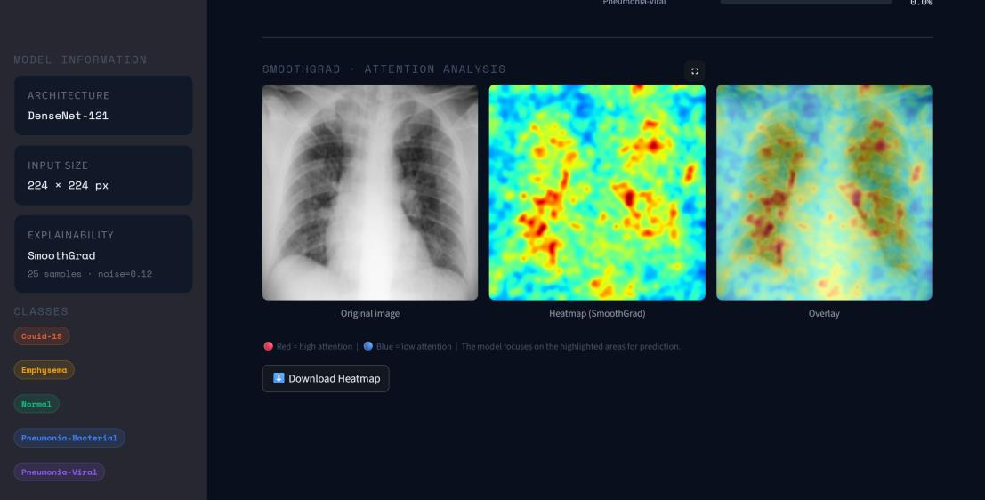
Figure 9: Explainability results generated using SmoothGrad, highlighting the regions of the image that influenced the model's decision.

6. Results and Evaluation

6.1 Model Performance Results
The trained DenseNet-121 model is evaluated on the held-out test set, which was not used at any point during model training or validation. The key performance metrics are summarised below:
Metric | Value
Test Accuracy | 85.72%
Test AUC | 0.9812
Test Loss | 0.4052
Macro Avg F1-Score | 0.856
Weighted Avg F1-Score | 0.853

The test accuracy of 85.72% indicates strong overall classification performance across the five diagnostic classes. The AUC of 0.981 demonstrates the model's high discriminative ability — its capacity to distinguish between classes — across all classification thresholds. The relatively low test loss of 0.4052 further confirms that the model's predicted probability distributions are well-calibrated. Taken together, these results indicate that the model has successfully learned to generalise from the training data to previously unseen chest X-ray images [30, 31].
It is worth noting that the AUC of 0.981 is more informative than the raw accuracy in this multi-class context, since it evaluates the model's ranking ability across all decision thresholds rather than its performance at a single fixed threshold. A score in this range is generally considered excellent in medical imaging applications and is comparable to the performance reported for benchmark systems such as CheXNet [19]. However, the gap between the AUC (0.981) and the accuracy (85.72%) also signals an important diagnostic insight: the model's internal probability scores tend to rank diseased and healthy cases correctly, but the final discrete predictions are weakened by errors concentrated in a specific pair of classes — the bacterial and viral pneumonia subtypes — as the analysis below confirms.

6.2 Confusion Matrix Analysis
Examination of the confusion matrix reveals important patterns in the model's classification behaviour across the five diagnostic categories. The model demonstrates strong performance for several classes:
- COVID-19: 273 out of 300 test samples correctly classified, yielding a class-level accuracy of 91.0%.
- Normal: 297 out of 300 test samples correctly classified, yielding a class-level accuracy of 99.0%.
- Emphysema: 240 out of 250 test samples correctly classified, yielding a class-level accuracy of 96.0%.
In contrast, the model encounters greater difficulty with the pneumonia subtype classes:
- Pneumonia-Bacterial: A notable proportion of bacterial pneumonia samples are misclassified as viral pneumonia, reflecting the visual similarity between the two subtypes.
- Pneumonia-Viral: This class exhibits the lowest recall of all five categories, indicating that a substantial number of viral pneumonia cases are incorrectly assigned to other classes, most frequently to the bacterial pneumonia category.
This pattern of misclassification between bacterial and viral pneumonia is not an artefact of the present model, but rather a reflection of a well-documented diagnostic challenge in radiology. Both subtypes can produce overlapping radiographic patterns including bilateral infiltrates, lobar or patchy consolidation, and ground-glass opacities, and the visual cues that historically have been considered indicative of bacterial versus viral aetiology — for example, lobar consolidation favouring bacterial infection, and bilateral interstitial patterns favouring viral infection — are neither sensitive nor specific enough to support reliable subtype differentiation in isolation. Studies of inter-observer agreement among radiologists report consistently low concordance for chest X-ray-based subtype classification of pneumonia, with disagreement rates often exceeding 30%, even among experienced specialists [4, 8]. In this light, the model's difficulty with these two specific classes mirrors the difficulty experienced by human experts working from the same imaging modality alone.
By contrast, the strong performance observed for COVID-19, Emphysema, and Normal classes can be attributed to the relative visual distinctiveness of these categories. COVID-19 X-rays typically exhibit characteristic bilateral, peripheral, lower-lobe ground-glass opacities that differ markedly from the patterns of bacterial or viral pneumonia [40]. Emphysema, a chronic structural condition rather than an acute infection, manifests through hyperinflation, flattened diaphragms, and increased lung lucency — features visually distinct from the consolidations and infiltrates of pneumonia. Normal chest X-rays, by definition, lack these pathological signs, providing the model with clear discriminative features. This contrast supports the interpretation that the model has successfully learned clinically meaningful representations rather than relying on spurious image artefacts: it performs well precisely on the classes that radiologists themselves can reliably distinguish, and struggles precisely on the classes that radiologists also struggle with.
The 75 cases of true viral pneumonia misclassified as bacterial pneumonia represent the single largest source of error in the model. From a clinical decision-support perspective, this specific failure mode is less harmful than it might initially appear, because both predictions correctly flag the case as a pneumonia requiring further investigation; the consequence is a potentially incorrect aetiological label rather than a missed diagnosis. The 35 viral pneumonia cases misclassified as Normal, while smaller in number, carry greater clinical risk and represent the most concerning error pattern. This observation suggests that future iterations of the model might benefit from a hierarchical decision approach, in which a first stage distinguishes pathological from normal cases (where the model already excels) and a second stage attempts subtype classification only when supplementary clinical or laboratory information is available — an approach increasingly advocated in the pneumonia AI literature [8, 12].
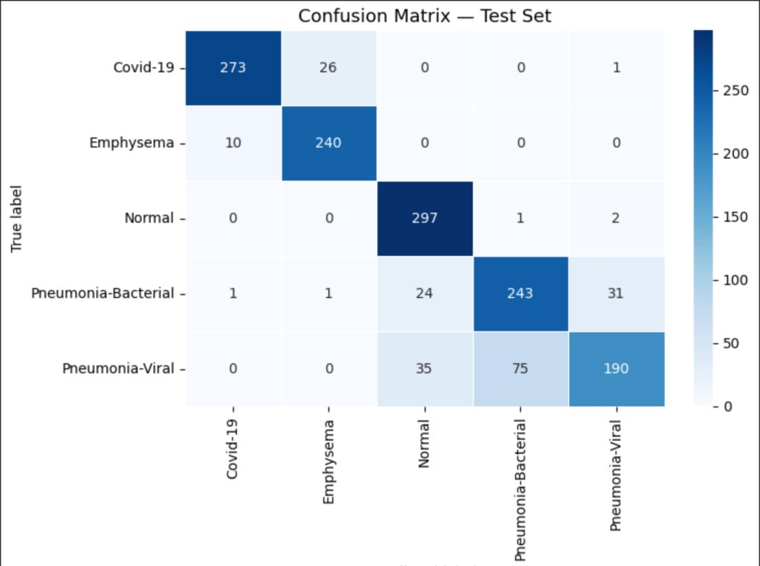
Figure 10: Confusion matrix for the multi-class classification model

6.3 Classification Report Analysis
The per-class classification report provides a detailed breakdown of precision, recall, and F1-score for each of the five diagnostic categories. Results are presented in Table 1 below.
Class | Precision | Recall | F1-Score | Support
COVID-19 | 0.961 | 0.910 | 0.935 | 129
Emphysema | 0.899 | 0.960 | 0.928 | 251
Normal | 0.834 | 0.990 | 0.905 | 327
Pneumonia-Bacterial | 0.762 | 0.810 | 0.785 | 301
Pneumonia-Viral | 0.848 | 0.633 | 0.725 | 166

The model achieves its highest F1-score for COVID-19 (0.935) and Emphysema (0.928), reflecting the relative distinctiveness of the radiographic features associated with these conditions [40]. The Normal class achieves the highest recall (0.990), indicating that the model rarely misclassifies normal chest X-rays as pathological — a clinically important characteristic [24], since a missed pathological case is generally a more serious error than an over-flagged normal case in a screening context.
A closer reading of the per-class metrics reveals a consistent pattern across the three classes that the model handles well. For COVID-19, precision (0.961) exceeds recall (0.910), meaning that when the model predicts COVID-19 it is almost always correct, although a small number of true COVID-19 cases are missed; this profile is consistent with the model having learned the strongly distinctive ground-glass opacity signature reported in the literature [40]. For Emphysema and Normal, the opposite pattern emerges: recall is higher than precision, indicating that the model rarely fails to identify these cases when they are present, but occasionally over-applies these labels to other classes. The slight reduction in Normal precision (0.834) is largely explained by the 26 COVID-19 cases visible in the confusion matrix that the model labelled as Emphysema and the 35 viral pneumonia cases mislabelled as Normal — a finding which, again, points to the difficulty of the viral pneumonia class specifically rather than to a generalised weakness on healthy cases.
Performance is comparatively lower for the pneumonia subtype classes, with Pneumonia-Bacterial achieving an F1-score of 0.785 and Pneumonia-Viral achieving the lowest F1-score of 0.725 [3]. The particularly low recall for Pneumonia-Viral (0.633) indicates that approximately one-third of viral pneumonia cases are not correctly identified by the model, which represents a clinically meaningful limitation. It is informative to compare this directly with the precision for the same class, which at 0.848 is considerably higher: when the model does predict viral pneumonia, it is correct 85% of the time, but it is reluctant to make this prediction at all, often preferring the bacterial pneumonia label instead. This precision-recall asymmetry is a known signature of class confusion driven by feature overlap rather than by class imbalance — class imbalance would typically depress both metrics rather than recall alone — and corresponds closely to findings reported in comparable studies, where viral pneumonia consistently emerges as the most difficult class to recall in multi-class chest X-ray models [12, 22].
The macro-average F1-score of 0.856 reflects strong overall performance when accounting for all classes equally, while the weighted average of 0.853 indicates that performance is reasonably consistent across class sizes. The fact that the macro and weighted averages are nearly identical suggests that the class-weighting strategy applied during training (Section 4.7) was effective in preventing the model from neglecting smaller classes, even though it could not overcome the more fundamental limitation imposed by inter-class visual overlap [39].

6.4 Comparison with Related Work
To contextualise the performance of the proposed model, the results are compared with those reported by selected related studies in the literature. It should be noted that direct comparison is complicated by differences in dataset composition, class definitions, and evaluation protocols across studies.
Colin and Surantha (2025) report an accuracy of 87.3% for a DenseNet-based model evaluated on a binary pneumonia detection task. Hasan et al. (2024) report AUC values in the range of 0.95–0.98 for multi-class chest X-ray classification using ResNet and EfficientNet architectures. Laos et al. (2025) report F1-scores between 0.82 and 0.91 for COVID-19 and pneumonia detection tasks. The proposed model's AUC of 0.981 and overall accuracy of 85.72% are broadly comparable with these reported results, and competitive given the additional complexity introduced by the five-class classification problem addressed in this study. It is particularly notable that the present results were achieved with a relatively small dataset of 1,450 images, suggesting that the combination of transfer learning, targeted data augmentation, and class weighting was effective in compensating for limited data — a finding consistent with the broader medical imaging literature [22, 28].

6.5 Limitations of the Model
While the proposed model demonstrates strong overall performance, several limitations are acknowledged. The primary limitation is the model's difficulty in reliably differentiating between bacterial and viral pneumonia. As discussed in detail in Section 6.2, this limitation is attributable to the substantial overlap in radiographic features between these two subtypes [4, 8], and is consistent with findings reported in the broader literature on chest X-ray-based pneumonia subtype classification. It is important to recognise that this is not primarily a modelling deficiency but an inherent limitation of the input modality: chest X-rays alone do not contain sufficient information to reliably distinguish bacterial from viral aetiology, and even expert radiologists routinely require supplementary clinical information — laboratory markers, microbiological cultures, patient history — to make this distinction with confidence.
A second limitation concerns the size and diversity of the dataset. The total dataset of 1,450 images is relatively small compared to large-scale medical imaging benchmarks [23], which may limit the model's ability to generalise across the full diversity of clinical presentation, patient demographics, and imaging equipment encountered in real-world settings [22].
The mild class imbalance in the dataset — with 250 Emphysema images compared to 300 for other classes — may also have influenced model performance for this class, despite the application of class weighting during training. Further validation on larger, more balanced, and more diverse datasets would be required before the model could be considered suitable for clinical deployment.

7. Discussion

7.1 Interpretation of Results
The proposed DenseNet-121-based model demonstrates strong overall performance on the multi-class chest X-ray classification task, achieving an AUC of 0.981 and a test accuracy of 85.72% [19, 30]. These results indicate that the model has successfully learned to extract and utilise clinically relevant visual features from chest X-ray images to support multi-class diagnostic classification [40].
The model's strong performance on the COVID-19, Emphysema, and Normal classes can be attributed to the relative visual distinctiveness of these categories. COVID-19-associated chest X-rays frequently exhibit bilateral, peripheral ground-glass opacities, while emphysema is characterised by hyperinflation and increased lung lucency [2] — features that differ markedly from those of bacterial or viral pneumonia. Normal chest X-rays, by definition, lack the consolidations and infiltrates present in pathological images, providing clear discriminative features for classification.
The comparatively weaker performance on the pneumonia subtype classes is consistent with the known clinical challenges of radiographic pneumonia subtype differentiation [4]. Bacterial and viral pneumonia can produce overlapping patterns of consolidation, infiltration, and airspace opacity in chest X-ray images, and even experienced radiologists frequently cannot reliably distinguish between subtypes based on imaging alone without supplementary clinical and laboratory information. The model's low recall for viral pneumonia in particular suggests that the radiographic features characteristic of this subtype are insufficiently distinct from those of bacterial pneumonia to support reliable automated differentiation at the current level of model complexity [12].
These findings suggest that future improvements in pneumonia subtype classification may require the integration of clinical metadata — such as patient age, symptom duration, inflammatory markers, and microbiological findings — alongside imaging data to provide additional discriminative information not available from X-ray images alone [8].

7.2 Clinical Relevance
The developed system has potential clinical utility as a decision support tool for medical professionals engaged in the diagnosis of pulmonary diseases [9]. In high-volume clinical settings, an AI-based screening tool capable of identifying normal cases and flagging abnormal chest X-rays for further review could substantially reduce radiologist workload and accelerate diagnostic pathways [11].
The system is particularly well-suited to resource-limited healthcare environments — such as rural clinics or healthcare systems in low- and middle-income countries — where access to specialist radiological expertise may be restricted [1, 9]. Rapid, automated chest X-ray triage could support timely clinical decision-making and reduce the burden of undiagnosed pneumonia in these settings.
The integration of SmoothGrad-based explainability visualisations [32] is an important feature for clinical acceptance. By highlighting the specific regions of the chest X-ray that influenced the model's prediction, these visualisations provide clinicians with a degree of transparency into the model's reasoning [25]. This supports informed clinical interpretation and allows clinicians to identify cases where the model's attention appears inconsistent with known pathological patterns, serving as a safeguard against uncritical reliance on automated predictions.
It is important to emphasise that the system is designed to function as a clinical decision support tool — providing a second opinion and assisting in the prioritisation of cases — rather than as a replacement for trained medical professionals [13]. Final diagnostic and treatment decisions must remain within the purview of qualified clinicians.

7.3 Ethical Considerations
The deployment of AI in medical diagnosis raises a range of important ethical considerations that must be carefully addressed to ensure the safe and equitable use of such technologies [13, 26].
A primary concern is the risk of algorithmic bias. If the training dataset does not adequately represent the diversity of the clinical population — including variations in patient age, sex, ethnicity, comorbidities, and imaging equipment — the model may perform less reliably for underrepresented groups, potentially exacerbating existing health inequalities [26]. Ensuring the representativeness and diversity of training datasets is therefore a critical requirement for the development of equitable AI-based diagnostic tools [13].
The opacity of deep learning models — their inherently limited interpretability — presents additional ethical challenges in the medical context, where the basis for a diagnostic decision may have significant consequences for patient welfare. The integration of explainability methods such as SmoothGrad represents a partial mitigation of this concern, but does not fully resolve questions about the trustworthiness and accountability of AI-based medical decisions [13].
The risk of excessive reliance on AI systems also warrants consideration. Healthcare professionals must be trained to understand the capabilities and limitations of AI diagnostic tools, and institutional frameworks should ensure that AI recommendations are critically evaluated rather than uncritically accepted. The responsibility for clinical decisions must remain with qualified human practitioners.
Regulatory compliance is a further important consideration. AI medical devices are subject to regulatory oversight in most jurisdictions [25], and any clinical deployment of the proposed system would require appropriate validation, registration, and post-market surveillance in accordance with applicable regulations.

7.4 Security and Data Privacy
The processing of medical imaging data — which constitutes sensitive personal health information — requires robust data security and privacy protection measures [26]. Any system handling chest X-ray images must comply with applicable data protection legislation, including the General Data Protection Regulation (GDPR) in the European Union, or equivalent national legislation.
Key security requirements for the clinical deployment of the proposed system include the encryption of data in transit and at rest, robust access controls limiting data access to authorised personnel, audit logging of all data access and processing activities, and procedures for the anonymisation or pseudonymisation of patient data prior to use in model training or evaluation [13].
The system architecture must be designed to prevent unauthorised access to patient data, and regular security audits should be conducted to identify and address potential vulnerabilities. The trust of patients and clinical staff in AI-powered healthcare technologies is contingent upon the demonstrated commitment of developers and deploying institutions to rigorous data governance and security practices.

8. Conclusion and Future Work

8.1 Summary of Findings
This study presented the development and evaluation of a deep learning-based system for the detection and multi-class classification of pneumonia and related lung conditions from chest X-ray images. The system employs the DenseNet-121 architecture [7] with transfer learning from ImageNet pre-trained weights [29], adapted for a five-class classification problem encompassing COVID-19, Emphysema, Normal, Pneumonia-Bacterial, and Pneumonia-Viral categories.
The model achieved a test accuracy of 85.72% and an AUC of 0.981, demonstrating strong overall classification performance. The system performed best in detecting COVID-19, Emphysema, and Normal cases, achieving high precision, recall, and F1-scores for these categories. Performance was comparatively lower for the pneumonia subtype classes — particularly Pneumonia-Viral — reflecting the inherent challenge of differentiating between radiographically similar bacterial and viral pneumonia presentations.
The integration of SmoothGrad-based explainability visualisations [32] within the Streamlit web application interface represents an important contribution to model transparency, providing clinicians with interpretable visual explanations of model predictions. These findings confirm that deep learning techniques are capable of producing clinically meaningful classification performance for chest X-ray analysis [5, 6], and that such systems can be effectively deployed as practical, user-facing diagnostic support tools.

8.2 Contribution of the Study
This research makes several contributions to the field of AI-based medical image analysis. First, it develops and evaluates a multi-class chest X-ray classification system addressing five clinically relevant diagnostic categories, extending beyond the binary classification approach common in earlier studies. Second, it demonstrates the effective application of transfer learning using the DenseNet-121 architecture to a medical imaging task, achieving competitive performance with a relatively small dataset through the use of data augmentation and fine-tuning strategies.
Third, the integration of SmoothGrad explainability visualisations represents a meaningful step towards clinically interpretable AI diagnostics, addressing a recognised gap in the translational applicability of deep learning models in healthcare. Finally, the development of a functional Streamlit web application demonstrates the feasibility of packaging a trained deep learning model into a user-friendly, accessible diagnostic tool suitable for deployment in practical settings.

8.3 Future Improvements

8.3.1 Larger and More Diverse Datasets
The most significant limitation of the current study is the relatively small size of the training dataset. Future work should prioritise the acquisition of larger, more diverse datasets [23] encompassing a broader range of patient demographics, imaging equipment types, and disease presentations. Collaboration with clinical partners to access real-world hospital imaging datasets would substantially improve the model's ability to generalise to the full diversity of clinical cases encountered in practice. The use of federated learning approaches — in which models are trained across multiple institutions without centralising patient data — could facilitate the development of more robust and generalisable models while preserving data privacy [26].

8.3.2 Improved Multi-Class Classification
The primary technical challenge identified in this study is the reliable differentiation between bacterial and viral pneumonia subtypes. Future research should investigate approaches to address this challenge, including the incorporation of multimodal data — such as clinical metadata, laboratory results [12], and patient history — alongside imaging data to provide additional discriminative information. Advanced architectural approaches, such as attention mechanisms or multi-scale feature extraction, may also improve the model's sensitivity to the subtle radiographic differences between pneumonia subtypes. Dedicated loss functions designed to handle fine-grained classification between visually similar categories could further improve subtype discrimination.

8.3.3 Real-Time Hospital Integration
The ultimate goal of this research is the integration of the developed system into operational clinical workflows. Future work should address the technical and organisational requirements for real-world deployment, including integration with hospital Picture Archiving and Communication Systems (PACS) and Electronic Health Record (EHR) platforms. The system should be validated prospectively in clinical settings to assess its real-world performance and clinical utility. Regulatory compliance with applicable medical device legislation — including CE marking in the EU and FDA clearance in the US — would be required for formal clinical deployment. User experience research with clinical staff should inform interface design improvements to optimise adoption and usability [17].

8.3.4 Additional Future Directions
Additional directions for future development include the investigation of lightweight model architectures suitable for deployment on mobile devices using TensorFlow Lite, enabling portable diagnostic tools for use in point-of-care settings in resource-limited environments. The application of more advanced explainability techniques — such as Grad-CAM++ or LIME — could further improve the clinical interpretability of model predictions. Longitudinal studies assessing the impact of AI-assisted diagnosis on clinical outcomes would provide important evidence regarding the real-world clinical value of such systems [9].

9. References
[1] World Health Organization (2022) Pneumonia. Available at: https://www.who.int/news-room/fact-sheets/detail/pneumonia (Accessed: 27 March 2026).
[2] Ruuskanen, O., Lahti, E., Jennings, L.C. and Murdoch, D.R. (2011) 'Viral pneumonia', The Lancet, 377(9773), pp. 1264–1275. Available at: https://doi.org/10.1016/S0140-6736(10)61459-6.
[3] Kareem, A., Hashim, A.S., Hameed, A.K. and Aldalwie, A.H.M. (2022) 'Review on pneumonia image detection: A machine learning approach', Human-Centric Intelligent Systems, 2(1–2), pp. 31–43. Available at: https://doi.org/10.1007/s44230-022-00002-2.
[4] Doi, K. (2007) 'Computer-aided diagnosis in medical imaging: Historical review, current status and future potential', Computerized Medical Imaging and Graphics, 31(4–5), pp. 198–211. Available at: https://doi.org/10.1016/j.compmedimag.2007.02.002.
[5] Avanzo, M., Poli, G., Revelant, A., Stancanello, J., Pirrone, G., Drigo, A., Sghedoni, R. and Piccoli, F. (2024) 'The evolution of artificial intelligence in medical imaging: From computer science to machine and deep learning', Cancers, 16(21), p. 3702. Available at: https://doi.org/10.3390/cancers16213702.
[6] Litjens, G., Kooi, T., Bejnordi, B.E., Setio, A.A.A., Ciompi, F., Ghafoorian, M., van der Laak, J.A.W.M., van Ginneken, B. and Sanchez, C.I. (2017) 'A survey on deep learning in medical image analysis', Medical Image Analysis, 42, pp. 60–88. Available at: https://doi.org/10.1016/j.media.2017.07.005.
[7] Huang, G., Liu, Z., van der Maaten, L. and Weinberger, K.Q. (2017) 'Densely connected convolutional networks', in Proceedings of the IEEE Conference on Computer Vision and Pattern Recognition (CVPR 2017). IEEE, pp. 2261–2269. Available at: https://doi.org/10.1109/CVPR.2017.243.
[8] Joshi, R.C., Yadav, S., Pathak, V.K., Malhotra, H.S., Khokhar, H.V.S., Parihar, A., Kohli, N., Himanshu, D., Garg, R.K., Bhatt, M.L.B., Kumar, R., Singh, N.P., Sardana, V., Burget, R., Alippi, C., Travieso-Gonzalez, C.M. and Dutta, M.K. (2021) 'A deep learning-based COVID-19 automatic diagnostic framework using chest X-ray images', Biocybernetics and Biomedical Engineering, 41(1), pp. 239–254. Available at: https://doi.org/10.1016/j.bbe.2021.01.002.
[9] Liang, H., Tsui, B.Y., Ni, H., Valentim, C.C.S., Baxter, S.L., Liu, G., Cai, W., Kermany, D.S., Sun, X., Chen, J., He, L., Zhu, J., Tian, P., Shao, H., Zheng, L., Benediktsson, R., Zhang, C.Y., Goldbaum, M.H., Valentim, P.P., Hsueh, C., Hou, C., Carter, M.J., Zhu, Q., Lee, A.G., Raman, R., Bhatt, A., Fang, Z., Zhang, K. and Fang, S. (2019) 'Evaluation and accurate diagnoses of pediatric diseases using artificial intelligence', Nature Medicine, 25(3), pp. 433–438. Available at: https://doi.org/10.1038/s41591-019-0351-9.
[10] Hasan, M.R., Fatema, K., Islam, M.T. and Yousuf, M.A. (2024) 'Recent advancement of deep learning techniques for pneumonia prediction from chest X-ray image', Medical Reports, 1, p. 100106. Available at: https://doi.org/10.1016/j.hmedic.2024.100106.
[11] Siddiqi, R. and Javaid, S. (2024) 'Deep learning for pneumonia detection in chest X-ray images: A comprehensive survey', Journal of Imaging, 10(8), p. 176. Available at: https://doi.org/10.3390/jimaging10080176.
[12] Hasan, M.R., Fatema, K., Islam, M.T. and Yousuf, M.A. (2024) 'Recent advancement of deep learning techniques for pneumonia prediction from chest X-ray image', Medical Reports, 1, p. 100106. Available at: https://doi.org/10.1016/j.hmedic.2024.100106.
[13] Weiner, E.B., Bhatt, K.N., Bhatt, D.L. and Bhatt, A.B. (2025) 'Ethical challenges and evolving strategies in the integration of artificial intelligence into clinical practice', PLOS Digital Health, 4(4), p. e0000810. Available at: https://doi.org/10.1371/journal.pdig.0000810.
[14] LeCun, Y., Bengio, Y. and Hinton, G. (2015) 'Deep learning', Nature, 521(7553), pp. 436–444. Available at: https://doi.org/10.1038/nature14539.
[15] Colin, J. and Surantha, N. (2025) 'Interpretable deep learning for pneumonia detection using chest X-ray images', Information, 16(1), p. 53. Available at: https://doi.org/10.3390/info16010053.
[16] Simonyan, K. and Zisserman, A. (2015) 'Very deep convolutional networks for large-scale image recognition', in Proceedings of the 3rd International Conference on Learning Representations (ICLR 2015). Available at: https://arxiv.org/abs/1409.1556.
[17] Kheirdoust, A., Hassanpour, H. and Bahrami, M. (2025) 'Evaluation of machine learning methods developed for prediction and diagnosis of pneumonia: A systematic review', Health Science Reports, 8(12), p. e71446. Available at: https://doi.org/10.1002/hsr2.71446.
[18] He, K., Zhang, X., Ren, S. and Sun, J. (2016) 'Deep residual learning for image recognition', in Proceedings of the IEEE Conference on Computer Vision and Pattern Recognition (CVPR 2016). IEEE, pp. 770–778. Available at: https://doi.org/10.1109/CVPR.2016.90.
[19] Rajpurkar, P., Irvin, J., Ball, R.L., Zhu, K., Yang, B., Mehta, H., Duan, T., Ding, D.Y., Bagul, A., Langlotz, C., Shpanskaya, K., Patel, B.N., Lungren, M.P. and Ng, A.Y. (2018) 'Deep learning for chest radiograph diagnosis: A retrospective comparison of the CheXNeXt algorithm to practicing radiologists', PLOS Medicine, 15(11), p. e1002686. Available at: https://doi.org/10.1371/journal.pmed.1002686.
[20] Tan, M. and Le, Q.V. (2019) 'EfficientNet: Rethinking model scaling for convolutional neural networks', in Proceedings of the 36th International Conference on Machine Learning (ICML 2019). PMLR, pp. 6105–6114. Available at: https://arxiv.org/abs/1905.11946.
[21] Laos, S.A., Solis, L. and Vera, M. (2025) 'Deep learning for early detection of pneumonia: Systematic review', in Proceedings of the 5th LACCEI International Multiconference on Entrepreneurship, Innovation and Regional Development (LEIRD 2025). Available at: https://doi.org/10.18687/leird2025.1.1.882.
[22] Kheirdoust, A., Hassanpour, H. and Bahrami, M. (2025) 'Evaluation of machine learning methods developed for prediction and diagnosis of pneumonia: A systematic review', Health Science Reports, 8(12), p. e71446. Available at: https://doi.org/10.1002/hsr2.71446.
[23] Khan, W., Zaki, N. and Ali, L. (2021) 'Intelligent pneumonia identification from chest X-rays: A systematic literature review', IEEE Access, 9, pp. 51747–51771. Available at: https://doi.org/10.1109/ACCESS.2021.3069937.
[24] Sarki, R., Ahmed, K., Wang, H., Zhang, Y. and Wang, K. (2022) 'Automated detection of COVID-19 through convolutional neural network using chest X-ray images', PLOS ONE, 17(1), p. e0262052. Available at: https://doi.org/10.1371/journal.pone.0262052.
[25] Gkiolnta, E., Papadopoulos, T. and Vlachos, K. (2025) 'Challenges and ethical considerations in implementing assistive technologies in healthcare', Technologies, 13(2), p. 48. Available at: https://doi.org/10.3390/technologies13020048.
[26] Obermeyer, Z., Powers, B., Vogeli, C. and Mullainathan, S. (2019) 'Dissecting racial bias in an algorithm used to manage the health of populations', Science, 366(6464), pp. 447–453. Available at: https://doi.org/10.1126/science.aax2342.
[27] Kingma, D.P. and Ba, J. (2015) 'Adam: A method for stochastic optimization', in Proceedings of the 3rd International Conference on Learning Representations (ICLR 2015). Available at: https://arxiv.org/abs/1412.6980.
[28] Avola, D., Bacciu, A., Cinque, L., Fagioli, A., Marini, M.R. and Taiello, R. (2022) 'Study on transfer learning capabilities for pneumonia classification in chest X-ray images', Computer Methods and Programs in Biomedicine, 221, p. 106833. Available at: https://doi.org/10.1016/j.cmpb.2022.106833.
[29] Deng, J., Dong, W., Socher, R., Li, L.-J., Li, K. and Fei-Fei, L. (2009) 'ImageNet: A large-scale hierarchical image database', in Proceedings of the IEEE Conference on Computer Vision and Pattern Recognition (CVPR 2009). IEEE, pp. 248–255. Available at: https://doi.org/10.1109/CVPR.2009.5206848.
[30] Mabrouk, A., Diaz Redondo, R.P., Dahou, A., Abd Elaziz, M. and Kayed, M. (2022) 'Pneumonia detection on chest X-ray images using ensemble of deep convolutional neural networks', Applied Sciences, 12(13), p. 6448. Available at: https://doi.org/10.3390/app12136448.
[31] Ahn, J.S., Ebrahimian, S., McDermott, S., Lee, S., Thrall, J., Wu, O. and Digumarthy, S.R. (2022) 'Association of artificial intelligence-aided chest radiograph interpretation with reader performance and efficiency', JAMA Network Open, 5(8), p. e2229289. Available at: https://doi.org/10.1001/jamanetworkopen.2022.29289.
[32] Smilkov, D., Thorat, N., Kim, B., Viegas, F. and Wattenberg, M. (2017) 'SmoothGrad: Removing noise by adding noise', in Workshop on Visualization for Deep Learning, International Conference on Machine Learning (ICML 2017). Available at: https://arxiv.org/abs/1706.03825.
[33] Khasawneh, N., Fraiwan, M., Fraiwan, L., Khassawneh, B. and Ibnian, A. (2021) 'Detection of COVID-19 from chest X-ray images using deep convolutional neural networks', Sensors, 21(17), p. 5940. Available at: https://doi.org/10.3390/s21175940.
[34] Kermany, D.S., Goldbaum, M., Cai, W., Valentim, C.C.S., Liang, H., Baxter, S.L., McKeown, A., Yang, G., Wu, X., Yan, F., Dong, J., Prasadha, M.K., Pei, J., Ting, M.Y.L., Zhu, J., Li, C., Hewett, S., Dong, J., Ziyar, I., Shi, A., Zhang, R., Zheng, L., Hou, R., Shi, W., Fu, X., Duan, Y., Huu, V.A.N., Wen, C., Zhang, E.D., Zhang, C.L., Li, O., Wang, X., Singer, M.A., Sun, X., Xu, J., Tafreshi, A., Lewis, M.A., Xia, H. and Zhang, K. (2018) 'Identifying medical diagnoses and treatable diseases by image-based deep learning', Cell, 172(5), pp. 1122–1131.e9. Available at: https://doi.org/10.1016/j.cell.2018.02.010.
[35] Abadi, M., Agarwal, A., Barham, P., Brevdo, E., Chen, Z., Citro, C., Corrado, G.S., Davis, A., Dean, J., Devin, M., Ghemawat, S., Goodfellow, I., Harp, A., Irving, G., Isard, M., Jia, Y., Jozefowicz, R., Kaiser, L., Kudlur, M., Levenberg, J., Mane, D., Monga, R., Moore, S., Murray, D., Olah, C., Schuster, M., Shlens, J., Steiner, B., Sutskever, I., Talwar, K., Tucker, P., Vanhoucke, V., Vasudevan, V., Viegas, F., Vinyals, O., Warden, P., Wattenberg, M., Wicke, M., Yu, Y. and Zheng, X. (2016) 'TensorFlow: A system for large-scale machine learning', in 12th USENIX Symposium on Operating Systems Design and Implementation (OSDI 2016). USENIX, pp. 265–283. Available at: https://arxiv.org/abs/1605.08695.
[36] Shorten, C. and Khoshgoftaar, T.M. (2019) 'A survey on image data augmentation for deep learning', Journal of Big Data, 6(1), p. 60. Available at: https://doi.org/10.1186/s40537-019-0197-0.
[37] Nishio, M., Noguchi, S., Matsuo, H. and Murakami, T. (2020) 'Automatic classification between COVID-19 pneumonia, non-COVID-19 pneumonia, and the healthy on chest X-ray image: Combination of data augmentation methods', Scientific Reports, 10(1), p. 17532. Available at: https://doi.org/10.1038/s41598-020-74539-2.
[38] Apostolopoulos, I.D. and Mpesiana, T.A. (2020) 'Covid-19: Automatic detection from X-ray images utilizing transfer learning with convolutional neural networks', Physical and Engineering Sciences in Medicine, 43(2), pp. 635–640. Available at: https://doi.org/10.1007/s13246-020-00865-4.
[39] Johnson, J.M. and Khoshgoftaar, T.M. (2019) 'Survey on deep learning with class imbalance', Journal of Big Data, 6(1), p. 27. Available at: https://doi.org/10.1186/s40537-019-0192-5.
[40] Bhattacharyya, A., Bhaik, D., Kumar, S., Thakur, P., Sharma, R. and Pachori, R.B. (2022) 'A deep learning-based approach for automatic detection of COVID-19 cases using chest X-ray images', Biomedical Signal Processing and Control, 71, p. 103182. Available at: https://doi.org/10.1016/j.bspc.2021.103182.

