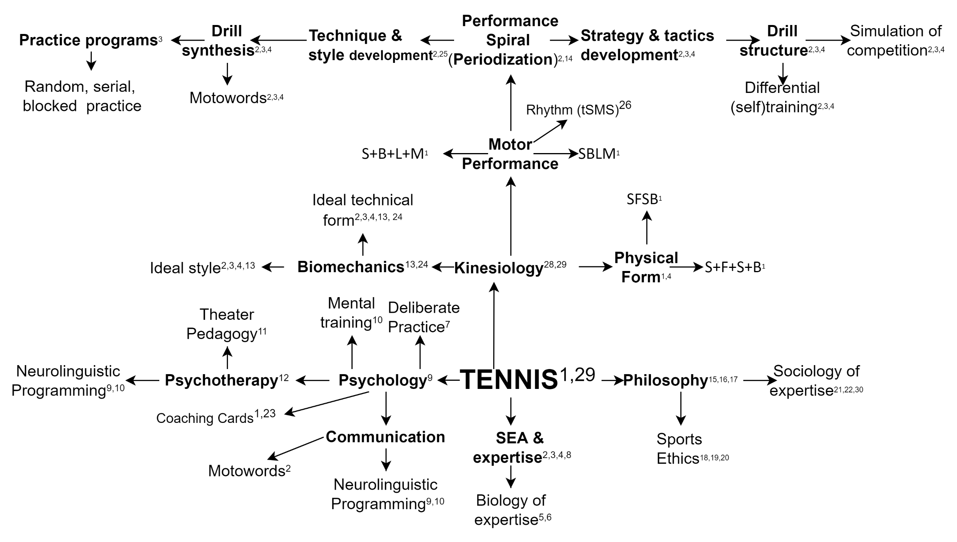

1 Παπαγεωργίου, Κωνσταντίνος Γ. 2017. *Tennis: η Άπω Μέθοδος*. Αθήνα: Κοντύλι.

2. Papageorgiou, Konstantinos G. 2019. “The Distal Method: From Psychomotor Education to Motor Expertise.” *Journal of Physical Education and Sport* 19 (1):633–44. https://doi.org/10.7752.

3 Παπαγεωργίου, Κωνσταντίνος Γ. 2017. *Η Άπω Μέθοδος: Οι Αρχές Της Επιτηδειότητας*. Αθήνα: Κοντύλι.

4 Papageorgiou, Konstantinos G. 2017. *The Distal Method*. Athens: distalmethod.com.

5 Papageorgiou, K. G. (2020). Expert characteristics: implications for expert systems. In P. Vlamos (Ed.), GeNeDis 2020: Computational Biology and Bioinformatics (Series: Advances in Experimental Medicine and Biology) (pp. 155–164). Springer International Publishing. https://doi.org/https://doi.org/10.1007/978-3-030-78775-2_18.

6 Konstantinos G. Papageorgiou, and Konstantinos G. Salonikidis. 2018. “Physiological Changes after One Month of Exclusive Supplement Consumption and Exercise: A Case Study.” *Journal of Sports Science* 6 (3):170–77.

7 Papageorgiou, Konstantinos G. 2014. “Deliberate Practice in Tennis.” *Journal of Medicine and Science in Tennis* 19 (3):113–19.

8 Papageorgiou, Konstantinos G. 2018a. *From Therapy to Learning - From Enhancement to Performance*. Athens: λεξίτυπον.

9 Παπαγεωργίου, Κωνσταντίνος Γ. 2017. *Θεραπεία Ως Προτεραιότητα - Προτεραιότητα Ως Θεραπεία*. Αθήνα: Κοντύλι.

10 Papageorgiou, Konstantinos G. 2018b. *Magical Thinking*. Athens: Lexitypon.

11 Παπαγεωργίου, Κωνσταντίνος Γ., and Σίμος Παπαδόπουλος. 2019. “Η Παιδαγωγική Του Θεάτρου Και η Άπω Μέθοδος Στην Ψυχοκοινωνική Ανάπτυξη.” Εφαρμοσμένη Παιδαγωγική, no. 4.

12 Papageorgiou, Konstantinos G., Dimitris Lekkas, and Maria Koulianou. 2015. “New Ideas and Directions about Musical Material in Music-Therapy (Greek).” In *Focusing on Education and Intervation II*.

13 Papageorgiou, Konstantinos G. 2016a. “An Analysis of the Kinetic Chain Model in Forehand Drive.” *Journal of Medicine and Science in Tennis* 21 (2):22–26.

14 Papageorgiou, Konstantinos G. 2016b. “Performance Spiral Effects on Motor Learning: The Case of Tennis Serve.” *Hellenic Journal of Physical Education and Sport Sciences* 36 (2):100.

15 Papageorgiou, K. G., & Lekkas, D. E. (2021). Epistēmē VS science. Arche, 2021(35), 279–312. https://doi.org/https://doi.org/10.19090/arhe.2021.35.279-312.

16 Papageorgiou, Konstantinos G., and Demetrios Lekkas. 2018. “On the Methodology of the Analytic Method: Historical Account, Epistemological Suggestions, Stages.” *Epistēmēs Metron Logos*, no. 1.

17 Papageorgiou, Konstantinos G. 2019. “The Predicate Fabric of Abstraction: The Hard Test of Logical Inversion.” *Epistēmēs Metron Logos*, no. 2.

18 Papageorgiou, Konstantinos G. 2015. “Talent as an Unintentional Agent.” *ΒΙΟ-ΗΘΙΚΑ* 1 (2):38–54.

19 Papageorgiou, Konstantinos G. 2017a. “The Subtle Colourings of (Informed) Consent in Performance Enhancement: Implications for Expertise.” *Philosophy Study* 7 (4):197–203.

20 Papageorgiou, Konstantinos G. 2017b. “Therapy, Consent and Autonomy in Perspective.” In *20 Years after the Oviedo Convention on Human Rights and Biomedicine*. Thessaloniki, Greece: Thessaloniki Conference. https://www.thessaloniki-conference2017.es/.

21 Παπαγεωργίου, Κωνσταντίνος Γ. 2015. “Ο Πιο Ειδικός Στην Επιστήμη.” *Αίτιον*, no. 1. Αθήνα:128–31.

22 Παπαγεωργίου, Κωνσταντίνος Γ. 2016. “Ένας Ανθρωπολόγος, Άγριοι Επιστήμονες, Ιπτάμενοι Γάιδαροι Και Άλλα Ζώα.” *Αίτιον*, no. 4:131–33.

23 Coaching Cards (2022). Kondyli.

24 Papageorgiou, K. G. (2021). The bridge between abstract biomechanics and tennis strokes. European Journal of Physical Education and Sport, 9(1), 32–41. <https://doi.org/10.13187/ejpe.2021.1.32>

25 Papageorgiou, K. G. (2020). Online coach development and certification programs in sports: are they possible? Central European Journal of Sport Sciences and Medicine, 32(4).

26 Papageorgiou, K. G. (2020). The Tennis SensoriMotor Synchronisation Paradigm. European Journal of Physical Education and Sport, 8(2), 57–67. <https://doi.org/10.13187/ejpe.2020.1.57>

27 Papageorgiou, K. G. (2020). The Distal Method Coach Development for tennis: a new Paradigm in Coach Education. Sport Science, 13(2), 89–101.

28 Salonikidis, K., Mantziou, A., Papageorgiou, K., & Arabatzi, F. (2021). *Palmaris longus* muscle contribution to maximum torque and steadiness in highly skilled grip and non-grip sport populations. Journal of Applied Sports Sciences, 1, 67–69. <https://doi.org/10.37393/JASS.2021.01.6>

29 Salonikidis, K., Papageorgiou, K. G., Meliadis, A., & Arabatzi, F. (2021). Force Steadiness during Submaximal Isometric Plantar and Dorsiflexion in Resistance Training: Experienced vs Non-experienced Individuals. Central European Journal of Sport Sciences and Medicine, 34(2), 5–13. <https://doi.org/10.18276/CEJ.2021.2-01>

30 Papageorgiou, K. G. (2020). Online Coach Development Components: the Tennis Distal Method Coach Development. Pedagogy, 92(7s), 17–28.

*www.distalmethod.com*