USER STUDY
Comparing temporal summaries of user interests
Estimated time: 15 minutes · Three short conditions, identical questions for each.

What this study is about
When people search the web or browse an information system, the topics they care about shift from month to month. Researchers and product teams want compact, readable summaries of that evolution — so they can see stable interests, sudden changes, and emerging themes at a glance. Several different methods can produce such a summary, and they can look quite different from each other even when they describe the same underlying data.x
In this study you will see three such summaries, labelled A, B, and C, all describing the same user-interest data across four months (M1, M2, M3, M4). For each one you will answer the same seven short questions about how clear, useful, and trustworthy it feels. At the end you will be asked which summary you would recommend including in the paper, and why.
You do not need any technical background — we are asking for your impression as a reader, not as a specialist. There are no right or wrong ratings; please answer with your honest first impression.

Before you start
Your responses are anonymous and will be used only for research purposes. You may withdraw at any time. Completing this form constitutes consent to participate.
The study takes about 15 minutes. Please answer all items — there are no right or wrong answers on the rating scales.

Background
Participant ID (assigned by researcher):
Date:
B1. Familiarity with Semantic Web / knowledge graphs
1  none | 2 | 3 | 4 | 5  expert
☐ | ☐ | ☐ | ☐ | ☐x

B2. Familiarity with data visualisation
1  none | 2 | 3 | 4 | 5  expert
☐ | ☐ | ☐ | ☐ | ☐x

B3. Familiarity with query logs / user modelling
1  none | 2 | 3 | 4 | 5  expert
☐ | ☐ | ☐ | ☐ | ☐x

How to read the figures
Conditions A and B both use the same diagram style: an alluvial flow that connects four monthly snapshots (M1, M2, M3, M4).
- Each column is one month. Each block in a column is a cluster of related entities.
- Block height is proportional to the number of entities in that cluster.
- Ribbons between columns track entities that appear in adjacent months. Ribbon width is proportional to the number of entities flowing between two clusters.
- Ribbon colour identifies the source cluster, so a stable concept keeps roughly the same colour across columns.
Condition C is a different format: a written narrative summary of the same monthly evolution.
COMPREHENSION CHECK
C1. In conditions A and B, what does the WIDTH of a ribbon represent?
☐ Time elapsed between months x☐ Number of entities flowing between two clusters ☐ How important the cluster is ☐ Random visual styling
C2. In conditions A and B, what does the HEIGHT of a coloured block represent?
☐ The colour intensity of the cluster x☐ The number of entities in the cluster that month ☐ The age of the cluster ☐ Nothing meaningful
Researcher note: please ROTATE the order of conditions A / B / C across participants using a Latin-square assignment so that each ordering is seen by approximately the same number of people.

CONDITION A

Summary A
Take ~30 seconds to read the figure before answering.
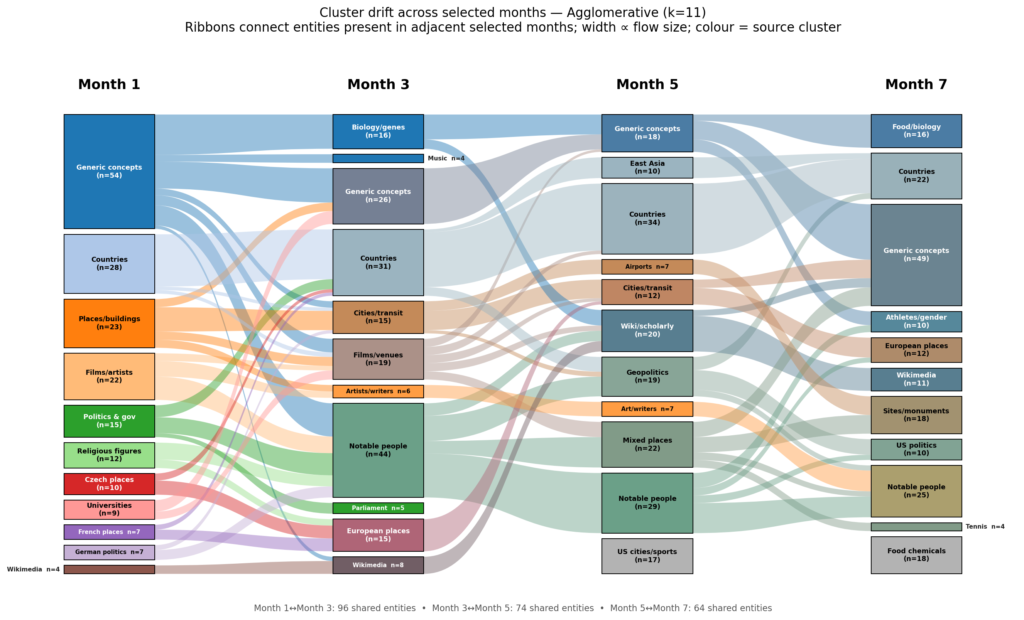
CONDITION A — TASKS
T1. How useful is this summary for understanding how user interests evolve over time?
1  not useful | 2 | 3 | 4 | 5  very useful
☐ | ☐ | ☐ | ☐ | x☐

T2. How easy is it to interpret the temporal evolution shown in this figure?
1  very difficult | 2 | 3 | 4 | 5  very easy
☐ | ☐ | ☐ | ☐ | x☐

T3. Which transition appears MOST STABLE?
x☐ M1 → M2 ☐ M2 → M3 ☐ M3 → M4 ☐ Not clear
T4. Which transition appears to show the STRONGEST semantic change?
☐ M1 → M2 ☐ M2 → M3 x☐ M3 → M4 ☐ Not clear
T5. I would trust this summary for analysing temporal changes in user interests.
1  strongly disagree | 2 | 3 | 4 | 5  strongly agree
☐ | ☐ | ☐ | x☐ | ☐

T6. This figure is visually overloaded.
1  strongly disagree | 2 | 3 | 4 | 5  strongly agree
x☐ | ☐ | ☐ | ☐ | ☐

T7. In one or two sentences, explain what changed most clearly across the months.

CONDITION B

Summary B
Take ~30 seconds to read the figure before answering.
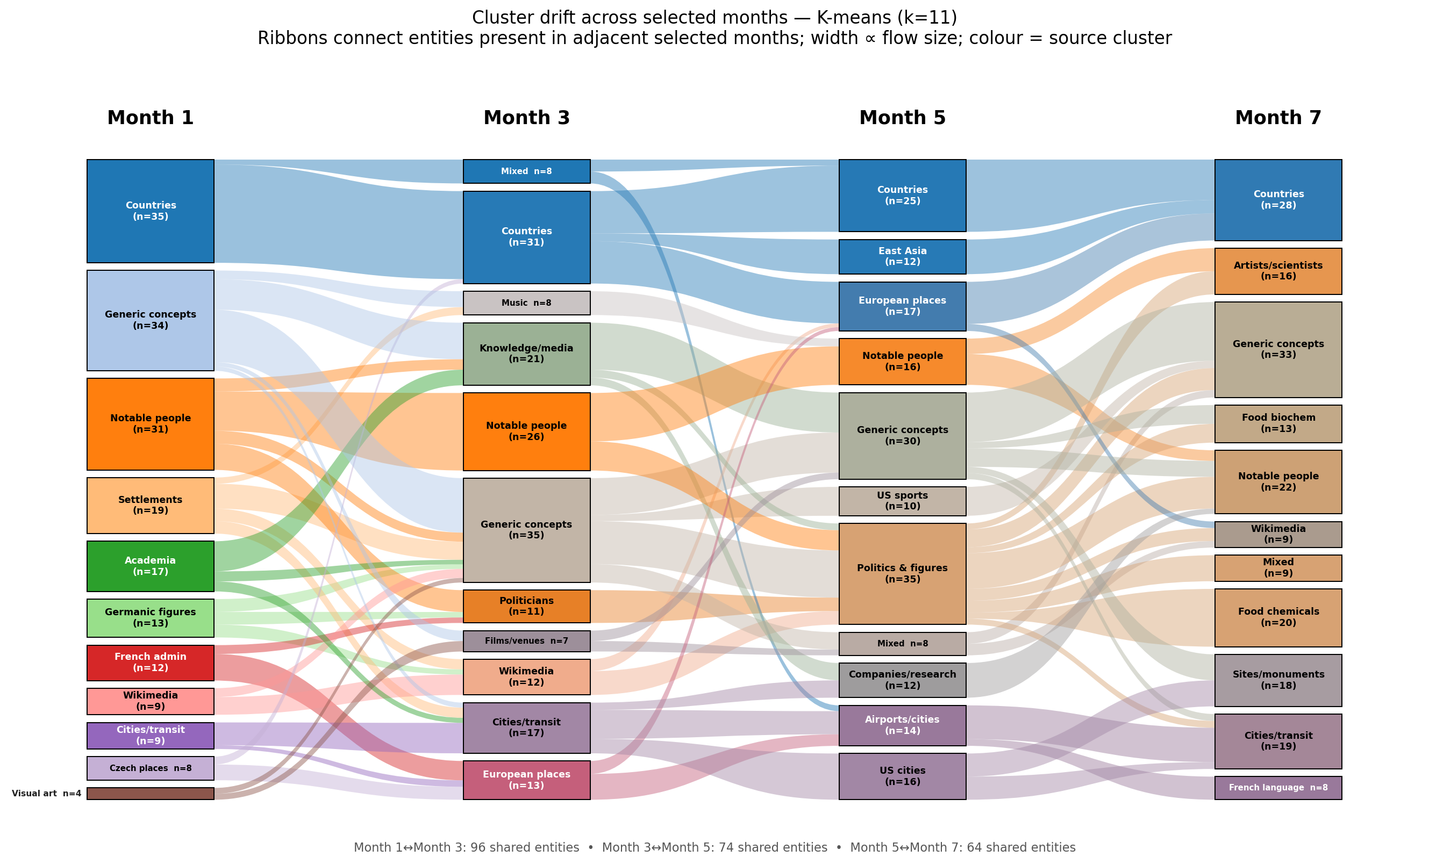
CONDITION B — TASKS
T1. How useful is this summary for understanding how user interests evolve over time?
1  not useful | 2 | 3 | 4 | 5  very useful
☐ | ☐ | ☐ | x☐ | ☐

T2. How easy is it to interpret the temporal evolution shown in this figure?
1  very difficult | 2 | 3 | 4 | 5  very easy
☐ | ☐ | ☐ | x☐ | ☐

T3. Which transition appears MOST STABLE?
x☐ M1 → M2 ☐ M2 → M3 ☐ M3 → M4 ☐ Not clear
T4. Which transition appears to show the STRONGEST semantic change?
☐ M1 → M2 ☐ M2 → M3 x☐ M3 → M4 ☐ Not clear
T5. I would trust this summary for analysing temporal changes in user interests.
1  strongly disagree | 2 | 3 | 4 | 5  strongly agree
☐ | ☐ | ☐ | x☐ | ☐

T6. This figure is visually overloaded.
1  strongly disagree | 2 | 3 | 4 | 5  strongly agree
x☐ | ☐ | ☐ | ☐ | ☐

T7. In one or two sentences, explain what changed most clearly across the months.

CONDITION C

Summary C
Open the following link in your browser, read the summary, then return to this form to answer the questions.
Link: https://giannisergo.pythonanywhere.com/
If the link does not open, please ask the researcher for a screenshot of the summary.
CONDITION C — TASKS
T1. How useful is this summary for understanding how user interests evolve over time?
1  not useful | 2 | 3 | 4 | 5  very useful
☐ | ☐ | x☐ | ☐ | ☐

T2. How easy is it to interpret the temporal evolution shown in this figure?
1  very difficult | 2 | 3 | 4 | 5  very easy
☐ | ☐ | ☐ | x☐ | ☐

T3. Which transition appears MOST STABLE?
☐ M1 → M2 ☐ M2 → M3 ☐ M3 → M4 x☐ Not clear
T4. Which transition appears to show the STRONGEST semantic change?
☐ M1 → M2 ☐ M2 → M3 x☐ M3 → M4 ☐ Not clear
T5. I would trust this summary for analysing temporal changes in user interests.
1  strongly disagree | 2 | 3 | 4 | 5  strongly agree
☐ | ☐ | x☐ | ☐ | ☐

T6. This figure is visually overloaded.
1  strongly disagree | 2 | 3 | 4 | 5  strongly agree
☐ | ☐ | x☐ | ☐ | ☐

T7. In one or two sentences, explain what changed most clearly across the months.

AFTER ALL THREE

Your overall preference
P1. If we had to include only ONE of these three summaries in a research paper, which would you choose?
x☐ Summary A ☐ Summary B ☐ Summary C ☐ No clear preference
P2. Why did you choose that one? (One or two sentences is enough.)
It is more clearly defining the “flow” of the users’ interests.

P3. Anything else you would like to add about the three summaries? (Optional.)
Summary A and B are nicer presented than C

Thank you. Please return this form to the researcher.

