CP372 – Computer Networks
Assignment 2: Reliable Data Transfer over UDP

1. Introduction
The goal of this assignment was to implement two reliable data transfer protocols - Stop-and-Wait and Go-Back-N (GBN) - on top of UDP sockets in Python. Because UDP provides no reliability, we had to add our own mechanisms including sequence numbers, ACKs, timeouts, and retransmissions. We then compared the performance of both protocols under different file sizes and packet loss rates.

UDP
UDP is a connectionless transport protocol that sends data with no guarantees. There is no connection setup, no ACKs, and no retransmission. It has a very small 8-byte header containing source port, destination port, length, and checksum. While this makes it fast and lightweight, it means the application has to handle reliability itself if needed.

Reliable Data Transfer Principles
To make an unreliable channel reliable, four mechanisms are needed:
- Sequence numbers - so the receiver can detect gaps and duplicates
- Acknowledgements (ACKs) - so the sender knows what was received
- Timers - so the sender can retransmit if no ACK comes back in time
- Checksums - to detect corrupted packets

Stop-and-Wait
Stop-and-Wait sends one packet at a time and waits for an ACK before sending the next. If the timer expires, it retransmits. It is simple but slow because the link is idle during the entire round-trip time between sending a packet and getting the ACK back.

Go-Back-N
Go-Back-N allows the sender to have multiple packets in flight at once using a sliding window. The receiver only accepts packets in order and discards anything out of sequence. If a timeout occurs, the sender goes back and retransmits all unacknowledged packets from the window. This is more efficient than Stop-and-Wait but wastes bandwidth when packets are lost since it retransmits packets that may have already arrived.

2. Design

Stop-and-Wait
Packet Format
The Stop-and-Wait header is 11 bytes using struct format '!IIBh':

Field | Size | Description
Sequence Number | 4 bytes | Packet identifier, increments by 1
ACK Number | 4 bytes | Used in ACK packets to confirm receipt
Type | 1 byte | DATA=0, ACK=1, START=2, END=3
Payload Length | 2 bytes | Size of the data payload in bytes
Payload | Variable | Up to 1024 bytes of file data

No checksum field is included in Stop-and-Wait. Four packet types are used: START notifies the receiver a transfer is beginning, DATA carries file chunks, END signals the transfer is complete, and ACK is sent by the receiver to confirm each packet.

Timer Design
The sender uses socket.settimeout(1.0) to set a 1-second timeout. After sending a packet it waits for an ACK. If the timeout fires, it retransmits. A maximum of 20 retries (MAX_RETRIES) is allowed before the transfer is aborted.

ACK Handling
The receiver sends an ACK after every correctly received in-order packet. The ACK carries the sequence number of the packet being acknowledged. The sender checks that the received ACK matches the expected sequence number before moving on.

Window
Window size is 1. The sender tracks a single sequence number and the receiver tracks a single expected_seq. Duplicates are re-ACKed. Out-of-order packets are discarded.

Packet Loss Flowchart (Stop-and-Wait):
Send packet → Start timer
↓
Wait for ACK
↙ ↘
ACK received Timeout / wrong ACK
↓ ↓
Next packet Retransmit (attempts++)
attempts >= 20? → Abort

Go-Back-N
Packet Format
The GBN header is 13 bytes using struct format '!iibHH', extending Stop-and-Wait with a checksum field:

Field | Size | Description
Sequence Number | 4 bytes | Packet identifier
ACK Number | 4 bytes | Cumulative ACK
Type | 1 byte | DATA=0, ACK=1, START=2, END=3
Payload Length | 2 bytes | Size of payload in bytes
Checksum | 2 bytes | 16-bit ones complement checksum
Payload | Variable | Up to 1024 bytes of file data

The checksum is computed over all header fields (with checksum set to 0) plus the payload using a 16-bit ones complement sum. Carry bits are wrapped back in and the result is bitwise inverted. The receiver recomputes the checksum and drops the packet if they do not match.

Timer Design
The GBN sender uses non-blocking sockets and a manual timeout. A timeoutClock timestamp is updated every time an ACK is received. At the end of each processing cycle, if (time.time() - timeoutClock) > 0.25 seconds, the sender declares a timeout and retransmits all in-transit packets. Maximum 30 retries before abort.

ACK Handling
The receiver sends cumulative ACKs for every in-order packet. The sender drains all available ACKs from the socket buffer each cycle using a non-blocking loop and finds the highest ACK received. The window then slides forward to highest_ack + 1.

Window
Window size is 4. The sender tracks base (oldest unACKed packet), nextseqnum, and two lists - packs_in_transit and packs_to_send. Each cycle fills the window with new chunks up to the available space. The receiver window is 1 - out-of-order packets are discarded.

Packet Loss Flowchart (Go-Back-N):
Fill window → Send packets
↓
Drain ACK buffer (non-blocking)
↙ ↘
ACK received No ACK
↓ ↓
Slide window Check timeout clock
Reset clock elapsed > 0.25s?
YES → Retransmit window
NO → Next cycle

3. Experimental Results
Tests were conducted on localhost (127.0.0.1) between sender and receiver processes on the same machine. Each configuration was tested up to 5 times and averaged. Packet loss was simulated in the receiver using Python's random module. File sizes larger than 5M and some high-loss configurations were omitted due to time constraints. Some configurations show missing data (indicated by -) for two reasons: at 0% loss, the Stop-and-Wait receiver startup timing caused some early runs to fail before the receiver was ready; at higher loss rates, Stop-and-Wait's 1-second timeout per dropped packet made larger file sizes impractical to test - a 5M file at 10% loss took over 1300 seconds per run, making full testing within time constraints impossible

Stop-and-Wait Results
Stop-and-Wait Average Transfer Time (seconds)
Loss Rate | 10K | 50K | 100K | 500K | 1M | 5M
0% | 0.0020 | 0.0065 | - | - | - | -
10% | - | 10.02 | 11.53 | 57.98 | 112.80 | 1308.58
20% | 2.21 | 15.25 | 26.68 | 123.32 | 252.39 | -
30% | - | - | - | - | - | -
Note: - Some tests were omitted due to time constraints. All times in seconds, averaged over 5 runs where available.

Go-Back-N Results
Go-Back-N Average Transfer Time (seconds)
Loss Rate | 10K | 50K | 100K | 500K | 1M | 5M
0% | 0.0104 | 0.0451 | 0.0883 | 0.4889 | 1.0236 | 5.2258
10% | 0.5198 | 1.5734 | 3.7038 | 15.8926 | 34.1138 | 174.62
20% | 0.6234 | 3.1133 | 5.364 | 28.9631 | 59.8672 | 289.16
30% | 0.6775 | 4.339 | 8.5555 | 41.5617 | - | -
Note: - Some tests were omitted due to time constraints. All times in seconds, averaged over 5 runs where available.

Graphs
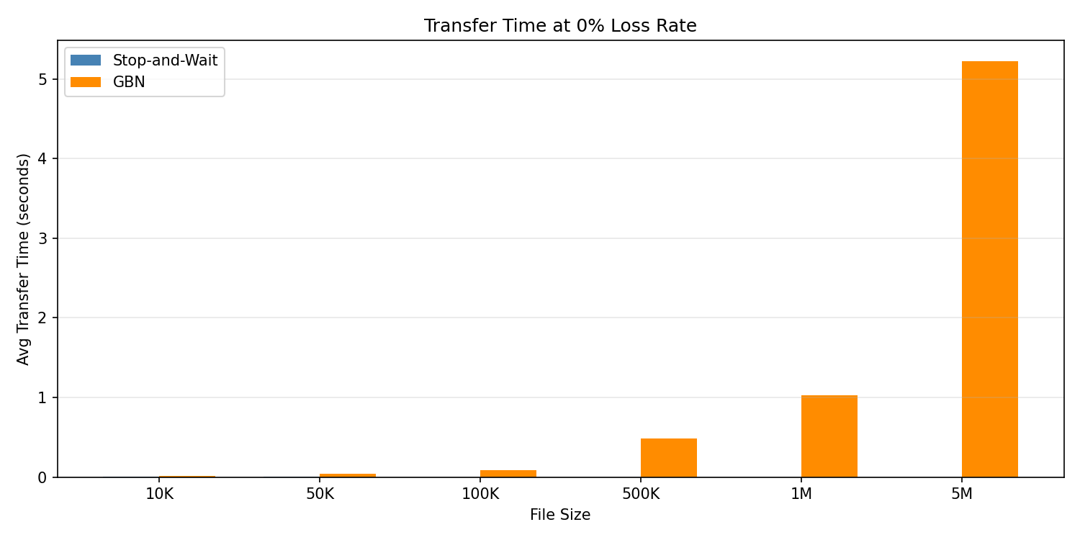
Figure 1: Transfer Time at 0% Loss - Stop-and-Wait vs GBN
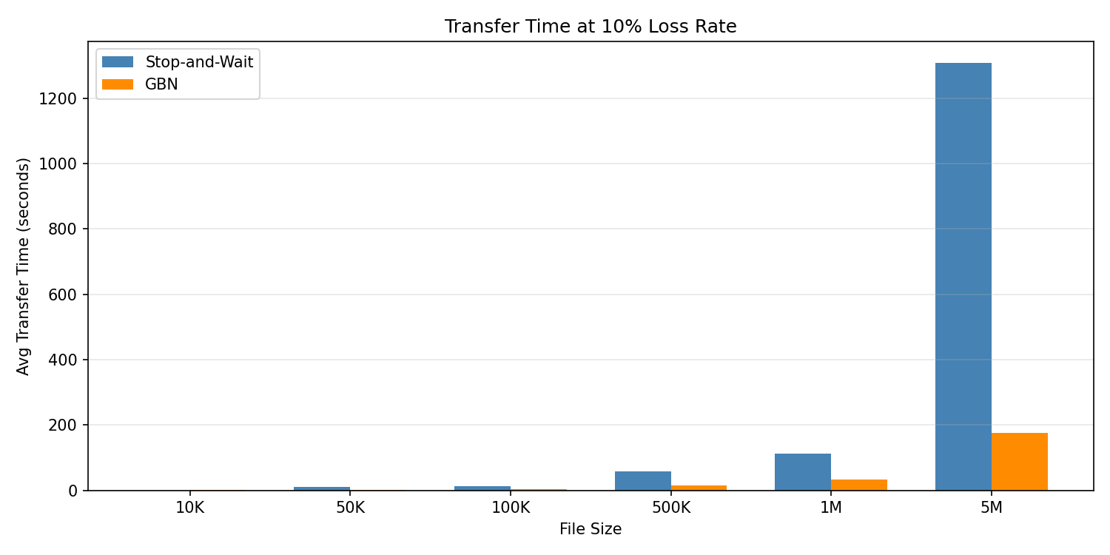
Figure 2: Transfer Time at 10% Loss - Stop-and-Wait vs GBN
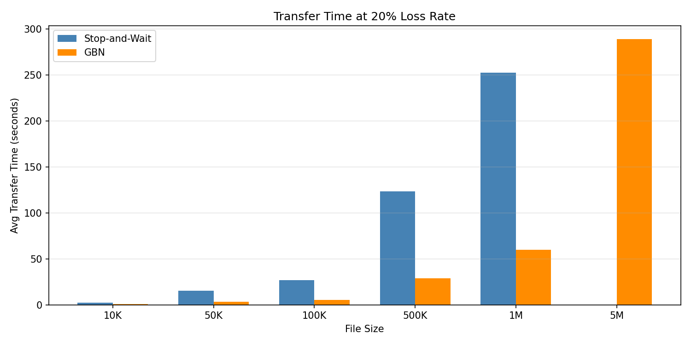
Figure 3: Transfer Time at 20% Loss - Stop-and-Wait vs GBN
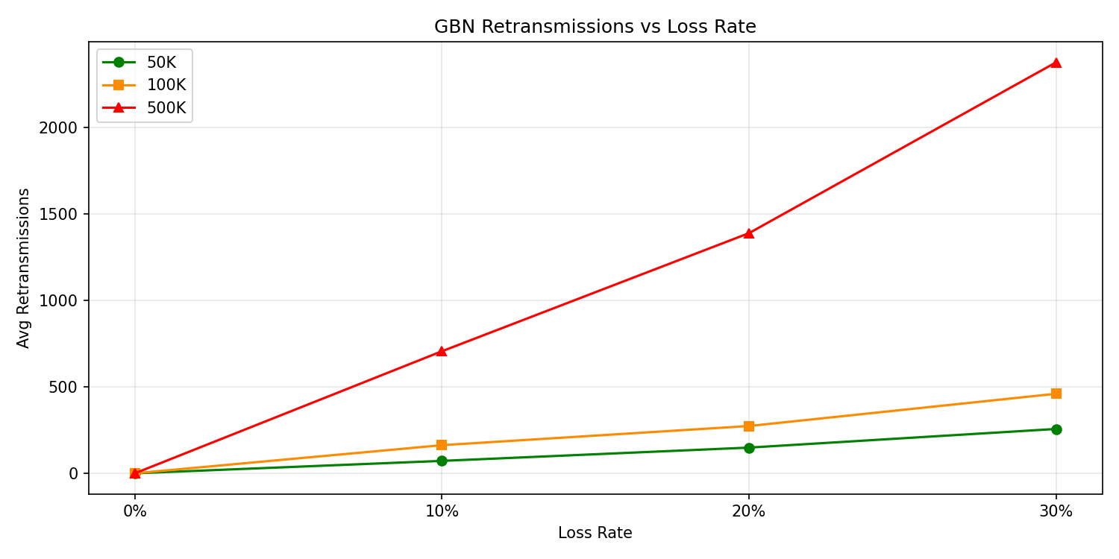
Figure 4: GBN Retransmissions vs Loss Rate by File Size

4. Analysis

Is GBN Always Faster?
Based on our results, GBN is not always faster than Stop-and-Wait. At 0% loss on localhost, Stop-and-Wait was actually faster for all file sizes because there is no meaningful RTT on a local machine, so pipelining provides no benefit. GBN's additional overhead from window management and non-blocking socket processing added latency. On a real network with non-trivial RTT, GBN would be significantly faster due to keeping multiple packets in flight simultaneously.

Impact of Packet Loss
As loss increased, both protocols degraded significantly but in different ways. Stop-and-Wait was severely impacted because each dropped packet causes a full 1-second timeout. At 10% loss, a 1M file took over 112 seconds vs 0.045 seconds at 0% loss. GBN used a shorter 0.25-second timeout but retransmitted the entire window on each timeout event, resulting in very high retransmission counts, 1508 retransmissions for a 1M file at 10% loss.

Trade-offs
Stop-and-Wait is much simpler to implement with no window management or buffering needed. However its throughput is severely limited on lossy networks due to the 1-second timeout per lost packet. GBN adds complexity but recovers from loss faster. The key trade-off is simplicity vs efficiency under loss.

When Stop-and-Wait Is Still Useful
Stop-and-Wait makes sense for very small transfers, embedded systems where memory is limited, or low-latency local networks where pipelining provides no benefit. As our results show, on localhost Stop-and-Wait actually outperformed GBN at 0% loss, suggesting that for near-zero latency environments the simplicity of Stop-and-Wait is preferable.

5. Conclusion
Both protocols successfully transferred files reliably over UDP by implementing sequence numbers, ACKs, timeouts, and retransmissions at the application layer. Contrary to the expected result, Stop-and-Wait outperformed GBN at 0% loss on localhost due to the absence of meaningful RTT. At higher loss rates, GBN recovered faster due to its shorter timeout but generated significantly more retransmissions due to window-based retransmission. Future improvements could include a larger GBN window size, Selective Repeat to avoid retransmitting already-received packets, and adaptive timeout estimation based on measured RTT.

