Facet & Attribute

Creation

Documentation

Creating new Attributes, Facets and Deployment

07.25.2014

Version 2.0.1

# DOCUMENT PURPOSE

This Document is a formal document that captures all of the operational information for the creation of new attributes and facet attributes. The Production team generated this document and its intended audience is those looking for an SOP on creating new attributes and faceted navigation. The purpose of this document is to capture all operations that are required to support the creation of attributes and facets and deploying to Belk.com .

The first half of this document will speak to the Business merchant team. The second half will outline steps for production to support facet and attribute creation.

- VERSION HISTORY -

|  |  |  |  |
| --- | --- | --- | --- |
| DATE | VERSION | REVISION DESCRIPTION | Author |
| 07.02.14 | 2 | Updated format and added Faceted attribute timeline | Giann Wilkerson |
| 07.02.14 | 2.1 | Added in Production process | Nathan Lewis |
|  |  |  |  |
|  |  |  |  |
|  |  |  |  |
|  |  |  |  |
|  |  |  |  |
|  |  |  |  |
|  |  |  |  |

# Creating A New Rule Attribute:

When creating a rule using an attribute that hasn’t been used on the site before, the process is as follows:

* Request attribute addition through data governance leadership (currently Rebecca Nash)
* Create and Apply new attribute to appropriate products in CARS
* Brand new attributes must be closed before it can be sent, DPM will assign a random or “dummy” product to car so that it can be closed and processed.
* Create rule using the new attribute
  + \***NOTE** – In order for the rule to work correctly, the attribute must exactly match the **Blue Martini** value within CARS Attribute Details (circled below). The **Attribute Label** only affects the display label within CARS, and may or may not correspond with the actual attribute name.

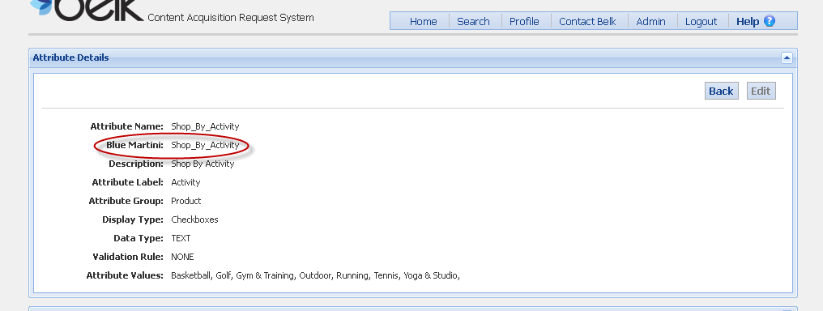

* Send to Producer partner to create folder in Blue Martini using the new rule
* Once in Blue Martini, it is a two day wait before the assortment will populate (one day for Blue Martini to recognize the attribute, then another for Endeca to generate the products).
* Once Blue Martini recognizes the attribute, any rules using the attribute can be tested using the Assortment Preview tool.

# Visual Process for merchant to CARS / DPM

# Creating A New Facet Attribute:

1. Request attribute addition through data governance leadership (currently Rebecca Nash)
2. Merchant requests new attribute to be created by CARS team with attribute category and list of values, and designate that it is intended for faceted navigation (DPM will provide CARS details once they have been completed 72 hours.)
3. Once DPM sends out complete CAR info, notify Production and IT to coordinate mapping in Endeca . This process has a week turn around time.
4. If applying attribute to existing products, these CARS will need to be resync’d and resent to CMP (turnaround time dependent on number of products that need to be resent)
5. Assign testing schedule to test new facet in Primary (Tuesday and Wednesday)
   1. Producer configures new facet for designated categories after Endeca partial extraction completes, to eliminate risk of deploying to live site
   2. Merchant testing between hours of 11-4 to ensure facets and assortments are behaving as expected
   3. After testing is complete, producer removes facet before nightly index
6. GOMEZ testing (subject to change)
7. Producer configures facet to go live with next index

Steps for Creating New Attribute

1. Log into CARS
2. Go to Admin, then Attribute Management
3. Click New Attribute
4. Edit Attribute values
   1. Attribute name must be completely unique
   2. Requirements for Blue Martini name-
      1. Must be under 26 characters
      2. No spaces – use underscores instead (ie. “***New_Attribute_Name***”)
   3. Attribute Group
      1. Select Facet if attribute is for a faceted nav attribute
      2. Select Category Left Nav if is for a category assortment rule
   4. Display Type
      1. Auto Complete Drop Down
      2. Check Boxes
      3. Drop Down
      4. HTML Text Area
      5. Radio Buttons
      6. Text Field
   5. Add Attribute Values, if applicable
   6. Associate to Departments or Product Types as necessary
5. Click Save

# Production process for new Attributes

1. Once new CAR information is sent to the merchant team from the CARS/DPM team merchant will create a simple rule using the new attribute.
2. After merchant has provided sample rule to production, Producer is then to navigate in Blue martini to **Assortment manager > Featured > Sales_Promotions > Trend_test** and create a folder for the new rule here.
3. Producer is to provide merchant with new custom built rule for testing within 48 hours. Link should appear as below with your folder name in the correct place.

EXAMPLE: www.belk.com/AST/Featured/Sales_Promotions/trend_test/YOUR_FOLDER_NAME.jsp

# Creating A New Facet Complete Attribute Timeline:

|  |  |
| --- | --- |
| Facet Attribute Creation –Deployment to Belk.com | |
| Week 1 | *New Attribute is created in the CARS System + Associated to departments |
| Week 2 | Attribute is included in Monday report to IT to be Mapped for a complete pipeline |
| Week 3 | *Facet is created and is available for merchant testing and possible CAR clean up. |
| Week 4 | Facet is turned on in Gomez for Performance Monitoring |
| Week 5 | Facet is Deployed to belk.com pending performance. |

* If Facets data is clean, and no additional CAR clean up is needed, Facets can be added to Monday report immediately and be put in Gomez for performance monitoring
* CAR cannot be closed out and completed if there are no products assigned. CAR team must assign “dummy” content.

# 

# HELPFUL URLS

| Descpription | URL |
| --- | --- |
| **CARS System** | [**https://cars.belk.com**](http://docs.gigaspaces.com/xap97/) |
|  |  |
|  |  |
|  |  |
|  |  |

# OTHER NOTES

Complete this later when we define this further.

# GLOSSARY

|  |  |
| --- | --- |
| **Term** | **Definition** |
| CARS |  |
| Attributes |  |
| Values |  |
| Endeca Pipeline Mapping |  |
| Gomez Performance Monitor |  |
| DPM |  |
|  |  |
|  |  |
|  |  |
|  |  |