Pictures and tabs
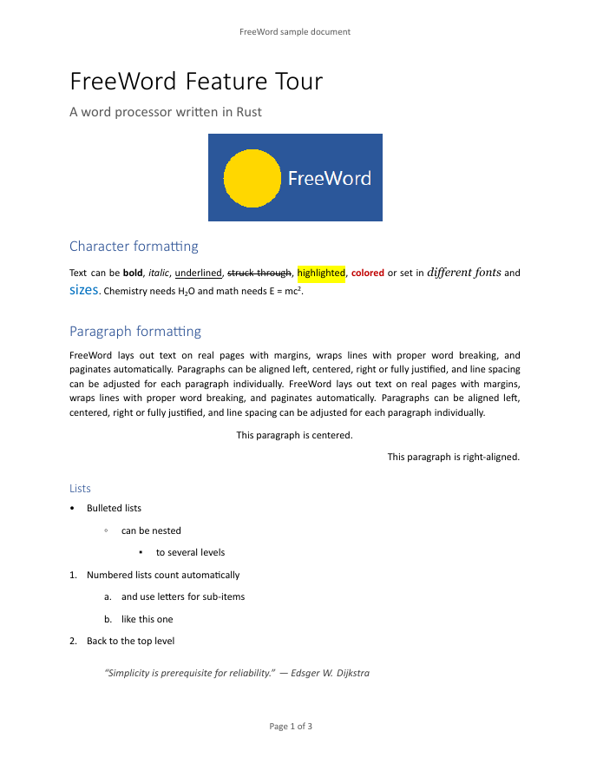
Left Centered Right
Text with a comment.
Tracked insertion.
Final paragraph.

