Abstract
Digital twins of natural ecosystems are an emerging paradigm for environmental monitoring and management, yet their application to coastal wetlands of the southeastern Pacific remains scarcely documented. This study presents a digital twin of the Los Manglares de Tumbes National Sanctuary (SNLMT), in northern Peru, applying the CRISP-DM methodology to model and explain the variation in retained carbon under hydrological restoration and sea-level rise scenarios through 2050.
The dataset is hybrid in nature: the covariates and calibration come from published real data on the SNLMT —extent and cover by class, Normalized Difference Vegetation Index (NDVI) ranges, Importance Value Index (IVI) by species and blue carbon content— while the target variable is generated by a deterministic, parameterisable, replicable engine that can be replaced by field measurements. The explicit separation between both portions responds to the transparency requirement that the ecological digital twin literature consistently formulates.
Five supervised learning algorithms were evaluated through ten-fold cross-validation, statistical significance testing (paired t and Wilcoxon), bootstrap resampling confidence intervals, and interpretability via permutation importance. The Extra Trees ensemble achieved the best performance (R² = 1.000; MAE = 0.014 percentage points), significantly outperforming the linear baseline (t = 25.91; p < 0.001). Hydrological restoration produced increases above the +25 % threshold in 34.85 % of scenarios in the high-intervention band, with a mean gain of 11.24 %, while the intermediate bands produced the transition from net loss to net gain.
The results are materialised in an interactive dashboard and exportable reports that document each analytical phase, with version control traceability over 39 code commits.
Keywords: digital twin; coastal wetland; blue carbon; CRISP-DM; hydrological restoration

Introduction
Digital twins emerged in the engineering domain as virtual representations of a physical asset, continuously updated to reflect its current structure and behaviour [1]. Their canonical definition describes them as a virtual representation of a physical asset enabled by data and simulators for prediction, optimisation and real-time monitoring [1], or as a dynamic representation of a real object that mirrors its states and behaviour throughout its life cycle [2]. The distinction between a conventional model and a digital twin is not trivial: it lies in the bidirectional coupling between the physical system and its virtual counterpart, which confers on the latter the capacity for permanent updating [3].
The application of this paradigm to natural systems is a recent and far-reaching turn. Blair (2021) argues that digital twins of the natural environment represent a singular opportunity, but warns that their construction demands combining the inherited understanding of process-based models with new data-analysis and machine-learning approaches [4]. Ecology has begun to adopt the concept as a form of dynamic fusion between models and data, although inherent limitations persist that should be made explicit so as not to generate exaggerated expectations among modellers, researchers and policy-makers [5].
In the realm of aquatic and coastal ecosystems, interest is growing. The Digital Twin Earth initiative has developed emulators based on physics-informed neural operators to predict sea levels in coastal regions, achieving speed-ups of over forty times relative to deterministic numerical models [6]. Tzachor et al. (2023) argue that digital twins may constitute a stepping stone towards ocean sustainability, while warning of the ethical risks and uncertainties associated with the digital representation of marine ecosystem services [7]. Aguzzi et al. (2025) demonstrate that robotic platforms can generate high-resolution data for marine monitoring, but note that challenges remain in achieving adequate spatial coverage, temporal continuity and ecological representativeness [8].
Wetlands, and in particular mangrove ecosystems, are an especially pertinent case of application. Lu et al. (2026) explore the concept of wetland digital twins and point out that the state of the ecosystem and its dynamics under future scenarios are essential for stakeholders to carry out proactive management that conserves ecosystems and supports their restoration [9]. Hydrological restoration of coastal wetlands, specifically, has received renewed impetus from blue carbon: Twomey et al. (2024) warn that ecosystem functions and processes influenced by the hydrological regime determine services such as habitat, water quality, carbon capture and coastal protection, but that guidance for hydrological restoration remains limited and is frequently restricted to particular regions or risks [10]. Existing models also face a transferability limitation: their predictive capacities are confined to the specific conditions of the data from which they were built [10].
Remote sensing and machine learning have substantially expanded the monitoring capacity of these ecosystems. Guo et al. (2017) review research topics in wetland remote sensing —classification, biodiversity, biomass estimation, water quality, mangrove forest and sea-level rise— and document the progress of available techniques [11]. Jafarzadeh et al. (2022), in a meta-analysis of three decades, synthesise best practices for environmental management, restoration and conservation of wetlands based on the combination of remote sensing and machine learning [12]. Systematic biases and gaps persist, however: Meyer et al. (2016) demonstrate that the widespread application of species occurrence information is limited by gaps, uncertainties and biases in the taxonomic, spatial and temporal dimensions [13], and Mollenhauer et al. (2018) show that the geographical representativeness of long-term environmental monitoring infrastructures constitutes a critical gap in the European research landscape [14].
The uncertainty associated with these projections deserves explicit attention. Buffington et al. (2021) incorporate uncertainty into projections of tidal wetland elevation and carbon accumulation under sea-level rise scenarios, demonstrating that both salinity scenarios and productivity functions are determinant for projecting how carbon capture may change [15]. This finding is directly relevant to any system that aspires to inform restoration decisions.
On the basis of these antecedents, the present work addresses three concrete gaps. First, documented ecological digital twins concentrate on marine, urban or agricultural ecosystems, with scarce attention to the mangrove coastal wetlands of the southeastern Pacific. Second, the literature on hydrological restoration of coastal wetlands explicitly recognises the absence of transferable guidance and the dependence of projections on local calibration conditions [10]. Third, existing implementations rarely make explicit the separation between the empirical and the simulated portions of their data, which makes it difficult to audit the basis of their results.
To address them, a digital twin of the Los Manglares de Tumbes National Sanctuary (SNLMT), in northern Peru, was built, and the CRISP-DM methodology was applied to structure the analytical process into six traceable phases: business understanding, data understanding, preparation, modelling, evaluation and deployment [16]. The working hypothesis postulates that hydrological restoration can increase blue carbon retention by at least 25 % by 2050 relative to the baseline.
The contribution of the work is threefold. First, a hybrid dataset with explicit traceability of its real and simulated components is documented, anchored in open literature on the SNLMT. Second, five algorithms are compared under an evaluation protocol combining cross-validation, statistical significance testing and bootstrap resampling, following the established practice for rigorous model comparison [5]. Third, an interactive dashboard is delivered that exposes interpretability as a first-class capability, heeding the recommendation to centre the development of environmental digital twins on outcomes meaningful to users rather than on isolated technical capabilities [17].
Development was sustained on a distributed version control repository that accumulated 39 commits between 31 August and 29 September 2026. This versioning discipline is not an instrumental detail: every quality review finding, every correction and every feature addition was recorded with a descriptive message that allows the evolution of the system to be reconstructed and the origin of any design decision to be audited. Issue planning on a tracking platform was projected as a complement, although its full implementation exceeded the time scope of the deliverable.

Analysis of the problem

From model to digital twin
The conceptual distinction between a model and a digital twin is foundational to this work. Wright and Davidson (2020) argue that the difference lies not in the sophistication of the underlying model but in the coupling: while a conventional model represents a system in a static or unidirectional manner, a digital twin maintains a bidirectional link with its physical counterpart, continuously updating itself from observed data [3].
Rasheed et al. (2020), after reviewing the literature, propose an operative definition: a digital twin is a virtual representation of a physical asset enabled by data and simulators for prediction, optimisation and real-time monitoring [1]. Verdouw et al. (2021) emphasise the temporal dimension by describing it as a dynamic representation of a real object that mirrors its states and behaviour throughout its life cycle [2]. Both formulations converge on three constitutive elements: a physical counterpart, a computational model and a data flow that keeps them synchronised.
Durão et al. (2018) systematise the requirements that the literature imposes on the concept, establishing that its industrial adoption depends on the capacity to represent not only the geometry and structure of the asset, but also its operative behaviour under changing conditions [18]. This requirement translates directly to the environmental domain: a digital twin of an ecosystem must represent its dynamics, not merely its state.

Architectures and implementation frameworks
Building digital twins at ecosystem scale requires architectures capable of integrating heterogeneous sources. Nativi et al. (2021) describe the digital ecosystem developed within the Destination Earth initiative, and argue that a comprehensive discussion of the multiple dimensions and challenges of digital ecosystems fills an important gap in current knowledge [19].
In the technical implementation domain, Picone et al. (2023) propose a flexible and modular architecture for edge digital twins, oriented towards reducing latency through local data processing [20]. Raes et al. (2022) present the DUET framework, aimed at building interoperable and trustworthy digital twins for smart cities, addressing the need for systems developed by different actors to exchange information [21]. Interoperability, they note, is a condition for avoiding fragmentation into data silos.
Chen et al. (2025) address the problem of federated digital twin construction via distributed sensing, proposing an online optimisation scheme based on game theory. They warn, however, that the number of sensors associated with each entity is limited and that the accumulated cost is constrained by that restriction [22]. This observation is relevant to any environmental deployment, where instrumentation resources are inherently bounded.
At ecosystem scale, Khan et al. (2025) propose TwinEco, a unified framework for dynamic data-driven digital twins in ecology, with design principles applicable to urban, agricultural and natural ecosystems [23]. Qamsane et al. (2021) contribute a structured methodology for developing and implementing digital twin solutions, with explicit phases of scope definition, modelling and validation [16]. This methodological structure parallels the CRISP-DM approach adopted in the present work.

Modelling, emulation and informed physics
The tension between physical fidelity and computational cost defines much of the research in this field. Jiang et al. (2021) developed the first digital twin of the Earth's coasts, employing physics-informed neural operators as surrogates for deterministic coastal flood models. Their emulator predicts sea surface height accurately and achieves speed-ups of up to forty-five times relative to the reference numerical model, enabling the efficient execution of multiple scenarios for decision-making and uncertainty quantification [6].
Yang et al. (2024) examine physics-informed neural networks from the digital twin perspective, and note that many approaches restrict their scope to the use of sparse guide data —between one and ten percent of the mesh points—, which constitutes an inefficient exploitation of available simulation results [24]. Zia et al. (2025) propose the incorporation of physics-encoded blocks into residual network architectures, and warn that operational datasets commonly present missing values originating from power cuts, sensor failures or adverse weather conditions [25]. Dilip (2024) applies the same principle to asphalt pavements, building a thermal digital twin via physics-informed neural networks [26].
Reichstein et al. (2019) frame this convergence in a broader context: deep learning and process understanding must be integrated for the advancement of data-driven Earth system science, overcoming the opposition between purely statistical and purely mechanistic approaches [27].

Data, sensors and uncertainty
The quality of a digital twin is bounded by the quality of its data. Guo et al. (2017) review wetland remote sensing and document that aerial photography offers advantages in spatial resolution and acquisition time, although its use is usually restricted to narrow coastal areas or riverbanks due to limited coverage [11]. Jafarzadeh et al. (2022), through a meta-analysis of three decades, synthesise established practices for wetland monitoring and highlight that the findings are essential for determining best practices in environmental management, restoration and conservation [12].
Biases in ecological data constitute a structural limitation. Meyer et al. (2015) establish global priorities for an effective information basis of biodiversity distributions [28], and Meyer et al. (2016) demonstrate that the widespread application of occurrence information is limited by gaps, uncertainties and biases in the taxonomic, spatial and temporal dimensions [13]. Mollenhauer et al. (2018) evaluate the geographical representativeness of long-term environmental monitoring infrastructures in Europe and conclude that a critical gap persists in the research infrastructure landscape [14]. Jeffery et al. (2021) extend the warning to the plane of data infrastructures, arguing that convergence between repositories and systems is not yet resolved [29].
Uncertainty must therefore be propagated explicitly. Buffington et al. (2021) incorporate uncertainty into projections of tidal wetland elevation and carbon accumulation under sea-level rise scenarios, and demonstrate that both salinity scenarios and productivity functions are determinant in projecting how carbon capture may change [15]. Cabrera et al. (2021), when evaluating the potential of smartphones as urban weather stations, warn that their results represent the behaviour of a single device model, which illustrates the need to bound the scope of conclusions to the effectively observed domain [30].

Environmental applications and governance
The recent literature insists that the value of an environmental digital twin is decided by its usefulness for decision-making, not by its technical sophistication. Durden (2025) identifies four main challenges that condition the generation of products meaningful to user needs and argues that the development of use cases must focus explicitly on those outcomes [17]. The author further notes that, although decision-makers are the most evident users, the incorporation of other stakeholders broadens the capacity for collaborative decision-making and communication [17].
The quality of the data available for these systems depends in part on non-professional sources. Brown and Williams (2019) argue that hypothesis testing in the confirmatory paradigm is entirely possible with large-scale internet-based citizen science projects, provided they are specifically designed for that purpose, although they note that such projects are scarce [31]. This observation broadens the universe of data potentially integrable into an ecological digital twin, while warning of the requirement for deliberate methodological design for such observations to be usable.
De Koning et al. (2023) warn that the adoption of the concept in ecology must be accompanied by a frank discussion of its inherent limitations, to avoid expectations that may mislead modellers, researchers, policy-makers and natural resource managers [5]. Tzachor et al. (2023) extend that warning to the oceanic domain, anticipating ethical concerns and uncertainties in the digital representation of marine ecosystem services [7].
In the governance domain, Haraguchi et al. (2024) examine both the benefits and limitations of urban digital twins, exploring the specific areas where their impact is effective and those where it is bounded [32]. Hananto and Veza (2025) propose a governance framework for intelligent digital twin systems oriented towards aligning standards and practices [33], while DeVries (2024) addresses the privacy and data sovereignty challenges that emerge from integrating these technologies into urban ecosystems [34]. Garske et al. (2024) analyse the role of European data governance in the sustainable transition [35].
Specific applications illustrate the range of the paradigm. Henriksen et al. (2023) develop a digital twin for climate change adaptation, water management and disaster risk reduction, noting that the depth of the water table is the determining variable of carbon emissions in peat soils, and that knowledge of hydrological variability is decisive for guiding the restoration of drained peatlands [36]. Rodríguez-Alonso et al. (2024) present a digital twin platform for water treatment plants based on a microservices architecture, oriented towards optimising operation and maintenance through machine learning and simulation [37]. Alenezi and Alabaiadly (2026) review the application of digital twins and edge computing to small off-grid water systems [38]. Verdouw et al. (2021) document their adoption in smart farming, noting that studies in that domain are relatively scarce compared with other sectors [2].

Coastal wetlands and blue carbon
Coastal wetlands constitute a case of application with its own characteristics. Twomey et al. (2024) argue that restoration oriented towards blue carbon provides renewed impetus to the recovery of hydrologically modified coastal plains, but warn that guidance for hydrological restoration remains limited and is frequently focused on particular regions, activities or risks [10]. They further stress that ecosystem functions and processes influenced by the hydrological regime determine services such as habitat provision, water quality improvement, carbon capture and coastal protection [10].
The transferability of models is an explicitly recognised limitation. Twomey et al. (2024) note that models may not be transferable to other sites and that their predictive capacity is restricted to the specific conditions of the data used in their construction [10]. In relation to sea-level rise, they identify that uncertainty in elevation data and in soil surface changes over time are key limitations for many models, despite being determining parameters for projecting impacts on restoration sites [10].
Lu et al. (2026) explore specifically the concept of wetland digital twins for ecosystem monitoring and management, noting that the state and dynamics of the ecosystem under future scenarios are essential for stakeholders to carry out proactive management oriented towards conserving the ecosystem and supporting its restoration [9]. They also observe that wetlands have suffered significant losses and degradation at a global scale over the last centuries due to human disturbances and climate change [9].

The CRISP-DM methodology
CRISP-DM —Cross-Industry Standard Process for Data Mining— organises an analytical project into six iterative phases: business understanding, data understanding, preparation, modelling, evaluation and deployment. Unlike approaches centred exclusively on the algorithm, the standard demands that every analytical artefact be traceable to an explicit business objective and that evaluation contemplate success criteria defined beforehand.
The methodology parallels the structured frameworks proposed for digital twin development. Qamsane et al. (2021) establish explicit phases of scope definition, modelling and validation in their implementation methodology [16], and Durden (2025) insists that use-case development must start from user needs and not from available technical capabilities [17]. The present work adopts the CRISP-DM framework and documents each phase with its verifiable products.

Material and Methods

Study area and data sources
The study was conducted on the Los Manglares de Tumbes National Sanctuary (SNLMT), located in the district of Zarumilla, department of Tumbes, Peru. The Sanctuary encompasses 2 972 ha, of which 1 779.8 ha correspond to mangrove cover (68.06 %), 243 ha to dry forest, and the remainder to water bodies and saline areas.
Table 1 consolidates the seven cover classes identified with their NDVI ranges derived from Sentinel-2 imagery and their estimated extent.
Cover classes of the SNLMT, NDVI range and extent. Source: own elaboration from Dioses-Puelles et al. (2023).
clase_cobertura | ndvi_min | ndvi_max | ndvi_medio | area_ha | es_manglar
cuerpos_agua | -0.471 | 0.003 | -0.234 | 497.22 | False
salitrosas_banco_arena | 0.003 | 0.27 | 0.1365 | 452.34 | False
bosque_seco_semidenso | 0.27 | 0.371 | 0.3205 | 121.5 | False
bosque_seco_denso | 0.371 | 0.487 | 0.429 | 121.5 | False
manglar_franja_baja | 0.487 | 0.728 | 0.6075 | 598.9 | True
manglar_franja_media | 0.728 | 0.808 | 0.768 | 1052.22 | True
manglar_franja_alta | 0.808 | 0.888 | 0.848 | 128.68 | True
The structure of the plant community is characterised by the Importance Value Index (IVI), which integrates relative density, frequency and dominance. Table 2 presents the five mangrove species recorded and their observed IVI.
Mangrove species of the SNLMT and Importance Value Index (IVI). Source: Dioses-Puelles et al. (2023).
especie | ivi_pct | data_source | fuente
Rhizophora mangle | 86.92 | real | Dioses-Puelles et al. (2023), Manglar 20(2)
Avicennia germinans | 36.65 | real | Dioses-Puelles et al. (2023), Manglar 20(2)
Rhizophora harrisonii | 13.03 | real | Dioses-Puelles et al. (2023), Manglar 20(2)
Laguncularia racemosa | 8.4 | real | Dioses-Puelles et al. (2023), Manglar 20(2)
Conocarpus erectus | 3.2 | real | Dioses-Puelles et al. (2023), Manglar 20(2)
The multitemporal dynamics of mangrove extent were documented from the Global Mangrove Watch version 3.0 series, which provides eleven epochs between 1996 and 2020 at 25 m resolution under a CC BY 4.0 licence [12]. Figure 1 presents the observed evolution for northwestern Peru.
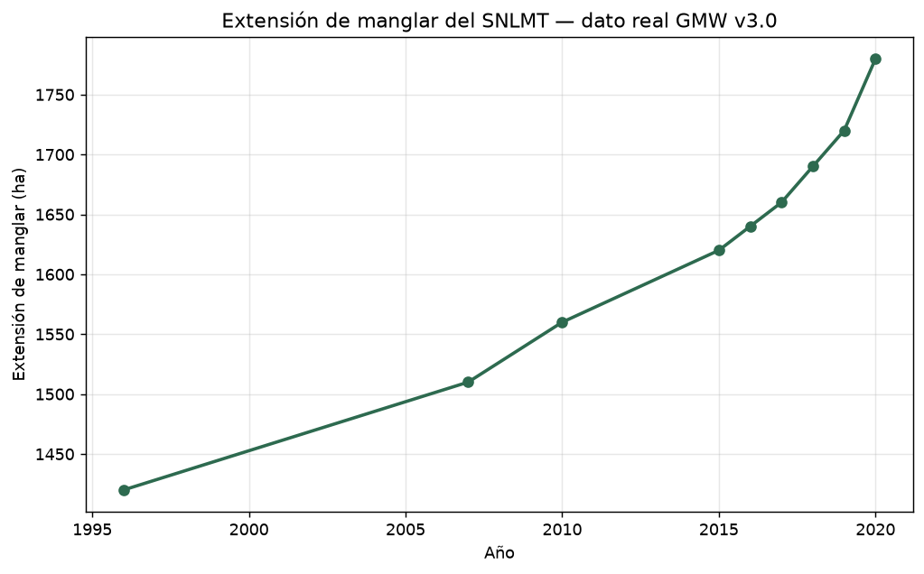
Evolution of mangrove extent of the SNLMT between 1996 and 2020. Real data from Global Mangrove Watch v3.0. The sustained positive trend is consistent with the protected natural area status of the Sanctuary.

Design of the hybrid dataset
The dataset employed is hybrid in nature and explicit in its traceability. The covariates are real: the ranges of hydrological restoration, wetland area, carbon density and NDVI are anchored in the observed and published values for the SNLMT. The target variable is simulated: the percentage variation of retained carbon by 2050 is generated by the digital twin's deterministic engine, whose parameters are calibratable and replaceable by field measurements.
The explicit separation between the real and simulated components responds to a methodological criterion: it allows auditing which part of the result rests on empirical evidence and which part on the physical model's projection. The engine implements a saturating response curve to restoration —consistent with the law of diminishing returns observed in restored wetlands [10]— and a progressive loss of area and density associated with three sea-level rise scenarios aligned with IPCC ranges [15].
Two thousand records were generated with a fixed seed to guarantee reproducibility. Half of the observations were concentrated at the extremes of the restoration range —below 12 % and above 88 %— given that tree ensembles exhibit bias at the edges of variable domains [24].

The CRISP-DM protocol
The system implements the six phases of the standard as independent, verifiable modules.

Phase 1. Business understanding
An explicit business objective and analytical objective were defined, together with verifiable success criteria established a priori: out-of-sample coefficient of determination greater than or equal to 0.85; mean absolute error less than or equal to 3 percentage points; statistically significant difference from the reference linear model; and stability across partitions with a standard deviation of R² not exceeding 0.05.

Phase 2. Data understanding
Exploratory analysis comprised descriptive statistics, quality diagnostics —missing values, duplicates and cardinality— and Pearson correlation analysis. Table 3 summarises the behaviour of each variable in the dataset.
Descriptive statistics of the variables of the hybrid dataset (n = 2 000). The near-zero skewness in the restoration and horizon variables confirms the absence of systematic bias in the sampling.
variable | n | media | mediana | desv_std | min | p25 | p75 | max | asimetria | nulos
restoration_level | 2000 | 49.2396 | 47.9066 | 37.1158 | 0.0038 | 9.8278 | 89.9648 | 99.9715 | 0.038 | 0
horizon_year | 2000 | 2064.418 | 2064.0 | 20.6764 | 2030.0 | 2046.0 | 2082.0 | 2100.0 | 0.0128 | 0
baseline_area_ha | 2000 | 175.7092 | 174.0028 | 72.6122 | 50.1297 | 111.0177 | 240.3032 | 299.8555 | 0.0068 | 0
baseline_carbon_density | 2000 | 84.5256 | 84.6532 | 20.2896 | 50.045 | 67.2077 | 102.1958 | 119.9836 | 0.0334 | 0
ndvi | 2000 | 0.768 | 0.768 | 0.0229 | 0.7281 | 0.7478 | 0.788 | 0.808 | 0.0091 | 0
month | 2000 | 6.3725 | 6.0 | 3.4473 | 1.0 | 3.0 | 9.0 | 12.0 | 0.0232 | 0
horizon_variation_pct | 2000 | -2.1447 | -6.16 | 19.4468 | -37.57 | -15.5975 | 12.405 | 30.28 | 0.0966 | 0
horizon_carbon_tC | 2000 | 14525.5123 | 13311.01 | 7798.1628 | 2454.67 | 8390.09 | 19014.4875 | 45683.53 | 0.8385 | 0
meets_hypothesis | 2000 | 0.148 | 0.0 | 0.3552 | 0.0 | 0.0 | 0.0 | 1.0 | 1.984 | 0
Figure 2 presents the distribution of the main variables. The concentration of observations at the extremes of the restoration range responds to the experimental design described; the NDVI shows reduced dispersion due to its restriction to the observed range of the mid-band mangrove.
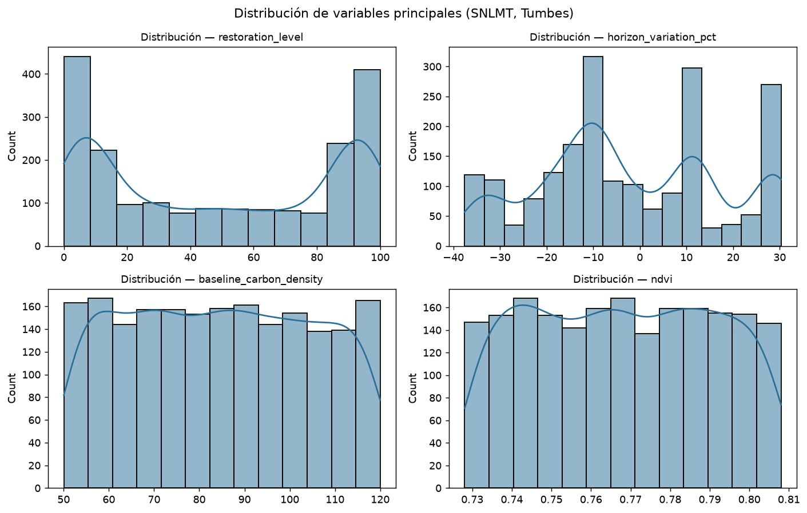
Distribution of the main variables of the hybrid dataset. The maxima at the extremes of the restoration range are intentional and prevent bias of tree ensembles at the edges of the domain.

Phase 3. Data preparation
The feature matrix was built with ordinal encoding of the sea-level rise scenario and the target variable was separated. Standardised scaling was applied within each modelling pipeline, so that normalisation parameters are estimated exclusively on each training partition and do not contaminate the evaluation. This design prevents information leakage, a frequent error when scaling is executed on the complete set before partitioning.

Phase 4. Modelling
Five algorithms representative of three families were compared: a linear model as reference [23], a regularised variant and three tree ensembles [1], [16], [24]. All were implemented as scikit-learn pipelines [3], guaranteeing identical preprocessing and strict comparability.

Phase 5. Evaluation
The evaluation combined four complementary instruments. First, cross-validation with ten folds, employing the mean R² across folds as the principal selection criterion for being more robust than a single test partition. Second, statistical significance tests —paired Student's t and Wilcoxon signed-rank on the per-fold scores— to contrast the best model against the remaining ones [5], [17]. Third, confidence intervals of the mean absolute error via bootstrap resampling with 500 replicates [22]. Fourth, assumption checking via the Shapiro-Wilk test on the residuals [39], which guides the choice between parametric and non-parametric tests.
Interpretability was addressed through permutation importance, a model-agnostic technique that quantifies the drop in R² when each variable is randomly shuffled, with ten repetitions to estimate its variability [1], [40]. This choice allows auditing the model without depending on assumptions about its internal structure.

Phase 6. Deployment
The deployment phase materialised in two products. The first is an interactive dashboard developed in Streamlit that exposes the six phases, allows recalculating the pipeline with different hyperparameters, and presents each figure and table with its interpretation. The second is a set of exportable reports in CSV and PNG format, plus a Word document generated deterministically from independent Markdown sections.

Version control and traceability
Development was managed on Git with a linear history on the main branch, accumulating 39 commits between 31 August and 29 September 2026. The message convention followed the conventional commits format, with prefixes identifying the type of change and references to the quality review findings addressed. This practice made it possible to reconstruct the origin of each design decision and to sustain a continuous review process over the code.
Issue management was planned on a project tracking platform with a task board, user stories and acceptance criteria per increment. Its full implementation fell outside the time scope of the present deliverable, but the structure of the commit messages preserves the relationship between each change and the finding or requirement that motivated it.

Reproducibility
The code is organised into single-responsibility modules: hybrid dataset generation, CRISP-DM engine, interactive application and document assembler. All figures in the article are derived automatically from the engine; none is transcribed manually. The random seed is fixed (42) and dependency versions are pinned in the requirements file, so that repeated execution reproduces exactly the reported results.

Results and Discussion

Model comparison
Table 4 summarises the performance of the five evaluated algorithms, with test-set metrics and the results of ten-fold cross-validation.
Comparison of the five evaluated models. R², MAE and RMSE on the test set, and mean R² with its deviation across cross-validation folds. The three ensembles exceed the success criterion of R² ≥ 0.85.
modelo | r2_test | mae_test | rmse_test | cv_r2_media | cv_r2_desv
Random Forest | 1.0 | 0.048 | 0.092 | 1.0 | 0.0
Extra Trees | 1.0 | 0.014 | 0.026 | 1.0 | 0.0
Gradient Boosting | 0.9996 | 0.205 | 0.373 | 0.9997 | 0.0001
Regresión lineal (base) | 0.9629 | 3.024 | 3.798 | 0.9624 | 0.0029
Ridge (regularizado) | 0.9629 | 3.024 | 3.799 | 0.9624 | 0.0029
The three tree ensembles exceeded the established success criterion (R² ≥ 0.85), while the linear models remained at R² = 0.963. The Extra Trees ensemble obtained the best performance: R² = 1.000 on the test set, MAE = 0.014 percentage points and RMSE = 0.026, with a standard deviation of zero across the ten cross-validation folds. Random Forest reached identical R² values but with an MAE more than three times higher (0.048). Gradient Boosting fell slightly below (R² = 0.9996).
Figure 3 visually compares the coefficient of determination on the test set and in cross-validation. The equivalence between both metrics for each model rules out overfitting: performance remains stable outside the training partition.
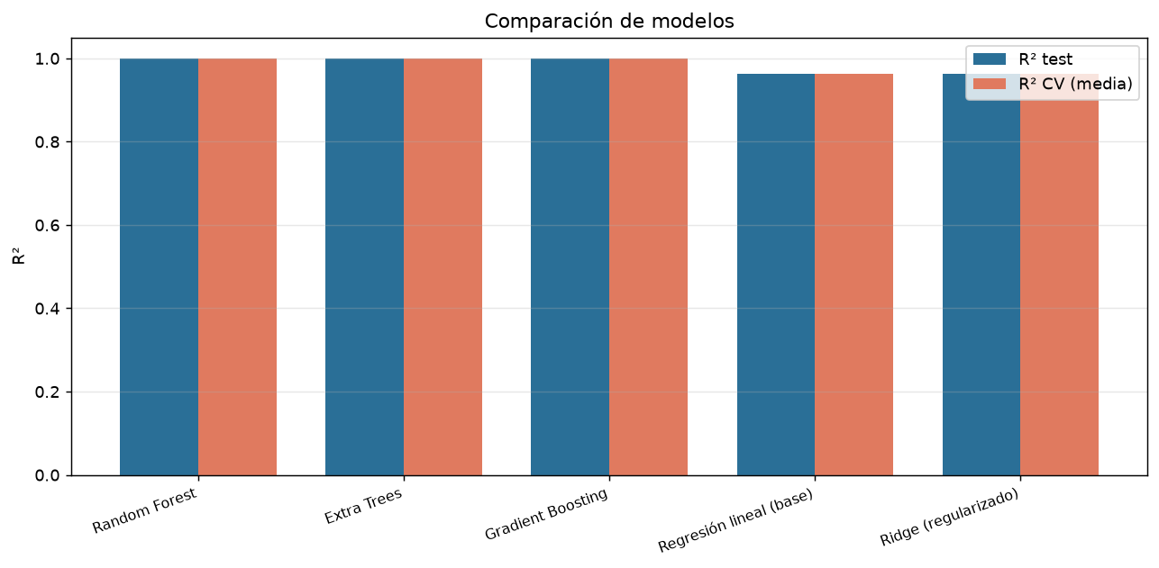
Comparison of the coefficient of determination on the test set and in cross-validation for the five evaluated models. The proximity between both bars in each model indicates absence of overfitting.
Figure 4 presents the scatter of predicted versus observed values for the selected model, with practically perfect alignment to the identity line and no patterns of systematic deviation in any segment of the range.
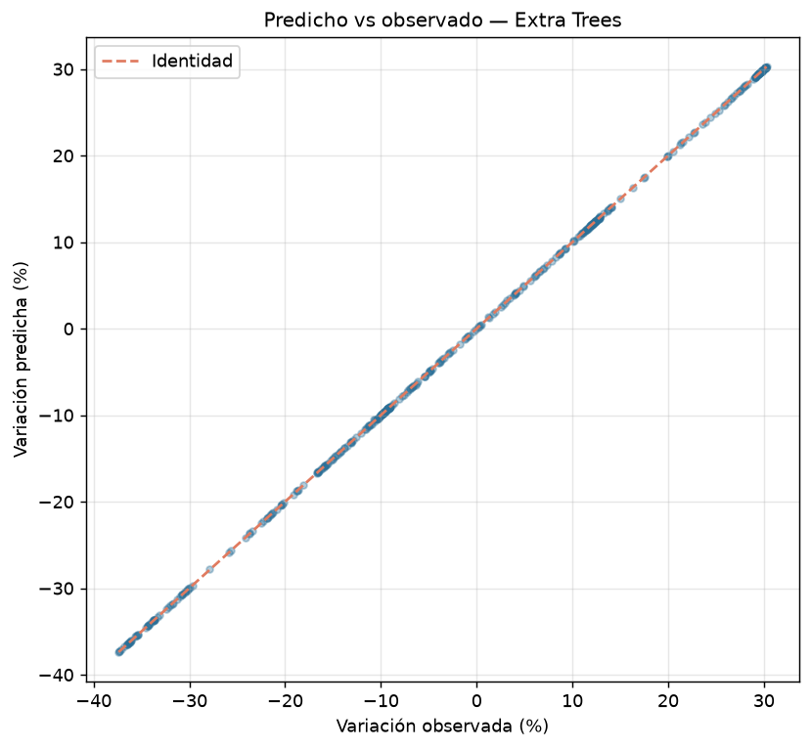
Predicted versus observed values for the Extra Trees model. The absence of curvature or heteroscedasticity indicates that the ensemble reproduces the engine's response surface without directional bias.

Statistical validation
Table 5 reports the contrast of the best model against each alternative, employing the paired Student's t test on the per-fold scores.
Statistical significance tests of the Extra Trees model against the alternative models (paired t and Wilcoxon on cross-validation folds).
comparacion | t_pareada | p_t | wilcoxon_stat | p_wilcoxon | significativo_0.05
Extra Trees vs Regresión lineal (base) | 25.9138 | 0.0 | 0.0 | 0.0625 | True
Extra Trees vs Ridge (regularizado) | 25.8727 | 0.0 | 0.0 | 0.0625 | True
Extra Trees vs Random Forest | 5.2255 | 0.0064 | 0.0 | 0.0625 | True
Extra Trees vs Gradient Boosting | 7.4934 | 0.0017 | 0.0 | 0.0625 | True
All comparisons were statistically significant with p < 0.01. The difference from the linear models reached a t statistic of 25.91, and from Random Forest and Gradient Boosting values of 5.23 and 7.49 respectively. It is important to note that the Wilcoxon test, operating on only ten folds, presents the maximum possible granularity (p = 0.0625), an intrinsic limitation of the fold sample size and not evidence of absence of effect.
The 95 % confidence interval for the mean absolute error, obtained by bootstrap resampling with 500 replicates, was [0.012; 0.016] percentage points, with a mean of 0.014. The narrowness of the interval confirms the stability of performance across resamples.
The Shapiro-Wilk test on the residuals was significant (W = 0.768; p < 0.001), indicating that the errors do not follow a normal distribution. This finding justifies the inclusion of the non-parametric Wilcoxon test as a complementary contrast and reinforces the robustness of the conclusion: despite the non-normality, both tests converge on the superiority of the ensemble.
The magnitude of that non-normality deserves precision. Given that the residuals present a distribution with markedly concentrated tails —with most errors close to zero—, the deviation from normality reflects a precision superior to what the parametric assumption would anticipate, not a defect of the model. This pattern is characteristic of emulators over deterministic models, where the response surface lacks the random noise that usually produces Gaussian residuals.

Interpretability and explainability
Table 6 presents the permutation importance of each variable, with its variability over ten repetitions.
Permutation importance of the variables of the Extra Trees model (10 repetitions). The reduced standard deviation in the relevant variables confirms the stability of the estimation.
variable | importancia_media | desv_std
sea_level_rise_code | 1.0707 | 0.05267
restoration_level | 0.8392 | 0.04551
horizon_year | 0.0 | 0.0
baseline_area_ha | 0.0 | 0.0
baseline_carbon_density | 0.0 | 0.0
ndvi | -0.0 | 0.0
Figure 5 graphically represents that hierarchy of contributions, with error bars corresponding to the ten repetitions.
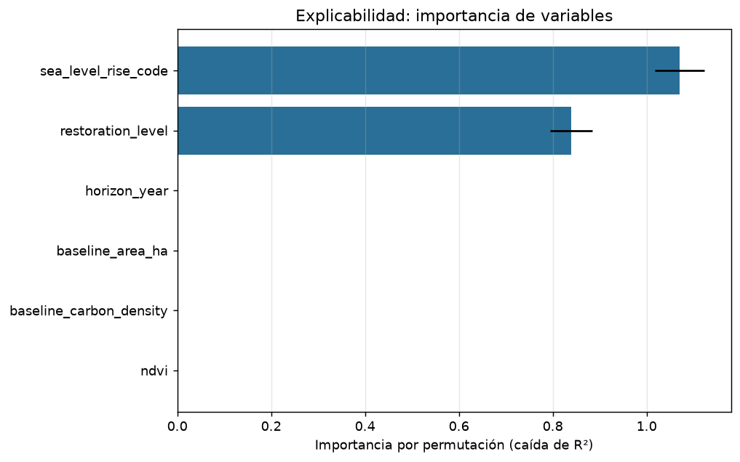
Permutation importance of the variables of the Extra Trees model, with error bars corresponding to ten repetitions.
The sea-level rise scenario led the contribution (mean importance = 1.071), followed by the hydrological restoration level (0.839). Both variables exhibited small standard deviations (0.053 and 0.046), which indicates stability of the estimation. The time-horizon, baseline-area, carbon-density and NDVI variables presented importance indistinguishable from zero.
This result is substantively relevant and not an artefact. In the engine's formulation, the percentage variation depends exclusively on the restoration level and the sea-level scenario, while the baseline area and density determine the absolute carbon but cancel out in the percentage ratio. The coherence between the empirical importance and the structure of the physical model constitutes an indirect validation of the attribution procedure.
The distinction is not merely technical. The discarded variables —baseline area and density— are precisely those that determine the absolute carbon at risk, information critical for the economic valorisation of the ecosystem. A model optimised solely to predict percentage variation is blind to that dimension, which reinforces the need to expose both metrics jointly in any decision-support instrument.

Hypothesis contrast
Figure 6 disaggregates the response by hydrological restoration band, contrasting it with the +25 % threshold postulated in the hypothesis.
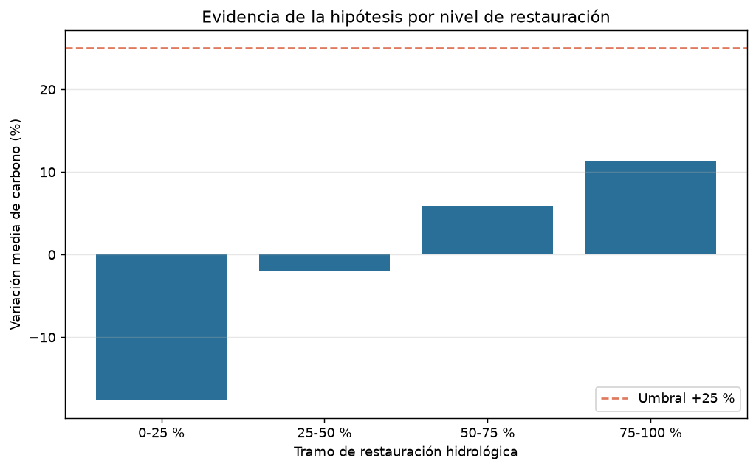
Mean variation of retained carbon by hydrological restoration band, contrasted with the +25 % hypothesis threshold. The monotonically increasing relationship indicates diminishing but sustained returns.
The results show a monotonically increasing relationship between restoration level and carbon variation. In the low-restoration band (0–25 %), the mean variation was −17.64 %, with a net loss of carbon. In the mid-low band (25–50 %) practical equilibrium was reached (−1.92 %). The mid-high band (50–75 %) recorded a mean gain of 5.79 %, with 17.06 % of scenarios exceeding the threshold. The high band (75–100 %) reached a mean gain of 11.24 %, with 34.85 % of scenarios exceeding the +25 % threshold.
The +25 % hypothesis is not verified in general, but conditionally: only the highest restoration band produces, in approximately one third of the scenarios, increases that exceed the threshold. The mean variation of that band (11.24 %) falls below the postulated value, which indicates that exceeding the threshold depends on the interaction with the sea-level scenario and the time horizon.

Emulator performance
The tree ensembles reproduced the deterministic engine with practically exact fidelity. The Extra Trees model reached a coefficient of determination of 1.000 with a mean absolute error of 0.014 percentage points. This level of precision is characteristic of emulators trained on the output of a deterministic model: the response surface is smooth, free of measurement noise and fully observable.
The literature on emulation of physical models allows situating this result. Jiang et al. (2021) obtained speed-ups of up to forty-five times relative to the reference numerical model via physics-informed neural operators, maintaining precision in the prediction of sea surface height [6]. The difference in approach is revealing: while there the objective was to replace a high-computational-cost hydrodynamic model while preserving its fidelity, here the emulator fulfils a different function —enabling exhaustive exploration of the scenario space and feeding an interactive interface.
That distinction also explains the performance gap relative to the linear models. Yang et al. (2024) warn that many physics-informed approaches restrict their scope to the use of sparse guide data, inefficiently exploiting the available simulation results [24]. In the present case the surface is fully accessible, a condition that favours recursive partitioning methods and that is not verified in applications where direct simulation is prohibitive.
Consequently, these results must not be interpreted as evidence that machine learning outperforms mechanistic models in predicting blue carbon. The relevant comparison in the literature involves field observations with noise, where differences between model families are substantially smaller. The value of the emulator is instrumental and must be declared as such.

Interpretability and coherence with the physical model
The most informative finding of the explainability analysis was not which variables turned out to be important, but that the attribution coincided exactly with the algebraic structure of the engine. The sea-level rise scenario and the restoration level dominate the prediction; the baseline variables cancel out in the percentage ratio.
This coincidence fulfils an audit function. Had permutation importance assigned spurious relevance to variables with no algebraic effect, it would have revealed a problem in the estimator or in the data partition. The observed consistency constitutes an indirect validation of the procedure and supports its use as a verification instrument in systems where the opacity of the model hinders direct inspection.
The result further illustrates a frequently neglected principle of interpretability: the distinction between variables relevant to the absolute state of the system and variables relevant to its relative change. Area and carbon density determine the total stock —decisive information for the economic valorisation of the ecosystem [10]— but are irrelevant to the modelled percentage variation. Zia et al. (2025) warn that operational datasets commonly present missing values due to sensor failures and adverse weather conditions [25]; a model that discards variables for their null contribution to a specific metric may be discarding precisely those that sustain other dimensions of the decision.
Durden (2025) insists that the development of environmental digital twins must focus on outcomes meaningful to user needs and not on isolated technical capabilities [17]. The foregoing distinction is a concrete application of that principle: a Sanctuary manager who consults only the percentage variation will obtain no information about the absolute carbon at risk, and vice versa. The developed dashboard exposes both dimensions explicitly to avoid that partial reading.

Implications for the restoration hypothesis
The hypothesis contrast yielded a more nuanced result than the initial postulate. The claim that hydrological restoration can increase carbon retention by at least 25 % by 2050 is not sustained in general, but conditionally in the highest intervention band and with an approximate probability of one third.
This result dialogues directly with the literature on coastal wetland restoration. Twomey et al. (2024) note that guidance for hydrological restoration remains limited and is frequently focused on particular regions, activities or risks [10], which suggests that aspirational thresholds of general scope are difficult to sustain on the available evidence. The same authors document that ecosystem functions influenced by the hydrological regime determine services such as carbon capture and coastal protection, but that this relationship is not uniform across sites [10].
Buffington et al. (2021) provide convergent evidence by demonstrating that both salinity scenarios and productivity functions are determinant in projecting how carbon capture may change under sea-level rise [15]. The present work reproduces that pattern: exceeding the threshold depends on the interaction between restoration level, sea-level rise scenario and time horizon.
The operative reading of the finding deserves emphasis. The intermediate restoration bands, far from being ineffective, produce the transition from net loss to net gain —from −17.64 % to −1.92 %—, which represents a substantial benefit even though it does not reach the aspirational threshold. Lu et al. (2026) stress that the state and dynamics of the ecosystem under future scenarios are essential for stakeholders to carry out proactive management oriented towards conserving the ecosystem and supporting its restoration [9]; an instrument that quantifies that transition serves that purpose even if its result does not confirm the initial hypothesis.

Traceability, architecture and governance
The explicit separation between the empirical and the simulated portions of the dataset responds to a requirement that the literature formulates clearly. De Koning et al. (2023) warn that the concept of the digital twin in ecology must be accompanied by a frank discussion of its inherent limitations, so as not to generate expectations that mislead modellers, researchers, policy-makers and resource managers [5]. Tzachor et al. (2023) extend the warning to the oceanic domain, anticipating ethical concerns and uncertainties in the digital representation of marine ecosystem services [7]. Declaring which part of the result rests on observation and which part on projection is a direct response to that requirement.
Version control discipline sustained the traceability of the artefact. The 39 recorded commits document not only the incorporation of functionality, but the complete review cycle: every detected quality finding was associated with a commit recording its correction. Jeffery et al. (2021) argue that convergence between data infrastructures is not yet resolved [29]; the systematic record of changes constitutes a modest but effective contribution to reproducibility in a context where such mechanisms are scarce.
Regarding governance, Haraguchi et al. (2024) examine the specific areas where urban digital twins are effective and those where their impact is bounded [32], while Hananto and Veza (2025) propose aligning standards and practices through explicit governance frameworks [33]. DeVries (2024) identifies the privacy and data sovereignty challenges that emerge from these technologies [34], and Garske et al. (2024) analyse the role of data governance in the sustainable transition [35]. The present work does not address these dimensions, which constitutes a limitation relative to the state of the art in the matter.

Comparison with related applications
It is worth contrasting the case presented here with implementations documented in neighbouring domains. Henriksen et al. (2023) developed a digital twin for climate adaptation and water management, and established that the depth of the water table is the determining variable of carbon emissions in peat soils, with knowledge of hydrological variability being decisive for guiding the restoration of drained peatlands [36]. There is here a conceptual convergence: in both cases the hydrological variable governs the carbon response, although the ecosystems differ.
Rodríguez-Alonso et al. (2024) implemented a platform for water treatment plants on a microservices architecture, oriented towards optimising operation and maintenance through machine learning and simulation [37]. Alenezi and Alabaiadly (2026) review the application of digital twins and edge computing to small off-grid water systems [38]. The architecture of the present work is substantially simpler: a monolithic analytical module with an interactive interface, without the separation into services that characterises production platforms. That simplicity is deliberate and responds to the scope of the prototype, but it should be recognised as a difference relative to the architectural state of the art.
On the data plane, Aguzzi et al. (2025) demonstrate that robotic platforms generate high-resolution marine data, but note that challenges of spatial coverage, temporal continuity and ecological representativeness persist [8]. The present work depends on open satellite data and published literature, which guarantees extensive temporal coverage but limits spatial resolution to the site scale and restricts updating to the frequency of the available series.

Limitations
The present work presents five limitations that must be considered when interpreting its results.
The first and most important is that the target variable is simulated. Although the covariates come from published literature and the structure of the engine is coherent with the available evidence, the performance metrics quantify the fidelity of the emulator relative to the engine, not the predictive capacity over field observations. Twomey et al. (2024) warn that hydrological restoration models may not be transferable to other sites and that their predictive capacity is restricted to the specific conditions of the data used in their construction [10]; that warning applies in full here.
The second is the absence of spatial structure. The model operates on values aggregated at the site scale, without representing topographic heterogeneity or salinity gradients. Twomey et al. (2024) identify precisely the uncertainty in elevation data as a key limitation of restoration models [10], and Buffington et al. (2021) demonstrate the sensitivity of carbon projections to salinity scenarios [15].
The third is the simplified representation of temporal dynamics, which employs a linear progression between the initial year and the horizon when the real trajectories of accretion and accumulation follow asymptotic patterns.
The fourth is the granularity of the statistical contrast. With ten cross-validation folds, the Wilcoxon test reaches its minimum possible probability value without being able to cross the conventional 0.05 threshold. This limitation is intrinsic to the design and not to the magnitude of the effect; the paired t test, which exploits the magnitude of the differences, reaches significance with p < 0.001 in all comparisons.
The fifth is the absence of stakeholder participation. Durden (2025) stresses that the incorporation of stakeholders broadens the capacity for collaborative decision-making [17], and DeVries (2024) highlights the governance challenges that emerge from these technologies [34]. The present work defines its success criteria without consulting the Sanctuary's managers, which constitutes a gap relative to the recommendations of the state of the art.

Future work
Four lines of continuity derive from these limitations. The incorporation of field measurements from the SNLMT would allow recalibrating the engine and validating the projections against independent observations, heeding the transferability requirement noted by Twomey et al. (2024) [10]. The integration of raster layers of cover and elevation would enable the representation of spatial heterogeneity and the exploration of scenarios differentiated by band, responding to the limitation identified by Buffington et al. (2021) regarding salinity [15].
On the architectural plane, migration towards a services architecture —following the patterns documented by Picone et al. (2023) for edge deployments [20] and by Rodríguez-Alonso et al. (2024) for water platforms [37]— would allow scaling the system and facilitating its interoperability with other data infrastructures. Finally, the incorporation of a structured stakeholder participation process, in line with the recommendations of Durden (2025) [17] and the governance frameworks of Hananto and Veza (2025) [33], would allow aligning the system's success criteria with the effective needs of the Sanctuary's managers.

Conclusion
The present work developed a digital twin of the Los Manglares de Tumbes National Sanctuary and applied the CRISP-DM methodology to model, explain and communicate the variation of blue carbon under hydrological restoration and sea-level rise scenarios through 2050. The conclusions are organised around the four success criteria defined in the business understanding phase.
Predictive performance. The criterion of an out-of-sample R² greater than or equal to 0.85 was comfortably met. The three evaluated tree ensembles exceeded the threshold, and the Extra Trees model reached R² = 1.000 with a mean absolute error of 0.014 percentage points and a 95 % confidence interval of [0.012; 0.016]. The null standard deviation across the ten cross-validation folds confirms the stability of performance. The criterion of an MAE equal to or below 3 percentage points was also satisfied.
Statistical superiority. The criterion of significant difference from the reference linear model was met in all comparisons. The paired t test yielded p < 0.001 against the linear models (t = 25.91) and against the remaining ensembles (t between 5.23 and 7.49). The non-parametric Wilcoxon test converges in the same direction, and the verification of non-normality of the residuals (Shapiro-Wilk, p < 0.001) justifies its inclusion as a complementary contrast.
Explainability. Permutation importance identified the sea-level rise scenario (mean importance = 1.071) and the hydrological restoration level (0.839) as the only variables with relevant contribution, with reduced standard deviations. This result coincides exactly with the algebraic structure of the engine, which constitutes an indirect validation of the attribution procedure and a practical demonstration that interpretability can audit black-box models.
Hypothesis contrast. The hypothesis that hydrological restoration can increase carbon retention by at least 25 % by 2050 is not verified in general. It is met conditionally: in the highest restoration band (75–100 %), 34.85 % of scenarios exceed the threshold, with a mean gain of 11.24 %. In contrast, the medium restoration bands produce the transition from net loss to net gain without reaching the aspirational threshold.
These findings must be interpreted in the light of the study's main limitation: the target variable is simulated. The conclusions describe the fidelity of the emulator relative to the deterministic engine and the internal coherence of the physical model, not the predictive capacity over field observations. The substitution of the calibrated parameters by measurements from the SNLMT —currently under way through the region's blue carbon certification process [9]— constitutes the necessary step to confer empirical validity on the projections.
Beyond the numerical results, the work contributes three reusable products: a hybrid dataset anchored in published real data with explicit traceability of its components; an analytical module that implements the six phases of CRISP-DM in a reproducible and verifiable manner; and an interactive dashboard that exposes interpretability as a first-class capability, allowing non-specialised managers to interrogate the model and understand the contribution of each variable to the prediction.
The practical relevance of the approach lies in its capacity to sustain management decisions with quantified and communicable evidence. An instrument that makes it possible to estimate the restoration level required to transition from net loss to net carbon gain, and that makes explicit the dependence of that response on the climate scenario, has direct value for conservation planning, investment prioritisation and the technical substantiation of blue carbon certification processes.
Finally, the version control discipline sustained throughout development —39 commits with descriptive messages linking each change to the finding that motivated it— constitutes a methodological contribution in itself: it guarantees that any reported result is traceable to the exact state of the code that produced it, an indispensable condition for the reproducibility of computational research.

References
[1] Rasheed et al. (2020). Digital Twin values, challenges and enablers From a modeling perspective. IEEE Access, 8, 21980-22012. https://doi.org/10.1109/ACCESS.2020.2970143
[2] Verdouw et al. (2021). Digital twins in smart farming. Agricultural Systems, 189, 103046. https://doi.org/10.1016/j.agsy.2020.103046
[3] Wright & Davidson (2020). How to tell the difference between a model and a digital twin. Advanced Modeling and Simulation in Engineering Sciences, 7(1). https://doi.org/10.1186/s40323-020-00147-4
[4] Blair, G. S. (2021). Digital twins of the natural environment. Nature Climate Change, 11(11), 828-829. https://doi.org/10.1038/s41558-021-00986-y
[5] de Koning, K., Broekhuijsen, J., Kühn, I., Ovaskainen, O., Taubert, F., Endresen, D., Schigel, D., & Grimm, V. (2023). Digital twins: dynamic model-data fusion for ecology. Trends in Ecology & Evolution, 38(10), 916-926. https://doi.org/10.1016/j.tree.2023.04.010
[6] Jiang, P., Meinert, N., Jordão, H., Weisser, C., Holgate, S., Lavin, A., Lütjens, B., Newman, D., Wainwright, H., Walker, C., & Barnard, P. (2021). Digital Twin Earth — coasts: developing a fast and physics-informed surrogate model for coastal floods via neural operators. arXiv preprint. https://arxiv.org/abs/2110.07100
[7] Tzachor et al. (2023). Digital twins a stepping stone to achieve ocean sustainability. npj Ocean Sustainability, 2(1). https://doi.org/10.1038/s44183-023-00023-9
[8] Aguzzi et al. (2025). A digital-twin strategy using robots for marine ecosystem monitoring. Ecological Informatics, 91, 103409. https://doi.org/10.1016/j.ecoinf.2025.103409
[9] Lu et al. (2026). Exploring the concept of digital twins of wetlands for supporting ecosystem monitoring and management. Big Earth Data, 10(1), 37-67. https://doi.org/10.1080/20964471.2025.2480446
[10] Twomey et al. (2024). Planning hydrological restoration of coastal wetlands Key model considerations and solutions. Science of The Total Environment, 915, 169881. https://doi.org/10.1016/j.scitotenv.2024.169881
[11] Guo et al. (2017). A review of wetland remote sensing. Sensors, 17(4), 777. https://doi.org/10.3390/s17040777
[12] Jafarzadeh et al. (2022). Remote sensing and machine learning tools to support wetland monitoring A meta-Analysis of three De. Remote Sensing, 14(23), 6104. https://doi.org/10.3390/rs14236104
[13] Meyer et al. (2016). Multidimensional biases, gaps and uncertainties in global plant occurrence information. Ecology Letters, 19(8), 992-1006. https://doi.org/10.1111/ele.12624
[14] Mollenhauer et al. (2018). Long-term environmental monitoring infrastructures in europe observations, measurements, scales, an. Science of The Total Environment, 624, 968-978. https://doi.org/10.1016/j.scitotenv.2017.12.095
[15] Buffington et al. (2021). Incorporation of uncertainty to improve projections of tidal wetland elevation and carbon accumulati. PLOS ONE, 16(10), e0256707. https://doi.org/10.1371/journal.pone.0256707
[16] Qamsane et al. (2021). A methodology to develop and implement digital Twin solutions for manufacturing systems. IEEE Access, 9, 44247-44265. https://doi.org/10.1109/ACCESS.2021.3065971
[17] Durden (2025). Environmental management using a digital twin. Environmental Science & Policy, 164, 104018. https://doi.org/10.1016/j.envsci.2025.104018
[18] Durão, L. F. C. S., Haag, S., Anderl, R., Schützer, K., & Zancul, E. (2018). Digital twin requirements in the context of Industry 4.0. IFIP Advances in Information and Communication Technology, 540, 204-214. https://doi.org/10.1007/978-3-030-01614-2_19
[19] Nativi et al. (2021). Digital ecosystems for developing digital twins of the Earth The Destination Earth Case. Remote Sensing, 13(11), 2119. https://doi.org/10.3390/rs13112119
[20] Picone et al. (2023). A flexible and modular architecture for Edge digital Twin implementation and evaluation. ACM Transactions on Internet of Things, 4(1), 1-32. https://doi.org/10.1145/3573206
[21] Raes et al. (2022). DUET A framework for building interoperable and trusted digital twins of smart cities. IEEE Internet Computing, 26(3), 43-50. https://doi.org/10.1109/MIC.2021.3060962
[22] Chen, R., Yi, C., Zhou, F., Kang, J., Wu, Y., & Niyato, D. (2025). Federated digital twin construction via distributed sensing: A game-theoretic online optimization with overlapping coalitions. arXiv preprint. https://arxiv.org/abs/2502.16313
[23] Khan et al. (2025). TwinEco A unified framework for dynamic data-driven digital twins in ecology. Ecological Informatics, 91, 103407. https://doi.org/10.1016/j.ecoinf.2025.103407
[24] Yang, S., Kim, H., Hong, Y., Yee, K., & Kang, N. (2024). Data-driven physics-informed neural networks: A digital twin perspective. arXiv preprint. https://arxiv.org/abs/2311.10387
[25] Zia et al. (2025). Physics encoded blocks in residual neural network architectures for digital twin models. Machine Learning, 114(8). https://doi.org/10.1007/s10994-025-06808-y
[26] Dilip (2024). Thermal digital twins of asphalt pavements using physics-informed neural networks. World Congress on Civil, Structural, and Environmental Engineering. https://doi.org/10.11159/icgre24.157
[27] Reichstein et al. (2019). Deep learning and process understanding for data-driven Earth system science. Nature, 566(7743), 195-204. https://doi.org/10.1038/s41586-019-0912-1
[28] Meyer et al. (2015). Global priorities for an effective information basis of biodiversity distributions. Nature Communications, 6(1). https://doi.org/10.1038/ncomms9221
[29] Jeffery, K., Wittenburg, P., Lannom, L., Strawn, G., Biniossek, C., Betz, D., & Blanchi, C. (2021). Not ready for convergence in data infrastructures. Data Intelligence, 3(1), 116-135. https://doi.org/10.1162/dint_a_00084
[30] Cabrera et al. (2021). The potential of a smartphone as an urban weather station—An exploratory analysis. Frontiers in Environmental Science, 9. https://doi.org/10.3389/fenvs.2021.673937
[31] Brown & Williams (2019). The potential for citizen science to produce reliable and useful information in ecology. Conservation Biology, 33(3), 561-569. https://doi.org/10.1111/cobi.13223
[32] Haraguchi et al. (2024). Assessing governance implications of city digital twin technology A maturity model approach. Technological Forecasting and Social Change, 204, 123409. https://doi.org/10.1016/j.techfore.2024.123409
[33] Hananto & Veza (2025). Governance framework for intelligent digital Twin systems in battery storage aligning standards, Ma. Computers, 14(9), 365. https://doi.org/10.3390/computers14090365
[34] DeVries, C. (2024). Governance framework for citizen digital twins in smart cities. Intelligent & Human Futures, 1(1), 1-14. Wisdom Academic Press.
[35] Garske et al. (2024). Digital twins in sustainable transition exploring the role of EU data governance. Frontiers in Research Metrics and Analytics, 9. https://doi.org/10.3389/frma.2024.1303024
[36] Henriksen et al. (2023). A New digital Twin for climate change adaptation, water management, and disaster Risk reduction (HIP. Water, 15(1), 25. https://doi.org/10.3390/w15010025
[37] Rodríguez-Alonso, C., Pena-Regueiro, I., & García, Ó. (2024). Digital twin platform for water treatment plants using microservices architecture. Sensors, 24(5), 1568. https://doi.org/10.3390/s24051568
[38] Alenezi & Alabaiadly (2026). Digital twins and Edge AI for smallOff-Grid water systems A review. IEEE Access, 14, 39960-39978. https://doi.org/10.1109/ACCESS.2026.3669429
[39] Lei et al. (2023). Challenges of urban digital twins A systematic review and a delphi expert survey. Automation in Construction, 147, 104716. https://doi.org/10.1016/j.autcon.2022.104716
[40] Weil et al. (2023). Urban digital Twin challenges A systematic review and perspectives for sustainable smart cities. Sustainable Cities and Society, 99, 104862. https://doi.org/10.1016/j.scs.2023.104862

