**Execution Instructions**

1. Go to the resources folder in the project folder.

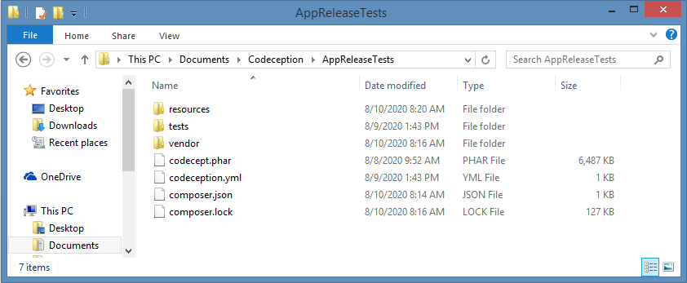

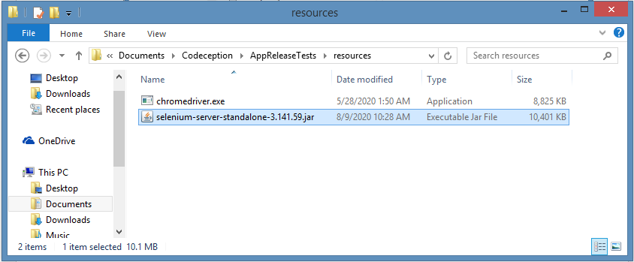

1. Open a command prompt on the resources folder and enter the following command to run the selenium jar file.

***java -jar selenium-server-standalone-3.141.59.jar***

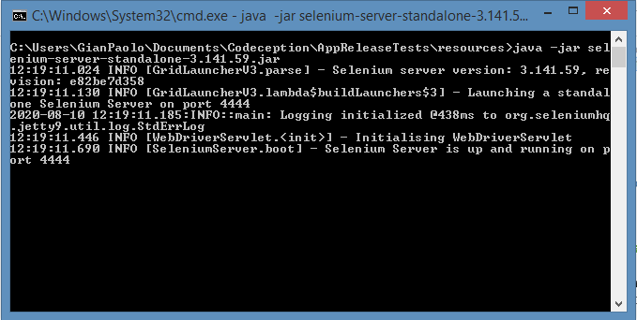

1. Go the root project folder and open another command prompt



1. Run the acceptance tests by the following command:

***php codecept.phar run acceptance --steps –html***

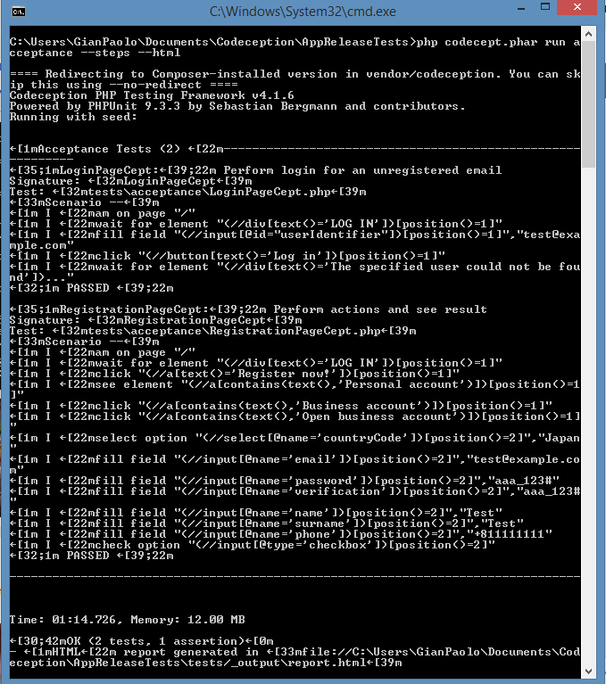

1. Report.html file shows the following.

