Christopher Klocke
Algorithms Homework #4
Submitted: October 26th, 2018

Part 1

1. Name of approach.
Burrows Wheeler Transform

2. What question/problem does this approach answer?
While originally developed for file compression in the 1990s, a 2009 paper (Li & Durbin) showed how this can be applied to fast short read alignment. Burrows Wheeler Transform as applied to this problem of aligning DNA reads to a reference genome was a huge improvement over existing methods (claimed 10-20x faster than MAQ in original paper). Searching an entire genome for sites matching a substring is computationally expensive, so this advance was important.

3. Describe/outline a naive/brute force/strawperson approach to the problem above.
Sliding window?

4. Describe/outline the steps to the approach named in question 1 (Include assumptions, inputs, outputs)
take input strand T
add terminal character
all rotations
lexicographic sort
remove all rows but first and last
can compress first massively (e.g. $:1 150:A 200:C 175:G 300:T)
can compress last some (combine adjacent repeats, with count)
add in FM index – can use checkpoints at a predetermined interval – don’t need to store whole thing
to query:
go last character to first in substring – start with last, find in condensed F strand
to search preceding characters, search this subset in L strand (using checkpoints, tallies as described)

5. Describe at least 2 advantages this approach has over the naive/brute force approach.
Ability to precompute (e.g. build BWT for reference genome, then re-use every time you need to align new reads

Huge compression
fast rank calculations – lookup speed --- you don’t have to search the entire L string / BWT string when you are looking for the preceding character in the substring – also you don’t have to store all these indices (checkpoints) – a lot of efficiencies here

6. Describe at least 1 limitation of this approach and a potential extension/solution for this limitation.

Significant pre-compute time – however, this can be done ahead of time with an entire reference genome (once), which then can be quickly searched for any substring very quickly
you need a reference genome? Not used for genome assembly – just search / alignment when you have the luxury of a pre-assembled reference genome

Part 2, Question 2

This graph does not have a Hamiltonian cycle. If it did, we would be able to start at any node and follow a path that passed through each other node exactly once, then returned to the starting node.

It does have a Hamiltonian path. An example of this is shown below:

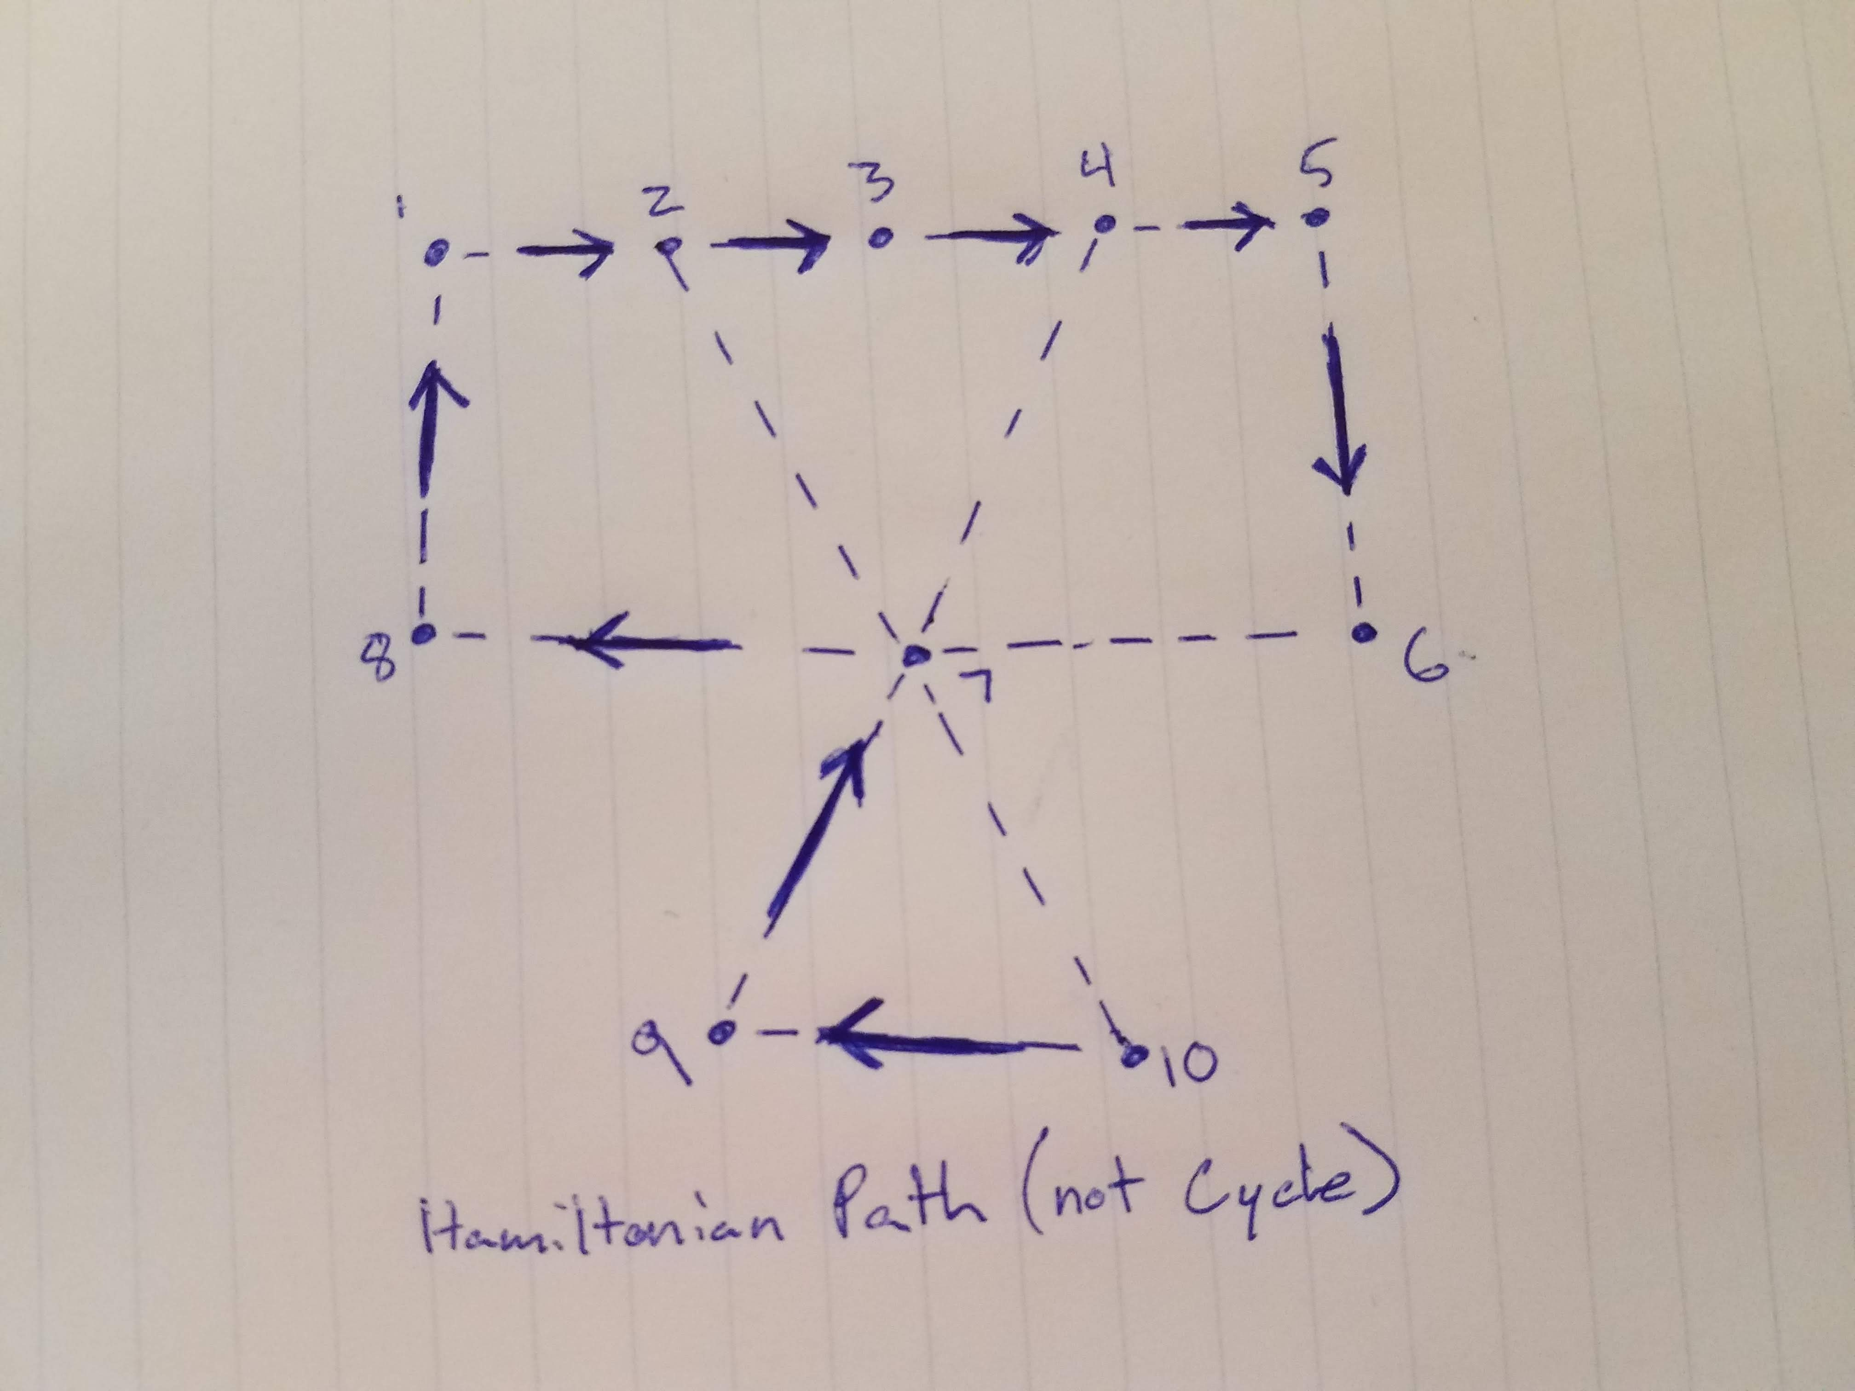

This graph has a Hamiltonian path, but not a Hamiltonian cycle. Node 7 interrupts this, serving as a bottleneck:

-If you start on node 1 through 6 or 8, you can’t access nodes 9 & 10 and then return to start node without passing node 7 more than once

-If you start on node 9 or 10, same thing – you can’t access nodes 1 through 6 and 8 and then return to start node without passing node 7 more than once

-If you start on node 7 and go up (nodes 1-6,8) or down (nodes 9,10) you cannot then access the nodes below (9,10) or above (1-6, 8), respectively, without passing node 7 more than once

