Christopher Klocke
Algorithms midterm
Submitted: November 9th, 2018

This will answer questions 2, 4, and 5 for the Algorithms midterm.

2. As reported in the HG38 version of the human genome, please answer the following questions about
the gene, CD8B.
a. What chromosome is this gene on? Chromosome 2
b. What is the start and end coordinate of this gene? 86815337 - 86861924
c. What strand of the DNA contains this gene? Reverse strand
d. How many transcripts are in this gene as reported by the RefSeq Consortium? 6 transcripts
e. How many distinct exons are reported in the RefSeq transcripts? 8 exons

f. How many distinct introns are reported in the RefSeq transcripts? 10 introns

g. List the genomic coordinates of 3 introns (start-end) from above which contains a canonical
splice sites.
86852996 – 86846775
86858056 - 86853087

i. What is the official gene symbol of the nearest gene to CD8B? What strand of the DNA
contains this nearest neighboring gene? How would the location of these genes be described in relation
to one another?
ANAPC1P1 forward strand These genes overlap, but are on opposite strands ANAPC1P1 starts at 86,861,825 and CD8B ends at 86861924

3. Describe the minimum information needed to unambiguously define the location of a gene? Provide
an example using a gene of your choice.

In order to unambiguously define the location of a gene, such as INS (human insulin), you need:

-the genome in question (species & build) hg38
-the chromosome where the gene is found chromosome 11
-the start and stop locations of the gene on that chromosome 2,159,779 to 2,161,341
-the strand containing the gene (forward or reverse) reverse strand

Other information, such as reading frame of the transcripts, & locations of transcripts, exons, and introns may be useful; however, this information is not necessary to locate the DNA sequence comprising the gene.

4. Align the protein sequences S1 and S2

Write down the Dynamic Programming (DP) recursion for global alignment of S1 and S2. Form and fill out the DP table with traceback indices. Trace the path and form your alignment. Discuss the resulting alignment with respect to the substitution metric H and the affine gap penalty. Compare and contrast the resultant alignment with the alignment generated without the affine gap penalty.

Adding the affine gap penalty, as opposed to the constant penalty used in Homework 2, reduces the number of optimal alignments. While 6 optimal alignments were found for these sequences in Homework 2, using an affine gap penalty chooses 2 of those 6 as optimal. It does this by preferentially selecting alignments that group gaps together rather than spacing them out (multiple gap openings).

The challenge here was that sometimes there were multiple possible scores for reaching a given node from a given direction, based on whether a gap had been opened or extended in an earlier step. To take this into account, I wrote both scores and found the appropriate one when tracing back the optimal path at the end. This alignment was very similar to the previous method of using a constant gap penalty (returned 2 of the 6 old sequences), but the change in scoring prioritized grouped gaps over gaps that were spaced out from each other.
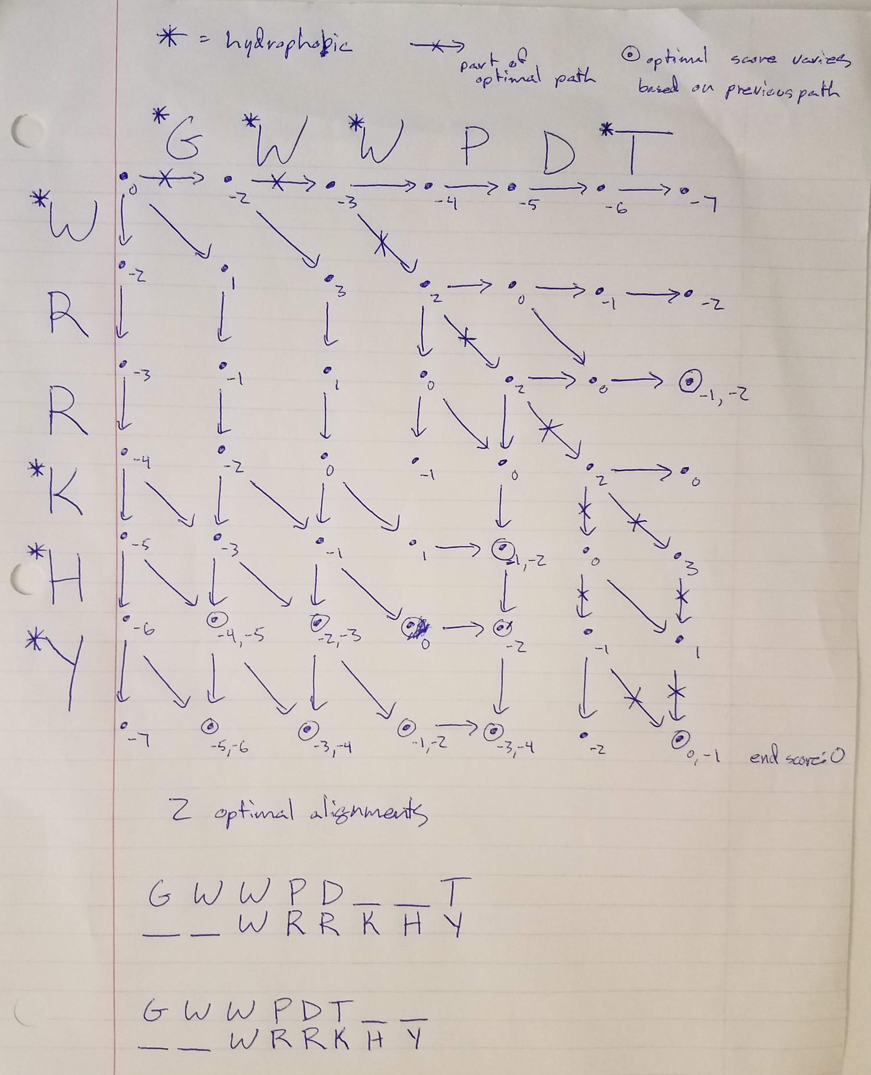

5. Describe a scenario where a researcher would be interested in investigating both the local and global alignment of two sequences.

A researcher could be interested in a sequence that could have one of two relationships with another sequence. One possibility is that the sequence is homologous to a gene in another species that is fairly phylogenetically distant. The other possibility is that the sequence is a pseudogene of a known gene in the same species.

If the two sequences have a good local alignment in one region but a poorer global alignment, but the region with the local alignment is known to be an important conserved region in homologs, the sequences could be for the same gene in different species. Alternately, if the two sequences have a good global alignment, but differ some in a region known to be evolutionarily conserved, one could be a pseudogene of the other. The pseudogene could be very similar (an almost exact copy) to the gene, while containing critical differences in an important conserved region that render it non-functional.

