Sogou数据分析报告
21860388 王畅然

map-reduce

查询频度前30的搜索词
由于计算力的原因，本报告使用的是500万的数据集。Map-reduce代码如下。
import org.apache.hadoop.conf.Configuration;
import org.apache.hadoop.fs.Path;
import org.apache.hadoop.io.IntWritable;
import org.apache.hadoop.io.LongWritable;
import org.apache.hadoop.io.Text;
import org.apache.hadoop.mapreduce.Job;
import org.apache.hadoop.mapreduce.Mapper;
import org.apache.hadoop.mapreduce.Reducer;
import org.apache.hadoop.mapreduce.lib.input.FileInputFormat;
import org.apache.hadoop.mapreduce.lib.input.TextInputFormat;
import org.apache.hadoop.mapreduce.lib.output.FileOutputFormat;
import org.apache.hadoop.mapreduce.lib.output.TextOutputFormat;
import org.apache.hadoop.util.GenericOptionsParser;
import org.apache.hadoop.mapreduce.Reducer.Context;

import java.io.IOException;
import java.util.TreeMap;
public class Top30 {
Public static class TopMapper extends Mapper<LongWritable, Text, Text, LongWritable>{
Text text =new Text();
@Override
protected void map(LongWritable key, Text value,Context context)throws IOException, InterruptedException {
String[] line= value.toString().split("\t");
String keys = line[2];
text.set(keys);
context.write(text,new LongWritable(1));
}
}
public static class TopReducer extends Reducer< Text,LongWritable, Text, LongWritable>{
Text text = new Text();
TreeMap<Integer,String > map = new TreeMap<Integer,String>();
@Override
protected void reduce(Text key, Iterable<LongWritable> value, Context context)throws IOException, InterruptedException {
int sum=0;
for (LongWritable ltext : value) {
sum+=ltext.get();
}
map.put(sum,key.toString());
if(map.size()>30){
map.remove(map.firstKey());
}
}
@Override
protected void cleanup(Context context) throws IOException, InterruptedException {
for(Integer count:map.keySet()){
context.write(new Text(map.get(count)),new LongWritable(count));
}
}
}
public static void main(String[] args) throws IOException, ClassNotFoundException, InterruptedException {
Configuration conf = new Configuration();

Job job = Job.getInstance(conf, "count");
job.setJarByClass(Top30.class);
job.setJobName("Top30");
job.setJar("Top30.jar");
job.setOutputKeyClass(Text.class);
job.setOutputValueClass(LongWritable.class);
job.setMapperClass(TopMapper.class);
job.setReducerClass(TopReducer.class);
FileInputFormat.addInputPath(job, new Path(args[0]));
FileOutputFormat.setOutputPath(job, new Path(args[1]));
System.exit(job.waitForCompletion(true) ? 0 : 1);
}
}
执行命令为：
Javac -classpath /usr/local/hadoop/share/hadoop/common/hadoop-common-2.8.5.jar:/usr/local/hadoop/share/hadoop/mapreduce/hadoop-mapreduce-client-core-2.8.5.jar:/usr/local/hadoop/share/hadoop/common/lib/commons-cli-1.2.jar -d classes/ src/*.java
jar -cvf Top30.jar classes
hadoop fs -put sogou.500w.utf8 /sogou/
hadoop jar Top30.jar Top30 /sogou/sogou.500w.utf8 /sogou/
最终结果为：
搜索关键词 搜索总数
凰图腾 3632
cf官网 3729
张去死 3848
qq个性签名 3880
龙门飞甲 3917
nba 4027
qq头像 4085
4399洛克王国 4112
123 4829
hao123 4834
新疆暴徒被击毙图片 4997
李宇春体 5310
新浪微博 5369
儿子与母亲不正当关系 5496
黑狐 5610
7k7k小游戏 5985
qq网名 6149
魏特琳 6665
4399 7041
百度一下 7104
百度一下 你就知道 7505
公安卖萌 8192
馆陶县县长闫宁的父亲 9127
新亮剑 9654
优酷 10158
qq空间 10317
4399小游戏 11438
人体艺术 14475
baidu 18312
百度 38441
可以看出百度作为国内最大的搜索引擎，占据了相当大的搜索比重。还可以看出搜索中有一些不良的词汇，净化网络空间依然任重道远。

被访问次数前10的网址及其次数占比
Map-reduce代码如下。
import java.io.IOException;
import java.util.TreeMap;
import org.apache.hadoop.conf.Configuration;
import org.apache.hadoop.fs.Path;
import org.apache.hadoop.io.IntWritable;
import org.apache.hadoop.io.LongWritable;
import org.apache.hadoop.io.FloatWritable;
import org.apache.hadoop.io.Text;
import org.apache.hadoop.mapreduce.Job;
import org.apache.hadoop.mapreduce.Mapper;
import org.apache.hadoop.mapreduce.Reducer;
import org.apache.hadoop.mapreduce.lib.input.FileInputFormat;
import org.apache.hadoop.mapreduce.lib.input.TextInputFormat;
import org.apache.hadoop.mapreduce.lib.output.FileOutputFormat;
import org.apache.hadoop.mapreduce.lib.output.TextOutputFormat;
import org.apache.hadoop.util.GenericOptionsParser;
import org.apache.hadoop.mapreduce.Reducer.Context;
public class Top10 {
public static float total = 0;
public static class TopMapper extends Mapper<LongWritable, Text, Text, FloatWritable>{
Text text =new Text();
@Override
protected void map(LongWritable key, Text value,Context context)throws IOException, InterruptedException {
String[] line= value.toString().split("\t");
String keys = line[5];
text.set(keys);
context.write(text,new FloatWritable(1));
}
}
public static class TopReducer extends Reducer< Text,FloatWritable, Text, FloatWritable>{
Text text = new Text();
TreeMap<Float,String> map = new TreeMap<Float,String>();
@Override
protected void reduce(Text key, Iterable<FloatWritable> value, Context context)throws IOException, InterruptedException {
float sum=0;
for (FloatWritable ltext : value) {
sum+=ltext.get();
}
map.put(sum,key.toString());
total+=sum;
if(map.size()>10){
map.remove(map.firstKey());
}
}
@Override
protected void cleanup(Context context)throws IOException, InterruptedException {
for(Float count:map.keySet()){
context.write(new Text(map.get(count)), new FloatWritable(count/total));
}
}
}
public static void main(String[] args) throws IOException, ClassNotFoundException, InterruptedException {
Configuration conf = new Configuration();
Job job = Job.getInstance(conf, "count");
job.setJarByClass(Top10.class);
job.setJobName("Top10");
job.setJar("Top10.jar");
job.setOutputKeyClass(Text.class);
job.setOutputValueClass(FloatWritable.class);
job.setMapperClass(TopMapper.class);
job.setReducerClass(TopReducer.class);
FileInputFormat.addInputPath(job, new Path(args[0]));
FileOutputFormat.setOutputPath(job, new Path(args[1]));
System.exit(job.waitForCompletion(true) ? 0 : 1);
}
}
执行命令：
Javac -classpath /usr/local/hadoop/share/hadoop/common/hadoop-common-2.8.5.jar:/usr/local/hadoop/share/hadoop/mapreduce/hadoop-mapreduce-client-core-2.8.5.jar:/usr/local/hadoop/share/hadoop/common/lib/commons-cli-1.2.jar -d classes/ src/*.java
jar -cvf Top10.jar classes
hadoop fs -put sogou.500w.utf8 /sogou/
hadoop jar Top10.jar Top10 /sogou/sogou.500w.utf8 /sogou/

最终结果：
网址 次数占比
http://www.12306.cn/ 0.0013922
http://www.xixiwg.com/ 0.0014086
http://cf.qq.com/ 0.0015088
http://weibo.com/ 0.0015094
http://www.7k7k.com/ 0.0016652
http://qzone.qq.com/ 0.002584
http://www.youku.com/ 0.0028172
http://www.hao123.com/ 0.0028676
http://www.4399.com/ 0.003803
http://www.baidu.com/ 0.0147474
可以看出百度网址搜索次数还是占了很大的比重，其次是一些网页游戏网站和社交视频网站。

hive数据分析

1从HDFS中创建表
CREATE EXTERNAL TABLE sogou.500w(
ts STRING,
uid STRING,
keyword STRING,
rank INT,
ord INT,
url STRING
)
COMMENT 'This is the sogou search data of extend data'
ROW FORMAT DELIMITED
FIELDS TERMINATED BY '\t'
STORED AS TEXTFILE
LOCATION “/sogou”;

2无重复总条数（根据 ts、 uid、 keyword、rank,ord, url）
hive>select count(*) from (select * from 500w group by ts,uid,keyword,rank,ord,url having count(*)=1) a;
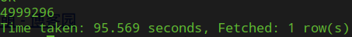
如图，无重复总条数是4999296。

3独立UID总数
hive> select count(distinct(uid)) from 500w;
如图，独立UID总数是1352664。

4查询关键词长度统计
hive> select avg(a.cnt) from (select size(split(keyword,'\\s+')) as cnt from 500w) a;
如图，关键词平均长度是1.0869984。

5查询频度排名（频度最高的前 50 词）
hive> select keyword,count(*) as cnt from 500w group by keyword order by cnt desc limit 50;
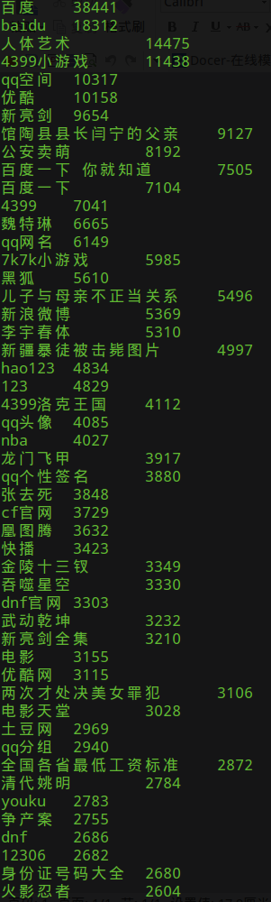

6UID 平均查询次数
hive> select sum(a.cnt)/count(a.uid) from (select uid,count(*) as cnt from 500w group by uid) a;
如图，UID 平均查询次数是3.6964094557111005。

7查询次数大于 2 次的用户总数
hive> select count(a.uid) from (select uid,count(*) as cnt from 500w group by uid having cnt > 2) a;
如图，查询次数大于 2 次的用户总数是546353。

8查询次数大于 2 次的数据展示（前50）
hive> create table as QUERYCNT2 select b.* from (select uid,count(*) as >cnt from 500w group by uid having cnt > 2) a
> join 500w b on a.uid=b.uid limit 50;
部分结果如图所示。
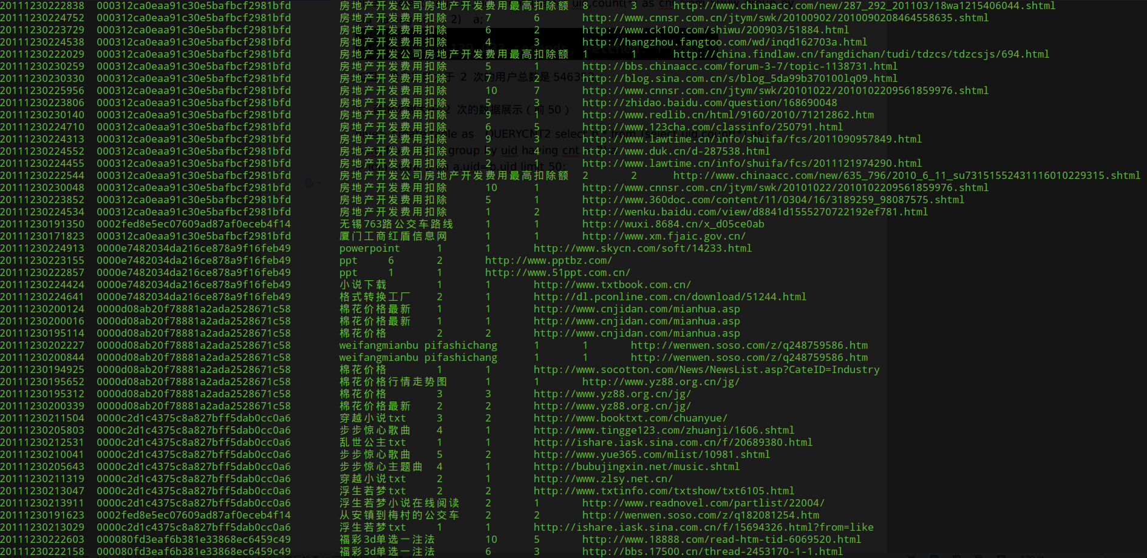

9查询次数大于 2 次的用户占比
A UID 总数：
hive> select count(distinct (uid)) from 500w;
B UID2 次以上的数量：
hive>select count(a.uid) from (
> select uid,count(*) as cnt from 500w group by uid having cnt > 2) a;
查询次数大于 2 次的用户占比为546353/1352664=0.4039088。

10点击次数与 Rank 之间的关系分析（Rank 在 10 以内的点击次数占比）
A:Rank在10以内的总点击数
hive> select count(*) from 500w where rank < 11;
Rank 在 10 以内的点击次数占比:4999869/5000000=0.9999738
用户只翻看搜索引擎返回结果的前 10 个结果，即返回结果页面的第一页。这个用户行为决定了尽管搜索引擎返回的结果数目十分庞大，但真正可能被绝大部分用户所浏览的，只有排在最前面的很小一部分而已。所以传统的基于整个结果集合查准率和查全率的评价方式不再适用于网络信息检索的评价，我们需要着重强调在评价指标中有关最靠前结果文档与用户查询需求的相关度的部分。

11直接输入 URL 查询的比例
hive> select count(*) from 500w where keyword like '%www%';
直接输入 URL 查询的比例:73979/5000000=0.0147958

12直接输入URL的查询中， 点击数点击的结果就是用户输入的URL的网址所占的比例
hive> select SUM(IF(instr(url,keyword)>0,1,0)) from
> (select * from 500w where keyword like '%www%') a;
27561/5000000=0.0055122
从这个比例可以看出，很大一部分用户提交含有URL的查询是由于没有记全网址等原因而想借助搜索引擎来找到自己想浏览的网页。因此搜索引擎在处理这部分查询的时候，一个可能比较理想的方式是首先把相关的完整URL地址返回给用户，这样有较大可能符合用户的查询需求。

13查询搜索过” 百度“的 uid，并且次数大于5
hive> select uid,count(*) as cnt from 500w where keyword='百度' group by uid having cnt > 5;
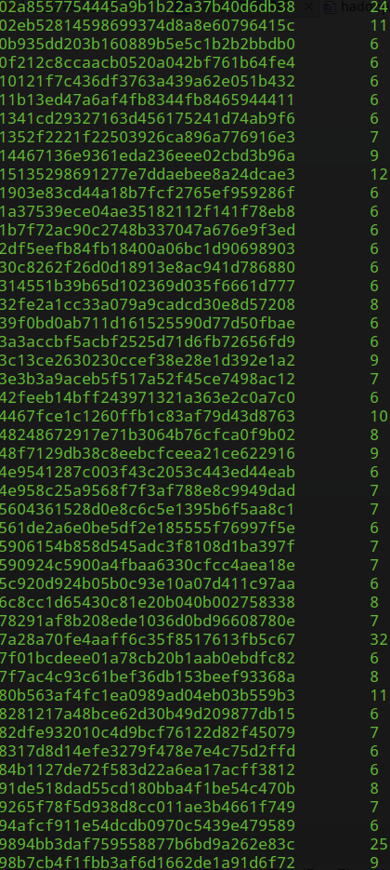
14
hive>select*from500w where uid='02a8557754445a9b1b22a37b40d6db38' and keyword like '%百度%';
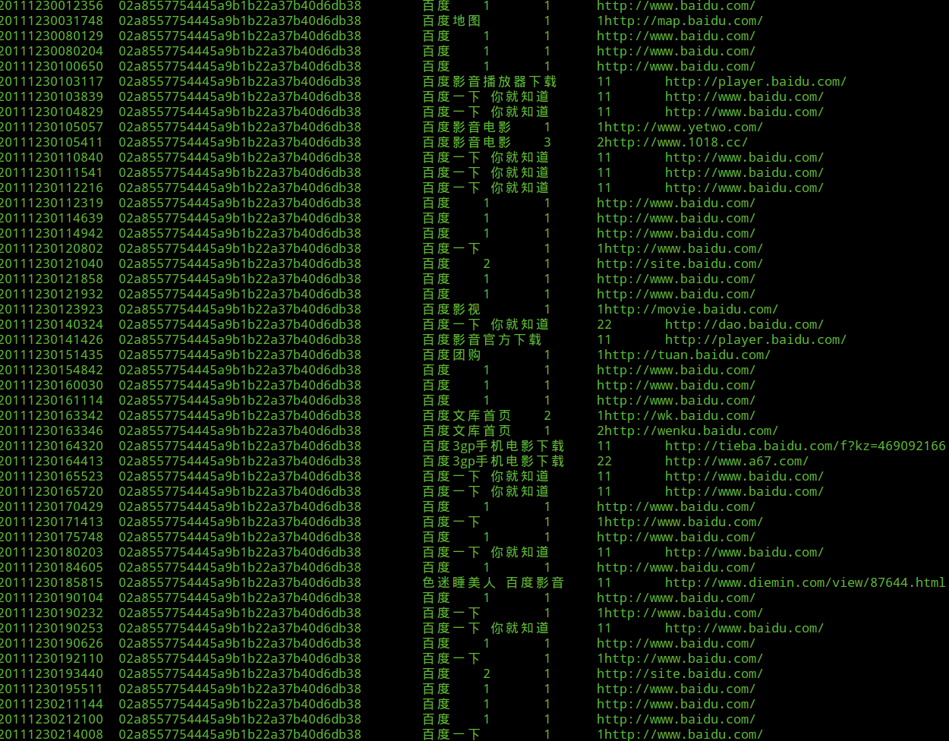
hive>select * from 500w where uid='9faa09e57c277063e6eb70d178df8529' and keyword like '%百度%';
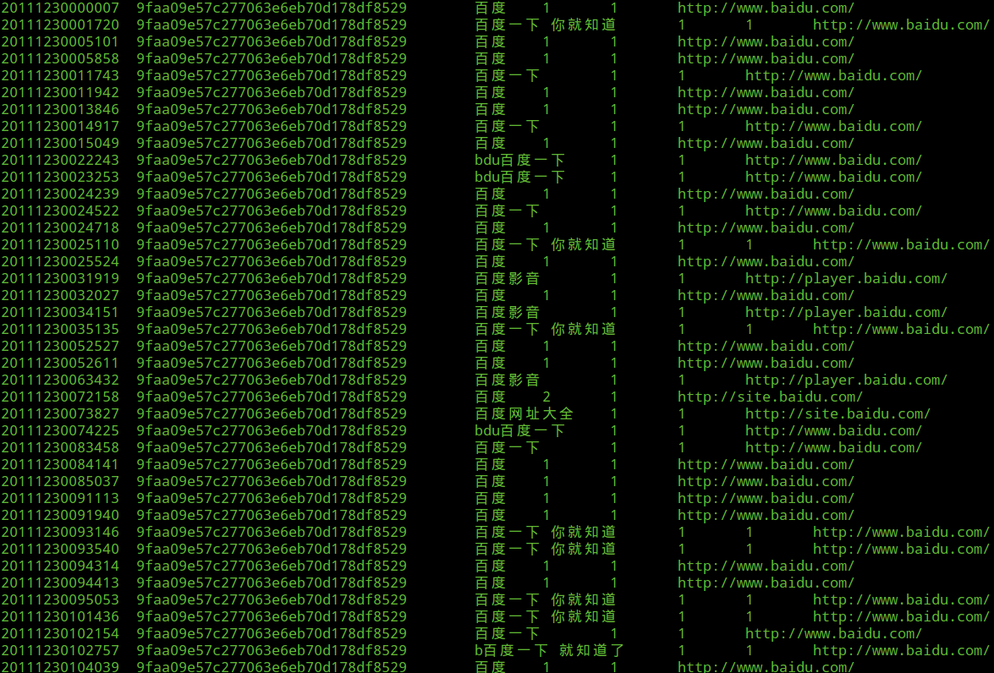

15查询排名前四十的网址
hive> select url,count(*) as cnt from 500w group by url order by cnt desc limit 40;
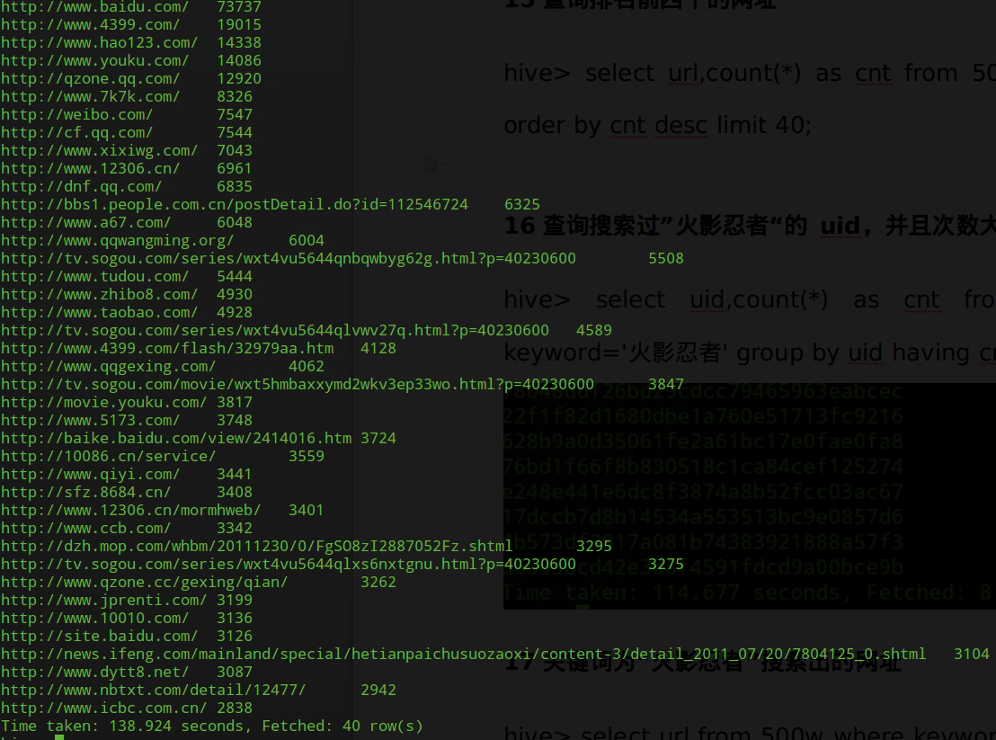

16查询搜索过”火影忍者“的 uid，并且次数大于2
hive> select uid,count(*) as cnt from 500w where keyword='火影忍者' group by uid having cnt > 2;
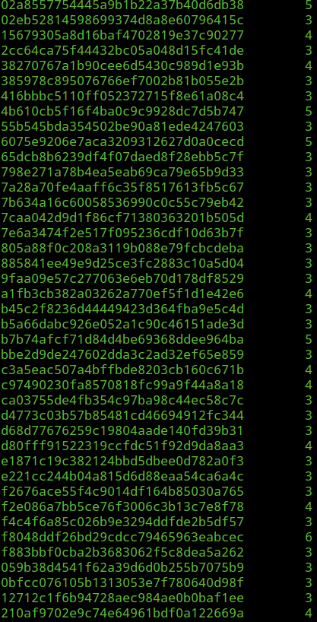

17关键词为“火影忍者”搜索出的网址
hive> select url from 500w where keyword='火影忍者' limit 50;
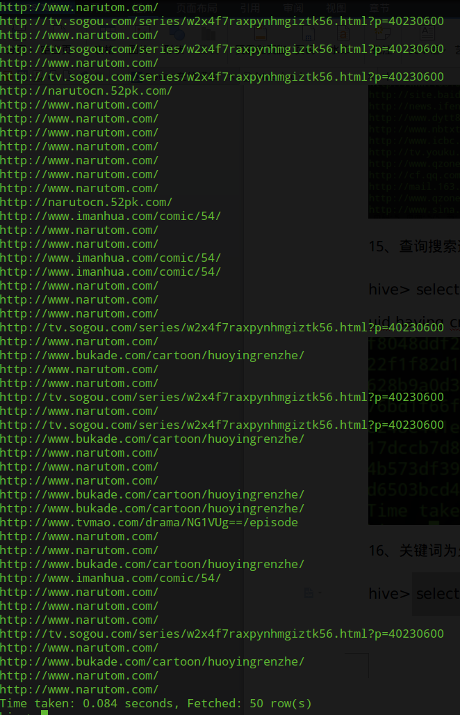

18搜索关键词为“火影忍者”的uid总数
hive> select count(*) from 500w where keyword='火影忍者' ;

19搜索关键词为“火影忍者”的时间
hive> select ts from 500w where keyword='火影忍者' limit 50;
