Excel Support Manual

Created on: Sep 30, 2010
Created by: Do Trong Nguyen
CodePlex

Revision History
No | Revised Content / Reason | PIC | Revised Day
1 | New creation | NguyenDT
2
3
4
5
6
7
8
9

Table of Contents
List of Tables 5
List of Figures 5
Overview 6
Overview 6
1 Installation 6
2 Menu overview 7
2.1 Sheet 7
2.1.1 Reduce File Size 7
2.1.2 Show sheet name 7
2.1.3 Show index sheet 7
2.1.4 Sort Sheet 7
2.1.5 Group Sheet by color 7
2.1.6 Clear Sheet 7
2.1.7 Combine Sheet 7
2.1.8 Add Sheet name number 7
2.1.9 Unhide Sheet 7
2.2 Cell 8
2.2.1 Auto Fit 8
2.2.2 Auto Fill Text 8
2.2.3 Border Cell 8
2.2.4 Merge Cell 8
2.2.5 Comment 9
2.3 Text 9
2.3.1 Bullet 9
2.3.2 Numbering 9
2.3.3 Paragraph 9
2.3.4 Split text to column 10
2.3.5 Extract Word 10
2.3.6 Increase/decrease font size 10
2.4 Row/Column 10
2.4.1 Delete blank row 10
2.4.2 Select row/column 10
2.5 Find and Replace 11
2.5.1 Find and highlight text 11
2.6 Print advance 11
3 Function overview 11

List of Tables
Table 1: List of function 8

List of Figures
Figure 1: Verification Preparation process flow chart 8
Figure 2: Peer Review process flow chart 12
Figure 3: Verification process flow chart 16

Overview
When creating test spec which has huge test cases, it can cost much human effort and causes many mistake if do it manually. To improve the productivity and quality of making test spec, user can use excel support add-in tool. This tool is not only useful for making test spec but also for excel user to create excel- document
This is first version of this tool and there’s some disadvantage, it will be upgraded in next version
This tool is open source, if you like VBA, you can contribute the development to make this tool more useful.
If you get any problem, feel free to contact me giaosucan1983@gmail.com

Installation
To install this tool, do following steps
- Open file ExcelSupport.xls
- Choose File/Save As “Microsoft Office Excel Add-in” and save this file as name “ExcelSupport.xla”
- Open Excel, choose Tool/Add-ins/Browse choose “ExcelSupport.xla”
- ExcelSupport Add-in tool automatic display in excel as a menu and toolbar
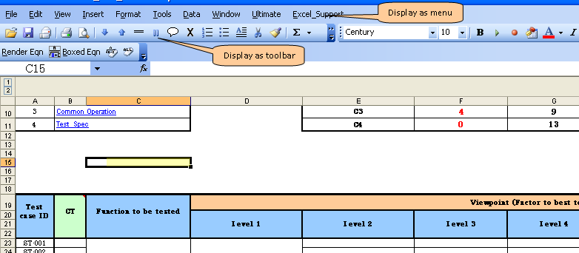
Figure 1: Display excel support add-in tool

Menu overview
  - Sheet

Reduce File Size
Automatic reduce excel file, help user easy to upload or transfer excel file

Show sheet name
Display Current Sheet name at active cell

Show index sheet
Short key: Ctrl+Shift+X
Display list of sheet name as popup menu, help user easy to manage sheets in workbook

Sort Sheet
Short key: Ctrl+Shift+S
Automatic Sort Sheet name as descendant or ascendant

Group Sheet by color
Automatic groups all sheets in workbook which have same color.

Clear Sheet
Automatic clear current sheet or all sheets in workbook

Combine Sheet
Can combine content of all sheets in workbook and output to a new sheet

Add Sheet name number
Automatic add number to beginning of sheet name. For example: 01_SheetName, 02_SheetXXX. (Also delete this number)

Unhide Sheet
Automatic unhide all sheets in workbook
  - Cell

Auto Fit
Short key: Ctrl+Shift+U

Make cell size is automatic fit with cell content

Auto Fill Text
Auto Fill any text to selection cell without overlap current text
For example: Before fill
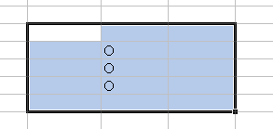
After fill
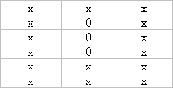

Border Cell
Short key: Ctrl+Shift+L
Draw border of range selection

Merge Cell
- Short key: Ctrl+Shift+M
Auto merge selection cell without lost text
- Short key: Ctrl+Shift+O
Combine texts in selection cell which need to merge
Etc: Cell 1: Nguyen, cell 2: PRDCV
Merge cell 1 & cell 2: Nguyen PRDCV

Comment
There are functions with comment
- Change format of comment
- Auto inserts comment in multi-selection cell
- Resize comment to fit its content
- Auto Show/Hide sheet comment
- Copy all comment to a new sheet

  - Text

Bullet
- Short key: Ctrl+Shift+B
Auto add any bullet to multi-line text in selection cells
For example
Line 1
Line 2
Line 3
Line 1
Line 2
Line 3
If user adds bullet “-“becomes
-Line 1
-Line 2
-Line 3
-Line 1
-Line 2
-Line 3

Numbering
Auto adds numbering or delete to multi-line text in selection cells similar to 2.3.1
User can choose various type of numbering

Paragraph
Auto paragraphs multi-line text in selection cells

Split text to column
- Short key: Ctrl+Shift+P
Extract all lines in selection cells in to each line
For example: Before
Line 1
Line 2
Line 3
Line 1
Line 2
Line 4
After
Line 1 | Line 2 | Line 3
Line 1 | Line 2 | Line 4

Extract Word
- Short key: Ctrl+Shift+W
Extract each word in a sentence.

Increase/decrease font size
Click the icon narrow in toolbar to increase/decrease font size. This command will increase and decrease font size with visual view.
  - Row/Column

Delete blank row
Automatic delete blank row in current sheet

Select row/column
Click the icon = or || in toolbar
Select row/column in data range
  - Find and Replace

Find and highlight text
Automatic find a text in selection range and change its format
Etc: Find “CodePlex” in we’re CodePlex → we’re CodePlex
  - Print advance
Advance print function in excel, support many type of print

Function overview
This tool included some more functions for excel user
Table 1: List of function
No. | Name | Parameter | Description
 | AddNumbering | Para1: Cell | Add number to text line in cell
 | StripOutCharType | Para1: Cell  Para2  True: Delete number  False: Delete text  Para3 : Specified char to keep  Para4: Specified char to delete | Remove number or alphabet char in string
 | Name | Para1: Cell  Para2: Number of word in name to be removed | Removed word in name at specified position
 | NameShort | Para1: Cell | Change complete name to shortcut name  Etc: Nguyen Do Trong → NDTrong

