|  |  |
| --- | --- |
|  | **FPT ACADEMY INTERNATIONAL**  **FPT – APTECH COMPUTER EDUCATION** |

***Centre Name: ACE-HCMC-2-FPT***

***Address: 590 Cach Mang Thang 8, District 3, Ho Chi Minh City, Viet Nam.***

**FURNITURE STORE**

|  |  |  |
| --- | --- | --- |
| **Supervisor:** | Mr. NGO PHUOC NGUYEN | |
| **Semester:** | 4 | |
| **Batch No:** | T1.2011.E1 | |
| **Group No:** | 3 | |
| **Members:** | **Full name** | **Roll No.** |
| 1 | lE GIA PHUC | Student1093602 |
| 2 | NGUYEN MINH TRUNG TRUC | STUDENT1141449 |

November 2020

# REVIEW 1

Table of Contents

1. Introduction 4

II. Existing Scenario 4

III. Requirement Specifications 4

1. Functional Requirement Specifications 4

a) Functions for Anonymous 4

b) Functions for Customer 5

c) Functions for Administrator 5

2. System Requirement Specifications 7

a) Server requirements 7

b) Client requirements 8

3. Technologies 8

IV. Task Sheet Review 1 9

V. E-R Diagram 9

VI. FurnitureStore.com 13

# Introduction

Furniture Store is a company that sells furniture. They started out as a small local business, making and selling furniture to those around them in a small city. After several years in business, Furniture Store has become a famous name in the area. They sell furniture at a variety of prices and designs for customers to choose from. They are always trusted and satisfied by customers with the value of the product and reasonable prices.

# Existing Scenario

Furniture Store was established in 2010, is a furniture retail chain with a large market share in Vietnam. The company has nearly 10 years in retail business of technology products with 10 stores in Hanoi and Ho Chi Minh City and is one of the 5 largest systems in Vietnam.

# Requirement Specifications

## Functional Requirement Specifications

### Functions for Anonymous

* Register
* Login
* View list product
* View product detail
* Search product
* Add product to cart
* View shopping cart
* Update shopping cart
* Check out

### Functions for Customer

* All functions of Anonymous
* Rating
* View rating
* Update rating
* Manage profile
* View profile
* Update profile
* Change password
* Manage order
* View history order
* Manage wishlist
* View wishlist
* Remove wishlist

### Functions for Administrator

* Login / Logout
* Manage profile
* View profile
* Update profile
* Change password
* Manage customers
* View customers
* Change status
* Manage orders
* View orders
* Change status
* Manage categories
* View category list
* Add category
* Update category
* Change status
* Manage types
* View types
* Insert type
* Update type
* Change status
* Manage brands
* View brands
* Insert brand
* Manage products
* View products
* Insert product
* Update product
* Change status
* Income report
* View report by Categories, Brands
* Priny report

## System Requirement Specifications

### Server requirements

* Hardware:

|  |  |
| --- | --- |
| **Component** | **Requirement** |
| CPU | 2.0 Ghz or faster |
| Memory | Minimum: 2Gb  Recommended: 4Gb or more |
| Hard Drive | Free space:  Minimum: 1Gb Mb  Recommended: 10Gb or more |

* Software:

|  |  |  |
| --- | --- | --- |
| **Component** | | **Requirement** |
| Operating System | Windows | |
| Java Runtime Environment | | JRE 1.8.0 |
| Application Server | | Glassfish Server (Version 4.0) |
| Database Server | | Microsoft SQL Server 2012 |



### Client requirements

* Hardware:

|  |  |
| --- | --- |
| **Component** | **Requirement** |
| CPU | 2.0 Ghz or faster |
| OS | Windows |
| Memory | Minimum: 1Gb  Recommended: 2Gb or more |

* Software:

|  |  |
| --- | --- |
| **Component** | **Requirement** |
| Web browser | Google Chrome, Mozilla Firefox, Microsoft Edge,  Safari... (You should use latest version) |

## 

## Technologies

* Java EE 7
* Java Server Faces 2.2
* Enterprise Java Beans (EJB)
* Boostrap & Jquery
* HTML 5 & CSS 3
* JavaScript
* jQuery
* Ajax

# TASK SHEET REVIEW 1

|  |  |  |  |  |  |  |
| --- | --- | --- | --- | --- | --- | --- |
| **Project Ref. No.** | | **Project Title** | **Activity Plan** **Prepared** **By** | **Date of Preparation of Activity Plan** | | |
| **No.** | **Task** | **Actual Start Date** | **Team Mate Names** | **Status** |
| 1 | Introduction | FURNITURE STORE | All team members | 24/11/2020 | All team members | Completed |
| 2 | Existing Scenario | Completed |
| 3 | Requirement Specifications | Completed |

# E-R DIAGRAM

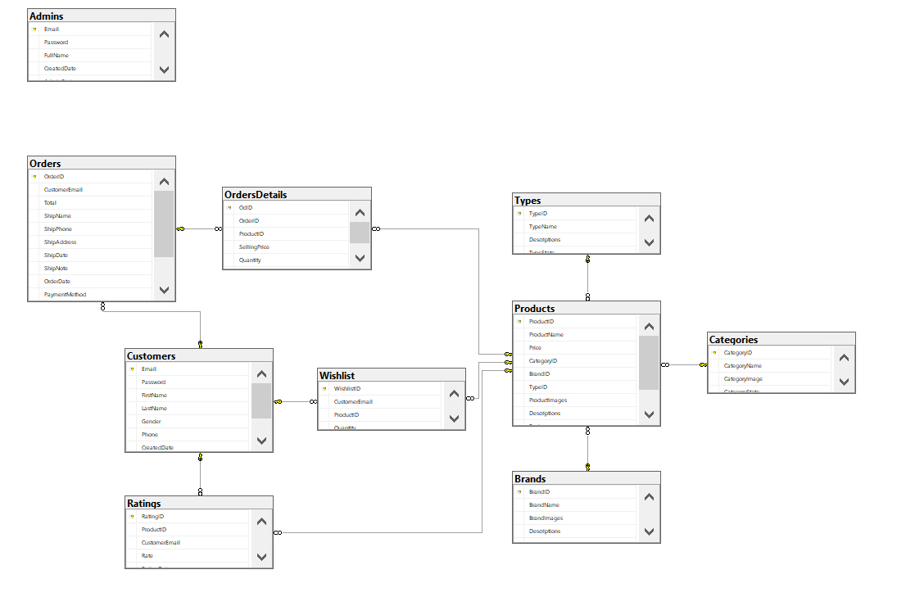

## 1. Admins

## 2. Brands

## 3. Categories

## 4. Customers

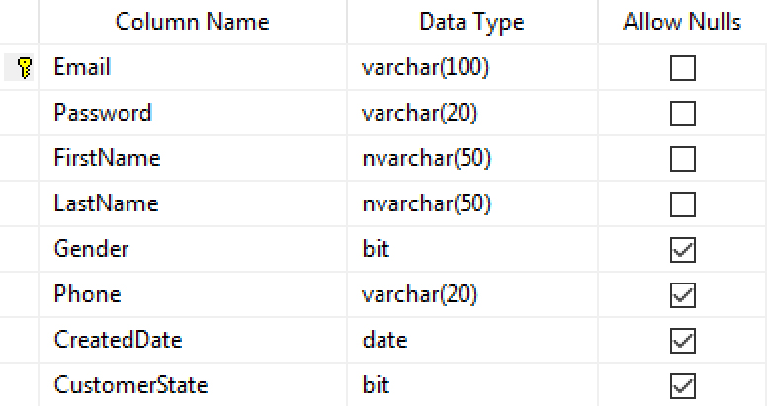

## 5. Orders

## 6. OrdersDetails

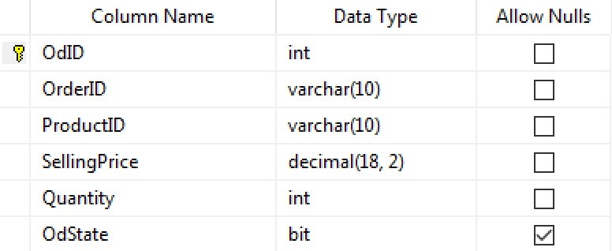

## 7. Products

## 8. Ratings

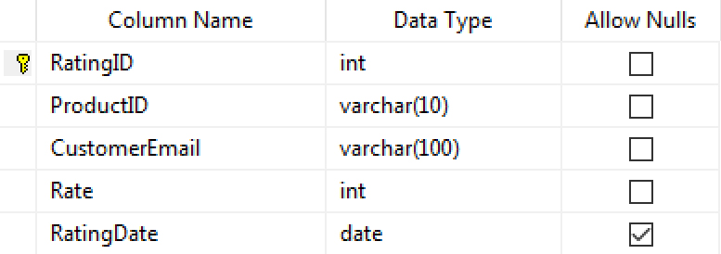

## 9. Types

## 10. Wishlist

# FURNITURESTORE.COM