**REVIEW 2**

# Architecture Of Project

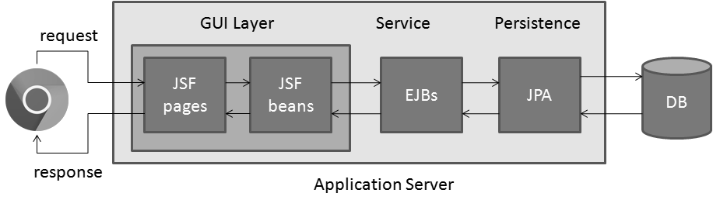

# Use Case Diagrams

1. **Anonymous & Customer Use Case**

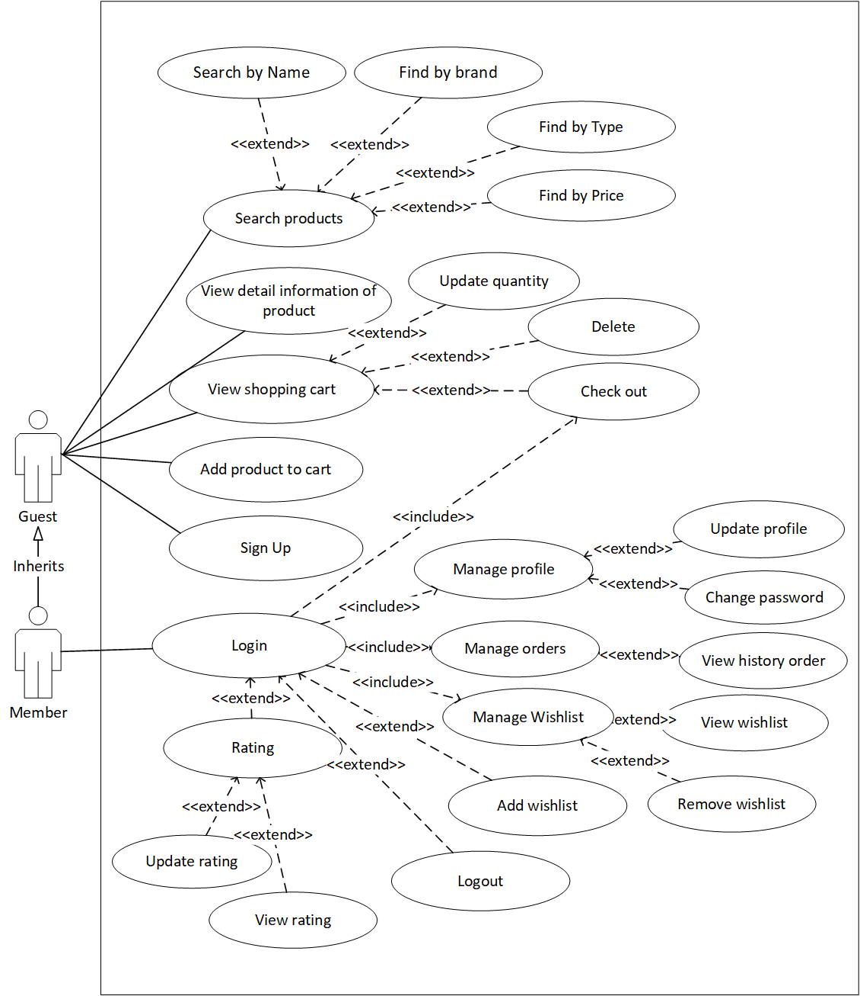

1. **Admin Use Case**

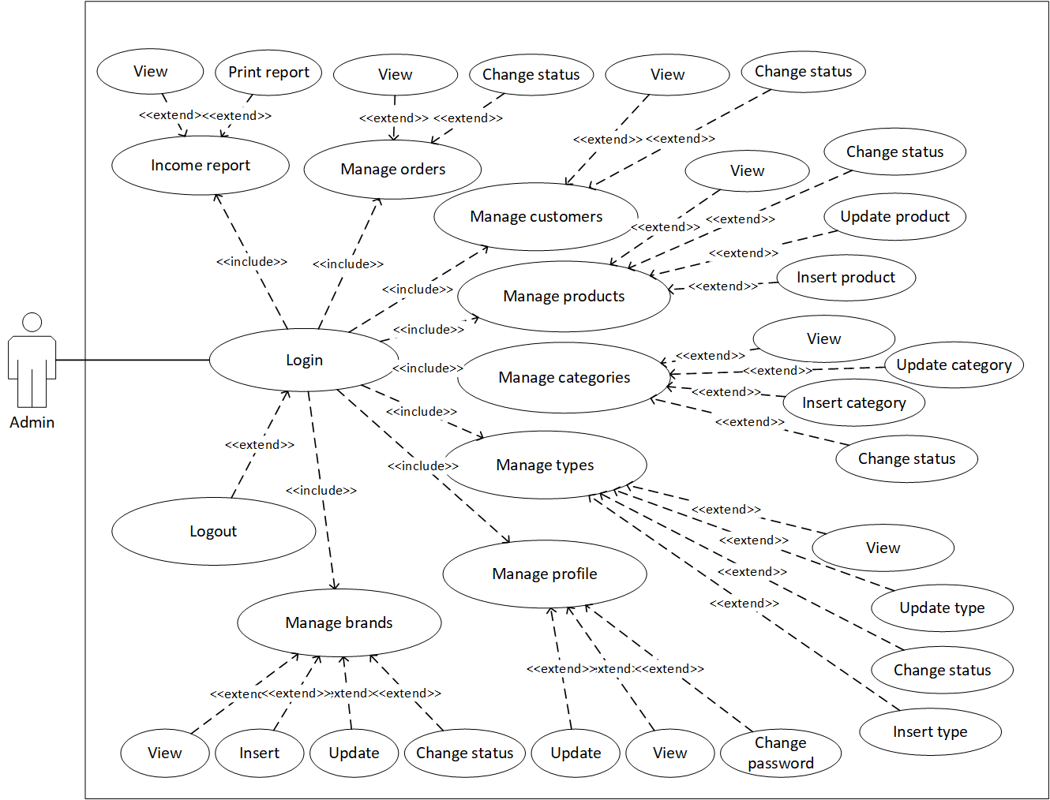

# Flow Chart

1. 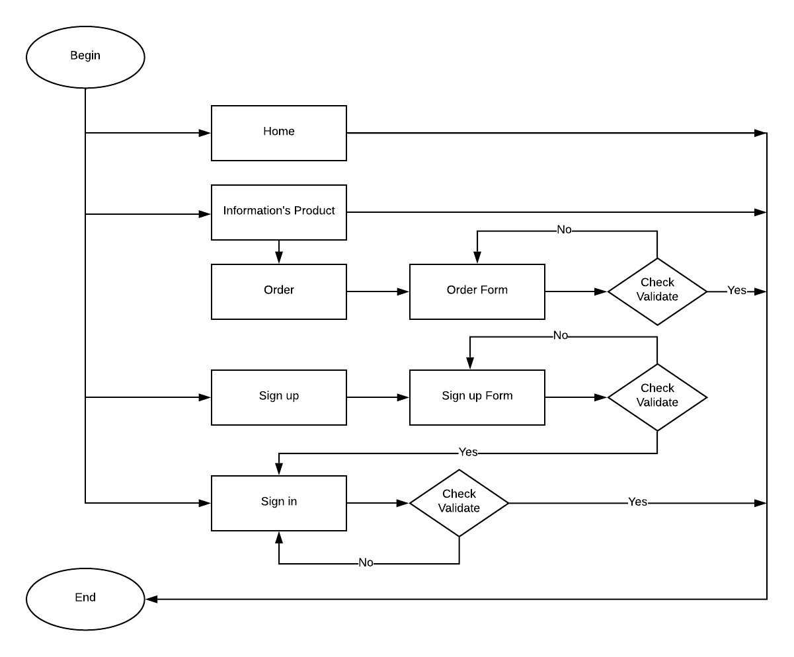**Anonymous**
2. **Customers**

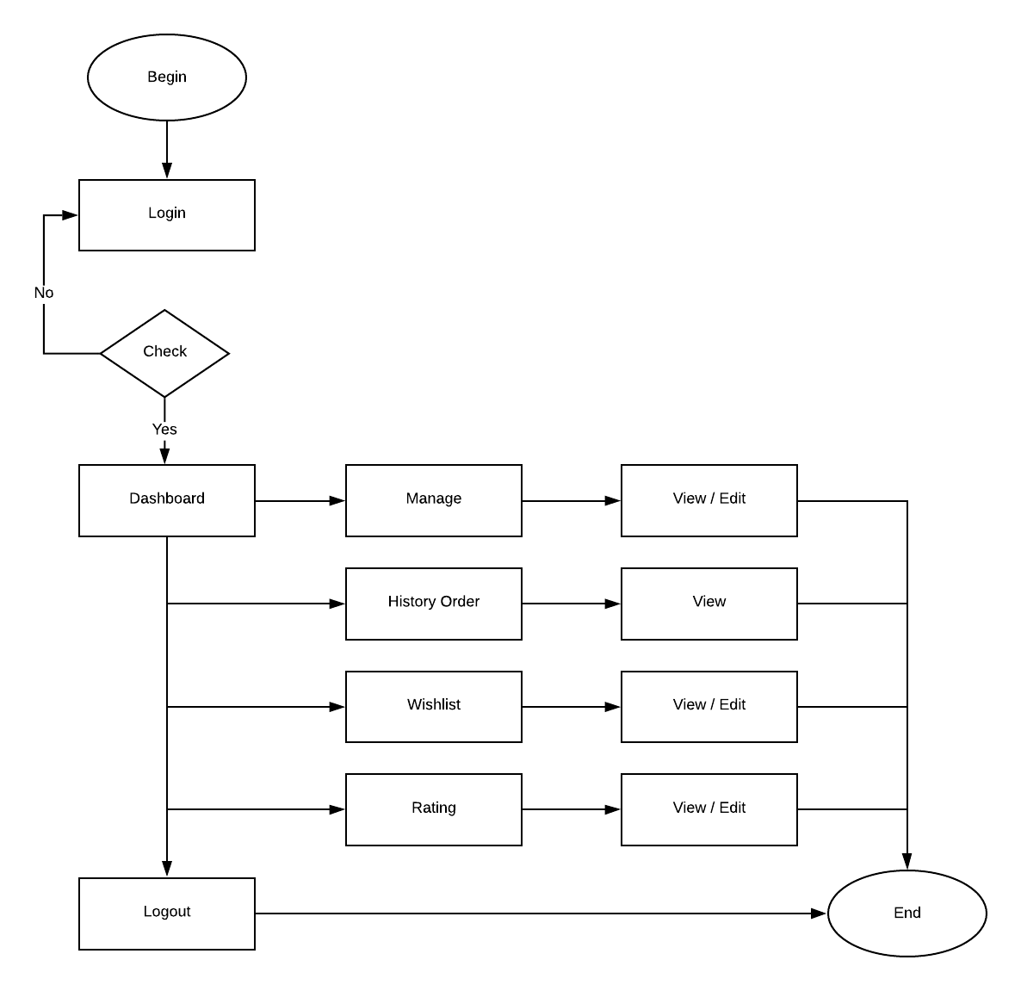

1. **Administrators**

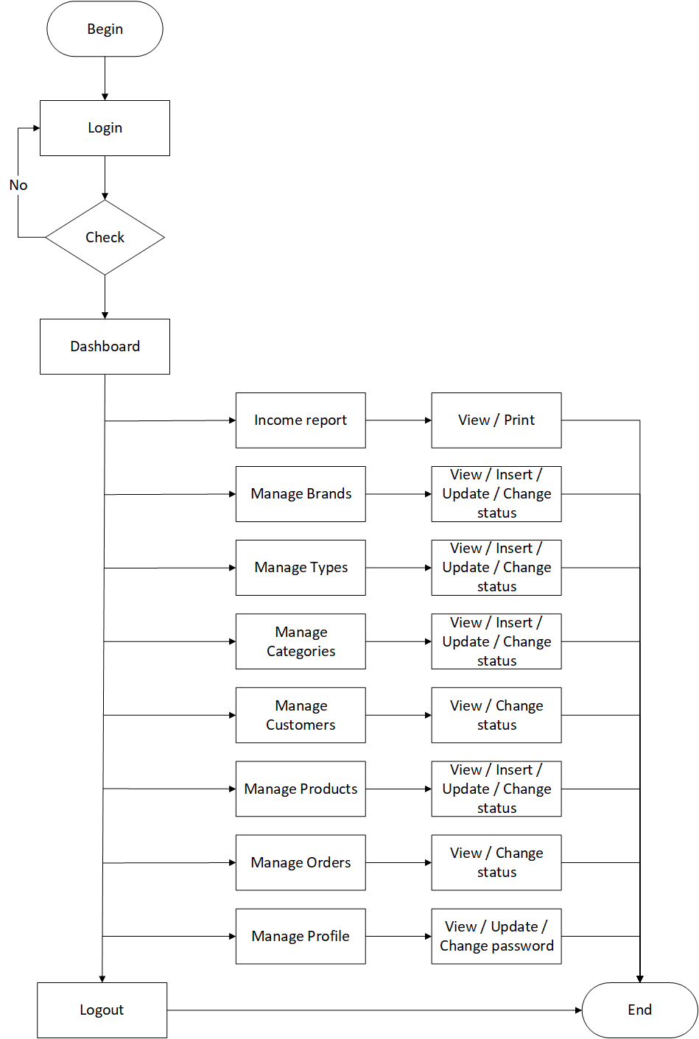

# Sequence Diagrams

1. **Sign up**

|  |  |  |
| --- | --- | --- |
| **Author** | NGUYỄN MINH TRUNG TRỰC | |
| **Use case name** | Sign Up | |
| **Actors** | Guests | |
| **Description** | Guest wants to sign up with the website to become a member | |
|  | **Actor Actions** | **System Responses** |
| **Basic flow** | 1. Input information clicks on Submit button. | 1. Check the information [Exception 1]. 2. Create customer account. 3. Display login page. |
| **Exception** | **[Exception 1]**   1. Actor left First Name blank. 2. Actor left Last Name blank. 3. Actor left Phone Number blank. 4. Actor left Gender blank. 5. Actor left Email blank. 6. Email is in wrong format. 7. Password length is greater than 3. 8. Confirm Password does not match with Password. | **Display error message:**   1. “First Name can’t be blank”. 2. “Last Name can’t be blank”. 3. “Phone Number can’t be blank”. 4. “Gender can’t be blank”. 5. “Email can’t be blank”. 6. “Email is in wrong format”. 7. “Password length must be greater than 3”. 8. Confirm Password does not match with Password”. |

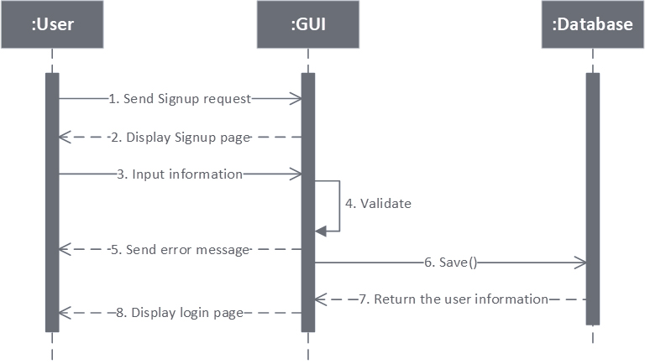

1. 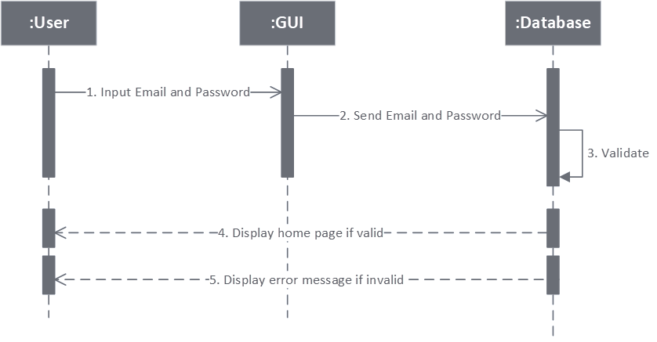**Customers – Login**

|  |  |  |
| --- | --- | --- |
| **Author** | NGUYỄN MINH TRUNG TRỰC | |
| **Use Case Name** | Login | |
| **Actors** | Members | |
| **Description** | Actor login with their email and password | |
|  | **Actor Actions** | **System Responses** |
| **Basic Flow** | 1. Input email and password, clicks on Submit button | 2. System check email and password [Exception 1]  3. System tracks the use’s information and display Home page |
| **Exception** | **[Exception 1]**  1. Actor left the Email blank  2. Actor left the Password blank  3. Actor inputs wrong email or password | **Display error message:**   1. “Email can’t be blank” 2. “Password can’t be blank” 3. “Wrong Email or Password” |

1. **Customers – Update information**

|  |  |  |
| --- | --- | --- |
| **Author** | NGUYỄN MINH TRUNG TRỰC | |
| **Use Case Name** | Update information | |
| **Actors** | Members | |
| **Description** | Customer want to change their private information | |
| **Requirements** | Login as member | |
|  | **Actor Actions** | **System Responses** |
| **Basic Flow** | 1. Actor change First Name, Last Name, Phone, Gender | 2. System check information [Exception 1]  3. Update new information to data in Customers table. |
| **Exception** | **[Exception 1]**  1. Actor left First Name blank  2. Actor left Last Name blank  3. Actor left Phone Number blank  4. Actor left Gender blank | **Display error message:**  1. “First Name can not be blank”  2. “Last Name can not be blank”  3. “Phone Number can not be blank”  4. “Gender can not be blank” |

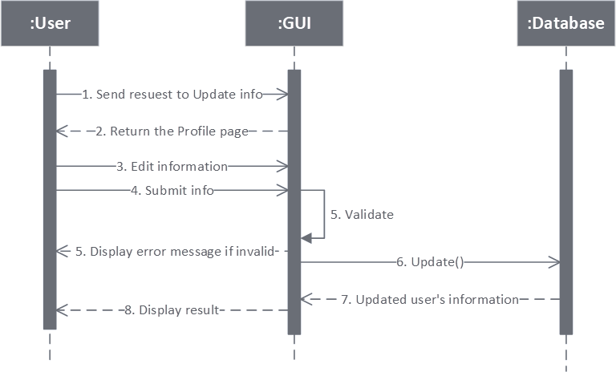

1. **Member – Change password**

|  |  |  |
| --- | --- | --- |
| **Author** | NGUYỄN MINH TRUNG TRỰC | |
| **Use Case Name** | Update information - Change password | |
| **Actors** | Members | |
| **Description** | Customer want to change the registered password | |
| **Requirements** | Login as member | |
|  | **Actor Actions** | **System Responses** |
| **Basic Flow** | 1. Input Old Password, New Password and Confirm Password | 2.Check information [Exception 1]  3.Update New Password into Customers table |
| **Exception** | **[Exception 1]**  1. Old Password is wrong  2. New Password length is less than 3  3. Confirm Password does not match with New Password | **Display error message:**  1. “Old Password is wrong”  2. “New Password length is less than 3”  3. “Confirm Password does not match with New Password” |

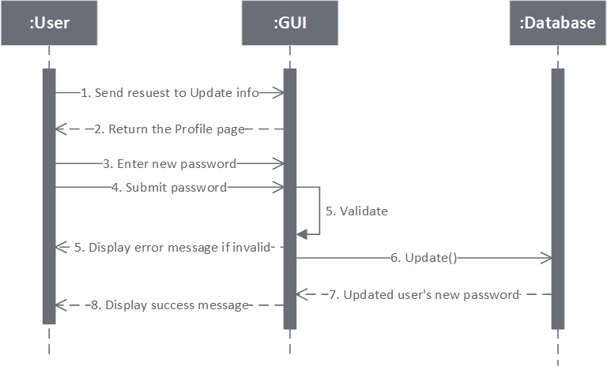

1. **Manage Order – View history orders**

|  |  |  |
| --- | --- | --- |
| **Author** | NGUYỄN MINH TRUNG TRỰC | |
| **Use Case Name** | Manage orders – View history orders | |
| **Actors** | Members | |
| **Description** | Customers can view all orders they made | |
| **Requirements** | Login as member | |
|  | **Actor Actions** | **System Responses** |
| **Basic Flow** | 1. Click on Orders page link | 2. System search all Orders and Orders Details which satisfy the current customerID and display in Orders page. |

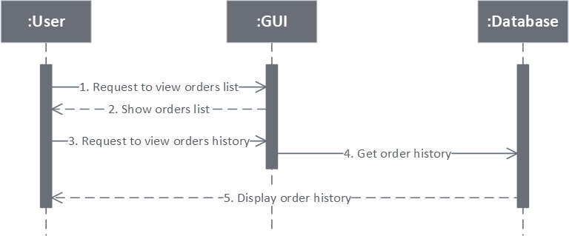

1. 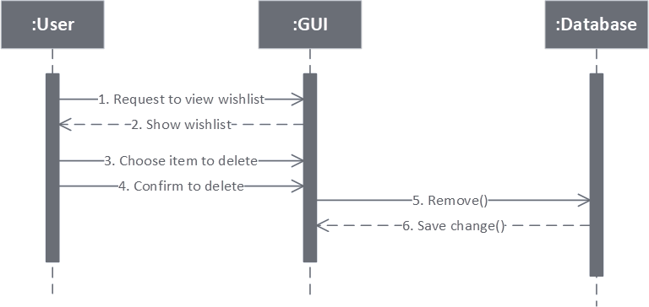**Manage Wishlist – Remove Wishlist**

|  |  |  |
| --- | --- | --- |
| **Author** | LÊ GIA PHÚC | |
| **Use Case Name** | Manage wishlist – Remove wishlist items | |
| **Actors** | Members | |
| **Description** | Customers can remove items in their wishlists | |
| **Requirements** | Login as member | |
|  | **Actor Actions** | **System Responses** |
| **Basic Flow** | 1. Clicks on Remove/Clear All button  2. Clicks on “Yes” to confirm removing  3. Clicks on “No” to cancel removing | 4. Display 2 buttons: “Yes” and “No”  5. Remove chosen item(s) from wishlist and data in Wishlist table  6. Hide the 2 buttons |

1. 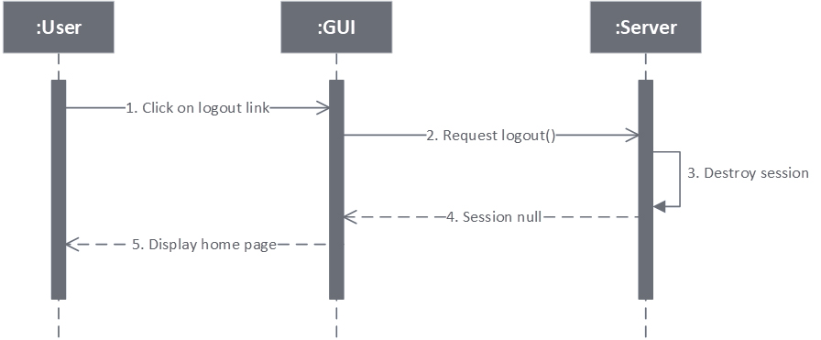**Logout**

|  |  |  |
| --- | --- | --- |
| **Author** | NGUYỄN MINH TRUNG TRỰC | |
| **Use Case Name** | Logout | |
| **Actors** | Member | |
| **Description** | Member logout | |
| **Requirements** | Login as member | |
|  | **Actor Actions** | **System Responses** |
| **Basic flow** | 1. Click “Logout” link | 1. Display home page. |

1. **Admin – Login**

|  |  |  |
| --- | --- | --- |
| **Author** | NGUYỄN MINH TRUNG TRỰC | |
| **Use Case Name** | Login | |
| **Actors** | Admin | |
| **Description** | Admin login | |
| **Requirements** | Login as admin | |
|  | **Actor Actions** | **System Responses** |
| **Basic flow** | 1. Input email and password, click on Login button. | 2. System check email and password [Exception 1]  3. Display admin page |
| **Exception** | [Exception 1]   1. Actor left the email blank 2. Actor input wrong email 3. Actor left the password blank 4. Actor input wrongs email or password | Display error message:   * “Email can not be blank” * “Email is invalid” * “Password cannot be blank” * “Wrong Email or Password” |

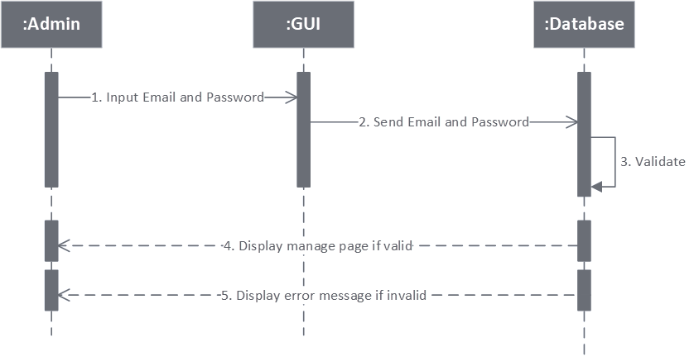

1. **Admin – Update information**

|  |  |  |
| --- | --- | --- |
| **Author** | NGUYỄN MINH TRUNG TRỰC | |
| **Use Case Name** | Update information | |
| **Actors** | Admin | |
| **Description** | Admin want to change private information | |
| **Requirements** | Login as admin | |
|  | **Actor Actions** | **System Responses** |
| **Basic flow** | 1. Actors change Full Name | 2. System check information [Exception 1]  3. Update new information to data in Admins table. |
| **Exception** | [Exception 1]  1. Actor left Full Name blank | Display error message:  1. “Full Name can not be blank” |

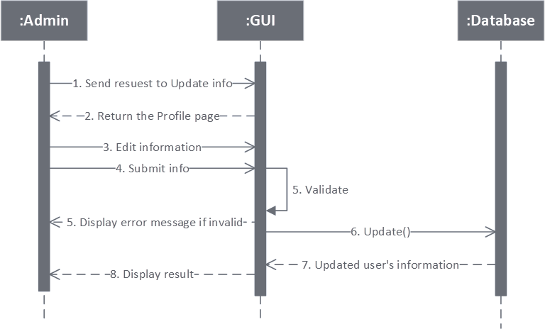

1. **Admin – Change password**

|  |  |  |
| --- | --- | --- |
| **Author** | NGUYỄN MINH TRUNG TRỰC | |
| **Use Case Name** | Update information – Change password | |
| **Actors** | Admin | |
| **Description** | Admins want to change password | |
| **Requirements** | Login as admin | |
|  | **Actor Actions** | **System Responses** |
| **Basic flow** | 1. Input Old Password, New Password and Confirm Password | 2. Check information  [Exception 1]  3. Update New Password into Admin table |
| **Exception** | **[Exception 1]**  1. Old Password is wrong.  2. New Password length is less than 3  3. Confirm Password does not match with New Password | **Display error message:**   1. “Old Password is wrong” 2. “New Password length is less than 3” 3. - “Confirm Password does not match with New Password” |

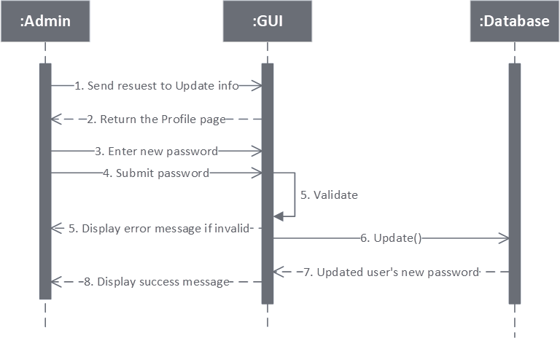

1. **Admin – Change status Customer**

|  |  |  |
| --- | --- | --- |
| **Author** | NGUYỄN MINH TRUNG TRỰC | |
| **Use Case Name** | Change status Customers | |
| **Actors** | Admin | |
| **Description** | Admin want to disable existed customers | |
| **Requirements** | Login as admin | |
|  | **Actor Actions** | **System Responses** |
| **Basic flow** | 1. Click on Disable button  3. Click on “Yes” to confirm disable  5. Click on “No” to cancel disable | 2. Display 2 buttons: “Yes” and “No”  4. Change status value of Customers.  6. Hide the 2 buttons.  7. Display Customers page |

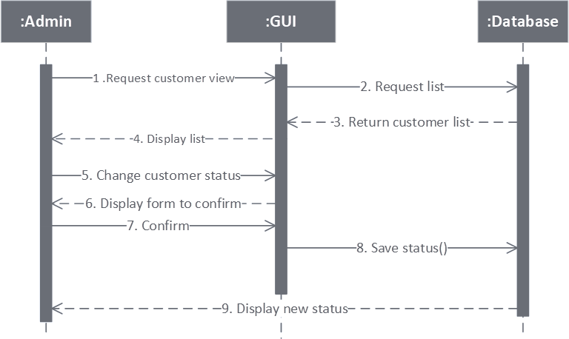

1. **Admin – Logout**

|  |  |  |
| --- | --- | --- |
| **Author** | NGUYỄN MINH TRUNG TRỰC | |
| **Use Case Name** | Logout | |
| **Actors** | Admin | |
| **Description** | Admin logout | |
| **Requirements** | Login as admin | |
|  | **Actor Actions** | **System Responses** |
| **Basic flow** | 1. Click “Logout” link | 1. Display Login admin page. |

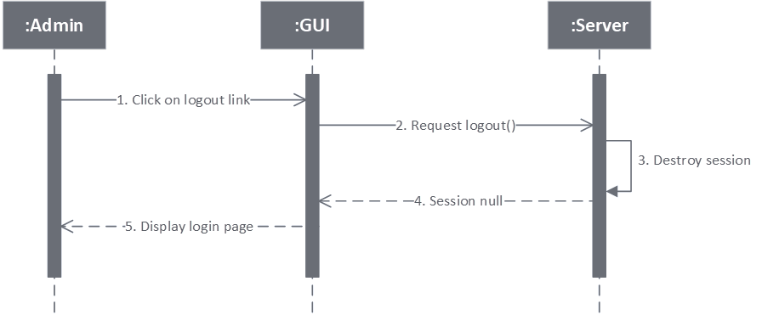

1. 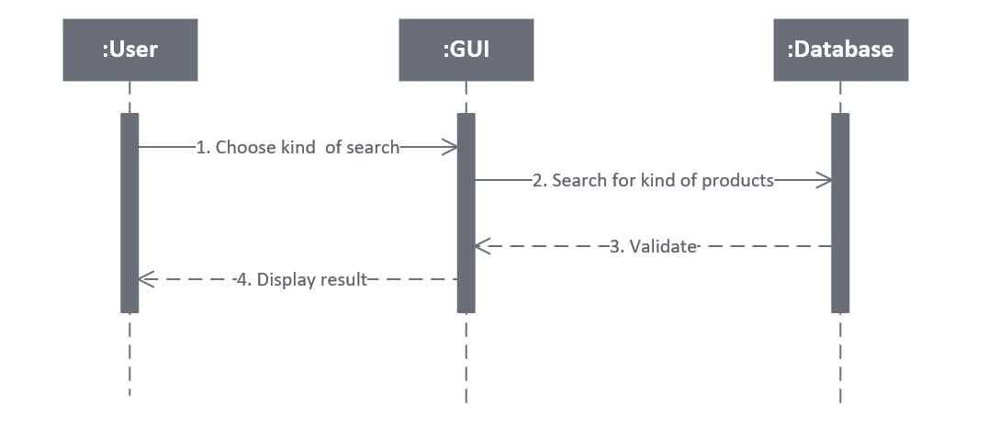**Search Product**

|  |  |  |
| --- | --- | --- |
| **Author** | LÊ GIA PHÚC | |
| **Use Case Name** | Search Product | |
| **Actors** | Guests and Members | |
| **Description** | Allows customers view all products which are in the same name, categories, types or have prices in special range. Products will be displayed with the pagination. | |
| **Requirements** | Search product by name: Search result appear in a panel right below the search field, which contains name and product’s image.  Links of Categories, Types must be clicked, or range of prices must be chosen. | |
|  | **Actor Actions** | **System Responses** |
| **Basic flow** | 1. Typing in search filed or Actor input search string and click on search button or Clicks on links of Categories, Types, or select range of prices. | 1. Validate Databse 2. Display the list in the products page. |
| **Exception** | 1. Search button: Actor left the search string empty. | 1. An error message will be displays: “Search string can’t be blank”. |

1. 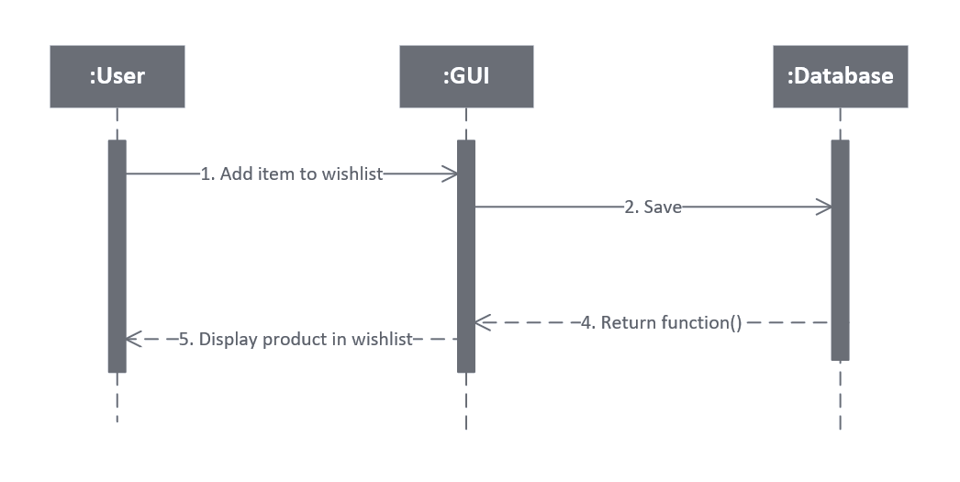**Add wishlist**

|  |  |  |
| --- | --- | --- |
| **Author** | LÊ GIA PHÚC | |
| **Use Case Name** | Add wishlist | |
| **Actors** | Members | |
| **Description** | When customers click add wishlist link in product detail page, a wishlist page will display. | |
|  | **Actor Actions** | **System Responses** |
| **Basic flow** | 1. Clicks on wishlist links. | 1. Add product to wishlist 2. Display the wishlist page |

1. **Rating**

|  |  |  |
| --- | --- | --- |
| **Author** | LÊ GIA PHÚC | |
| **Use Case Name** | Rating | |
| **Actors** | Members | |
| **Description** | Customers want to rate for products (from 1 to 5 stars), if rated, they can view their ratings and can update ratings. | |
| **Requirements** | Login as member | |
|  | **Actor Actions** | **System Responses** |
| **Basic Flow** | 1. Clicks on stars (include 5 stars) to rate for products and clicks on Submit/Ute button. | 2. System search in Ratings table to find record contains current productID:  + if found, update the value of current rating to new rating.  + else, create new record with the current productID and rating values  3. Display new rating in SingleProduct Page |

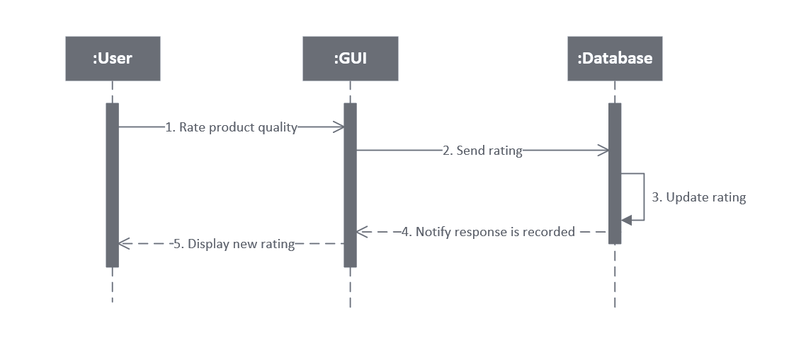

1. **Admin – Income** 
   1. **Report By Brand**

|  |  |  |
| --- | --- | --- |
| **Author** | LÊ GIA PHÚC | |
| **Use Case Name** | Income report by brand | |
| **Actors** | Admin | |
| **Description** | Admin want to view and print report | |
| **Requirements** | Login as admin | |
|  | **Actor Actions** | **System Responses** |
| **Basic flow** | 1. Click income report by Brand link | 1. Display report by Brand |

* 1. 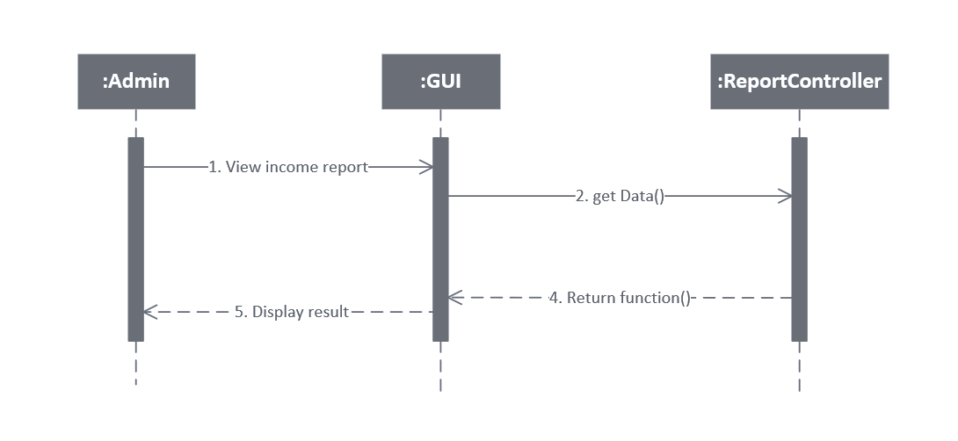**Report By Category**

|  |  |  |
| --- | --- | --- |
| **Author** | NGUYỄN MINH TRUNG TRỰC | |
| **Use Case Name** | Income report by category | |
| **Actors** | Admin | |
| **Description** | Admin want to view and print report | |
| **Requirements** | Login as admin | |
|  | **Actor Actions** | **System Responses** |
| **Basic flow** | 1. Click income report by Category link | 1. Display report by Category |



1. **Manage Brand – Insert**

|  |  |  |
| --- | --- | --- |
| **Author** | LÊ GIA PHÚC | |
| **Use Case Name** | Manage brands – Insert | |
| **Actors** | Admin | |
| **Description** | Admin want to insert new brand | |
| **Requirements** | Login as admin | |
|  | **Actor Actions** | **System Responses** |
| **Basic flow** | 1. Input information to input fields: Name, image and Description. Then clicks on Insert button. | 2. System check the information [Exception 1]  3. Create new brand in database  4. Display brand page. |
| **Exception** | [Exception 1]  1. Actor left Name blank | Display error message:   1. “Name can not be blank” |

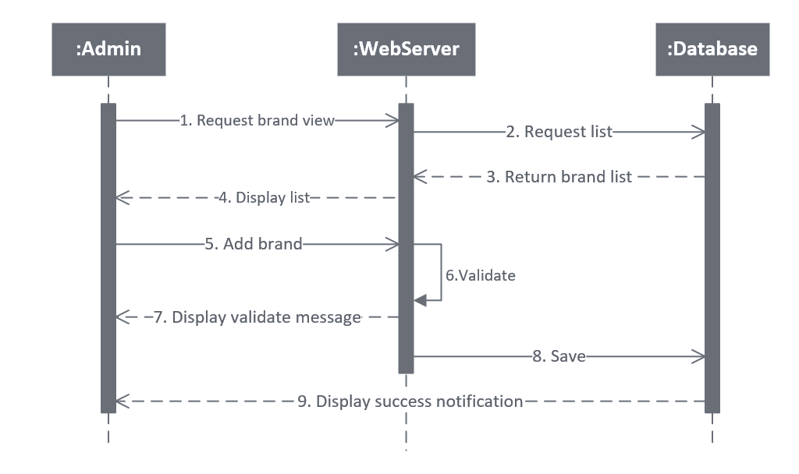

1. **Manage Brand – Update**

|  |  |  |
| --- | --- | --- |
| **Author** | LÊ GIA PHÚC | |
| **Use Case Name** | Manage Brands – Update | |
| **Actors** | Admin | |
| **Description** | Admin want to update brand | |
| **Requirements** | Login as admin | |
|  | **Actor Actions** | **System Responses** |
| **Basic flow** | 1. Input information to input fields: Name, Image and Description. Then clicks on Update button. | 2. System check the information [Exception 1]  3. Update existed brand in database  4. Display Brand page |
| **Exception** | [Exception 1]  1. Actor left Name blank | Display error message:  - “Name can not be blank |

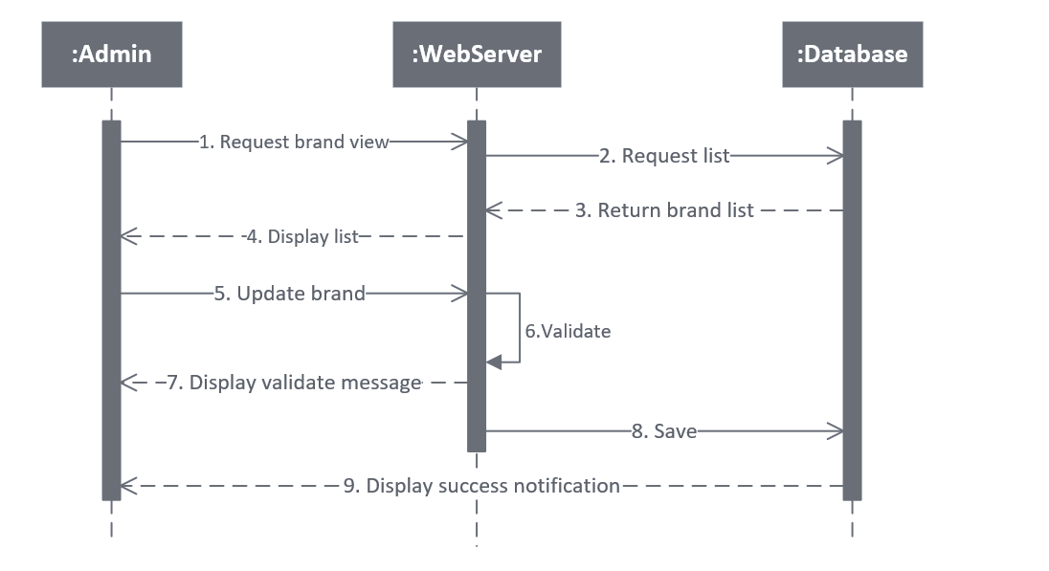

1. 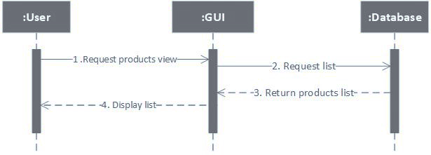**View product detail**

|  |  |  |
| --- | --- | --- |
| **Author** | LÊ GIA PHÚC | |
| **Use Case Name** | View product details | |
| **Actors** | Guests and Members | |
| **Description** | When customers click on any products’ link, a page will display to show all products’ information. | |
|  | **Actor Actions** | **System Responses** |
| **Basic flow** | 1. Clicks on products’ links. | 1. Receive parameters passing with the links and search products which have product ID satisfied with the parameters. 2. Display the product details |

1. 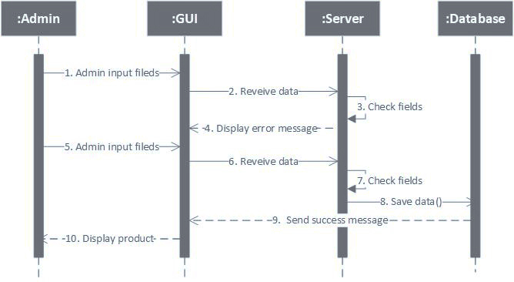**Manage Product – Insert**

|  |  |  |
| --- | --- | --- |
| **Author** | LÊ GIA PHÚC | |
| **Use Case Name** | Manage Products – Insert | |
| **Actors** | Admin | |
| **Description** | Admin want to insert new product | |
| **Requirements** | Login as admin | |
|  | **Actor Actions** | **System Responses** |
| **Basic flow** | 1. Input information to input fields: Product Name, Price, Category, Type, 4 Images, Description and features. Then clicks on Insert button. | 2. System check the information [Exception 1]  3. Create new product in database  4. Return to product management page. |
| **Exception** | 1. Actor left Product Name blank  2. Actor left Price blank  3. Actor left Description blank | Display error message:   1. “Product Name cannot be blank” 2. “Price cannot be blank” 3. - “Description cannot be blank” |

1. **Manage Product – Update**

|  |  |  |
| --- | --- | --- |
| **Author** | LÊ GIA PHÚC | |
| **Use Case Name** | Manage Products – Update | |
| **Actors** | Admin | |
| **Description** | Admin want to update product information | |
| **Requirements** | Login as admin | |
|  | **Actor Actions** | **System Responses** |
| **Basic flow** | 1. Input information into fields: Product Name, Price, Category, Type,  Images, Description and features. Then clicks on Update button. | 2. System check the information [Exception product ID]  3. Update information in database 4. Return to product admin page New values was displayed. |
| **Exception** | [Exception Product ID field]  1. Actor left Product Name blank  2. Actor left Price blank  3. Actor left Description blank | Display error message:   1. “Product Name cannot be blank” 2. “Price cannot be blank” 3. - “Description cannot be blank” |

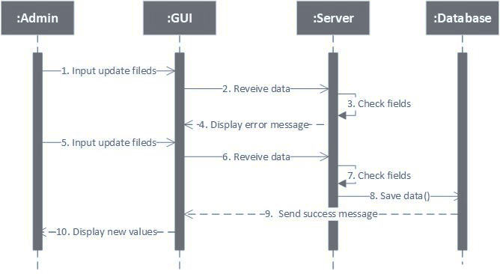

1. **Manage Product – Change status**

|  |  |  |
| --- | --- | --- |
| **Author** | LÊ GIA PHÚC | |
| **Use Case Name** | Manage Products – Change status | |
| **Actors** | Admin | |
| **Description** | Admin want to change status of product | |
| **Requirements** | Login as admin | |
|  | **Actor Actions** | **System Responses** |
| **Basic flow** | 1. Clicks on Disable / Active button  3. Clicks on “Yes” to confirm  5. Clicks on “No” to cancel | 2. Display a confirm form  4. The new status value of product was changed and display on table.  6. Hide the form  7. Return to Product admin page |

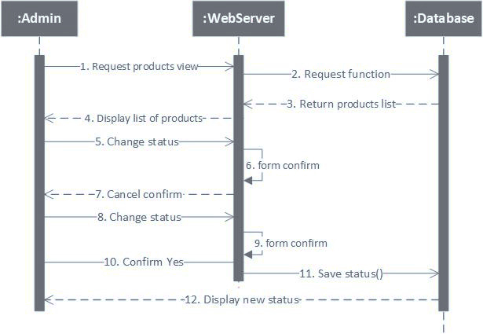

1. **Manage Categories – Insert**

|  |  |  |
| --- | --- | --- |
| **Author** | LÊ GIA PHÚC | |
| **Use Case Name** | Manage Categories – Insert | |
| **Actors** | Admin | |
| **Description** | Admin want to insert new category | |
| **Requirements** | Login as admin | |
|  | **Actor Actions** | **System Responses** |
| **Basic flow** | 1. Input information to input fields: Category Name and Image. Then clicks on Create button. | 2. Validate the information  3. Create new category in database 4. Return to categories page. |
| **Exception** | 1. Actor left Category Name blank | Display error message:  - “Category Name cannot be blank” |

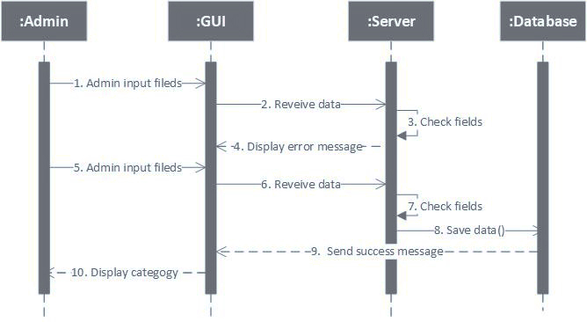

1. **Manage Categories – Update**

|  |  |  |
| --- | --- | --- |
| **Author** | LÊ GIA PHÚC | |
| **Use Case Name** | Manage Categories – Update | |
| **Actors** | Admin | |
| **Description** | Admin want to update category | |
| **Requirements** | Login as admin | |
|  | **Actor Actions** | **System Responses** |
| **Basic flow** | 1. Input information to input fields: Category Name and Image. Then clicks on Update button. | 2. System check the information [Exception 1]  3. Update existed category in database  4. Display Categories page |
| **Exception** | [Exception 1]  1. Actor left Category Name blank | Display error message:   1. “Category Name can not be blank |

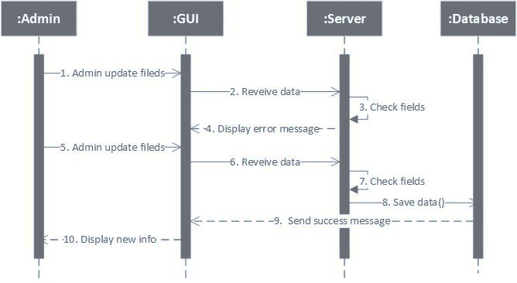

1. **Manage Categories – Change status**

|  |  |  |
| --- | --- | --- |
| **Author** | LÊ GIA PHÚC | |
| **Use Case Name** | Manage Category – Change status | |
| **Actors** | Admin | |
| **Description** | Admin want to change status of categoriess | |
| **Requirements** | Login as admin | |
|  | **Actor Actions** | **System Responses** |
| **Basic flow** | 1. Clicks on Disable / Active button  3. Clicks on “Yes” to confirm  5. Clicks on “No” to cancel | 2. Display a form to confirm change  4. The new status value of category was changed and display on table.  6. Hide the confirm form  7. Return to category admin page |

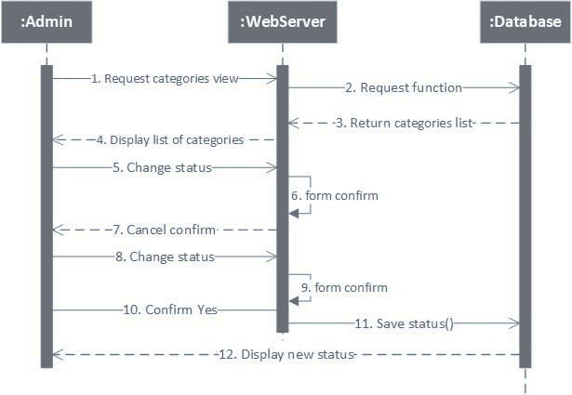

1. **View Cart**

|  |  |  |
| --- | --- | --- |
| **Author** | NGUYỄN MINH TRUNG TRỰC | |
| **Use Case Name** | View shopping cart | |
| **Actors** | Guests and Members | |
| **Description** | When custormers click on cart icon | |
|  | **Actor Actions** | **System Responses** |
| **Basic flow** | 1. Cart view | 1. Cart empty   Empty cart  4. Display cart list |
| **Exception** |  | 1. Empty cart notification |

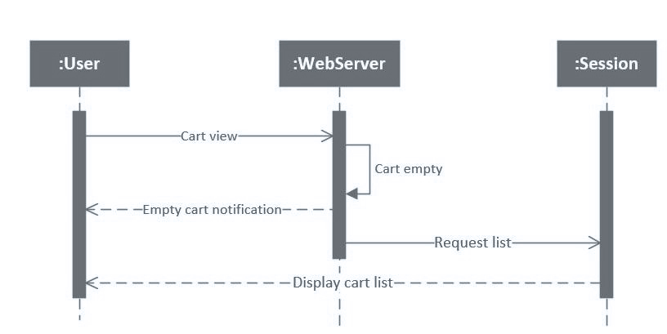

1. **Add to Cart**

|  |  |  |
| --- | --- | --- |
| **Author** | NGUYỄN MINH TRUNG TRỰC | |
| **Use Case Name** | Cart – Add | |
| **Actors** | Guests and Members | |
| **Description** | When customers select the quantity and clicks on “Add to Cart” in product detail page, the current product will be added/updated into list of cart items, and cart page will be displayed with all cart items. | |
|  | **Actor Actions** | **System Responses** |
| **Basic flow** | 1. Add product to cart | 1. Check the added product:   + If existed in cart, system will add the quantity to the existed item’s quantity.  + Else, system will add the product with the selected quantity into the list of cart items.  +Success notification |
| **Exception** |  | 1. Out of stock notification |

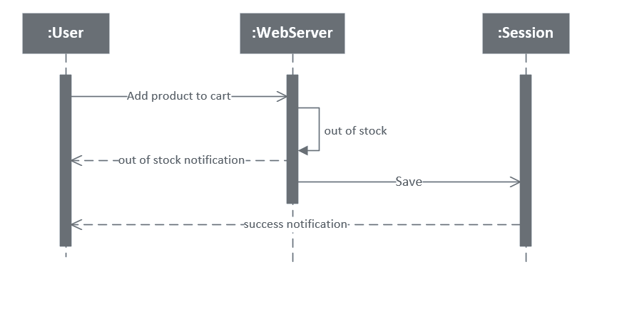

1. 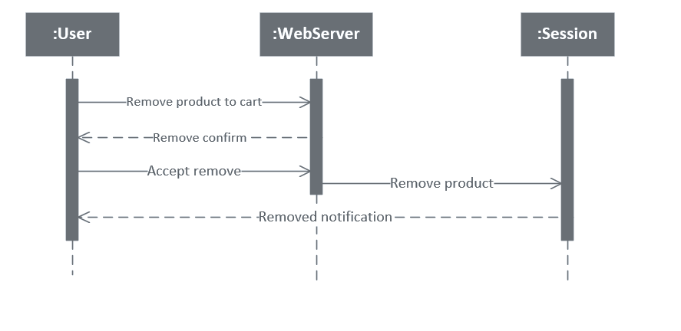**Remove Cart**

|  |  |  |
| --- | --- | --- |
| **Author** | NGUYỄN MINH TRUNG TRỰC | |
| **Use Case Name** | Cart - Remove | |
| **Actors** | Guests and Members | |
| **Description** | When customers clicks on remove links and choose “Yes” to confirm, the selected product will be remove from the list of cart items. | |
|  | **Actor Actions** | **System Responses** |
| **Basic flow** | 1.Remove product to cart 3.Accept remove | 2.Remove confirm  4. Remove product  5. Removed notification |
| **Alternative flow** | Clicks on “No”. | The 2 buttons disappear. |

1. **Update Quantity**

|  |  |  |
| --- | --- | --- |
| **Author** | NGUYỄN MINH TRUNG TRỰC | |
| **Use Case Name** | Cart – Update Quantity | |
| **Actors** | Guests and Members | |
| **Description** | When customers input quantity field of cart item, system will update the quantity, subtotal, total and display cart page with new information. | |
| **Requirements** | Quantity must be greater than 0. | |
|  | **Actor Actions** | **System Responses** |
| **Basic flow** | 1. Update new number in the quantity field. | 1. Check the new quantity [Exception 1]. 2. Update new quantity, subtotal and total of cart items. 3. Display cart page with new information. 4. Success notification |
| **Exception** | 1. [Exception 1] 1. Actor input a number less than 0. 2. Actor input a string not in number format. | 1. Display error message “Quantity must be greater than 0”. 2. Display error message “Quantity is not in number format”. |

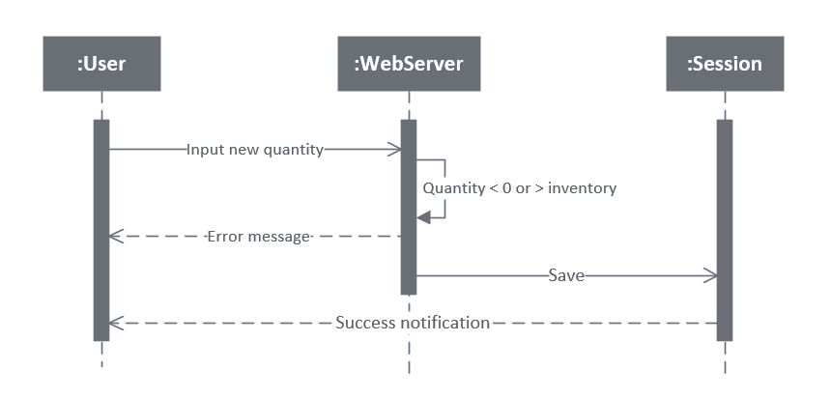

1. **Input Check Out Information**

|  |  |  |
| --- | --- | --- |
| **Author** | NGUYỄN MINH TRUNG TRỰC | |
| **Use Case Name** | Check Out – Input Information | |
| **Actors** | Guests and Members | |
| **Description** | Display field for customers to input information about shipping and payment method. | |
| **Requirements** | List of cart items can’t be null. | |
|  | **Actor Actions** | **System Responses** |
| **Basic flow** | 1. Check out request  3. Display  4. Input shipping info  7. Confirm | 2. Input shipping info Input form  5. Order confirm  6. Order confirm  8. Save  9. Success notification |

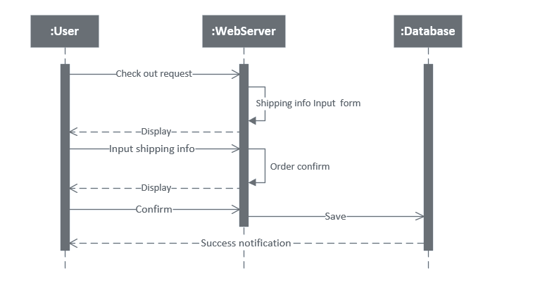

# Database Design

**1.** **Entity Relationship Diagrams**

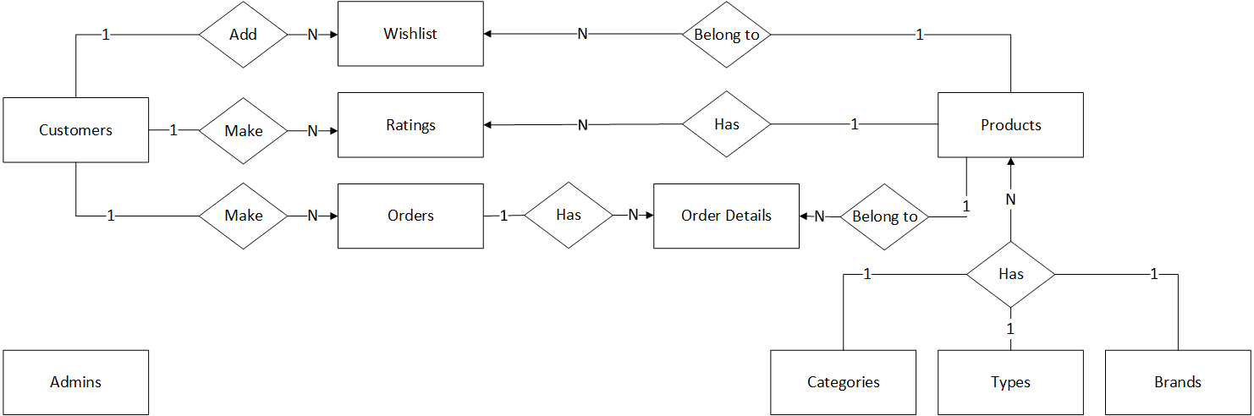

**2. Entity**

**a. Admins**

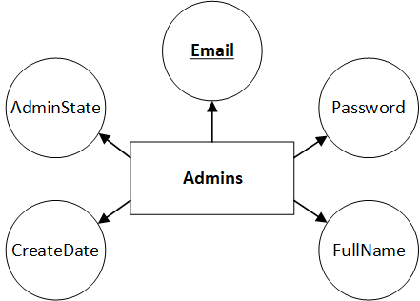

**b. Categories**

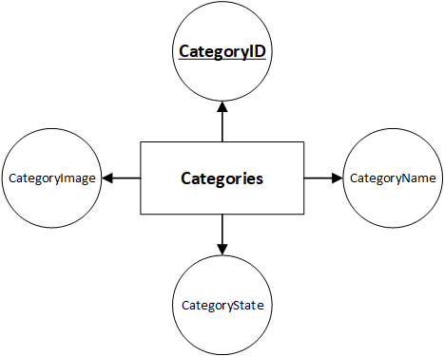

**c. Types**

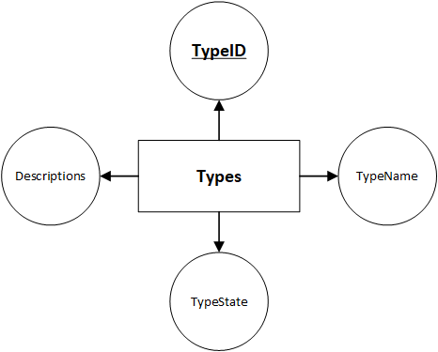

**d. Products**

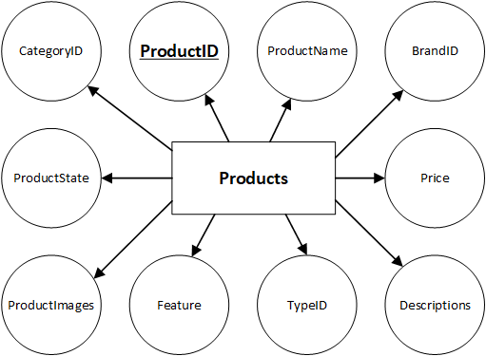

**e. Orders**

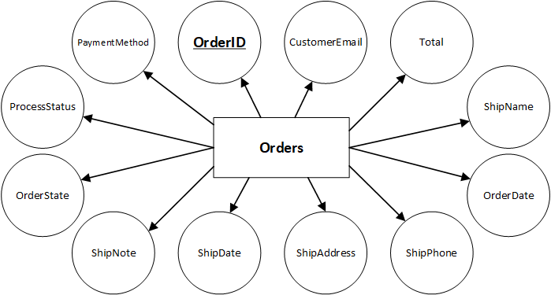

**f. Orders Details**

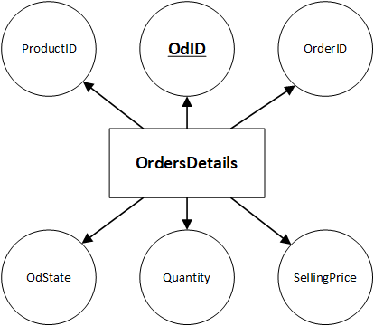

**g. Brands**

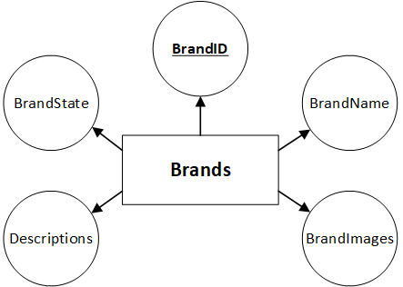

**h. Customers**

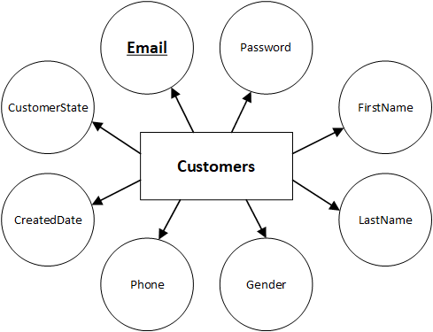

**i. Wishlists**

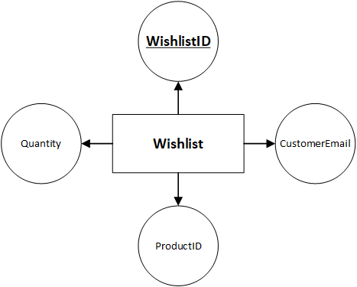

**j. Ratings**

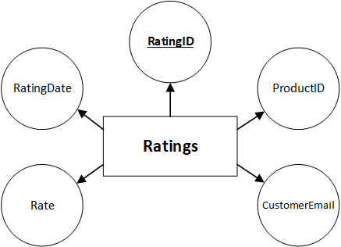

# Task Sheet

|  |  |  |  |  |  |
| --- | --- | --- | --- | --- | --- |
| **Project Ref. No.** | | **Project Name:**  **Furniture Store** | **Date of Preparation** | | |
| **No** | **Task** | **Description** | **Start Date** | **Completed Date** | **Team member** |
| 1 | Review 2 | Architecture and Design of System | 25/11/2020 | 28/11/2020 | All team member |
| 2 | Flow Chart |
| 3 | Use Case and Sequence Diagram |