**REVIEW 3**

# Web Sitemap

1. **Customer**

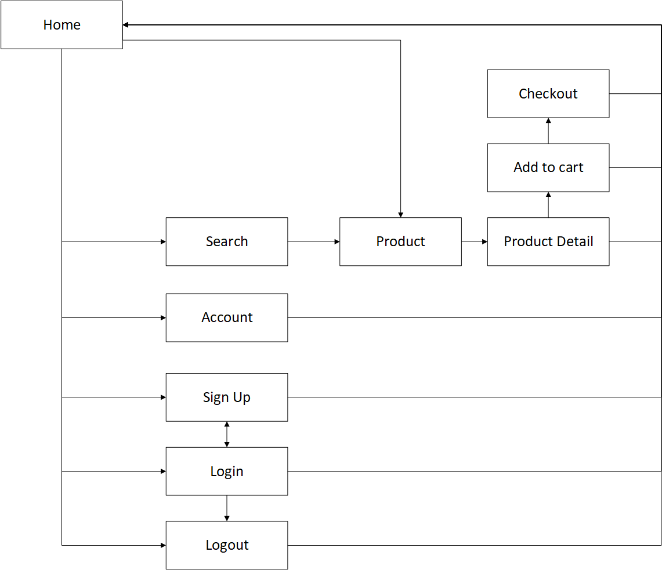

1. **Admin**

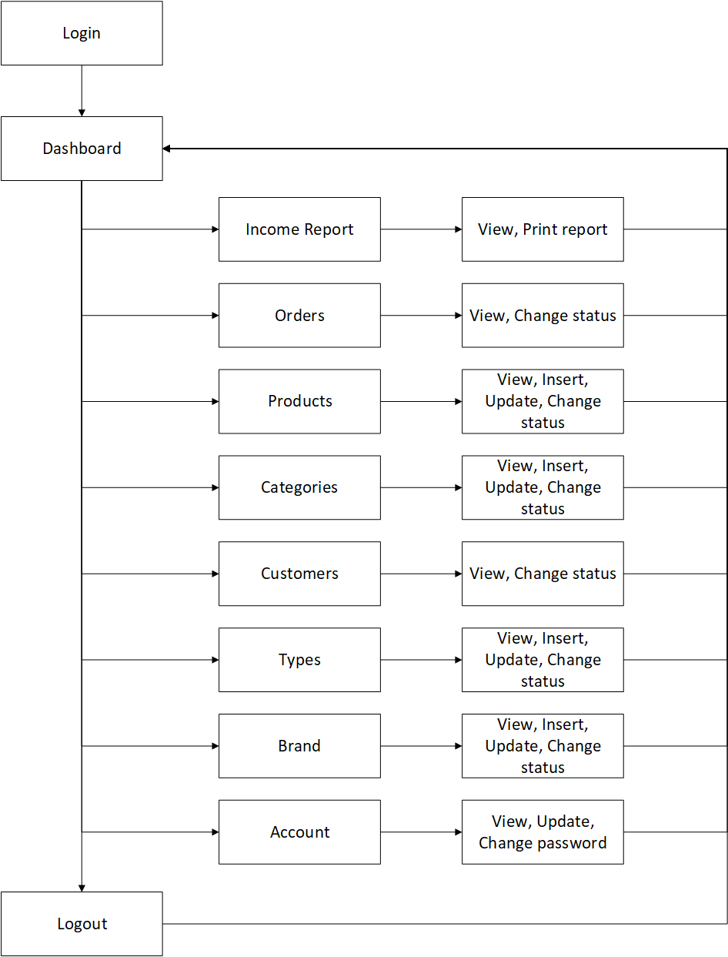

# GUI Design

1. **Client Website**
2. **Template**
3. 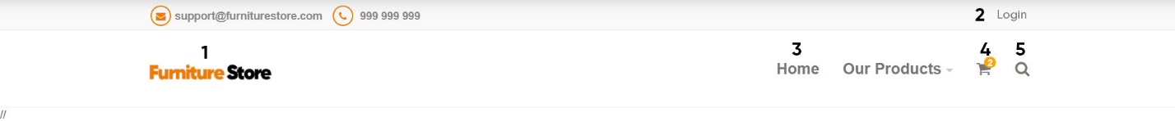**Header**

|  |  |  |  |  |  |
| --- | --- | --- | --- | --- | --- |
| **No** | **Name** | **Type** | **Validation** | **Event** | **Description** |
| 1 | Logo | Link |  | Click | Redirect to Home page |
| 2 | Login | Link |  | Click | Redirect to Login page |
| 3 | Home | Link |  | Click | Redirect to home page |
| 4 | Cart | Link |  | Click | Redirect to Cart page |
| 5 | Search | Button |  | Click | Click to type product name to search |

1. **Footer**

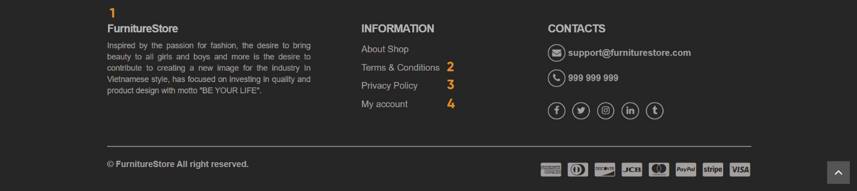

|  |  |  |  |  |  |
| --- | --- | --- | --- | --- | --- |
| **No** | **Name** | **Type** | **Validation** | **Event** | **Description** |
| 1 | About Shop | Link |  | Click | Redirect to About page |
| 2 | Terms & Conditions | Link |  | Click | Redirect to Terms & Conditions page |
| 3 | Privacy Policy | Link |  | Click | Redirect to Privacy Policy page |
| 4 | My account | Link |  | Click | Redirect to My account page |

1. 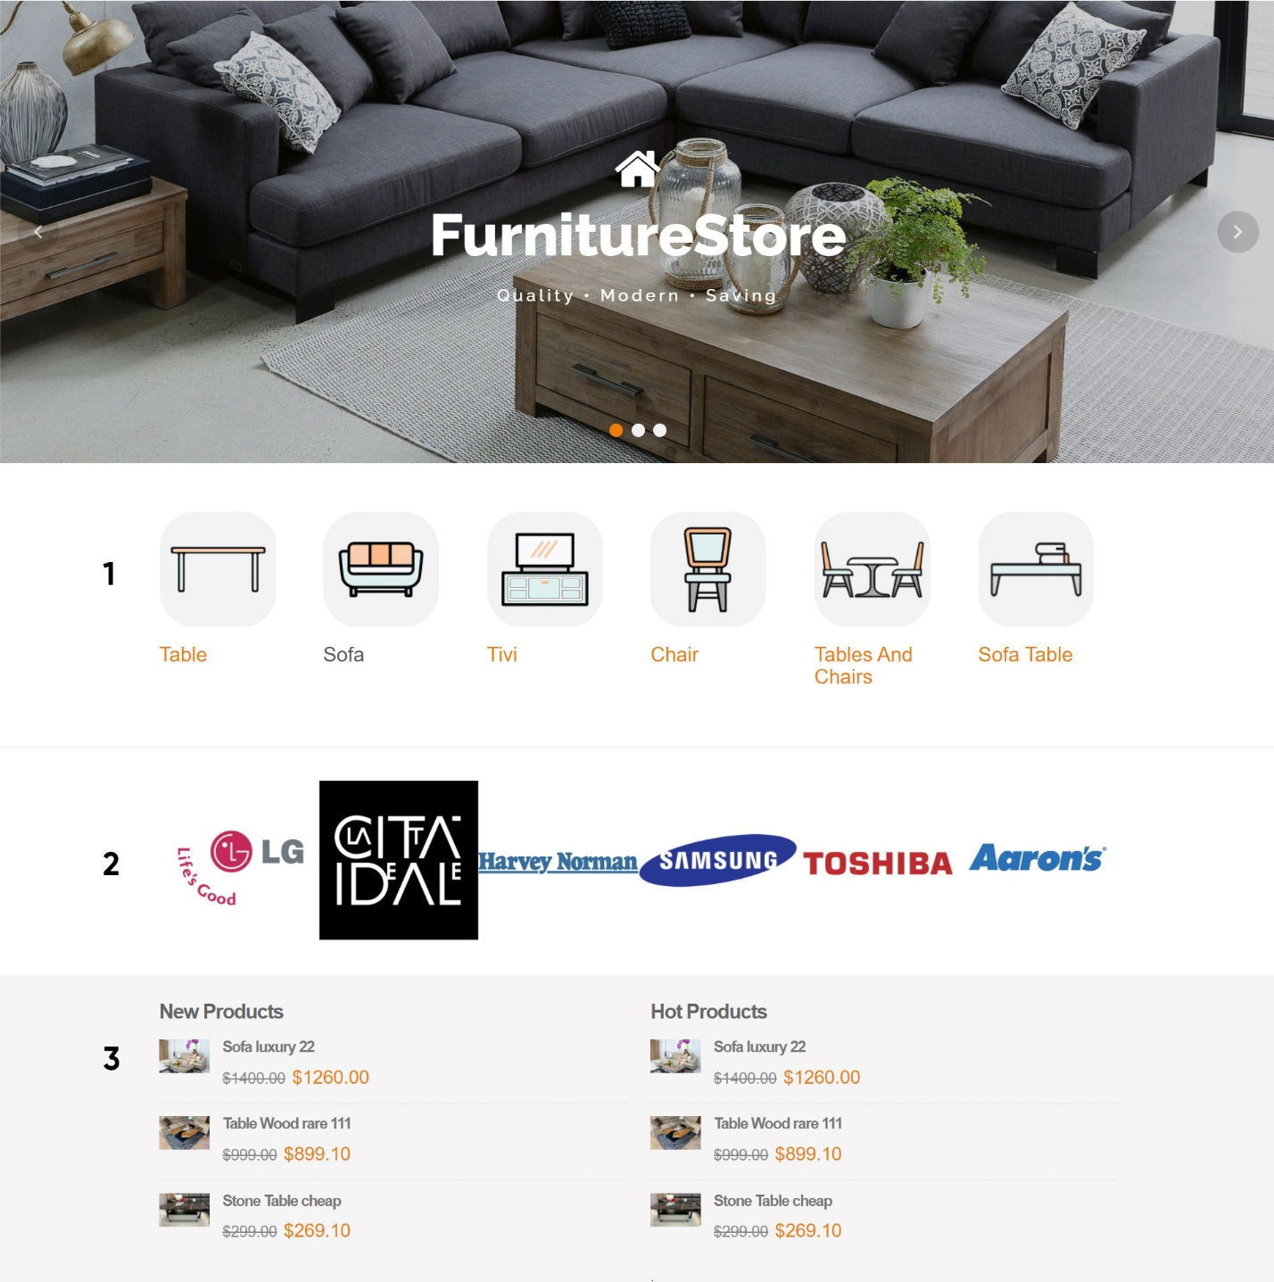**Home**

|  |  |  |  |  |  |
| --- | --- | --- | --- | --- | --- |
| **No** | **Name** | **Type** | **Validation** | **Event** | **Description­** |
| 1 | Category | Image + Text |  | Click | Redirect to Products Page |
| 2 | Brand’s image sliders | Bootstrap Carousel |  | Click | Redirect to Products Page |
| 3 | Product | Image + Text |  |  | Redirect to Product Destail Page |

1. 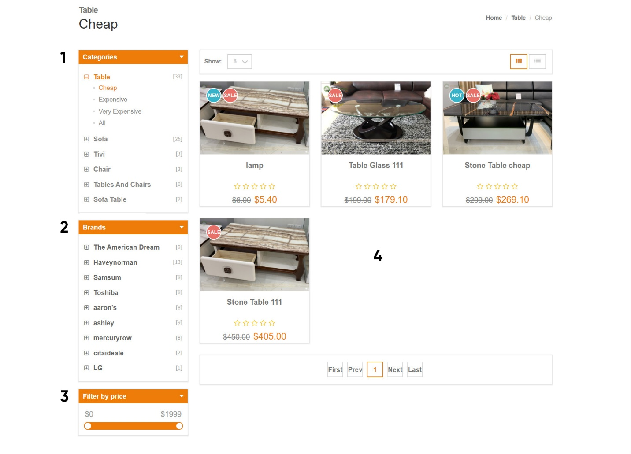**Products**

|  |  |  |  |  |  |
| --- | --- | --- | --- | --- | --- |
| **No** | **Name** | **Type** | **Validation** | **Event** | **Description­** |
| 1 | Categories panel | Text |  | Click | Show all Categories |
| 2 | Brands panel | Text |  | Click | Show all Brands |
| 3 | Filter by price | Scroll |  |  | Filter by price |
| 4 | List products | Image + Text |  |  | List products |

1. 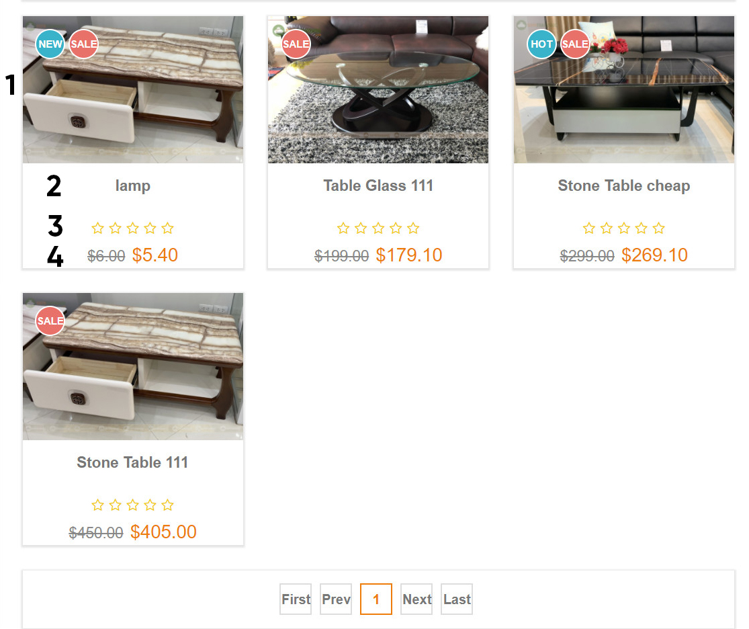**Product list**

|  |  |  |  |  |  |
| --- | --- | --- | --- | --- | --- |
| **No** | **Name** | **Type** | **Validation** | **Event** | **Description­** |
| 1 | Product Image | Image |  | Click | Show product detail |
| 2 | Product Name | Text |  | Click | Show product detail |
| 3 | Product Rating |  |  |  |  |
| 4 | Product Price | Text |  |  |  |

1. **Product Details**

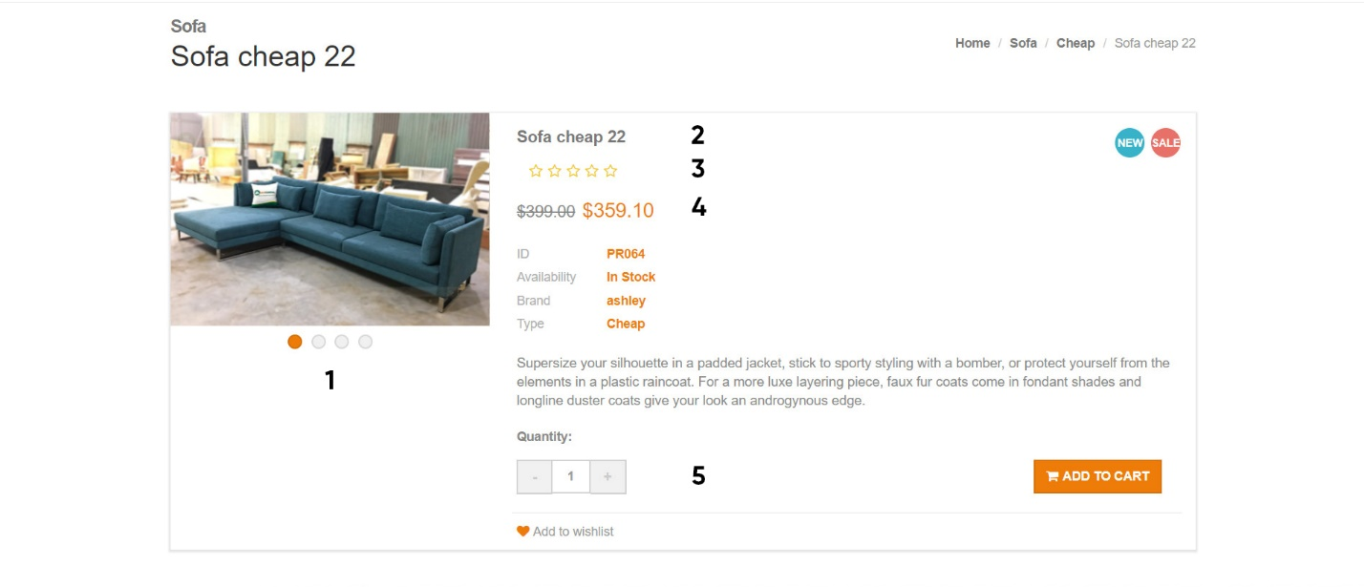

|  |  |  |  |  |  |
| --- | --- | --- | --- | --- | --- |
| **No** | **Name** | **Type** | **Validation** | **Event** | **Description­** |
| 1 | Product Image | Sliders |  | Click | Display next image |
| 2 | Product Name | Link |  | Click | Redirect to Product Details page |
| 3 | Product Ratings | Bootstrap Font Awesome |  | Click | Display rating panel |
| 4 | Product price | Input number |  | Click |  |
| 5 | Quantity | Input number |  | Click | Change the quantity min value = 1 |

1. 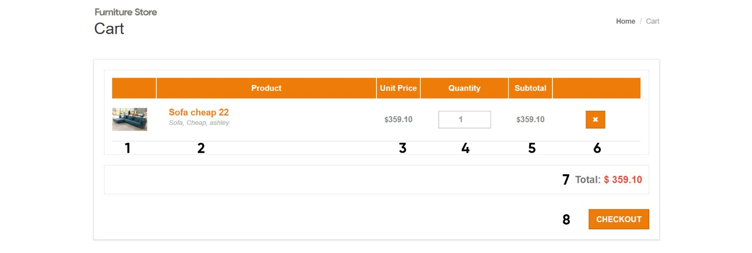**Cart**

|  |  |  |  |  |  |
| --- | --- | --- | --- | --- | --- |
| **No** | **Name** | **Type** | **Validation** | **Event** | **Description­** |
| 1 | Product Image | Image |  |  |  |
| 2 | Product Name | Link |  | Click | Redirect to Product Page |
| 3 | Product Price | Text |  |  |  |
| 4 | Quantity | Input number |  | Change | Update quantity of cart items |
| 5 | Subtotal | Text |  |  | Subtotal of product |
| 6 | Remove | Button |  | Click | Remove cart items |
| 7 | Total | Text |  |  | Total payment of cart items |
| 8 | Checkout | Button |  | Click | Redirect to Checkout page |

1. **Check Out**
2. 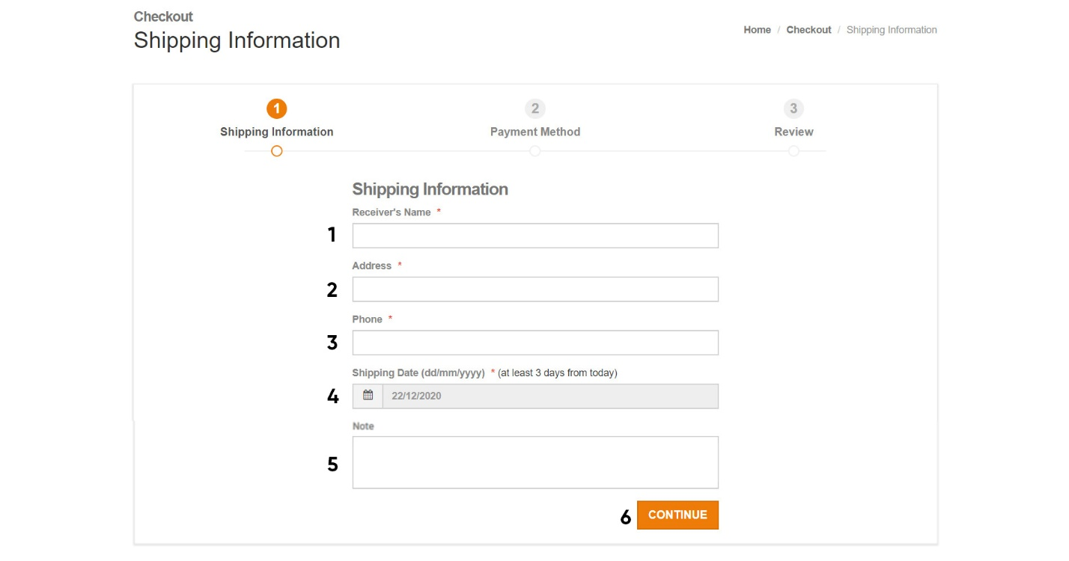**Shipping Information**

|  |  |  |  |  |  |
| --- | --- | --- | --- | --- | --- |
| **No** | **Name** | **Type** | **Validation** | **Event** | **Description­** |
| 1 | Receiver’s name | Input text | Not null |  |  |
| 2 | Address | Input text | Not null |  |  |
| 3 | Phone | Input text | Not null |  |  |
| 4 | Shipping Date | Date picker | Not null |  | At least 3 days from current date |
| 5 | Note | Text Area |  |  |  |
| 6 | Continue | Button |  | Click | Redirect to Payment method page |

1. 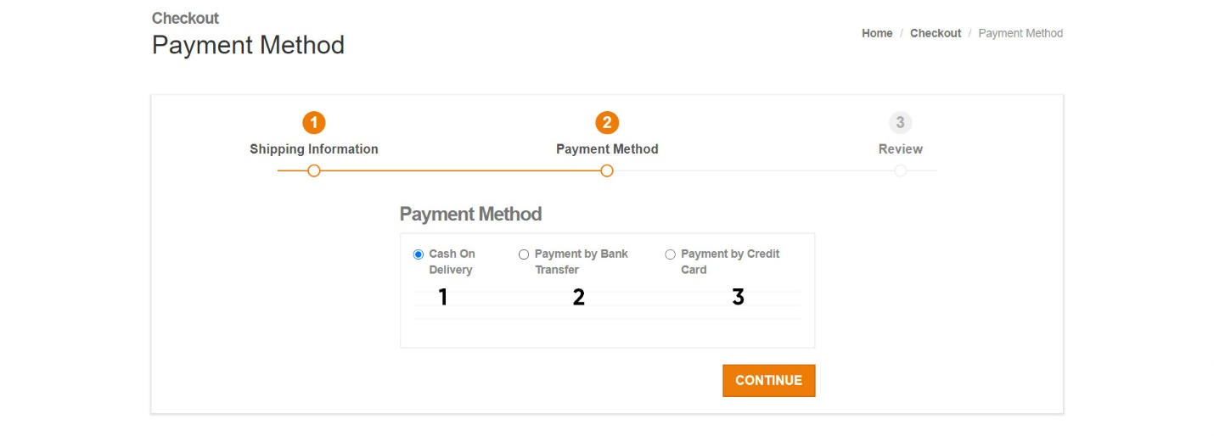**Payment Method**

|  |  |  |  |  |  |
| --- | --- | --- | --- | --- | --- |
| **No** | **Name** | **Type** | **Validation** | **Event** | **Description­** |
| 1 | Cash On Delivery | Radio Button |  | Click | Select payment by cash |
| 2 | Payment By Bank | Radio Button |  | Click | Select payment by bank |
| 3 | Payment By Credit Card | Radio Button |  | Click | Select payment by credit card |

1. 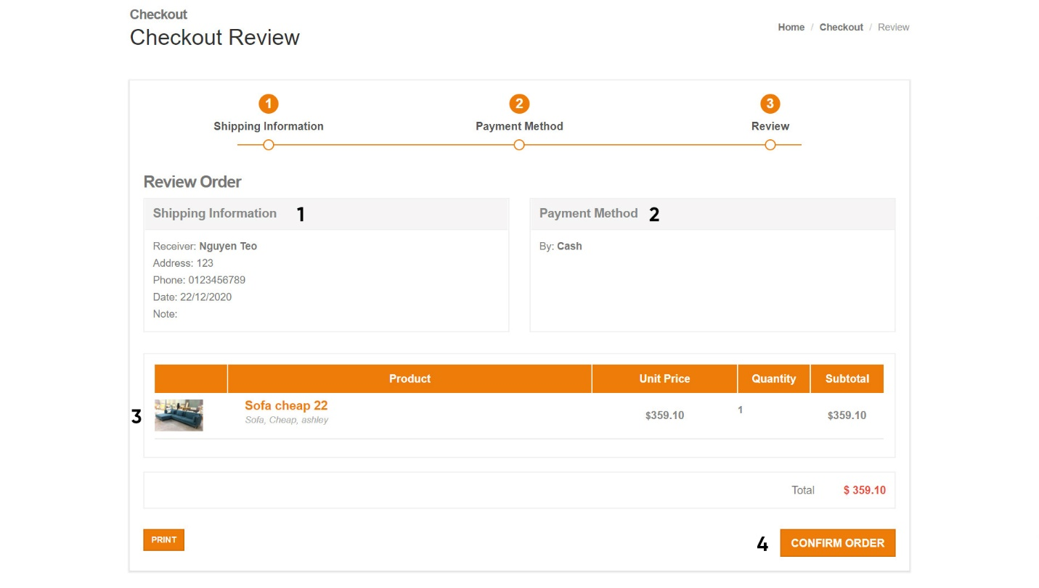**Review**

|  |  |  |  |  |  |
| --- | --- | --- | --- | --- | --- |
| **No** | **Name** | **Type** | **Validation** | **Event** | **Description­** |
| 1 | Shipping Information | Text |  |  | Contains all shipping info |
| 2 | Payment method | Text |  |  | Contains all payment info |
| 3 | Cart items | Table |  |  | Contains all cart items info |
| 4 | Confirm order | Button |  |  | Redirect to Order Success Page |

1. 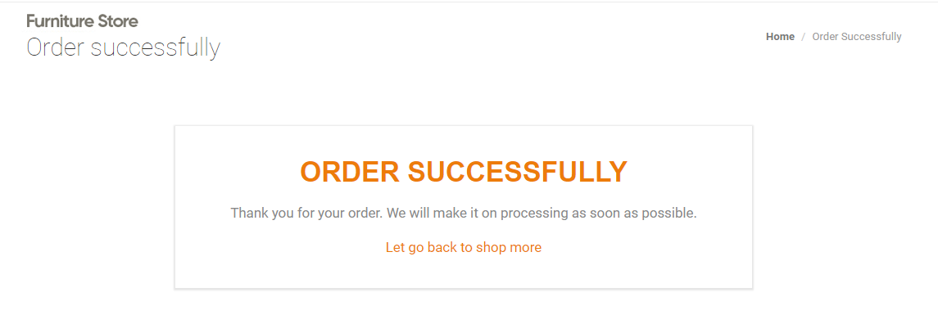**Order Success**
2. **Customer**
3. 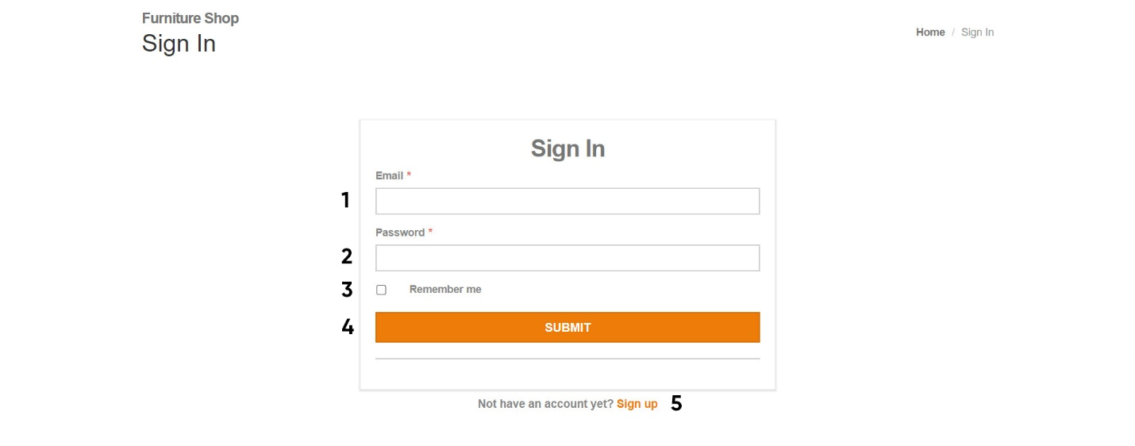**Sign In**

|  |  |  |  |  |  |
| --- | --- | --- | --- | --- | --- |
| **No** | **Name** | **Type** | **Validation** | **Event** | **Description­** |
| 1 | Email | Input text | Not null |  |  |
| 2 | Password | Input password | Not null |  |  |
| 3 | Remember | Checkbox |  | Checked | Save the login info |
| 4 | Submit | Button |  | Click | Check login and redirect to Account page |
| 5 | Sign up | Link |  | Click | Redirect to Sign up page |

1. 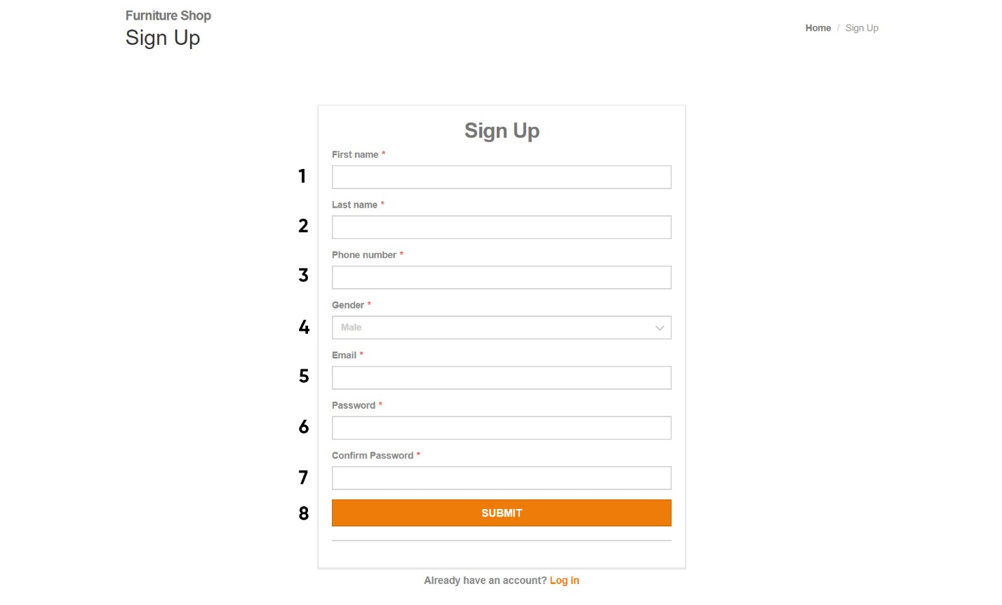**Sign Up**

|  |  |  |  |  |  |
| --- | --- | --- | --- | --- | --- |
| **No** | **Name** | **Type** | **Validation** | **Event** | **Description­** |
| 1 | First Name | Input text | Not null |  |  |
| 2 | Last name | Input text | Not null |  |  |
| 3 | Phone | Input text | Not null |  |  |
| 4 | Gender | Combo box |  | Change | Select customer’s gender |
| 5 | Email | Input text | Email format |  |  |
| 6 | Password | Input password | Not null |  |  |
| 7 | Confirm password | Input password | Not null |  |  |
| 8 | Submit | Button |  | Click | Submit new user’s info |

1. **Account Dashboard**

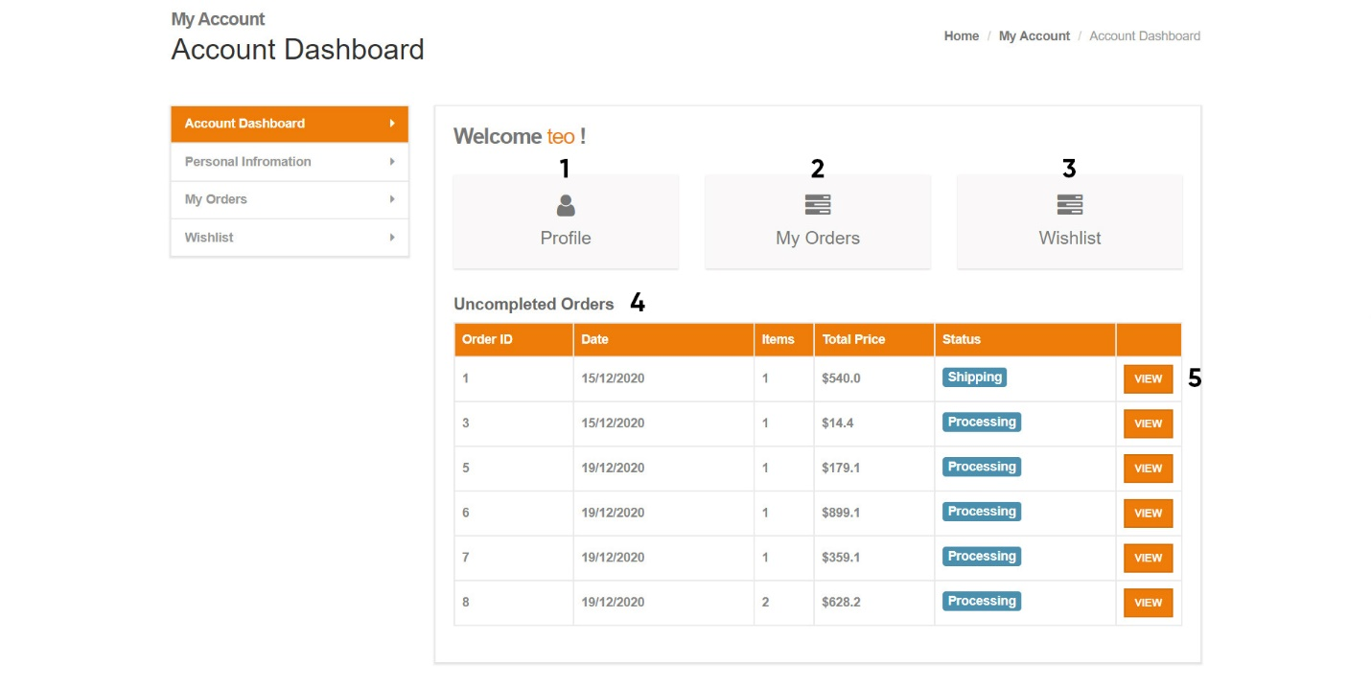

|  |  |  |  |  |  |
| --- | --- | --- | --- | --- | --- |
| **No** | **Name** | **Type** | **Validation** | **Event** | **Description­** |
| 1 | Profile | Link |  | Click | Redirect to Profile page |
| 2 | My Orders | Link |  | Click | Redirect to My Orders page |
| 3 | Wishlist | Link |  | Click | Redirect to Wishlist page |
| 4 | Uncompleted Orders | Table |  |  | All customers’s uncompleted orders info |
| 5 | View | Button |  | Click | Redirect to Profile page |

1. **Personal Information**

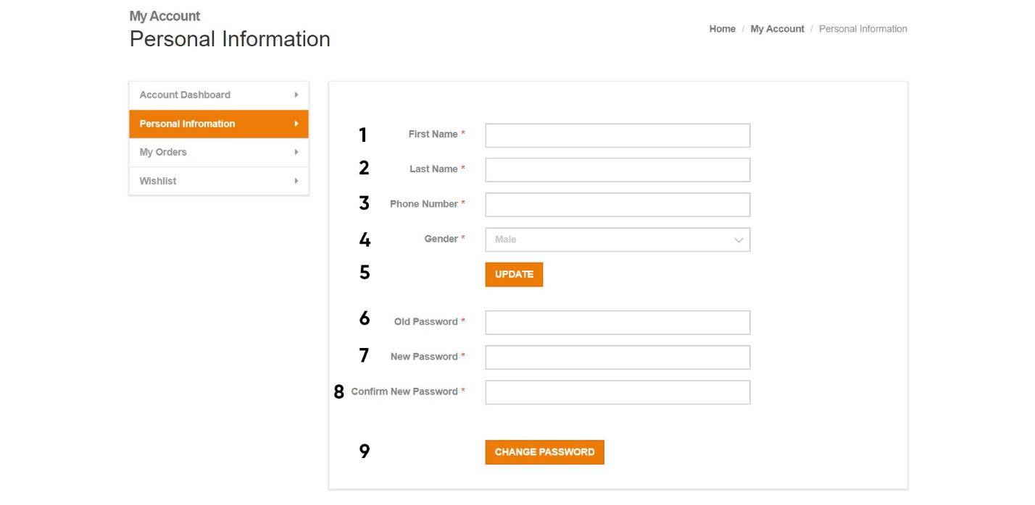

|  |  |  |  |  |  |
| --- | --- | --- | --- | --- | --- |
| **No** | **Name** | **Type** | **Validation** | **Event** | **Description­** |
| 1 | First Name | Input text | Not null |  |  |
| 2 | Last Name | Input text | Not null |  |  |
| 3 | Phone | Input text | Not null |  |  |
| 4 | Gender | Combo box |  | Change | Select customer’s gender |
| 5 | Update | Button |  | Click | Update customer info and redirect to Profile page |
| 6 | Old Password | Input password | Not null |  |  |
| 7 | New Password | Input password | Not null |  |  |
| 8 | Confirm Password | Input Password | Not null |  |  |
| 9 | Change Password | Button |  | Click | Check if correct: “Old password” matched “current password” and “new password” matched “confirm new password”. Then redirect to Profile page |

1. 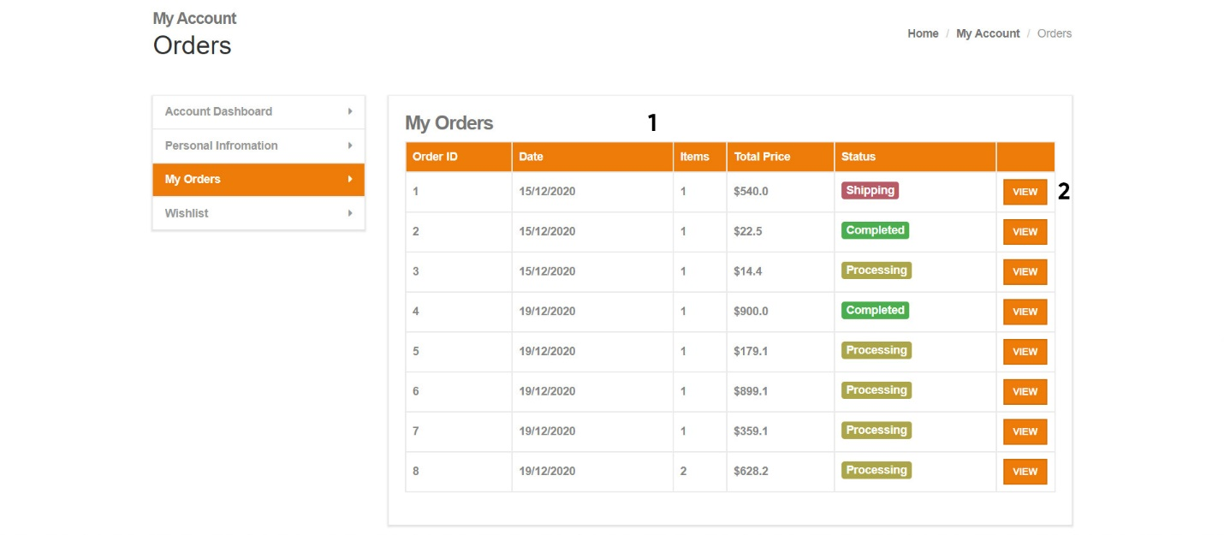**My Orders**

|  |  |  |  |  |  |
| --- | --- | --- | --- | --- | --- |
| **No** | **Name** | **Type** | **Validation** | **Event** | **Description­** |
| 1 | All customer’s orders | Table |  |  | All customer’s order info: ID, Order Date, Quantity, Total, Status |
| 2 | View | Button |  | Click | Redirect to Orders Details page |

1. 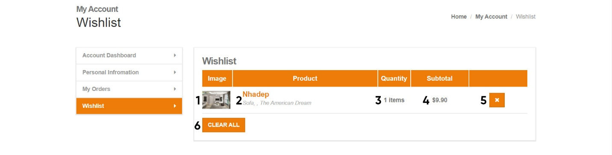**Wishlist**

|  |  |  |  |  |  |
| --- | --- | --- | --- | --- | --- |
| **No** | **Name** | **Type** | **Validation** | **Event** | **Description­** |
| 1 | Product Image | Image |  |  |  |
| 2 | Product Name | Link |  | Click | Redirect to Product Details page |
| 3 | Quantity | Input number |  | Change | Update quantity of cart items |
| 4 | Product Price | Text |  |  |  |
| 5 | Remove | Button |  | Click | Remove wishlist item |
| 6 | Clear all | Button |  | Click | Clear all wishlist items |

1. **Admin Website**
2. **Login**

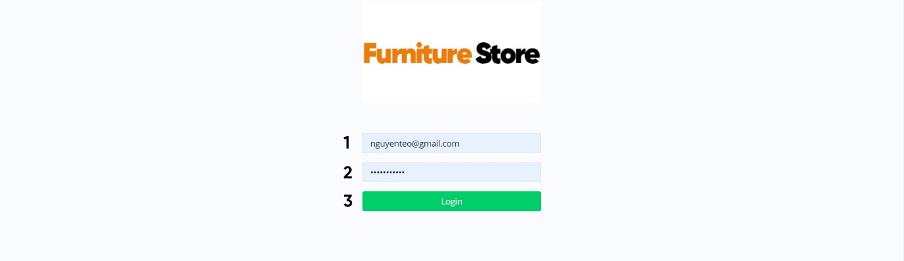

|  |  |  |  |  |  |
| --- | --- | --- | --- | --- | --- |
| **No** | **Name** | **Type** | **Validation** | **Event** | **Description­** |
| 1 | Username | Input Text | Not null |  |  |
| 2 | Password | Input Password | Not null |  |  |
| 3 | Login | Button |  | Click | Check login and redirect to Admin page |

1. 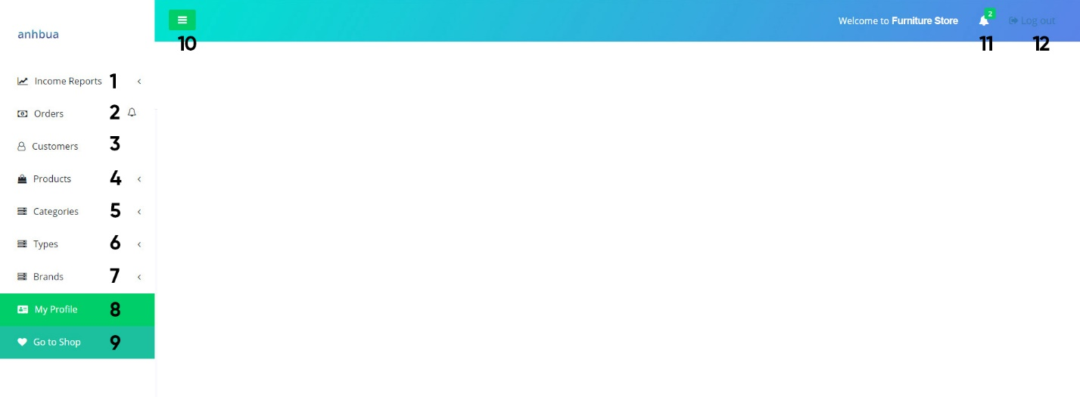**Template**

|  |  |  |  |  |  |
| --- | --- | --- | --- | --- | --- |
| **No** | **Name** | **Type** | **Validation** | **Event** | **Description­** |
| 1 | Reports | Dropdown list |  |  | Contains reports link |
| 2 | Orders | Link |  | Click | Redirect to Orders page |
| 3 | Customers | Link |  |  | Redirect to Customers page |
| 4 | Products | Dropdown list |  |  | Contains: view and create link |
| 5 | Categories | Dropdown list |  |  | Contains: view and create link |
| 6 | Types | Dropdown  list |  |  | Contains: view and create  link |
| 7 | Brands | Dropdown list |  |  | Contains: view and create link |
| 8 | My Profile | Link |  | Click | Redirect to My Profile page |
| 9 | Go to Shop­ | Link |  | Click | Redirect to Index page |
| 10 | Resize button | Button |  | Click | Minimize the sidebar |
| 11 | Notificaitons | Dropdown list |  |  | Contains notifications about new orders and on shipping orders |
| 12 | Logout | Link |  | Click | Log admin out |

1. **My Profile**

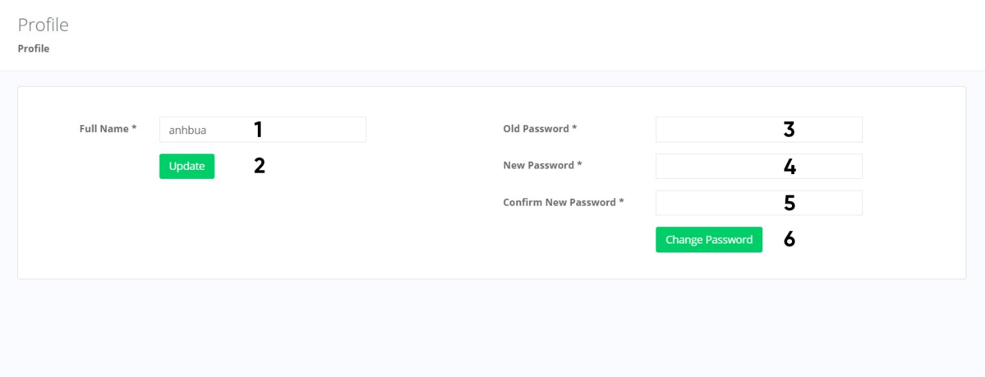

|  |  |  |  |  |  |
| --- | --- | --- | --- | --- | --- |
| **No** | **Name** | **Type** | **Validation** | **Event** | **Description­** |
| 1 | Full Name | Input Text | Not null |  |  |
| 2 | Update | Button |  | Click | Update Admin’s fullname |
| 3 | Old Password | Input password | Not null |  |  |
| 4 | New Password | Input password | Not null |  |  |
| 5 | Confirm password | Input password | Not null |  |  |
| 6 | Change password | Button |  | Click | Check if correct: Old password, matched Confirm Password. Then update customer’s password |

1. 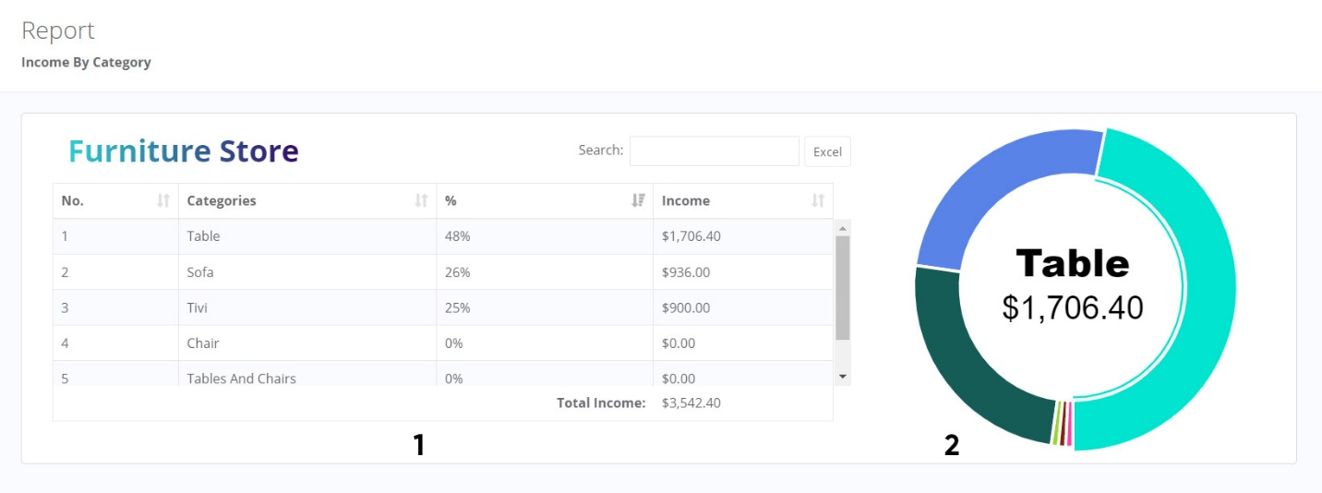**Reports – Income By Category**

|  |  |  |  |  |  |
| --- | --- | --- | --- | --- | --- |
| **No** | **Name** | **Type** | **Validation** | **Event** | **Description­** |
| 1 | Data | Bootstrap DataTable |  |  |  |
| 2 | Pie Chart | Morris Pie  Chart |  |  |  |

1. **Reports – Income By Brand**

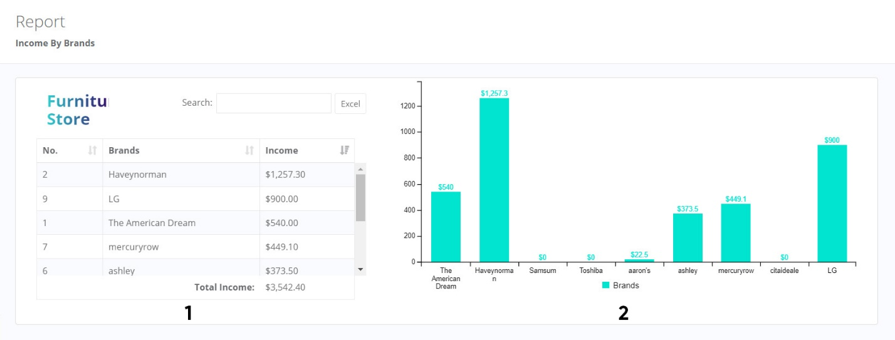

|  |  |  |  |  |  |
| --- | --- | --- | --- | --- | --- |
| **No** | **Name** | **Type** | **Validation** | **Event** | **Description­** |
| 1 | Data | Bootstrap DataTable |  |  |  |
| 2 | Chart | C3 Stacked Chart |  |  |  |

1. **Orders – View**

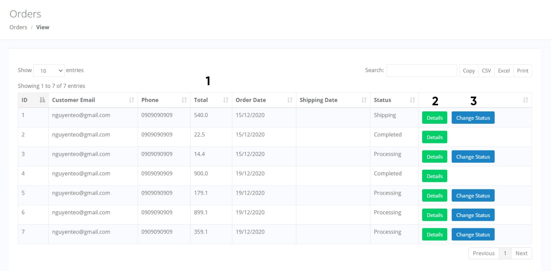

|  |  |  |  |  |  |
| --- | --- | --- | --- | --- | --- |
| **No** | **Name** | **Type** | **Validation** | **Event** | **Description­** |
| 1 | Orders list | Bootstrap Datatable |  |  | Contains all field of Orders table. Use bootstrap datatable libraries with buttons to export data to files |
| 2 | Details | Button |  | Click | Redirect to Order Details  page |
| 3 | Change Status | Button |  | Click | Redirect to Order Status page |

1. 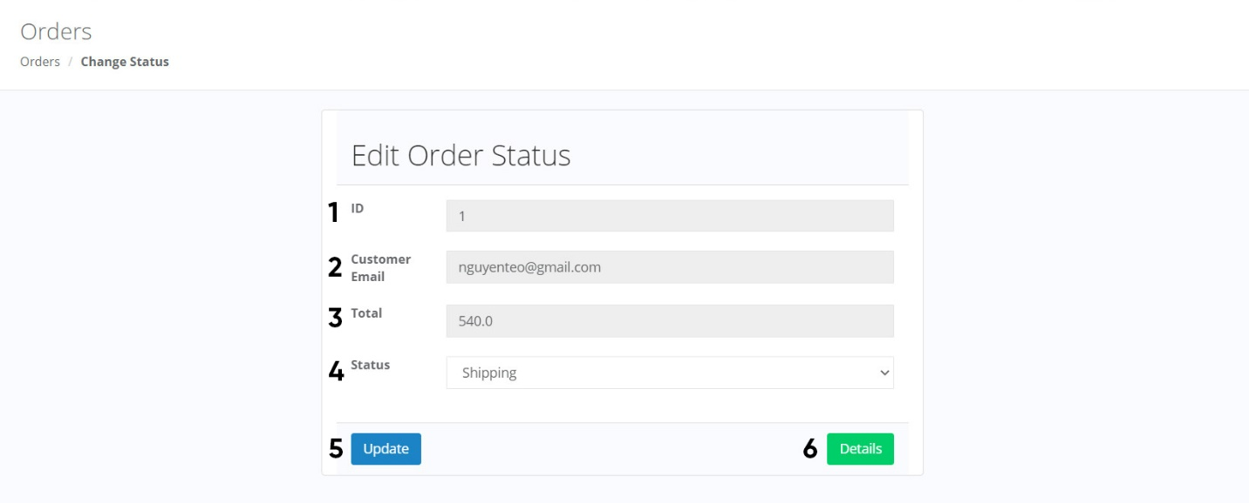**Order – Change Status**

|  |  |  |  |  |  |
| --- | --- | --- | --- | --- | --- |
| **No** | **Name** | **Type** | **Validation** | **Event** | **Description­** |
| 1 | ID | Text |  |  | Read only |
| 2 | Customer Email | Text |  |  | Read only |
| 3 | Total | Text |  |  | Read only |
| 4 | Status | Combo box |  |  |  |
| 5 | Update | Button |  | Click | Update Orders’ status |
| 6 | Details | Button |  | Click | Redirect to Orders Details |

1. 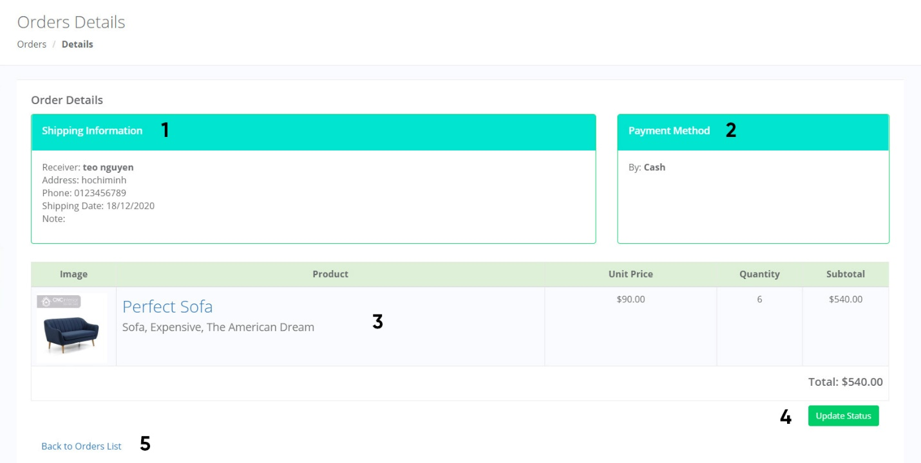**Order Detail**

|  |  |  |  |  |  |
| --- | --- | --- | --- | --- | --- |
| **No** | **Name** | **Type** | **Validation** | **Event** | **Description­** |
| 1 | Shipping Information | Text |  |  | Contains all shipping infor |
| 2 | Payment Method | Text |  |  | Contains all payment info |
| 3 | Order’s Items | Table |  |  | Contains all order’s items info |
| 4 | Update Status | Button |  | Click | Redirect to Order Status page |
| 5 | Back to Orders List | Link |  | Click | Redirect to Orders Views page |

1. **Products – View**

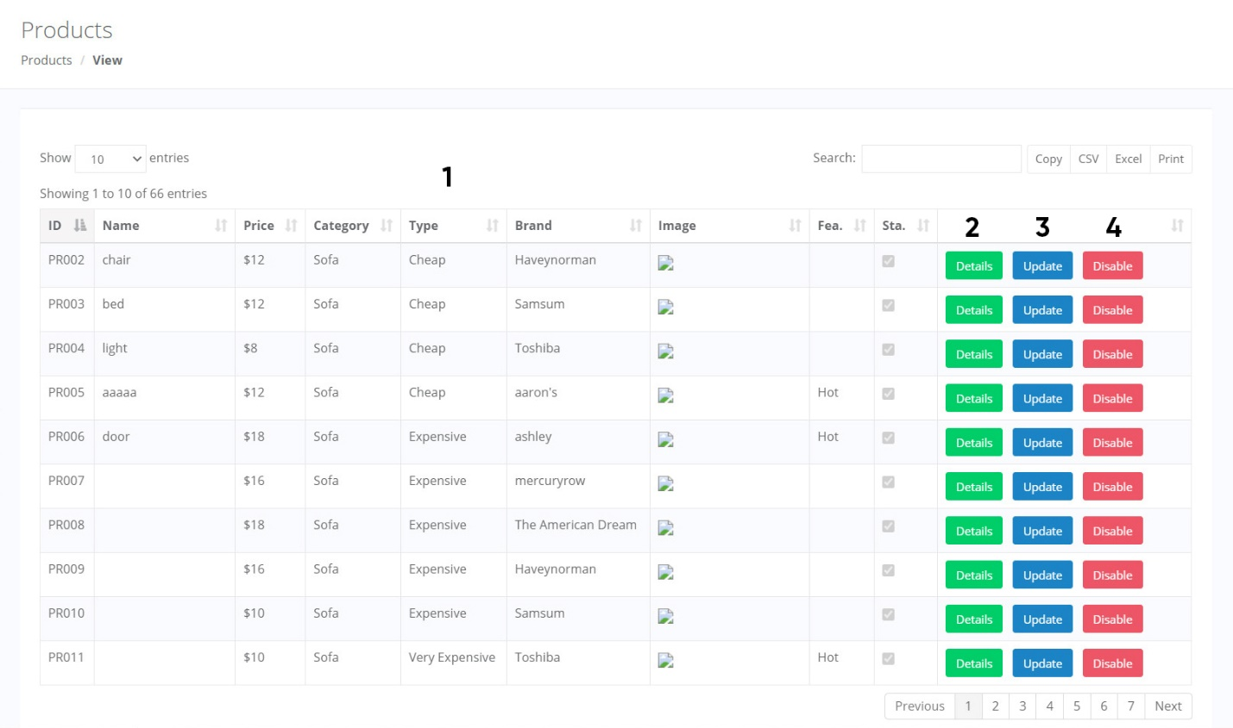

|  |  |  |  |  |  |
| --- | --- | --- | --- | --- | --- |
| **No** | **Name** | **Type** | **Validation** | **Event** | **Description­** |
| 1 | Products list | Bootstrap Datatable |  |  | Contains all field of Products table. Use bootstrap datatable libraries with buttons to export data to files |
| 2 | Details | Button |  | Click | Redirect to Product Detail page |
| 3 | Update | Button |  | Click | Redirect to Update Product page |
| 4 | Disable | Button |  | Click | Disable the product |

1. 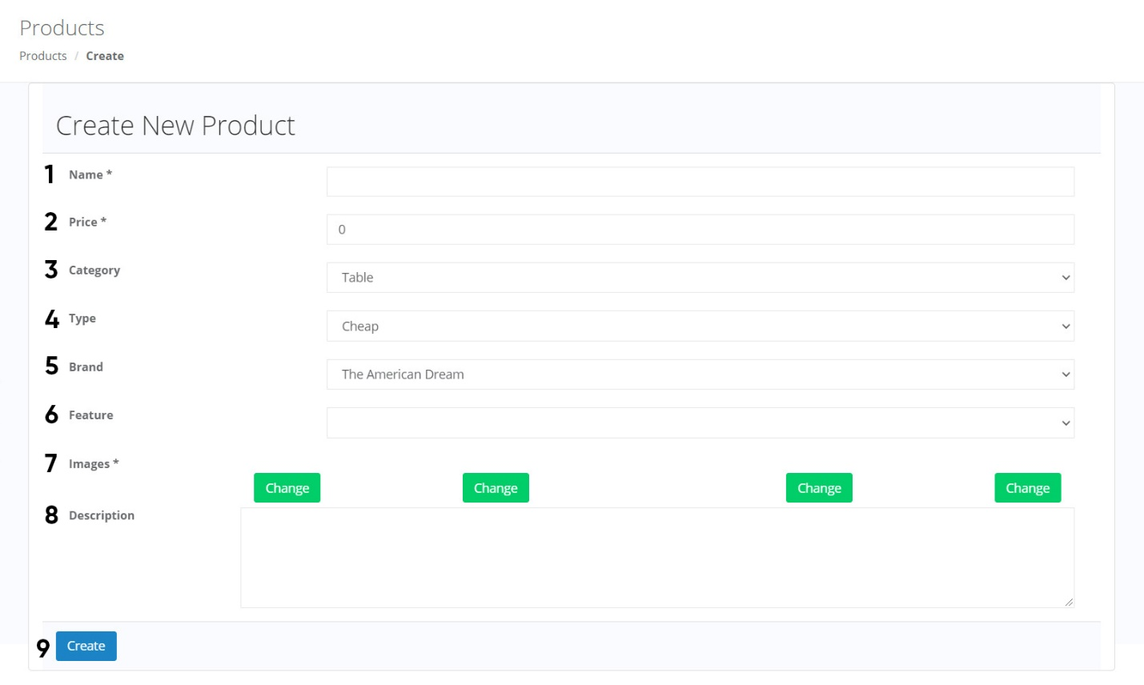**Product – Create**

|  |  |  |  |  |  |
| --- | --- | --- | --- | --- | --- |
| **No** | **Name** | **Type** | **Validation** | **Event** | **Description­** |
| 1 | Name | Input Text | Not null |  |  |
| 2 | Price | Input number | Not null, > 0 |  |  |
| 3 | Category | Combo  box |  |  | Values from Categories  table |
| 4 | Type | Combo box |  |  | Values from Types table |
| 5 | Brand | Combo box |  |  | Values from Brands table |
| 6 | Feature | Input Text |  |  |  |
| 7 | Images | 4 Input file | Images, size < 1MB |  |  |
| 8 | Description | Input  Textarea |  |  |  |
| 9 | Create | Button |  | Click | Create new product |

1. 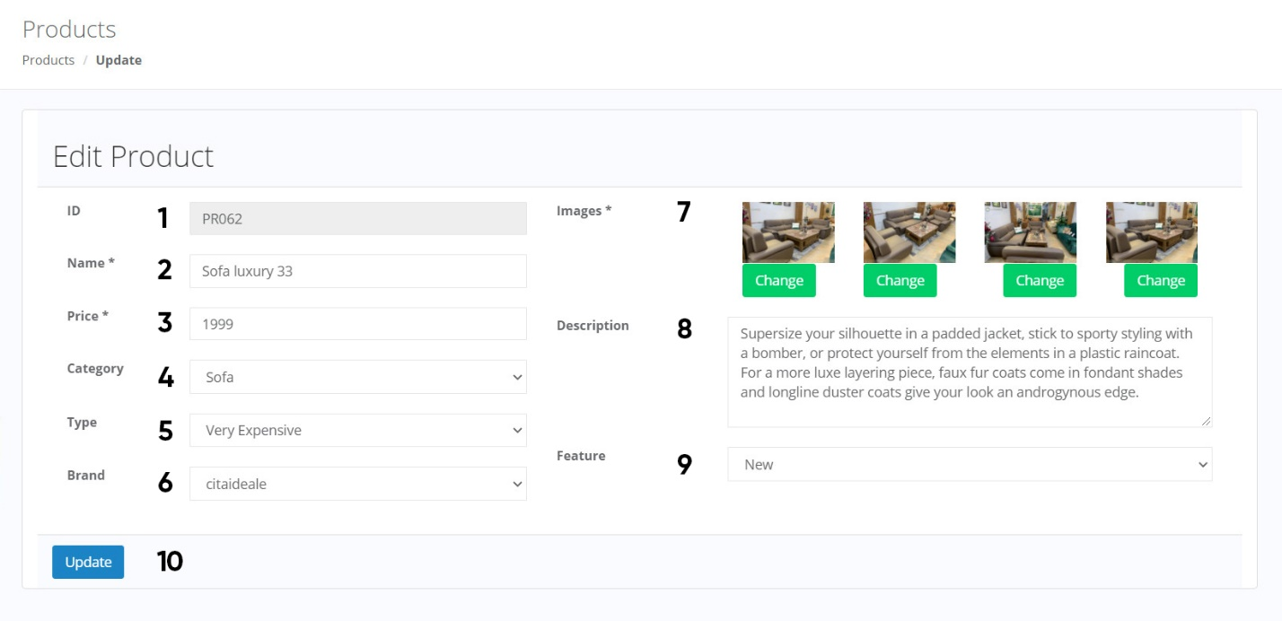**Product – Update**

|  |  |  |  |  |  |
| --- | --- | --- | --- | --- | --- |
| **No** | **Name** | **Type** | **Validation** | **Event** | **Description­** |
| 1 | ID | Input Text |  |  | Read only |
| 2 | Name | Input Text | Not null |  |  |
| 3 | Price | Input number | Not null, > 0 |  |  |
| 4 | Category | Combo box |  |  | Values from Categories table |
| 5 | Type | Combo  box |  |  | Values from Types table |
| 6 | Brand | Combo box |  |  | Values from Brands table |
| 7 | Images | 4 Input  file | Images,  size < 1MB |  |  |
| 8 | Description | Input Textarea |  |  |  |
| 9 | Feature | Combo  box |  |  | Values: Hot, New, Sale |
| 10 | Update | Button |  | Click | Update the product’s info |

1. 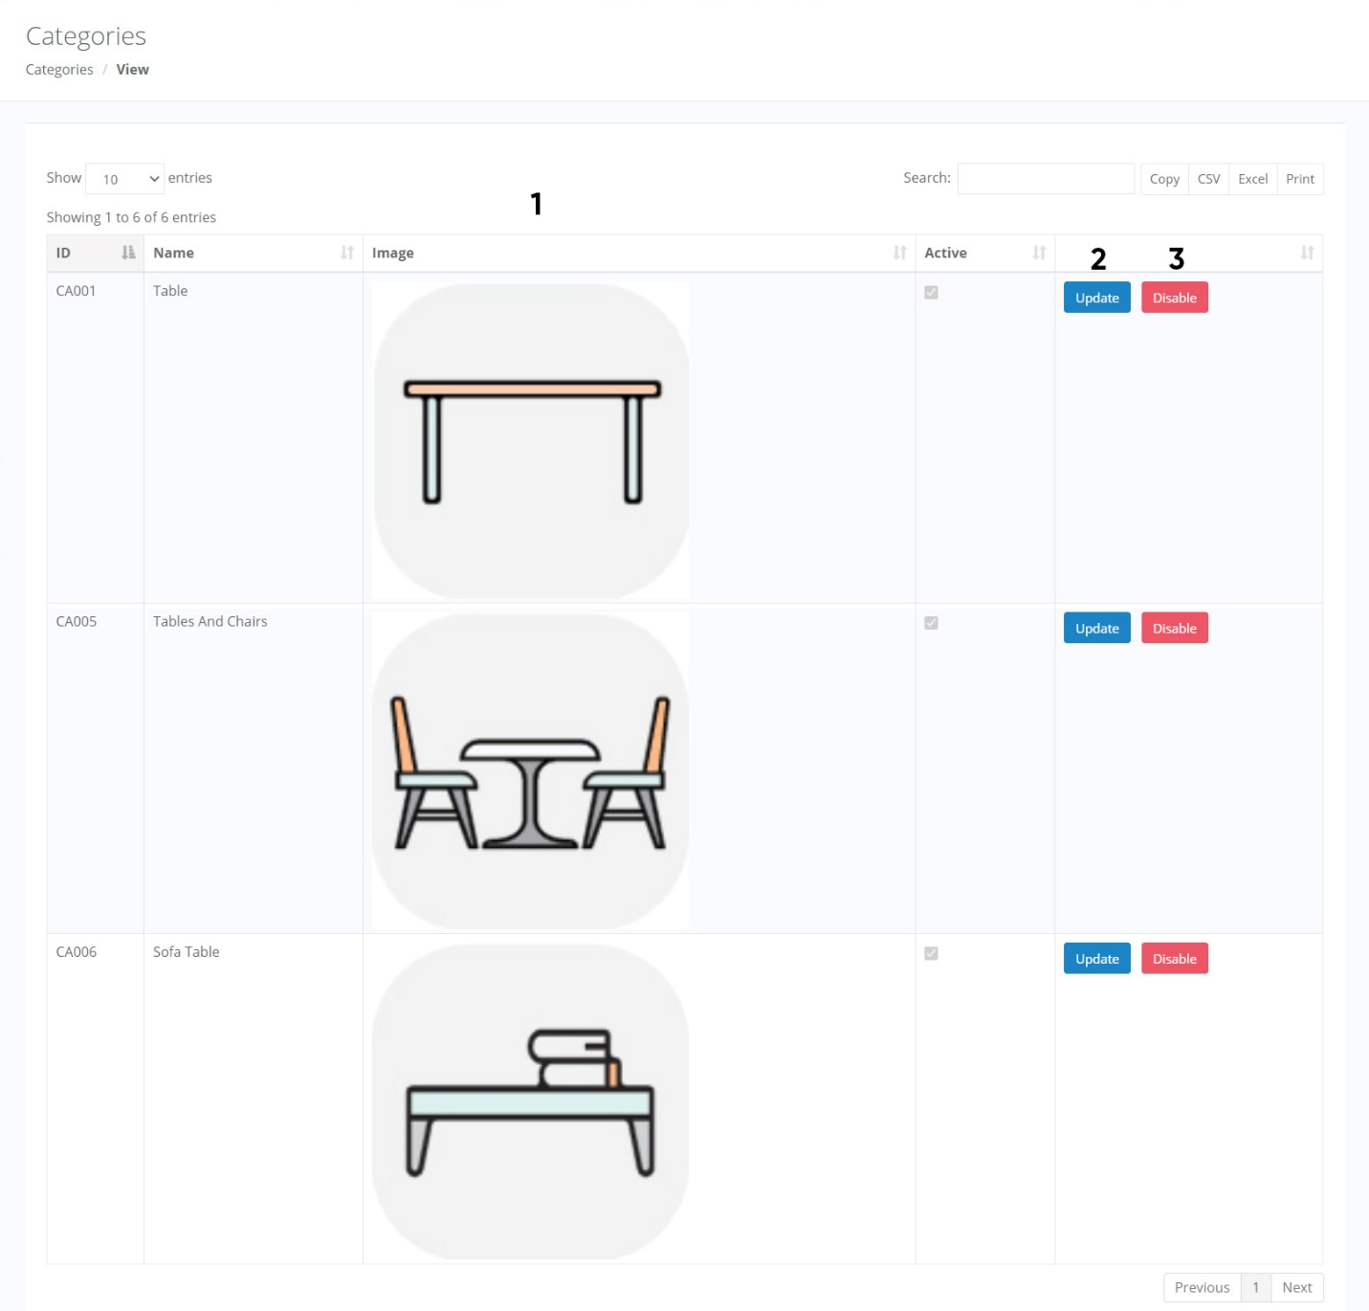**Categories – View**

|  |  |  |  |  |  |
| --- | --- | --- | --- | --- | --- |
| **No** | **Name** | **Type** | **Validation** | **Event** | **Description­** |
| 1 | Categories | Bootstrap Data Table |  |  | Contains all field of Categories table. Use bootstrap data table libraries with button to export data to files |
| 2 | Update | Button |  | Click | Redirect to Update Category page |
| 3 | Disable | Button |  | Click | Disable the category |

1. 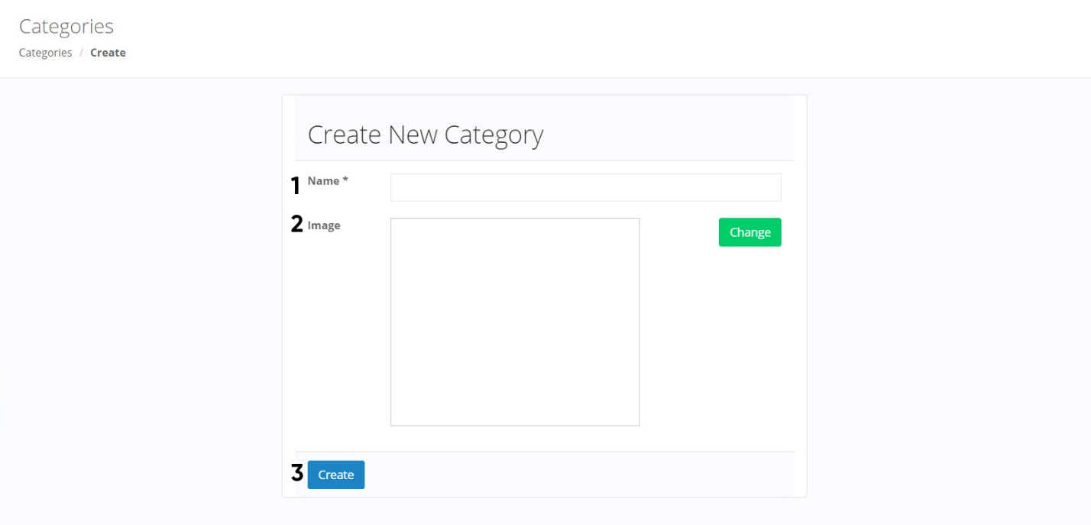**Category – Create**

|  |  |  |  |  |  |
| --- | --- | --- | --- | --- | --- |
| **No** | **Name** | **Type** | **Validation** | **Event** | **Description­** |
| 1 | Name | Input Text | Not null |  |  |
| 2 | Image | Input file | Images, size < 1MB |  |  |
| 3 | Create | Button |  | Click | Create new Categories |

1. 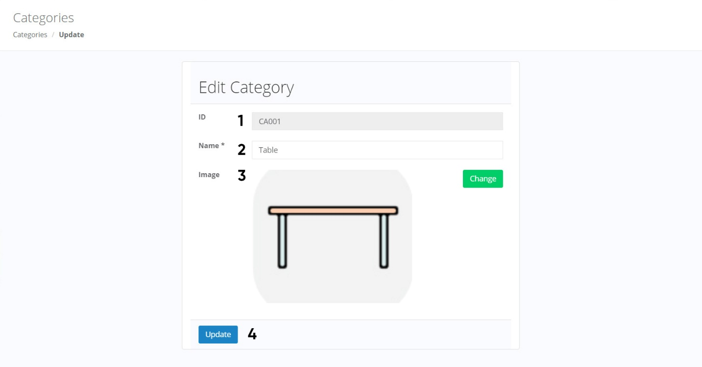**Category – Update**

|  |  |  |  |  |  |
| --- | --- | --- | --- | --- | --- |
| **No** | **Name** | **Type** | **Validation** | **Event** | **Description­** |
| 1 | ID | Input Text |  |  | Read only |
| 2 | Name | Input Text | Not null |  |  |
| 3 | Image | Input file | Images, size < 1MB |  |  |
| 4 | Update | Button |  | Click | Update the category’s info |

1. 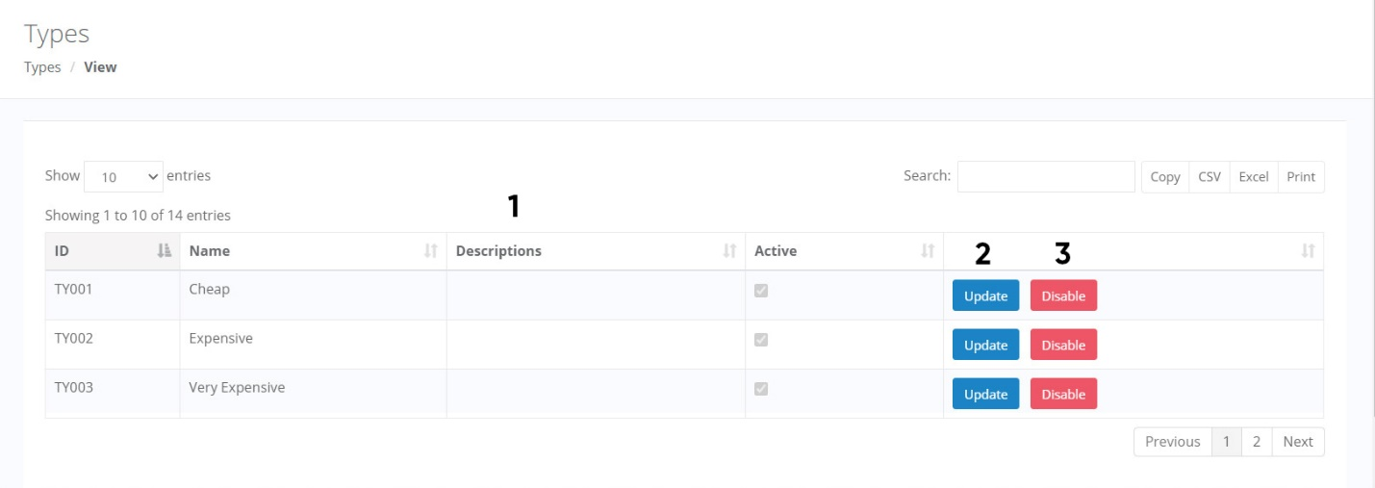**Types – View**

|  |  |  |  |  |  |
| --- | --- | --- | --- | --- | --- |
| **No** | **Name** | **Type** | **Validation** | **Event** | **Description­** |
| 1 | Types list | Bootstrap Datatable |  |  | Contains all field of Types table. Use bootstrap datatable libraries with buttons to export data to files |
| 2 | Update | Button |  | Click | Redirect to Update Type  page |
| 3 | Disable | Button |  | Click | Disable the type |

1. 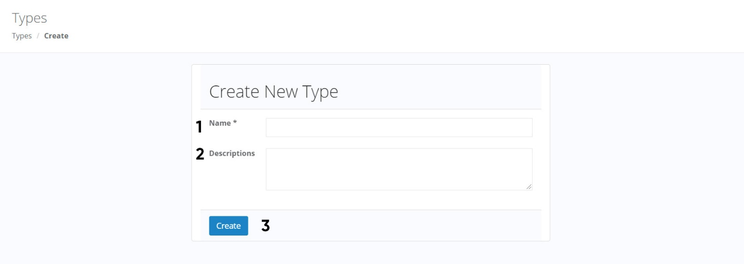**Type – Create**

|  |  |  |  |  |  |
| --- | --- | --- | --- | --- | --- |
| **No** | **Name** | **Type** | **Validation** | **Event** | **Description­** |
| 1 | Name | Input Text | Not null |  |  |
| 2 | Description | Input Textarea |  |  |  |
| 3 | Create | Button |  | Click | Create new Type |

1. 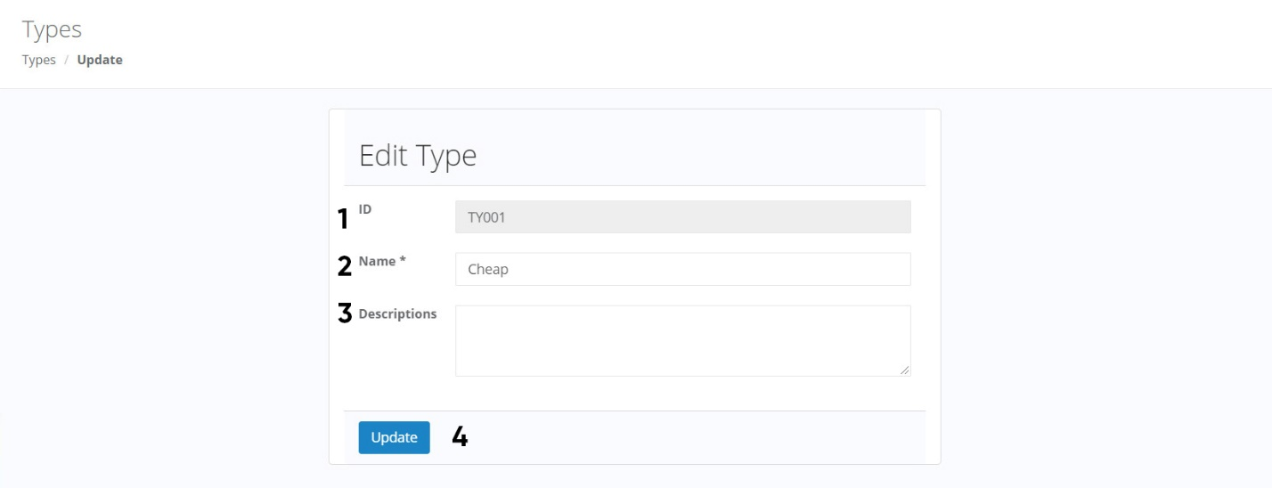**Type – Update**

|  |  |  |  |  |  |
| --- | --- | --- | --- | --- | --- |
| **No** | **Name** | **Type** | **Validation** | **Event** | **Description­** |
| 1 | ID | Input Text |  |  | Read only |
| 2 | Name | Input Text | Not null |  |  |
| 3 | Description | Input Textarea |  |  |  |
| 4 | Update | Button |  | Click | Update the type’s info |

1. 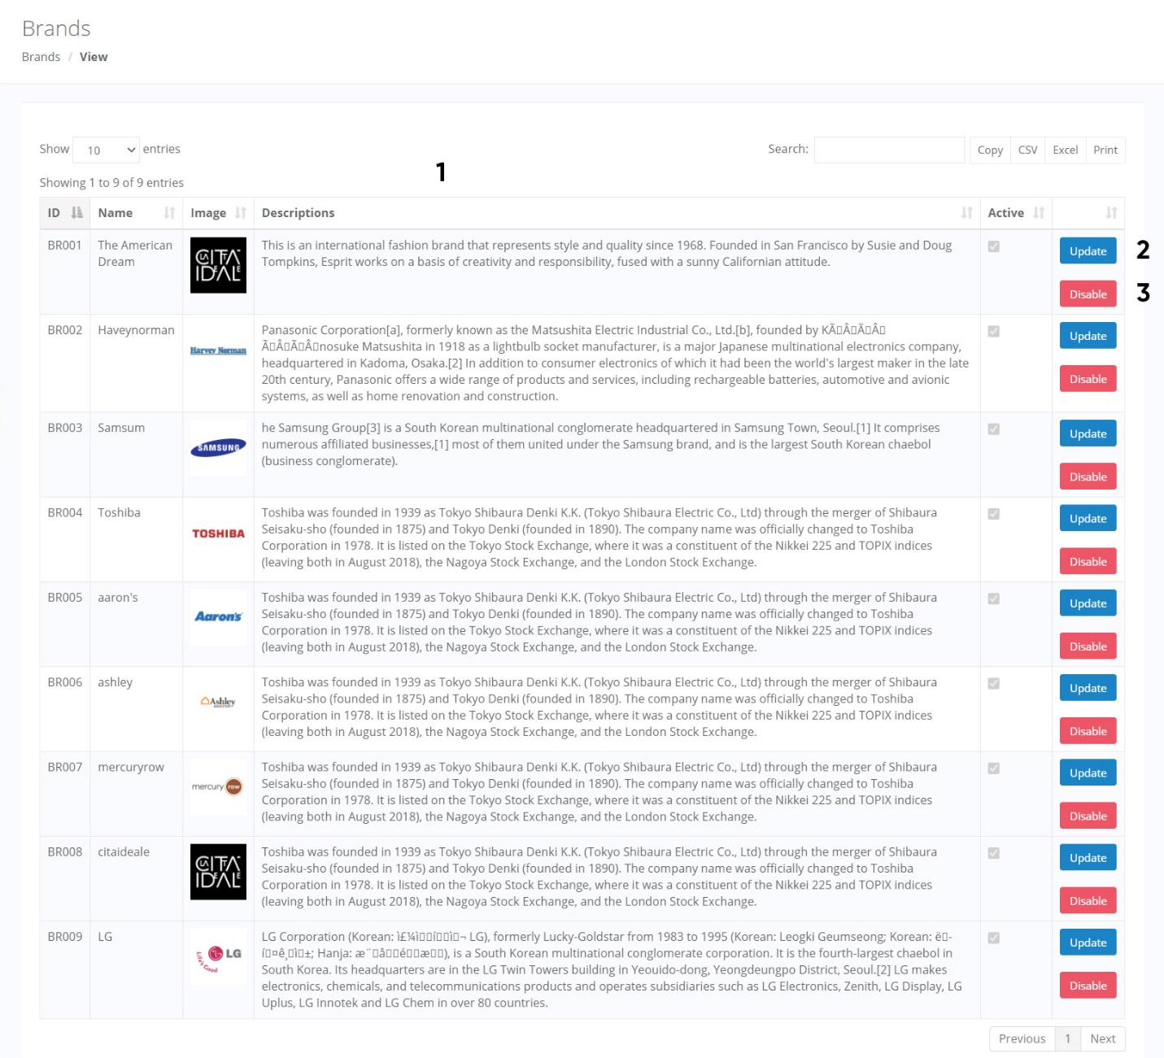**Brands – View**

|  |  |  |  |  |  |
| --- | --- | --- | --- | --- | --- |
| **No** | **Name** | **Type** | **Validation** | **Event** | **Description­** |
| 1 | Brands list | Bootstrap Datatable |  |  | Contains all field of Admins table. Use bootstrap datatable libraries with buttons to export data to files |
| 2 | Update | Button |  | Click | Redirect to Update Brand page |
| 3 | Disable | Button |  | Click | Disable the brand |

1. 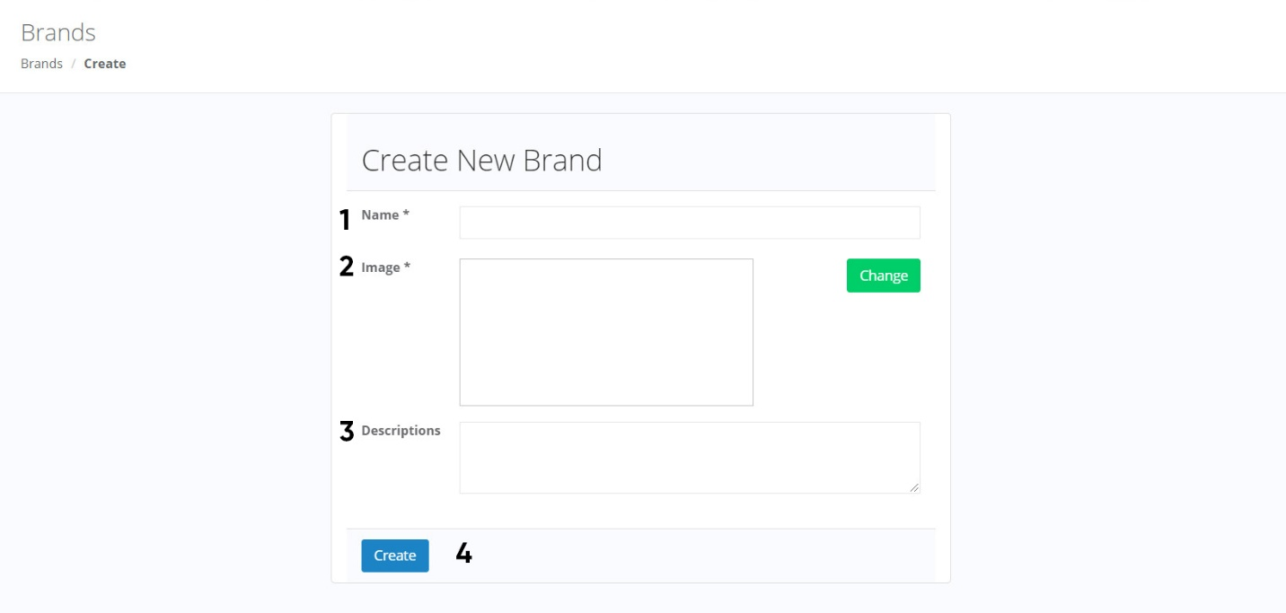**Brand – Create**

|  |  |  |  |  |  |
| --- | --- | --- | --- | --- | --- |
| **No** | **Name** | **Type** | **Validation** | **Event** | **Description­** |
| 1 | Name | Input Text | Not null |  |  |
| 2 | Image | Input file | Images, size < 1MB |  |  |
| 3 | Description | Input Textarea |  |  |  |
| 4 | Create | Button |  | Click | Create new Brand |

1. 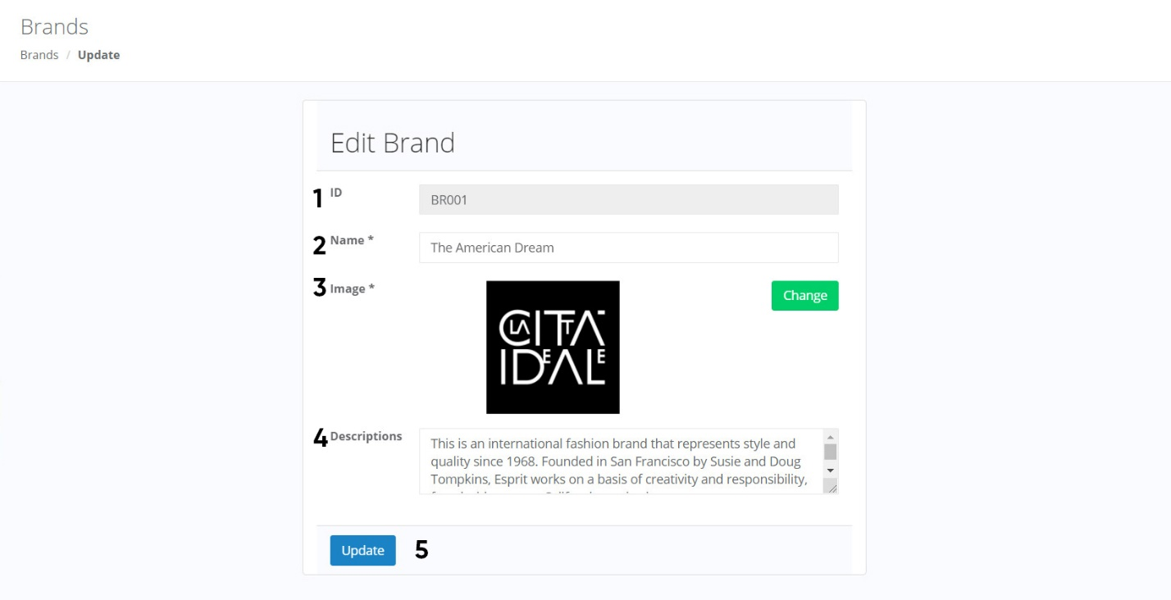**Brand – Update**

|  |  |  |  |  |  |
| --- | --- | --- | --- | --- | --- |
| **No** | **Name** | **Type** | **Validation** | **Event** | **Description­** |
| 1 | ID | Input Text |  |  | Read only |
| 2 | Name | Input Text | Not null |  |  |
| 3 | Image | Input file | Images, size < 1MB |  |  |
| 4 | Description | Input Textarea |  |  |  |
| 5 | Update | Button |  | Click | Update the brand’s info |

# Task Sheet

|  |  |  |  |  |  |
| --- | --- | --- | --- | --- | --- |
| **Project Ref. No.** | | **Project Name:**  **Furniture Store** | **Date of Preparation** | | |
| **No** | **Task** | **Description** | **Start Date** | **Completed Date** | **Team member** |
| 1 | Review 3 | Physical Entity Relationship Diagram | 29/11/2020 | 30/11/2020 | All team member |
| 2 | Table Design |
| 3 | Website map |
| 4 | Class Diagram |
|  | **Client Website** |  |  |  |
| 5 | Login | 1/12/2020 | 5/12/2020 | NGUYỄN MINH TRUNG TRỰC |
| 6 | Register |
| 7 | Manage account (Update information + Change password) |
| 8 | Logout |
|  | **Admin Website** |  |  |  |
| 9 | Admin Login | 6/12/2020 | 10/12/2020 | NGUYỄN MINH TRUNG TRỰC |
| 10 | Manage Customers (Change status) |
| 11 | Manage account  (Update information + Change password) |
| 12 | Admin Logout |
|  | **Client Website** |  |  |  |
| 13 | Show list product, show list categories | 1/12/2020 | 3/12/2020 | LÊ GIA PHÚC |
|  | **Admin Website** |  |  |  |
| 14 | Manage Products (View, Insert, Update, Change status) | 4/12/2020 | 10/12/2020 | LÊ GIA PHÚC |
| 15 | Manage Categories  (View, Insert, Update, Change status) |
| 16 | Manage Brands (View, Insert, Update, Change status) |
| 17 | Manage Types (View, Insert, Update, Change status) |
|  | **Client Website** |  |  |  |
| 18 | Search product by name, by type, by brand, by price | 11/12/2020 | 18/12/2020 | LÊ GIA PHÚC |
| 19 | Rating for product  (By Customer) |
| 20 | Add product to wishlist |
|  | **Admin Website** |  |  |  |
| 21 | Income report by Categories | 11/12/2020 | 18/12/2020 | NGUYỄN MINH TRUNG TRỰC |
| 22 | Income report by Brands | 11/12/2020 | 18/12/2020 | LÊ GIA PHÚC |
|  | **Client Website** |  |  |  |
| 23 | Cart (Add product to cart, view cart, update quantity) | 19/12/2020 | 26/12/2020 | NGUYỄN MINH TRUNG TRỰC |
| 24 | Checkout |
|  | **Admin Website** |  |  |  |
| 25 | Manage Orders (View, Change status) | 19/12/2020 | 26/12/2020 | NGUYỄN MINH TRUNG TRỰC |