Test Document with Images

This is a **test document** created to verify the *Word to HTML converter with image support* functionality.

Here is the first test image:



This paragraph is centered

And here is the second test image:

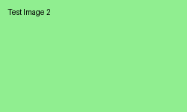

Features being tested:

* • Bold and italic text formatting
* • Color changes in text
* • Different paragraph alignments
* • Table creation and formatting
* • Image insertion and conversion

|  |  |  |
| --- | --- | --- |
| **Feature** | **Status** | **Notes** |
| Text Formatting | ✅ Working | Bold, italic, colors |
| Image Support | 🔄 Testing | PNG, JPEG formats |

This document demonstrates various formatting and image features that should be preserved in the HTML conversion.