Kebutuhan
-Sampling 1 kHz
-Range ±9V
Pin Map
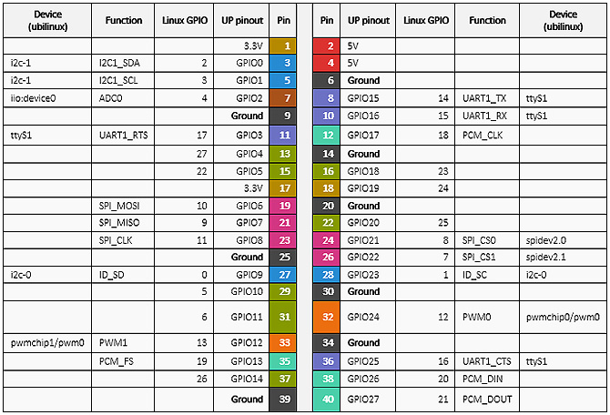

UpBoard |  | AD7606
4 | 6 | GND | +5V
3 | 5 | OS1 | OS0
7 | 8 | RAGE | OS2
11 | 10 | CVB | CVA
13 | 12 | RD | RST
15 | 16 | BUSY | CS
17 | 18 | FRST | VIO
19 | 22 | DB1 | DB0
21 | 24 | DB3 | DB2
23 | 28 | DB5 | DB4
27 | 32 | DB7 | DB6
29 | 36 | DB9 | DB8
31 | 38 | DB11 | DB10
33 | 40 | DB13 | DB12
35 | 37 | DB15 | DB14

Mode
- Reading after conversion
- Oversampling ratio 64
- Range ±10V
- Terakhir FRST dan BUSY tidak dipakai
Flowchart
- Start
- Set all configuration pin
- Rising Reset for minimal 50 ns
- Waiting minimal 50 ns from step 3
- Cycle
  - Falling CONVSTX for 25 ns
  - Wait BUSY fall
  - Falling CS and RD
  - Wait for FRSTDATA rise
  - For 1 to 6
    - Read VX
    - Rising RD for t_11 ns
    - Falling Rd for t_10 ns

  - Cycle 7
    - Fallin
    - Read Vx
    - Rising RD fro min 15 ns
  - Rising CS
Contingency Plan:

Catatan
- Interrupt cuma bisa 1 setiap saat, kalau ada dua atau lebih, sinyal interrupt manapun akan masuk ke Interrupt terakhir saja
- For upboard dari bawah ke atas minimal sekitar 600ns
- Read write gpio sekitar minimal 12 µs

Step
- Data terbaca
- Kecepatan
- Monitor

Multithreading
Ada dua sampling dan print
Sampl

