PROGRESS MEMO
Brazil Sovereign Compute Nexus
Where each dataset came from, how the four phases fit together, and what is still open
Prepared by Gia Nichole · September 14, 2026, figures updated September 17, 2026 · Workspace: ~/Projects/Brazil
AT A GLANCE
12 layers harmonized  nine external sources, three derived in-workspace | 4 phases complete  H3 harmonization, remote sensing, policy, optimization
2,808 → 25 cells  candidate grid to recommended shortlist, 10 needing review | 63.5 TWh curtailed  wind and solar, Oct 2021 – May 2026, 11.2% of potential

1. What the project has become
The workspace began as a cleaning exercise on a Global Energy Monitor–style energy workbook for Brazil. It is now something larger: a reproducible siting pipeline that asks where hyperscale data-center infrastructure can physically and lawfully go, and refuses to answer that question with price alone.
The organizing idea is a strict ordering. Every physical, environmental and legal layer is harmonized into the same spatial decision unit, hard constraints are applied to that unit, and only the cells that survive are scored against competing objectives. Cheap power does not buy its way past a protected area, an indigenous territory, a water body, or a degradation risk above threshold. Those are exclusions, not penalties — and they are applied before the optimizer sees the data.
The national layers cover all of Brazil. The four-phase case study runs on a 50 km × 50 km box in coastal Ceará, chosen because it is where the tension is sharpest: strong wind resource and subsea fiber landing, against the worst transmission headroom score in the national screening and a Caatinga biome that raises licensing sensitivity. If constraints bind anywhere, they bind here.

2. Where the data comes from, and what each layer does
Twelve layers feed the pipeline — nine drawn from external sources, three derived inside the workspace. Figure 1 shows how they move from raw form into the harmonized layers and then into the four phases; the table that follows says what each one is and why it is there.
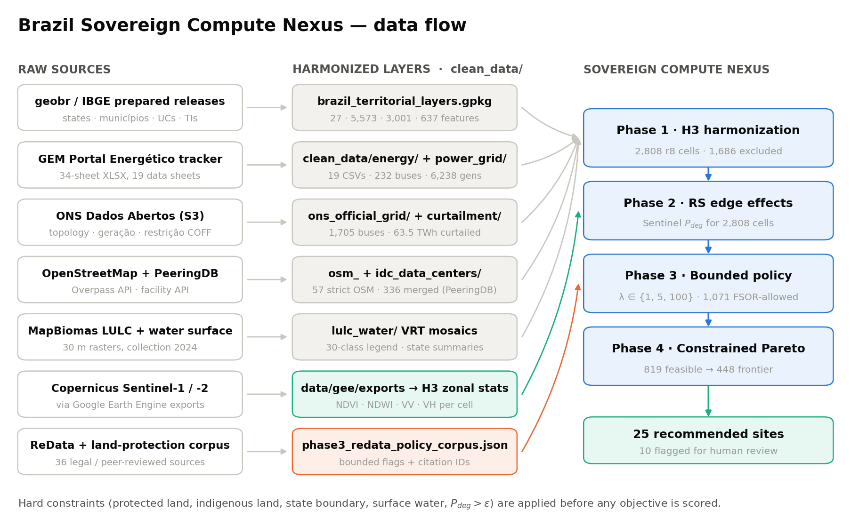
Figure 1. Data flow from raw sources through the harmonized clean_data layers into the four Sovereign Compute Nexus phases. Green marks the remote-sensing path into Phase 2; orange marks the policy corpus path into Phase 3.
What the layer is | Where it comes from | Why it is in the model
SOCIAL IMPACT — the people and places the project must not disturb
Brazil’s protected and indigenous lands | Brazil's official map layers, published by IPEA through the geobr project. Four files, merged into one: every state, all 5,573 municipalities, 3,001 protected conservation areas, and 637 indigenous territories. | This is the legal map. If a location sits on protected or indigenous land, or outside the state, it is ruled out from the start — cheap electricity cannot buy its way back in.
ENERGY — where the power is, and where it is being wasted
What generates power, and where | A tracker spreadsheet of Brazil's power projects (March 2026). Of its 34 tabs, 19 held real data; those became 19 clean tables covering 22,323 projects, with 49 empty columns removed and no rows lost. | The inventory of Brazil's generating fleet. It tells the model how much clean electricity sits near any candidate location.
A first sketch of the wires | Built from the power-project tables above. The spreadsheet had no transmission lines, so plausible ones were estimated by connecting nearby plants: 232 substations, 826 lines, 6,238 generators, 229,698 MW. | A rough first draft of the grid, kept only to sanity-check the official data below. It never decides where a data center can go.
The real grid | Brazil's grid operator, ONS, publishes its actual network as open data — substations, transmission lines and capacity. 1,705 substations, 1,838 live lines, 4,626 generating units, 198,138 MW. | The grid that counts. Every “how far is this site from power?” measurement is taken against this layer.
Clean power that was thrown away | ONS records of renewable electricity that was generated but ordered off the grid because the wires could not carry it. 82 monthly files, October 2021 to May 2026. | Evidence that the waste is real and large: 63.5 TWh discarded out of 502.3 TWh produced. That wasted power is the opportunity a well-sited data center could absorb.
The same waste, plant by plant | The detailed version of the records above — half-hourly, per power plant, with weather. 92 million rows across 1,593 plants. | Lets us separate officially ordered curtailment from every other kind of shortfall (108.6 TWh in total), so each claim can be labeled with how solid the evidence behind it is.
What happens if the pipeline gets built | 3,552 power projects that are proposed but not yet built (463,005 MW), placed onto today's grid to see what would happen. | A what-if. If all that generation arrives without new transmission, overloaded lines jump from 1 to 236. It is the clearest sign that siting compute is a wires problem, not only a land problem.
LAND — the ground itself, and what is already built on it
Where data centers already are | Two open sources: OpenStreetMap (57 strictly tagged sites) and PeeringDB, the industry's own facility directory (302 Brazilian facilities), merged into 336 unique locations. | A stand-in for fiber. A new site has to sit near existing internet infrastructure, so distance to the nearest facility is both a hard limit and something the model tries to minimize.
A first pass across all 27 states | Everything above, combined into one score per state, weighted toward market access (30%), grid access (20%), clean power (20%), spare transmission capacity (15%) and environment (15%). | The national screen that told us where to look closely. São Paulo scores highest at 86.1; Ceará comes 7th at 64.0 — excellent renewables, strained grid — which is exactly what makes it a useful test case.
What is on the ground, and where the water is | Two satellite-derived maps of Brazil at 30-meter detail for 2024: land cover (forest, pasture, city and 27 other categories) and surface water. | Scores how sensitive the land is, and rules out anywhere sitting on water.
Satellite evidence of stress | European Space Agency satellites, pulled through Google Earth Engine. Sentinel-2 sees color and vegetation health; Sentinel-1 is radar and sees through cloud. Three-month snapshots from October 2021 to May 2026 at 10-meter detail, then averaged over each decision cell. | The real measurement behind the environmental risk score. Vegetation health, wetness and radar texture replace an earlier stand-in estimate, across all 2,808 cells in the study area.
POLICY — the rules the model has to obey
What the law allows | 36 hand-picked documents: 12 government sources on ReData and data-center policy, 15 on indigenous rights, protected areas and environmental law, and 9 peer-reviewed articles. | Turns law into rules the model can actually follow. It decides which legal conditions rule a place out, which ones need a person to look, and which simply count against a site.
Table 1. What each layer is, where it came from, and the job it does — grouped by the question it answers.

3. How the four phases work
The phases are sequential and each one hands the next a narrower, better-characterized set of cells. Nothing downstream can widen what an earlier phase has excluded.
Phase | What it does
Phase 1 — H3 harmonization  build_phase1_h3_baseline.py | Tiles a 50 km × 50 km box centered on −3.56, −38.82 in coastal Ceará into 2,808 H3 resolution-8 cells and joins every layer onto a single h3_id key. 1,686 cells are excluded immediately: 1,353 fall outside the state boundary, 254 overlap protected areas, 124 overlap indigenous land.
Phase 2 — Remote-sensing edge effects  run_scn_phase2_rs.py | Reconstructs each h3_id as a polygon, masks the Sentinel composites to it, and takes the mean of valid 10 m pixels. NDVI (optical stress), NDWI (wetness), and VV/VH (radar pressure) combine into a degradation probability P_deg for all 2,808 cells; mean 0.51. The earlier PCA reconstruction-error proxy is retained as a fallback and validation scaffold.
Phase 3 — Bounded policy classifier  run_scn_phase3_policy.py | Deliberately not an open-ended language model. Deterministic rules read the corpus and emit only categorical outputs: stringency Low / Medium / Critical with weights 1 / 5 / 100, a hard-exclusion flag, and a human-review flag inside a 2.5 km boundary buffer. 1,734 cells come back Critical, 1,071 are permitted to proceed, 821 are marked for human review.
Phase 4 — Constrained optimization  run_scn_phase4_optimization.py | Applies every hard constraint before scoring anything: policy must permit the cell, P_deg ≤ 0.62, and the cell must lie within 25 km of a high-voltage ONS bus, 15 km of an ONS line, and 50 km of a data-center anchor. 966 cells survive; Pareto sorting over six minimized objectives leaves 505 non-dominated cells, from which 25 are ranked as a shortlist. (Figures reflect the September 15, 2026 correction of a zero-distance defect; the May run gave 819 / 448 / 25.)
Table 2. The four Sovereign Compute Nexus phases and the script that runs each.
The cumulative effect of applying constraints before objectives is severe, and that is the point. Figure 2 traces the attrition from the full grid to the shortlist.
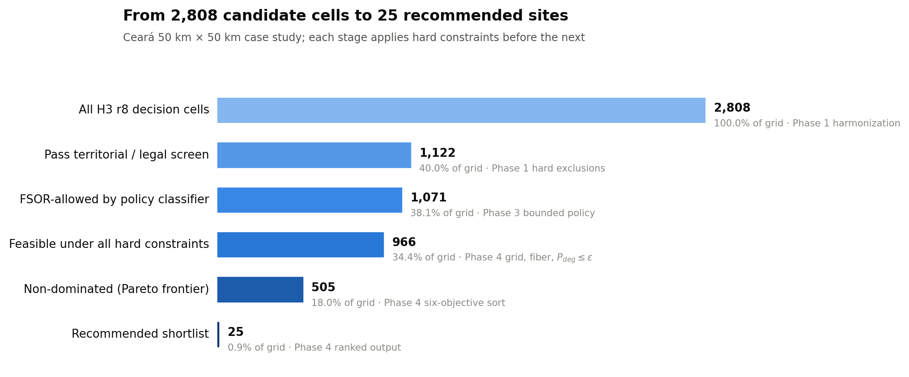
Figure 2. Attrition across the pipeline. Less than 1% of the candidate grid reaches the recommended shortlist, and the largest single loss is the legal and territorial screen applied in Phase 1.

Figure 3 shows the same four phases as maps of the case-study box. Panel A is the legal screen; panel B is the Sentinel-derived degradation surface; panel C is the bounded policy classification; panel D is what the optimizer returns.
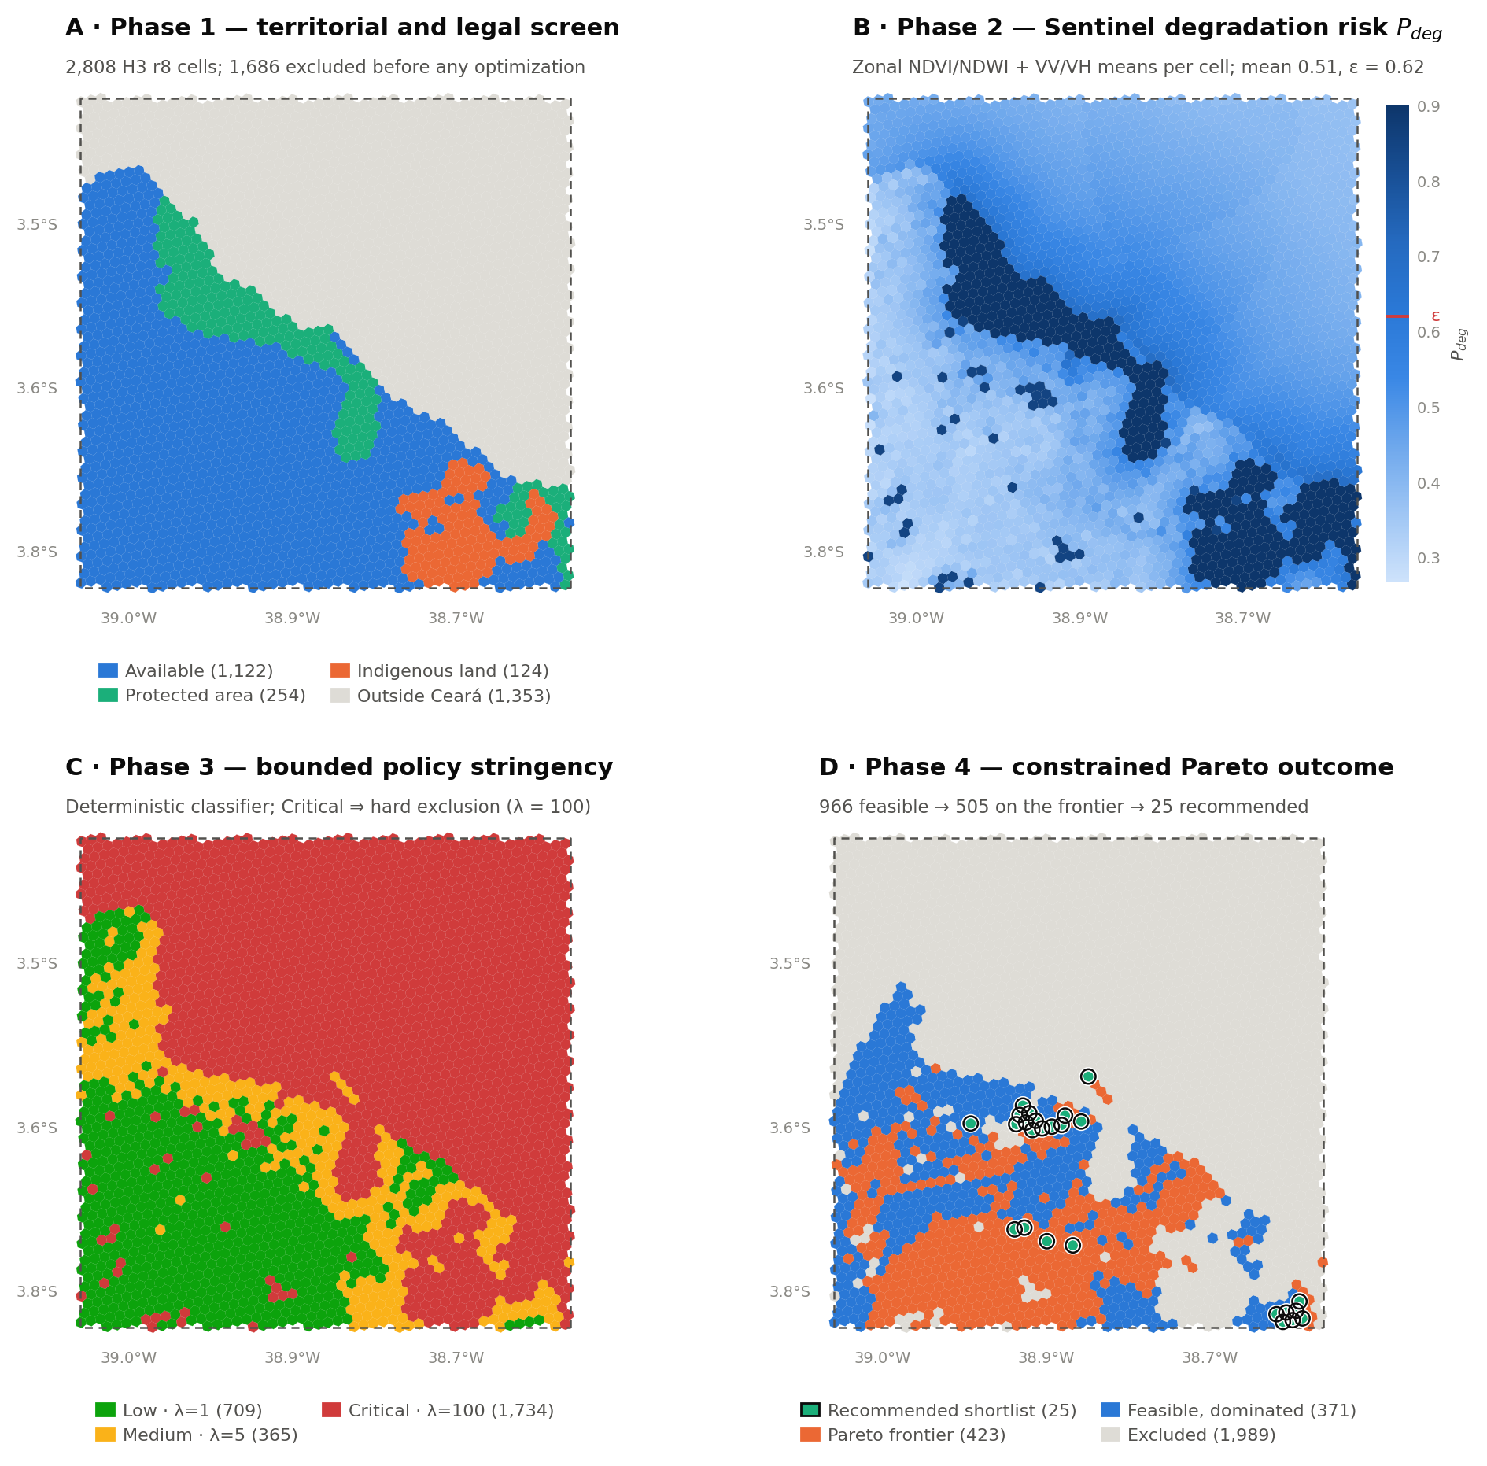
Figure 3. The Ceará case study through each phase. The dashed outline is the 50 km × 50 km study box. In panel C the whole offshore area reads Critical because outside-boundary cells are a hard exclusion; in panel D the circled cells are the 25-cell recommended shortlist.

4. What the results say so far
Finding | Evidence
Curtailment is material and geographically concentrated | 63.5 TWh curtailed against 502.3 TWh generated (11.2% of potential) between October 2021 and May 2026, of which 45.6 TWh is wind. Rio Grande do Norte (21.6 TWh) and Bahia (18.2 TWh) dominate; Ceará contributes 6.0 TWh. Transmission-attributed curtailment only appears from 2025 onward, reaching 10.7 TWh.
Proposed generation would break the current topology | Holding transmission fixed and adding 463,005 MW of proposed capacity takes overloaded branches from 1 to 236 and branches above 75% utilization from 9 to 335. This is a stress proxy rather than a dispatch forecast, but it is the clearest argument that siting compute near curtailed generation is a grid question, not just a land question.
ONS and GEM disagree enough to matter | ONS reports 198,138 MW installed against GEM's 229,698 MW, and the mix differs materially — hydropower is 55.4% of the ONS fleet but 47.7% of the GEM fleet, bioenergy 2.1% versus 7.8%. ONS is treated as authoritative for topology and capacity; GEM is used for project-level and proposed assets.
National screening points to the Southeast, but the case study is Ceará | São Paulo (86.1), Minas Gerais (74.8), Paraná (71.3) and Rio Grande do Sul (70.8) form Tier 1 on market depth and grid access. Ceará ranks 7th at 64.0 — strong on subsea fiber and renewable resource, penalized on transmission headroom (0.07 of 1) and biome sensitivity — which is precisely why it is the interesting test of whether constraints bind.
Very little of the case-study box survives the constraints | Of 2,808 cells, 966 are feasible and 25 are recommended — 0.9% of the grid. The binding constraint is policy (1,737 cells hard-excluded), then distance to an ONS line (684), then degradation risk above ε (474). 12 of the 25 recommended cells are Medium-stringency and still require human review, and 15 sit directly on a transmission line.
Table 3. Principal findings to date, with the evidence behind each.
The shape of the trade-off within the feasible set is worth a look on its own. Figure 4 plots the two objective pairs that discriminate most. The left panel shows the familiar tension between grid interconnection cost and fiber proximity, with the shortlist clustering where both are cheap. The right panel is more surprising: the feasible cells split into two distinct populations on renewable energy shortfall — one cluster near the large wind complexes at roughly 0.50, another near 0.92 — with almost nothing between them. Siting in this box is effectively a binary choice about which cluster to join, not a continuous trade.
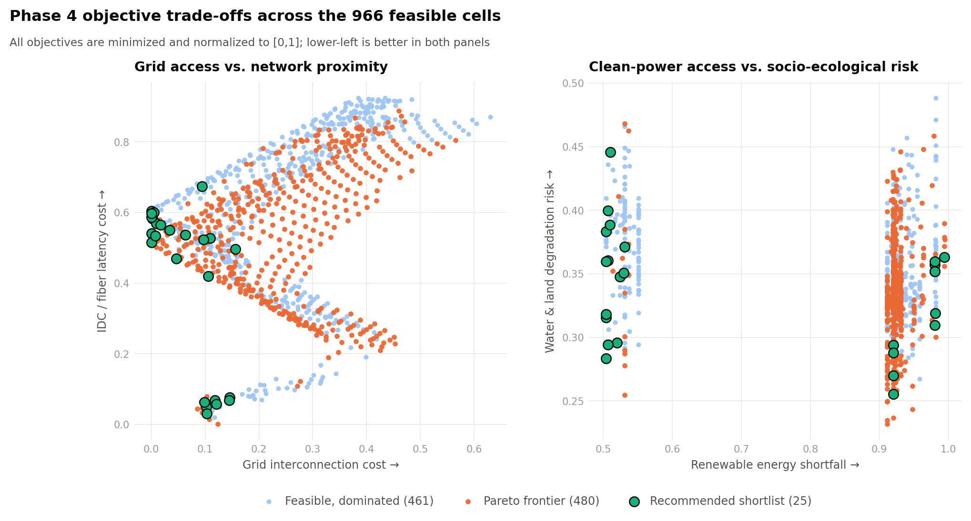
Figure 4. Objective trade-offs across the 966 feasible cells. All objectives are minimized, so lower-left is better in both panels.

5. What is still open
The first four came out of a line-by-line check of the phase outputs against the summaries the scripts write, and I would want them resolved before the framework is described anywhere external. They are ordered by how much they affect a claim.
1. One of the six Phase 4 objectives does no work.
objective_curtailment_shortfall is identically 0.0 across all 966 feasible cells, because curtailment enters the model only at state resolution and the entire case-study box sits in Ceará. The frontier is therefore effectively a five-objective sort, not six. The plant-level detail data already in the workspace could support sub-state attribution; otherwise the objective should be dropped from single-state runs and the claim adjusted.
2. The degradation probability is clipped at 0.90.
355 cells (12.6%) sit exactly at the ceiling, and the 95th percentile equals the maximum. Feasibility is unaffected because ε = 0.62, but all ranking information in the high-risk tail is lost — which will matter when the weighted score is replaced by a trained autoencoder, and again for any difference-in-differences design that needs variation in the treated tail.
3. water_surface_share_proxy is binary, not a share.
It takes only the values 0 and 1 across all 2,808 cells: it records whether the cell centroid fell on water, not what fraction of the cell is water. 64 cells are flagged this way and the flag drives a hard exclusion. The Phase 1 summary already notes that raster features are centroid proxies; the field name should follow, and the measure should move to true zonal statistics before publication.
4. The Sentinel ingest log contradicts the ingest itself.
sentinel_drive_ingest_summary.json records drive_dir as "…/My Drive/gee_ceara" and reports 0 visible GeoTIFFs with all 38 expected exports missing, while data/gee/exports/ holds a working symlink into "…/My Drive/SCN_GEE_Sentinel_Ceara" and the export catalog CSV is empty. The solver features clearly came from more than one composite — the quarterly and median NDVI columns differ — but the repository cannot currently say which. Re-running the ingest against the correct Drive folder would close the provenance gap.
5. Two counts in the README do not match their own sources.
The README reports 22,874 rows processed in the energy cleaning step; cleaning_report.json sums to 22,323 across the 19 sheets. It also describes the Phase 3 corpus as 15 ReData / data-center sources and 12 land-protection sources, but both the corpus JSON categories and the order of the corpus Markdown table give 12 and 15 — the two figures are transposed. Small, but these are exactly the numbers that get quoted.
6. The land-cover raster is still a partial download.
lulc_candidate_2024.vrt still points at a file named "Unconfirmed 614937.crdownload". It is readable and the class codes match the MapBiomas family, but it should be replaced with the completed, renamed file before any publication-grade zonal statistics.
7. Three inputs live outside the repository.
The Phase 3 notes PDF sits in ~/Downloads, the land-cover and water rasters in OneDrive, and the Sentinel exports in Google Drive. Each is a reproducibility risk for anyone re-running the pipeline, including a future version of this project.

Standing caveats that are not defects
These are limits of the design rather than things to fix, but they should travel with any result the pipeline produces.
- Grid stress is modeled with DC power-flow approximations, not full AC optimal power flow, and the proposed-generation scenario includes no new transmission or market dispatch.
- PeeringDB and OpenStreetMap facility records are user-maintained; they are adequate for national screening but should be validated before any site-specific claim.
- The state-level investor suitability score excludes tariffs, land costs, tax incentives, water permits, fiber contracts, interconnection queues and permitting timelines.
- Phase 3 is a bounded deterministic classifier, not a legal retrieval system. That is a deliberate safety choice, and it means the policy layer is only as good as the curated corpus behind it.
- The 25 recommended cells are a screening output. Nothing in the pipeline substitutes for environmental licensing, FUNAI consultation, or ANA water permitting.

6. Where things live
Path | Contents
clean_data/ | All harmonized outputs, one subdirectory per layer, each with a GeoPackage or CSV plus an interactive HTML map.
clean_data/sovereign_compute_nexus/ | The four SCN phases: phase1_h3_baseline, phase2_rs/, phase3_policy/, phase4_optimization/, plus the retained MVP proof-of-logic run.
scripts/ | 18 Python stage scripts, reproducible end to end. The README lists them in execution order.
data/ | Raw and intermediate pulls: brazil_geospatial/ (geobr Parquet), ons/ (13 ONS dataset folders), osm/, idc/, gee/ (Earth Engine manifests and export symlinks).
docs/ | Phase 1 data manifest, SCN methodology note, and the Phase 3 ReData policy corpus in Markdown and JSON.
papers/, gov_docs/ | Literature and the ReData exposição de motivos PDF.
Table 4. Workspace layout. The README at the repository root carries the full stage-by-stage record and the scripts in execution order.

All figures in this memo were generated directly from the current phase outputs in the workspace; every count and metric quoted was re-derived from the source files rather than copied from the README.

