VIETNAM GENERAL CONFEDERATION OF LABOR
TON DUC THANG UNIVERSITY
FACULTY OF INFORMATION TECHNOLOGY



NGUYEN GIA HUY – 524H0158
TRAN DO QUOC ANH – 524H0074
NGUYEN GIA VIET – 524H0075

FINAL REPORT

DISCRETE STRUCTURES

HO CHI MINH CITY, 2025
VIETNAM GENERAL CONFEDERATION OF LABOR
TON DUC THANG UNIVERSITY
FACULTY OF INFORMATION TECHNOLOGY

NGUYEN GIA HUY– 524H0158
LE ANH TUAN – 524H0074
NGUYEN GIA VIET – 524H0075

FINAL REPORT

DISCRETE STRUCTURES
Advised by
Dr. Nguyen Quoc Binh

HO CHI MINH CITY, 2025
ACKNOWLEDGEMENT

We would like to express our sincere gratitude to Mr. Nguyen Quoc Binh, our instructor and mentor, for his valuable guidance and support throughout the mid-term report of our project on Building a book management and ordering system on the MERN stack platform. He has been very helpful and patient in providing us with constructive feedback and suggestions to improve our work. He has also encouraged us to explore new technologies and techniques to enhance our system's functionality and performance. We have learned a lot from his expertise and experience in web development and software engineering. We are honored and privileged to have him as our teacher and supervisor.

Ho Chi Minh city, 25th December 2025.
Author
(Signature and full name)

Tuan
Le Anh Tuan
Viet
Nguyen Gia Viet
Huy
Nguyen Gia Huy
DECLARATION OF AUTHORSHIP
We hereby declare that this is our own project and is guided by Mr. Nguyen Quoc Binh; The content research and results contained herein are central and have not been published in any form before. The data in the tables for analysis, comments and evaluation are collected by the main author from different sources, which are clearly stated in the reference section.
In addition, the project also uses some comments, assessments as well as data of other authors, other organizations with citations and annotated sources.
If something wrong happens, We’ll take full responsibility for the content of my project. Ton Duc Thang University is not related to the infringing rights, the copyrights that We give during the implementation process (if any).
Ho Chi Minh city, 25th December 2025
Author
(Signature and full name)

Tuan
Le Anh Tuan

Viet
Nguyen Gia Viet

Huy
Nguyen Gia Huy

TABLE OF CONTENT
CHAPTER 1. Tasks v
1.1 Task 1: v
1.2 Task 2: vi
1.3 Task 3: viii
1.4 Task 4: viii
1.5 Task 5: viii
1.6 Task 6: viii
1.7 Task 7: x
1.8 Task 8: xi
CHAPTER 2. Solutions 1
1.1 Problem 1: 1
1.2 Problem 2: 2
a. 2
b. 3
1.3 Problem 3: 5
a. 5
b. 6
1.4 Problem 4: 7
a. 7
1.5 Problem 5: 8
2.1 Problem 6: 9
$a.$ 9
$b.$ 13
1.7 Problem 7: 20
a. 20
$c.$ 21
1.8 Problem 8: 22
a. 22
b. 23
CHAPTER 3. Self-Evaluation 27
REFERENCES 29

Tasks

1 Task 1:
A hacker is trying to hack a password. He knows that this password has 3 characters, each of which is a distinct number from 1 to 9. He also learns from his trials that:
- 472: one number is correct but in an incorrect position.
- 581: one number is correct but in an incorrect position.
- 483: one number is correct and in the correct position.
- 317: two numbers are correct but in incorrect positions.
- 956: all numbers are incorrect.
Please help him to find the password with good reasoning.

1.2 Task 2:
Giving the following Tarski's world.
 | 1 | 2 | 3 | 4 | 5 | 6 | 7 | 8 | 9
A
B
C
D
E
F
G
H
I
Items are named by their positions. These notations are defined:
- Triangle(x), meaning “x is a triangle,”
- Circle(x), meaning “x is a circle,”
- Square(x), meaning “x is a square,”
- Red(x), meaning “x is red,”
- Green(x), meaning “x is green,”
- Orange(x), meaning “x is orange,”
- $RightOf(x, y),$ meaning “x is to the right of y (but possibly in a different row),”
- $LeftOf(x, y),$meaning “x is to the left of y (but possibly in a different row),”
- $AboveOf(x, y),$ meaning “x is to the above of y (but possibly in a different column),”
- $BelowOf(x, y),$ meaning “x is to the below of y (but possibly in a different column).”
The domain for all variables is the set of objects in Tarski’s world shown in the picture.
a. Modify the above Tarski's world as follows:
- If $\overline{abcd}$ % 7 = 0 then add a red square in A5.
- If $\overline{abcd}$ % 7 = 1 then add a green triangle in F3.
- If $\overline{abcd}$ % 7 = 2 then delete the item at G6.
- If $\overline{abcd}$ % 7 = 3 then delete the item at H5.
- If $\overline{abcd}$ % 7 = 4 then change the item at E4 into an orange square.
- If $\overline{abcd}$ % 7 = 5 then change the item at E5 into a green circle.
- If $\overline{abcd}$ % 7 = 6 then change the item at E6 into a red triangle.
Re-draw your new Tarski's world.
b. Determine the truth or falsity of all the following statements, based on the modified Tarski's world. Give the reasons for your justification.
- $∀x, Circle(x) → Green(x)$ .
- $∀x, Triangle(x) → \sim Orange(x)$.
- $∃x such that Red(x) ∧ Triangle(x)$.
- $∃x such that \sim Green(x) ∧ BelowOf(x, E4)$.
- $∀x, Square(x) → RightOf(E5, x)$.
- $∃x such that AboveOf(E5, x) ∧ LeftOf(x, E5)$.
- There is a triangle x such that for all squares y, x is above y.
- For all circles x, there is a square y such that y is to the right of x.
- There is a circle x and there is a square y such that y is below x.
- For all circles x and for all triangles y, x and y have the same color.

1.3 Task 3:
Our group: 524H0158 and 524H0075 and 524H0074
- $Using Euclid’s algorithm to caculate gcd(2025, 1074) and lcm(2025, 1074):$
- Apply above result(s) in to find 5 integer solution pairs $(x, y)$ of this equation: $2025x+1074y=gcd⁡(2025, 10074)$

Task 4:
Our group: 524H0158 and 524H0075 and 524H0074
Solve the equation $2x+101y=44$ for integer $x, y$

Task 5:
Our group: 524H0158 and 524H0075 and 524H0074
Solve this recurrence relation.
$$a_{n}=8⋅a_{n−1}−15⋅a_{n−2}$$
With $a_{0}=3$ and $a_{1}=74$

Task 6:
Self-study on planar graphs
In this section, you will use a Large Language Model (LLM) as a study partner to investigate the properties of planar graphs. However, LLMs are known to “hallucinate” or make logical leaps in spatial reasoning. Your task is to extract knowledge, apply it to a problem, and rigorously verify the AI’s output.

Part A – Theoretical Report
Please use an LLM to prepare a concise written report (2–3 pages) of your study about planar graphs. You should address and present the key points of the topic, focusing on solving the exercise in Part B. Please ensure that the final version of this study is your own, i.e., you understand and modify the AI’s answers in your own words and support them with diagrams where appropriate.
Submission: Formal theoretical report about planar graphs.

Part B – Application
You are a research assistant validating a dataset of network topologies for a chip design company. An intern has classified a specific network topology, Graph H, as planar because it satisfies the basic Euler inequality condition
$$e≤3v−6$$
Your supervisor suspects this is incorrect and has asked you to audit the conclusion and provide a rigorous mathematical proof.
The graph is defined by the following adjacency list.
- Vertices (V): {0, 1, 2, 3, 4, 5, 6, 7, 8, 9, 10} (Total: 11 vertices)
- Edges (E): The graph consists of 20 edges constructed as follows:
  - A 5-cycle: {0,1}, {1,2}, {2,3}, {3,4}, {4,0}
  - A set of “twin” connections: {5,0}, {5,2}, {6,1}, {6,3}, {7,2}, {7,4}, {8,3}, {8,0}, {9,4}, {9,1}
  - A central hub connected to the twins: {10,5}, {10,6}, {10,7}, {10,8}, {10,9}
Use an AI to verify the conclusion and give a formal proof demonstrating that Graph H is non-planar. You must clearly state:
- Why the standard Euler inequality failed to detect non-planarity.
- The calculation of the triangle-free inequality showing the contradiction.
- A prompt trace attempting to get the AI to identify a homeomorphic subgraph to $K_{4}$or $K_{3,3}$.
Submission:
- Your conversation with the AI used to obtain the answers.
- Formal answers.
- Notes on modifications made from the AI’s answers.

Task 7:
- Does the following graph have an Eulerian circuit or Eulerian trail? Why?
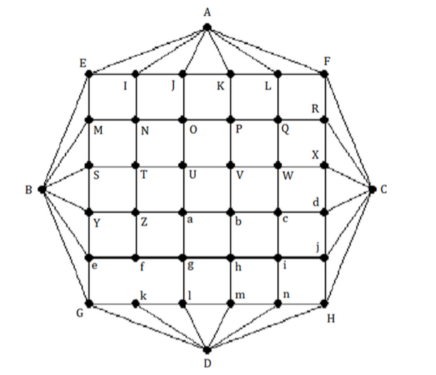
- If the graph has an Eulerian trail, based on the idea of Hierholzer’s algorithm, find an Eulerian trail of the graph. Present your solution step by step.

Task 8:
Giving this map of the United States of Africa:

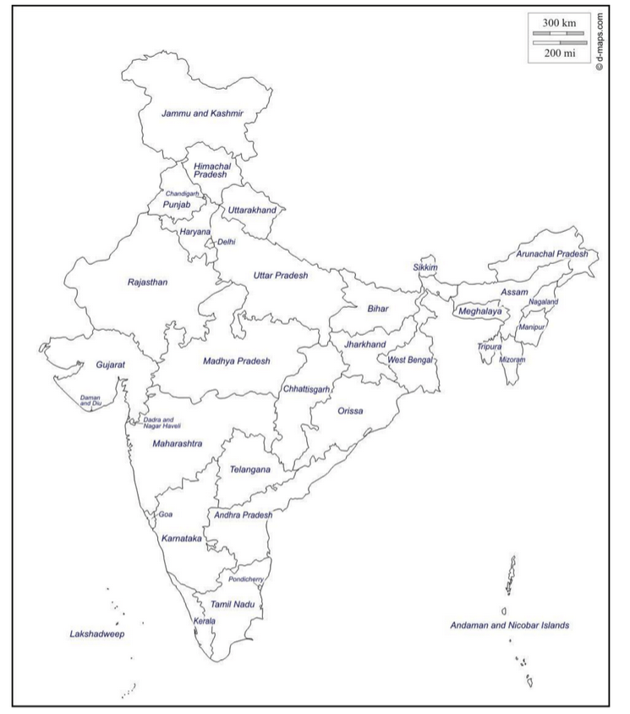
- Modeling this map by a graph.
- Color the map with a minimun number of colors. Present your solution step by step.
- If $\overline{abcd} \% 4=0$ then start from Bihar.
- If $\overline{abcd} \% 4=1$ then start from Orissa.
- If $\overline{abcd} \% 4=2$ then start from Rajasthan.
- If $\overline{abcd} \% 4=3$ then start from Meghalaya.

Solutions

1.1 Problem 1:

Let the password be an ordered triple $(d1,d2,d3)$ of three DISTINCT digits from {1,2,3,4,5,6,7,8,9}.
Syllogism 1:
Major premise: If a clue says “all numbers are incorrect”, then none of those digits appears in the password.
Minor premise: Clue (e) is 956: all numbers are incorrect.
Conclusion: Digits 9, 5, and 6 are not in the password. Hence the password digits come from {1,2,3,4,7,8}. (by Elimination)
Syllogism 2:
Major premise: If a clue says “one number is correct and in the correct position”, then exactly one of its digits matches the password in that same position, and the other two digits do not appear in the password.
Minor premise: Clue (c) is 483: one number is correct and in the correct position.
Conclusion: Exactly one of the following is true: (i) d1=4, or (ii) d2=8, or (iii) d3=3; and the other two digits among {4,8,3} are excluded. (by Modus Ponens)
Now we test the three cases against the remaining clues (a), (b), and (d):
Case 1: Assume d1 = 4 (so 8 and 3 are excluded).
From clue (d) 317: two digits are correct but both in wrong positions.
Since 3 is excluded, the two correct digits must be 1 and 7. So 1 and 7 are in the password.
But clue (a) 472 says exactly one digit among {4,7,2} is in the password (and misplaced). Here both 4 and 7 are in the password, which contradicts “exactly one”. Therefore Case 1 is impossible.
Case 2: Assume d2 = 8 (so 4 and 3 are excluded).
From clue (d) 317: since 3 is excluded, the two correct digits must be 1 and 7. So 1 and 7 are in the password.
Clue (b) 581 says exactly one digit among {5,8,1} is in the password and misplaced.
Since 5 is excluded and 1 is in the password, we would have at least two digits (8 and 1) present, contradicting “exactly one”. Therefore Case 2 is impossible.
Case 3: Assume d3 = 3 (so 4 and 8 are excluded).
Clue (b) 581: since 5 and 8 are excluded, the only correct digit is 1, and it must be misplaced. So 1 is in the password and not in position 3.
Clue (d) 317: two digits among {3,1,7} are correct but misplaced. We already have digit 3, and digit 1 is in the password, so the two correct digits are 3 and 1; hence 7 is excluded.
Clue (a) 472: since 4 and 7 are excluded, the only correct digit is 2, and it must be misplaced. So 2 is in the password.
So the digits are exactly {1,2,3} with d3=3. Now use clue (d) again: in the guess 317, digit 1 is placed at position 2 but must be misplaced, so 1 ≠ d2. Therefore d1=1 and d2=2.
Thus the password is 123.

1.2 Problem 2:

Solve:
Re-drawn Tarski’s world with the condition:

With $\overline{abcd} \% 7=4, (\overline{0074} \% 7=4)$then change the item at E4 into an orange square.

 | 1 | 2 | 3 | 4 | 5 | 6 | 7 | 8 | 9
A
B
C
D
E
F
G
H
I

b.

- $∀x,Circle\left(x\right)→Green\left(x\right)$
- Truth value: False
- Justification: Not all circles are green. For example, the circle at A8 is Red and the circle at H2 is Orange.

- $∀x,Triangle\left(x\right)→ ∼Orange\left(x\right)$
- Truth value: True
- Justification: Looking at all triangles (A2, D8, F2, H5), they are either Green or Red. None of them are Orange.

- $∃x such that Red\left(x\right)∧Triangle\left(x\right)$
- Truth value: True
- Justification: There is at least one red triangle. For example, the object at D8 is a Red Triangle.

- $∃x such that∼Green\left(x\right)∧BelowOf\left(x,E4\right)$
- Truth value: True
- Justification: The Red Square at F1 is not Green and is in Row F, which is below Row E.

- $∀x,Square\left(x\right)→RightOf\left(E5,x\right)$
- Truth value: False
- Justification: The Green Square at C7 is to the right of E5, not to the left.

- $∃x such that AboveOf\left(E5,x\right)∧LeftOf\left(x,E5\right)$
- Truth value: True
- Justification: The Red Square at F1 is below E5 and is located in column 1, which is to the left of column 5.

- There is a triangle x such that for all squares y, x is above y.
- Truth value: True
- Justification: The Triangle at A2 is in the top row (Row A), which is strictly above the rows of all squares on the board.

- For all circles x, there is a square y such that y is to the right of x.
- Truth value: False
- Justification: The Circle at A8 is in column 8, and there are no squares in column 9.

- There is a circle x and there is a square y such that y is below x.
- Truth value: True
- Justification: The Square at F1 is below the Circle at D2.

- For all circles x and for all triangles y, x and y have the same color.
- Truth value: False
- Justification: Circle A8 is Red, while Triangle A2 is Green; they do not share the same color.

1.3 Problem 3:

a.
Solve:
$$gcd⁡(2025,1074)$$
$2025=1074 ×1+951←gcd⁡(1074,951)$
$1074=951 ×1+123←gcd⁡(951,123)$
$$951=123 ×7+90←gcd⁡(123,90)$$
$$123=90 ×1+33←gcd⁡(90,33)$$
$$90=33 ×2+24←gcd⁡(33,24)$$
$$33=24 ×1+9←\gcd\left(24,9\right)$$
$$24=9 ×2+6←gcd⁡(9,6)$$
$$9=6 ×1+3←gcd⁡(6,3)$$
$6=3 ×2+0←gcd⁡(3,0)$
$Thus\gcd\left(2025,1074\right)=3$
Lmc(2025,1074)
Solve:
Formula: $\gcd\left(a,b\right)∙lcm\left(a,b\right)=ab$
$$⟹lcm\left(a,b\right)=\frac{\left|ab\right|}{gcd⁡(a,b)}$$
$$⟹lcm\left(2025,1074\right)=\frac{\left|2025×1074\right|}{3}$$
$$⟹lcm\left(2025,1074\right)=675×1074$$
$$⟹lcm\left(2025,1074\right)=724950$$

$$⟹2025x+\left(1074\right)y=3$$
$$3 = 9 − 6 × 1$$
$= 9 − \left(24 − 9 × 2\right)× 1$ $=$ $9×3−24×1$
$= \left(33 − 24 × 1\right)× 3 − 24 × 1$ $=$ $33×3−24×4$
$= 33 × 3 − (90 − 33 × 2) × 4$ $=$ $33×11−90×4$
$= (123 − 90 × 1) × 11 − 90 × 4$ $=$ $123×11−90×15$
$= 123 × 11 − (951 − 123 × 7) × 15$ $=$ $123×116−951×15$
$$= \left(1074 − 951 × 1\right)× 116 − 951 × 15 =1074×116−951×131$$
$$= 1074 × 116 − (2025 − 1074 × 1) × 131 =2025×\left(−131\right)+1074×247$$
Thus $3=2025∙\left(−131\right)+1074∙(247)$
So, a particular solution for $2025x+\left(1074\right)y=3$ is: $x_{0}=−131,y_{0}=247$
We have the general solution:
$\left(−131+\frac{k1074}{3},247−\frac{k2025}{3}\right),k ∈ℤ$
$$⟹\left(−131+358k,247−675k\right),k ∈ℤ$$
Five integer solutions are given by:
- For $k=1:$
$$⟹\left(−131+358(1),247−675(1)\right),$$
$$⟹\left(227,−428\right)$$
- For $k=2:$
$$⟹\left(−131+358(2),247−675(2)\right)$$
$$⟹\left(585,−1103\right)$$
- For $k=3:$
$$⟹\left(−131+358(3),247−675(3)\right)$$
$$⟹\left(943,−1778\right)$$
- For $k=4:$
$$⟹\left(−131+358(4),247−675(4)\right)$$
$$⟹\left(1301,−2453\right)$$
- For $k=5:$
$$⟹\left(−131+358(5),247−675(5)\right)$$
$$⟹\left(1659,−3128\right)$$

1.4 Problem 4:

Solve:
We have:
$$gcd⁡(101,2)$$
$101=2 ×50+1←gcd⁡(2,1)$
$2=1 ×2+0←gcd⁡(1,0)$
$Thus\gcd\left(101,2\right)=1$
- Extended Euclidean Algorithm:
$$1 = 101−2×50$$
$$=101\left(1\right)+2(−50)$$
Thus $1=101\left(1\right)+2(−50)$
We have:
$$Equation:2x+101y=77$$
- Re-write: $2x=77−101y$.
- Then $2x=77\left(mod 101\right),$by Modular Equivalences.
- Note that $\gcd\left(101,2\right)=1$.
- And the inverse is -50, by multiplicative inverse, using Extended Euclidean Algorithm.
- Thus, $(−50)∙2x≡(−50)∙77$ (mod 101), multiply both sides of the inverse.
- Thus, $x≡−3850$(mod 101).
- Thus, $x≡89$(mod 101), because $−3850=−39∙101+89$.
- Thus, $x=89$ is a solution
- Substituting back into the equation: $2\left(89\right)+101y=77$.
- And, thus $y=−1$
The General integer solution (let $k∈ℤ$):
$$x=89+101k,y=−1−2k.$$

1.5 Problem 5:
The characteristic equation is:
$$t^{2}−8t+15=0$$
$$∆=b^{2}−4ac={(−8)}^{2}−4×1×15=4>0$$
So this formula has two distinct roots:
t1=−b+∆2a=−(−8)+42×1=5
t2=−b−∆2a=−(−8)−42×1=3
$$a_{n}=C{t_{1}}^{n}+D{t_{2}}^{n}=C×{(5)}^{n}+D×{(3)}^{n}$$
$$a_{0}=C+D=3$$
$$a_{1}=C×(5)+D×(3)=5C+3D=74$$
$$\left\{\begin{aligned}a_{0}=C+D=3 \\ a_{1}=5C+3D=74\end{aligned}\right.$$
$$\left\{\begin{aligned}D=3−C \\ 5C+3(3−C)=74\end{aligned}\right.$$
$$\left\{\begin{aligned}D=3−C \\ 5C+9−3C=74\end{aligned}\right.$$
$$\left\{\begin{aligned}D=3−C \\ 2C=65\end{aligned}\right.$$
$$\left\{\begin{aligned}D=3−C \\ C=\frac{65}{2}\end{aligned}\right.$$
$$\left\{\begin{aligned}D=−\frac{59}{2} \\ C=\frac{65}{2}\end{aligned}\right.$$
So $a_{n}=\frac{65}{2}{(5)}^{n}−\frac{59}{2}{(3)}^{n}$.

Problem 6:

$$a.$$
Solve:
Theoretical Report: Planar Graphs
1. Introduction to Planarity
In graph theory, a planar graph is defined as a graph that can be embedded in the plane. This means it can be drawn on a two-dimensional surface such that no two edges cross each other, except meeting at their common endpoints. This property is fundamental in fields ranging from circuit design (PCB layout) to cartography.
2. Euler’s Formula and Necessary Conditions
The most significant property of connected planar graphs is encapsulated in Euler’s Formula. For any finite, connected, planar graph drawn without crossing edges, the number of vertices $(v)$, edges ($e$), and faces ($f$) is related by the equation:
$v−e+f=2$
Note: The "faces" include the bounded regions enclosed by edges as well as the single unbounded region surrounding the graph.
- 2.1 The Standard Necessary Condition
From Euler's formula, we derive a constraint on the maximum number of edges. Since every face in a planar graph $($with $v≥3)$is bounded by at least 3 edges, and every edge borders exactly two faces, we have the inequality$2e≥3f$. Substituting this into Euler's formula yields the standard necessary condition:
$e≤3v−6$
This inequality states that planar graphs are mathematically "sparse".
Necessity vs. Sufficiency & False Positives:
It is crucial to understand that this condition is necessary (all planar graphs must satisfy it), but not sufficient.
- True Negative: If a graph violates the condition (i.e.,$e>3v−6$), it is definitively non-planar.
- False Positive: A graph may satisfy the condition $(e≤3v−6$) and yet be non-planar. The condition only checks if the graph is sparse enough, not if it has topological conflicts.
- Example: The graph $K_{3,3}$has $v=6$ and $e=9.$ Checking the formula: $3(6) − 6 = 12$. Since $9≤12$the graph passes the standard condition, despite being well-known to be non-planar.
3. Triangle-Free Graphs and Stricter Detection
To address false positives like $K_{3,3}$, we examine triangle-free graphs.
- Definition: A triangle-free graph is a graph that contains no cycle of length 3 (no subgraph isomorphic to $K_{3}$). Bipartite graphs are inherently triangle-free because they contain no odd cycles.
For triangle-free planar graphs, the boundary of every face must contain at least 4 edges. This changes the face-edge relationship to $2e>4f$. Substituting this into Euler’s formula yields a stricter inequality:
$e≤2v−4$
Application to Non-Planarity Detection:
This formula is a powerful tool for auditing sparse graphs that pass the standard test.
- Re-evaluating $K_{3,3}$: Since $K_{3,3}$ is bipartite, it is triangle-free.
- Test:$e≤2v−4→9≤2\left(6\right)−4$.
- Result:$9≤8$ is False. By applying this stricter bound, we correctly identify $K_{3,3}$as non-planar, despite it passing the $3v−6$ check.
- 4. Homeomorphic Subgraphs and Forbidden Minors
When algebraic inequalities fail or become too complex, we rely on topological characterizations involving forbidden subgraphs.
- Homeomorphism: Two graphs are homeomorphic if one can be obtained from the other by a sequence of subdivision operations (inserting a vertex onto an edge).
- Kuratowski’s Theorem: A finite graph is planar if and only if it does not contain a subgraph that is homeomorphic to $K_{3,3}.$
- Wagner's Theorem (Minors): A related characterization states that a graph is planar if and only if it does not have $K_{3,3}$as a minor.
- Definitions of the Forbidden Structures
- $K_{3,3}$(The Complete Bipartite Graph / Utility Graph):
  - A graph partitioned into two sets of 3 vertices each. Every vertex in the first set connects to every vertex in the second.
  - Properties: $v=6, e=9$. It is non-planar despite satisfying$e≤3v−6$, because it fails the triangle-free condition $e≤2v−4 .$
- $K_{4}$ (The Complete Graph on 4 Vertices):
  - Properties: $v=4, e=6.$
  - Status: $K_{4}$is Planar. It satisfies$6≤3\left(4\right)−6(6≤6)$ and can be drawn as a tetrahedron without crossings. Note that $K_{4}$ is the forbidden minor for outerplanarity, not general planarity.

Modifications from AI’s answers
The following points highlight exactly where the provided scenes expanded upon or corrected standard general knowledge:
- Detailed "False Positive" Analysis:
  - Instead of simply stating the formula, the report now explicitly details why the standard condition $(e≤3v−6)$ is insufficient. It uses $K_{3,3}$ as a specific case study to prove that a graph can pass the algebraic check but fail the topological check.
- Introduction of the Triangle-Free Inequality:
  - Expansion: The report introduces the stricter inequality$e≤2v−4$. This is not always included in basic definitions but is critical for detecting non-planarity in bipartite graphs (like$K_{3,3}$) where the standard formula fails.

$$b.$$

Solve:

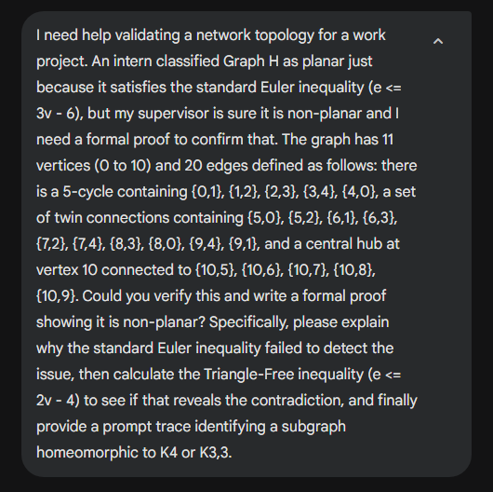
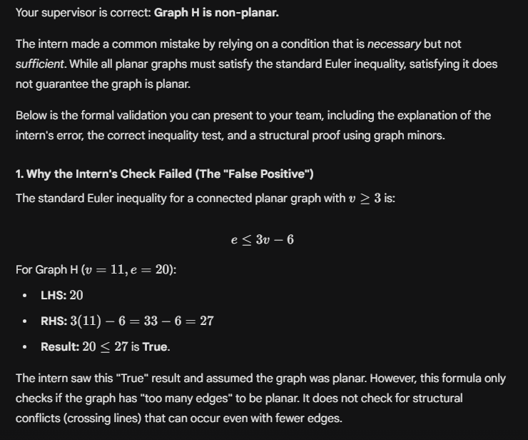
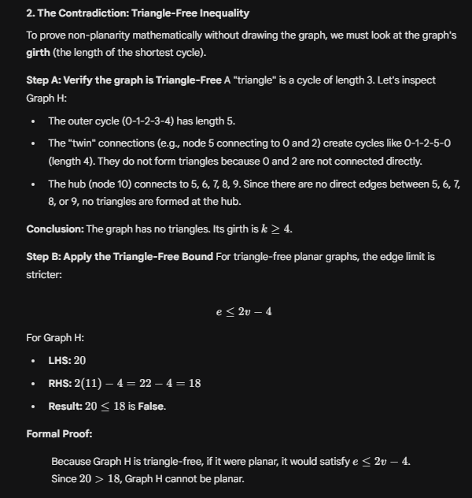
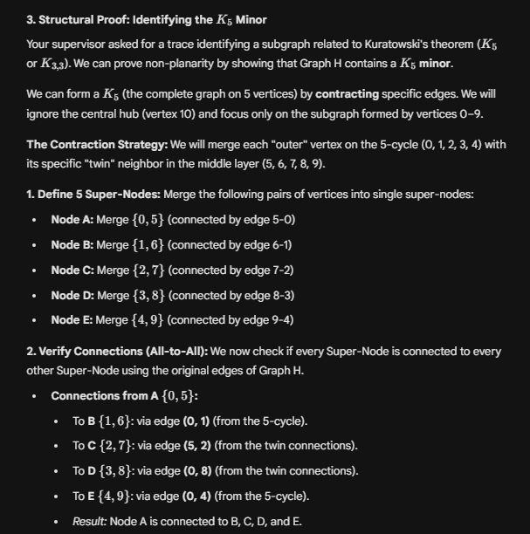
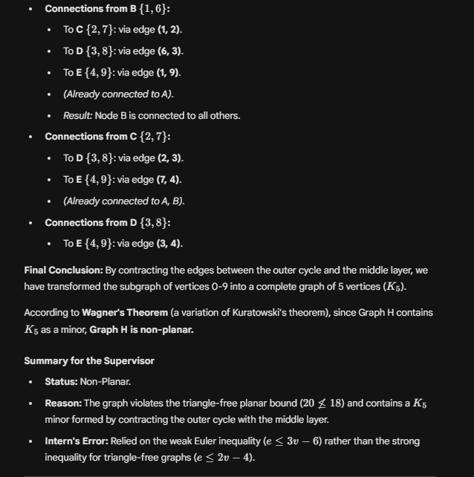
Analysis of the Euler Inequality Failure:
The initial classification of Graph H as planar relied on the Standard Euler Polyhedral Formula for connected planar graphs. While this formula provides a necessary condition for planarity, it is not a sufficient condition.
The Standard Test:
For any connected planar graph with $v ≥3$ vertices and e edges, the inequality $e ≤3v −6$ must hold.
Application to Graph H:
Given parameters $v =11$ and $e =20$, we calculate the standard bound:
$$MaxEdges=3v −6$$
$$= 3(11) − 6$$
$$= 33 − 6$$
$$= 27$$
Comparing this to the actual edge count:
$$20≤27$$
Failure Analysis:
The inequality held true because 20 is numerically less than 27. However, this specific bound assumes the graph can be fully triangulated. Graph H is structurally sparse in a way that prevents triangulation (as proven in Section 2), meaning the "capacity" for edges in a planar embedding of H is significantly lower than 27. Consequently, the standard formula overestimated the planar capacity, resulting in a false positive classification.
Formal Proof by Contradiction: The Triangle-Free Inequality:
To rigorously prove non-planarity using edge density, the graph's specific structural properties—specifically its girth (the length of the shortest cycle)—must be incorporated.
Step A: Verification of Girth (Triangle-Free Status)
A planar graph is "triangle-free" if it contains no cycles of length 3.
- Outer Cycle (Vertices 0–4): The edges form a cycle of length 5 (0-1-2-3-4-0).
- Twin Connections (Vertices 5–9): These vertices connect non-adjacent nodes on the outer ring. For example, Vertex 5 connects to 0 and 2. The shortest cycle formed involves the path 0-5-2 and the outer edges 2-1-0, resulting in a length of 4.
- Central Hub (Vertex 10): Vertex 10 connects to {5, 6, 7, 8, 9}. As there are no edges directly connecting any pair of vertices in the set {5..9}, any cycle involving Vertex 10 must utilize at least two edges connected to the hub (e.g., 5-10-6) and additional edges to return to the start. The minimum length of such a cycle is 4.
Conclusion: Graph H contains no cycles of length 3. Therefore, it is a triangle-free graph (girth ≥ 4).
Step B: The Refined Inequality
For a triangle-free planar graph, the maximum number of edges is governed by the stricter inequality:
$$e ≤2v −4$$
Step C: The Contradiction
Substituting the parameters of Graph H $(v =11, e =20)$ into the triangle-free bound:
$$MaxEdges=2v −4$$
$$= 2(11) − 4$$
$$= 22 − 4$$
$$= 18$$
Comparing this to the actual edge count yields the contradiction:
$$20>18$$
This yields a direct mathematical contradiction. It is impossible to embed a triangle-free graph with 11 vertices and 20 edges on a 2D plane without edge crossings. Thus, Graph H is non-planar.
Structural Trace: K_{3,3} Subdivision:
The following trace identifies a subgraph within Graph H that is homeomorphic to K_{3,3} (the complete bipartite graph), confirming non-planarity via Kuratowski's Theorem.
Partitions:
- Red Set: {0, 2, 6}
- Blue Set: {1, 3, 5}
Required Paths:
To verify the K_{3,3} subdivision, 9 vertex-disjoint paths must be identified connecting every vertex in the Red Set to every vertex in the Blue Set.
- From Red Node 0:
  - To Blue 1: Direct Edge (0, 1)
  - To Blue 3: Path $0→8→3$ (Uses intermediate node 8)
  - To Blue 5: Direct Edge (0, 5)
- From Red Node 2:
  - To Blue 1: Direct Edge (2, 1)
  - To Blue 3: Direct Edge (2, 3)
  - To Blue 5: Direct Edge (2, 5)
- From Red Node 6:
  - To Blue 1: Direct Edge (6, 1)
  - To Blue 3: Direct Edge (6, 3)
  - To Blue 5: Path $6→10→5$ (Uses intermediate node 10, the Hub)
Verification:
The paths utilize intermediate vertices 8 and 10, which are distinct from the partition sets and from each other. This creates a valid K_{3,3} topological minor, confirming the non-planar nature of the topology.
Note on modification:
I changed several recommendations for the AI, originally it insisted on only using K₅ because it says K₅ is better than using K_{3,3}. But this exercise only has K₄ and K_{3,3}. So I changed the solution in this exercise accordingly for the AI to process. However, I also changed some text for the AI to use, the detail it has provided is not yet clear, and lacked some information. Therefore, I checked the algorithm by using sources from Wikipedia and rewrote its solution.

1.7 Problem 7:

The graph has an Eulerian trail.
Reason:
If the graph is connected and the degree of every vertex is a positive even integer, then the graph is an Eulerian circuit.
We have two vertex have not even degree: f, k.
This graph is an Eulerain trail if the graph is connected, two vertices have positive odd degree and all other vertices of the graph have positive even degree.
In this case, this graph is connected, two vertices f, k have positive odd degree and all other vertices of the graph have positive even degree.
So this graph is an Eulerian trail.

$$c.$$
Based on the idea of Hierholzer's algorithm:
R1: f, Z, a, b, c, d, c, j, i, h, g, f.
Q1: a, U, V, b, h, m, D, l, g, a.

R2: f, Z, a, U, V, b, h, m, D, l, g, a, b, c, d, C, j, i, h, g, f.
Q2: U, T, Z, Y, S, T, N, O, U.

R3: f, Z, a, U, T, Z, Y, S, T, N, O, U, V, b, h, m, D, l, g, a, b, c, d, C, j, i, h, g, f.
Q3: N, M, E, I, N.

R4: f, Z, a, U, T, Z, Y, S, T, N, M, E, I, N, O, U, V, b, h, m, D, l, g, a, b, c, d, C, j, i, h, g, f.
Q4: I, A, J, I.

R5: f, Z, a, U, T, Z, Y, S, T, N, M, E, I, A, J, I, N, O, U, V, b, h, m, D, l, g, a, b, c, d, C, j, i, h, g, f.
Q5: M, B, S, M.

R6: f, Z, a, U, T, Z, Y, S, T, N, M, B, S, M, E, I, A, J, I, N, O, U, V, b, h, m, D, l, g, a, b, c, d, C, j, i, h, g, f.
Q6: Y, B, e, Y.

R7: f, Z, a, U, T, Z, Y, B, e, Y, S, T, N, M, B, S, M, E, I, A, J, I, N, O, U, V, b, h, m, D, l, g, a, b, c, d, C, j, i, h, g, f.
Q7: O, J, K, A, L, K, P, Q, W, V, P, O.

R8: f, Z, a, U, T, Z, Y, B, e, Y, S, T, N, M, B, S, M, E, I, A, J, I, N, O, J, K, A, L, K, P, Q, W, V, P, O, U, V, b, h, m, D, l, g, a, b, c, d, C, j, i, h, g, f.
Q8: L, Q, R, F, L.

R9: f, Z, a, U, T, Z, Y, B, e, Y, S, T, N, M, B, S, M, E, I, A, J, I, N, O, J, K, A, L, Q, R, F, L, K, P, Q, W, V, P, O, U, V, b, h, m, D, l, g, a, b, c, d, C, j, i, h, g, f.
Q9: W, c, i, n, H, j, d, X, W.

R10: f, Z, a, U, T, Z, Y, B, e, Y, S, T, N, M, B, S, M, E, I, A, J, I, N, O, J, K, A, L, Q, R, F, L, K, P, Q, W, c, i, n, H, j, d, X, W, V, P, O, U, V, b, h, m, D, l, g, a, b, c, d, C, j, i, h, g, f.
Q10: R, X, C, R.

R11: f, Z, a, U, T, Z, Y, B, e, Y, S, T, N, M, B, S, M, E, I, A, J, I, N, O, J, K, A, L, Q, R, X, C, R, F, L, K, P, Q, W, c, i, n, H, j, d, X, W, V, P, O, U, V, b, h, m, D, l, g, a, b, c, d, C, j, i, h, g, f.
Q11: n, m, l, k, D, G, B, E, A, F, C, H, D, n.

R12: f, Z, a, U, T, Z, Y, B, e, Y, S, T, N, M, B, S, M, E, I, A, J, I, N, O, J, K, A, L, Q, R, X, C, R, F, L, K, P, Q, W, c, i, n, m, l, k, D, G, B, E, A, F, C, H, D, n, H, j, d, X, W, V, P, O, U, V, b, h, m, D, l, g, a, b, c, d, C, j, i, h, g, f.
Q12: f, e, G, k.
Because this graph is an Eulerian trial.
R13: f, Z, a, U, T, Z, Y, B, e, Y, S, T, N, M, B, S, M, E, I, A, J, I, N, O, J, K, A, L, Q, R, X, C, R, F, L, K, P, Q, W, c, i, n, m, l, k, D, G, B, E, A, F, C, H, D, n, H, j, d, X, W, V, P, O, U, V, b, h, m, D, l, g, a, b, c, d, C, j, i, h, g, f, e, G, k.
Final result is:
f, Z, a, U, T, Z, Y, B, e, Y, S, T, N, M, B, S, M, E, I, A, J, I, N, O, J, K, A, L, Q, R, X, C, R, F, L, K, P, Q, W, c, i, n, m, l, k, D, G, B, E, A, F, C, H, D, n, H, j, d, X, W, V, P, O, U, V, b, h, m, D, l, g, a, b, c, d, C, j, i, h, g, f, e, G, k.

1.8 Problem 8:

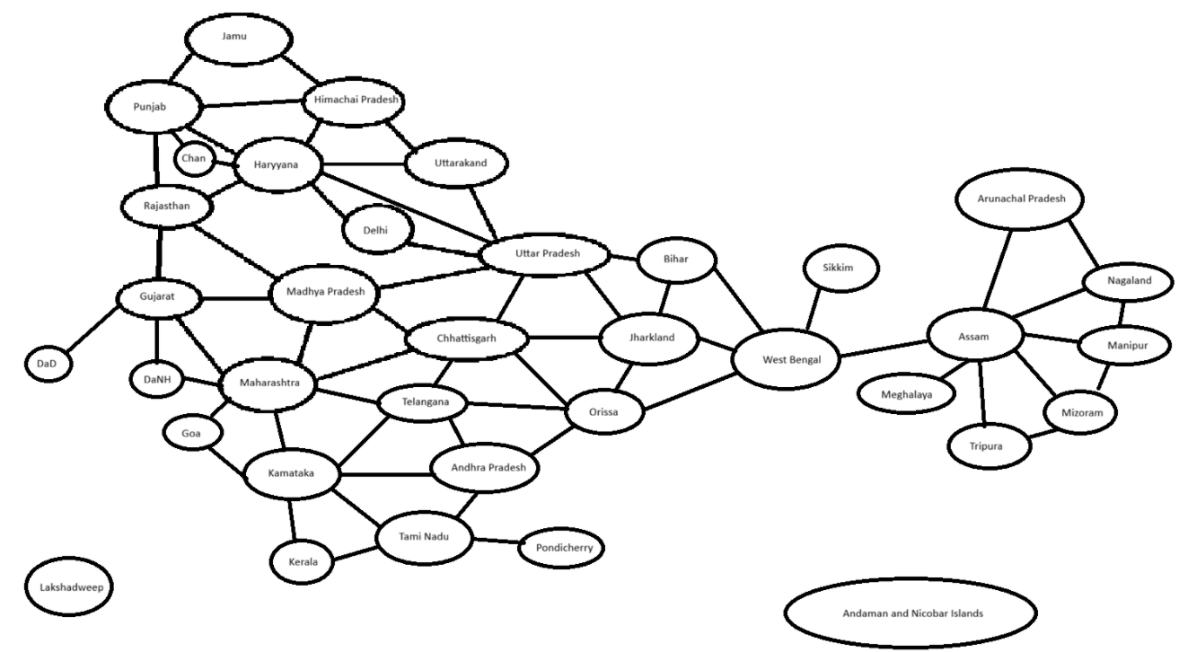

Solve:
1. Determine the Starting Condition
For Student ID 524H0074, the last 4 digits are 0074, so N = 74 and N % 4 = 2. Therefore, we START from Rajasthan.
2.Map Coloring Solution (Step-by-Step)
We will use a Greedy Coloring Algorithm.
- Strategy: Start with Rajasthan (as required). For the remaining states, we will prioritize them by descending degree (number of neighbors) to ensure the minimum number of colors is used.
- Colors Used:
  - C1: Red
  - C2: Green
  - C3: Blue
  - C4: Yellow
Step-by-Step Allocation:
Step | State / Region | Connected Neighbors (Already Colored) | Color Assigned
1 | Rajasthan | (Start Node) | Red (C1)
2 | Uttar Pradesh | Rajasthan (Red) | Green (C2)
3 | Madhya Pradesh | Rajasthan (Red), UP (Green) | Blue (C3)
4 | Maharashtra | MP (Blue), Gujarat (Uncolored), Chatt (Uncolored) | Green (C2)
5 | Gujarat | Rajasthan (Red), MP (Blue), Mah (Green) | Yellow (C4)
6 | Chhattisgarh | UP (Green), MP (Blue), Mah (Green) | Red (C1)
7 | Haryana | Rajasthan (Red), UP (Green) | Blue (C3)
8 | Punjab | Rajasthan (Red), Haryana (Blue) | Green (C2)
9 | Chandigarh | Punjab (Green), Haryana (Blue) | Red (C1)
10 | Karnataka | Maharashtra (Green) | Red (C1)
11 | Telangana | Mah (Green), Chatt (Red), Kar (Red) | Blue (C3)
12 | Andhra Pradesh | Chatt (Red), Tel (Blue), Kar (Red) | Green (C2)
13 | Orissa | Chatt (Red), AP (Green) | Yellow (C4)
14 | Jharkhand | UP (Green), Chatt (Red), Orissa (Yellow) | Blue (C3)
15 | West Bengal | Jharkhand (Blue), Orissa (Yellow) | Green (C2)
16 | Bihar | UP (Green), Jharkhand (Blue), WB (Green) | Red (C1)
17 | Himachal Pradesh | Punjab (Green), Haryana (Blue) | Red (C1)
18 | Uttarakhand | HP (Red), Haryana (Blue), UP (Green) | Yellow (C4)
19 | Delhi | Haryana (Blue), UP (Green) | Red (C1)
20 | Jammu | HP (Red), Punjab (Green) | Blue (C3)
21 | Tamil Nadu | Karnataka (Red), AP (Green) | Blue (C3)
22 | Kerala | Karnataka (Red), TN (Blue) | Green (C2)
23 | Goa | Maharashtra (Green), Karnataka (Red) | Blue (C3)
24 | Pondicherry | Tamil Nadu (Blue) | Red (C1)
25 | DaNH | Gujarat (Yellow), Mah (Green) | Red (C1)
26 | DaD | Gujarat (Yellow) | Red (C1)
27 | Assam | WB (Green) — Connecting bridge | Red (C1)
28 | Sikkim | West Bengal (Green) | Red (C1)
29 | Arunachal Pr. | Assam (Red) | Green (C2)
30 | Meghalaya | Assam (Red) | Green (C2)
31 | Nagaland | Assam (Red), Arunachal (Green) | Blue (C3)
32 | Manipur | Assam (Red), Nagaland (Blue) | Green (C2)
33 | Mizoram | Assam (Red), Manipur (Green) | Blue (C3)
34 | Tripura | Assam (Red), Mizoram (Blue) | Green (C2)
35 | Lakshadweep | None (Isolated Island) | Red (C1)
36 | Andaman & Nicobar | None (Isolated Island) | Red (C1)
The colored map:

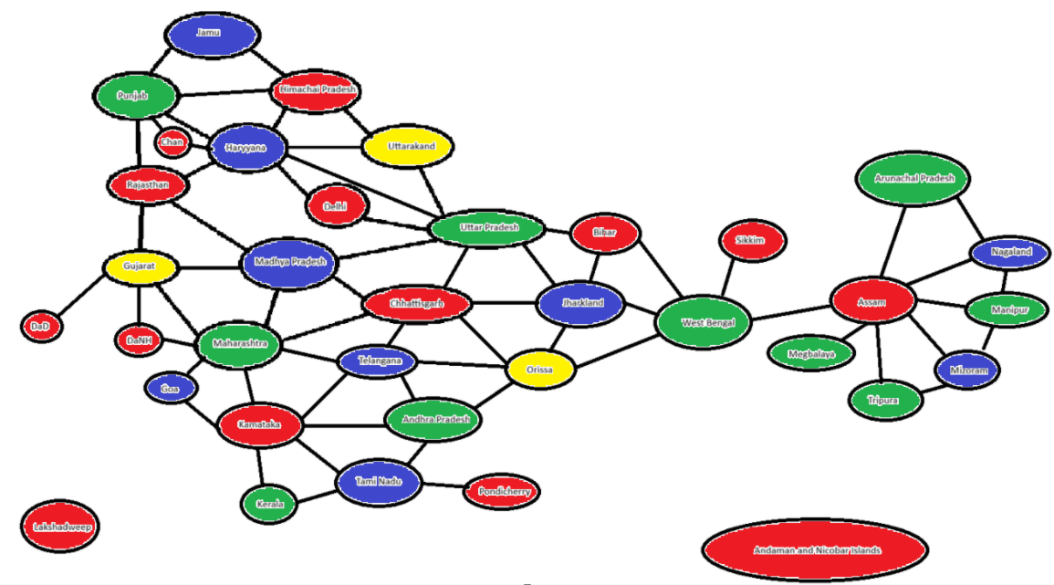

Self-Evaluation
Criteria | Scale | 1 | 2 | 3 | Self-evalutaion |  | Reason
 | Score /10 | 0 score | 1/2 score | Full score
Problem 1 | 1 | Do nothing or wrongly. | Right password but the reasoning is not good enough. | Right password and good reasoning. | 1
Problem 2 | 1 | Do nothing or wrongly.  Wrong a) | Right result but wrong explaination. | Right result and right explaination. | 1
Problem 3 | 1 | Do nothing or wrongly. | Correct gcd and lcm, but incorrect solutions of the Bezout’s identity. | Correct calculation, detailed explanation. | 1
Problem 4 | 1 | Do nothing or wrongly. | Right method but wrong result. | All are correct. | 1
Problem 5 | 1 | Do nothing or wrongly. | Correct calculation but wrong result or conclusion. | Correct calculation, detailed explanation. | 1
Problem 6A | 0.5 | Do nothing or wrongly or use the AI’s answers directly. | Minor modifications on AI’s answers. | Re-evalute, re-arrange, modify AI’s answers with your own words and pictures. | 0.5
Problem 6B | 1 | Do nothing or wrongly or use the AI’s answers directly. | Minor modifications on AI’s answers. | Re-evalute, re-arrange, modify AI’s answers with your own words and pictures. | 1
Problem 7 | 2 | Do nothing or wrongly. | a-Correct recognition, right explanation.  b-Good idea but incorrect applications. | a-Correct recognition, right explanation.  b-Good idea, right calculation, detailed explanation. | 1
Problem 8 | 1.5 | Do nothing or wrongly. | Correct modeling but wrong coloring. | Correct modeling but right coloring. | 1
Total | 10 | Result |  |  |  | 10

REFERENCES
https://angelacarnevale.github.io/2425Algebra/notes/2425-alg03.pdf
https://drive.google.com/file/d/0B1Mf881jZI0zQnU2YjhhSTNROTA/view?resourcekey=0-0EPktjDdMox5ajBHkD13sQ

https://en.wikipedia.org/wiki/Planar_graph

