Tên: Lý Gia Vinh

Lớp: 11_ĐH_THMT

MSSV: 1150080041

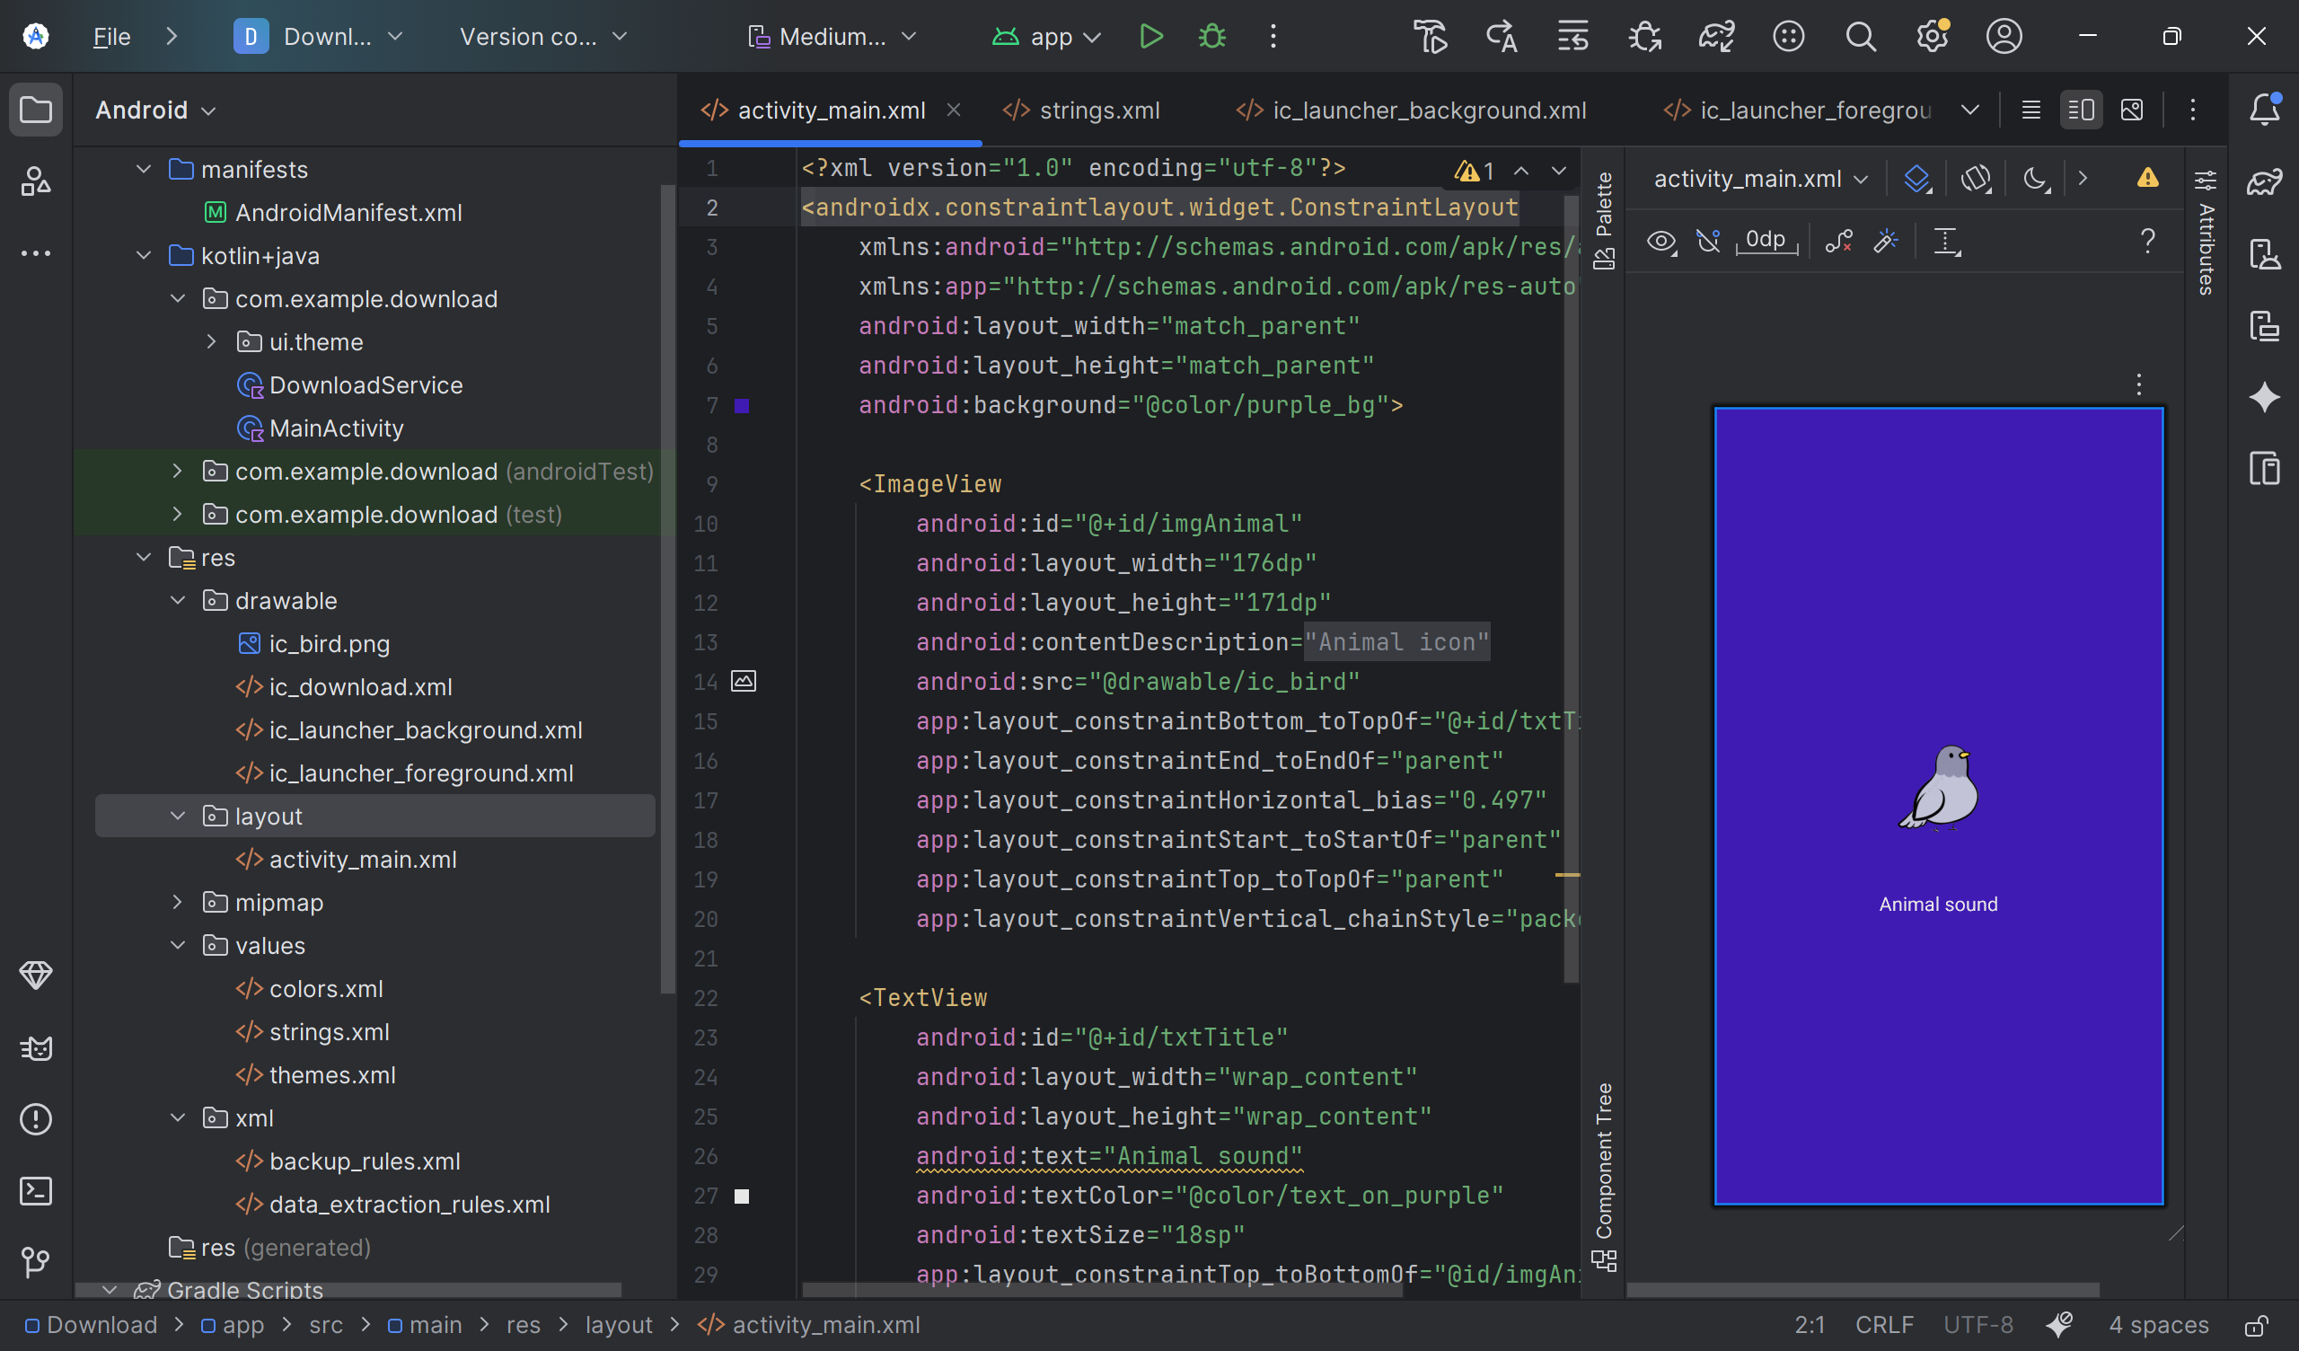

MainActivity

package com.example.download  
  
import android.Manifest  
import android.content.Intent  
import android.content.pm.PackageManager  
import android.os.Build  
import android.os.Bundle  
import android.widget.Button  
import android.widget.EditText  
import androidx.activity.result.contract.ActivityResultContracts  
import androidx.appcompat.app.AppCompatActivity  
import androidx.core.content.ContextCompat  
  
  
  
  
class MainActivity : AppCompatActivity() {  
 override fun onCreate(savedInstanceState: Bundle?) {  
 super.onCreate(savedInstanceState)  
 setContentView(R.layout.*activity_main*)  
 }  
}

activity_main.xml

<?xml version="1.0" encoding="utf-8"?>  
<androidx.constraintlayout.widget.ConstraintLayout  
 xmlns:android="http://schemas.android.com/apk/res/android"  
 xmlns:app="http://schemas.android.com/apk/res-auto"  
 android:layout_width="match_parent"  
 android:layout_height="match_parent"  
 android:background="@color/purple_bg">  
  
 <ImageView  
 android:id="@+id/imgAnimal"  
 android:layout_width="176dp"  
 android:layout_height="171dp"  
 android:contentDescription="@string/animal_icon"  
 android:src="@drawable/ic_bird"  
 app:layout_constraintBottom_toTopOf="@+id/txtTitle"  
 app:layout_constraintEnd_toEndOf="parent"  
 app:layout_constraintHorizontal_bias="0.497"  
 app:layout_constraintStart_toStartOf="parent"  
 app:layout_constraintTop_toTopOf="parent"  
 app:layout_constraintVertical_chainStyle="packed" />  
  
 <TextView  
 android:id="@+id/txtTitle"  
 android:layout_width="wrap_content"  
 android:layout_height="wrap_content"  
 android:text="Animal sound"  
 android:textColor="@color/text_on_purple"  
 android:textSize="18sp"  
 app:layout_constraintTop_toBottomOf="@id/imgAnimal"  
 app:layout_constraintStart_toStartOf="parent"  
 app:layout_constraintEnd_toEndOf="parent"  
 app:layout_constraintBottom_toBottomOf="parent"  
 android:layout_marginTop="8dp"/>  
</androidx.constraintlayout.widget.ConstraintLayout>

Colors.xml

<?xml version="1.0" encoding="utf-8"?>  
<resources>  
 <color name="purple_200">#FFBB86FC</color>  
 <color name="purple_500">#FF6200EE</color>  
 <color name="purple_700">#FF3700B3</color>  
 <color name="teal_200">#FF03DAC5</color>  
 <color name="teal_700">#FF018786</color>  
 <color name="black">#FF000000</color>  
 <color name="white">#FFFFFFFF</color>  
</resources>  
 <resources>  
<color name="purple_bg">#3F1AB3</color> <!-- nền tím đậm như ảnh -->  
<color name="text_on_purple">#E6E6E6</color>  
</resources>

Themes.xml

<?xml version="1.0" encoding="utf-8"?>  
<resources>  
<style name="AppTheme" parent="Theme.Material3.DayNight">  
 <item name="windowActionBar">false</item>  
 <item name="windowNoTitle">true</item>  
</style>  
</resources>