About Odd Duck Fashions
Welcome to Odd Duck Fashions — where weird is wonderful, and fashion bites back (sometimes literally).
We’re a small, delightfully offbeat brand that believes the best accessories aren’t just worn — they start conversations. From handmade gold and silver jewelry shaped like real human teeth to purses so strange they deserve their own fan clubs, Odd Duck Fashions is a love letter to the beautifully bizarre.
Each piece we create is meant to make you stop, stare, and smile — because normal is overrated. Our tiny team of eccentric artists handcrafts every item with a dash of rebellion, a pinch of dark humor, and a whole lot of creativity. Whether it’s a pair of weirdly wonderful shoes or a glimmering molar pendant, every item in our collection celebrates individuality and unapologetic self-expression.
At Odd Duck Fashions, we don’t follow trends — we hatch them.
So, if you’ve ever felt like the odd one out, congratulations — you’ve found your flock.

🦆 Tagline Ideas
- “Where Weird Meets Chic.”
- “For the Beautifully Bizarre.”
- “Fashion That Doesn’t Fit the Mold.”
- “Style with a Strange Twist.”
- “Odd? Good. You Belong Here.”
- “Because Normal Is Boring.”
- “Wear Your Weird.”

💎 Mission Statement Options
- Odd Duck Fashions celebrates individuality through bold, handcrafted accessories that defy convention and embrace the strange.
- Our mission is to turn the unconventional into the unforgettable — one gold tooth, one weird purse, one wild idea at a time.
- We exist for the dreamers, rebels, and misfits who see beauty in the bizarre and confidence in the unconventional.
- Odd Duck Fashions is dedicated to making wearable art that stands out — because fitting in is highly overrated.
- 🦆 Odd Duck Fashions
- Tagline:
- “For the Beautifully Bizarre.”
- (Optional image idea: a moody close-up of gold tooth jewelry on velvet, or a duck wearing a pearl necklace — weird but stylish.)

- About Us
- Welcome to Odd Duck Fashions — where weird is wonderful, and fashion bites back (sometimes literally).
- We’re a small, delightfully offbeat brand that believes the best accessories aren’t just worn — they start conversations. From handmade gold and silver jewelry shaped like real human teeth to purses so strange they deserve their own fan clubs, Odd Duck Fashions is a love letter to the beautifully bizarre.
- Each piece we create is meant to make you stop, stare, and smile — because normal is overrated. Our tiny team of eccentric artists handcrafts every item with a dash of rebellion, a pinch of dark humor, and a whole lot of creativity. Whether it’s a pair of weirdly wonderful shoes or a glimmering molar pendant, every item in our collection celebrates individuality and unapologetic self-expression.
- At Odd Duck Fashions, we don’t follow trends — we hatch them.

- Our Mission
- Odd Duck Fashions celebrates individuality through bold, handcrafted accessories that defy convention and embrace the strange.
We exist for the dreamers, rebels, and misfits who see beauty in the bizarre and confidence in the unconventional. Every piece we make is a reminder that being “odd” isn’t a flaw — it’s a fashion statement.

<!DOCTYPE html>
<html lang="en">
<head>
<meta charset="utf-8" />
<meta name="viewport" content="width=device-width, initial-scale=1" />
<title>Odd Duck Fashions — About</title>
<meta name="description" content="Odd Duck Fashions: handmade gold & silver human-teeth jewelry, strange purses, and wonderfully weird shoes." />
<style>
:root{
--bg:#0f0f12; --card:#16161b; --ink:#e7e7ea; --muted:#b9b9c3; --accent:#ffd166;
--radius:18px; --shadow:0 10px 30px rgba(0,0,0,.35);
}
html,body{margin:0;background:var(--bg);color:var(--ink);font:16px/1.6 system-ui, -apple-system, Segoe UI, Roboto, Ubuntu, Cantarell, "Helvetica Neue", Arial, "Noto Sans", "Apple Color Emoji","Segoe UI Emoji";}
a{color:var(--accent)}
.wrap{max-width:980px;margin:auto;padding:28px}
header{display:flex;align-items:center;justify-content:space-between;gap:16px;margin-bottom:26px}
.brand{display:flex;align-items:center;gap:12px;text-decoration:none;color:var(--ink)}
.logo{width:40px;height:40px;border-radius:50%;background:linear-gradient(135deg,#fff 0%,var(--accent) 100%);display:inline-grid;place-items:center;color:#111;font-weight:900;box-shadow:var(--shadow)}
.name{font-weight:800;letter-spacing:.3px}
.tag{font-size:1rem;color:var(--muted)}
.hero{background:radial-gradient(1200px 400px at 10% -10%,rgba(255,209,102,.12),transparent), radial-gradient(1200px 400px at 110% -10%,rgba(255,209,102,.08),transparent);border-radius:var(--radius);padding:28px;border:1px solid #24242c;box-shadow:var(--shadow);margin-bottom:26px}
.hero h1{font-size:2.25rem;line-height:1.15;margin:0 0 6px}
.pill{display:inline-block;background:#23232a;border:1px solid #2c2c35;color:var(--muted);padding:6px 12px;border-radius:999px;font-size:.9rem}
.grid{display:grid;grid-template-columns:1fr;gap:22px}
@media (min-width: 820px){ .grid{grid-template-columns:1.2fr .8fr} }
.card{background:var(--card);border-radius:var(--radius);border:1px solid #23232a;box-shadow:var(--shadow);padding:22px}
h2{margin:.2rem 0 10px;font-size:1.4rem}
p{margin:.3rem 0 1rem}
.imgbox{aspect-ratio:4/3;border-radius:14px;background:#1e1e24;border:1px dashed #2a2a34;display:grid;place-items:center;color:var(--muted);font-size:.95rem}
footer{margin-top:26px;color:var(--muted);font-size:.9rem}
</style>
</head>
<body>
<div class="wrap">
<header aria-label="Site header">
<a class="brand" href="#">
<span class="logo" aria-hidden="true">🦆</span>
<span class="name">Odd Duck Fashions</span>
</a>
<div class="tag">For the Beautifully Bizarre.</div>
</header>

<section class="hero" aria-labelledby="about-title">
<span class="pill">About</span>
<h1 id="about-title">Where weird is wonderful—and fashion bites back.</h1>
<p>We’re a tiny, delightfully offbeat label crafting accessories that don’t just get worn—they start conversations. From handmade gold and silver jewelry shaped like human teeth to purses so strange they deserve their own fan clubs, Odd Duck Fashions is a love letter to the beautifully bizarre.</p>
</section>

<main class="grid" aria-label="Main content">
<article class="card" aria-labelledby="story">
<h2 id="story">Our Story</h2>
<p>Each piece is made to make you stop, stare, and smile—because normal is overrated. Our eccentric micro-team handcrafts every item with a dash of rebellion, a pinch of dark humor, and an avalanche of imagination.</p>
<p>Whether it’s a glimmering molar pendant, a purse with personality, or shoes that tread the line between art and oddity, everything we create champions individuality and unapologetic self-expression.</p>
<p>At Odd Duck Fashions, we don’t follow trends—we hatch them.</p>
</article>

<aside class="card" aria-labelledby="visual">
<h2 id="visual">Visual Mood</h2>
<div class="imgbox" role="img" aria-label="Moody close-up of gold tooth jewelry on velvet.">
<!-- Replace the text below by dropping an <img> tag here -->
Add your photo: gold/silver tooth jewelry on velvet
</div>
<p style="margin-top:.8rem">Tip: Use a high-contrast, moody image (velvet, shadow, shine) to amplify the chic-weird vibe.</p>
</aside>

<section class="card" aria-labelledby="mission">
<h2 id="mission">Our Mission</h2>
<p><strong>Odd Duck Fashions celebrates individuality through bold, handcrafted accessories that defy convention and embrace the strange.</strong></p>
<p>We exist for the dreamers, rebels, and misfits who see beauty in the bizarre and confidence in the unconventional. Every piece is a reminder that being “odd” isn’t a flaw—it’s a fashion statement.</p>
</section>
</main>

<footer>
© Odd Duck Fashions — a fictitious brand created for a school project.
</footer>
</div>
</body>
</html>

Jewelry
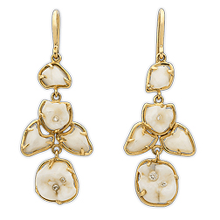
Description:
Elegant, unsettling, and a little bit unhinged — the Golden Grin Earrings turn dentistry into high art. Each dangling piece is hand-cast in gold and delicately cradles human-tooth forms that gleam like porcelain petals. Designed for those who smile at the strange, these earrings balance dark humor with luxe craftsmanship.
Tagline:
When you flash a smile, make sure it’s gold-plated.

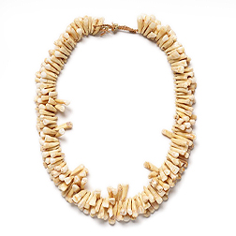

🦴 “Molars of Majesty” Necklace
Description:
Part relic, part rebellion — the Molars of Majesty Necklace is Odd Duck Fashions’ statement piece for the truly fearless. Crafted from a collection of sculpted teeth forms strung together in wild, organic rhythm, it transforms the macabre into the magnificent. Each curve and cusp celebrates imperfection, individuality, and the art of standing out.
Tagline:
Wear your bite proudly.

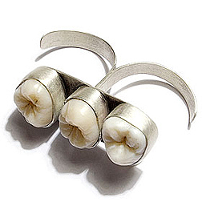

🦷 “Triple Threat” Double Ring
Description:
Three perfectly imperfect teeth, one unapologetic statement. The Triple Threat Ring spans two fingers with raw silver bands that fuse elegance and edge. It’s the ultimate conversation starter — handcrafted for the fashion-forward oddball who likes a little bite in their style.
Tagline:
Twice the fingers, triple the attitude.

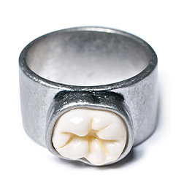

💀 “Root Cause” Ring
Description:
Minimalist and menacing, the Root Cause Ring captures quiet rebellion in a single tooth. A smooth silver band frames one perfect molar — a subtle nod to imperfection and the beauty of human design. It’s clean, bold, and just unsettling enough to make small talk interesting.
Tagline:
Because every smile has a story.

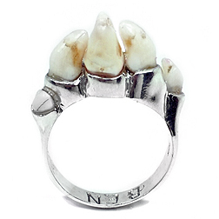

🦴 “Molars of Majesty” Necklace
Description:
Part relic, part rebellion — the Molars of Majesty Necklace is Odd Duck Fashions’ statement piece for the truly fearless. Crafted from a collection of sculpted teeth forms strung together in wild, organic rhythm, it transforms the macabre into the magnificent. Each curve and cusp celebrates imperfection, individuality, and the art of standing out.
Tagline:
Wear your bite proudly.

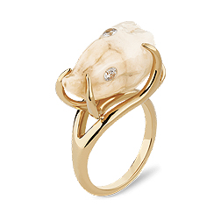

🦷 “Golden Grin” Earrings
Description:
Elegant, unsettling, and a little bit unhinged — the Golden Grin Earrings turn dentistry into high art. Each dangling piece is hand-cast in gold and delicately cradles human-tooth forms that gleam like porcelain petals. Designed for those who smile at the strange, these earrings balance dark humor with luxe craftsmanship.
Tagline:
When you flash a smile, make sure it’s gold-plated.

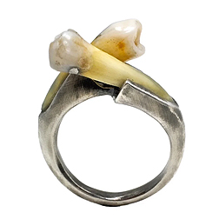

🦷 “Crossbite” Ring
Description:
Fierce meets fine art in the Crossbite Ring. Two natural tooth forms intersect atop a sleek silver band, creating a sculptural clash between organic and industrial. It’s equal parts science, sculpture, and statement — made for those who like their accessories with an edge (and a bite).
Tagline:
Sharp style. Real roots.

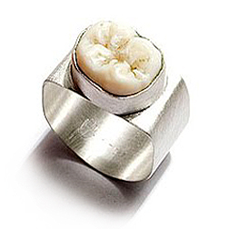

💍 “Cusp Couture” Ring
Description:
Sleek, heavy, and unapologetically bold — the Cusp Couture Ring takes the classic signet silhouette and gives it a dental twist. A single molar gleams from its brushed silver face, turning everyday refinement into something deliciously disturbing. Perfect for the fearless minimalist.
Tagline:
Luxury with a bite.

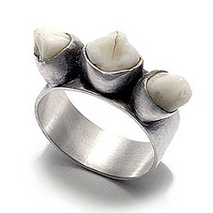

🦴 “Tri-Crown” Ring
Description:
Three teeth, one throne. The Tri-Crown Ring fuses silver craftsmanship with raw anatomy-inspired design, making it the ultimate emblem of rebellion-meets-elegance. It’s a wearable smirk — a little royal, a little rogue, and all attitude.
Tagline:
Because one crown isn’t enough.

Purses

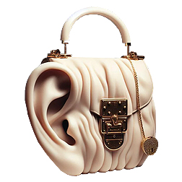

👜 “Can You Hear Me Now?” Ear Purse
Description:
Fashion meets anatomy in the Can You Hear Me Now? purse — a sculptural handbag shaped like a human ear, finished with creamy folds and gleaming gold hardware. Equal parts conversation piece and couture oddity, it listens when no one else will. Perfect for the bold listener who’s always in tune with style.
Tagline:
Because fashion should speak volumes.

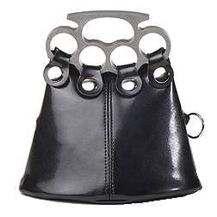

🖤 “Knuckle Up” Clutch
Description:
The Knuckle Up Clutch turns elegance into a weapon of style. With a handle inspired by brass knuckles and a body of slick black leather, this bag is unapologetically tough and undeniably chic. It’s not just a purse — it’s armor for your aesthetic.
Tagline:
Hold your ground — and your lipstick.

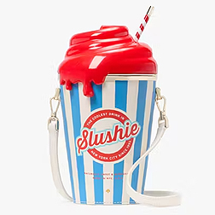

🍧 “Brain Freeze” Slushie Bag
Description:
Sweet, silly, and slightly sinister — the Brain Freeze Bag is a wearable sugar rush. Designed like a striped slushie cup with a glossy red “spill,” it’s nostalgia and chaos in one perfect pop-art accessory. Carry it to add a shot of weird flavor to any outfit.
Tagline:
Fashion that melts minds.

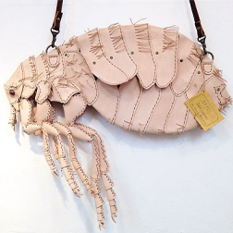

🪳 “Little Pest” Flea Bag
Description:
Creepy-cute and hand-stitched to perfection, the Little Pest Bag turns an everyday nuisance into wearable art. Crafted from soft leather panels shaped like a giant flea, it’s an ode to the tiny creatures that make us squirm — now stylishly oversized and unapologetically weird.
Tagline:
The itch you’ll actually love to scratch.

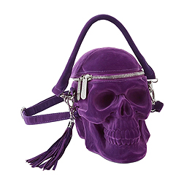

💜 “Rest in Purse” Skull Bag
Description:
Velvet darkness meets high drama in the Rest in Purse handbag. Sculpted into a vivid purple skull with gleaming silver hardware, it’s part gothic masterpiece, part practical accessory. Perfect for nights when you’re dressed to kill (figuratively, of course).
Tagline:
Because every outfit deserves a deadly accessory.

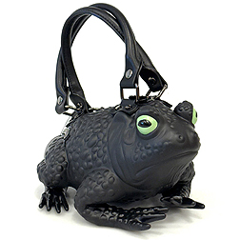

🐸 “Toadally Chic” Handbag
Description:
Jump into absurd luxury with the Toadally Chic Bag. This glossy amphibian-shaped purse is equal parts fairytale and freak show, featuring lifelike details and enough personality to leap off the shelf. It’s bold, bizarre, and begging for compliments.
Tagline:
Hop on the wild side.

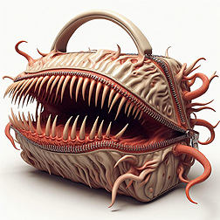

🦷 “Monster Chic” Bite Bag
Description:
A handbag with teeth — literally. The Monster Chic Bag fuses haute couture with nightmare fuel, featuring a full set of sculpted fangs and curling tendrils bursting from soft leather. Equal parts terrifying and tempting, it’s the ultimate statement piece for those who like their fashion with a little bite.
Tagline:
Beauty with teeth.

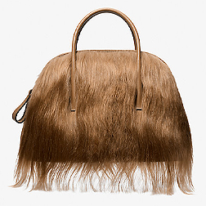

💇‍♀️ “Bad Hair Day” Fur Bag
Description:
Soft, sleek, and slightly unsettling, the Bad Hair Day Bag is a furry fantasy gone rogue. Made from realistic faux hair that swishes as you walk, it blurs the line between accessory and creature. Equal parts fabulous and freaky — it’s impossible not to stare.
Tagline:
When your bag has better hair than you do.

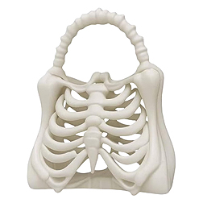

💀 “Bone Collector” Ribcage Bag
Description:
Delicate yet daring, the Bone Collector Bag reimagines anatomy as art. This sculptural ribcage purse is crafted in smooth white resin and shaped to cradle your essentials — and your dark side. It’s gothic elegance with a wink of science.
Tagline:
Carry your heart in style.

Shoes
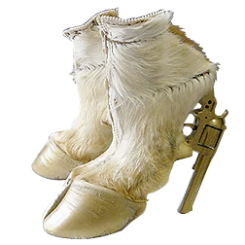

🔫 “Wild West Walk” Gun-Heel Boots
Description:
When cowgirl couture meets chaos. The Wild West Walk Boots feature real fur uppers and golden revolver heels that make every step a power move. Equal parts outlaw and runway-ready, they’re the perfect blend of danger, drama, and daring design.
Tagline:
These boots were made for raising eyebrows.

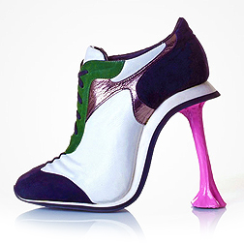

💗 “Sticky Situation” Shoe
Description:
Chewed gum, but make it fashion. The Sticky Situation Shoe transforms an everyday mishap into high-art absurdity — a sleek sneaker morphs into a high heel with a glossy pink “gum” stem. Playful, ironic, and unapologetically weird, it’s a reminder that even sticky moments can look fabulous.
Tagline:
Style that refuses to let go.

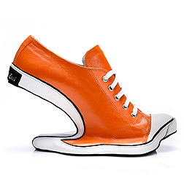

🍊 “Bend Reality” Shoe
Description:
The Bend Reality Shoe takes comfort and contortion to new heights — literally. Its warped silhouette flips the sneaker on its head (and heel), creating a gravity-defying illusion in glossy orange leather. It’s more than footwear — it’s a flex for your imagination.
Tagline:
For those who walk their own twisted path.

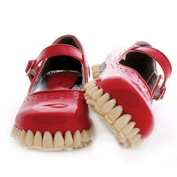

👠 “Bite Me” Mary Janes
Description:
Sweet meets sinister in the Bite Me Mary Janes. Shiny red patent leather uppers sit atop soles lined with human teeth — yes, teeth. Equal parts playful and horrifying, they’re the perfect mix of candy-coated charm and nightmare fuel.
Tagline:
Chew on this: fashion just got fanged.

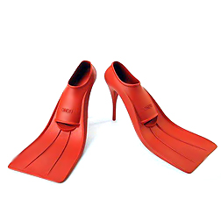

🧜‍♀️ “Deep End” Flipper Heels
Description:
Take the plunge into surreal style with the Deep End Heels. Designed like sleek red diving fins perched on stiletto heels, they merge aquatic fantasy with absurd elegance. Perfect for making waves wherever you walk (or attempt to).
Tagline:
Sink into style. Swim through stares.

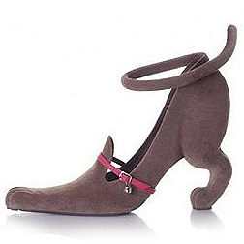

🐕 “Pup Step” Heel
Description:
Because every dog deserves its day — even in footwear form. The Pup Step Heel features the sculpted back end of a dog, complete with a raised tail ankle strap and a dainty pink collar detail. Equal parts cute and chaotic, it’s the ultimate conversation starter for animal lovers with a twisted sense of humor.
Tagline:
Heel, girl. Heel.

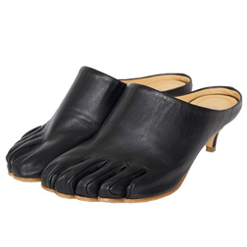

🦶 “Toe-tally Bound” Mules
Description:
Elegantly disturbing, the Toe-tally Bound Mules blur the line between fashion and flesh. Crafted from supple black leather sculpted to hug each individual toe, they bring a surreal human touch to classic design. Equal parts refined and uncanny, they’re shoes that dare you to get a little too comfortable in your own skin.
Tagline:
For those who like their style a little too close for comfort.

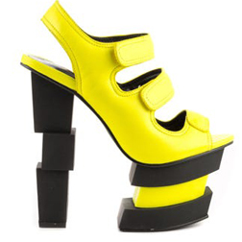

💛 “Matrix Malfunction” Heel
Description:
Something went wrong in the simulation — and it looks fabulous. The Matrix Malfunction Heel plays with broken geometry and visual distortion, stacking bold black blocks beneath a vibrant yellow upper. It’s architectural chaos with a cyber-chic edge, proving that fashion’s best moments are just beautiful glitches.
Tagline:
Error: normal not found.

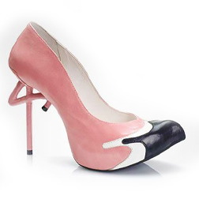

🦩 “Flaminglow” Pump
Description:
Graceful, playful, and a little ridiculous — the Flaminglow Pump balances pink poise with avian attitude. Its sculpted flamingo-leg heel and color-blocked toe create a shoe that’s equal parts elegant and absurd. Because subtlety just isn’t your style.
Tagline:
Stand tall. Strut strange.

