Exercise One

Question 2
- cc hello_world_mpi.c -o hello_world_mpi.out.
- srun -n <number of processes> ./hello_world_mpi.out.
- By changing the number of processes parameter in the command srun -n <number of processes> ./hello_world_mpi.out.
- MPI_Comm_rank for retrieving rank. MPI_Comm_size for getting the total number of processes.
- OpenMPI and MPICH

Exercise Two

Question 2.1

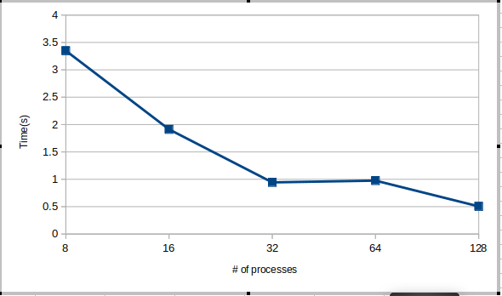
- For MPI_Recv it means that the message has been received into the buffer specified by the buffer argument. For MPI_Send it means that the message envelope has been created and the message has been sent or that the contents of the message have been copied into s system buffer.
- MPI_Wtime()

Question 2.2

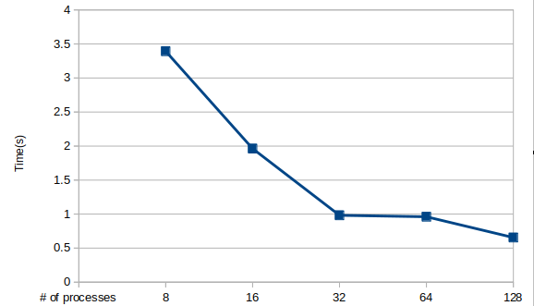
- The Linear Reduction Algorithm performs better
- For a large number of processes the Linear Reduction Algorithm will perform better because less messages are sent between processes. In linear each process sends directly to the root while in binary tree message goes through multiple procceses.

Question 2.3

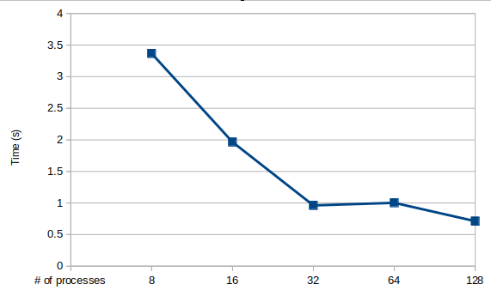

- MPI_Irecv(*buf, count, datatype, source, tag, comm, *request, ierror)
and MPI_Isend(*buf, count, datatype, destination, tag, comm, *request). The I in MPI_Irecv stands for “immediate” i.e they return immediately.

- The blocking performs better.

Question 2.4

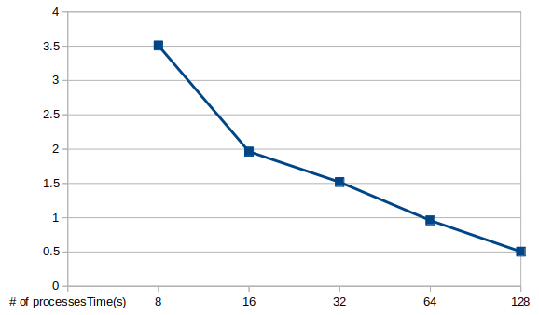
- MPI_Bcast function e.g MPI_Bcast(&pi, 1, MPI_DOUBLE, 0, MPI_COMM_WORLD)

Question 2.5

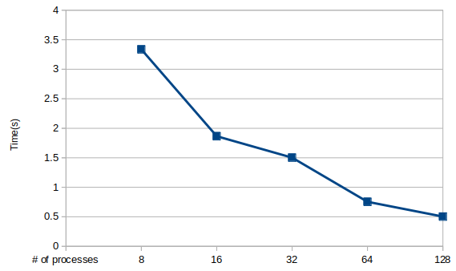

Question 2.6

