**Design Choices**

**1. Identify the objects of our program**

The central nouns in the game requirements were **Director** and **Deck**

**2. Define responsibility, behaviours and state for each object and Translate object designs to class designs**

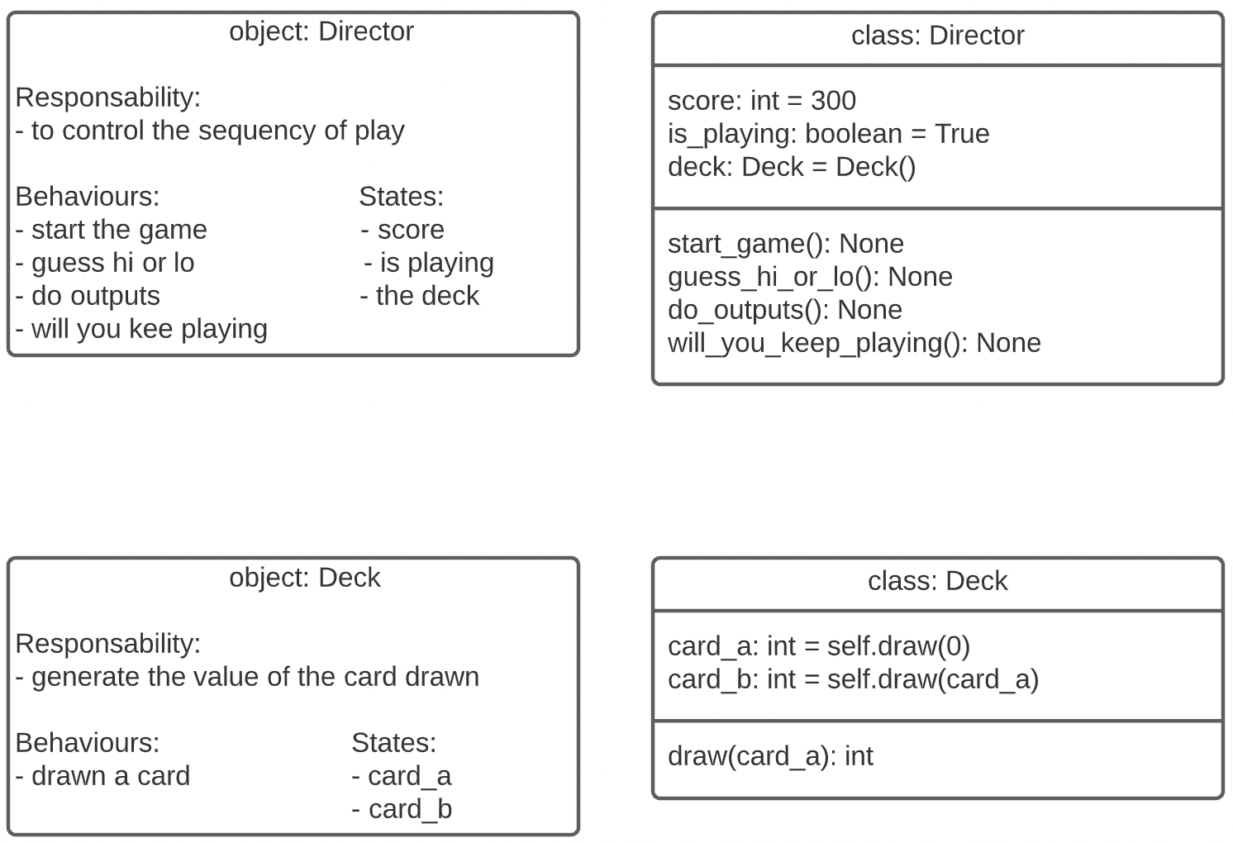  
  
**3. Identify the relationships between your objects**

Structural Relationships  
