**Design Choices**

**1. Identify the objects of our program**

The central nouns in the game requirements were **Director**, **Puzzle** (SecretWord), **Seeker** (Player), **Parachute**, and **TerminalService**.

**2. Define responsibility, behaviours and states for each object and Translate object designs to class designs**

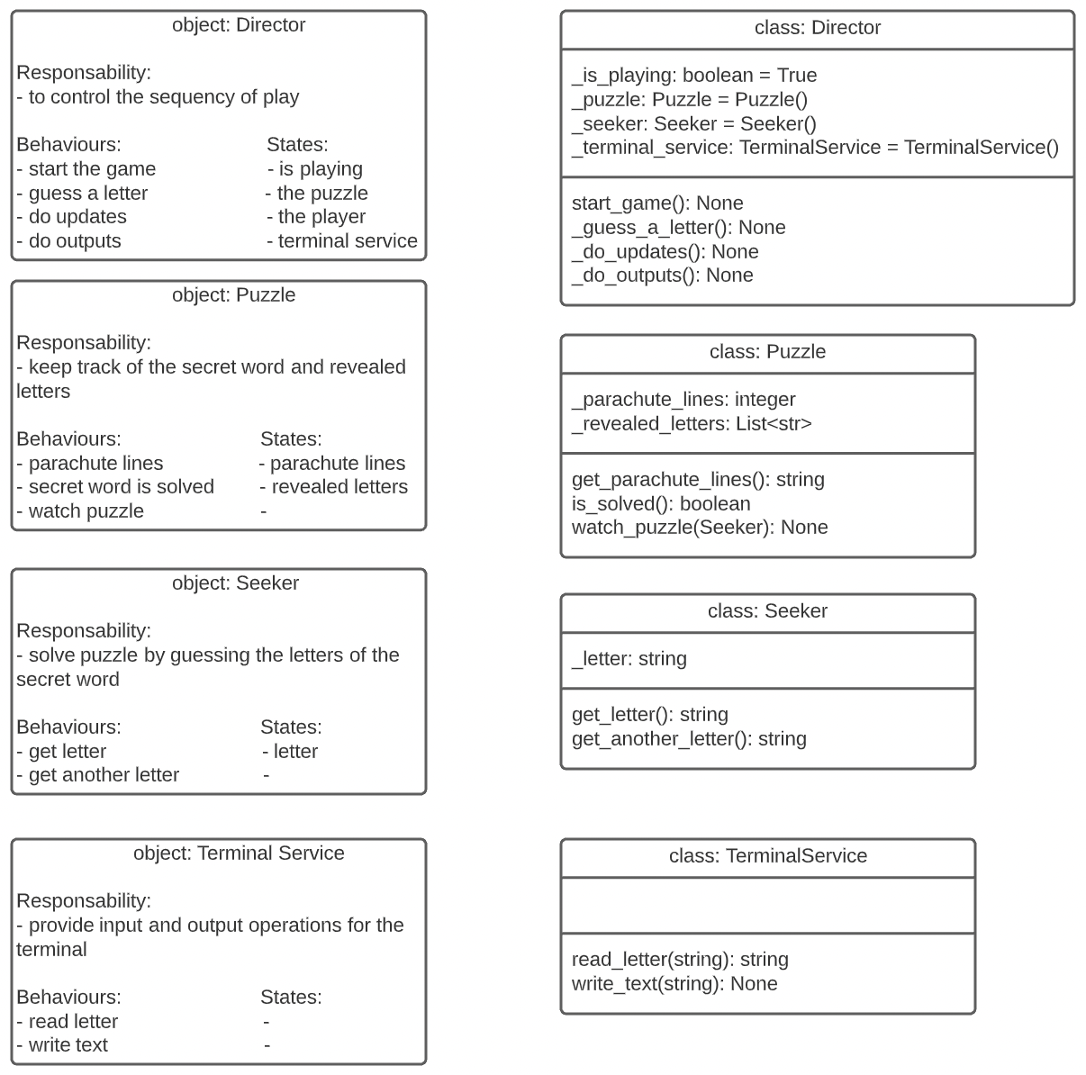

**3. Identify the relationships between your objects**

Structural Relationships

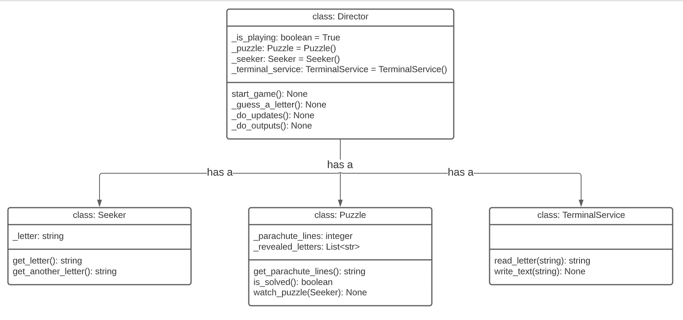  
  
  
  
Behavioral Relationships  
