**Design Choices**

**1. Identify the objects of our program**

The central nouns in the game requirements were **Director**, **VideoService**, **KeyboardService**, **Cast**, **Actor**, **Gem**, **Rock**, **Color**, and **Point**.

**2. Define responsibility, behaviours and states for each object and Translate object designs to class designs  
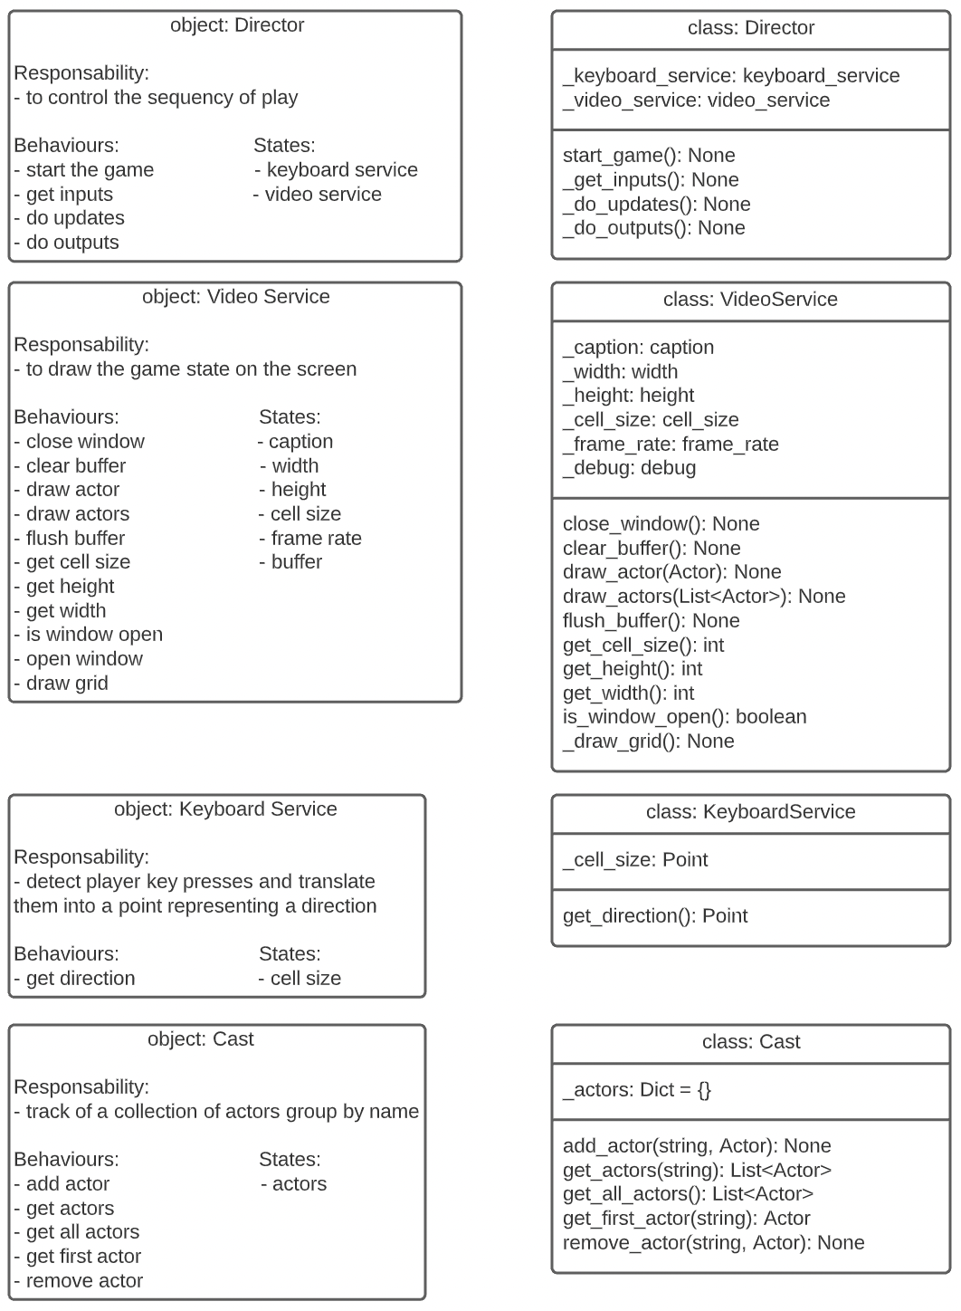  
  
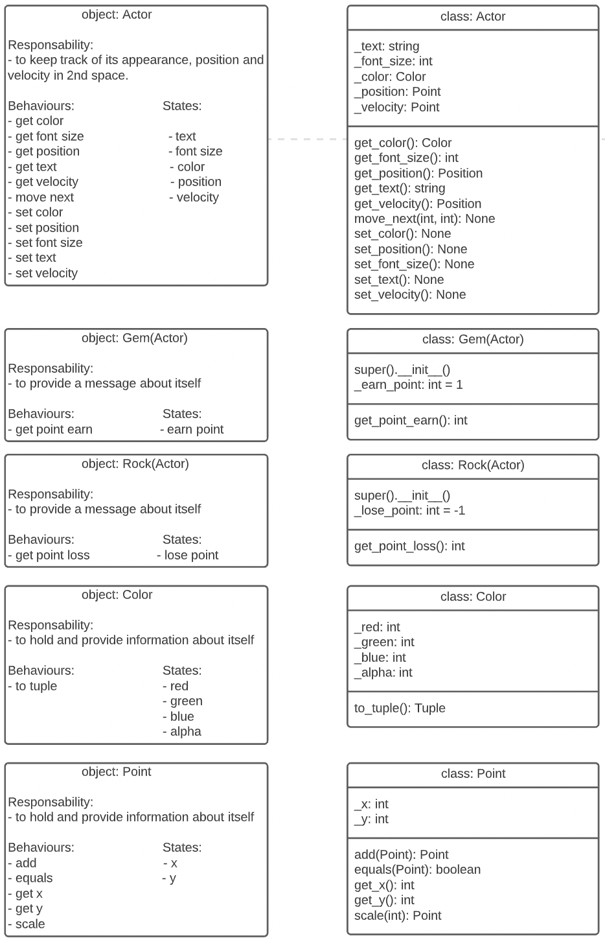**

**3. Identify the relationships between your objects**

Structural Relationships  
