Given an excel file with Kickstarter data, I analyzed the campaigns in order to uncover trends. By organizing and analyzing 4000 past projects I had hoped to reveal some secrets to success.

I started by conditionally formatting the “state” column to be filled with either red, yellow, blue, or green depending on whether the campaign had failed, was canceled, is still live, or was successful. I added “Percent Funded” to column O, and then conditionally formatted it using a 3-color scale transitioning from red at 0 to green at 100 and then blue at 200. I then created a new column P called “Average Donation” so show how much each backer paid on average. The last two columns I added were column Q and R, “Category” and “Sub-Category”, which I split from “Category and Sub-Category” column.

I started a new sheet named Category Stats with a pivot table that counted the state of a campaign by category. On the same sheet, based off the pivot I had previously created, I added a stacked column pivot chart filtered by country.

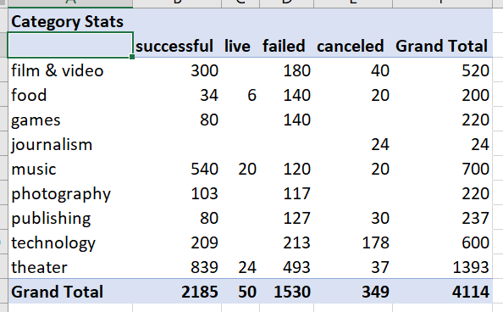 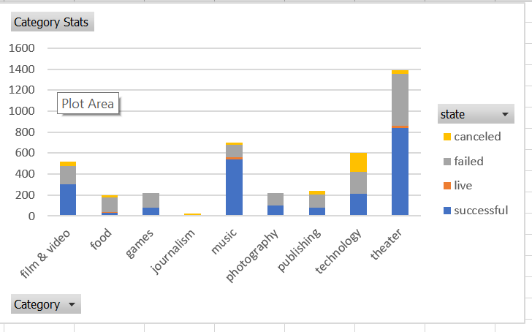

I added a new sheet named Sub-Category with a pivot table that counted the state of a campaign by sub-category. On the same sheet, based off the pivot I had previously created, I added a stacked column pivot chart filtered by country and category.

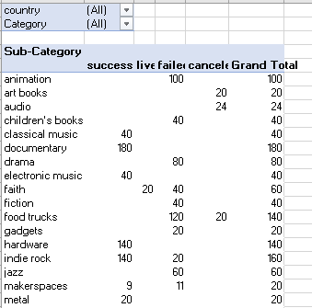 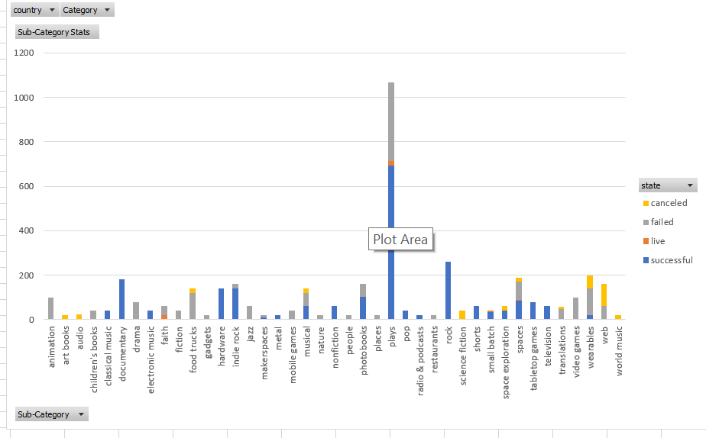

On the original raw data sheet, I created a new column named “Date Created Conversion” and converted the data in the “launched at” into Excel’s date format. I then created a new column named “Date Ended Conversion” and converted the data in “deadline” into Excel’s date format.

Next, I created a new sheet named “Outcomes Based on Launch Date” with a pivot table containing the columns “state” with rows of “Date Created Conversion. The count is based on state and filters Category and Years. Lastly, I created a pivot chart line graph that visualizes the table just created.

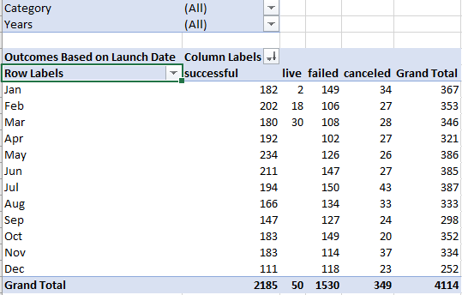 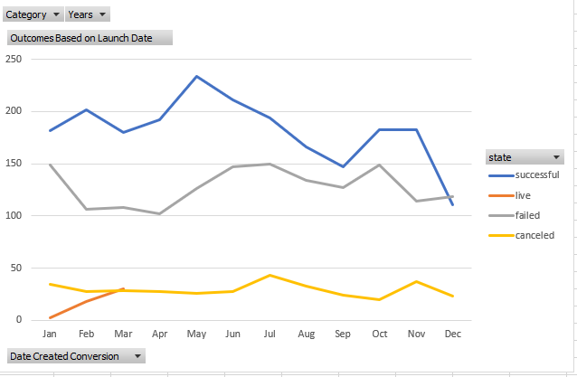

In conclusion, one could use this data to try to determine the success of your campaign. If your goal is less than $10,000, you’re more likely to be successful.