BUSINFO 710 – Project Management
Individual Assignment

PredictNow – AI Forecasting Tool Launch Schedule Evaluation

Consultancy Report Prepared for
Emma Torres, Product Analytics Lead, PredictNow

Executive Summary
PredictNow’s AI-powered forecasting tool is required to launch by 2 November 2026 to align with the pre–Black Friday retail cycle. The deadline is commercially fixed and makes schedule certainty the primary constraint. A detailed feasibility assessment was undertaken using ProjectLibre to determine whether delivery is achievable under realistic operational, resource, and financial conditions without unnecessary cost escalation.
The refined project plan commences on 13 April 2026. The schedule incorporates corrected dependency logic, explicit vendor configuration lead times (10 days for cloud credits and 15 days for GPU packages), and the New Zealand 2026 working calendar, including public holidays. Resource allocations were validated against defined capacity limits (400% for technical and marketing roles, 100% for Procurement). One Temporary Data Engineer was introduced solely to remove structural over-allocation without extending duration.
Validated outputs confirm:
- Completion Date: 28 October 2026
- Total Duration: 139 calendar days
- Total Labour Effort: 9,424 hours
- Estimated Labour Cost: $673,120
- Resource Overallocation: None
- Critical Path: Infrastructure assessment → model selection → model training → GPU procurement and vendor setup → provisioning → launch
Completion on 28 October provides approximately three working days of contingency before the mandated launch. Acceleration through further temporary staffing increases cost while delivering minimal schedule advantage. The refined baseline is operationally feasible, financially controlled, and strategically aligned with the commercial deadline. Formal adoption and disciplined monitoring of critical path milestones are recommended.

1. INTRODUCTION
PredictNow’s AI forecasting tool is planned for commercial launch on 2 November 2026 to align with the pre–Black Friday retail cycle. The timing is strategically important because retailers make major inventory and replenishment decisions before peak holiday demand. Forecast accuracy directly influences purchasing volumes, supply planning, and margin protection. Entering the market within this window strengthens early adoption, builds credibility, and improves competitive positioning in the expanding AI analytics sector. Missing the deadline would reduce commercial impact and weaken market momentum.
Competitive pressure further heightens schedule sensitivity

Project Priority Matrix
PredictNow’s forecasting tool launch is governed by a clearly defined priority structure anchored to the fixed commercial deadline of 2 November 2026. The commercial window linked to the pre–Black Friday cycle cannot shift, making time the dominant constraint. All sequencing, dependency design, and resource allocation decisions are therefore evaluated against their impact on schedule certainty.
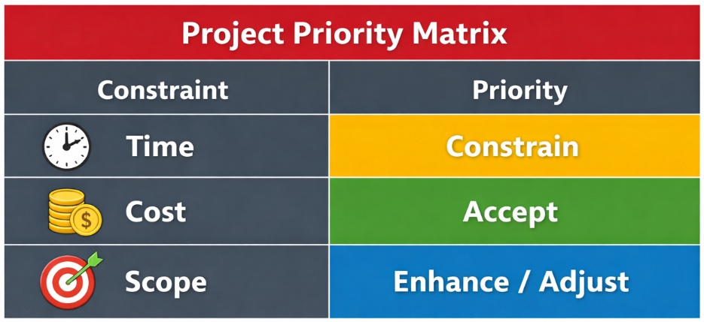
Figure 1: Project Priority Matrix

Time – Constrain
The November launch date is non-negotiable. Activities on the critical path require continuous monitoring, and any variance must trigger immediate corrective action. Protecting completion on or before 2 November takes precedence over finishing early. Schedule reliability is more important than acceleration.
Cost – Accept (Controlled)
Financial discipline remains important, but budget flexibility exists where necessary to protect the deadline. Additional spending is justified only when it reduces schedule risk or removes structural constraints. Cost increases aimed solely at early completion are not supported.
Scope – Enhance / Adjust
Core forecasting performance, infrastructure readiness, and dashboard functionality must be operational at launch. Non-essential enhancements may be phased post-launch if required to preserve schedule integrity.
This priority structure establishes clear governance logic for execution and decision-making throughout the project lifecycle. (ref: Figure 1)

2. PROBLEM STATEMENT
The central question is whether PredictNow’s AI forecasting tool can be delivered by 2 November 2026 under realistic operational and financial conditions. The launch date is commercially fixed, so the primary measure of success is schedule certainty rather than early completion.
Five key analytical questions guide this assessment:
• Is the activity sequence logically complete and structurally sound?
• Can internal resources deliver the work without exceeding defined capacity limits?
• Have vendor configuration lead times and non-working calendar constraints been fully incorporated?
• Is additional temporary staffing required to protect the deadline?
• What is the total projected labour cost under a realistic execution model?
The original draft schedule contained structural gaps. Joint dependencies between parallel technical activities were not fully enforced, allowing downstream work to appear ready earlier than practically possible. Vendor-side configuration delays for cloud credits and GPU packages were also understated, compressing the infrastructure timeline.
Capacity constraints further increased risk. Data Engineers were heavily loaded across concurrent activities, and procurement relied on a single constrained resource. Without correction, these factors could have created hidden bottlenecks.
The problem therefore extends beyond timeline estimation. It requires validating dependency logic, confirming resource feasibility, integrating external lead times, quantifying cost exposure, and enabling informed executive decision-making within a fixed commercial window.

3. PROJECT OBJECTIVES
The purpose of this report is to provide a structured feasibility assessment aligned with executive priorities and the fixed 2 November 2026 launch deadline. The goal is not simply to outline a schedule, but to determine whether the project can be executed within realistic operational, capacity, and financial constraints.
The assessment is designed to:
- Validate and refine task sequencing to ensure logical completeness and structural accuracy.
- Develop a realistic ProjectLibre schedule incorporating New Zealand public holidays and standard working-day assumptions.
- Identify and confirm the activities that form the critical path and directly determine completion.
- Detect resource conflicts and evaluate utilisation against defined capacity limits.
- Estimate total labour effort and cost based on approved rates and actual allocations.
- Assess whether temporary staffing provides meaningful deadline protection.
- Provide a clear execution recommendation balancing time certainty, cost discipline, and risk exposure.
Combining schedule logic, capacity validation, and cost evaluation ensures that conclusions are evidence-based rather than theoretical. The outcome is a defensible managerial recommendation grounded in operational realism and aligned with PredictNow’s time-constrained governance framework.

4. ANALYSIS OF THE INITIAL PLAN
The initial draft schedule provided a reasonable structural outline but contained weaknesses that reduced credibility. While the timeline appeared feasible, several modelling gaps understated risk and overstated delivery certainty. Without correction, the schedule would have produced an artificially compressed completion date and misrepresented the true drivers of completion. Review of the baseline identified issues in dependency logic, procurement modelling, calendar configuration, and resource allocation.
4.1 Logical Dependency Gaps
Three structural issues affected schedule realism.
Simultaneous Completion Requirement
Model Architecture Design and Data Infrastructure Assessment were originally treated as independent predecessors to Model Selection Review. Operationally, both must be complete before review can begin. Architecture defines modelling logic, while infrastructure assessment confirms data readiness and compute feasibility. If one finishes early, review cannot proceed until the other concludes. Failure to enforce this joint dependency caused downstream tasks to appear ready earlier than practically possible and distorted float calculations.
Missing Vendor Waiting Periods
Procurement tasks assumed infrastructure became available immediately after order placement. In practice, cloud credits and GPU packages require vendor-side configuration before provisioning can begin. These delays function as schedule gates.
Premature Provisioning Risk
Provisioning was allowed to begin before vendor configuration completed. This created a logical inconsistency and understated the true critical path. Together, these gaps weakened confidence in delivery certainty.
4.2 Procurement Lead Time Reality
External procurement lead times materially influence completion. Vendor configuration requires 10 days for cloud credits and 15 days for GPU packages. These periods begin after purchase orders are issued but before infrastructure becomes operational.
Although no internal labour cost accrues during vendor configuration, the project timeline advances. Engineering teams cannot provision systems until compute capacity is accessible. This creates a passive waiting phase in which capital is committed but productive work cannot proceed.
If vendor setup is not explicitly modelled, downstream activities begin prematurely and the schedule reflects artificial efficiency. Incorporating vendor configuration as a mandatory predecessor ensures provisioning begins only when resources genuinely exist.
From a governance perspective, vendor lead times are external schedule drivers. They do not increase labour cost but directly constrain completion. Ignoring them would overstate deadline security and reduce reliability of risk evaluation.
4.3 Calendar Constraints
Accurate calendar configuration is essential for credibility. The revised model incorporates eight-hour workdays, a Monday–Friday schedule, and New Zealand public holidays including ANZAC Day observed, King’s Birthday, Matariki, and Labour Day.
Treating weekends or public holidays as working days artificially increases available productive hours and compresses duration. In a technically intensive project with tightly linked dependencies, even minor inaccuracies accumulate into several days of apparent time gain. (ref: Figure 2)
Under a fixed commercial deadline, such distortion directly affects feasibility assessment. Embedding realistic working constraints ensures the reported 28 October 2026 completion date reflects achievable execution rather than theoretical availability.

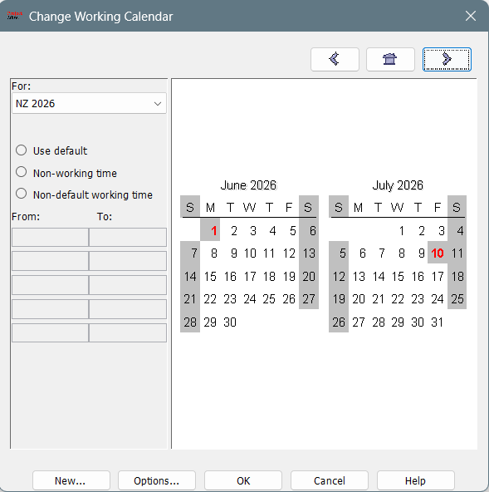
Figure 2: Calendar Configuration
4.4 Resource Capacity Risk
Internal capacity limits are defined as 400% for Marketing Analysts, Data Scientists, ML Engineers, and Data Engineers, and 100% for the Procurement Officer. The original schedule concentrated technical effort during infrastructure assessment, model training, and provisioning, creating overload risk. (As shown in Figure 3).

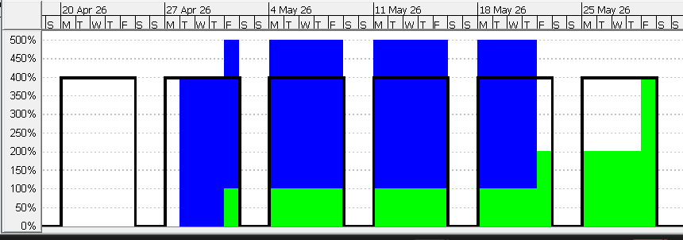
Figure 3: Resource Capacity Histogram

Resource over-allocation introduces three risks: schedule slippage if levelling is applied, unrealistic multitasking if ignored, and declining quality under strain.
A structural conflict emerged between Model Architecture Design and Data Infrastructure Assessment, requiring five Data Engineers concurrently and exceeding the 400% cap. One Temporary Data Engineer was introduced to preserve simultaneous completion while keeping allocation within limits.
After refinement, no red overallocation indicators remain. The schedule is therefore both time-feasible and operationally executable.

5. REFINED PROJECT PLAN
Dependency corrections, vendor lead times, calendar realism, and capacity validation were incorporated into a revised ProjectLibre model. The resulting schedule reflects executable operating conditions rather than theoretical sequencing assumptions. (ref: Appendix 1.2 for Network diagram)
5.1 Final Gantt Schedule
Validated outputs confirm:
• Project Start: 13 April 2026
• Project Finish: 28 October 2026
• Total Duration: 139 calendar days
Completion on 28 October provides approximately three working days of contingency before the 2 November launch. The buffer represents structured risk protection rather than surplus time. It absorbs moderate model training variance, integration defects, or minor vendor delays. (ref: Figure 4 & Appendix for clarity)
Calendar settings and vendor configuration periods are embedded explicitly. The finish date therefore represents a defensible forecast grounded in realistic execution conditions.
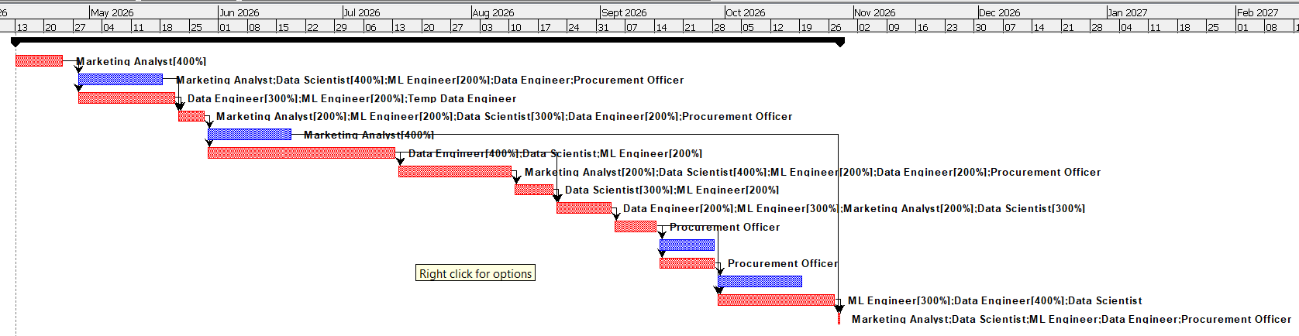
Figure 4: Gantt Chart

5.2 Critical Path Analysis
The validated critical path includes:
• Market & User Research
• Data Infrastructure Assessment
• Model Selection Review
• Model Training & Pipeline Build
• Final Model & Dashboard Integration
• Procure GPU Compute Packages
• Vendor Setup – GPU
• Provision Compute Resources
• Launch Event & Internal Demo
These activities form the longest dependency chain. Delay within this sequence directly extends completion. Model Training anchors the technical schedule due to duration and complexity. GPU procurement and vendor setup function as external gating constraints before provisioning can begin.
Marketing Strategy and Dashboard Development are non-critical. Sequencing adjustments prevented over-allocation without altering the critical path. The refined network therefore isolates true schedule drivers. (Ref: Red bars from Figure 4)
5.3 Resource Allocation Validation
Resource validation confirms:
• No red overallocation indicators
• All roles operate within defined limits
• No hidden levelling delays
Technical roles remain capped at 400%. The Procurement Officer remains at 100%. One Temporary Data Engineer resolved the structural allocation conflict. (Ref: Figure 5)
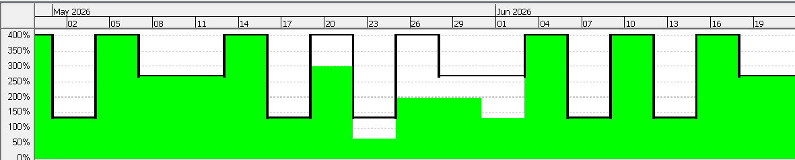
Figure 5: Histogram of Data Engineer Work Allocation

Histogram analysis confirms balanced workload distribution. The schedule avoids unrealistic staffing assumptions and is operationally sustainable. (ref: Appendix 1.3 for all key resources)
5.4 Cost Analysis
Total planned labour cost is $673,120 based on 9,424 hours. (ref: Figure 6)
Cost concentration occurs in:
• Model Training & Pipeline Build
• Final Integration
• Provision Compute Resources
Vendor configuration periods extend duration but incur no internal labour cost. Cost structure reflects approved rates, no overtime assumptions, and minimal temporary staffing. Financial exposure aligns with governance expectations.
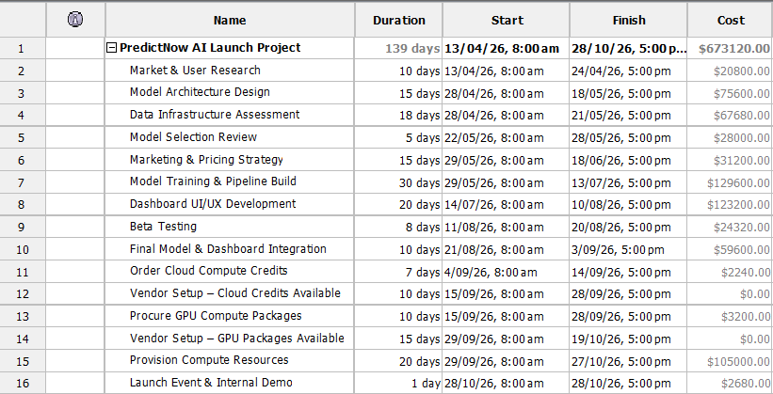
Figure 6: Cost Summary

6. EVALUATION OF ADDITIONAL RESOURCES
Temporary staffing was authorised only if it materially protected the 2 November deadline. Analysis confirms limited strategic value in further acceleration.
6.1 Temporary Resources
Four activities were tested for compression:
• Marketing & Pricing Strategy
• Dashboard UI/UX Development
• Provision Compute Resources
• Data Infrastructure Assessment
Only Infrastructure Assessment and Provisioning intersect with the critical path. Even when compressed, vendor configuration and model training remain binding constraints. Overall completion improves marginally and remains well before the deadline. Gains are minimal relative to the three-day buffer.
6.2 Market Timing
Completion on 28 October already precedes the fixed 2 November launch. Acceleration would not shift the external market window tied to the Black Friday cycle.
6.3 Financial Trade-Off
Additional staffing increases cost while delivering limited schedule improvement. Vendor lead times cannot be compressed internally.
6.4 Strategic Decision Logic
Time is secured. Cost discipline governs execution. Maintain the baseline, preserve contingency, and accelerate only if critical path slippage reduces protection.

7. RISK AND CONTINGENCY ANALYSIS
The refined schedule demonstrates structural feasibility, but execution risk remains. Planned completion on 28 October 2026 leaves approximately three working days before the 2 November launch. The strength of that margin depends on active management of technical, procurement, and integration exposures.
7.1 Technical Risk
Model Training & Pipeline Build presents the highest technical risk. Machine learning development is iterative by nature. Model tuning may require repeated validation cycles, hyperparameter adjustments, and performance benchmarking. Data quality issues or feature refinements can extend the assumed 30-day duration.
Because model training lies on the critical path, any delay directly shifts provisioning and launch preparation. No parallel activities exist to absorb slippage. Final Integration adds further exposure, particularly when aligning model outputs with dashboards and production infrastructure. Even minor late-stage rework can materially affect completion.
7.2 Procurement Risk
Vendor configuration for cloud credits (10 days) and GPU packages (15 days) represents binding external constraints. These lead times cannot be compressed internally. Queue delays, logistics issues, or configuration verification problems would directly delay provisioning.
Since provisioning precedes launch readiness, vendor delays proportionally reduce available contingency. The three-day buffer can absorb limited variance but not prolonged supplier disruption.
7.3 Integration Risk
Integration risk spans three interfaces: model output into dashboards, infrastructure provisioning into deployment architecture, and coordination between technical readiness and marketing preparation. Interface mismatches often surface during final testing, creating rework risk.
Because integration sits near the end of the critical path, late defects have disproportionate schedule impact. Early validation checkpoints and disciplined milestone reviews are essential safeguards.
7.4 Buffer
Three working days of contingency provide limited but adequate protection. The margin absorbs moderate technical or procurement variance and should be preserved as risk capacity, not eliminated through unnecessary acceleration.

8. STRATEGIC BUSINESS INTERPRETATION
The refined schedule provides more than technical validation. It clarifies how disciplined execution supports competitive positioning, financial control, and portfolio stability within a fixed commercial window.
Competitive Timing Advantage
Completion by 28 October 2026 positions the product immediately before the Black Friday planning cycle. Sales teams can activate campaigns, onboard clients, and finalise messaging without compressing internal validation. Entering the market within the intended window strengthens perception of PredictNow as a prepared and proactive analytics provider rather than a reactive follower.
Avoiding Rushed Deployment
Schedule acceleration without contingency increases defect risk and post-launch instability. Maintaining the validated baseline preserves structured testing, controlled integration, and stable deployment. A measured release reduces operational disruption and avoids emergency remediation immediately after launch.
Preserving Brand Credibility
Forecasting accuracy and system stability directly influence customer trust. Performance failures at launch would weaken credibility in a competitive analytics market. Prioritising reliability over unnecessary speed supports long-term brand strength.
Financial Governance Alignment
A projected labour cost of $673,120 reflects disciplined utilisation within approved capacity limits. Avoiding additional temporary staffing protects budget integrity and aligns execution with executive cost governance expectations.
Portfolio Resource Balance
Delivery without exceeding capacity limits reduces burnout risk and safeguards performance across concurrent initiatives. Balanced allocation supports organisational stability while maintaining progress on cloud migration and enterprise programs.

9. CLIENT RECOMMENDATION
The validated ProjectLibre schedule provides a structurally sound and operationally feasible execution baseline aligned with PredictNow’s strategic priorities. The following actions are recommended:
1. Formally approve the refined baseline schedule.
Completion on 28 October 2026 secures delivery three working days before the 2 November commercial deadline. Logical dependencies, vendor lead times, and calendar constraints are fully incorporated. Formal approval establishes a clear control benchmark for performance tracking.
2. Do not deploy additional temporary resources.
Simulation demonstrates limited schedule improvement relative to increased labour cost. The deadline is already protected; further staffing would reduce financial efficiency without improving market timing.
3. Implement weekly critical path monitoring.
Infrastructure assessment, model selection, model training, GPU procurement and vendor setup, provisioning, and final integration require structured review. Early detection of variance is essential because delay directly affects completion.
4. Preserve the three-day contingency buffer.
The margin between 28 October and 2 November should function as risk protection rather than surplus capacity.
5. Reassess only if contingency erodes.
Acceleration should be considered only if critical path slippage materially reduces schedule protection.
This disciplined approach safeguards schedule certainty, cost control, and strategic positioning.

10. CONCLUSION
PredictNow’s AI Forecasting Tool launch is feasible within the mandated timeframe under the validated ProjectLibre baseline. With a project start date of 13 April 2026 and a planned finish on 28 October 2026, delivery is achieved approximately three working days ahead of the fixed 2 November 2026 commercial launch window. The deadline is therefore secured under current assumptions.
Schedule credibility is strengthened by correcting dependency logic, explicitly modelling vendor-side configuration delays (10 days for cloud credits and 15 days for GPU packages), and applying the New Zealand 2026 working calendar with public holidays. These refinements remove structural optimism and ensure the plan reflects real execution conditions rather than ideal sequencing.
Labour effort totals 9,424 hours with an estimated labour cost of $673,120. Cost concentration aligns with the technically intensive phases, especially model training, provisioning, and final integration. Vendor waiting periods extend the timeline but correctly incur no internal labour cost, preserving financial realism.
Resource checks confirm no remaining over-allocation across roles under the defined limits (400% for technical and marketing roles, 100% for Procurement). Only one Temporary Data Engineer was required to resolve a structural conflict without extending duration. Overall, the baseline schedule provides a disciplined, resource-feasible, and financially controlled plan that supports a credible, on-time market entry.

Appendix
  - Gantt Chart
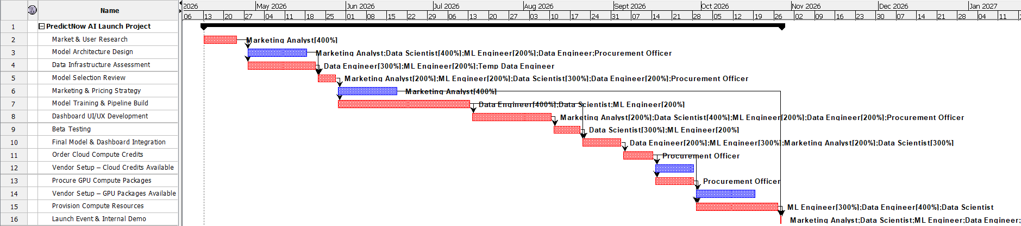
  - Network Diagram
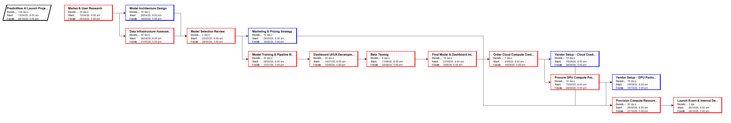

  - Histogram – Work Allocation (Mark Analyst, Data Engineer, Temp Resource, Procurement)

