BUSINFO 710 – Project Management
Individual Assignment

PacificFresh Regional Distribution Hub Launch Schedule Evaluation

Consultancy Report Prepared for
Lani Patel, Operations Manager, PacificFresh

Executive Summary
PacificFresh is establishing a new regional distribution hub in Tauranga to improve delivery speed, safeguard product freshness, and strengthen supply chain resilience across the upper North Island. Full operations must commence no later than 1 June 2026. The facility cannot open until construction, safety, and compliance requirements are completed and validated. Continuous customer service during transition remains essential.
A structured schedule was developed in ProjectLibre beginning 1 March 2026 using seven-day weeks and eight-hour days, in accordance with assignment guidelines. The plan is divided into logical phases: administrative preparation and design, contractor procurement and mobilisation, construction works, equipment procurement and installation, IT configuration and commissioning, supplier preparation and training, followed by staged operational transition.
Key sequencing rules reflect operational and statutory logic. Contractor mobilisation must align with completion of detailed drawings. Raised-floor inspection is required before refrigeration and racking installation. Electrical upgrades precede racking delivery. Conveyor installation follows racking completion. Commissioning depends on inspection approval, refrigeration installation, and safety induction. Soft launch requires commissioning, system integration testing, supplier dry runs, and operations training. Full operations begin only after the monitoring period confirms stability.
ProjectLibre calculates completion on 17 April 2026, resulting in a total duration of 48 calendar days. Critical path analysis confirms that mobilisation, construction, inspection, installation, commissioning, dry runs, soft launch, monitoring, and go-live drive completion. Any delay in this chain shifts the finish date.
Mid-April completion provides approximately six weeks of schedule buffer before the 1 June deadline, confirming operational feasibility under current assumptions.

Introduction
PacificFresh operates from a single central warehouse that is nearing its storage and throughput limits. Distribution volumes across the upper North Island continue to grow, placing pressure on handling capacity, dispatch speed, and cold-chain integrity. Longer delivery routes increase transit time and reduce freshness margins for perishable goods. A single-site model also exposes the business to disruption risk if mechanical failure, weather events, or transport issues occur. Sustained growth under current infrastructure would gradually erode service reliability. Expanding regional capability has therefore become an operational necessity rather than a discretionary investment.
Tauranga was selected to strengthen regional coverage and reduce delivery lead times to key markets. A second hub improves resilience by providing redundancy if the primary warehouse faces disruption. Shorter transport distances protect product freshness and lower handling risk. Regional presence also enables closer supplier coordination and faster replenishment cycles. The hub supports long-term growth while stabilising service levels under rising demand. Executive leadership has positioned the facility as a strategic asset that balances operational efficiency with risk mitigation across the broader supply chain network.
Full operations must commence by 1 June 2026. Customer deliveries cannot be disrupted during transition. All statutory safety and compliance approvals must be secured before processing commercial volumes. Planning began on 1 March 2026 using eight-hour days and seven-day weeks. Sequencing logic and regulatory gates drive the schedule structure.

Project Priority Matrix
Time as Primary Constraint
Operational readiness by 1 June 2026 is mandatory. Executive leadership has defined this date as non-negotiable, making time the dominant constraint in the project environment. Every major activity—mobilisation, construction, statutory inspection, equipment installation, commissioning, and go-live—must be sequenced to protect the finish date. Activities on the critical path require continuous monitoring because any delay within that chain directly shifts completion. Buffer time exists, but it must be preserved as contingency rather than consumed casually. Schedule discipline therefore governs decision-making, risk response, and coordination across contractors, suppliers, and internal teams. (ref: Figure 1)
Cost – Accept
No strict budget ceiling has been imposed. Management priority focuses on operational continuity and regulatory compliance rather than cost minimisation. Expenditure is acceptable provided it supports timely completion and does not introduce delivery risk. Financial control remains important, but schedule reliability outweighs aggressive cost optimisation in this context.
Scope – Enhance / Adjust
Safety compliance, inspection approval, refrigeration readiness, and operational functionality are mandatory deliverables. However, non-critical enhancements or aesthetic improvements may be deferred if required to protect the schedule. Scope flexibility provides management with adjustment capacity without compromising regulatory or operational standards.
Strategic Implications of Time-Constrained Projects
Time-constrained infrastructure projects demand proactive monitoring and disciplined sequencing. Decision-making must prioritise schedule protection over incremental optimisation. Early detection of variance, structured milestone reviews, and preservation of contingency capacity are essential to maintain deadline certainty and safeguard operational readiness.
Priority Matrix
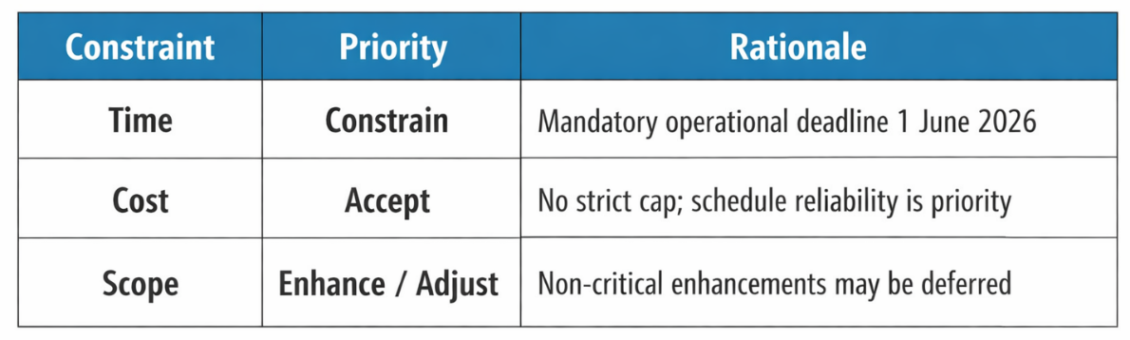
Figure 1: Priority Matrix
Work Breakdown Structure (WBS) and Scheduling Logic
Project activities were decomposed into deliverable-oriented phases to reflect how the Tauranga facility transitions from concept approval to full operational readiness. Sequencing logic was built around three governing principles: physical construction constraints, statutory inspection requirements, and operational readiness conditions. Each task was positioned to mirror how work would realistically unfold on site rather than how it might appear in a simplified timeline. Dependencies were structured to prevent premature progression and to avoid artificial compression of duration.
Planning commenced on 1 March 2026 using an eight-hour day and seven-day work calendar, as specified. Activities were grouped into seven structured phases: administrative and design, contractor procurement and mobilisation, construction, equipment procurement and installation, IT configuration and commissioning, supplier preparation and training, and go-live transition. Each phase produces a defined deliverable that enables the next stage to proceed. (ref: Figure 2)
Administrative & Design Phase
The project began with a formal kickoff meeting to confirm scope, responsibilities, and compliance expectations. Three foundational tasks followed: site lease execution (5 days), council permit application preparation (7 days), and detailed design drawings (10 days).
Lease execution was a legal prerequisite for any contractor engagement. No procurement or physical mobilisation could proceed without secured tenancy. Permit submission had to be completed before mobilisation began to ensure statutory review progressed alongside early works.
Detailed design drawings defined refrigeration layout, electrical zoning, racking alignment, and conveyor mounting interfaces. These drawings functioned as technical blueprints for both construction and equipment procurement. Mobilisation was deliberately structured to finish on the same day drawings were completed. This alignment prevented contractor idle time and ensured immediate transition from planning into execution.
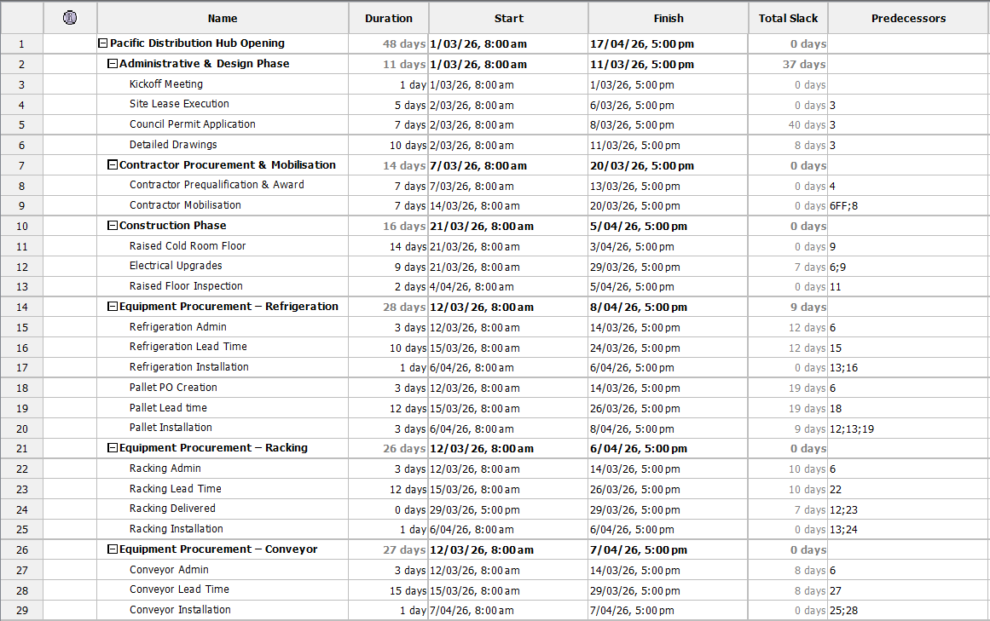
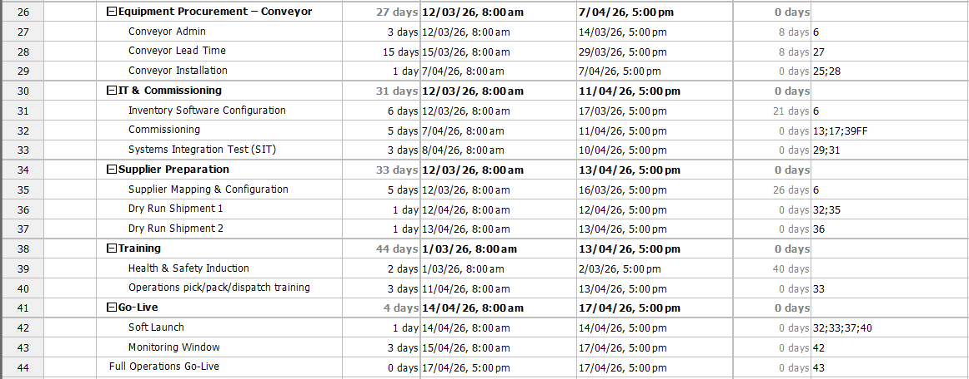
Figure 2: Task Schedule Summary

Contractor Procurement & Mobilisation
Contractor prequalification and award (7 days) commenced only after lease completion. Formal award confirmed contractual authority to perform works.
Mobilisation (7 days) followed award and included site setup, temporary utilities, safety barriers, and equipment staging. Construction could not begin until both mobilisation and detailed drawings were complete. This sequencing integrated legal readiness, technical clarity, and physical preparation.
Aligning mobilisation finish with drawing completion ensured that construction started immediately without delay, reinforcing schedule efficiency and eliminating unnecessary standby cost.
Construction Phase
Physical renovation commenced once mobilisation concluded. Two activities ran in parallel:
- Raised cold-room floor construction (14 days)
- Electrical upgrades (9 days)
The raised floor was required to support refrigeration units and racking loads. Electrical upgrades ensured sufficient power distribution for refrigeration systems and material handling equipment.
A mandatory raised-floor inspection (2 days) followed floor completion. Inspection acted as a statutory compliance gate. Refrigeration installation and racking placement were prohibited until inspection clearance was granted.
Parallel execution shortened duration without compromising compliance. However, inspection sequencing ensured regulatory standards were satisfied before equipment installation began. This prevented rework risk and ensured downstream activities progressed only after formal approval.
Equipment Procurement & Installation
Equipment procurement introduced schedule sensitivity due to vendor lead times. Each equipment category followed a structured sequence:
- Three days administrative processing
- Vendor lead time ranging from 10 to 15 days
- Delivery confirmation prior to installation
Refrigeration installation required two conditions: inspection clearance and confirmed delivery. Without inspection approval, refrigeration mounting could not legally proceed.
Pallet racking installation required completion of electrical upgrades, inspection approval, and confirmed delivery. Functional power was necessary before racking placement to ensure operational safety and lighting adequacy.
Conveyor installation was dependent on racking installation. Mounting interfaces could not be obstructed or misaligned. Conveyor installation therefore commenced immediately after racking placement to prevent sequencing conflict.
These dependencies created a cascading installation chain. Delay in construction or inspection directly affected equipment readiness. Vendor lead times operated independently of internal labour effort, making procurement sequencing a critical schedule driver. Installation logic therefore reflected both physical constraints and operational commissioning requirements.
IT Configuration & Commissioning
Inventory-control software configuration (6 days) began after drawing completion and ran in parallel with physical works. Configuration included SKU mapping, system setup, and initial connectivity testing.
Commissioning (5 days) required refrigeration installation, inspection clearance, and completion of health and safety induction. Commissioning verified temperature stability, system functionality, and operational readiness.
Health and safety induction was sequenced to finish before commissioning sign-off to ensure regulatory compliance. Commissioning therefore marked the transition from construction to operational validation.

Supplier Preparation & Staff Training
Supplier onboarding included SKU mapping (5 days) and two consecutive dry-run inbound shipments. Dry runs could only occur after commissioning confirmed refrigeration readiness.
Staff training comprised health and safety induction (2 days) and operational pick-pack-dispatch training (3 days). Operational training had to be completed before soft launch.
Go-Live & Operational Transition
Soft launch required completion of commissioning, systems integration testing, dry runs, and operations training. A one-day controlled launch was followed by a three-day monitoring window.
Full operations commenced immediately after monitoring, completing the transition from construction project to active distribution hub. (ref:Appendix 1.4 for detailed ProjectLibre Activity Schedule)

Critical Path and Project Duration
Project scheduling confirms a start date of 1 March 2026 and a calculated completion date of 17 April 2026, producing a total duration of 48 calendar days under the defined seven-day work calendar. Operational readiness is therefore achieved well in advance of the 1 June 2026 deadline. Schedule security, however, depends on understanding which activities directly determine that finish date. Critical path analysis isolates those tasks and identifies where managerial attention must remain focused. (ref: Appendix 1.1 for complete Network diagram)
Definition of Critical Path & Zero Slack
Critical path refers to the longest continuous chain of dependent activities that determines overall project duration. Tasks on this path have zero total slack. Zero slack means there is no scheduling flexibility. If any critical activity is delayed by one day, the entire project completion date shifts by one day. (ref: Figure 3 and Appendix 1.2 for clear Gantt chart)
Non-critical tasks may contain float and can tolerate minor delay without affecting final delivery. Critical activities cannot. Identifying zero-slack tasks allows management to prioritise monitoring, allocate oversight appropriately, and respond immediately to emerging variance.
Identification of Critical Activities
Analysis of the ProjectLibre output identifies the following sequence as critical:
- Kickoff and site lease completion
- Contractor prequalification and mobilisation
- Raised cold-room floor construction
- Raised-floor inspection
- Refrigeration installation
- Commissioning
- Supplier dry-run inbound shipments
- Soft launch
- Monitoring window
- Full operations go-live
Kickoff initiates legal and planning readiness. Lease completion enables contractor engagement. Mobilisation prepares the site for physical works. Raised-floor construction determines when inspection can occur. Inspection functions as a statutory compliance gate and blocks refrigeration installation until clearance is granted.
Refrigeration installation must finish before commissioning begins. Commissioning validates system functionality and temperature stability. Supplier dry runs test inbound flow and confirm operational viability. Soft launch validates live processing capability. Monitoring confirms stability before commercial volumes are processed.
No alternative parallel sequence shortens this chain. Each activity directly enables the next.
The sequence is schedule-driving because every stage depends on completion of the prior task, and no float exists between them. Inspection legally prevents equipment installation. Installation enables commissioning. Commissioning enables operational testing. Testing enables soft launch. Monitoring precedes full operations.
Delay at any point cascades forward. There is no buffer within this chain itself. Completion on 17 April 2026 is therefore controlled entirely by this uninterrupted sequence. Effective governance must concentrate on these activities to protect overall delivery certainty.
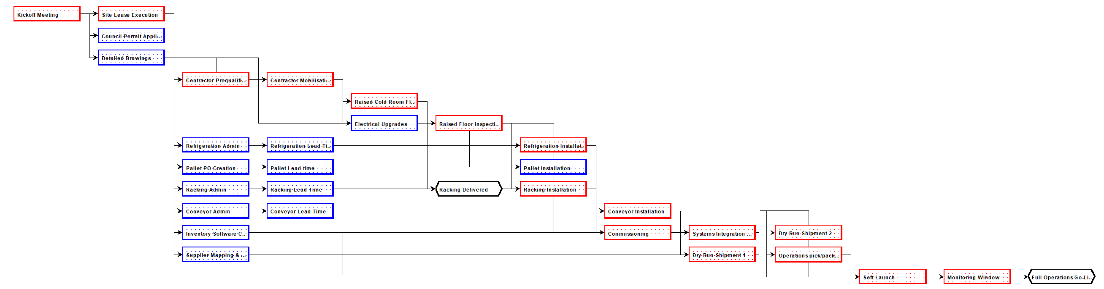
Figure 3: Critical Path

Schedule Buffer and Risk
Full operational readiness is achieved on 17 April 2026, approximately six weeks before the mandated 1 June 2026 deadline. This margin represents structured schedule protection rather than spare time. The project is therefore logic-driven, not deadline-driven. Internal sequencing determines the finish date, and external pressure does not currently constrain completion. (ref: Figure 4)
Contingency strengthens confidence but does not remove risk. Several activities remain highly sensitive because they sit on the critical path. Delay within these stages would immediately consume buffer and shift the final delivery date. Risk management must therefore focus on the specific activities that control the finish milestone. (ref: Appendix 1.3 for full task summary)
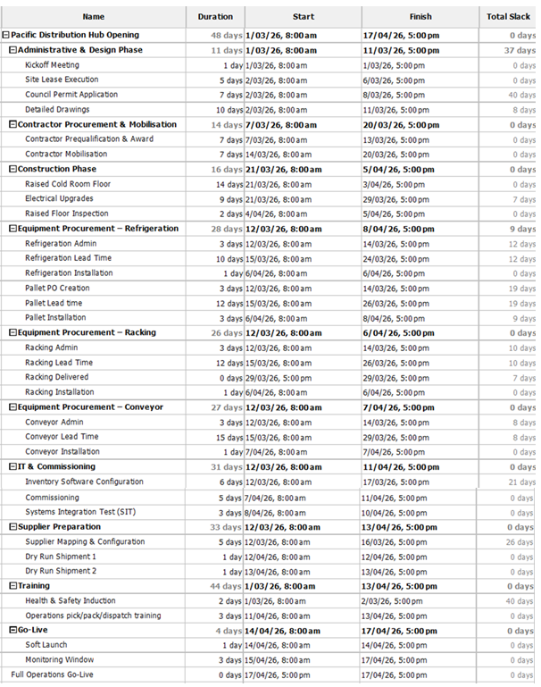
Figure 4: Task Slack

Buffer Analysis & Deadline Comparison
Completion on 17 April creates roughly six weeks of separation from the 1 June operational requirement. This gap provides resilience against moderate delay. Under current assumptions, the schedule does not rely on last-minute execution to meet the deadline.
However, buffer should not be interpreted as surplus capacity. It functions as protection against uncertainty. If multiple critical activities slip simultaneously, contingency could narrow quickly. Maintaining the buffer is essential to preserving delivery confidence and protecting uninterrupted customer service during transition.
Long-Lead Procurement Risk
Refrigeration units and the conveyor system introduce supplier-dependent risk. Refrigeration carries a 10-day vendor lead time, while conveyor procurement requires 15 days. Fabrication delays, freight disruption, or coordination errors could postpone installation readiness.
Installation cannot begin without confirmed delivery. Commissioning cannot begin without completed installation. Delay in either equipment stream therefore cascades into downstream milestones. While current buffer can absorb isolated delay, simultaneous vendor issues would reduce contingency rapidly. Active supplier monitoring and confirmation of delivery schedules are essential risk controls.
Statutory Inspection Risk
Raised-floor inspection functions as a mandatory compliance gate. Refrigeration and racking installation cannot proceed without formal approval. Inspection failure would trigger corrective work followed by reinspection, introducing potential delay.
Inspection sits directly on the critical path. Any delay here shifts installation, commissioning, dry runs, and ultimately go-live. Unlike discretionary tasks, inspection timing cannot be compressed. Early quality checks prior to formal inspection reduce failure probability and protect schedule continuity.
Commissioning & Operational Readiness Risk
Commissioning validates refrigeration performance, system integration, and safety compliance. Technical calibration issues, integration defects, or performance instability could extend this stage.
Supplier dry runs depend on successful commissioning. Soft launch depends on dry runs. Monitoring depends on soft launch. These activities occur sequentially with no float. Delay at commissioning therefore propagates directly to completion. Maintaining close technical oversight during installation and early testing protects the operational transition milestone and preserves buffer integrity.

Recommendations
Delivery feasibility is confirmed; however, maintaining schedule integrity requires disciplined governance and proactive control of critical activities. The following recommendations are proposed to safeguard operational readiness before 1 June 2026.
Schedule Governance & Monitoring
Formal approval of the current baseline schedule should be secured immediately. The zero-slack chain—mobilisation, construction, inspection, refrigeration installation, commissioning, dry runs, soft launch, and monitoring—must be reviewed weekly. Variance tracking against planned finish dates should be documented and escalated early. Maintaining visibility over critical milestones prevents minor delays from compounding and preserves the six-week contingency buffer.
Inspection & Compliance Controls
Raised-floor inspection represents a statutory gate. Pre-inspection quality verification should be completed internally before council review. Early coordination with inspection authorities will reduce scheduling uncertainty. Minimising rework risk at this stage protects downstream installation and commissioning milestones.
Procurement Oversight
Refrigeration and conveyor procurement require active supplier management. Fabrication status, freight timelines, and confirmed delivery windows should be monitored through structured check-ins. Early identification of supply disruption enables corrective action before installation sequencing is affected.
Cross-Functional Coordination
Commissioning, training, and supplier onboarding must remain synchronised. Operations, facilities, and IT teams should conduct joint readiness reviews before soft launch. Clear communication protocols and milestone alignment meetings will reduce interface risk. Preserving integration discipline across technical and operational functions ensures smooth transition from construction project to fully functioning logistics hub.
These actions will protect schedule integrity and ensure operational readiness within the mandated timeframe.

Conclusion
The Tauranga distribution hub schedule demonstrates clear structural logic and operational alignment. Commencing on 1 March 2026 and concluding on 17 April 2026, the project achieves full readiness within 48 calendar days. All statutory approvals, installation requirements, and commissioning milestones are properly sequenced and achievable under defined assumptions. Mobilisation, construction, inspection, refrigeration installation, commissioning, dry runs, soft launch, monitoring, and final operations form the zero-slack sequence. These activities directly determine completion. Continuous oversight of this chain is essential, as any delay within these tasks immediately extends the project finish date.
Completion in mid-April provides approximately six weeks of contingency before the 1 June 2026 deadline. This buffer strengthens schedule resilience while protecting compliance and service continuity. With disciplined monitoring and proactive risk management, the project remains strategically secure and operationally achievable.

Appendix:
1.1 Network Diagram
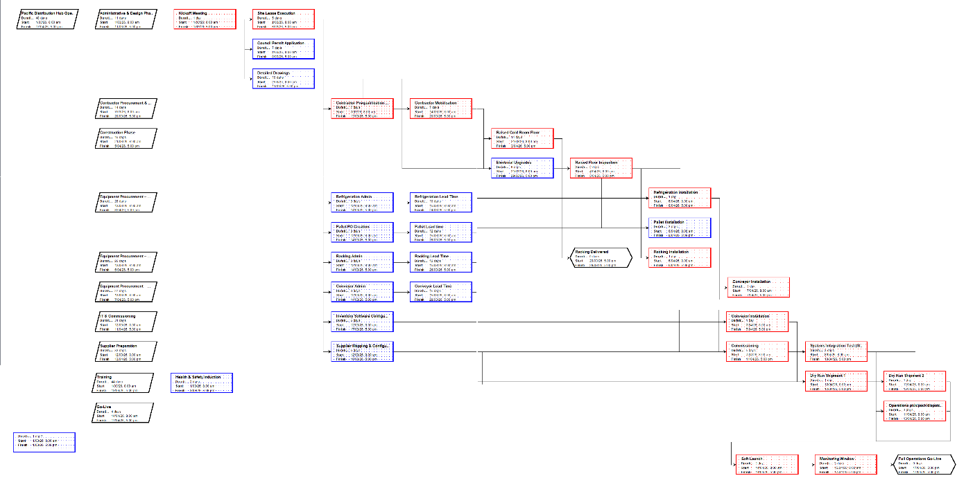

1.2 Gantt Chart
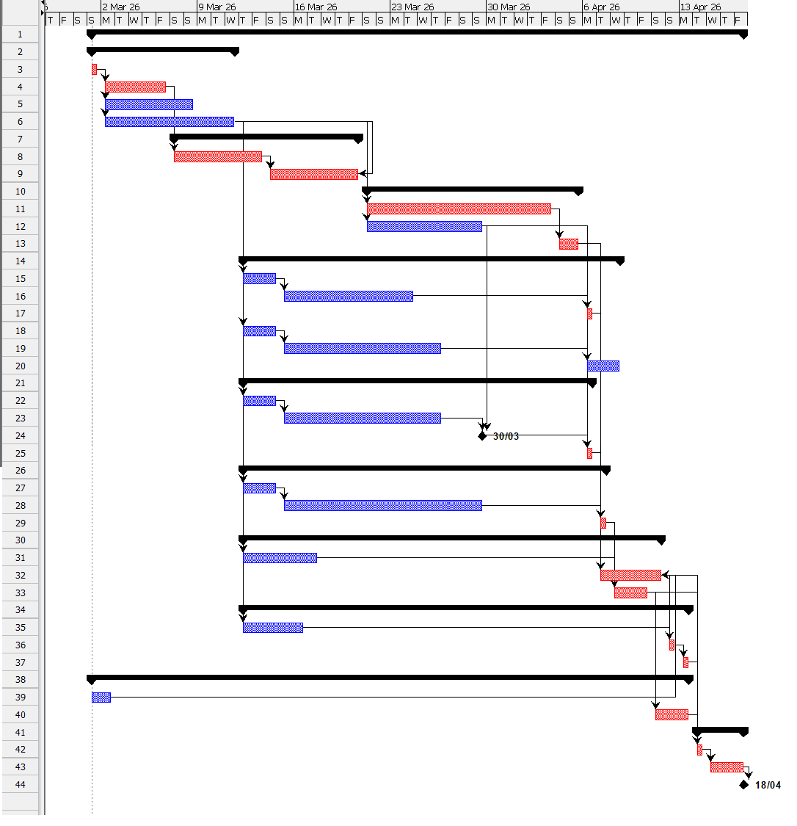

1.3 Summary of tasks
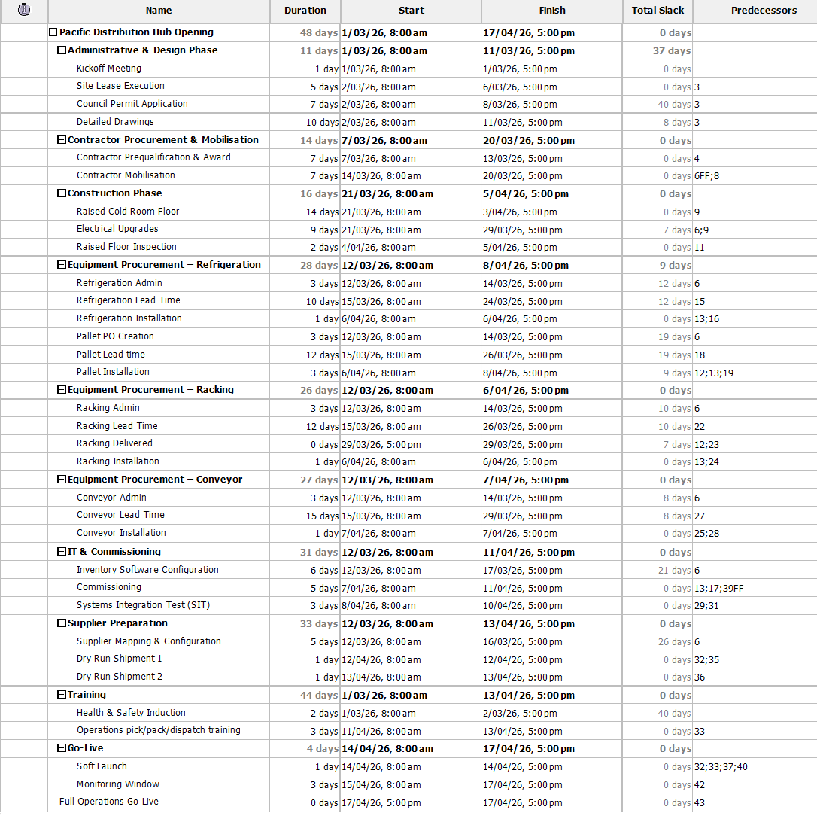

1.4 Activity Schedule Summary.

ID | Task Name | Duration (Days) | Predecessor(s) | Special Constraints | Total Slack (Days)
1 | Kickoff Meeting | 1 | – | Project start fixed: 1 Mar 2026 | 0
2 | Site Lease Execution | 5 | 1 | Lease required before contractor award | 0
3 | Council Permit Application | 7 | 1 | Must be submitted before mobilisation | 40
4 | Detailed Design Drawings | 10 | 1 | Required before mobilisation & procurement | 8
5 | Contractor Prequalification & Award | 7 | 2 | Cannot proceed without lease | 0
6 | Contractor Mobilisation | 7 | 4,5 | Must align with drawing completion | 0
7 | Raised Cold-Room Floor | 14 | 6 | Precedes statutory inspection | 0
8 | Electrical Upgrades | 9 | 6 | Required before racking installation | 7
9 | Raised Floor Inspection | 2 | 7 | Statutory gate before installation | 0
10 | Refrigeration Admin | 3 | 4 | Procurement processing | 12
11 | Refrigeration Lead Time | 10 | 10 | Vendor lead time | 12
12 | Refrigeration Installation | 1 | 9,11 | Requires inspection clearance | 0
13 | Racking Admin | 3 | 4 | Procurement processing | 10
14 | Racking Lead Time | 12 | 13 | Vendor lead time | 10
15 | Racking Installation | 1 | 8,9,14 | Requires electrical completion | 0
16 | Conveyor Admin | 3 | 4 | Procurement processing | 8
17 | Conveyor Lead Time | 15 | 16 | Vendor lead time | 8
18 | Conveyor Installation | 1 | 15,17 | After racking placement | 0
19 | Inventory Software Configuration | 6 | 4 | Parallel to construction | 21
20 | Health & Safety Induction | 2 | 6 | Must finish before commissioning | 40
21 | Commissioning | 5 | 12,20 | Validates refrigeration readiness | 0
22 | Systems Integration Test (SIT) | 3 | 19,21 | Required before soft launch | 0
23 | Supplier Mapping & Configuration | 5 | 4 | Preparation phase | 26
24 | Dry Run Shipment 1 | 1 | 22,23 | Requires commissioning & supplier readiness | 0
25 | Dry Run Shipment 2 | 1 | 24 | Consecutive inbound testing | 0
26 | Operations Pick/Pack Training | 3 | 23 | Must complete before soft launch | 0
27 | Soft Launch | 1 | 25,26 | Controlled go-live | 0
28 | Monitoring Window | 3 | 27 | Post-launch validation | 0
29 | Full Operations Go-Live | 0 | 28 | Official operational readiness | 0

