SmartMin: An AI-Powered Meeting Transcription and Task Delegation System for ZPPSU Departments

A Capstone Project

Presented to
The Faculty of the College of Information and Computing Science
Zamboanga Peninsula Polytechnic State University

In Partial Fulfillment of the Requirements
For the Degree of Bachelor of Science in Information Technology

By

Bandahali, Aliemar S.
Gelera, Gibson P.
Muco, Mouadz S.
Saliddin, Ayman Nadier C.

Lobella DP. Calago, MAEd
Adviser

May 2026

TABLE OF CONTENTS

CHAPTER 1: BACKGROUND OF THE PROBLEM
1.1 Introduction 1
1.2 Project Context 2
1.3 Purpose and Description 2
1.4 Objectives 3
1.5 Scope and Limitations 4
1.6 Definition of Terms 5
CHAPTER 2: REVIEW OF RELATED LITERATURE AND SYSTEMS
2.1 Technical Background 6
2.2 Review of Related Literature 6
2.3 Review of Related Systems 8
2.4 Synthesis of the Study 9
CHAPTER 3: DESIGN AND METHODOLOGY
3.1 Requirements Analysis 15
3.2 Requirements Documentation 15
3.3 Design of Software System 16
A. System Architecture 16
B. Entity Relationship Diagram (ERD) 17
C. Data Flow Diagram (DFD) 17
D. Use Case Diagram 18
E. Initial UI Wireframes / Mockups 18
REFERENCES
References 19

LIST OF TABLES

Table 1. Specific Objectives using the SMART Framework 3
Table 2. Table of Synthesis 9
Table 3. Entity Relationship Diagram Summary 17

LIST OF FIGURES

Figure 1. Agile Methodology 16
Figure 2. SmartMin System Architecture 16
Figure 3. Entity Relationship Diagram (ERD) 17
Figure 4. Level 0 Data Flow Diagram (Context Diagram) 17
Figure 5. Level 1 Data Flow Diagram (Core Processes) 17
Figure 6. Use Case Diagram 18
Figure 7. UI Wireframe: Main Dashboard & Capture Interface 18
Figure 8. UI Wireframe: Institutional Editor 18
Figure 9. UI Wireframe: Accountability Matrix 18

CHAPTER 1
BACKGROUND OF THE PROBLEM

1.1 INTRODUCTION
Meetings are indispensable for organizational decision-making, yet their productivity is frequently undermined by poor manual documentation and ambiguous follow-up tracking. In the current technological landscape, Large Language Models (LLMs) and advanced Automatic Speech Recognition (ASR) have transformed how institutions manage information. However, while robust commercial solutions (e.g., Otter.ai) provide excellent online transcription, they are generalized for Western corporate environments and lack integration into strict academic, bureaucratic workflows. The primary gap lies in the absence of a localized web system that transcribes mixed-language discussions (Tagalog-English code-switching), safeguards institutional data privacy, and automatically routes extracted tasks into a formal, verifiable approval matrix tailored for Philippine academic administrative offices.

1.2 PROJECT CONTEXT
Within Zamboanga Peninsula Polytechnic State University (ZPPSU), departmental offices conduct frequent faculty meetings that generate significant operational directives. Currently, department secretaries manually transcribe these meetings, resulting in delayed Minutes of the Meeting (MoM) and poor tracking of assigned tasks. Implementing 'SmartMin' addresses these bottlenecks by providing automated MoM generation and a unified accountability dashboard tailored specifically for ZPPSU.

1.3 PURPOSE AND DESCRIPTION
The purpose of this project is to develop a highly efficient, online web application that transforms raw meeting audio into structured, searchable, and actionable intelligence. To justify its necessity against existing market solutions, SmartMin is built upon Four Core Features:

1. Institutional MoM Generator: Unlike generic tools, the system specifically parses transcripts into rigid, CHED-compliant Minutes of the Meeting formats required by the university.
2. Code-Switched Semantic Processor: Tuned specifically to recognize and extract actionable tasks from Tagalog-English (Taglish) conversational shifts common in local faculties.
3. Data-Private Localized Routing: Ensures that sensitive administrative data remains governed within the university's operational matrix, rather than being exposed to third-party corporate dashboards.
4. Unified Accountability Dashboard: Features an institutional approval workflow, including a role-based 'Approve & Lock' feature for Department Heads to finalize and delegate directives.

Note: The system also includes an extra feature allowing optional offline local-execution for devices with high-end hardware, ensuring operational resilience.

1.4 OBJECTIVES
This system is an online AI-powered meeting intelligence platform that automates transcription, summarization, and task tracking for ZPPSU departments over a 5 to 7-month development timeline.

Table 1. Specific Objectives using the SMART Framework
Objective | Specific | Measurable | Achievable | Relevant | Time-bound
Design UI/UX & Capture | Develop a cross-platform web application using React.js for audio capture. | Secure user-initiated capture of system and mic audio. | Yes, using standard Web Audio APIs. | Ensures ease of use for non-technical secretaries. | Month 1
Implement Cloud STT | Integrate cloud-based ASR APIs for fast transcription with Whisper as optional fallback. | Output raw, speaker-segmented text within 60 seconds. | Yes, using cloud APIs on standard hardware. | Reduces hardware dependency for standard office PCs. | Months 2-3
Develop LLM Processing | Utilize cloud-hosted LLMs to parse transcripts and generate CHED-format MoM. | Generate CHED-format MoM and flag missing task parameters. | Yes, via targeted prompt engineering. | Automates the core documentation workflow. | Month 4
Build Task Dashboard | Create a FAISS-powered chat interface and a role-based approval workflow. | Role-based locking functionality for Department Heads. | Yes, utilizing React.js and FastAPI. | Fulfills institutional accountability needs. | Months 5–6
Evaluate Usability | Conduct user testing with ZPPSU administrative staff. | Attain positive ISO 25010 software quality metric scores. | Yes, via standardized survey deployment. | Validates system efficiency and usability. | Month 7

1.5 SCOPE AND LIMITATIONS
Scope
SmartMin is designed primarily as an online web-based platform for ZPPSU departments. It covers user-initiated audio capture, multilingual transcription (English and Tagalog), AI-based summarization generating formal MoM, and a role-based task tracking dashboard utilizing cloud-based APIs for fast processing on standard office computers. As an auxiliary feature, the system offers an optional offline processing mode.

Limitations
The project does not feature automatic bot integrations for video calls due to platform privacy rules. Users with standard office hardware must maintain a stable internet connection to utilize the core cloud-based transcription and LLM features. The optional offline capability is strictly hardware-dependent, requiring a minimum of 16GB of RAM and a dedicated GPU to function.

1.6 DEFINITION OF TERMS
ASR (Automatic Speech Recognition): Computational technology used to transcribe spoken audio into text.
Code-Switching: The practice of alternating between two or more languages (e.g., Tagalog and English) in conversation.
Data Privacy / Localization: The practice of keeping sensitive university meeting data managed and stored within the institution's approved systems rather than open commercial servers.
FAISS: A vector database library used to store transcript data rapidly, powering the interactive query features.
LLM (Large Language Model): Advanced AI systems capable of understanding and generating human language, utilized for summarization and task extraction.
MoM (Minutes of the Meeting): A formal institutional document summarizing discussions, resolutions, and assigned tasks from an official meeting.
Ollama: A lightweight framework that allows LLMs to be run locally on consumer-grade hardware, used in the optional offline mode.
pyannote.audio: An open-source toolkit used for speaker diarization—detecting who spoke when within a recorded conversation.
React.js: A JavaScript library used to build the dynamic, responsive web interface of SmartMin.
Whisper.cpp: A highly optimized, C++ port of OpenAI's Whisper model designed for fast, offline speech-to-text processing, used as an optional fallback engine.

CHAPTER 2
REVIEW OF RELATED LITERATURE AND SYSTEMS

2.1 TECHNICAL BACKGROUND
The shift from manual note-taking to automated meeting minutes involves a cascading pipeline: Automatic Speech Recognition (ASR) converts raw audio to text, Speaker Diarization segments the audio by distinct speakers, and Large Language Models (LLMs) parse the text to extract semantic meaning, summarize discussions, and isolate actionable tasks. SmartMin implements this pipeline primarily through online APIs to ensure that legacy hardware in Philippine State Universities and Colleges (SUCs) can access advanced AI effortlessly, with an optional offline processing mode for institutions with high-end equipment.

2.2 REVIEW OF RELATED LITERATURE

Foreign
Radford et al. (2022) established the capabilities of Whisper, demonstrating that large-scale weak supervision yields robust multilingual speech recognition capable of handling varied accents without fine-tuning.
Zhong et al. (2021) introduced QMSum, highlighting that generic meeting summaries often miss critical details, proving that query-based summarization performs better.
Bredin et al. (2020) developed pyannote.audio, proving that neural-based end-to-end diarization significantly improves 'who spoke when' tracking.
Zhang et al. (2024) surveyed text summarization, finding that LLMs drastically improve semantic coherence over older extractive models.
Fu et al. (2024) researched domain-adaptive continual pre-training of LLMs, demonstrating that applying structured prompts yields substantial gains in action item extraction.
Kirstein et al. (2024) investigated LLM evaluation metrics, finding that automated scores fail to penalize hallucinations effectively.
Feng et al. (2021) explored dialogue summarization, concluding that dialogues require models capable of understanding informal turn-taking.
Laskar et al. (2024) proved in Query-OPT that batching multiple extraction tasks into a single LLM multi-query prompt drastically reduces computational load.

Local
Dorado and Villanueva (2023) proved that locally trained acoustic models outperform generalized cloud APIs in handling local accents and low-latency environments.
Guia (2023) analyzed SUC service delivery, documenting that manual bureaucratic processing causes severe service delays across Philippine university departments.
Borjal et al. (2023) verified that modern language models can achieve nearly 90% accuracy in structuring code-switched (Tagalog-English) natural language into rigid database queries.
CHED-DICT (2023) issued a Memorandum of Understanding on E-Governance, providing evidence that manual processing compromises document veracity, mandating an urgent shift toward automated e-governance.
Copiaco et al. (2021) explored deep learning approaches to Filipino speech recognition, highlighting the need for specialized phonetic parsing.
Ilaya et al. (2021) noted that open-source datasets remain a bottleneck, making zero-shot multilingual models necessary for Philippine applications.
The Department of Trade and Industry (DTI, 2021) highlighted a critical gap: the lack of localized NLP tools actively hinders the digitalization of Philippine public sectors.

2.3 REVIEW OF RELATED SYSTEMS

Foreign
Otter.ai (2023) provides highly accurate English transcription but requires expensive subscriptions and persistent internet, and routes all data through foreign commercial servers.
Fireflies.ai (2024) integrates with CRM platforms for task extraction but is generalized heavily for Western corporate workflows with no CHED-format support.
Tactiq (2024) acts as a browser-extension transcriber that is lightweight but fails if browser connections drop.
Fathom (2023) is a free AI assistant for Zoom calls but cannot process purely physical, in-room meetings.
Whisper.cpp (2022) enables state-of-the-art ASR to run entirely offline on standard CPUs, used as SmartMin's optional fallback.
Ollama (2023) ensures private NLP processing by running LLMs locally, also utilized in the optional offline mode.
pyannote.audio (2021) provides state-of-the-art speaker diarization accuracy.
Taskade (2024) offers excellent task management but is too flexible for rigid institutional document locking.

Local
The UP Document Tracking System (2022) tracks physical and digital paper trails but requires manual typing of initial documents.
The PUP Document Tracking System (2023) serves as a centralized document routing system but has no AI natural language processing layer.
The DICT eGov PH Super App (2023) standardizes digital identity and routing for LGUs, though not specialized for meeting extraction.
The DOST-ASTI ALAM Project (2021) develops Filipino speech-to-text models as an API/research repository without a user-facing product.
The DPWH Document Tracking System (DoTS) streamlines bureaucratic communications but cannot extract actionable data from audio.
Project SPARTA NLP Modules (2020) produced fragmented local NLP tools across separate repositories.
Senti AI (2024) provides localized Philippine NLP APIs built for commercial enterprises, not SUC-specific workflows.

2.4 SYNTHESIS OF THE STUDY

Table 2. Table of Synthesis
No. | Title of Study / System | Author/s & Year | Purpose / Objective | Methodology | Key Findings | Relevance to Proposed Project | Research Gap
RELATED STUDIES
1 | Robust Speech Recognition via Large-Scale Weak Supervision | Radford et al., 2022 | Investigate Whisper's multilingual ASR capability. | Weak supervision on varied audio datasets. | High robustness against accents and noise. | Provides the core transcription engine via API or optional offline. | Outputs raw text without task extraction.
2 | QMSum: A New Benchmark for Query-Based Meeting Summarization | Zhong et al., 2021 | Evaluate query-based meeting summarization. | Dataset benchmarking across domains. | Query-based prompting outperforms generic summaries. | Justifies prompt-engineered queries for CHED MoM. | Ignores audio preprocessing
3 | pyannote.audio: Neural Building Blocks for Speaker Diarization | Bredin et al., 2020 | Develop neural speaker diarization. | End-to-end neural network modeling. | Significantly improves 'who spoke when' tracking. | Used to segment speakers in the backend pipeline. | Computationally heavy for non-GPU hardware.
4 | Systematic Survey of Text Summarization | Zhang et al., 2024 | Survey transition to LLM summarizers. | Systematic review of generative models. | LLMs improve semantic coherence drastically. | Validates using cloud LLMs for CHED MoM creation. | Prone to hallucinations in long text.
5 | Domain-Adaptive Continual Pre-Training of LLMs | Fu et al., 2024 | Improve LLM action item extraction. | Structured prompting on conversation transcripts. | Structured prompts yield extraction gains. | Tailors extraction specifically to academic workflows. | Tested only on corporate business calls.
6 | Investigating Automatic Metrics on Meeting Summarization | Kirstein et al., 2024 | Investigate LLM evaluation failures. | Comparing automated scores vs. human evaluation. | Metrics fail to penalize hallucinations effectively. | Mandates a UI-driven human-in-the-loop review step. | Theoretical evaluation study only.
7 | A Survey on Dialogue Summarization | Feng et al., 2021 | Explore dialogue structure constraints. | Review of conversational structures. | Dialogues require models understanding turn-taking. | Utilizes models that support Taglish turn-taking. | Focused on formal English datasets.
8 | Query-OPT: Optimizing Inference via Multi-Query Instructions | Laskar et al., 2024 | Optimize LLM inference load. | Multi-query instruction prompting. | Batching tasks reduces computational load. | Applies logic to minimize cloud API token costs. | Theoretical framework only.
9 | Development of Low-Latency Filipino ASR System | Dorado & Villanueva, 2023 | Develop fast Filipino acoustic models. | Deep neural networks for local accents. | Local ASR outperforms cloud APIs for Filipino speech. | Informs Taglish-tolerant transcription design. | Focused on children's speech only.
10 | Public Service Delivery in State Universities and Colleges | Guia, 2023 | Analyze SUC bureaucratic delays. | Review of administrative tracking efficiency. | Manual processing causes severe service delays. | Replaces manual routing with an automated dashboard. | Offers policy solutions, not software tools.
11 | Parallel Corpus Curation for Filipino Text-to-SQL | Borjal et al., 2023 | Parse Taglish into databases. | Modern language models for semantic parsing. | 90% accuracy in structuring code-switched text. | Validates Taglish semantic extraction design. | Limited to simple database queries.
12 | CHED-DICT MOU on E-Governance | CHED-DICT, 2023 | Mandate shift to automated e-governance. | Policy implementation guidelines. | Manual processing compromises document veracity. | Provides institutional mandate for the system. | Lacks an out-of-the-box technical tool.
13 | A Deep Learning Approach to Filipino Speech Recognition | Copiaco et al., 2021 | Improve Tagalog phonetic parsing. | Deep learning acoustic modeling. | Specialized models required for Tagalog phonetics. | Guides robust handling of physical meeting audio. | Evaluated only in clean audio environments.
14 | Tagalog Speech Recognition using DeepSpeech | Ilaya et al., 2021 | Address open-source dataset bottlenecks. | DeepSpeech implementation testing. | Zero-shot multilingual models are necessary. | Uses transformer models to handle Taglish natively. | DeepSpeech struggles with code-switching.
15 | National Artificial Intelligence Strategy Roadmap | DTI, 2021 | Identify gaps in public sector digitalization. | Strategic sector analysis. | Lack of local NLP tools hinders e-governance. | Directly deploys a localized, AI-enabled tool. | Strategic overview only; no concrete tool.
RELATED SYSTEMS
16 | Otter.ai | Otter.ai, 2023 | Live transcription tool. | Cloud-based AI transcription. | Highly accurate English transcription. | Benchmark reference; SmartMin adds CHED formatting and data privacy. | Expensive; exposes data to foreign servers.
17 | Fireflies.ai | Fireflies.ai, 2024 | AI meeting assistant for CRM. | API integration for sales extraction. | Robust corporate task extraction. | SmartMin replaces with a localized SUC approval matrix. | Generalized for Western corporate workflows.
18 | Tactiq | Tactiq, 2024 | Browser-based Meet/Zoom transcriber. | Chrome extension processing. | Lightweight real-time summaries. | SmartMin uses a dedicated web app to capture audio securely. | Fails if internet drops; browser limited.
19 | Fathom | Fathom, 2023 | Free AI assistant for Zoom. | Video-call integration. | Records and summarizes digital calls effectively. | SmartMin allows manual audio uploads for physical meetings. | Cannot process physical in-room meetings.
20 | Whisper.cpp | Gerganov, 2022 | C++ port of Whisper. | CPU optimization of transformer models. | State-of-the-art ASR runs entirely offline. | Used as the optional offline fallback transcription engine. | Command-line only; no UI or institutional format.
21 | Ollama | Ollama, 2023 | Framework for local LLMs. | Secure local deployment of quantized LLMs. | Cost-efficient and private NLP processing. | Used in the optional offline mode for LLM processing. | Requires high-end hardware; not standard office PCs.
22 | pyannote.audio | pyannote, 2021 | Open-source speaker diarization. | Neural framework integration. | State-of-the-art speaker detection accuracy. | Integrated into the backend pipeline for diarization. | Hard to deploy for non-programmers.
23 | Taskade | Taskade, 2024 | AI workspace and Kanban. | Collaborative UI development. | Excellent for task management organization. | SmartMin implements irreversible 'Approve & Lock' for official minutes. | Too flexible; lacks institutional document locking.
24 | UP Document Tracking System (UP DTS) | UP, 2022 | Track physical/digital paper trails. | Centralized database routing. | Excellent historical document tracking. | SmartMin auto-generates MoM content before tracking begins. | Requires manual typing; no AI processing.
25 | PUP Document Tracking System | PUP, 2023 | Centralized document routing. | Web-based transmittal logging. | Reduces lost paperwork significantly. | SmartMin appends an AI transcription layer to the workflow. | No AI natural language processing.
26 | DICT eGov PH Super App | DICT, 2023 | Standardize digital identity. | National portal development. | Streamlines LGU digital identity routing. | SmartMin targets the specific niche of academic faculty meetings. | Generalized portal; no meeting extraction.
27 | DOST-ASTI ALAM Project | DOST, 2021 | Filipino speech-to-text API. | Localized acoustic data modeling. | Improved local STT recognition. | Informs Taglish ASR design; SmartMin delivers the full user-facing product. | Primarily an API/research repository.
28 | DPWH Document Tracking System (DoTS) | DPWH, 2021 | Document transmittal framework. | National network infrastructure. | Streamlines internal government communications. | SmartMin uses LLMs to auto-populate tasks from transcripts. | Cannot extract actionable data from audio/files.
29 | Project SPARTA | DOST, 2020 | Local NLP data science tools. | Fragmented script development. | Promotes local data science research. | SmartMin unifies ASR, NLP, and Diarization into one web app. | Tools are fragmented across repositories.
30 | Senti AI | Senti, 2024 | Localized Philippine NLP API. | Enterprise algorithm refinement. | Improves Tagalog semantic recognition. | Bridges local ASR with an accountability dashboard. | Built for commercial enterprises, not SUCs.

Analysis of the reviewed studies and systems reveals a critical gap in automated documentation technology for Philippine academia. Foreign literature proves the efficacy of using LLMs to extract actionable tasks from complex, multi-speaker meetings. However, these powerful methodologies are predominantly locked inside commercial SaaS systems (like Otter.ai or Fireflies.ai) that cater strictly to Western corporate environments.

Crucially, these commercial systems pose significant data sovereignty and privacy risks. University faculty and administrative meetings frequently involve sensitive institutional data, student information, and internal academic policies. Relying on Western corporate tools means exposing this private university data to foreign third-party servers that operate under foreign data governance laws—a direct conflict with the data privacy mandates established by the Philippine Republic Act 10173 (Data Privacy Act of 2012) and the CHED-DICT MOU on E-Governance (2023), which requires state universities to maintain data veracity and control.

SmartMin justifies its development by serving as a localized, institution-first alternative. It bridges the gap by natively formatting outputs to rigid CHED standards and properly handling Tagalog-English code-switching. More importantly, it provides a localized system architecture, ensuring that all transcribed data, minutes, and delegated tasks are governed strictly within ZPPSU's private operational matrix. Unlike empty local e-governance routing systems (like UP DTS) that require manual typing, SmartMin safely merges automated AI processing with institutional data privacy through its role-based approval workflow and data-private routing architecture.

CHAPTER 3
DESIGN AND METHODOLOGY

3.1 REQUIREMENTS ANALYSIS

Administrative personnel at ZPPSU face significant delays due to manual minute-taking, which produces intermittent and subjective data. Mixed-language discussions combined with multi-speaker environments create conditions that severely impair manual documentation, making rapid task extraction untrustworthy. Faculty members tend to delay their follow-up actions because a centralized, automated task dashboard does not yet exist. A technological solution is required that minimizes documentation times while ensuring accountability for operational directives. The system must be readily accessible via standard web browsers to accommodate the average office computers used by university staff.

3.2 REQUIREMENTS DOCUMENTATION

• Software Requirements: The system requires a web-based frontend (React.js) with a FastAPI backend. It routes audio data securely to cloud-based ASR and LLM APIs for standard online users, returning structured MoM data to the institutional dashboard.
• Hardware Requirements: For standard online use, any modern computer with a web browser and a reliable internet connection is sufficient. For the auxiliary offline processing mode, the host machine must have a minimum of 16GB RAM and a dedicated GPU.
• Performance Standards: The system must output CHED-formatted institutional minutes within a reasonable processing window and utilize validation protocols to flag missing task fields (assignees and deadlines) prior to document finalization.

3.3 DESIGN OF SOFTWARE SYSTEM

A. System Architecture
SmartMin is built on a responsive online architecture. Audio is captured via the web UI and transmitted securely to cloud-based ASR and LLM services to perform transcription, diarization, and semantic extraction. The processed data is then returned to the user’s dashboard and parsed into the university’s specific CHED MoM template. The frontend (React.js) communicates with the backend (FastAPI) through RESTful API calls. For users with high-end machines opting for the extra offline feature, the architecture temporarily bypasses the cloud and utilizes locally installed model binaries (Whisper.cpp for ASR and Ollama for LLM processing). The overall system architecture is illustrated in Figure 2.
To ensure continuous improvement and adaptability throughout the development process, the project utilizes the Agile Methodology. This approach divides the system's creation into iterative sprints, allowing the team to incrementally build the web interface, integrate the cloud-based AI services, and refine the CHED MoM generation based on continuous testing and stakeholder feedback. The flexibility of Agile is particularly beneficial for managing the parallel development and hardware testing of the optional offline processing capabilities alongside the core online architecture.
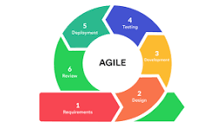
Figure 1. Agile Methodology

B. Entity Relationship Diagram (ERD)

The database is structured around four core entities: User, Meeting, MoM_Document, and Task. The relationship cardinality is defined as follows: one User may record many Meetings (1:N); each Meeting generates exactly one MoM_Document (1:1); and each MoM_Document may contain many Tasks (1:N). The ERD entity summary is presented in Table 3.

Table 3. Entity Relationship Diagram Summary

Entity | Attributes | Description
User | UserID (PK), Name, Role (Head / Secretary / Faculty), Department | Captures all system actors and their institutional roles.
Meeting | MeetingID (PK), Date, AudioData, Transcript | Stores raw audio reference and generated transcript text.
MoM_Document | DocID (PK), MeetingID (FK), CHED_Format_Data, Status (Draft, Locked) | Holds the formatted institutional minutes and its approval state.
Task | TaskID (PK), DocID (FK), AssignedTo, Deadline, Status (Pending / Complete) | Tracks individual action items extracted from each finalized MoM.

Figure 3. Entity Relationship Diagram (ERD)
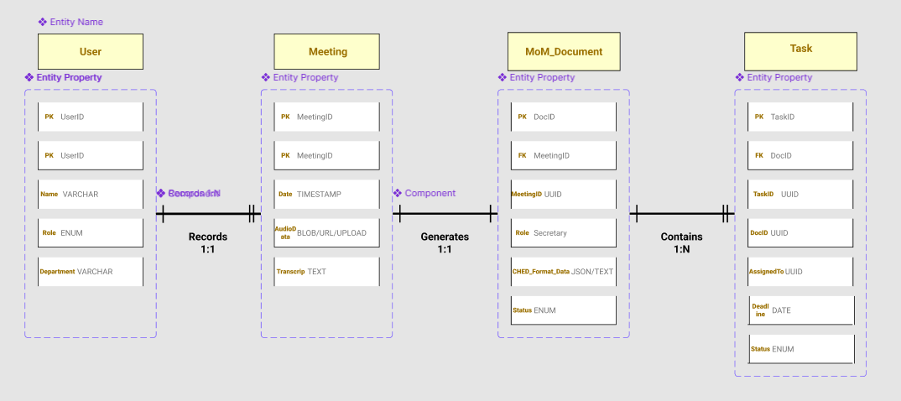

C. Data Flow Diagram (DFD)

Level 0 — Context Diagram (Figure 4):

Users (Department Secretaries, Heads, and Faculty Members) input audio data into the SmartMin Web System. The system outputs formatted MoM documents and Task Dashboard updates back to the users, while keeping all institutional data within the university's private database.

Level 1 — Core Processes (Figure 5):

1. Audio Capture: The web UI records system or microphone audio initiated by the user.
2. AI Processing: Audio data routes securely to cloud AI APIs (or optional local hardware) to produce a speaker-segmented transcript with extracted Taglish task semantics.
3. Document Assembly: The processed output populates the rigid CHED MoM template with meeting data, flagging any missing fields for secretary review.
4. Dashboard State Update: The frontend is updated to reflect the draft minutes and pending tasks for Secretary review and Department Head approval.

Figure 4 & 5. Level 0 and Level 1 Data Flow Diagrams
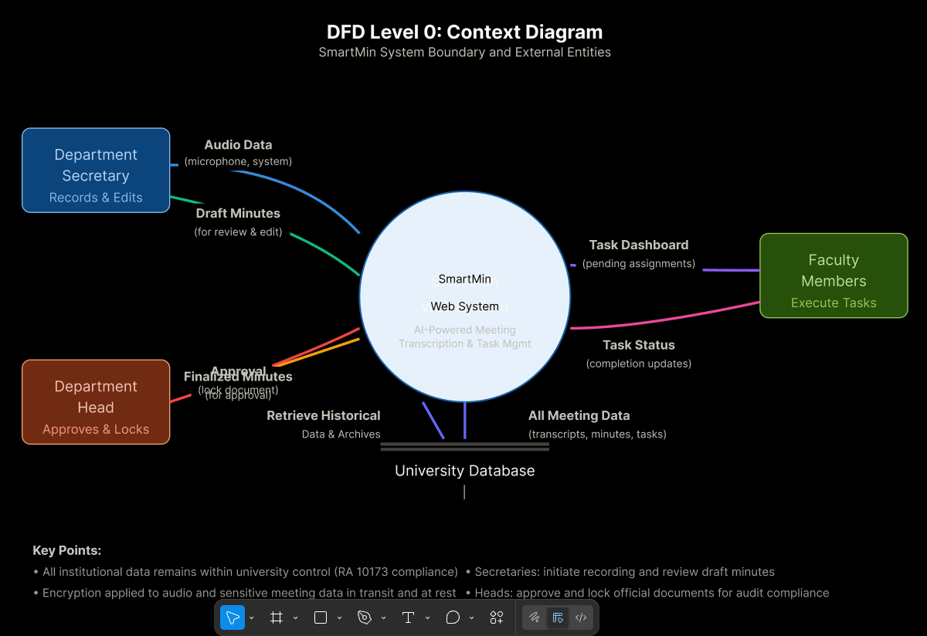
D. Use Case Diagram

The system defines three primary actors with distinct interaction roles, as illustrated in Figure 6.

• Department Secretary: Initiates audio capture, edits AI-generated draft minutes, and validates flagged missing task parameters before submission.
• Department Head: Reviews finalized draft minutes, executes the 'Approve & Lock' institutional protocol to commit the document, and oversees the macro-view of the task accountability dashboard.
• Faculty Member: Logs into the system to receive automated task assignments extracted from the finalized MoM, and updates task statuses (Pending or Complete) on the dashboard.

Figure 6. Use Case Diagram
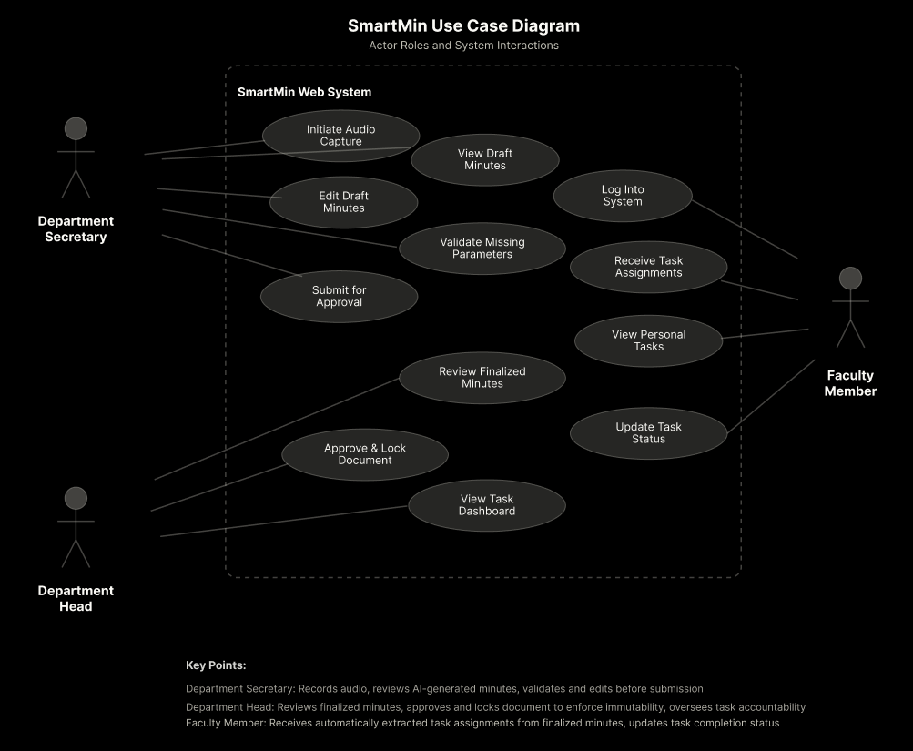

E. Initial UI Wireframes / Mockups

The system’s interface is designed around three primary screens, illustrated in Figures 7, 8, and 9.

• Screen 1 — Main Dashboard & Capture (Figure 7): A modern web interface featuring a prominent 'New Meeting' button and audio waveform visualizers. A settings menu contains an advanced toggle for the optional offline processing mode.
• Screen 2 — Institutional Editor (Figure 8): A split-screen validation UI. The left panel displays the transcribed text with speaker tags. The right panel displays the official ZPPSU/CHED document template, auto-filled by the AI. Empty required fields are highlighted in red to enforce secretary review before submission.
• Screen 3 — Accountability Matrix: A role-gated Kanban board. Standard users see their own assigned tasks. Department Heads see a master list with an irreversible 'Lock Final Minutes' button that commits the document securely to the university database.

Figure 7. UI Wireframe: Main Dashboard & Capture Interface
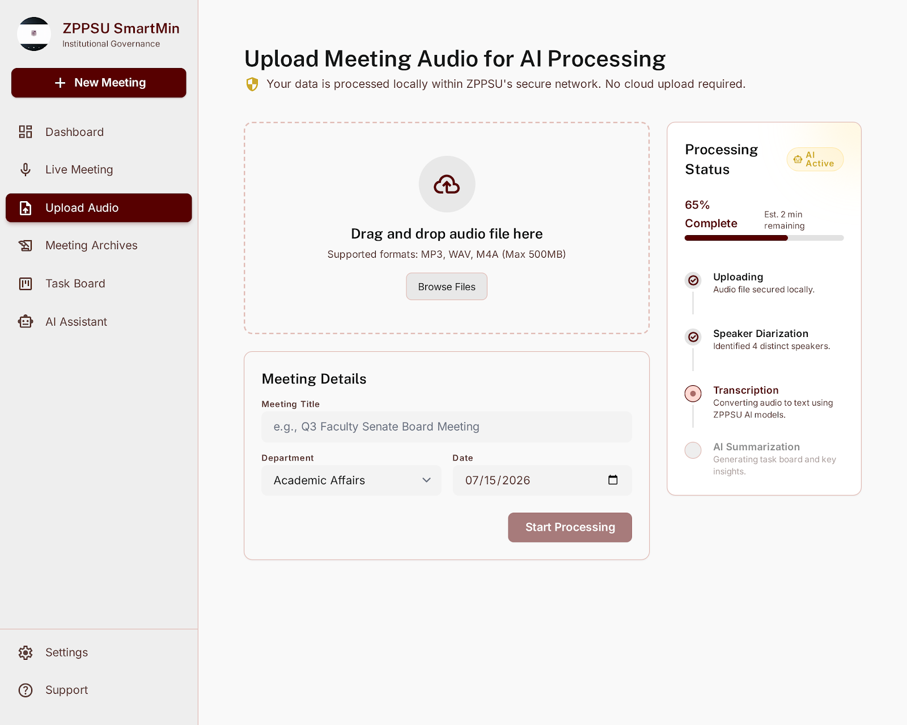
Figure 8. UI Wireframe: Institutional Editor
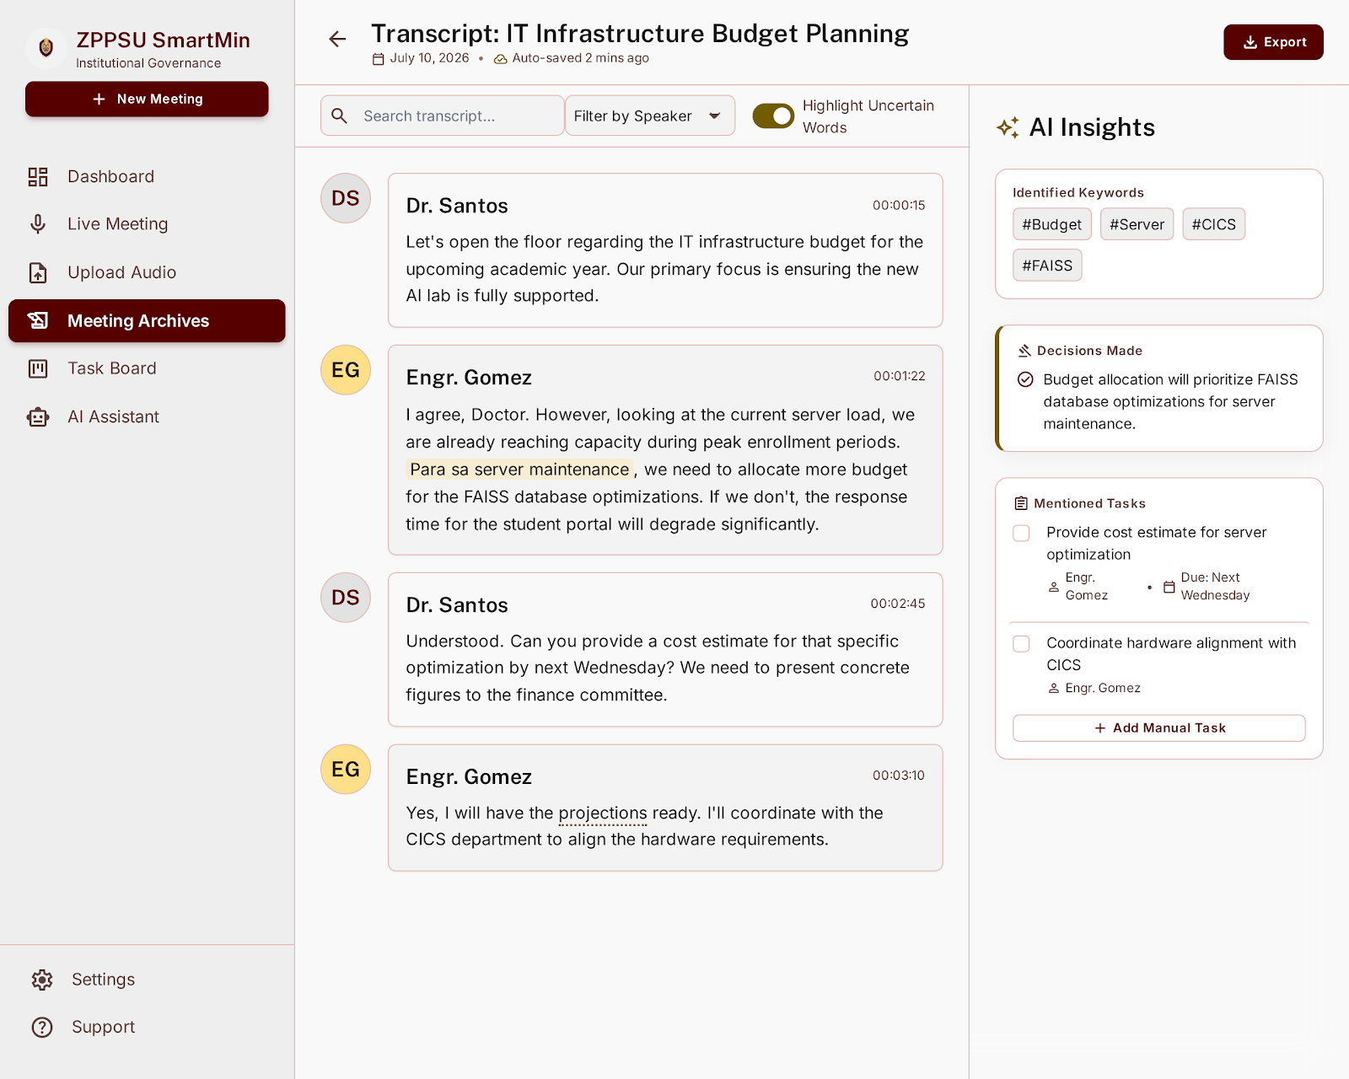

Figure 9. UI Wireframe: Accountability Matrix


REFERENCES

Borjal, C. J., Visperas, M., Adoptante, A. J., Abia, M. T., Catapang, J. K., & Peramo, E. (2023). Parallel Corpus Curation for Filipino Text-to-SQL Semantic Parsing. 2023 International Conference on Artificial Intelligence in Information and Communication (ICAIIC), 163–169.
Bredin, H., Yin, R., Coria, J. M., Gelly, G., Korshunov, P., Lavechin, S., ... & Barras, C. (2020). pyannote.audio: neural building blocks for speaker diarization. ICASSP 2020–2020 IEEE International Conference on Acoustics, Speech and Signal Processing (ICASSP), 7124–7128. IEEE.
Commission on Higher Education & Department of Information and Communications Technology. (2023). CHED-DICT Memorandum of Understanding on E-Governance and ICT Integration in Higher Education. Republic of the Philippines.
Copiaco, A., et al. (2021). A deep learning approach to Filipino speech recognition. IEEE Access, 9, 155163–155173.
Department of Information and Communications Technology. (2023). eGov PH Super App https://e.gov.ph/
Department of Public Works and Highways. (2021). DPWH Document Tracking System (DoTS) . https://www.dpwh.gov.ph/dpwh/services/dots
Department of Trade and Industry. (2021). National Artificial Intelligence Strategy Roadmap. Republic of the Philippines.
Dorado, B., & Villanueva, A. (2023). Development of Low-Latency and Real-Time Filipino Children Automatic Speech Recognition System using Deep Neural Network. 2023 11th International Symposium on Digital Forensics and Security (ISDFS), 1–6.
DOST-ASTI. (2021). ALAM Project: Advanced Local Acoustic Models. https://asti.dost.gov.ph/projects/alam/
DOST-PCIEERD. (2020). Project SPARTA: Smarter Philippines through Data Analytics. https://sparta.dost.gov.ph/
Fathom. (2023). Fathom: Free AI Meeting Assistant. https://fathom.video
Feng, X., Feng, X., Qin, B., & Liu, T. (2021). A survey on dialogue summarization: Recent advances and new frontiers. arXiv preprint arXiv:2107.03175.
Fireflies.ai. (2024). Fireflies.ai: AI meeting assistant. https://fireflies.ai
Fu, X. Y., Khasanova, E., Laskar, M. T. R., Saini, H., & TN, S. B. (2024). DACP: Domain-Adaptive Continual Pre-Training of Large Language Models for Phone Conversation Summarization. arXiv preprint arXiv:2410.05858.
Gerganov, G. (2022). Whisper.cpp: High-performance inference of OpenAI's Whisper automatic speech recognition (ASR) model. https://github.com/ggerganov/whisper.cpp
Guia, J. (2023). Public service delivery system in State Universities and Colleges: Controversies and best practices across frontline services. Munich Personal RePEc Archive (MPRA).
Ilaya, A., et al. (2021). Tagalog Speech Recognition using DeepSpeech. International Journal of Advanced Trends in Computer Science and Engineering, 10(1), 120–125.
Kirstein, F., Wahle, J. P., Ruas, T., & Gipp, B. (2024). What's under the hood: Investigating Automatic Metrics on Meeting Summarization. EMNLP 2024 Findings.
Laskar, M. T. R., Khasanova, E., Fu, X. Y., Chen, C., & Tn, S. B. (2024). Query-OPT: Optimizing Inference of Large Language Models via Multi-Query Instructions in Meeting Summarization. Proceedings of the 2024 Conference on Empirical Methods in Natural Language Processing: Industry Track.
Ollama. (2023). Ollama: Get up and running with large language models locally. https://ollama.com
Otter.ai. (2023). Otter.ai: Voice meeting notes & real-time transcription. https://otter.ai
Polytechnic University of the Philippines. (2023). PUP Document Tracking System. https://apps.pup.edu.ph/dts/
Pyannote. (2021). pyannote.audio: Open-source toolkit for speaker diarization. https://github.com/pyannote/pyannote-audio
Radford, A., Kim, J. W., Xu, T., Brockman, G., McLeavey, C., & Sutskever, I. (2022). Robust speech recognition via large-scale weak supervision. arXiv preprint arXiv:2212.04356.
Senti AI. (2024). Senti AI: Localized Philippine Artificial Intelligence. https://senti.ai/
Tactiq. (2024). Tactiq: AI Meeting Summaries. https://tactiq.io
Taskade. (2024). Taskade: AI Workspace for Teams. https://www.taskade.com
University of the Philippines. (2022). UP Document Tracking System (UP DTS). https://dts.up.edu.ph/
Zhang, H., Yu, P. S., & Zhang, J. (2024). A Systematic Survey of Text Summarization: From Statistical Methods to Large Language Models. arXiv preprint arXiv:2406.11289.
Zhong, M., Yin, D., Yu, T., Zaidi, A., Mutuma, M., Jha, R., ... & Qiu, X. (2021). QMSum: A new benchmark for query-based multi-domain meeting summarization. arXiv preprint arXiv:2104.05938.

