ZPPSU ADMISSION PORTAL REGISTRATION FOR ENTRANCE EXAM AND SMS UPDATES

An IT Capstone Project
Presented to the Faculty of
Institute of Technical Education
Zamboanga Peninsula Polytechnic State of University

In Partial Fulfillment of the Requirements
For the Diploma Technology of Information Technology

By:
Amorganda, Sjlyn D.
Garcia, Larabel B.
Guihamban, Babylyn S.
Ocharon, Faith R.

Mr. Jhonel Flores
Adviser
Ms. Ma.Recca Faye A. Lacsi
Co-Adviser
March 2025
CHAPTER I
INTRODUCTION
An Automated Student Registration System, Administrative procedures have changed as a result of technological integration in educational institutions, becoming more dependable and efficient. Student registration is a crucial area that gains from automation. Conventional human registration methods frequently result in inefficiencies like delays, data input mistakes, and challenges handling massive amounts of student data (Feiswal, 2022). In order to overcome these obstacles, the ZPPSU Admission Portal Registration for Entrance Exam and SMS Updates provides an automated mechanism that improves communication and expedites the registration procedure. Student records are safely stored and managed by the system using a Database Management System (DBMS), which also offers real-time updates via automated SMS notifications. This guarantees that parents and students are informed in a timely manner about admissions status, entrance examinations, and other pertinent developments.

Zamboanga Peninsula Polytechnic State University (ZPPSU) offers an online Admission portal for prospective students to register for the College Admission Test (CAT). The application process, new applicants, including freshmen and transferees of Zamboanga Peninsula Polytechnic State University (ZPPSU), need to create an account on the Integrated ZPPSU Management System platform. This can be done by selecting the “New Applicant (freshmen, transferees)” option on the login page. During the application it’s important to provide accurate personal information and review the admission policies and data privacy policy. After submission, a pooling number is generated for reference. Applicants should check their email for updates. For updates, they can visit the ZPPSU Admission Office Facebook page.

One of the challenges faced by prospective students applying to Zamboanga Peninsula Polytechnic State University (ZPPSU) is the hassle free admission process, because the admission is hassle free the number of applicants is increasing due to the fact that there is no limit on the number of students who can take the entrance exam, the only limitation is reaching the deadline or cut off. If the applicants miss it, they have to wait until the next year for the admission registration portal to open again. However, with the growing number of applicants, sending updates has become a problem. Sometimes, their response to the ZPPSU applicants come too early, while other times their response or updates to student applicants of ZPPSU are delayed. In some cases, there are no updates at all leaving some student applicants uninformed.

To address the challenges in the admission process at Zamboanga Peninsula Polytechnic State University (ZPPSU), this study proposes the ZPPSU Admission Portal Registration for Entrance Exam and SMS Updates for smoother process of a registration through SMS. With SMS, applicants can receive updates even without mobile data, making it easily accessible for new for incoming applicants of ZPPSU. The portal will also have a mobile friendly interface, ensuring that the admission system is accessible not only on computers but also on mobile phones for easier use. With these solutions, the admission process will be faster and hassle free, providing a better experience for the ZPPSU applicants.

This system will bring significant benefits to the faculty admissions staff and the freshmen and transferees of ZPPSU, including improve the ZPPSU portal, ensuring that deadlines are not missed or no confusion in their schedules for the entrance exam. And reducing the admissions staff task or workload allows them to focus on more important responsibilities such as assisting applicants with unique concerns and make a smoother admission process for everyone.

1.1 PROJECT CONTEXT
The Admission process plays a crucial role in ensuring that all the incoming students can easily enter higher education. Zamboanga Peninsula Polytechnic State University (ZPPSU) faces challenges in managing the increasing number of applicants, leading to missed deadlines and confusion among students regarding their entrance exam schedules. The manual or outdated processes can overburden the admissions staff, affecting the overall efficiency of the system.
To address these challenges, this project aims to develop an enhanced ZPPSU Admission Portal that will help the registration and communication process for applicants. By integrating automated SMS notifications, and a friendly user interface, the system will ensure that applicants stay informed about important deadlines and requirements. Additionally, the platform will help reduce the workload of the admissions staff by minimizing manual tasks and providing real time updates.
Through this project, Zamboanga Peninsula Polytechnic State University (ZPPSU) can improve its admission process, making it more accessible and responsive to the needs of both applicants and faculty members. The system will contribute to a smoother and more organized enrollment experience for all.

1.2 PURPOSE AND DESCRIPTION
The purpose of this study is to improve the admission process at Zamboanga Peninsula Polytechnic State University (ZPPSU) by developing an enhanced ZPPSU Admission Portal. This system aims to provide a more accessible way for applicants to register for the entrance exam, receive timely updates and track their admission status. The purpose seeks to reduce the workload of the admissions staff by automating tasks such as sending notifications to the new applicants of Zamboanga Peninsula Polytechnic State University (ZPPSU).
The Zamboanga Peninsula Polytechnic State University (ZPPSU) Admission Portal will serve as a centralized platform where prospective students can create accounts, submit their applications and monitor their progress. The system will have Automated SMS notifications that can ensure all applicants receive timely updates on their application status, entrance exam schedules and other important announcements, such as important deadlines and requirements. The website is accessible through cross-platform. ZPPSU can ensure a more organized and hassle free admission process for both applicants and faculty, leading to a better overall experience.
This system will enhance transparency and accountability in the admission process by providing applicants with real time access to their application status and exam schedules. By minimizing manual errors and delays, the system will help build trust between the university and its prospective students. The automation of admissions staff to focus on more critical responsibilities, such as evaluating applications and assisting students with special concerns.

1.3 OBJECTIVES OF THE STUDY
This study aims to develop an effective ZPPSU Admission Portal Registration for Entrance Exam and SMS Updates.
1.3.1 Specific Objectives
- To develop an enhance ZPPSU Admission Portal.
- To implement an automated notification system using SMS.
- To create a user friendly and responsive interface.
- To providing real-time access to application status.
1.4 SCOPE AND LIMITATION
The ZPPSU Admission Portal is designed to improve the admission process by providing an accessible platform for applicants to register for the entrance exam, track their application status and receive timely updates. The system will include features such as automated SMS, where once applicants fill out their information in the Zamboanga Peninsula Polytechnic State University (ZPPSU) Admission portal, they will automatically receive updates on their entrance exam schedule. Instead of waiting for updates through a Gmail account, which may sometimes be delayed or send double schedules, applicants will receive faster and more accurate updates via SMS, ensuring they know their exact entrance exam schedule at ZPPSU in a timely manner and it has a user-friendly interface. The system will be accessible in multiple devices, ensuring that students can easily navigate the application process. The primary users of the system will be the incoming freshmen, transferees and admissions staff of Zamboanga Peninsula Polytechnic State University (ZPPSU).
Considering the portal’s multiple device responsiveness and its real-time updates features, internet connection is the main factor to thoroughly utilize the platform. System downtimes or technical issues may temporarily affect its performance; and other university related processes such as enrollment, class scheduling and tuition payments will not be included. If the students applicants of ZPPSU enter incorrect or inactive email addresses and phone numbers, they will not receive admission updates.
While the project aims to reduce manual workload for admissions staff, some processes, such as verifying applicant documents and resolving individual concerns, may still require human intervention.

1.5 SIGNIFICANCE OF THE STUDY
This study aims to enhance the admission process at Zamboanga Peninsula Polytechnic State University (ZPPSU) by developing an accessible ZPPSU Admission Portal. The implementation of this system will benefit various students, admissions staff and the university administration. By automating key processes such as registration, application tracking and communication, the system will help create a more organized and hassle free admission experience.
For prospective students, particularly freshmen and transferees at Zamboanga Peninsula Polytechnic State University (ZPPSU), the system will provide a more convenient way to register for the entrance exam and stay updated on their application status. The automated SMS notifications will ensure that they do not miss deadlines or important announcements, reducing confusion and enhancing their preparedness.
For admissions staff and university personnel, the system will significantly reduce their workload by automating routine administrative tasks such as data entry, schedule management and applicant communication. This will allow them to focus on more critical tasks, such as evaluating applications and assisting students with unique concerns. The system will minimize errors in record keeping, ensuring a more accurate admission process.
The ZPPSU Admission Portal will contribute to the university’s digital transformation efforts, promoting a more modern and technology driven approach to admissions. It will also improve transparency and accountability in the admission process by providing real time access to applicant data. This study will help Zamboanga Peninsula Polytechnic State University (ZPPSU) establish a more structured admission system, benefiting both the institutions.

1.6 DEFINITION OF TERMS
- ZPPSU Admission Portal- An online platform to be developed to streamline the admission process at Zamboanga Peninsula Polytechnic State University (ZPPSU) allowing applicants to register, receive updates and track their application status.
- Automated Notifications- A system feature that sends alerts to applicants regarding their admission status, exam schedules and important deadline through SMS updates.
- User friendly interface- A system design that ensures easy navigation and accessibility for applicants using the admission portal.
- Mobile Responsive- The ability of the admission portal to be accessed and function properly on mobile devices such as smartphones and tablets.
- Admission Process- A series of steps that applicants must complete to be considered for enrollment at ZPPSU, including registration, documents submission and examination.
- Transparency- The openness and clarity of the admission process, ensuring that applicants receive accurate and real time information regarding their application status.
- Application Tracking System -A feature that allows applications to monitor their admission progress from registration to final approval.
- Real-Time Processing – The ability of the admission portal to update and display information instantly as applicants complete different steps in the admission process
- Data Security- Measure and protocols implemented to protect applicants personal information and application details from unauthorized access or cyber threats.
- Document Upload- A feature that allows applicants to submit required files online

CHAPTER II
REVIEW OF RELATED LITERATURE/STUDIES
This chapter presents the purpose of the study and support the significance proposed ZPPSU admission portal registration for entrance exam SMS updates by compiling data and information on related themes and articles from local and foreign published books and other sources.
2.1 RELATED LITERATURE /STUDIES
2.1.1 Web Based Registration and Entrance Exam Information System
The system guarantees correctness and efficiency in managing registration data by using technologies such designing the information system, the UML (Unified Modeling Language) model which consist of use case diagram, class diagram, activity diagram, and sequence diagram is and used. In Coding fase, the PHP programing language with the Code Igniter framework and MySQL and database management system are use. And the block box method is used as the testing method for the information system. (Indri Rahmayuni, 2023)
2.1.2 Web-Based New Student Registration Information System
Data is collected to provide information about prices and the purchasing
process. Design, At the design stage, a program is created to design the system that will be used. The design stages used are Use Case Diagram, Entity Relationship Diagram (ERD), Unified Modeling Language (UML), Class Diagram, Flowchart. Implementation, At the Implementation stage, the system that will be used to create website-based applications is PHP programming, MySQL and the Code Igniter Framework. The method used in software testing is using Black box. Maintenance, the maintenance stage carried out is correcting errors on the website that has been created. (Umar Mansyuril,2024).
2.3 Online New Student Registration System Supported by SMS
The process of registering new student, registration system is built with PHP programming language and utilizing a MySQL database as a database server, and using the Code Igniter Framework. The type of research used is research and development, with the 4-d model stand for Define, Design, Develop and Disseminate. While the system Development model used adopts the SDLC cycle (System Development life cycle, namely the waterfall model .(Bahiyah, 2021)

2.4 The Designing Registration System and Exam Schedule for Pusat Kegiatan Belajar Masyarakat (PKBM)
The process of reporting is still carried out by copying data from the physical form to a computer. The aim of this research is to design a registration information system and exam schedule for PKBM Kiat Usaha which can simplify and speed up the administration and communication process between student and web based PKMB managers using the PHP and MySQL programing languages
(Maulian Saputra1, 2023)

2.5 Web Based Collage Admission System

The process of Web based is designed to automate and streamline the entire admission process for educational institutions. And technologies used in web based admission system database management system (DBMS) system like MySQL, PostgreSQL, and Oracle are widely used for storing and managing application data. Web technologies using HTML, CSS, JavaScript, and framework like react or angular are used for developing user interface. Back-end technologies like PHP, Node.js, and Django power the server-side logic. (kumeriya, 2024)

2.6 Analysis of the Influence of College Entrance Examination System

In order to further educational equity, the college entrance exam system must be reformed. The examination procedure has undergone modifications over time in an effort to address concerns about social distinction, regional inequities, and evaluation fairness. This study examines how the system has changed over time, the steps made to increase equity, and the difficulties in putting thorough assessments into practice. The study offers insights into improving the examination system for a more just and efficient educational framework by examining these factors. (Ana, 2025)
2.7 Design of New Student Registration Information System
The process of accepting new student, admission to SMAN 3 Payakumbuh should be done online. Through the design of this system, student don’t need to come to school to fill out forms and share the result of the selection of new students. This design system is based on technology using the PHP/MySQL programing language. (rahmadani, 2022)

2.2 RELATED SYSTEMS

2.2.1 CREATING A WEB PORTAL FOR AN ONLINE ENTRANCE EXAM AND LEARNING MATERERIAL
The CMS (ContentManagement System) was used in order to guarantee less complexity in the management and generation of the exam at any given time. When it comes to developing and editing content, WordPress as a CMS doesn't require any coding knowledge. Using an HTML/CSS page, PHP script, MySQL database, and WordPress, this CMS (Content Management System) makes it easier to manage and create the test at any time. When it comes to developing and editing content,WordPress as a CMS doesn't require any coding knowledge. Using an HTML/CSS page, PHP script, MySQL database, and WordPress, this CMS (Content Management System) makes it easier to manage and create the test at any time. When it comes to developing and editing content, WordPress as a CMS doesn't require any coding knowledge.
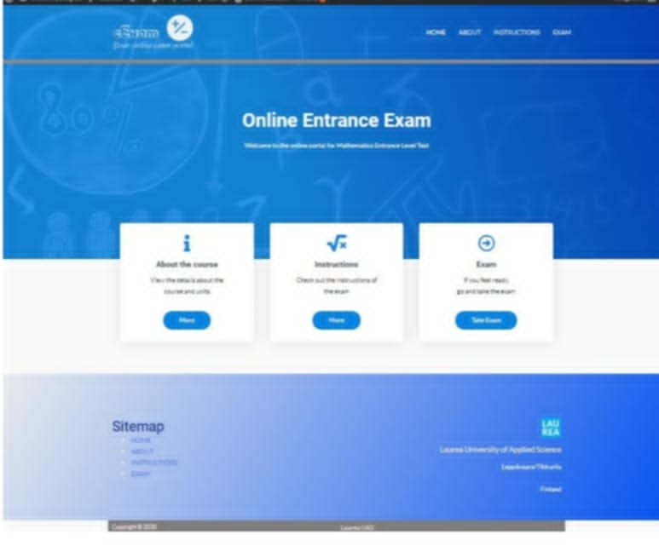
Figure 2.2.1 CREATING A WEB PORTAL FOR AN ONLINE ENTRANCE EXAM AND LEARNING MATERIAL

2.2.2COMPUTER BASED EXAMINATION SYSTEM WITH MULTIFACTOR AUTHENTICATION AND MESSAGE NOTIFICATION FEATURES
HTML serves as the design language for the presentation layer in the suggested implementation architecture. PHP is used to design thedata layer is designed using MySQL databaseserver (XAMPP control panel) is installed in the computer system. Also, router is use to create a network in which other computer systems can join and a modem is used to provide internet service that would facilitate the sending of notifications (SMS and Email). Thecomputer system captures users detail, allows the creation of Exams and saves the information in the CBT System information database, where each computer system can easily access the database information.
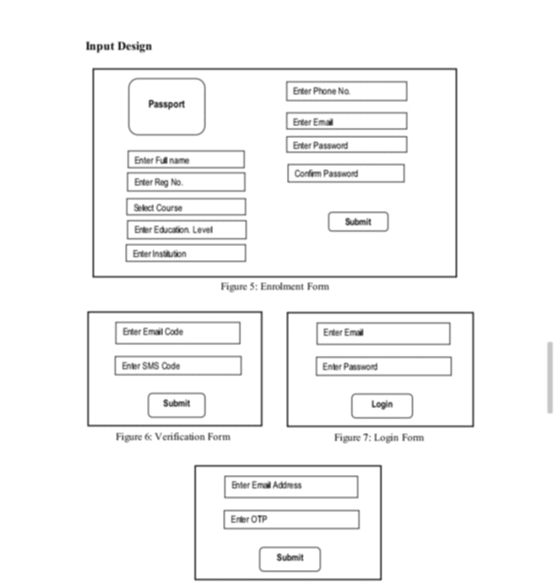
Figure2.2.2 COMPUTER BASED EXAMINATION SYSTEM WITH MULTIFACTOR AUTHENTICATION AND MESSAGE NOTIFICATION FEATURES

2.2.3 Web Based Student Registration and Exam Form Fill-up Management System
Academic data management and student registration are essential for efficient administrative procedures in contemporary educational institutions. Many institutions have historically relied on inefficient, human error-prone paper-based registration processes. These approaches result in delays and inaccurate processing of student records by consuming important time for educators, students, and administrative personnel. The web-based student registration and academic data management system presented in this study is intended to increase user accessibility, decrease errors, and boost efficiency. This system attempts to offer academic institutions a dependable and user-friendly solution by incorporating features like automated data management, approval procedures, and online form submission.
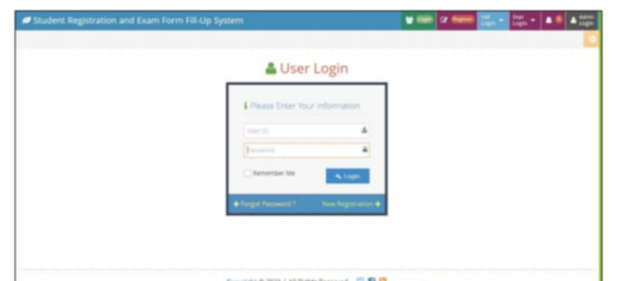
Figure 2.2.3 Web Based Student Registration and Exam Form Fill-up Management System

2.2.4 AN AUTOMATED MULTI-OBJECTIVE INVIGILATOR-EXAM ASSIGNMENT SYSTEM
In educational institutions, assigning invigilators to exam sessions in a fair and efficient manner is a crucial duty. This procedure has historically been carried out by hand, which frequently results in schedule conflicts, inefficiencies, and an increase in administrative workload. Automated methods have drawn interest as a potential way to solve these issues by optimizing invigilator assignments while maintaining efficiency and justice. This study presents the Automated Invigilator Assignment System (AIAS), a web-based tool that uses a mathematical model to expedite invigilator distribution. The system incorporates a user-friendly web interface to promote interaction and a database to retain pertinent data. The mathematical model at the heart of AIAS assures optimal assignment by taking into account a variety of restrictions, including workload balance, faculty availability, and institutional policies.
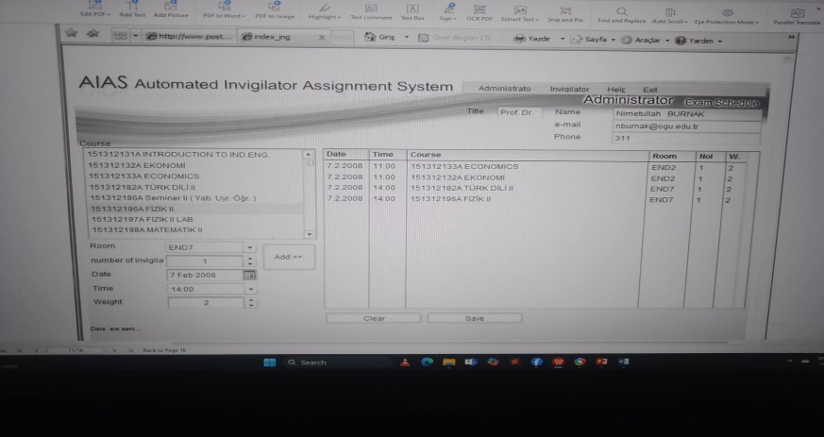
Figure 2.2.4 AN AUTOMATED MULTI-OBJECTIVE INVIGILATOR-EXAM ASSIGNMENT SYSTEM
2.2.5 DEVELOPMENT OF WEB-BASED EXAMINATION SYSTEM USING
OPEN SOURCE PROGRAMMING MODEL
In the educational system, assessment is essential since it gives teachers a way to gauge their students' performance and knowledge. Traditional paper-based examination techniques, however, are frequently linked to serious problems, such as question leaks, human mistake in marking, processing delays for results, and inefficiencies when managing high data volumes. The efficacy and integrity of the examination procedure may be jeopardized by these problems.EnterWeb technologies such as CSS, HTML, PHP, SQL, MySQL, and Dreamweaver are used in the development of WES, which makes it a scalable and reliable solution. Examiners' burden is greatly decreased by the system, which also removes common mistakes that come with manual marking by automating tasks like exam administration, grading, and result management. It also facilitates real-time data capture, prompt feedback, and effective analysis, which makes it the perfect tool for distant learning and extensive educational assessments.
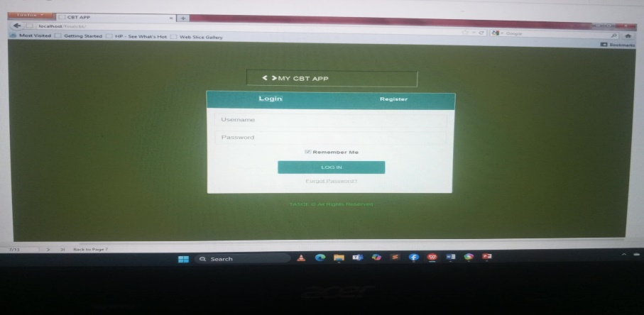
Figure2.2.5 DEVELOPMENT OF WEB-BASED EXAMINATION SYSTEM USING
OPEN SOURCE PROGRAMMING MODEL
2.2.6 ONLINE Student admission REGISTRATION management system
University admission is the process through which students enter tertiary education at universities. The online web application operates with the following web browsers; Microsoft internet explorer version7.0 and above and Mozilla Firefox 3.5. The admission process was designed as per the requirements and as integrated with dynamic web to manage our online Admissions smoothly and effectively; modern day tools like SMS& email integration online payment gateway has eased the communication with applicants during the process. The increasing number of students seeking admission in the university is causing tremendous pressure on the administrative body of the institutes to manage and arrange the admission process manually.
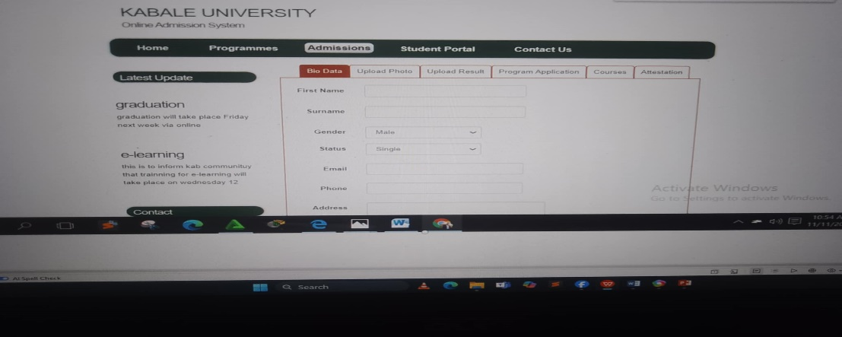
Figure 2.2.6 ONLINE Student admission REGISTRATION management system
2.2.7AN ONLINE SCHOOL REGISTRATION AND MANAGEMENT
INFORMATION SYSTEM
This project's goal was to create an online registration and school administration system. employing the client-server system methodology. While creating the system, we concentrated on schools. which allows schools to register pupils without requiring them to go to the school. Students will be able to examine their information on the client side of the system, and server side, where data will be kept and changes will be made. Consequently, the system has the capacity to store all student-related data. The system's implementation will enhance features like scalability, efficiency, and adaptability, among others. on, which will allow the organization to reach a bigger area and draw in a larger quantity of pupils.
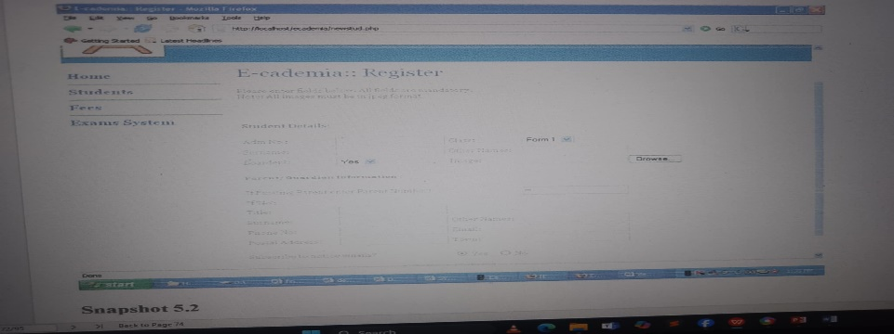
Figure 2.2.7AN ONLINE SCHOOL REGISTRATION AND MANAGEMENT
INFORMATION SYSTEM

Table 2.1 Table of Comparison
FEATURES | SMS Notification | Printable Admission slip | Cross-platform | Real-time access
ZPPSU Admission Portal Registration For Entrance Exam SMS Updates | ✓ | ✓ | ✓ | ✓
Web-based Registration And Entrance Exam Information System For Islamic Boarding School
Web-Based New Student Registration Information System |  |  | ✓
Online New Student Registration System |  |  | ✓
The Designing Registration System and Exam Schedule | ✓
The Design of Assistant Analysis System about Application Form Filling System for College Entrance Examination |  |  | ✓
Analysis of the Influence of College Entrance Examination System |  |  | ✓
Design of New Student Registration Information System |  |  | ✓

This Table represent the study and the purpose of related studies

CHAPTER III
TECHNICAL BACKROUND
SMS updates for admission registrations depend on a system that combines an application server which processes registrations and generates SMS, a database which stores applicant data, and an SMS gateway which sends messages to applicants. Through an API, the server sends out SMS and updates the database with the registration status. Reliability, ensuring message delivery, security, protecting applicant data, internationalization supporting many languages and number formats, and scalability managing huge volumes are important factors. A versatile message template system and strong error handling are also essential.

3.1 TECHNICALITY OF THE PROJECT
A key aspects of the project is ensuring all important parts work together smoothly, a dependable SMS gateway for message delivery and status reporting, a high-availability application server to manage registration processing and SMS triggering, a robust and scalable database to manage applicant data, and a clearly defined API to enable communication between these elements. In order to ensure dependable message delivery with suitable error handling and security measures to safeguard critical application information, the system must be built with scalability in mind to handle peak loads during registration times. Budget, anticipated traffic, and security needs are some of the variables that will influence the technologies database, server-side language, SMS gateway provider that are selected. To guarantee system performance and spot possible bottlenecks, extensive testing and monitoring are important. Depending on the applicant pool, assistance with internationalization might also be required.

3.2 DETAILS OF THE TECHNOLOGIES TO BE USED IN DEVELOPMENT OF THE PROJECT
Depending on team experience and project complexity, the project's development could make use of a scalable application server framework like Python Java with a reliable relational database MySQL for flexible data handling. The delivery and reporting of messages will be handled by a dependable SMS gateway, it may also be possible to incorporate a message and to handle large volumes effectively and use monitoring tools.

3.2.1 DETAILS OF THE TECHNOLOGIES TO BE USED IN IMPLEMENTATION OF THE PROJECT
SOFTWARE
- DATABASE
MySQL, PostgreSQL, Relational database to for storing applications information.
- API Development
For communication between the front-end and back-end and for SMS integration.
- Web Development (front end)
HTML, CSS, JavaScript these are the fundamental technologies for building the user interface of the registration form.
- Web Development (back end)
Python is popular for web development due to its readability and extensive libraries
HARDWARE
- Computer and laptop
For code developers to write code for administration to management the portal and data.
- NETWORK INSFRASTRUCTURE
Reliable internet connection

3.3 HOW THE PROJECT WORKS
Using a safe database to handle student information and message history, the admission registration SMS update project automates communication with prospective students throughout the admissions process by sending timely and relevant text messages triggered by predefined workflows, such as application confirmations, deadline reminders, status updates, schedules, and missing document reminders. It also offers administrators a user-friendly interface to control the system and customize communication.

