Business rules

Function Builder :

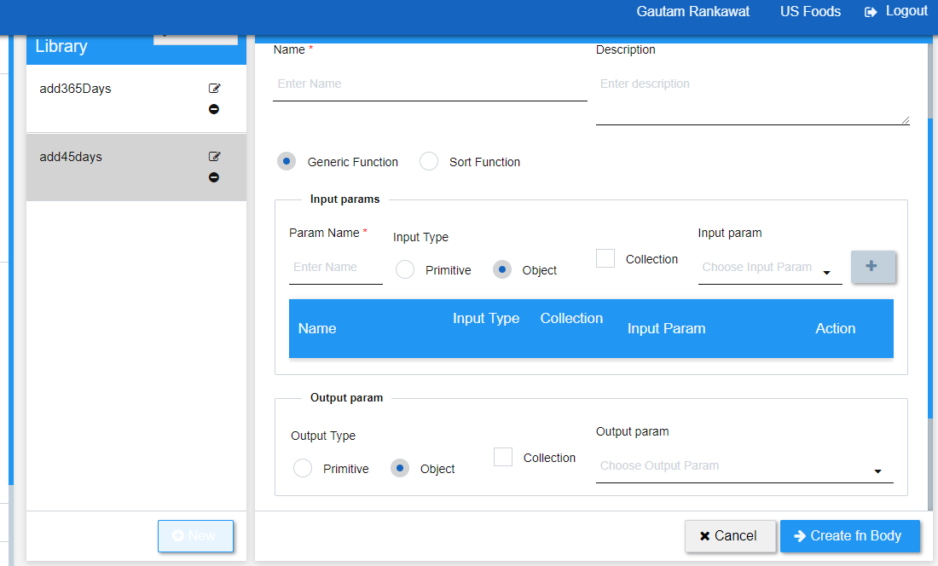
Create function

Field | Type | Value | Description
Description | Textbox |  | Use of the function
Collection | Checkbox |  | This collection is for Input param
Input param | Dropdown
Collection | Checkbox |  | This collection is for Output param
Output param | Dropdown

Mendatory Fields* | Type | Value | Description
Name | Textbox |  | Function name
Param name | Textbox |  | Parameter name
Function type | Radio | Dynamic function and sort function
Input type | Radio | Primitive and object
Output type | Radio | Primitive and object

Action | Description
New | For creating new function.
Cancel
Create fn body | To create function body

- This page is use to create function.
- In this page there are some mendatory and non mendatory fields
- In Name field we have to put function Name and in Description field we have to describe the function, that what will this function do.
- Next fields are radio buttons where we set the type of function where the function is with prototype and body or only with prototype so if you want to make a fully defined function then we have to choose dynamic function otherwise just select sort function
- Then the next fields are regarding Input params where we have to specify the param name, input type, a checkBox for collection and at last, input type and same for the Output param,
now click on create fn body.

Write function

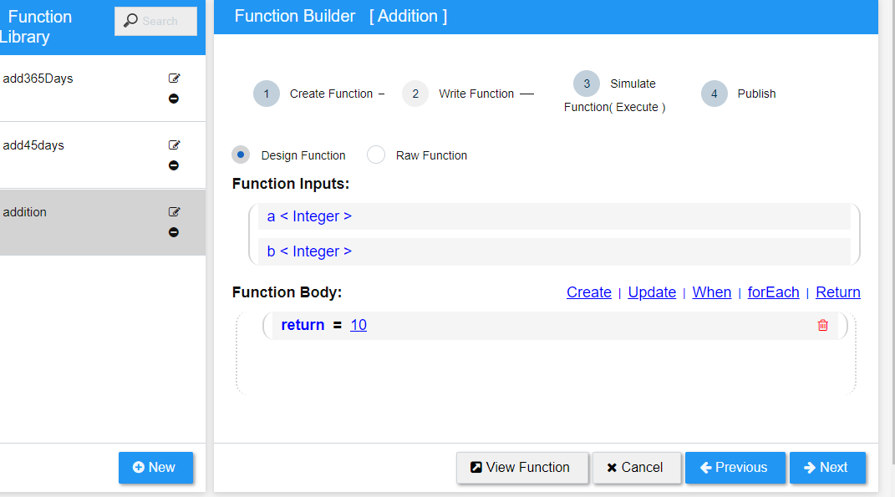

Field | Type | Value | Description
Function type | Radio | Design and Raw function | We have to choose one of them for complete function we have to choose design function and only for declaration choose Raw function radio.
Function body | Choose from the written option | Create | Update | When | forEach | Return

Action | Description
Cancel
Show Function | It will show the function what we have created as of now from that fields
Previous | It will go at the previous tab where we have created function
Next | It will move to the next Tab where we provide data for function
Delete | What ever we have selected or added in function body we can delete from there.

- In this Tab we are going to write function body.
- First we have to select type of function where we have to select one of the radio on the basis of what type of function we going to make, like if we want to create a function with prototype and body then select design function and only for declaration we have to choose Raw function.

Simulate Function( Execute )

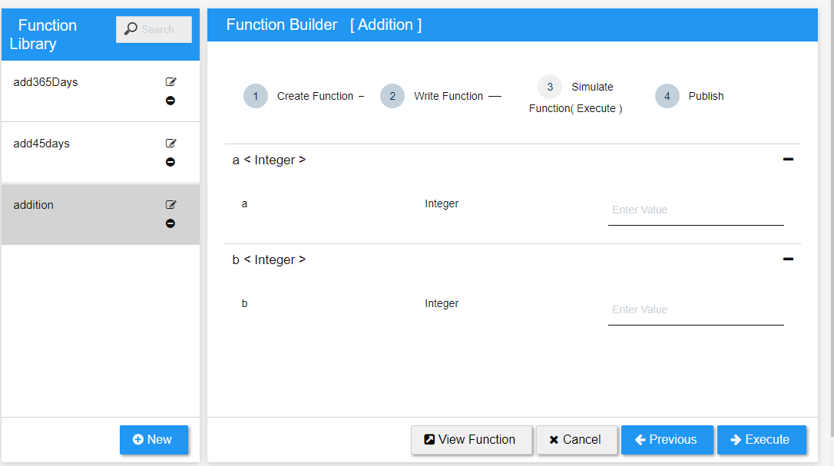
Action | Description
Cancel
Show Function | It will show the function what we have created as of now from that fields
Previous | I will go at the previous tab where we have written function
Execute | On the given function values it will simulate the function
-/+ | Use to minimise and maximise the tab

- In this tab we have to pass the values what ever we have mentioned in the parameters, and click on Execute.

Publish:

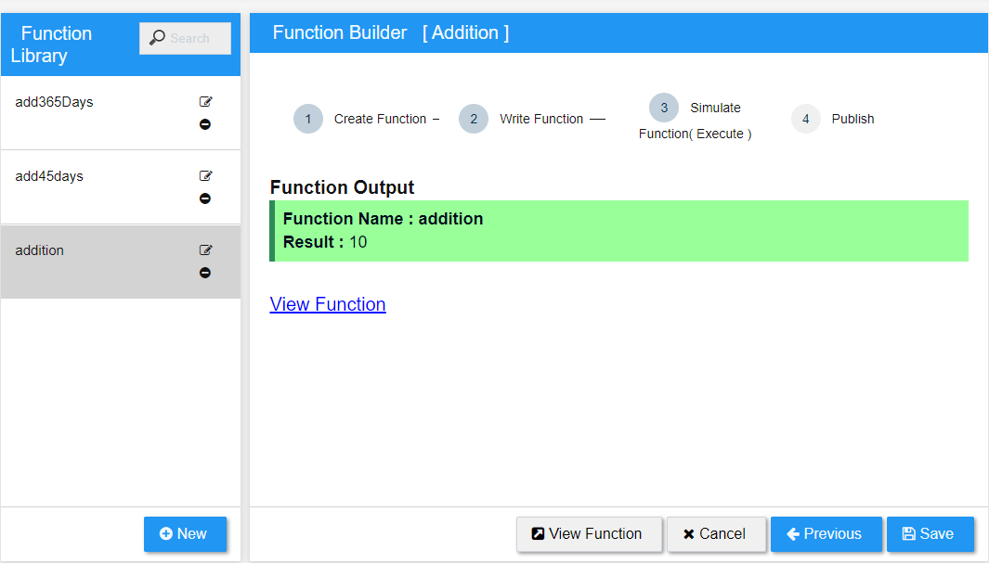
Action | Description
Cancel
Show Function | It will show the function what we have created as of now from that fields
Previous | It will go to the previous tab where we have simulated the function.
Save | It will save the function in the library

- In this tab we will see the output of the function. And after getting the output click on save to save the function in the library.

