# GECKO IMAGER

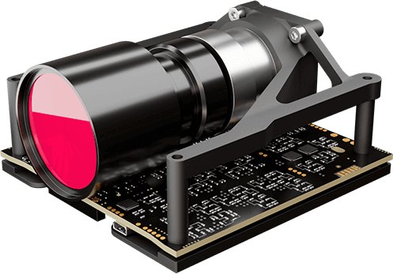

**Gecko Camera Technical Specifications**

|  |  |  |  |
| --- | --- | --- | --- |
| **Spatial resolution (GSD) at 500 km** | 39 m | **Compression** | RAW or J2K lossless or lossy |
| **Swath at 500 km** | 80 km | **Data interface** | LVDS, SPI, PC, CAN |
| **Mass (Including electronics)** | 0.4 kg | **Power Usage** | imaging mode: 2.6 W; readout mode 4.5 W |
| **Spectral bands** | RGB (Bayer) | **Power Supply** | 5V DC |
| **Satellite Bus Size** | Compatible with 2U | **Operating temperature** | 0˚C to +30˚C |
| **Physical Size** | 1U (10 cm × 10 cm × 6.5 cm) | **Survival temperature** | -20˚C to +70˚C |
| **Data format** | 8-bit or 10-bit | **Radiation Tolerance (TID)** | Tested to 30k Rad |
| **Integrated mass data storage** | 128 Gigabytes |  |  |