FIREWALL RULE OPTIMIZER

By
James Gichia
Registration Number: P01/0010/2022

Supervisor:
Dr. Elijah Maseno

A Project Proposal Submitted to the Department of Computing and
Information Technology in Partial Fulfilment of the Requirements for
the Award of the Degree of Bachelor of Science in Computer Science at Mama Ngina University College

MAMA NGINA UNIVERSITY COLLEGE
November, 2025

DECLARATION AND RECOMMENDATION

Declaration

This research proposal is my original work and has not been presented for an award of diploma or conferment of degree in any other University.

Signature:............................................................ Date: ..........................
James Gichia
P01/0010/2022

Recommendation
This research proposal has been submitted for examination with our approval as university supervisors.

Signature:............................................................ Date: ..................................
Dr. Elijah Maseno, PhD. Mama Ngina University College.

Signature:............................................................ Date: ..................................
Dr. Peter Murage, PhD. Mama Ngina University College

ABSTRACT
Firewall systems play a critical role in securing modern computer networks by filtering traffic based on predefined rules. However, as networks expand and evolve, firewall rule sets often become excessively long, redundant, or poorly structured. Such inefficiencies can degrade network performance, introduce security vulnerabilities, and make administrative management increasingly complex. This project seeks to design and implement a firewall rule optimization framework that enhances performance, security, and maintainability without altering intended policy behavior. The study involves analyzing existing firewall rule structures, identifying common anomalies, and developing an automated optimization tool capable of detecting redundancy, shadowed rules, conflicts, and suboptimal ordering. Using Python and Linux-based firewall systems such as iptables and nftables, the project will simulate rule processing before and after optimization to measure improvements. The expected outcome is a lightweight, practical optimization model that system administrators can integrate into real-world environments to maintain efficient and secure firewall configurations. This work contributes to closing the gap between theoretical optimization approaches and the practical needs of organizations that rely on complex firewall infrastructures.

DECLARATION AND RECOMMENDATION 2
Declaration 2
Recommendation 2
ABSTRACT 3
1. Introduction 5
1.1 Background of the Study 5
1.2 Problem Statement 5
1.3 Objectives of the Study 6
General Objective 6
Specific Objectives 6
1.4 Justification / Significance of the Study 6
2. Literature Review 8
2.1 Commercial Solutions 8
2.2 Policy Anomaly Detection 8
2.3 Optimization Approaches 8
2.4 Foundational Perspectives 9
Summary 9
3. Methodology 10
3.1 Research Design 10
3.2 Data Collection Plan / Simulation Setup 10
3.3 Tools and Software 10
3.4 Data Analysis Methods 11
3.5 Ethical Considerations 11
4. Work Plan / Timeline 13
Project schedule 13
Project Gantt chart 14
5. References (APA 7th Edition) 15
6. Appendix 16

1. Introduction

1.1 Background of the Study
Firewalls are among the most fundamental components of network security architecture. They inspect incoming and outgoing packets and make decisions based on predefined rules that govern which traffic should be allowed, denied, or logged. As organizations expand their networks, deploy new services, and adjust security requirements, firewall rule sets grow rapidly in size and complexity. Over time, this accumulation leads to rule redundancy, conflicting rules, shadowed rules, and inefficient ordering—all of which negatively impact system performance and weaken security enforcement.
Modern network environments increasingly rely on Linux-based firewalls such as iptables and nftables, which support thousands of rules for enterprise-level infrastructures. While these tools are robust, they require careful management to remain efficient. Manual review and optimization of rule sets is error-prone, time-consuming, and often infeasible for system administrators overseeing large-scale deployments. This creates a pressing need for automated or semi-automated optimization tools that enhance firewall efficiency without compromising policy integrity.

1.2 Problem Statement
Firewall rule sets in most organizations expand continuously as services evolve and security policies change. This incremental growth often produces redundant, shadowed, misordered, or conflicting rules that cause slow packet processing, unnecessary CPU overhead, and potential security loopholes. Administrators typically lack automated mechanisms to identify such inefficiencies, resulting in bloated configurations that are difficult to maintain.
The absence of practical, lightweight optimization tools for everyday firewall management leaves a gap between theory and real-world practice. Therefore, there is a need for a structured optimization framework capable of analyzing rule sets, detecting anomalies, and reorganizing rules to enhance both performance and security.

1.3 Objectives of the Study

General Objective
To design and implement a firewall rule optimization framework that improves performance, security, and maintainability in Linux-based firewalls.

Specific Objectives
- To analyze existing firewall rule structures and identify common inefficiencies such as redundancy, shadowing, and conflicts.
- To develop an algorithm capable of detecting and optimizing inefficient firewall rules.
- To implement a prototype firewall rule optimization tool using Python and Linux firewall systems (iptables and nftables).
- To develop a user friendly dashboard for visualization and managing firewall rules.

1.4 Justification / Significance of the Study
Efficient firewall configurations are essential for maintaining secure, high-performance networks. However, large and unoptimized rule sets introduce delays, increase the likelihood of misconfigurations, and expose systems to avoidable risks. Despite extensive academic work on firewall analysis, many solutions remain too complex or impractical for daily administrative use.
This project is significant because it provides a practical optimization framework and prototype tool that system administrators can adopt without specialized training. The results will help organizations maintain lean, effective firewall policies, reduce manual workload, improve network performance, and strengthen overall security posture.
By bridging the gap between theoretical optimization models and operational needs, this study contributes to the development of more efficient network security management practices.

2. Literature Review
Firewall rule optimization has been widely studied in both academic and industry contexts due to the increasing complexity of modern networks. As organizations expand, firewall rule sets often become lengthy, redundant, and difficult to manage, creating inefficiencies and potential vulnerabilities. Several tools and research efforts have attempted to address these challenges.

2.1 Commercial Solutions
Tools such as FireMon and AlgoSec provide advanced firewall policy management features, including anomaly detection and compliance reporting. While effective, these solutions are often commercial and costly, making them less accessible to small and medium-sized organizations (FireMon, n.d.; AlgoSec, n.d.). Firewall Builder, another open-source project, offers rule management capabilities but has limitations in scalability and usability for enterprise environments.

2.2 Policy Anomaly Detection
Al-Shaer and Hamed (2004) introduced a systematic approach to detecting policy anomalies in distributed firewalls. Their work categorized anomalies into redundancy, shadowing, correlation, and conflict, laying the foundation for automated analysis. This research demonstrated that unmanaged rule sets can significantly weaken security enforcement.

2.3 Optimization Approaches
Recent studies have explored algorithmic and heuristic methods for firewall optimization. Hakani and Mann (2024) proposed a particle swarm optimization (PSO)-based approach to reorder firewall rules, showing measurable improvements in packet filtering efficiency. Similarly, parallelization techniques have been investigated to distribute rule processing across multiple cores, thereby enhancing throughput in large-scale deployments (Springer, 2021).

2.4 Foundational Perspectives
Stallings (2020) emphasized the importance of efficient firewall configurations in his work on network security essentials. He highlighted that poorly managed rule sets not only degrade performance but also increase the risk of misconfigurations, reinforcing the need for optimization frameworks that balance usability and security.

Summary
The literature reveals that while commercial tools provide comprehensive solutions, they are often inaccessible to smaller organizations due to cost and complexity. Academic research has focused on anomaly detection, heuristic optimization, and parallelization, but practical, lightweight tools remain limited. This project builds on these insights by proposing an open-source, user-friendly optimizer that bridges the gap between theoretical models and real-world administrative needs.

3. Methodology

3.1 Research Design
This project will adopt an iterative computational experimental design. The design emphasizes cycles of analysis, optimization, and evaluation to progressively refine the firewall rule optimizer. Each cycle will involve:
- Importing firewall rule sets.
- Parsing and structuring rules.
- Detecting inefficiencies (redundancy, shadowing, conflicts).
- Applying optimization algorithms.
- Measuring performance improvements through simulation.
This approach ensures that the tool evolves through continuous testing and validation, producing reliable results applicable to real-world environments.

3.2 Data Collection Plan / Simulation Setup
- Data Source: Firewall rule sets will be obtained from Linux-based systems (iptables and nftables). Both simulated rule sets (constructed to represent common inefficiencies) and anonymized real-world configurations will be used.
- Simulation Environment: A controlled testbed will be created using virtualized Linux servers. Traffic will be generated using tools such as iperf and tcpreplay to simulate packet flows through the firewall before and after optimization.
- Evaluation Metrics:
  - Packet filtering latency.
  - CPU utilization during rule processing.
  - Number of redundant, shadowed, or conflicting rules detected.
  - Rule set size reduction percentage.
  - Overall throughput improvement.

3.3 Tools and Software
- Programming Language: Python (for parsing, analysis, and optimization algorithms).
- Firewall Systems: iptables and nftables (Linux-based).
- Backend Framework: Django (to provide APIs and backend logic).
- Frontend (Dashboard): Web-based interface using React.js for visualization and management.
- Libraries/Frameworks:
  - PyParsing or ANTLR for rule parsing.
  - Pandas/Numpy for data analysis.
  - Matplotlib/Plotly for visualization.
- Simulation Tools: iperf, tcpreplay, Linux traffic control utilities.
- Version Control: GitHub for collaborative development and open-source distribution.
- Database: SQLite for storing rule sets, logs, and optimization reports.

3.4 Data Analysis Methods
- Rule Parsing and Classification: Raw firewall rules will be converted into structured representations (tables or JSON objects).
- Anomaly Detection: Algorithms will identify:
  - Redundant rules (duplicates).
  - Shadowed rules (never executed due to precedence).
  - Conflicts (contradictory actions).
- Optimization Techniques:
  - Rule reordering based on frequency of matching conditions.
  - Merging similar rules to reduce complexity.
  - Suggesting removal of redundant rules.
- Performance Evaluation: Comparative analysis will be conducted between pre-optimization and post-optimization rule sets using simulation metrics. Statistical methods will validate improvements in efficiency and security.

3.5 Ethical Considerations
- Data Privacy: Only anonymized or simulated firewall rule sets will be used to avoid exposing sensitive organizational policies.
- Security: The web-based dashboard will implement HTTPS, authentication, and role-based access control to prevent unauthorized access.
- Open-Source Licensing: The prototype tool will be released under a permissive license (e.g., MIT or GPL) to ensure transparency and accessibility.
- Responsible Use: Documentation will emphasize that the tool is intended for legitimate administrative purposes only.

4. Work Plan / Timeline

Project schedule
Task / Activity | Week 1–2 | Week 3–4 | Week 5–6 | Week 7–8 | Week 9 | Week 10 | Week 11–12
Requirement Analysis & System Design | ✔ | ✔
Rule Parsing & Anomaly Detection |  | ✔ | ✔
Optimization Algorithm Development |  |  | ✔ | ✔
Backend Implementation (Python + Firewall APIs) |  |  | ✔ | ✔
Web Dashboard Development (Frontend + Integration) |  |  |  | ✔ | ✔
Testing & Simulation (Traffic Analysis) |  |  |  |  | ✔ | ✔
Refinement & Bug Fixing |  |  |  |  |  | ✔
Documentation & Final Report Writing |  |  |  |  |  | ✔ | ✔
Project Submission & Presentation |  |  |  |  |  |  | ✔
The project will be carried out over a period of 12 weeks. The work plan is divided into phases: Requirement analysis, design, development, testing, and documentation.

Project Gantt chart
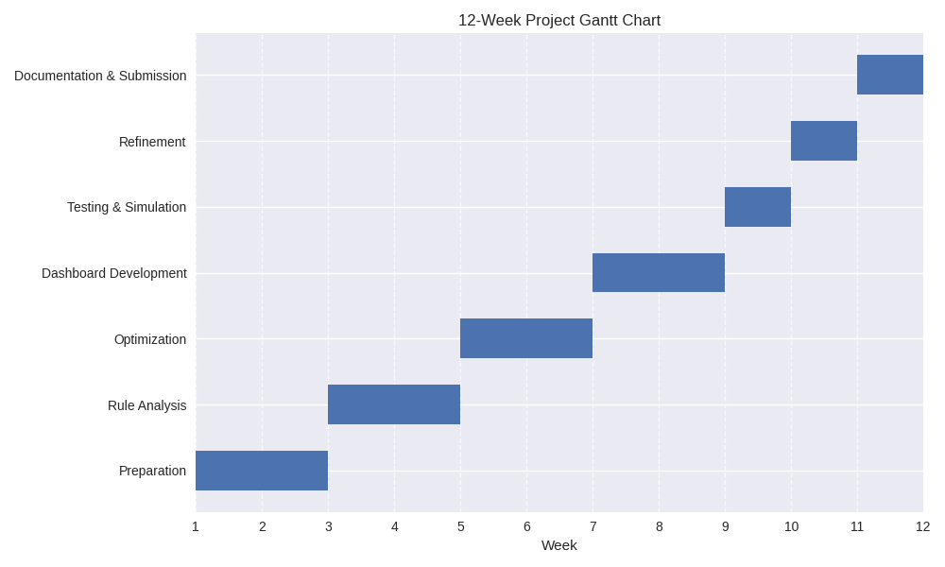

5. References (APA 7th Edition)
- Al-Shaer, E., & Hamed, H. (2004). Discovery of policy anomalies in distributed firewalls. IEEE INFOCOM, 2605–2616.
- AlgoSec. (n.d.). Firewall policy management solutions. https://www.algosec.com
- FireMon. (n.d.). Firewall management solutions. https://www.firemon.com
- Hakani, D., & Mann, P. S. (2024). Enhanced particle swarm optimization-based approach to firewall optimal rule reordering. International Journal of Computer Theory and Engineering, 16(4), 134–144. https://doi.org/10.7763/IJCTE.2024.V16.1361
- Springer. (2021). Optimization of parallel firewalls filtering rules. International Journal of Information Security, 20(5), 789–804. https://doi.org/10.1007/s10207-021-00557-4
- Stallings, W. (2020). Network security essentials: Applications and standards (6th ed.). Pearson.

6. Appendix
- Redundant rules (duplicate entries).
- Shadowed rules (rules that never execute due to precedence).
- Conflicting rules (contradictory actions for the same traffic).

