COT Load Utilization Framework and Finance Handoff Guide
Updated for current tool logic and historical utilization script workflow
Source basis: COT Load Utilization Framework (v1 12.23.25). This handoff preserves the same business framing while updating calculations to match the current optimization engine and script behavior in AppDev-V2.

1. Overview
This framework defines how load utilization is estimated for historical loads. The primary metric remains space-based utilization, but the calculation now reflects current tool mechanics including trailer defaults, upper-deck handling, two-across treatment, and overflow guardrails.
Key principles:
- Each stack position consumes trailer length based on the longest unit in that position.
- Vertical fill drives position credit (full stacks receive full credit; partial stacks receive proportional credit).
- Mixed-SKU positions are allowed when physical stacking constraints are met.
- Final utilization is computed from credited feet divided by trailer capacity feet.

2. Trailer Specifications Used by the Tool
Current trailer profiles in stack calculator:
Trailer Type | Capacity (ft) | Lower Deck (ft) | Upper Deck (ft)
STEP_DECK | 53 | 43 | 10
STEP_DECK_48 | 48 | 38 | 10
FLATBED | 53 | 53 | 0
FLATBED_48 | 48 | 48 | 0
WEDGE | 51 | 51 | 0
HOTSHOT | 40 | 40 | 0
Default trailer assumptions by origin plant in current logic:
- VA -> FLATBED_48
- NV -> STEP_DECK_48
- All other plants -> STEP_DECK
- If origin plant is blank, script uses the first two letters of load number as fallback.

3. Capacity and Stacking Process (Current Engine)

3.1 Data Preparation
- Read historical order report rows (load number, SO #, SKU, qty, origin plant).
- Map each SKU to cheat sheet specs: length_with_tongue_ft, max_stack_step_deck, max_stack_flat_bed, category.
- Choose trailer for each load using override -> reported trailer -> plant default -> load-prefix fallback.

3.2 Position Build Logic
- Units are assigned into positions using each SKU's max stack height for the selected trailer type.
- Mixed positions are allowed when length/order/stop constraints remain valid.
- For step deck upper deck, short positions may receive two-across treatment using configured threshold length.
- A controlled singleton overflow allowance can add one extra unit to certain mixed full stacks.

3.3 Capacity Check
- Lower and upper deck usage is tracked separately.
- Back overhang and upper-deck exception overhang allowances are applied by configured rules.
- Loads exceeding allowed deck/overhang constraints are flagged (exceeds_capacity = True).

4. Utilization Calculation
The current engine computes utilization using credited feet, not only raw occupied feet.
- Core formula:
- utilization_pct = (utilization_credit_ft / capacity_feet_used) x 100
- Position credit concept:
- position_credit_ft = position_length_ft x position_credit_multiplier
Where position_credit_multiplier is driven by vertical fill and controlled overflow rules.
Additional current-engine behaviors:
- Upper-deck effective length can differ from raw length when two-across is applied.
- For step deck loads with partially occupied upper deck, upper credit is normalized to full upper-deck basis.
- Grade thresholds are settings-driven (defaults: A >= 85, B >= 70, C >= 55, D >= 40, else F).

5. Worked Utilization Example (From Script Output)
Example load: VA26-1001
- Trailer type used: FLATBED_48
- capacity_feet_used: 48.0
- utilization_credit_ft: 33.6
- utilization_pct = 33.6 / 48.0 x 100 = 70.0%
- Resulting grade (default thresholds): B
Interpretation: this is a modeled best-guess reconstruction using the same stack assumptions as the tool; it is not a physical loading audit.

6. Historical Script Instructions for Finance
Script file:
- scripts/historical_load_utilization_report.py
Primary run command:
- python scripts/historical_load_utilization_report.py --order-report <input.csv or .xlsx> --output <output.csv>
Optional parameters:
- --sku-cheat-sheet <path> (override default cheat sheet source)
- --load-trailers <path> (load-level trailer/capacity overrides)

7. Finance Input Template (Expected Headers)
Template file provided: docs/examples/historical_order_report_finance_template.csv
load_number | so_num | sku | qty | origin_plant | destination_state | destination_zip | trailer_type | capacity_feet | item_desc | stop_sequence
GA26-2001 | SO-1001 | 5.5X10GWPR | 4 | GA | NC | 27513 |  |  |  | None
GA26-2001 | SO-1002 | 5X10DUMPLP10K | 2 | GA | SC | 29601 |  |  |  | None
VA26-1001 | SO-2001 | 5X10DUMPLP10K | 3 | VA | VA | 22572 | FLATBED_48
VA26-1001 | SO-2002 | 4X6G | 6 | VA | VA | 22572 | FLATBED_48

8. Output Example
Sample output file provided: docs/examples/historical_load_utilization_sample_output.csv
load_number | origin_plant_assumed | trailer_type_used | capacity_feet_used | orders_on_load | rows_in_report_load | rows_used_in_calc | units_on_load | utilization_pct | utilization_grade | utilization_credit_ft | total_linear_feet | lower_deck_used_length_ft | upper_deck_effective_length_ft | exceeds_capacity | warning_count | missing_sku_rows | missing_skus
GA26-2001 | GA | STEP_DECK | 53.0 | 2 | 2 | 2 | 6 | 44.0 | F | 23.3 | 28.0 | 14.0 | 14.0 | False | 1 | 0
VA26-1001 | VA | FLATBED_48 | 48.0 | 2 | 2 | 2 | 9 | 70.0 | B | 33.6 | 35.0 | 35.0 | 0.0 | False | 0 | 0

9. Revisions from Framework v1 (12.23.25)
- Expanded trailer support now includes STEP_DECK_48, FLATBED_48, WEDGE, and HOTSHOT in addition to 53' profiles.
- Capacity handling now applies configurable overhang and upper-deck exception allowances.
- Upper-deck two-across logic and effective-length treatment are included in utilization credit.
- Controlled singleton overflow logic can provide limited additional vertical credit in eligible mixed stacks.
- Grade thresholds are configurable in app settings; defaults still align to A/B/C/D/F bands used in v1.

10. Framework Visuals (from v1 Source)
The following visuals are retained from the source framework for continuity in Finance review discussions.
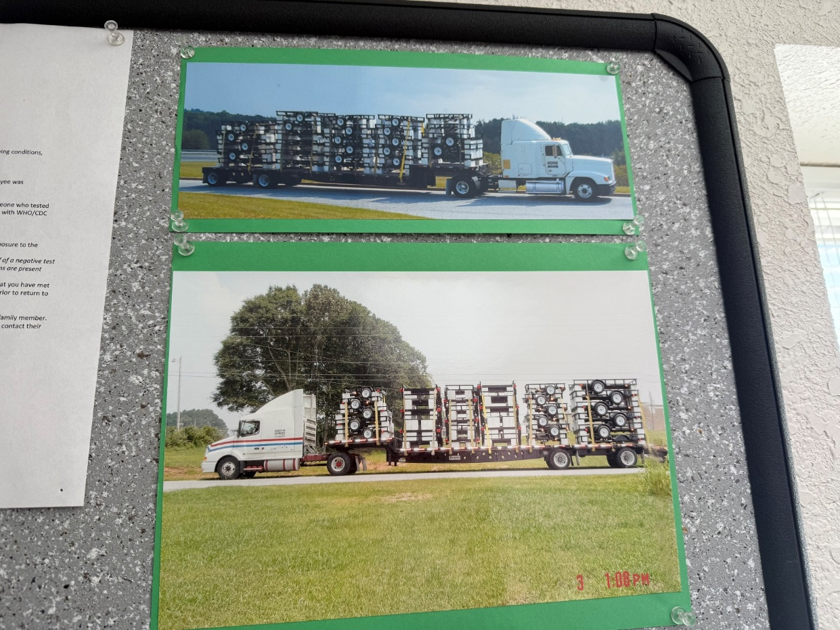
Figure 1: Source framework visual asset (image1.jpeg)
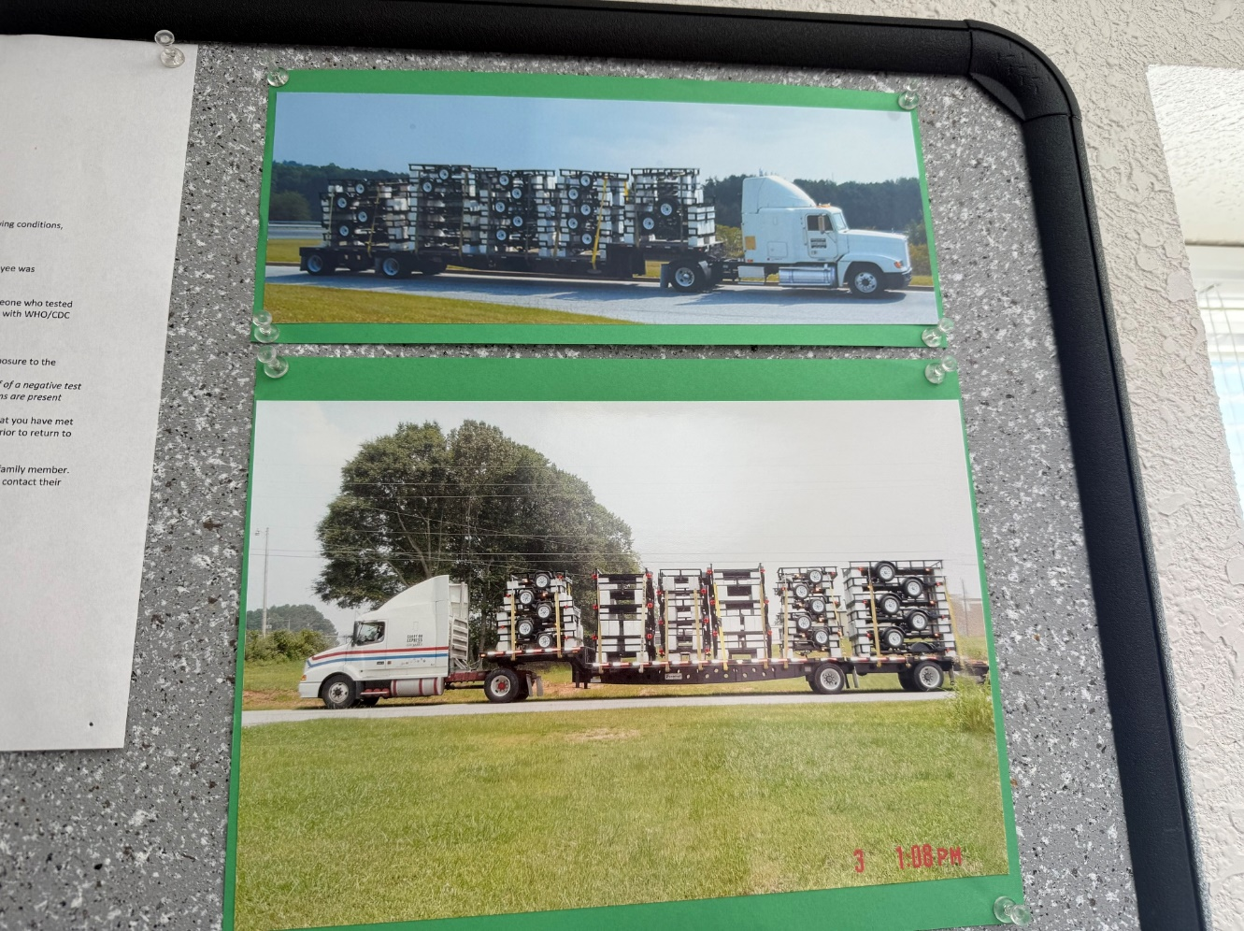
Figure 2: Source framework visual asset (image2.jpeg)
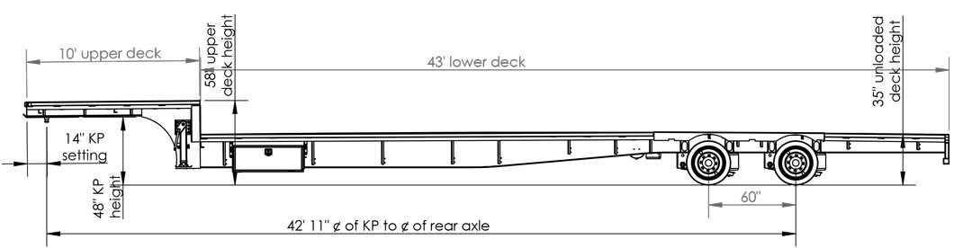
Figure 3: Source framework visual asset (image3.jpeg)
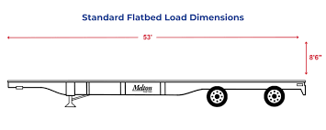
Figure 4: Source framework visual asset (image4.png)
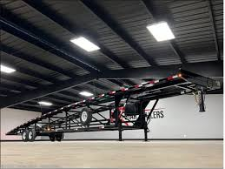
Figure 5: Source framework visual asset (image5.jpeg)

Figure 6: Source framework visual asset (image6.jpeg)

