Executive Summary

Strategic Purpose
The ProGrade Load Building Tool converts brand-specific stacking knowledge into a repeatable, tribal knowledge-independent process. It enables fulfillment and sales teams to design, validate, and refine trailer loads without relying on shipping experts to communicate fit logic and validate load combinations.

The tool is hosted within ATW’s Azure Environment at: https://cot-freight-tool-cddsc8hqe8caeuf3.eastus-01.azurewebsites.net/prograde/

Expected Usage
- Primary use case: build and validate non-standard load combinations that would otherwise require direct shipping manager intervention.
- Pre-approval planning: allow fulfillment and sales teams to test fit feasibility before escalating to shipping leadership.
- Scenario comparison: evaluate alternative SKU mixes and trailer profiles to improve utilization and reduce dead space.
- Inventory-aware gap closure: identify on-hand units that can complete an in-progress load based on available space and existing stack rules.
- Customer-facing support: equip sales representatives to discuss load fill opportunities during sales conversations, providing additional value to customers who can conserve freight cost.
- Training and knowledge transfer: codify stacking logic so new planners can execute consistently without relying on tribal knowledge.
- The tool is intended to support operational decision quality and speed; final shipment release decisions remain with shipping and carrier compliance stakeholders.

Why This Matters
- Reduces key-person dependency in daily shipping and fulfillment decisions
- Improves trailer utilization through standardized stacking rules and real-time fit validation
- Accelerates cycle time for load planning, customer response, and internal load approvals
- Creates a durable training platform for future planners, fulfillment coordinators, and sales teams

Brand Paths, Users, and Core Value

Brand Path | Primary User Group | Core Business Value
PJ | Sales representatives | Build customer-ready load scenarios in real time and identify incremental units that improve freight economics and customer margin.
Big Tex | Order fulfillment team | Independently validate non-standard load mixes, reducing approval bottlenecks with shipping leadership.
B-Wise | User group TBD | Extend the same value proposition to improve utilization consistency and reduce tribal knowledge dependency risk.

End-to-End Process Overview
The diagram below illustrates the load building workflow that applies across all brand paths.

1  Select Brand  Using left hand side brand focus buttons | ▶ | 2  Start Build Session  By beginning new load or resuming existing load build session from session history | ▶ | 3  Sketch Load  Drag and drop appropriate SKUs from add table | ▶ | 4  Close Gap  Evaluate fill opportunities using inventory gap finder | ▶ | 5  Review  Finalize load design and export as PDF to continue down fulfillment process

Operating Guardrails
Important: This Tool Is Decision Support — Not a Compliance Authority
Final shipping release still requires carrier judgment and regulatory review (state height limits, overhang, route-specific constraints). Confirm truck profile early (53_step_deck, 53_flatbed, ground_pull) to avoid late-stage redesign. Maintain SKU dimensions and stack assumptions as controlled operational data.

Business Value and Expected Outcomes

Primary Outcomes
- Reduce single-person dependency in load design and release decisions
- Reduce time spent by shipping directors and load engineers on routine fit validation
- Improve trailer utilization and load quality through standardized configuration logic
- Accelerate training readiness for future planners and support teams

Additional Outcomes
- Faster customer-facing decisions, particularly in PJ sales workflows
- Faster inventory movement by surfacing feasible fill candidates that are currently available
- Stronger cross-functional alignment — sales, fulfillment, and shipping operating from one consistent logic standard

Suggested KPIs
The following metrics can be used to measure adoption and impact over time:

Metric | What It Measures | Target Baseline
% of loads built without shipping-manager intervention | Self-sufficiency of planning teams | TBD
Average planning time per load | Efficiency gain vs. prior process | TBD
Average load utilization % by brand | Trailer fill quality | TBD
% of loads where Inventory Gap suggestions were used | Adoption of gap-fill feature | TBD

Use Cases by Brand

Brand | Typical User Group | Typical Trigger | Business Benefit
PJ | Sales representatives | Customer requests quote or load feasibility check | Faster customer response; improved freight absorption recommendations; reduced engineer bottleneck.
Big Tex | Order fulfillment team | Non-standard or mixed load request | Faster internal decisioning without waiting on a manager for each scenario.
B-Wise | To be finalized | Early-stage adoption and support use | Reuse of proven workflow reduces dependency risk and improves consistency across the network.

Practical Impact by Brand

Big Tex — Order Fulfillment
Fulfillment teams can sketch and independently validate a broader range of loads, reducing repeated approval dependency on a small number of load engineering experts. The result is faster throughput on non-standard and mixed-unit orders.

PJ — Sales
Sales representatives can pre-validate load fit in real time during customer conversations and proactively suggest incremental units that improve delivered economics — without requiring a callback to a shipping expert.

Shared Impact Across Brands
Inventory-aware load suggestions help reduce the time that finished product sits in facilities waiting for an optimal load to form. Both teams benefit from working from the same load logic standard.

Core Workflow With Brand-Specific Notes

The ProGrade Load Building Tool follows a consistent five-step workflow across all brand paths. Brand-specific notes are called out within each step.

Step 1 — Select Account and Initialize Session

User accounts have been created for the appropriate user groups for each brand. Select account using the dropdown, then select Continue with Selected Account to proceed. To add a new account, simply type the user’s name in the ‘add new account function at the bottom, to add an account that will persist in the app.
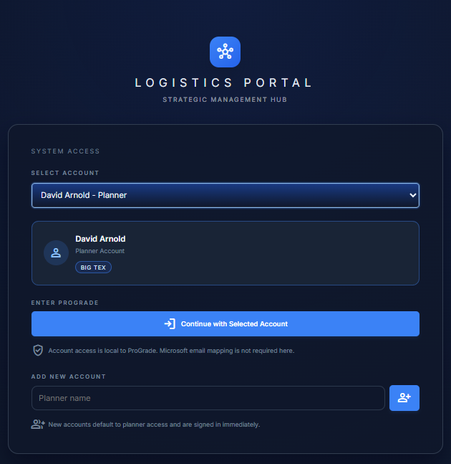

1 | ▶ | 2 | ▶ | 3 | ▶ | 4 | ▶ | 5
Select Account |  | Select Brand |  | New or Resume |  | Confirm Truck Profile |  | Begin Building
Choose from dropdown |  | PJ / Big Tex / B-Wise |  | Start new or resume existing |  | 53_step_deck, 53_flatbed, or ground_pull |  | Proceed to load builder

- Select the relevant brand path (PJ, Big Tex, or B-Wise) using the brand cards on the left-hand side.
- Start a new draft session (by clicking Create Load) or resume an existing one by selecting the session from the history.
- Navigate through previous load build sessions from this page too, which will allow you to resume existing sessions, view a summary of previous work, or directly export a PDF summary.

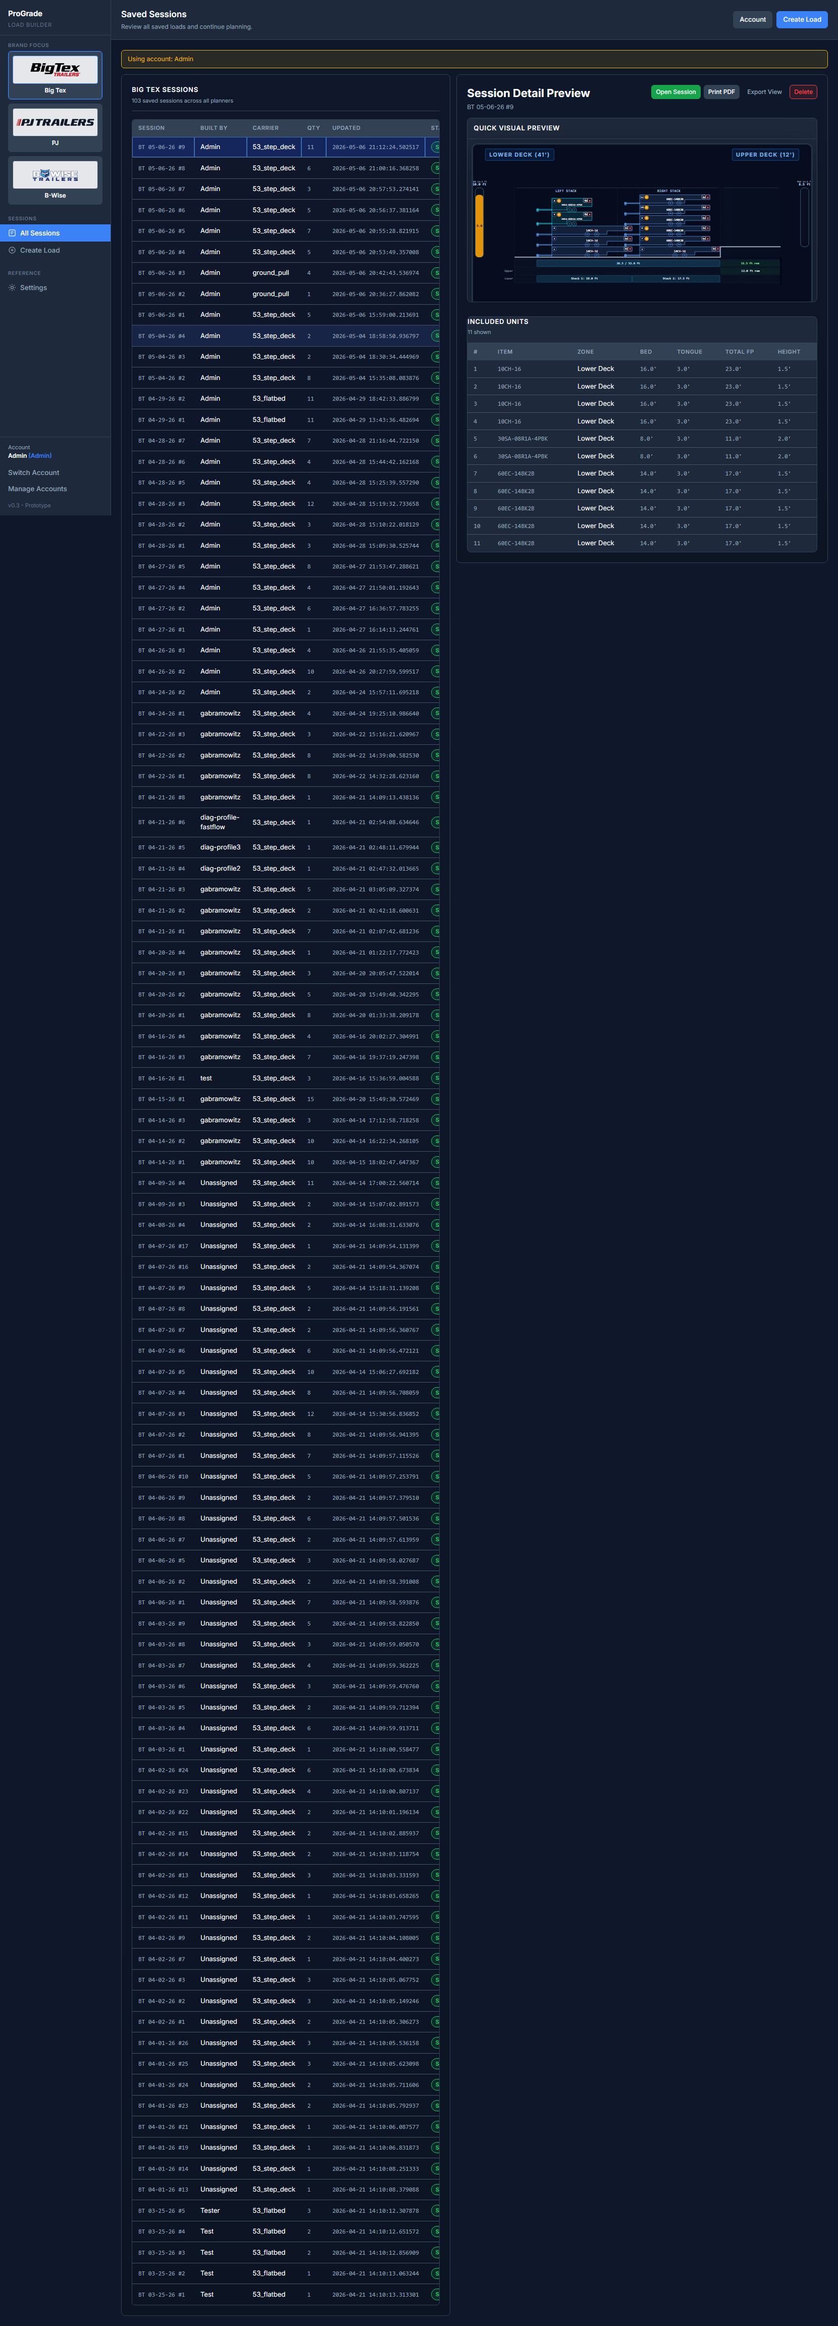
Figure 1. ProGrade sessions workspace used to start or resume the flow.

Step 2 — Build and Refine the Load

1  Add Units  from SKU List | ▶ | 2  Drag & Drop  Stack Positions | ▶ | 3  Check Meters  Capacity / Fit | ▶ | 4  Adjust  Resolve Conflicts

- Add units from the SKU list by navigating: Category → Model → Item.
- Drag and drop units into desired stack positions. Options are either to start new stacks on each deck, or add to existing stacks.
- Monitor real-time schematic and capacity meters to validate load fill.
- Adjust orientation and placement as needed to resolve fit conflicts.
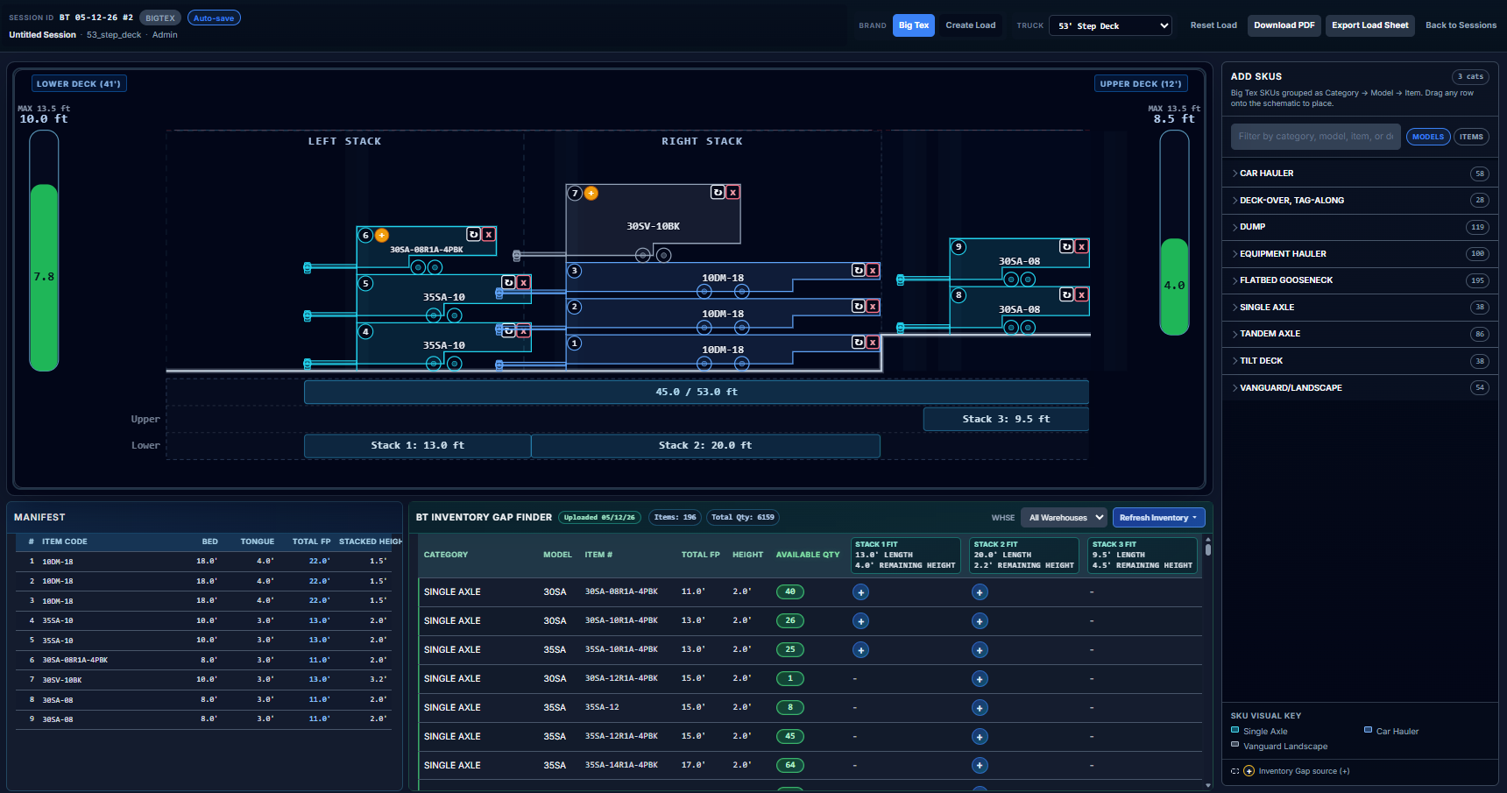
Figure 2. Load Build Workspace with all core elements (add skus table, load schematic diagram, freight manifest and inventory gap finder)

Outcome of This Step
Teams can confirm operational viability visually before escalating for shipping leadership review — reducing unnecessary back-and-forth and approval delays.

Step 3 — Close Remaining Capacity with Inventory Gap Finder

1  Open Gap  Finder Panel | ▶ | 2  Apply Warehouse  Filter | ▶ | 3  Review Candidates  & Gap Feet | ▶ | 4  Add Units  That Fit
As the load is built, the Inventory Gap Finder panel at the bottom of the load builder page will surface eligible fill candidates. Use it to close remaining trailer capacity before finalizing the load.
- Apply the warehouse filter when available.
- Review remaining gap footage and candidate items surfaced by the tool.
- Add suggested units that satisfy stack constraints and current on-hand inventory.


Figure 3. Inventory Gap Finder panel used to close remaining capacity with eligible inventory.
Outcome of This Step | Teams can confirm gap-fill candidates against real on-hand inventory before finalizing the load — improving trailer utilization and supporting upsell conversations without requiring a callback to shipping.

What the Inventory Gap Finder Does | The Gap Finder matches open trailer space to real SKU geometry and current on-hand inventory, then recommends units that can complete the load more efficiently. This improves utilization, accelerates inventory movement, and supports practical upsell conversations.

Settings and Assumption Management

Settings are the operational knowledge base that powers the ProGrade Load Building Tool. They encode brand-specific stacking behavior and space-consumption assumptions. Keeping them accurate is essential — if the underlying dimensions are wrong, fit recommendations will be wrong.

What Is Configured in Settings
- SKU catalog by brand and category
- Key dimensions by SKU: deck length, tongue length, stack heights, and height envelopes
- Stacking behavior and space-consumption assumptions
- Trailer profiles (e.g., 53_step_deck, 53_flatbed, ground_pull)
- Tongue profile conventions, including bumper-pull vs. gooseneck behavior where applicable

Process: Adding or Editing a SKU

1  Open Settings | ▶ | 2  Select Brand  Tab | ▶ | 3  Search SKU  First | ▶ | 4  Add / Edit  Fields | ▶ | 5  Save & Re-  Validate

- Open Settings within the ProGrade Load Building Tool.
- Select the relevant brand tab (PJ Standards, Big Tex Standards, or B-Wise Standards).
- Search for the existing SKU first to avoid creating duplicates.
- Add the new SKU or edit existing fields (dimensions and stack assumptions).
- Save settings, then re-open or refresh any affected sessions and re-validate load fit before final export.

Quality Rule
SKU data quality is operationally critical to the tool. Incorrect dimensions cascade directly into incorrect fit recommendations across all active loads using that SKU.

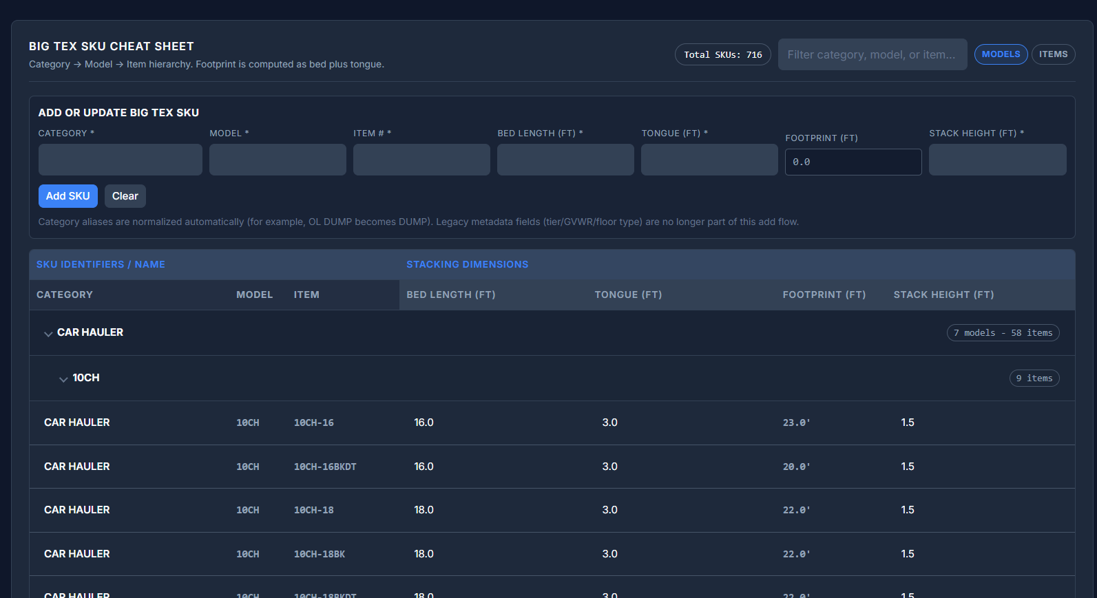

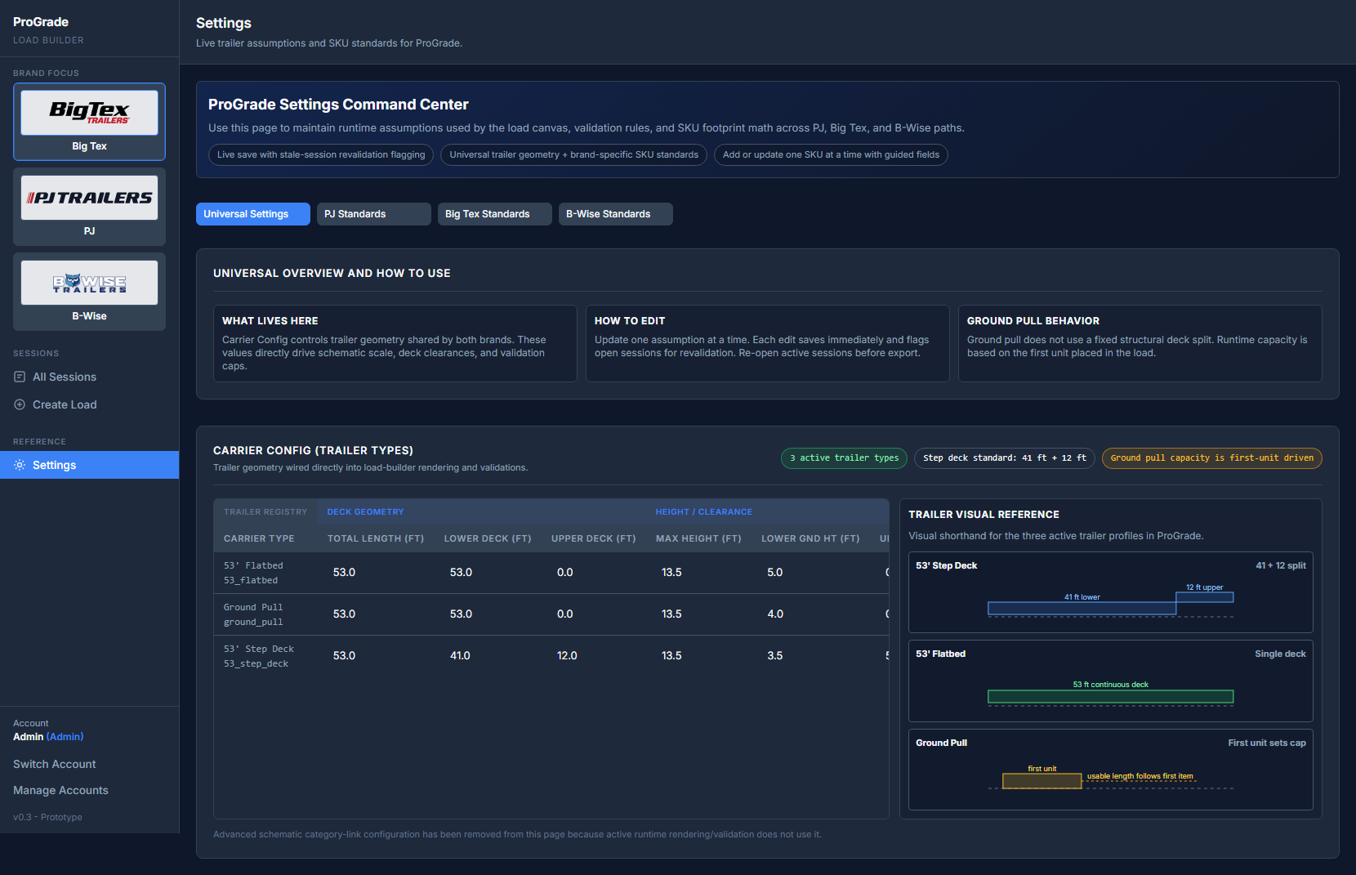
Figure 4. Settings workspace used to maintain SKU dimensions and stacking assumptions.

How Inventory Gap Finder Uses Settings
The Inventory Gap Finder is not a separate rule system — it depends on three inputs working in concert:
- Current load geometry (remaining space and active stack constraints)
- SKU assumptions from Settings
- Available inventory snapshot data (when uploaded)
Accurate settings directly determine the quality of gap-fill recommendations.

Handoff, Ownership, and Support Model

A) Recommended Ownership Structure

Area | Recommended Owner | Backup Owner | Cadence
SKU dimensions and stack assumptions | Brand shipping lead | Operations analyst | Weekly review + ad hoc updates
Inventory upload and process quality | Fulfillment operations | Planning support | Daily
User enablement and training | Ops excellence or PM | Brand coordinator | Monthly
Tool administration and support triage | Internal app owner | IT support | Ongoing

B) Change Governance Process

1  User Submits  Request | ▶ | 2  Brand Owner  Reviews | ▶ | 3  Update in  Settings | ▶ | 4  Re-Validate  Load | ▶ | 5  Log Change  Note

- User submits a SKU or assumption update request to the brand owner.
- Brand owner reviews and approves the proposed change.
- Update is made in Settings.
- One representative load is re-validated to confirm expected behavior.
- Change note is logged, capturing: what changed, why, by whom, and the date.

C) Support Escalation Path

Issue Type | First Contact
Workflow or usage question | Team super-user
Data or assumption issue | Brand shipping lead
Tool behavior issue or bug | App owner + development support

D) Transition Completion Checklist
- Document approved by operations leadership
- Named owners assigned for each brand path (PJ, Big Tex, B-Wise)
- Initial training delivered to target user groups
- KPI baseline captured for pre/post comparison
- First review date scheduled (30 days post go-live)

