Freight Optimization App - User Guide
Updated: March 24, 2026
This guide covers the main planner workflows in the app: uploading open orders, generating loads, reviewing and approving loads, maintaining settings, and reviewing prior planning sessions.

1) Sign In and Navigate
- Open the app login page and select your account profile.
- If you choose an Admin profile, enter the admin password and sign in.
- Use the left navigation to move between Orders, Loads, Session History, Settings, and Dashboard.
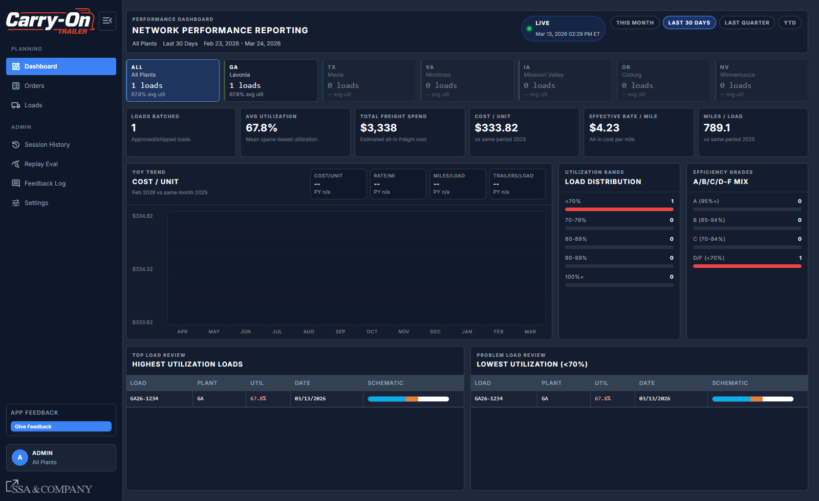
Dashboard view (performance reporting).

2) Upload Open Orders
Use the Data Intake Hub in Orders to keep planning data current.
- Go to Orders.
- In Data Intake Hub, click Upload Orders and select the daily CSV export.
- Wait for the upload progress modal to complete.
- Review Recent Upload Results for mapped/unmapped counts and order changes.
- If status shows Outdated, open the refresh guide and complete the daily intake checklist.
- If unmapped SKUs appear, save SKU specs from the upload modal or Settings -> SKUs before re-running optimization.
- Use the Last Import timestamp and freshness badge to confirm data recency.
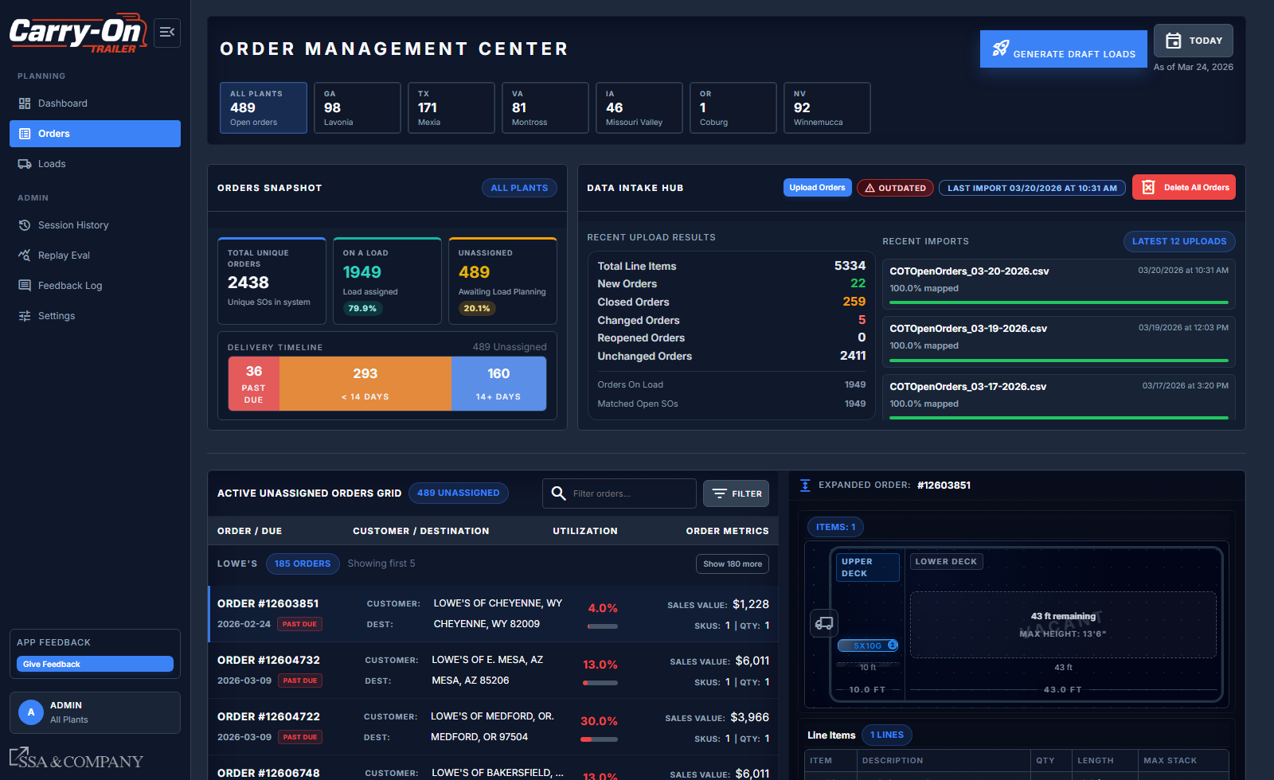
Orders page with Data Intake Hub and order snapshot.

3) Generate Auto Loads
- From Orders, click Generate Draft Loads.
- In Session Config Workbench, set Origin Plant and trailer profile.
- Set scope filters (states/customers), scheduling window, and category scope.
- Click Generate/Run to build draft loads.
- Open Loads to review output and approve loads.
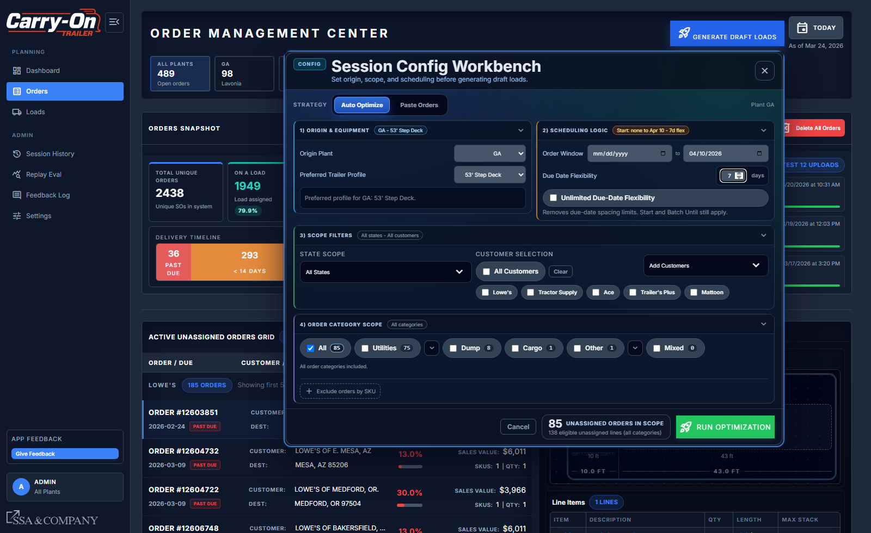
Generate Draft Loads workbench (auto mode).

4) Generate Loads with Manual SOs (Paste Orders)
- Open Generate Draft Loads from Orders.
- Switch Strategy to Paste Orders.
- Paste SO numbers (one per line, or comma/tab/space separated).
- Validate the matched count and missing orders preview.
- Run optimization; the system uses only matching unassigned orders from one plant.
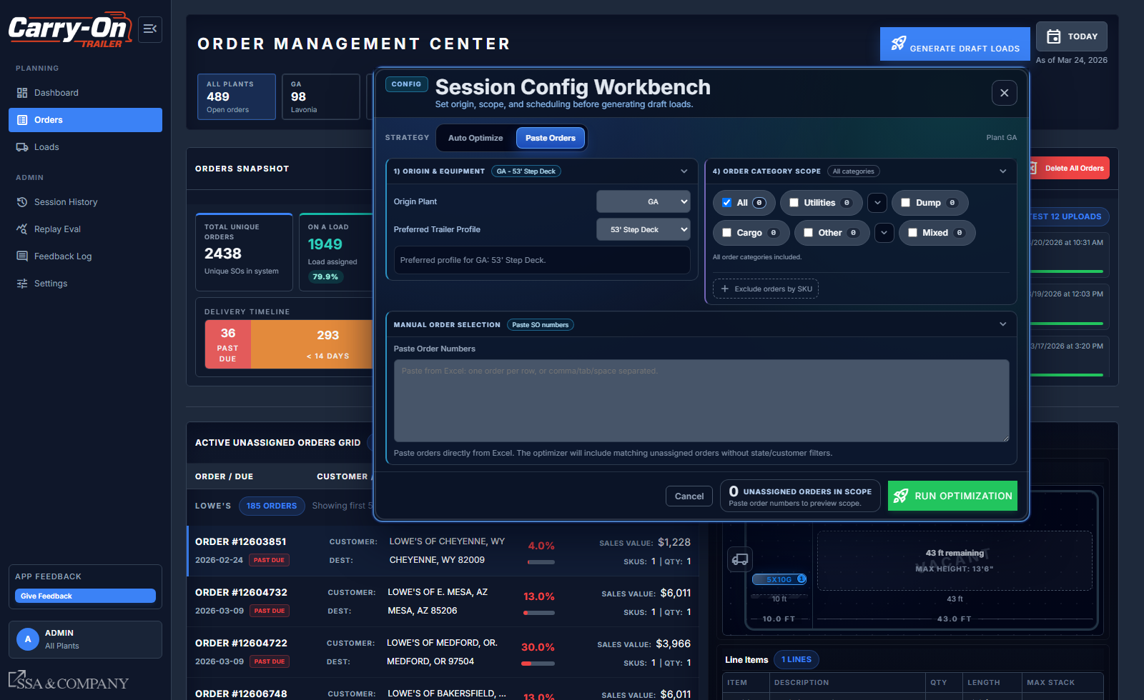
Paste Orders mode for manual SO-driven load generation.

5) Monitor and Work Orders in Orders Page
- Use filter controls (due date, date range, state, customer) to narrow unassigned orders.
- Use the search box to find orders quickly.
- Click an order row to open expanded details (stack footprint, line items, map).
- Review the snapshot cards: total orders, on-load %, unassigned %, and delivery timeline.
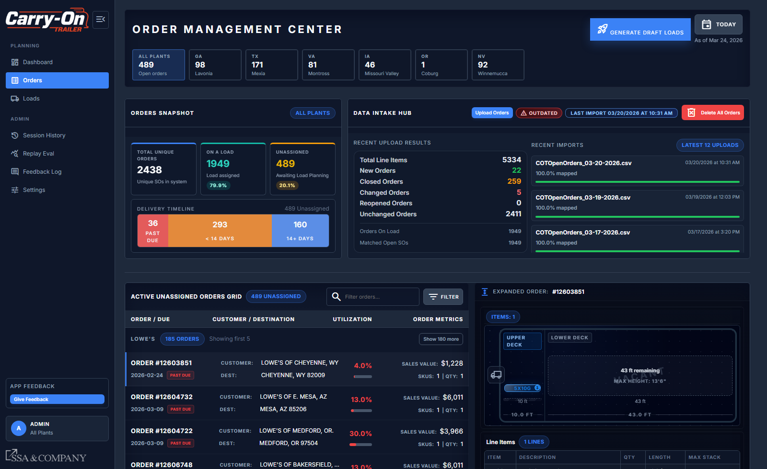
Expanded order detail pane (stack/line/map).

6) Approve Loads
- Open a load detail from Loads (or Session Detail -> View Loads).
- Review route timeline, map, manifest, utilization grade, and estimated freight metrics.
- Use Approve to Draft or Approve & Lock to finalize.
- Use Unapprove to Draft if a finalized load needs to move back to draft status.
- Approve & Lock assigns the final load number and can complete the session when all loads are finalized.
- Approved loads are read-only for key layout edits.
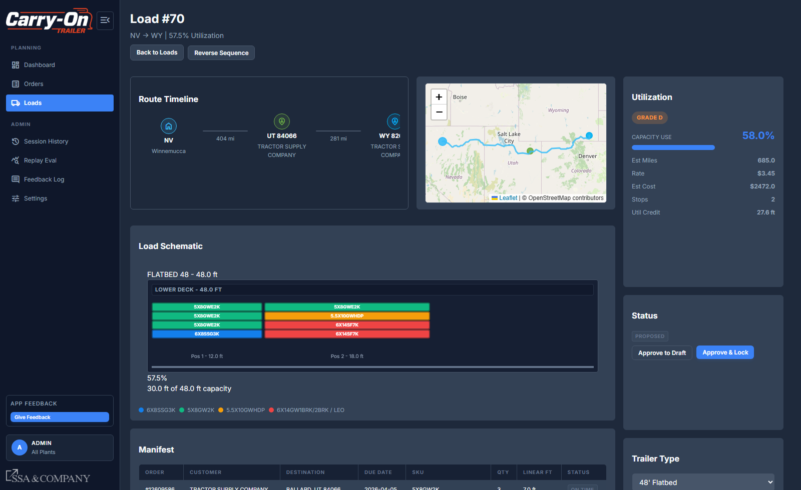
Load detail review and approval controls.

7) Edit Load Schematics
- From Loads Review Center, expand a draft load.
- Click Edit Schematic on the schematic card.
- Reposition units/stacks as needed and review warning messages.
- Click Save Schematic. If violations are detected, confirm/save only after review.
- Use Manually Add Orders if additional SOs should be layered into a draft load before re-optimization.

8) Update Settings
- Go to Settings.
- Use Command Center (Overview) for stop fee, load minimum, fuel surcharge, stop colors, optimizer defaults, and utilization grade thresholds.
- Use Rates tab for lane rates and carrier-specific rate tables.
- Use SKUs tab for SKU dimensions/stack rules and lookup mappings.
- Save each section after edits.
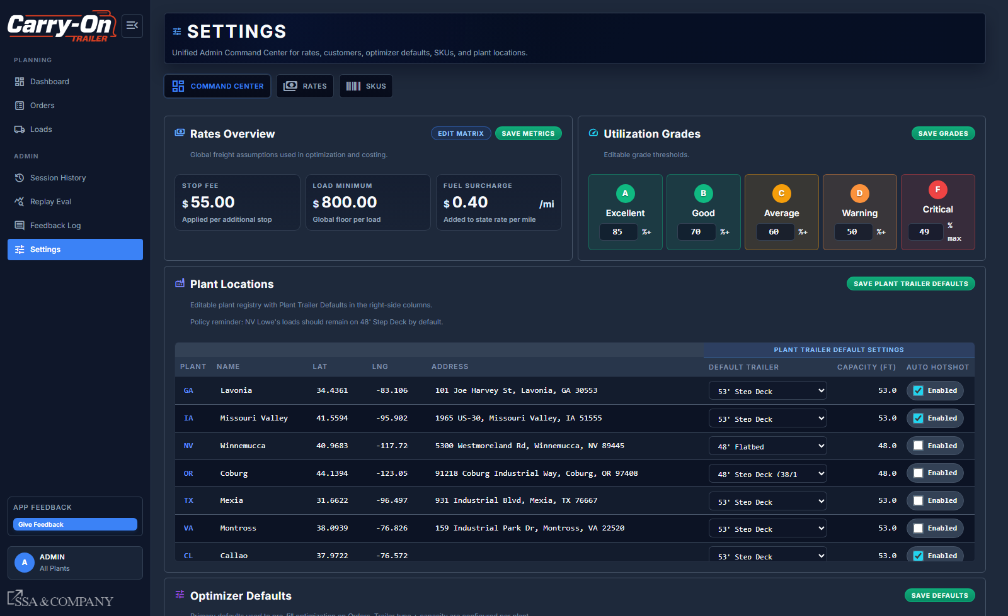
Settings Command Center (overview).
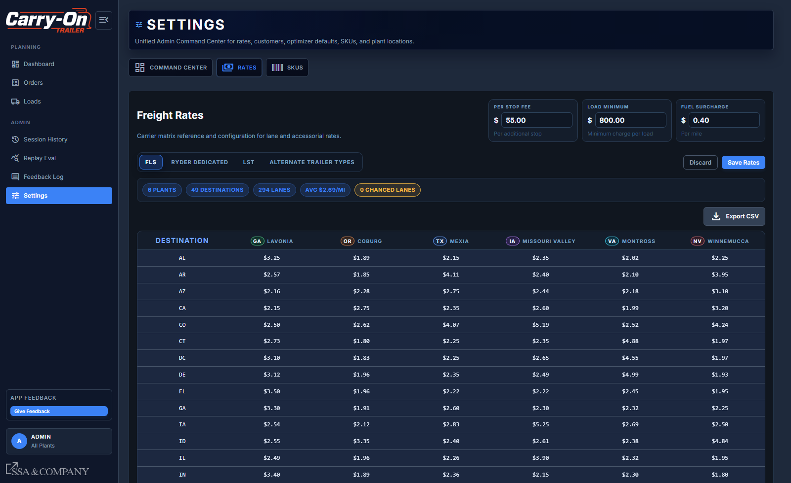
Settings Rates tab.

9) View Previous Sessions
- Open Session History.
- Filter by plant/planner/date and search for the target session.
- Select a session row to open the detail preview.
- Use Resume (for draft sessions), Load Report, or Export Excel as needed.
- Use Archive actions to close sessions while preserving history.
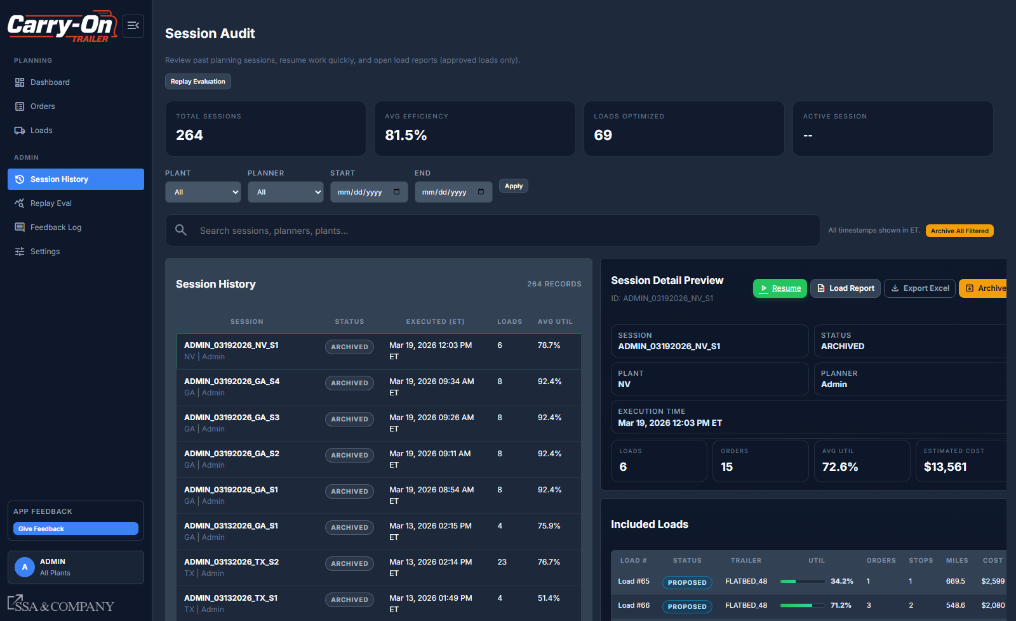
Session History (audit view).
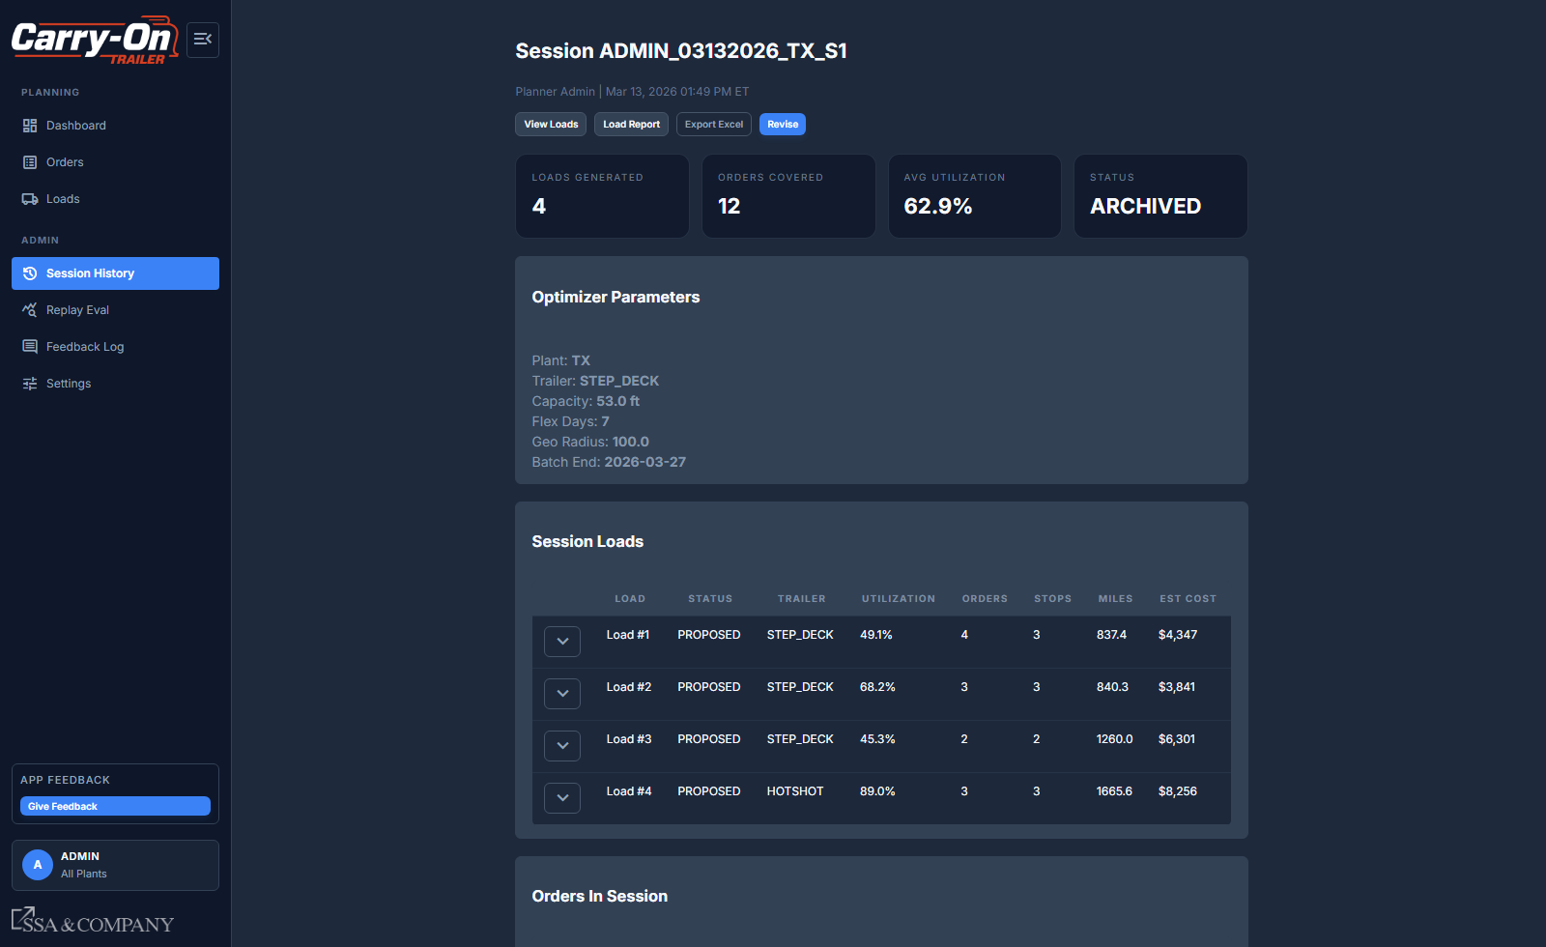
Session Detail with report/export/revise actions.

10) Other Core Processes Worth Using
- Load Report + Export Excel: produce approved-load outputs for operations.
- Feedback Log: capture reasons for returned orders/loads and review planner feedback trends.
- Replay Eval (Admin): compare optimized vs baseline scenarios for historical analysis.

Quick Tips
- Run daily intake first; optimization quality depends on current open-order data.
- Use Paste Orders mode when planners need controlled SO-specific runs.
- Before approving, validate route sequence, stop timing, and schematic warnings.
- Use Session History to avoid losing context between planning cycles.

