Block 1: Data Model Refresh (Completed)
Trailhead Modules
- ✅ Data Modeling
- ✅ Object Relationships
Task 1: Mini Data Model Design (Completed)
Scenario Chosen:
- Gym Management System
Objects Created:
- Trainer (Custom Object)
- Member (Custom Object)
Relationship Implemented:
- Lookup Relationship
  - Parent: Trainer
  - Child: Member
Reason for Choosing Lookup:
- A trainer can be assigned to multiple members.
- Members can exist independently even if a trainer is changed or removed.
- Lookup provides flexibility without enforcing dependent record deletion.
Evidence:
- Screenshot 1: Trainer Object
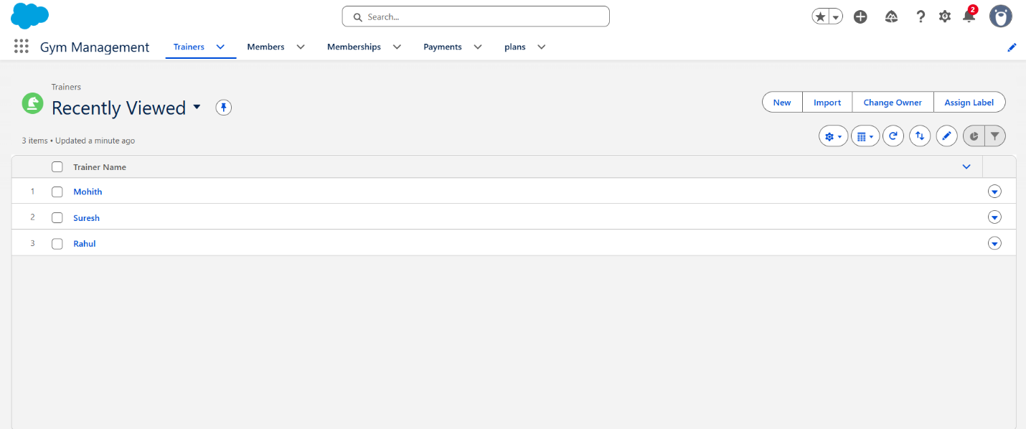
Block 2: Apex Basics (Partially Completed)
Task 2: Apex Basics Practice
Worked through Apex examples using Developer Console → Execute Anonymous.
Practiced:
- Variable declaration
- Creating Trainer__c objects
- Assigning field values
- Inserting records
- Running code and viewing Debug Logs
Evidence:
- Screenshot 3: Execute Anonymous / Debug Log Output
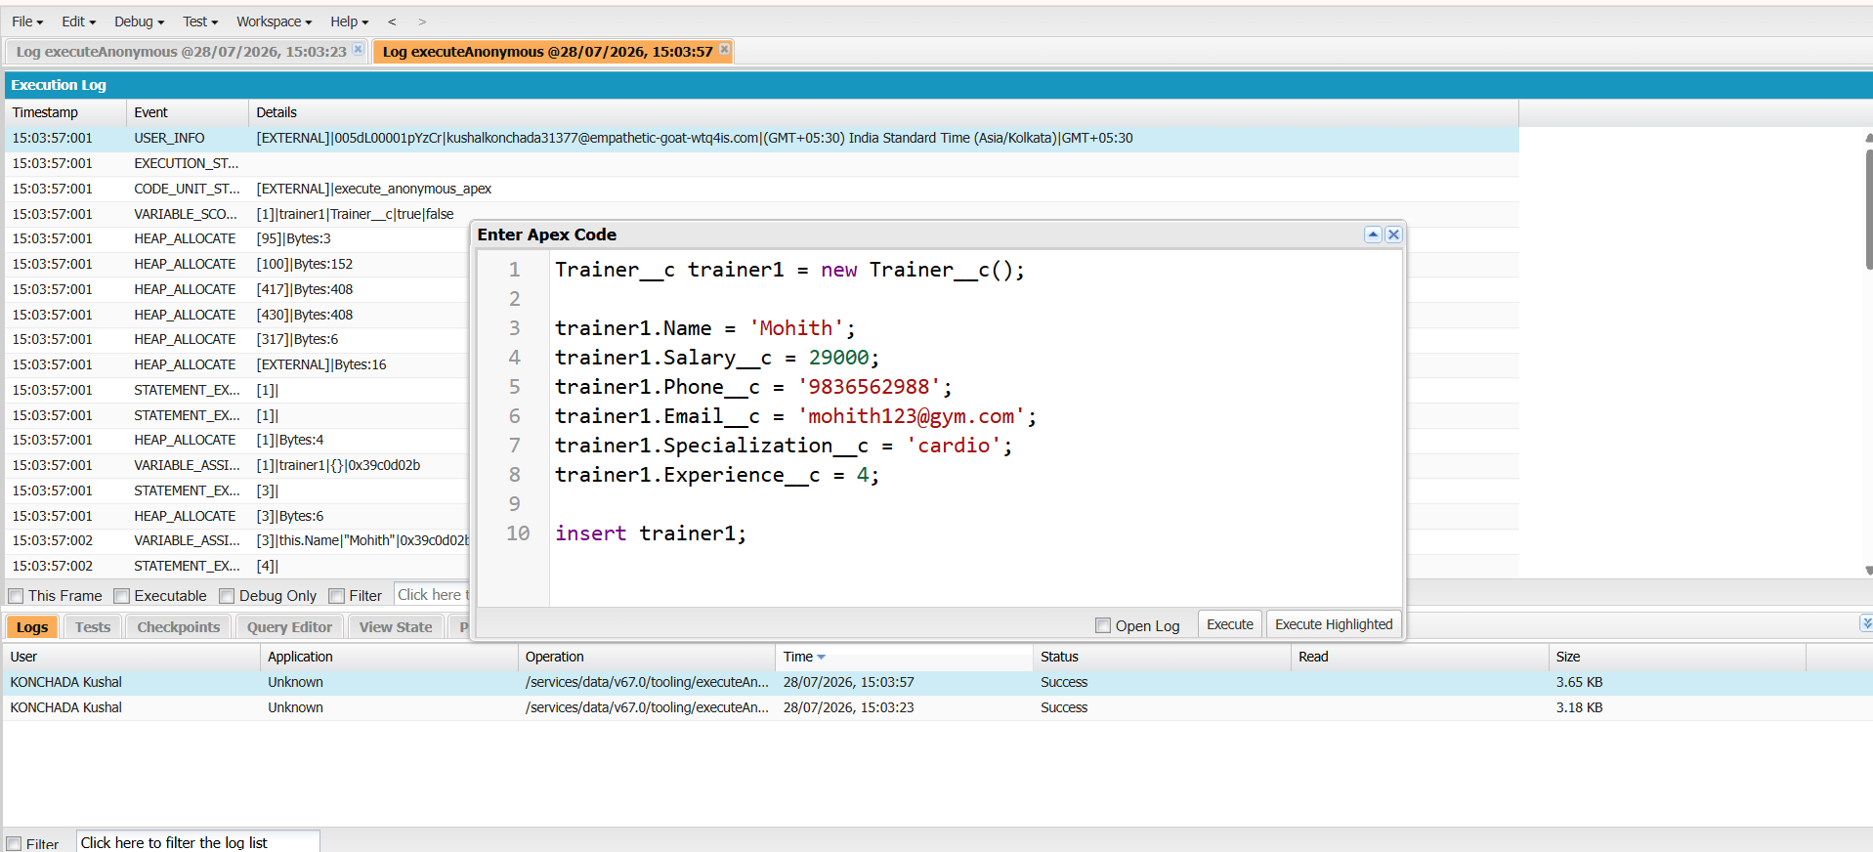

Task 3: SOQL Practice (Partially Completed)
Successfully executed and verified the following SOQL queries:
Query 1: Basic Query
SELECT Name, Phone__c
FROM Trainer__c
Retrieved Trainer records with selected fields.
Query 2: Child-to-Parent Relationship Query
SELECT Name, Trainer__r.Name
FROM Member__c
Retrieved Member records along with their assigned Trainer names using relationship queries.
Evidence:
- Screenshot 3 & 4: SOQL Query Results
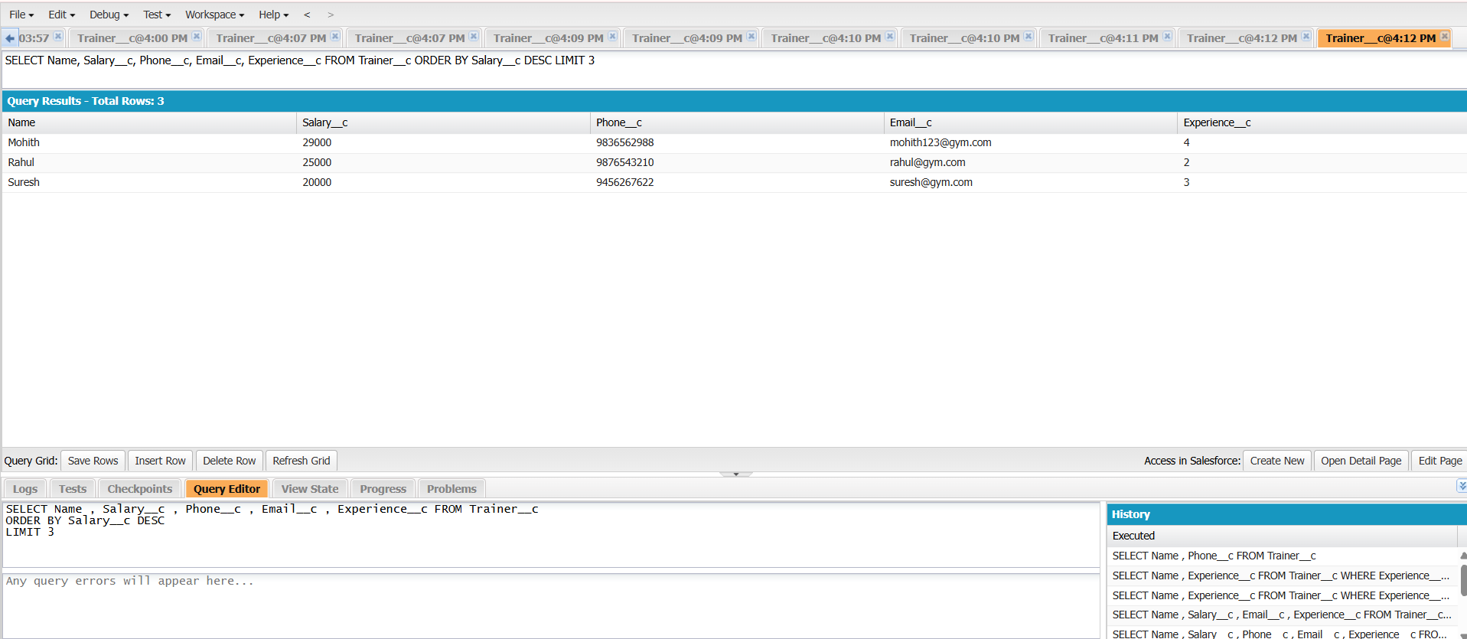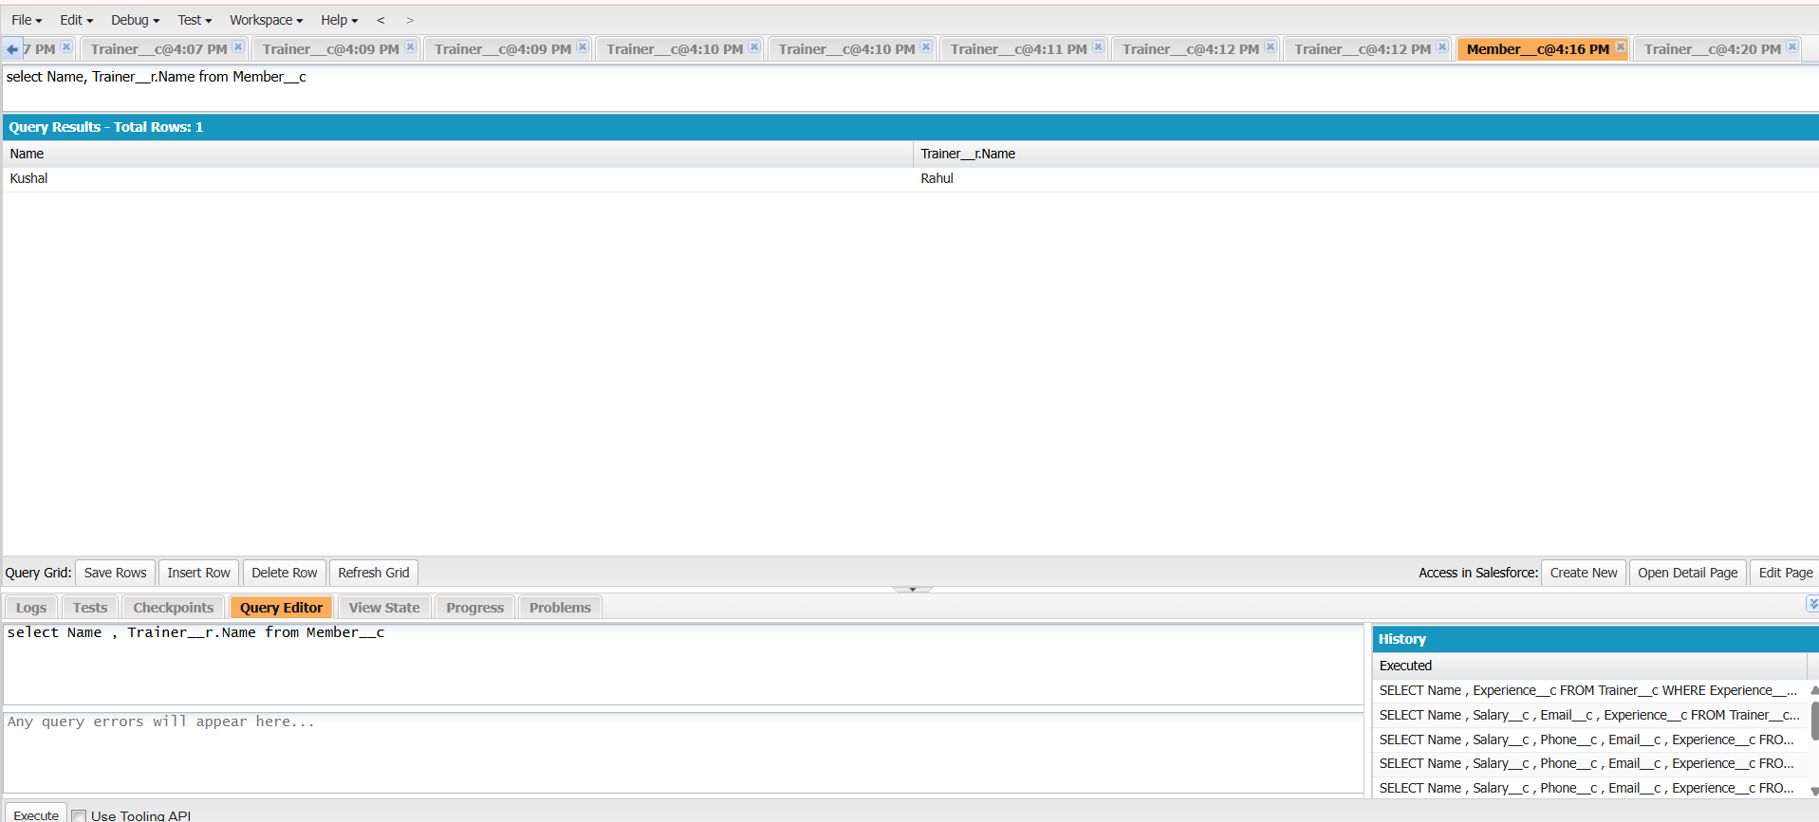
Block - 3
Task 4.1 – Apex Trigger (Before Insert)
Implemented a Before Insert Apex Trigger on the Trainer custom object to prevent duplicate trainer records based on the email address. The trigger follows Salesforce best practices by keeping the trigger lightweight and delegating all business logic to a separate TrainerTriggerHandler class.
The trigger executes automatically whenever a new Trainer record is created. It passes the incoming records (Trigger.new) to the handler class, where all email addresses from the new records are collected into a Set. A SOQL query is then executed to retrieve existing Trainer records with matching email addresses. The existing email addresses are stored in another Set for efficient lookup.
Before the records are saved, each incoming Trainer record is validated against the existing email Set. If a duplicate email is found, the addError() method is used to display a custom error message and prevent the record from being inserted into the database.
Concepts Practiced
- Apex Triggers
- Before Insert Trigger
- Trigger Context Variable (Trigger.new)
- Trigger Handler Pattern
- SOQL Query
- Collections (List and Set)
- Duplicate Record Validation
- addError() Method
- Separation of Business Logic from Trigger
Outcome
Successfully implemented a Before Insert trigger that validates Trainer email uniqueness. The solution prevents duplicate Trainer records from being created and demonstrates the use of Apex triggers, SOQL, collections, and the Trigger Handler design pattern in Salesforce development.
This is suitable for an internship daily report or documentation. I can also prepare a shorter (5–6 line) version if your mentor expects concise daily updates.

