Here is the professional English translation of the provided resume, maintaining the original structure and embedding images at their relevant positions:

### ​****​Jiang Tianyu (Skylen Jiang)​****​

### ​****​Personal Info​****​

​**​Ethnicity:​**​ Han  
​**​Date of Birth:​**​ Nov 1996  
​**​Phone:​**​ 182-0123-2205  
​**​Political Status:​**​ League Member of Communist Youth League  
​**​Email:​**​ 793758592@qq.com  
​**​Address:​**​ Beijing, China

### ​****​Work Experience​****​

#### ​****​2020.05 – Present​****​

#### ​****​NetEase Youdao Information Technology (Beijing) Co., Ltd.​****​

#### ​****​Senior Video Designer​****​

​**​Focus:​**​ Director, Director of Photography, Creative Scriptwriter.  
​**​Scope:​**​ Execution of video courses, TV commercials (TVC), documentaries, conceptual promotional films, short videos, and live streams.

​**​Responsibilities:​**​

1. Execute video shooting and production based on project requirements, continuously optimizing visual quality to enhance product value.
2. Lead equipment setup and team coordination for live streams, manage on-site directing and cinematography.

​**​Project Experience:​**​  
​**​Project 1: Full-Cycle Creative Projects​**​ (Brand TVCs / Conceptual Videos / Short Video Series)

* Led creative proposals, scriptwriting, storyboarding, execution, and distribution.
* Analyzed market trends for ad films, identified product strengths, and studied user personas/pain points.
* Integrated brand positioning with video content, delivering cost-effective creative solutions.  
  Examples:
  + Youdao Hardware Documentary: The Birth of Dictionary Pen
  + Dr. Tao Yong’s Eye Care Science Short Video Series
  + Feiji Student Series: Memory Short Videos
  + Youdao Campus Recruitment TVC
  + Youdao Kaoshen Brand Film: Chasing Dreams
  + Premium Course Conceptual Video: Decryption X Plan

​**​Project 2: Documentary Series​**​ Bowen Field Study: Bao Juncheng’s National Tour (15 Episodes)

* Managed production, coordination, cinematography, and editing for educational travel documentaries.
* Filmed across Beijing, Guangzhou, Zhongshan, etc., covering culture, history, and regional landscapes.
* Delivered stable, high-quality visuals that resonated with audiences, driving user renewals and acclaim.

​**​Project 3: Entertainment-Style Courses​**​ Lu Feifei’s Extraordinary Memory & Tai Chi English Talk Show

* Developed content formats and executed production.
* Innovated with reality-show and talk-show styles to enhance engagement.
* Elevated visual quality through cinematography, art design, and VFX packaging, adding marketing appeal.

​**​Project 4: English Course Series​**​ Yang Liang’s English Learning Camp & Alice Model English (81 Episodes)

* Designed main courses (talking-head format) with integrated cinematography, lighting, and post-production.
* Created immersive supplementary skits using first-person POV and gamified visuals.
* Addressed users’ need for practical spoken English scenarios, boosting interactivity and marketability.

#### ​****​2018.08 – 2020.03​****​

#### ​****​Baoji Goldstone Film & Media Co., Ltd.​****​

#### ​****​Cinematographer​****​

​**​Project 1:​**​

* Served as cinematographer for behind-the-scenes footage and stills of the web film Peak Rescue.
* Shot on location in Yunnan (Xishuangbanna), Vietnam border, Xi’an (Shaanxi), and Bangkok (Thailand).

​**​Project 2:​**​

* Worked as cinematographer for a promotional film for the Western Theater Command.
* Collaborated with directors and crew to deliver high-quality results under demanding conditions.

#### ​****​2018.05 – 2018.08​****​

#### ​****​Dalian Facing the Sea Film & Culture Co., Ltd.​****​

#### ​****​Cinematography Team Member​****​

* Served in the cinematography unit for the film Romantic City.
* ​**​Achievement:​**​ The film was nominated for the Dublin Silk Road International Film Festival and Huayi Youth Film Festival, with releases across theaters, TV, and online platforms.

#### ​****​2018.01 – 2018.04​****​

#### ​****​Shenzhen Smile Culture Media Co.​****​

#### ​****​Documentary Director​****​

* Directed documentary shoots and supervised post-production.
* Managed on-site scheduling and logistical coordination.

### ​****​Awards​****​

* ​**​2019​**​ Shoucai (Miser): Best Director, 1st Kenuo Short Film Competition; Official Selection, ICC China-US Film Innovation Summit.
* ​**​2019​**​ N>1: National First Prize & Provincial First Prize, 11th National College Student Advertising Competition.

### ​****​Skills & Certifications​****​

* ​**​Certification:​**​ Directing Qualification, Communication University of China.
* ​**​Technical Skills:​**​ Proficient with cinema cameras, DSLRs, lighting gear, and live-stream equipment.
* ​**​Software:​**​ DaVinci Resolve, Premiere Pro, Photoshop, OBS.

### ​****​Education​****​

​**​2015.09 – 2019.06​**​  
Dalian Minzu University  
Bachelor’s Degree

### ​****​Self-Assessment​****​

* ​**​Experience:​**​ Passionate about media industry with a strong understanding of internet-driven workflows.
* ​**​Traits:​**​ Outgoing, optimistic, excellent communication and teamwork skills.
* ​**​Adaptability:​**​ Quick-thinking with strong on-site problem-solving and presentation abilities.
* ​**​Language:​**​ Proficient in spoken English and business communication (overseas work experience).

### ​****​Portfolio Highlights​****​

* ​**​TVC​**​ Youdao Employer Brand Promo: Creative Scriptwriter
* ​**​TVC​**​ Youdao Kaoshen: Chasing Dreams: Director / Scriptwriter / DoP / Editor / Colorist
* ​**​TVC​**​ MAOMAO MEMORY (Brand Mood Film): Director / Scriptwriter / DoP / Editor / Colorist
* ​**​Short Video​**​ Dr. Tao Yong x Youdao Eye Care: Director / Scriptwriter / DoP / Editor
* ​**​Conceptual Promo​**​ Decryption X Plan: Director / Scriptwriter / DoP / Editor / Colorist
* ​**​Documentary​**​ Bao Juncheng’s National Tour: Director / Producer / DoP / Editor
* ​**​Immersive Theater​**​ Yang Liang Learning Camp: DoP / Creative Planner
* ​**​Courses​**​ Alice Model English (Main) & Extraordinary Memory (Main): DoP / Creative Planner / Editor
* ​**​Variety Theater​**​ Extraordinary Memory: DoP / Executive Director / Editor
* ​**​Talk Show​**​ Tai Chi English: Director / DoP / Editor
* ​**​Theater Skits​**​ Alice Model English: Director / Scriptwriter / DoP / Editor

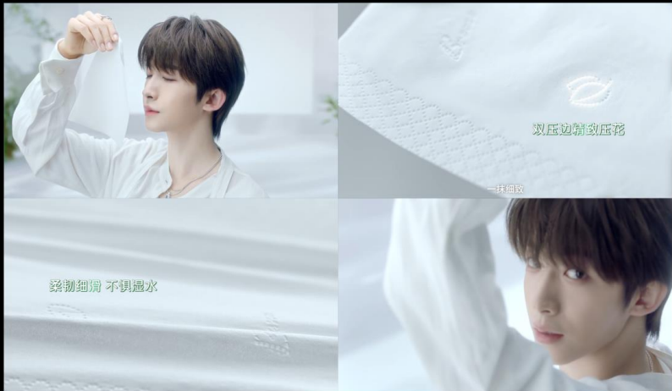

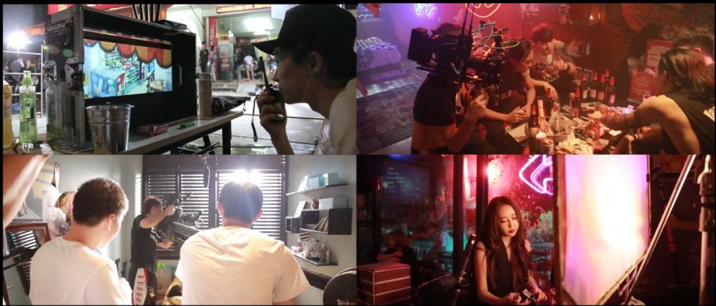

### ​****​Showreel & Contact​****​

​**​Portfolio:​**​ [Xinpianchang](https://www.xinpianchang.com/u10003156)  
​**​Closing:​**​ Thanks for watching! —Skylen