**Increasing blood flow to the bladder is more effective at selectively targeting the tumor**

**Mesh**

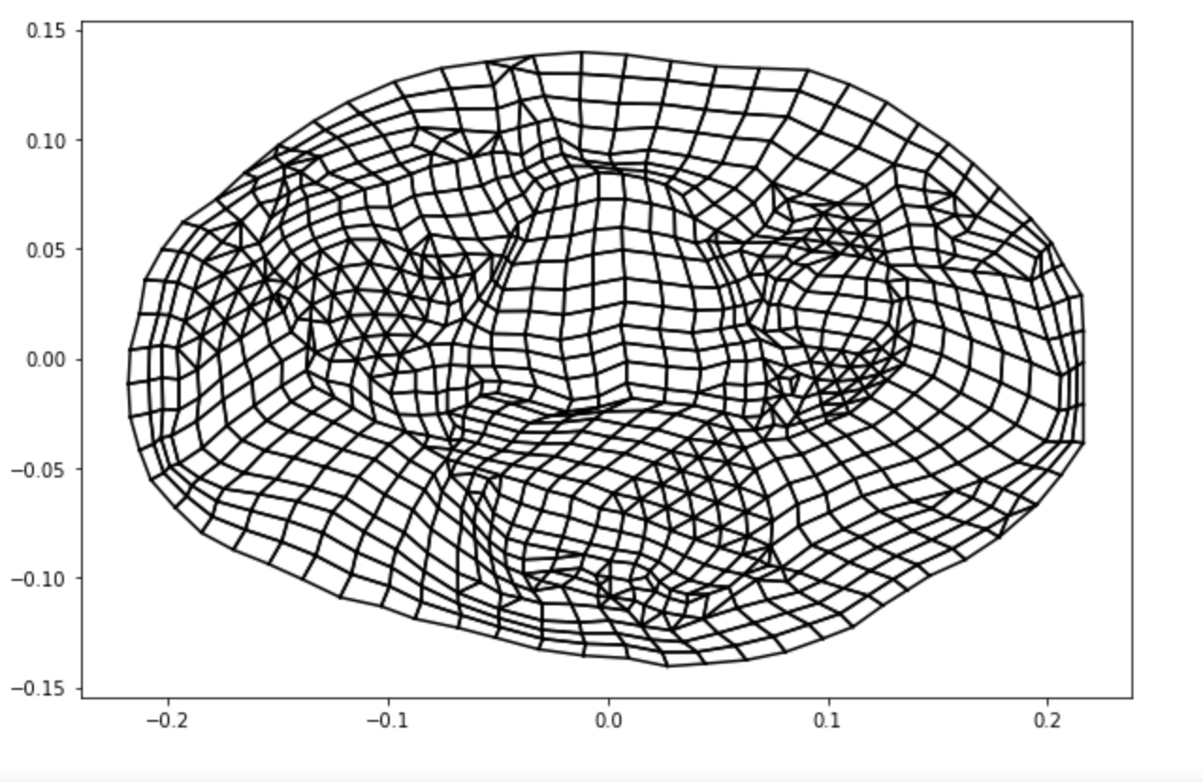

**Type I**

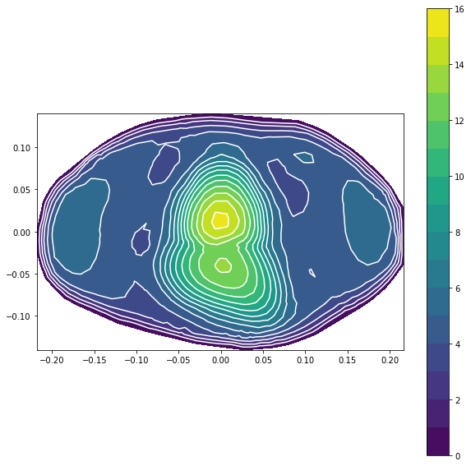

**Type III (A)**

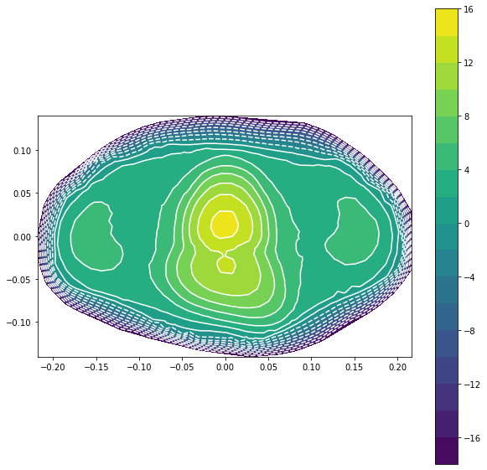

**Type III (B)**

