Q Search

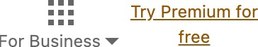

Ad •••

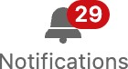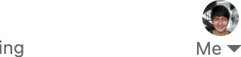



Gideon, explore relevant opportunities with GRIT

#### OIIO

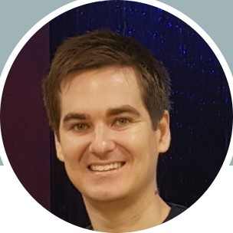Adrian Casey 2nd

9 years experience in communications, technology and change management across corporates and start ups.

Australia Contact info 468 connections

Mitchel Woods, Reece Frazier, and 1 other mutual connection

 More



Message

# Activity

469 followers



James Cook University



People also viewed

Reza Maghami @| 2nd Dev manager, Technical Lead C#/Angular/AWS/Azure



i Conne t

James Entwisle 2nd Product Builder X Growth



-I- Follo



Pao Salcedo good luck with the job hunt! You're an asset to whoever is lucky to snatch you up :)

Great points Pao. I agree and I think we tend to be sucked into sunk cost fallacy when it comes to quitting. Adrian Casey commented on a post • 6mo

Yes! And professional communicators and marketers too proud to acknowledge this future state in the name of their years of experience in the trade will be way behind and left wondering what happened. Just look at the comments section of any jasper.ai ad to see this denial in practice. There will undoubtedly be a need for skilled con ...show more

Martin Wells 2nd CTO

i Conne t

Stuart Burnicle 3rd Executive Director | Portfolio & Program Management...



-I- Follo

## Experience

Show all comments -+

Yousef Hosseini 2nd Founder at Clanz.com

i Conne t

Sen or



’

’F u”i

duty Manager

Show more

Jun 2021 - Present 2 yrs 1 mo Queensland, Australia

DS **Smith**



Internal Communications Channels Manager Full-time

Sep 2019 — Mar 2021- 1 yr 7 mos London, United Kingdom

Led procurement, maintenance and development of Internal Communications and PR tools including the company intranet and mobile applications.

Corporate Communications Manager Sep 2018 - Sep 2019- 1 yr 1 mo

London, United Kingdom

Company positioning on key issues, media monitoring, reporting on communications performance, and content planning.

Group Communications Executive Apr 2016 - Sep 2018- 2 yrs 6 mos

Internal communications, employee insights, digital communications and community management.

Marketing and Communications Officer The UCL Academy



2014 - 2016- 2 yrs

London, United Kingdom

Responsible for all marketing and communications activity including website, internal communications, PR, social media and recruitment events.

## Education

James Cook University

Doctor of Philoso hy - PhD, Social Psychology 2010 — 2014



"

James Cook University Bachelor's degree, Psychology

” 2005 - 2009

People you may know

Christine Marie I. Gohetia "when things are bound to happen, it will happen"

i



Conne t

Lito Cabornay

DevOps Engineer | Fullstack Software Engineer | Server...

i Conne t

Miriam Mae Iglesia  Software Development

Manager at Lanex... i Conne t

Nestor Calizar Software Development Engineer at LANEX...



i



Conne t

Augustus John Leyson Software Development Engineer at LANEXUS

&

i Conne t

Show more

@ L E A R N IN G

Add new skills with these courses, free for 24 hours

Quantum Computing Fundamentals

# Skills

Grade: Honours (2A)



React: Design Patterns

#### Communication

¥, t„ Endorsed by 3 colleagues at DS Smith  3 endorsements

Internal Communications

Endorsed by Sam Hodlin and 1 other who is highly skilled at this

¥, t„ Endorsed by 5 colleagues at DS Smith  5 endorsements

InDesign

Wioleta Koszolko has given an endorsement for this skill  1 endorsement

Show all 29 skills -+

Nano Tips for Negotiating Your Sala...

See my recommendations

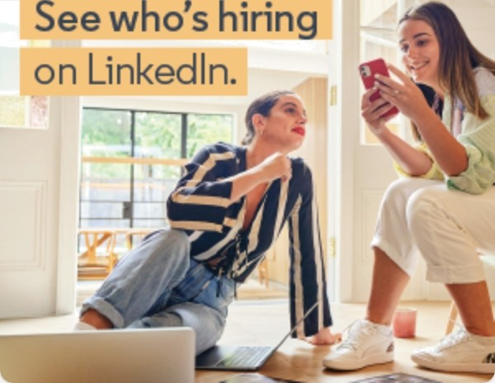

# Recommendations

Received Given

### Louisa Mellor 3rd

People & Change consultant at Newton Europe

June 7, 2021, Louisa managed Adrian directly

Adrian was a game—changing appointment to our communications function at DS Smith. His intellectual fire- power coupled with such strong passion for delivering quality work meant he threw himself into all aspects of the role with outstanding results. What really stood out for me was Adrian's ability to bring the rigour of social science research methods and measurement and a creativity that brought incredible profe ...see more

### Debo Dyson 3rd

*, Internal Communications Manager

April 18, 2021, Debo worked with Adrian on the same team

Adrian has a natural understanding of internal communications and employee engagement. He's both technical and creative, highly capable and adaptable. He's a creative content creator and a problem solver. Most of all he's a supportive and collaborative teammate.

### Greg Dawson 3rd

Group Corporate Affairs and Sustainability Director

April 8, 2021, Greg managed Adrian directly

Adrian helped me to build the the Corporate Affairs function at DS Smith and his brilliant mind and dedication enabled us to put a powerful measurement model together for all of the channels in the function. Adrian is not only a good analytical mind but a strong communications business partner. Adrian will be missed by all at DS Smith.

Show all 9 received -+

Interests

Top Voices Companies Groups Schools

### Daniel Ricciardo @ 3rd

Chief of Optimism at Optus. Driver of fast cars.

328,910 followers

+ Follo

About



Privacy & Terms



Safety Center

LnkednCorporaton O 2023

Accessibility







Advertising



Questions?

VisitourHetp Center.

Manage your account and privacy

Go to your Settings

Recommendation transparency

Learn more about Recommended Co

Here is the PH

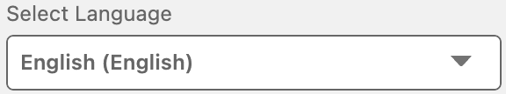Messaging 