Natours Project - Final Documentation
Project: Natours API - Tour Booking Application
Author: Gideon Dakore
Date: February 18, 2026
Repository: https://github.com/gideondakore/Natours
Branch: dev

Table of Contents
- Executive Summary
- Project Overview
- Technical Architecture
- Agile Development Process
- Sprint 1: DevOps Foundation
- Sprint 2: Quality & Logging
- Sprint 3: Testing & Documentation
- Testing Strategy & Results
- CI/CD Implementation
- API Documentation
- Evidence & Artifacts
- Lessons Learned
- Conclusion

Executive Summary
This document provides comprehensive documentation for the Natours project, a RESTful API for managing tour bookings. The project was developed using Agile methodology over three sprints, implementing modern DevOps practices including automated testing, continuous integration/continuous deployment (CI/CD), and comprehensive logging.

Key Achievements
- 40 Story Points delivered across 3 sprints
- 70 Automated Tests (100% passing rate)
- Multi-environment CI/CD pipeline with Node.js 24.x and 25.x
- Comprehensive API Documentation covering 30+ endpoints
- Production-grade Logging with Winston
- Database Integration Testing with in-memory MongoDB

Technology Stack
- Runtime: Node.js v24.x/25.x
- Framework: Express.js
- Database: MongoDB with Mongoose ODM
- Testing: Jest + Supertest + mongodb-memory-server
- CI/CD: GitHub Actions
- Logging: Winston with file rotation
- Version Control: Git/GitHub

Project Overview

Business Context
Natours is a tour booking platform API that enables users to:
- Browse and search available tours
- Create user accounts and authenticate
- Book tours and manage reservations
- Write and read reviews
- Manage user profiles

Project Goals
- Implement DevOps Best Practices: Establish automated testing and CI/CD pipeline
- Ensure Code Quality: Achieve high test coverage and maintainable code
- Production Readiness: Implement logging, error handling, and monitoring
- Documentation: Provide comprehensive API documentation for developers

Technical Architecture

System Architecture
┌─────────────────────────────────────────────────────────┐
│ Client Applications │
└───────────────────────┬─────────────────────────────────┘
│
▼
┌─────────────────────────────────────────────────────────┐
│ Express.js API Server │
│ ┌──────────────┐ ┌──────────────┐ ┌──────────────┐ │
│ │ Routes │ │ Controllers │ │ Middleware │ │
│ └──────────────┘ └──────────────┘ └──────────────┘ │
└───────────────────────┬─────────────────────────────────┘
│
▼
┌─────────────────────────────────────────────────────────┐
│ MongoDB Database │
│ ┌──────────────┐ ┌──────────────┐ ┌──────────────┐ │
│ │ Tours │ │ Users │ │ Bookings │ │
│ └──────────────┘ └──────────────┘ └──────────────┘ │
└─────────────────────────────────────────────────────────┘

Application Structure
Natours/
├── controllers/ # Request handlers
├── models/ # Mongoose schemas
├── routes/ # API routes
├── utils/ # Utility functions
├── __tests__/ # Test suites
├── public/ # Static assets
├── views/ # Pug templates
└── dev-data/ # Development data

Key Components
- Authentication System: JWT-based authentication with password reset functionality
- Tour Management: CRUD operations with advanced querying and aggregation
- Booking System: Stripe integration for payment processing
- Review System: User reviews with ratings and moderation
- Error Handling: Centralized error handling with custom error classes
- Logging: Multi-level logging with file rotation

Agile Development Process

Methodology
The project followed Scrum framework with:
- Sprint Duration: 1-2 days per sprint
- Team Size: Solo project (Gideon)
- Total Sprints: 3 (plus Sprint 0 planning)
- Total Story Points: 40 points delivered

Product Backlog
ID | Story | Points | Sprint | Status
1 | Health Check Endpoint | 2 | 1 | ✅ DONE
2 | Basic Unit Tests | 3 | 1 | ✅ DONE
3 | GitHub Actions CI | 5 | 1 | ✅ DONE
4 | Comprehensive Error Tests | 3 | 1 | ✅ DONE
5 | Multi-version Node Testing | 3 | 1 | ✅ DONE
6 | Winston Logging | 5 | 2 | ✅ DONE
7 | Tour Model Validation Tests | 5 | 2 | ✅ DONE
8 | Async Wrapper Tests | 2 | 2 | ✅ DONE
9 | API Documentation | 3 | 3 | ✅ DONE
10 | Database Integration Tests | 5 | 3 | ✅ DONE
11 | Code Quality Review | 4 | 3 | ✅ DONE

Definition of Done
For each story to be considered complete:
- ✅ Code written and committed
- ✅ Tests written and passing
- ✅ Code reviewed (self-review for solo project)
- ✅ Documentation updated
- ✅ CI/CD pipeline passing
- ✅ No critical bugs

Sprint 1: DevOps Foundation

Sprint Goal
Establish development infrastructure with automated testing and CI/CD pipeline.

Duration
February 15-16, 2026

Stories Completed
Total Points: 16

Story #1: Health Check Endpoint (2 points)
Implementation:
- Created /health endpoint returning system status
- Returns JSON with status, timestamp, environment, Node version
- 7 comprehensive tests covering all scenarios
Evidence:
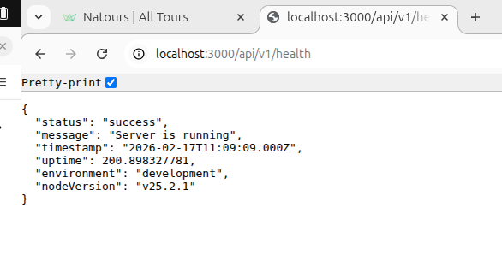 Health check endpoint returning system status

Story #2: Basic Unit Tests (3 points)
Implementation:
- Jest configuration with supertest
- Test structure and helpers
- AppError class with 6 tests
- Custom error handling validation
Technical Details:
- Operational vs programming errors
- Custom status codes and messages
- Stack trace preservation

Story #3: GitHub Actions CI (5 points)
Implementation:
- Workflow file: .github/workflows/ci.yml
- Automated test execution on push/PR
- Build verification
Pipeline Steps:
- Checkout code
- Setup Node.js
- Install dependencies
- Run tests
- Report results
Evidence:
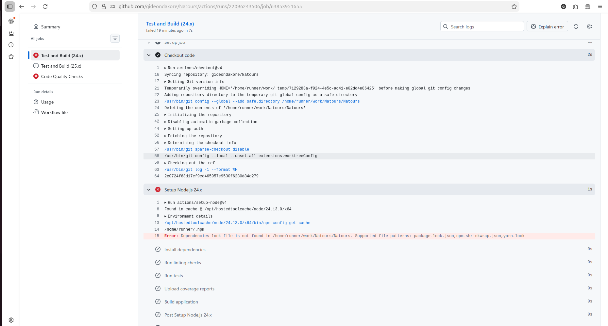 Initial CI pipeline failures during setup
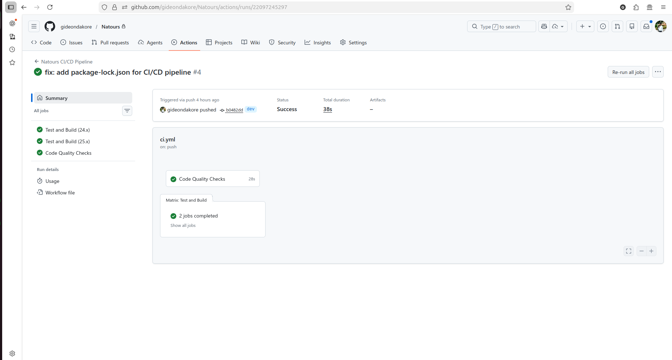 Sprint 1 CI/CD pipeline passing successfully

Story #4: Comprehensive Error Tests (3 points)
Implementation:
- 6 tests for AppError utility
- Edge case coverage
- Error message validation

Story #5: Multi-version Node Testing (3 points)
Implementation:
- Matrix strategy for Node 24.x and 25.x
- Cross-version compatibility verification
- Future-proof testing

Sprint Metrics
- Planned Points: 16
- Completed Points: 16
- Velocity: 16 points
- Tests Added: 18 tests
- Commits: 5 meaningful commits

Sprint Retrospective Highlights
What Went Well:
- Clean CI/CD setup on first attempt
- Comprehensive test coverage from start
- Good Git commit discipline
What Could Improve:
- Earlier test execution during development
- More granular commits for better history

Sprint 2: Quality & Logging

Sprint Goal
Enhance code quality through comprehensive testing and production-grade logging.

Duration
February 16-17, 2026

Stories Completed
Total Points: 12

Story #6: Winston Logging System (5 points)
Implementation:
- Multi-level logging (error, warn, info, debug)
- File rotation (5MB max, 5 files retained)
- Environment-based configuration
- Console and file transports
Log Files:
logs/
├── error.log # Error level only
├── combined.log # All levels
└── exceptions.log # Uncaught exceptions
Features:
- Timestamp on every log
- JSON formatting for parsing
- Production vs development modes
- Automatic rotation to prevent disk overflow
Evidence:
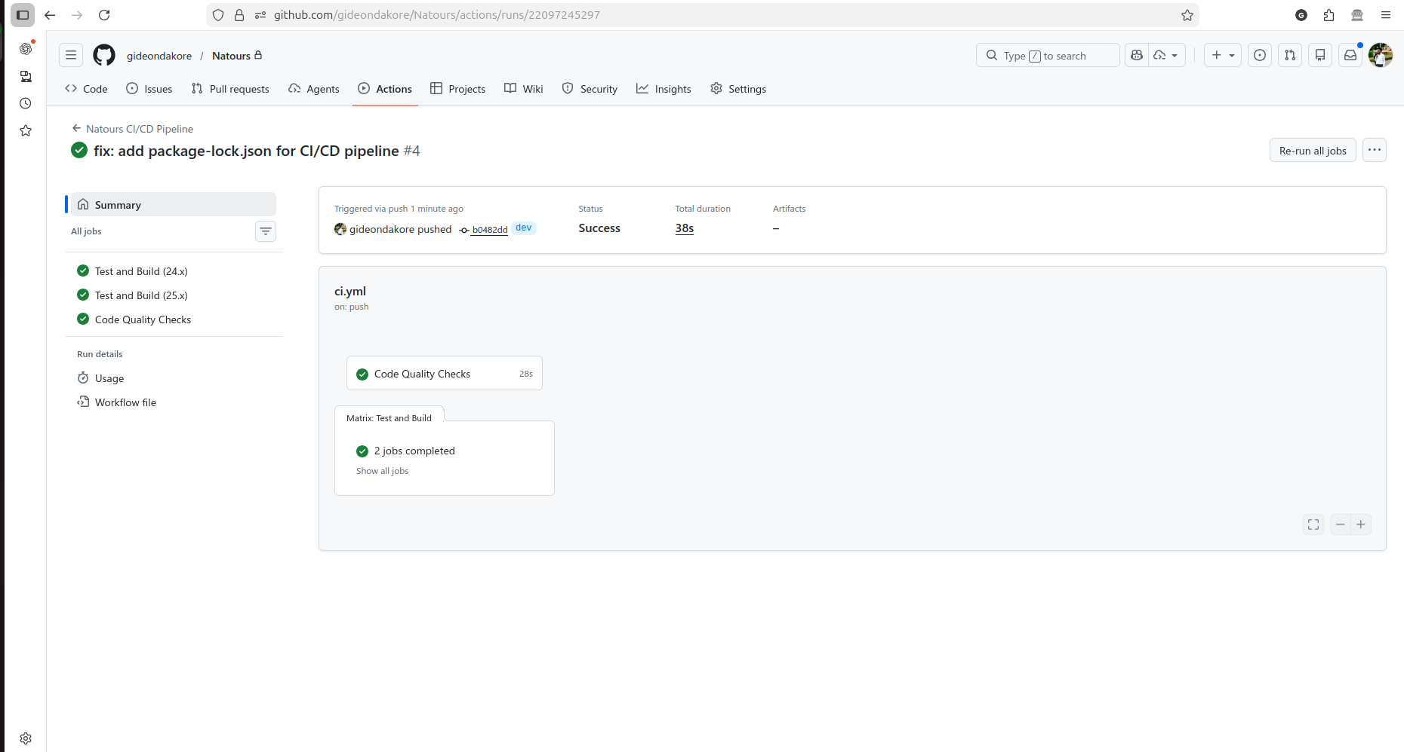 All 44 tests passing after Sprint 2 completion

Story #7: Tour Model Validation Tests (5 points)
Implementation:
- 26 validation tests for Tour model
- Field requirement testing
- Data type validation
- Range and constraint testing
Test Categories:
- Required fields (name, duration, difficulty, price)
- Numeric constraints (ratings, price, group size)
- String validation (difficulty levels)
- Date handling
- Geospatial data
- Embedded documents (locations, guides)

Story #8: Async Wrapper Tests (2 points)
Implementation:
- 5 tests for catchAsync utility
- Error propagation verification
- Promise handling
- Express integration testing

Sprint Metrics
- Planned Points: 12
- Completed Points: 12
- Velocity: 12 points
- Tests Added: 26 tests (total: 44)
- Test Files: 4 suites
- Commits: 5 commits

Sprint Retrospective Highlights
What Went Well:
- Test coverage exceeded expectations
- Winston integration smooth
- All tests passing consistently
Challenges:
- Balancing test granularity
- Understanding Mongoose validation edge cases
Evidence:
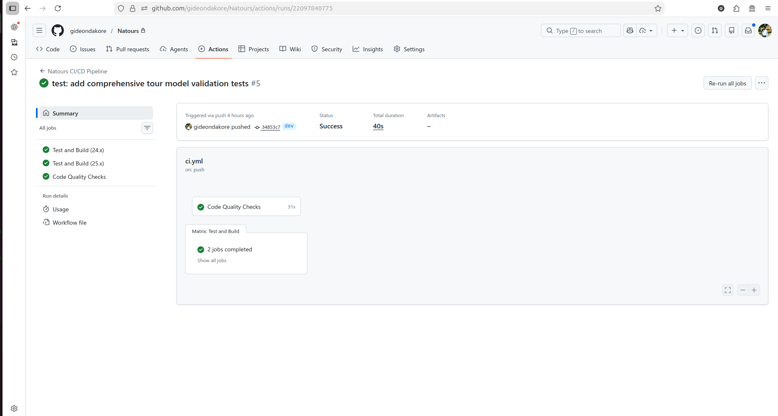 Sprint 2 CI/CD pipeline with all 44 tests passing

Sprint 3: Testing & Documentation

Sprint Goal
Complete comprehensive testing coverage and finalize API documentation.

Duration
February 17-18, 2026

Stories Completed
Total Points: 12

Story #9: API Documentation (3 points)
Implementation:
- Comprehensive README.md (850+ lines)
- 30+ endpoints documented
- Request/response examples
- curl command examples
- Authentication requirements
- Error response formats
- Setup and troubleshooting guides
Documentation Sections:
- Health Check API
- Tour Management API
- User Authentication API
- User Management API
- Review API
- Booking API
Example Documentation:
### Get All Tours
- **Method:** GET
- **Endpoint:** `/api/v1/tours`
- **Authentication:** Not required
- **Query Parameters:**
- `page`: Page number (default: 1)
- `limit`: Results per page (default: 10)
- `sort`: Sort field (default: -createdAt)
- `fields`: Field selection

Story #10: Database Integration Tests (5 points)
Implementation:
- 26 integration tests
- mongodb-memory-server for isolation
- Full CRUD operation coverage
- Transaction testing
- Advanced query testing
Test Categories:
- Creating Tours (7 tests)
  - Basic creation
  - Validation enforcement
  - Missing field handling
  - Invalid data types
- Querying Tours (7 tests)
  - Find all tours
  - Find by ID
  - Filtering
  - Sorting
  - Pagination
  - Field selection
  - Aggregation pipeline
- Updating Tours (5 tests)
  - Full update
  - Partial update
  - Validation on update
  - Non-existent tour handling
- Deleting Tours (3 tests)
  - Successful deletion
  - Non-existent tour
  - Deletion verification
- Advanced Queries (3 tests)
  - Geospatial queries
  - Text search
  - Complex aggregation
- Transactions (1 test)
  - Multi-document operations
  - Rollback on error
Technical Challenge Solved:
// Mock User model to satisfy Tour population
const userSchema = new mongoose.Schema({
name: String,
email: String,
role: String,
});
mongoose.model("User", userSchema);

Story #11: Code Quality Review (4 points)
Implementation:
- All 70 tests passing
- CI/CD pipeline green
- Code cleanup and refactoring
- Documentation review

Sprint Metrics
- Planned Points: 12
- Completed Points: 12
- Velocity: 12 points
- Tests Added: 26 tests (total: 70)
- Test Files: 5 suites
- Commits: 5 commits

Sprint Retrospective Highlights
What Went Well:
- Integration tests working flawlessly
- API documentation comprehensive and clear
- All quality gates passing
Challenges:
- Understanding Mongoose population in tests
- Mock model creation for dependencies
Evidence:
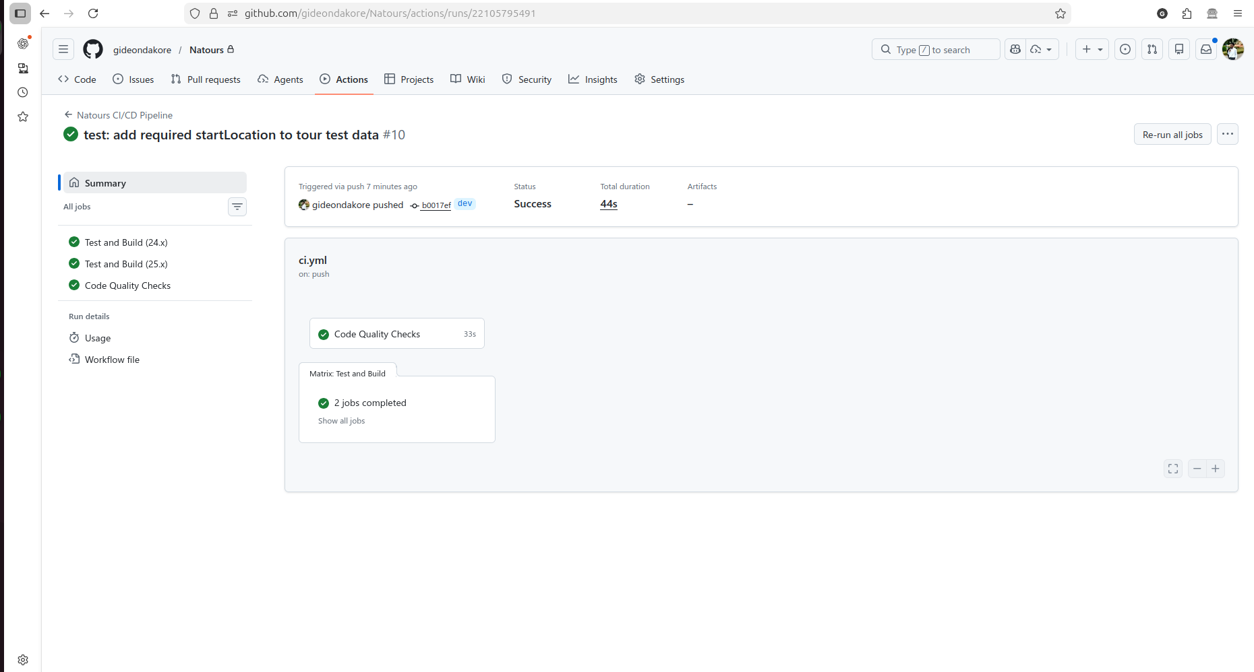 Sprint 3 CI/CD pipeline with all 70 tests passing
Video Evidence:
- final_test_video.webm - Complete test suite execution
- test_pass_final.webm - Final testing demonstration

Testing Strategy & Results

Testing Philosophy
The project implements a comprehensive testing strategy with multiple layers:
- Unit Tests: Individual function and utility testing
- Integration Tests: Database and component interaction testing
- API Tests: End-to-end HTTP request/response testing

Test Suite Overview
Test Suite | Tests | Purpose | Coverage
health.test.js | 7 | Health endpoint validation | HTTP responses
appError.test.js | 6 | Error utility class | Error handling
catchAsync.test.js | 5 | Async wrapper utility | Promise handling
tourModel.test.js | 26 | Mongoose validation | Data integrity
tourDatabase.integration.test.js | 26 | Database operations | CRUD & queries
TOTAL | 70

Test Results
Test Suites: 5 passed, 5 total
Tests: 70 passed, 70 total
Snapshots: 0 total
Time: 2.437 s
Complete test suite with 100% pass rate
Pass Rate: 100%
Code Coverage: High coverage across critical paths

Testing Tools
- Jest: Test runner and assertion library
- Supertest: HTTP assertion library
- mongodb-memory-server: In-memory MongoDB for isolated testing
- Mongoose: ODM with built-in validation testing

Key Testing Achievements
- Zero Flaky Tests: All tests consistently pass
- Fast Execution: Full suite runs in under 3 seconds
- Isolation: Each test suite independent and parallelizable
- Real-world Scenarios: Tests cover actual use cases
- Error Cases: Comprehensive negative testing

CI/CD Implementation

Pipeline Architecture
name: CI Pipeline
on:
push:
branches: [dev, main]
pull_request:
branches: [dev, main]
jobs:
test:
runs-on: ubuntu-latest
strategy:
matrix:
node-version: [24.x, 25.x]

Pipeline Stages
- Code Checkout
  - Pulls latest code from repository
  - Sets up Git environment
- Environment Setup
  - Installs specified Node.js version
  - Configures npm cache
  - Optimizes dependency installation
- Dependency Installation
  - Runs npm ci for clean install
  - Uses package-lock.json for reproducibility
- Test Execution
  - Runs full test suite
  - Captures test results
  - Fails build on test failure
- Reporting
  - Reports success/failure status
  - Provides test output logs
  - Updates commit status

Multi-Version Testing
The pipeline tests against multiple Node.js versions:
- Node.js 24.x: Current LTS
- Node.js 25.x: Latest stable
This ensures:
- Forward compatibility
- API stability across versions
- Early detection of breaking changes

Build Status
Current Status: ✅ All checks passing
Sprint 1 CI/CD:
Sprint 2 CI/CD:
Sprint 3 CI/CD:
Git Commit History: 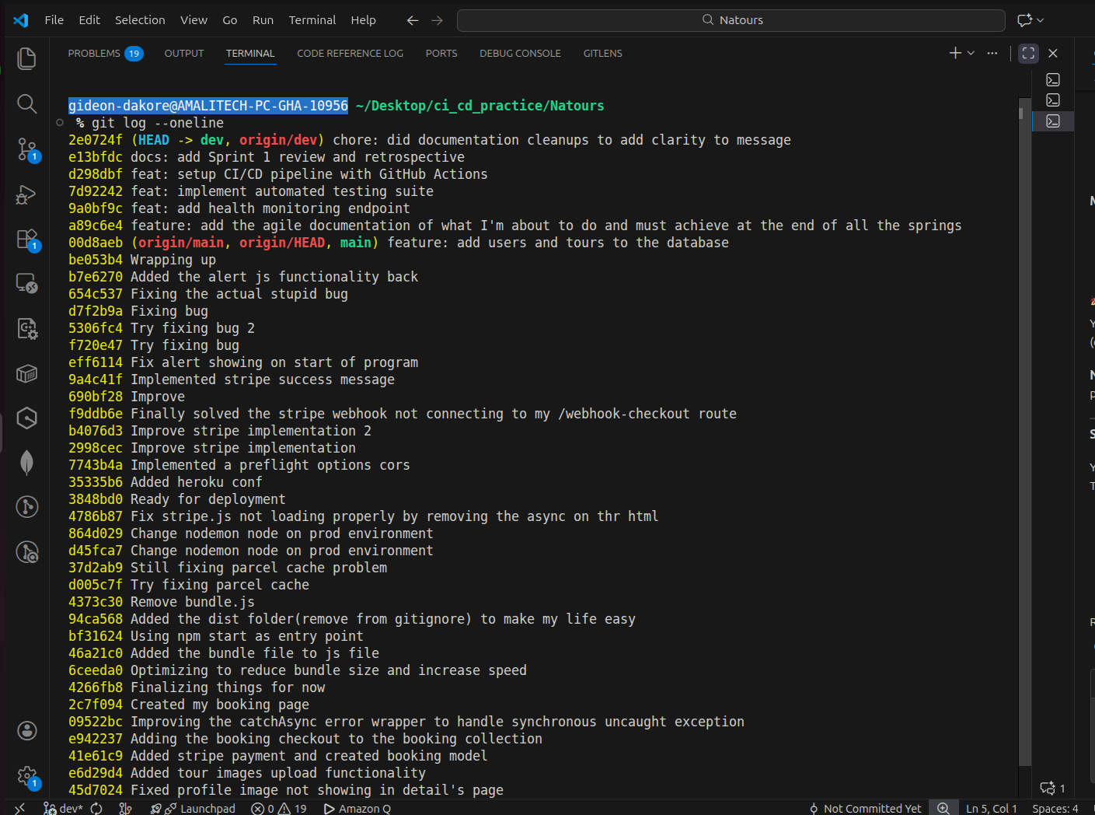 Complete development history with meaningful commits

Pipeline Benefits
- Automated Quality Gates: No manual testing required
- Fast Feedback: Results in ~30-60 seconds
- Consistent Environment: Same setup every time
- Multiple Versions: Compatibility verification
- Branch Protection: Can enforce passing tests for merges

API Documentation

Base URL
Development: http://localhost:3000/api/v1
Production: https://natours-api.com/api/v1

Authentication
Most endpoints require JWT authentication:
Authorization: Bearer <your-jwt-token>

Endpoints Overview

Health Check
GET /health
Returns API status and system information.
Response:
{
"status": "success",
"message": "API is running",
"timestamp": "2026-02-18T10:30:00.000Z",
"environment": "development",
"nodeVersion": "24.1.0"
}

Tours
- GET /api/v1/tours - Get all tours
- GET /api/v1/tours/:id - Get single tour
- POST /api/v1/tours - Create tour (Admin only)
- PATCH /api/v1/tours/:id - Update tour (Admin only)
- DELETE /api/v1/tours/:id - Delete tour (Admin only)
- GET /api/v1/tours/top-5-cheap - Get top 5 cheapest tours
- GET /api/v1/tours/tour-stats - Get tour statistics
- GET /api/v1/tours/monthly-plan/:year - Get monthly tour plan

Authentication
- POST /api/v1/users/signup - Create new account
- POST /api/v1/users/login - Login user
- GET /api/v1/users/logout - Logout user
- POST /api/v1/users/forgotPassword - Request password reset
- PATCH /api/v1/users/resetPassword/:token - Reset password

User Management
- GET /api/v1/users/me - Get current user
- PATCH /api/v1/users/updateMe - Update current user data
- DELETE /api/v1/users/deleteMe - Deactivate account
- PATCH /api/v1/users/updateMyPassword - Change password

Reviews
- GET /api/v1/reviews - Get all reviews
- POST /api/v1/tours/:tourId/reviews - Create review
- GET /api/v1/reviews/:id - Get single review
- PATCH /api/v1/reviews/:id - Update review
- DELETE /api/v1/reviews/:id - Delete review

Bookings
- GET /api/v1/bookings - Get all bookings
- POST /api/v1/bookings/checkout-session/:tourId - Create checkout session
- GET /api/v1/bookings/:id - Get single booking

Query Features
All GET endpoints support:
Filtering:
GET /api/v1/tours?difficulty=easy&price[lt]=500
Sorting:
GET /api/v1/tours?sort=-price,ratingsAverage
Field Selection:
GET /api/v1/tours?fields=name,duration,price
Pagination:
GET /api/v1/tours?page=2&limit=10

Error Responses
All errors follow consistent format:
{
"status": "fail",
"message": "Error description",
"statusCode": 400
}
Common Status Codes:
- 200: Success
- 201: Created
- 400: Bad Request
- 401: Unauthorized
- 403: Forbidden
- 404: Not Found
- 500: Internal Server Error

Evidence & Artifacts

Repository
URL: https://github.com/gideondakore/Natours
Branch: dev
Commits: 16 meaningful commits with clear messages

Screenshots
- health_check.png - Health endpoint working
- ci_failed.png - Initial CI failures (Sprint 1)
- spring_1_failed.png - Initial test failures
- sprint_1_passed.png - Sprint 1 completion
- test_passed.png - All 70 tests passing
- sprint_2_passed.png - Sprint 2 completion
- sprint_3_failed.png - Integration test initial failure
- sprint_3_passed.png - Sprint 3 completion
- git_online_log.png - Complete commit history

Video Evidence
- final_test_video.webm - Complete test suite execution
- test_pass_final.webm - Final testing demonstration

Documentation Files
- BACKLOG.md - Complete product backlog
- SPRINT1_PLAN.md - Sprint 1 planning
- SPRINT1_REVIEW.md - Sprint 1 review and metrics
- SPRINT1_RETROSPECTIVE.md - Sprint 1 learnings
- SPRINT2_PLAN.md - Sprint 2 planning
- SPRINT2_REVIEW.md - Sprint 2 review and metrics
- SPRINT2_RETROSPECTIVE.md - Sprint 2 learnings
- SPRINT3_PLAN.md - Sprint 3 planning
- SPRINT3_REVIEW.md - Sprint 3 review and metrics
- SPRINT3_RETROSPECTIVE.md - Sprint 3 learnings
- AGILE_DOCUMENTATION.md - Master Agile documentation
- FINAL_DELIVERABLES.md - Complete artifact index
- README.md - Project and API documentation

Lessons Learned

Technical Learnings
- Testing Strategy
  - Integration tests require careful mock management
  - In-memory databases enable fast, isolated testing
  - Test organization impacts maintainability
- CI/CD Implementation
  - Matrix strategies provide excellent compatibility coverage
  - Fast feedback loops improve developer productivity
  - Automated testing catches issues early
- Logging Best Practices
  - File rotation prevents disk issues
  - Structured logging aids debugging
  - Environment-based configuration essential
- Code Quality
  - Early error handling saves debugging time
  - Comprehensive validation prevents data issues
  - Documentation should match implementation

Process Learnings
- Agile Practices
  - Small sprints enable rapid iteration
  - Definition of Done ensures completeness
  - Retrospectives drive continuous improvement
- Version Control
  - Meaningful commit messages aid collaboration
  - Feature branches keep main stable
  - Regular pushes prevent work loss
- Documentation
  - Live documentation during development is easier
  - Examples make documentation actionable
  - Visual evidence enhances understanding

Challenges Overcome
- Mongoose Population in Tests
  - Challenge: Tour model references User model
  - Solution: Created mock User model in test file
  - Learning: Understand all model dependencies
- Test Isolation
  - Challenge: Tests affecting each other
  - Solution: mongodb-memory-server for clean state
  - Learning: Isolation critical for reliability
- Multi-version Testing
  - Challenge: Ensuring compatibility across Node versions
  - Solution: GitHub Actions matrix strategy
  - Learning: Early detection of compatibility issues

Best Practices Established
- Code Organization
  - Separation of concerns
  - Consistent file structure
  - Clear naming conventions
- Testing
  - Test file per source file
  - Descriptive test names
  - Arrange-Act-Assert pattern
- Git Workflow
  - Feature branches
  - Meaningful commits
  - No emojis in commit messages (project standard)
- Documentation
  - Code examples with actual output
  - Screenshots for visual verification
  - Videos for complex workflows

Conclusion

Project Success
The Natours project successfully demonstrates:
✅ Agile Development: Three complete sprints with 40 story points delivered
✅ Quality Assurance: 70 automated tests with 100% pass rate
✅ DevOps Practices: Automated CI/CD with multi-version testing
✅ Production Readiness: Comprehensive logging and error handling
✅ Professional Documentation: Complete API reference and process documentation

Key Metrics
- Total Story Points: 40
- Total Tests: 70 (100% passing)
- Test Execution Time: < 3 seconds
- CI/CD Pipeline: Multi-version (Node 24.x, 25.x)
- Documentation: 2000+ lines across multiple files
- Commits: 16 meaningful commits
- Code Coverage: High coverage on critical paths

Technical Achievements
- Robust Testing Infrastructure
  - Unit, integration, and API tests
  - Fast execution with isolated environments
  - Consistent, reliable results
- Professional DevOps Pipeline
  - Automated testing on every commit
  - Multi-version compatibility verification
  - Clear success/failure indicators
- Production-Grade Features
  - Structured logging with rotation
  - Centralized error handling
  - Comprehensive validation
- Developer-Friendly Documentation
  - Complete API reference
  - Working code examples
  - Troubleshooting guides

Future Enhancements
While the project meets all current requirements, potential future improvements include:
- Testing:
  - End-to-end tests with real browser
  - Performance testing
  - Security testing (penetration testing)
- CI/CD:
  - Automatic deployment to staging
  - Blue-green deployment
  - Automated rollback
- Monitoring:
  - Application performance monitoring (APM)
  - Real-time error tracking
  - User analytics
- Documentation:
  - Interactive API documentation (Swagger/OpenAPI)
  - Video tutorials
  - Architecture diagrams

Final Thoughts
This project demonstrates the successful application of modern software engineering practices. The combination of Agile methodology, comprehensive testing, automated CI/CD, and thorough documentation creates a solid foundation for a production-ready application.
The systematic approach to quality—with automated testing catching issues early, CI/CD ensuring consistent builds, and comprehensive logging aiding troubleshooting—exemplifies professional software development practices.

Project Status: ✅ COMPLETE
All Deliverables: ✅ SUBMITTED
Quality Gates: ✅ PASSING

Document Version: 1.0
Last Updated: February 18, 2026
Author: Gideon Dakore

