**A Method for Microbiome-based Prediction, Diagnosis and Treatment of Relapsing Obesity:**

**A Novel Method for Maintaining Target Body Weight Following a Diet Using Gut Microbiome Analysis**

|  |  |
| --- | --- |
| **Project Number:** | 1781 |
| **Principal Investigators:** | Prof. Eran Elinav  Prof. Eran Segal |
| **Patent Status:** | Pending |
| **Last Updated:** | 12-08-2018 |

**Overview**

**A novel method for maintaining target body weight and analyzing the likelihood of weight regain following a diet, based on gut microbiome analysis**

**Background and Unmet Need**

The past century has seen an overwhelming increase in prevalence obesity, with an estimate 44% of the adult population being overweight and about 10% suffering from morbid obesity. Obesity-related pathologies are strongly associated with risk factors for stroke, diabetes, high blood pressure, musculoskeletal disorders, and ischemic heart disease, considered to be a leading cause of overall mortality.

Despite continuous efforts to find a solution for the obesity epidemic, no dietary approach has been able to maintain, for a prolonged period of time, the reduced weight after the initial weight loss. Moreover, the recurrent weight gain usually exceeds that of the pre-dieting weight, irrespective of fitness level or genetic background. This risk is further enhanced with each weight gain-loss cycle.

**Consequently, there is a strong need for the development of novel methods for weight loss and, more importantly, for maintaining the post-diet target weight.**

**The Innovation**

The teams of Profs. Elinav and Segal have developed a method for analyzing the gut microbiome and inferring the likelihood of weight regain from the presence/absence of specific microbes.

**The Technical Essence:**

The Elinav-Segal research teams discovered that the amount of certain microbes in the gut are correlated with obesity. Therefore, down regulating certain microbes that are associated with weight gain while simultaneously upregulating microbes associated with weight loss can help achieve and maintain the target weight. The developed method consists of :

1. Treating the individual with a dieting aid.
2. monitoring the amounts of different gut microbes indicative of weight gain/loss.
3. Administering an agent which alters the gut microbiome signature to that similar to a non-obese individuals.

The researchers have developed a personalized machine learning algorithm that, based on the gut microbiome population, can predict the likelihood of recurrent weight gain. Additionally, the researchers have tested different agents such as antibiotics, Flavanoids, probiotics and fecal transplants in order to directly modulate the gut microbiome population, changing it to that of a non obese individual.

**Applications and Advantages:**

* **Novel approach** - The method addresses one of the main causes for weight gain that has, until now, been overlooked - the gut microbiome population.
* **Analysis** - The method can be used to predict the likelihood of success for different diets, by analyzing changes in the gut microbiome.
* **Improving existing diet programs**  - Based on the provided analysis individual weight loss programs can be modified for optimal results.
* **Treatment -** Different agents can be used to *directly* modulate the gut microbiome population or their metabolites, improving the results of the weight loss program and helping to maintain the target weight.
* **Personal** - Personalized dietary recommendations are given based on the individual’s gut microbiome population, genetic variance and dietary preferences.

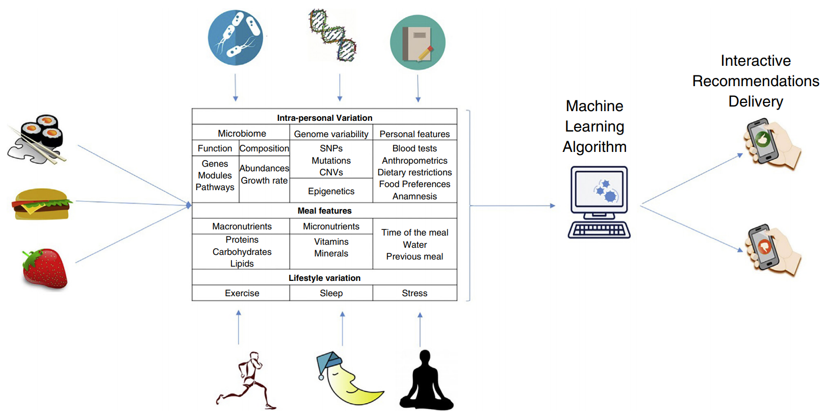

A personalized Machine learning algorithm utilizes comprehensive datasets such as dietary consumption, microbiome population and genetic variability to deliver dietary recommendations.

**Development Status**

The teams of Profs. Elinav and Segal have developed a personalized machine learning algorithm enabling microbiome based prediction of relapsing weight gain and have demonstrated, in mice, that fecal transplantation and post-biotic intervention may prevent excessive secondary weight gain. The method is currently being tested on human subjects.

**For additional information please contact:**

Dr. Shay Sela  
VP Business Development Life Sciences  
Tel: +972.8.9344095  
Email: Shay.Sela@weizmann.ac.il