Flowchart
A flowchart is a visual diagram that represents a process, algorithm, or workflow as a series of steps connected by arrows. It shows the order in which things happen, where decisions are made, and where the process begins and ends — making complex logic easy to read at a glance.
- Flowcharts illustrate step-by-step solutions to problems, making them useful for beginner programmers.
- Flowcharts help in debugging and troubleshooting issues.
- Flowchart consists of sequentially arranged boxes that depict the process flow.

Flowchart Symbols and functions

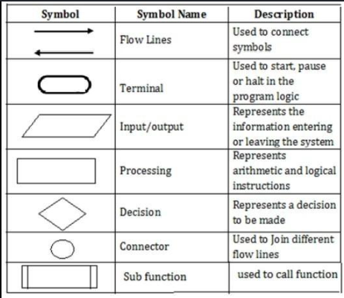

Advantages of using a Flowchart
- Flowcharts are a better way of communicating the logic of the system.
- Flowcharts act as a guide for blueprint during program designed.
- Flowcharts help in debugging process.
- With the help of flowcharts programs can be easily analyzed.
- They provide better documentation.
- Flowcharts serve as a good proper documentation.

Disadvantages of using a Flowchart
- It is difficult to draw flowcharts for large and complex programs.
- There is no standard to determine the amount of detail.
- It is very difficult to modify the Flowchart.
- Making a flowchart is costly.
- If changes are done in software, then the flowchart must be redrawn.

